Function

Content

+ Introduce

- what is function?

- type of function:

-Standard library function

-User-defined function

This lesson, We only focus on user-defined function

-Advantage of user-defined function

1. The program will be easy to understand, maintain and debug.

2. Reusable codes that can be used in other programs.

3. A large program can be divided into small modules. Hence, a large project can be divided among many programmers.

+ User-defined function

1.function declaration

- syntax:

return_data_type function_name (data_type variable1, ...); or

return_data_type function_name (data_type_list);

**Note: If the function does not return a value, the return type is specified by the keyword void.

Syntax:

void function_name (data_type variable1, data_type variable2, ……);

Example:

float division (void);

int isPrime (int);

void printMessage (void);

void fiboSeries (int);

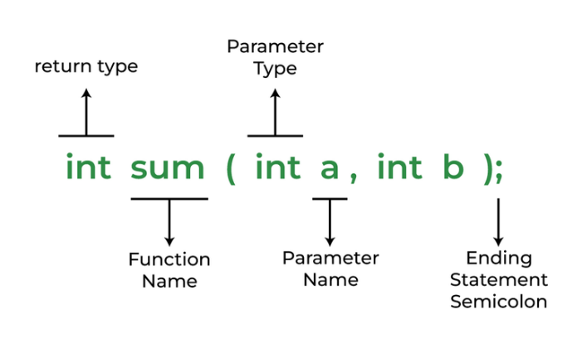

2.function definition

- Syntax:

return_data_type function_name (data_type variable1, data_type variable2, ……) {

/* Function Body */

/* Return Statement */

}

-Example:

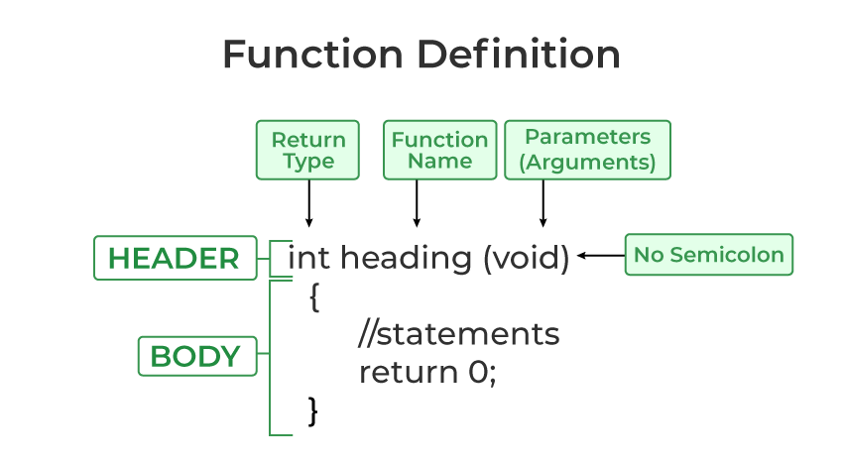

- Syntax return statement

return expression; or

return (expression);

-Example

return x;

return (x + y);

3.function calling

- Syntax:

function_name(variable1, variable2,…); or

variable_name = function_name(variable1, variable2,…);

**Note: If there are no arguments(variable) to be passed in the function, syntax will be :

function_name ( ); or

variable_name = function_name ( );

* Example

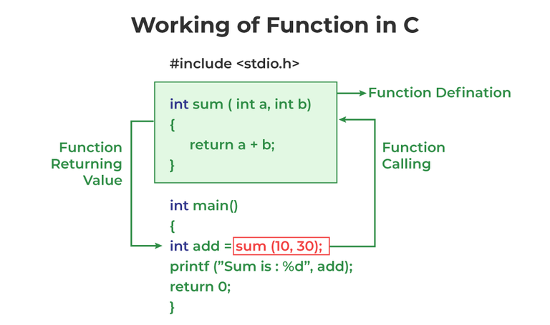

4. Type of user-defined function

4.1 no arguments and no return values

- Syntax:

void function_name () {

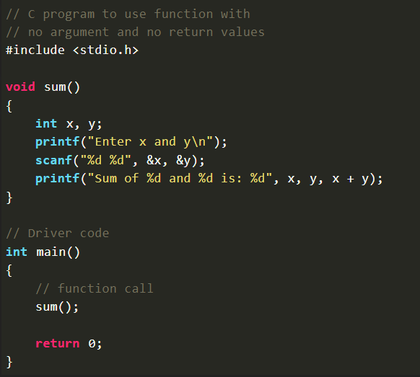/* Function Body */

}

* Example

4.2 no arguments and return values

- Syntax:

return_data_type function_name () {

/* Function Body */

/* Return Statement */

}

* Example
* 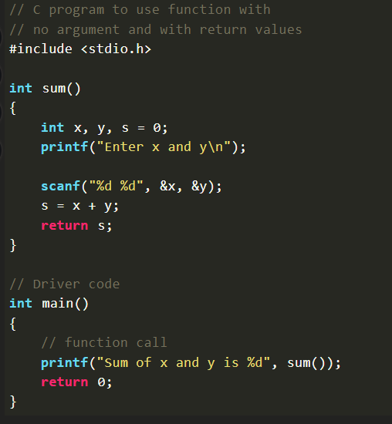

4.3 arguments and no return values

- Syntax:

void function_name (data_type variable1, data_type variable2, ……) {

/* Function Body */

}

- Example:

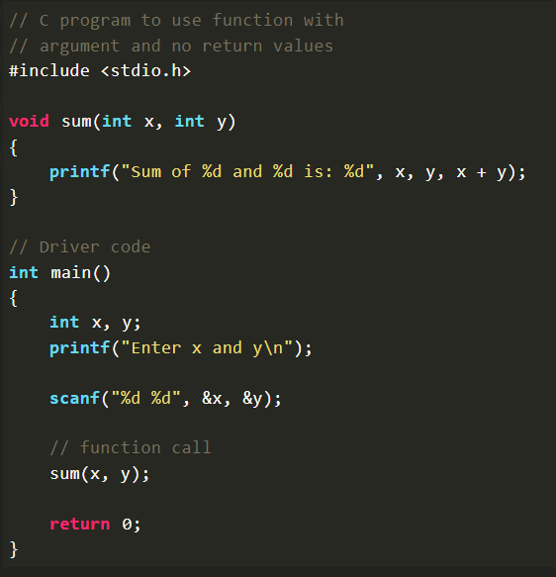

4.4 arguments and return values

- Syntax:

return_data_type function_name (data_type variable1, data_type variable2, ……) {

/* Function Body */

/* Return Statement */

}

* Example
* 