MORAv2 - A Mixed-Integer Linear Programming Framework for Real-Time Resource Allocation in Building Fire Emergencies
Khoa Nguyen Hoang Anh∗, Phuc Nguyen Song Thien∗, and Do Cao Kim∗ Ho Chi Minh City, Vietnam
{10422037, 10422067, 10422018}@student.vgu.edu.vn

Abstract—Recent literature extensively applies Mixed-Integer Linear Programming (MILP) to solve complex optimization problems in emergency manage- ment. Within this domain, rapid and effective emergency response to urban building fires remains a critical challenge. In these high-pressure situations, where incident commanders face dynamic and uncertain en- vironments, Operations Research (OR) methodologies provide the necessary framework for fast, robust, and mathematically optimal decision-making. Motivated by these operational needs, this paper introduces MORAv2, a novel adaptation of the Multicriteria Optimization- Based Resource Allocation (MORA) framework. Orig- inally developed for large-scale wildfire suppression, MORAv2 is re-engineered specifically for building fire emergencies. The proposed MORAv2 model formu- lates indoor emergency response as an Integer Linear Programming (ILP) constrained optimization problem. Unlike traditional models that focus on macro-level station location or fleet routing, this study focuses on micro-level tactical response actions during an active incident to maximize rescued individuals and minimize property loss. While retaining the core lexicographic concepts and operational constraints of the original MORA framework, this research introduces a dynamic “smoke factor” to realistically capture the hazardous conditions of indoor rescue planning. Operating through a lexicographic optimization strategy, the algorithm sequentially calculates optimal deployment to strictly minimize the total population at risk, property loss, and operational transit times. The results demonstrate the solver’s computational viability, bridging the gap between passive smart-building technologies and active mathematical optimization for real-time indoor emer- gency response.
Index Terms—Optimization, Resource Allocation, Mixed-Integer Linear Programming, Decision Support Systems, Building Fire Emergencies

- Introduction
Fire safety within contemporary built environments encounters escalating obstacles owing to increased archi- tectural complexity, high occupancy densities, and the widespread use of synthetic materials that intensify fire hazards [1]. Conventional fire safety mechanisms generally function independently and lack integration with overar- ching building infrastructures, limiting their adaptability during rapidly evolving, “Black Swan” crises [2], [3]. In these high-pressure, dynamic situations where quick and
accurate decisions are critical to saving lives, incident commanders require advanced Decision Support Systems (DSS) capable of providing robust, mathematically optimal solutions [4].
The strategic management of fire protection services (FPS) is undergoing a paradigm shift from experience-based heuristics to rigorous, data-driven Resource Allocation in Fire Departments (RAFD) [5]. Historically, these models have utilized Integer Programming (IP) and Data Envelop- ment Analysis (DEA) to optimize macro-level objectives, such as fire station placement and fleet distribution, to minimize social costs [5], [6], [7]. However, a significant “tactical gap” persists; while existing research excels at macro-level 2D coverage, it lacks the granularity to route rescue teams inside 3D structures during active incidents [5].
Concurrently, innovations in smart buildings—specifi- cally the Internet of Things (IoT), Building Information Modeling (BIM), and Digital Twins—have enabled real- time monitoring of environmental hazards [8], [9]. Yet, these systems remain largely passive, providing visualization without the algorithmic capacity to autonomously compute optimal deployment strategies.
Motivated by these operational needs, this paper in- troduces MORAv2, a novel adaptation of the Multicri- teria Optimal Resource Allocation (MORA) framework originally developed for wildfire suppression [10], [11]. By re-engineering MORA’s lexicographic optimization for 3D indoor node networks, MORAv2 functions as an active decision-making solver [4]. A primary contribution is the introduction of a dynamic “smoke factor” that accounts for toxicological constraints and human behavioral nuances, preventing responder engagement in unsurvivable conditions [2], [12].
- Related Work
- Evolution of MCDM in Fire Science
Multi-Criteria Decision-Making (MCDM) has emerged as the dominant paradigm for structuring complex fire emergency problems [13], [4]. While the Analytic Hierar- chy Process (AHP) remains a foundational tool for risk ranking, recent literature emphasizes the need for objective weighting methods like CRITIC and Entropy to reduce

expert bias [7], [3] [13]. Advanced logic systems, including Spherical Fuzzy Sets (SFS) and Neutrosophic logic, are increasingly utilized to handle the “indeterminacy” and epistemic uncertainty inherent in high-pressure disaster operations [14], [15], [16], [17].
- Strategic Resource Allocation and Fleet Management
Resource Allocation in Fire Departments (RAFD) is a high-stakes domain focused on minimizing social costs—specifically life and property loss [5]. Literature reviews identify over 400 variables influencing resource distribution, ranging from population density to temporal demand shifts [5], [18]. Recent research focuses on the management of heterogeneous fleets—combining engines, ladders, and SUVs—utilizing Multi-Depot Vehicle Routing (MDHF-VRPTW-SPD) and Queueing Models (M/G/∞) to improve Effective Response Force (ERF) assembly times [19], [6], [20], [21], [22].
- IoT, Digital Twins, and 3D Fire Monitoring
The shift toward “Smart Firefighting” is enabled by the bidirectional flow of data between physical environments and Digital Twins [8]. Integration of IoT sensor arrays (temperature, CO, smoke) allows for the calculation of the Improved Risk Index (IRI), providing dynamic haz- ard visualization in multi-story residential buildings [9]. Knowledge-graph-based approaches further enhance this by fusing textual reports with live sensor data to predict fire propagation laws autonomously [8], [23].
- Optimization Algorithms for Evacuation Efficiency
Tactical response relies on high-speed pathfinding algo- rithms capable of operating in degraded environments [24], [25]. Hybrid models like the PTS algorithm (Pathfinder and Tunicate Swarm) and GreyGNN-MARL have demonstrated significant reductions in evacuation times, ranging from 7.7% to 25% [24], [4]. These models are increasingly tested against bio-inspired metaheuristics, such as NSGA-III, to optimize critical infrastructure reliability under fire stress [25].
- Human Behavior and the “Smoke Factor”
One of the most critical trends is the interdisciplinary assessment of human behavior in fires (HBiF) [2], [12]. Scoping reviews identify nearly 40 research gaps, specifically regarding how toxic and irritant smoke affects wayfinding and decision-making [2]. MORAv2 incorporates these nuances by treating the “smoke factor” as a dynamic constraint, prioritizing nodes for evacuation based on real- time visibility and toxicological thresholds [26].
- MILP and the MORA Framework
Operations research in wildland fire suppression has pioneered the use of Mixed-Integer Linear Programming (MILP) for real-time hazard adaptation [4], [10]. The MORA toolkit utilize lexicographic optimization to strictly prioritize life-safety over property and operational costs
[10], [11]. MORAv2 bridges the gap between these large- scale wildfire models and indoor tactical reality by mapping wildfire suppression logic onto 3D structural as multi 2D grid [10], [24].

- Experimental Setup
To validate the computational viability and operational efficacy of the proposed MORAv2 framework, a simulation- optimization approach was employed. Because deploying a live IoT sensor network in a burning building presents significant practical and safety challenges, this study utilizes synthetic data to act as “virtual sensors”, rigorously testing the Integer Linear Programming (ILP) solver’s ability to dynamically allocate resources under high-stress conditions.

- Simulation Environment and “Virtual Sensor” Data Generation
The evaluation of MORAv2 requires highly accurate, time-dependent spatial data regarding fire and smoke propagation. To simulate the continuous data stream that would theoretically be provided by a smart building’s IoT network, a synthetic disaster scenario was generated.
Two distinct hazard matrices were programmed into the simulation environment: a Fire Map and a Smoke Map.
  - The Smoke Map: Represents the rapid propagation of toxic gases. If a zone is heavily concentrated with smoke, it triggers the dynamic “smoke factor” constraint (𝜎_{𝑎,𝑡}), immediately altering the zone’s accessibility and prioritizing it for evacuation.
  - The Fire Map: Represents the thermal boundary of the actual flames (𝜇_{𝑎,𝑡}). By decoupling these two threats, the simulation realistically mimics how smoke travels faster and further than flames, providing the solver with the complex hazard intelligence necessary to prioritize human rescue over property containment.

- Case Study Scenario: Multi-Story Building Fire
The algorithm was tested on a multi 2D grid representing a multi-story building. Each grid represent an area where sensors work.
For the primary test scenario, the ignition point was simulated in a lower-level utility room with high fire-load density. The progression was modeled over a defined set of discrete time periods (𝑇). The incident commander’s available resources (𝐼) were categorized into two distinct functional units to reflect real-world firefighting operations:
- Rescue Teams: Specialized units strictly assigned to occupant evacuation, characterized by a specific human extraction rate.
- Suppression Teams: Specialized units assigned to extinguish flames and protect structural integrity, characterized by a specific fire suppression rate.

- Algorithmic Implementation and Lexicographic Execu- tion
The MORAv2 mathematical model was implemented in Python using the PuLP optimization modeling library, which is highly effective for solving complex Mixed-Integer Linear Programming (MILP) problems.
To satisfy the operational hierarchy of emergency man- agement, the solver was programmed to execute a strict lexicographic optimization. Rather than blending the objectives into a single weighted-sum function—which could unethically allow the algorithm to trade human lives for lower operational costs—the Python solver runs in three distinct, locked phases:
  - Phase 1 (Life Safety): The solver first processes the Smoke Map and runs the objective function to minimize the total population at risk (𝑂₁). Once the absolute minimum number of exposed individuals is calculated, this value is locked as a strict constraint for the next phase.
  - Phase 2 (Property Protection): With 𝑂₁ locked,
the solver processes the Fire Map to route the Sup- pression Teams, optimizing for the minimum possible property loss and prevention of fully burnt zones (𝑂₂). This optimal value is then locked.
  - Phase 3 (Operational Efficiency): Finally, with both life safety and property protection mathemati- cally guaranteed, the solver optimizes the allocation variables (𝑥_{𝑖,𝑎,𝑡}) to minimize the total operational cost and transit time of the deployed units (𝑂₃).
- Evaluation Metrics
The performance of the MORAv2 solver is evaluated against two primary metrics. First, computational effi- ciency is measured by recording the CPU execution time required to solve the complete lexicographic sequence. In dynamic emergencies, decision support algorithms must yield actionable routing within seconds. Second, allocation efficacy is evaluated by comparing the MORAv2 output against standard, static dispatch protocols, measuring the total reduction in smoke-exposed occupants and the total structural value saved.
- Modeling
We incorporate the modeling of the original paper, which is for wildfire, into our context of high-building fire. We extend the modeling to include smoke at the spreading layer, as well as another allocation aspect of rescue teams. Despite our effort, more advanced modeling incorporating more factors is still needed to better simulate the real-world scenario.
- Model Assumptions
We approach this spatial allocation problem as a con- strained optimization problem, following the modeling of the original paper. We construct our overall cost function with three separate objective functions: the total population
lost, the total property loss, and the total cost of unit deployment, in order of importance. To reflect this, we adopt the lexicographic (sequential) optimization strategy, which minimizes the objective functions in order.
We model the fire and smoke spread as in the original paper, while suppression is a process during which the availability of units differs. The spread model estimates the time at which the fire and smoke will reach each cell, together with the population and property value in each cell, are given to the solver to find the optimal solution.
We build the solver on the assumption that the optimal allocation is guided by the on-ground development, includ- ing the cell conditions, population in each cell, property value of each cell, and the accessibility of each cell. The cell condition is determined by the fire and smoke spread arrival time and allocation decision in previous time-step, which results an update of situation and changes in these conditions itself.
- Model Formulation
The model includes the following sets, parameters, decision variables, objective functions, and constraints described below
  - Set: We construct the following sets in our model:
    - 𝐴: the set of cells, indexed by 𝑎
    - 𝐼: the set of resources type, indexed by 𝑖.
    - 𝑇: the set of time steps, indexed by 𝑡.
  - Parameters: We define the following parameters for constraint in our model:
    - 𝐵: the total budget for unit deployment.
    - 𝑃_{𝑎}: the population in cell 𝑎
    - 𝐽_{𝑎}: the minimum suppression rate in cell 𝑎.
    - 𝑉_{𝑎}: the property value in cell 𝑎.
    - 𝐺_{𝑎}: the accessibility of cell 𝑎. It is either -1, 0, 1, or 2, meaning inaccessible, land only, air only, or both, respectively.
    - 𝐺_{𝑖,𝑎}: the binary parameter defining whether cell 𝑎 is accessible to unit 𝑖.
    - 𝐶_{𝑖}: the cost of deploying one unit of resource type 𝑖.
    - 𝑆_{𝑖}: the suppression rate of resource type 𝑖.
    - 𝑅_{𝑖}: the rescue rate of resource type 𝑖.
    - 𝐾_{𝑖,𝑡}: the availability of resource type 𝑖 at time step 𝑡.
    - 𝐻_{𝑎,𝑡}: the binary parameter defining whether cell 𝑎 will be high-risk at fire at time step 𝑡.
    - 𝜞_{𝑎,𝑡}: the binary parameter defining whether cell 𝑎 will be high-risk at smoke at time step 𝑡.
  - Decision Variables: We define the following decision variables in our model:
    - 𝑥_{𝑖,𝑎,𝑡}: the number of unit 𝑖 deployed to cell 𝑎 at time step 𝑡.
    - 𝜇_{𝑎,𝑡}: the binary variable defining whether the fire in cell 𝑎 is high-risk at time step 𝑡.
    - 𝑘_{𝑎,𝑡}: the binary variable defining whether the fire in cell 𝑎 is untreatable at time step 𝑡.
    - 𝜙_{𝑎,𝑡}: the binary variable defining whether the fire in cell 𝑎 is treated at time step 𝑡.

    - 𝜎_{𝑎,𝑡}: the binary variable defining the smoke in cell 𝑎
is high-risk at time step 𝑡.
    - 𝑓_{𝑎,𝑡}: the binary variable defining whether the popula- tion in cell 𝑎 is untreatable at time step 𝑡.
    - 𝜓_{𝑎,𝑡}: the binary variable defining whether the popula- tion in cell 𝑎 is rescued at time step 𝑡.
𝜓_{𝑎,𝑡} ≤ 𝜎_{𝑎,𝑡}, ∀𝑎 ∈ 𝐴, ∀𝑡 ∈ 𝑇
    - High-risk cells in this time step will become untreat- able cells in the next time step if they are not treated with resources.
𝑘_{𝑎,𝑡} ≤ 𝜇_{𝑎,𝑡−1} − 𝜙_{𝑎,𝑡−1}, ∀𝑎 ∈ 𝐴, ∀𝑡 ∈ (1, 𝑇 )

    - 𝜌_{𝑎,𝑡}: the binary variable defining
    - 𝑥_{𝑖,𝑎,𝑡}: the binary variable defining whether resource 𝑖
𝑓𝑎,𝑡
≤ 𝜎

𝑎,𝑡−1
− 𝜓

𝑎,𝑡−1
, ∀𝑎 ∈ 𝐴, ∀𝑡 ∈ (1, 𝑇 )

is deployed to cell 𝑎 at time step 𝑡.
  - Objective Functions: We define the following objective functions for our model:
    - 𝑂₁: the total population at risk
𝑂₁ = ∑(𝑃_{𝑎} ∑ 𝜌_{𝑎,𝑡})
    - Each cell can only a high-risk cell, an untreatable cell, or a treated cell at most once.
∑ 𝜇_{𝑎,𝑡} ≤ 1, ∀𝑎 ∈ 𝐴, ∀𝑡 ∈ 𝑇
𝑡∈𝑇
∑ 𝜎_{𝑎,𝑡} ≤ 1, ∀𝑎 ∈ 𝐴, ∀𝑡 ∈ 𝑇

𝑎∈𝐴
𝑡∈𝑇
𝑡∈𝑇

      - 𝑂₂: the total property value lost
𝑂₂ = ∑(𝑉_{𝑎} ∑ 𝑥_{𝑎,𝑡})
∑ 𝑘_{𝑎,𝑡} ≤ 1, ∀𝑎 ∈ 𝐴, ∀𝑡 ∈ 𝑇
𝑡∈𝑇

𝑎∈𝐴
𝑡∈𝑇
∑ 𝑓_{𝑎,𝑡} ≤ 1, ∀𝑎 ∈ 𝐴, ∀𝑡 ∈ 𝑇

      - 𝑂₃: the total cost of all unit deployment
𝑂3 = ∑ ∑ ∑ 𝑥𝑖,𝑎,𝑡𝐶𝑖
𝑖∈𝐼 𝑎∈𝐴 𝑡∈𝑇
The objective functions are optimized in subjection to the constraints.
  - Constraints: We define the following constraints that
express the general conditions and assumptions and bound the allocation of resources in our model:
𝑡∈𝑇
∑ 𝜙_{𝑎,𝑡} ≤ 1, ∀𝑎 ∈ 𝐴, ∀𝑡 ∈ 𝑇
𝑡∈𝑇
∑ 𝜓_{𝑎,𝑡} ≤ 1, ∀𝑎 ∈ 𝐴, ∀𝑡 ∈ 𝑇
𝑡∈𝑇
    - Treated or untreatable cells must previously be high- risk cells.
∑ 𝑘_{𝑎,𝑡} ≤ ∑ 𝜇_{𝑎,𝑡}, ∀𝑎 ∈ 𝐴, 𝑡 ∈ 𝑇

      - The total cost of unit deployment must not exceed
𝑡∈𝑇
𝑡∈𝑇

the budget
∑ 𝜙_{𝑎,𝑡} ≤ ∑ 𝜇_{𝑎,𝑡}, ∀𝑎 ∈ 𝐴, 𝑡 ∈ 𝑇

∑ ∑ ∑ 𝑥_{𝑖,𝑎,𝑡}𝐶_{𝑖} ≤ 𝐵
𝑖∈𝐼 𝑎∈𝐴 𝑡∈𝑇
      - The number of units of each resource type deployed
𝑡∈𝑇

∑ 𝑓
𝑡∈𝑇

𝑎,𝑡
𝑡∈𝑇

≤ ∑ 𝜎
𝑡∈𝑇

𝑎,𝑡

, ∀𝑎 ∈ 𝐴, 𝑡 ∈ 𝑇

to each cell at each time step must not exceed the availability of that resource type at that time step
∑ 𝜓
𝑡∈𝑇

𝑎,𝑡
≤ ∑ 𝜎
𝑡∈𝑇

𝑎,𝑡
, ∀𝑎 ∈ 𝐴, 𝑡 ∈ 𝑇

∑ 𝑥_{𝑖,𝑎,𝑡} ≤ 𝐾_{𝑖,𝑡}, ∀𝑖 ∈ 𝐼, 𝑡 ∈ 𝑇
𝑎∈𝐴
        - A high-risk cell can only be either treated or untreat- able in the end, but not both.

      - The total suppression rate of all resources sent to each cell must be sufficient to contain the fire in that cell.
∑ 𝑘
𝑡∈𝑇

𝑎,𝑡
+ ∑ 𝜙
𝑡∈𝑇

𝑎,𝑡
≤ 1, ∀𝑎 ∈ 𝐴, 𝑡 ∈ 𝑇

∑ ∑ 𝑥_{𝑖,𝑎,𝑡}𝑆_{𝑖} ≥ 𝜙_{𝑎,𝑡}𝐽_{𝑎}, ∀𝑎 ∈ 𝐴, 𝑡 ∈ 𝑇
∑ 𝑓_{𝑎,𝑡} + ∑ 𝜓_{𝑎,𝑡} ≤ 1, ∀𝑎 ∈ 𝐴, 𝑡 ∈ 𝑇

𝑖∈𝐼 𝑡∈𝑇
𝑡∈𝑇
𝑡∈𝑇

      - The total rescue rate of all resources sent to each cell must be sufficient to rescue the whole population in
      - Each high-risk cell must be treated or untreatable in the end.

that cell.
∑ ∑ 𝑥_{𝑖,𝑎,𝑡}𝑅_{𝑖} ≥ 𝜓_{𝑎,𝑡}𝑃_{𝑎}, ∀𝑎 ∈ 𝐴, 𝑡 ∈ 𝑇
∑ 𝑘
𝑡∈𝑇

𝑎,𝑡
+ ∑ 𝜙_{𝑎,𝑡}
𝑡∈𝑇
≥ ∑ 𝜇_{𝑎,𝑡}
𝑡∈𝑇
, ∀𝑡 ∈ 𝑇

𝑖∈𝐼 𝑡∈𝑇
∑ 𝑓_{𝑎,𝑡} + ∑ 𝜓_{𝑎,𝑡} ≥ ∑ 𝜎_{𝑎,𝑡}, ∀𝑡 ∈ 𝑇

      - Units are only deployed to a cell if that cell is accessible
𝑡∈𝑇
𝑡∈𝑇
𝑡∈𝑇

for these units.

𝑥𝑖,𝑎,𝑡 ≤ 𝐺𝑖,𝑎
        - Fire and smoke spread must be consistent with the spread model.

𝑥𝑖,𝑎,𝑡 ≤ 𝑚𝑎𝑥𝑖𝐾𝑖,𝑡𝑥𝑖,𝑎,𝑡
      - Only high-risk cells are treated with resources.
10𝜇𝑎,𝑡 = 𝐻𝑎,𝑡 ∑
𝑎𝐹∈𝑛𝑒𝑖𝑔ℎ𝑏𝑜𝜏𝑠(𝑎)
𝑘𝑎𝐹,𝑡

𝜙𝑎,𝑡
≤ 𝜇

𝑎,𝑡
, ∀𝑎 ∈ 𝐴, ∀𝑡 ∈ 𝑇
10(1 − 𝜇_{𝑎,𝑡}) ≥ 1 − (𝐻_{𝑎,𝑡} ∑
𝑎𝐹∈𝑛𝑒𝑖𝑔ℎ𝑏𝑜𝜏𝑠(𝑎)
𝑘𝑎𝐹,𝑡)

10𝜎𝑎,𝑡 = 𝜞𝑎,𝑡 ∑
𝑎𝐹∈𝑛𝑒𝑖𝑔ℎ𝑏𝑜𝜏𝑠(𝑎)

10(1 − 𝜎_{𝑎,𝑡}) ≥ 1 − (𝜞_{𝑎,𝑡} ∑

𝑓𝑎𝐹,𝑡

𝑓𝑎𝐹,𝑡)
The simulation is evaluated over four discrete time periods (𝑇 = {0, 1, 2, 3}). In this demonstration, fire and smoke spread rates are assumed to be constant, and parameters such as fire arrival time, population density, and property value remain fixed throughout the simulation.

      - People at risk
𝑎𝐹∈𝑛𝑒𝑖𝑔ℎ𝑏𝑜𝜏𝑠(𝑎)

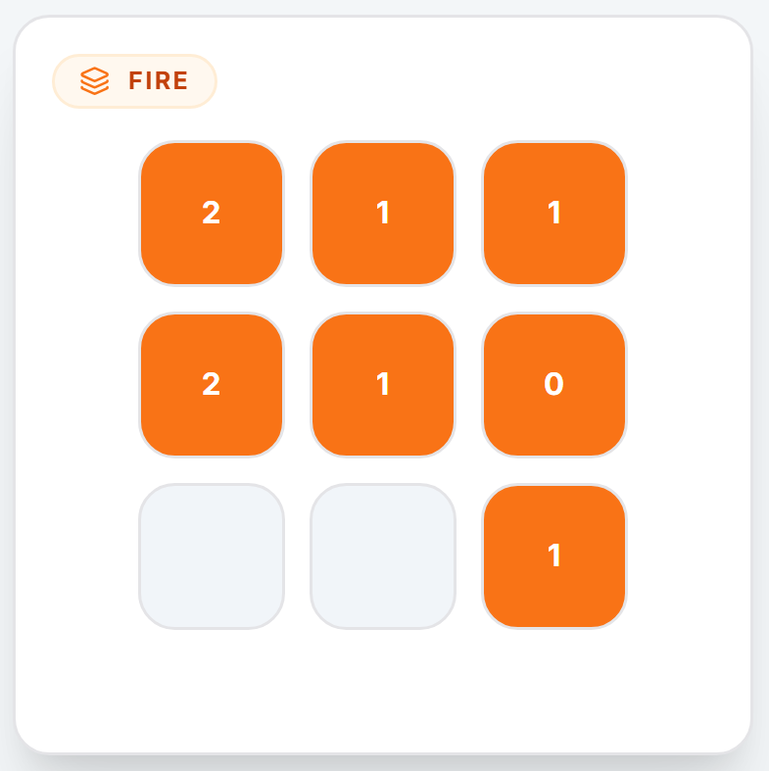
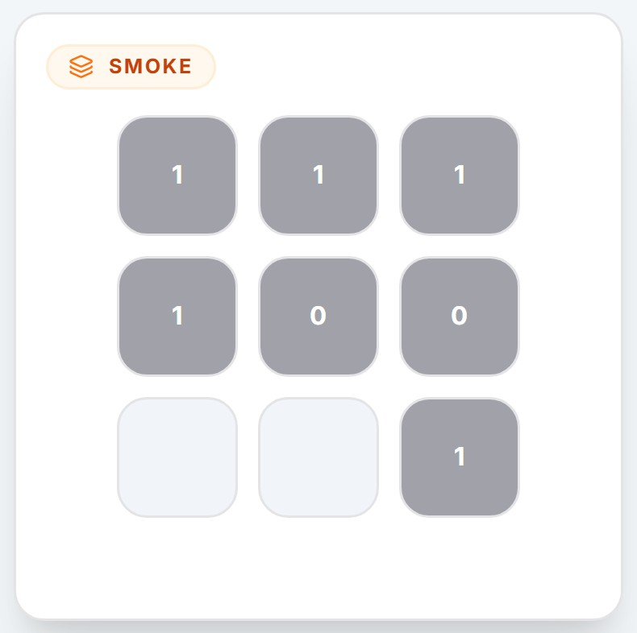
∀𝑎 ∈ 𝐴, ∀𝑡 ∈ (1, 𝑇 )

𝜌𝑎,𝑡 ≥ 𝜇𝑎,𝑡 − 𝜙𝑎,𝑡
𝜌𝑎,𝑡 ≥ 𝜎𝑎,𝑡 − 𝜓𝑎,𝑡

- Model Demonstration
To illustrate the functionality of the proposed system, a web-based application has been developed and deployed at: https://mora-building.vercel.app
The application provides an interactive interface that allows users to configure scenarios, execute the optimization model, and visualize the resulting fire-response strategy in real time.
- Case Study 1: Single-Floor Apartment Scenario

(a) Fire Arrival Time (b) Smoke Arrival Time

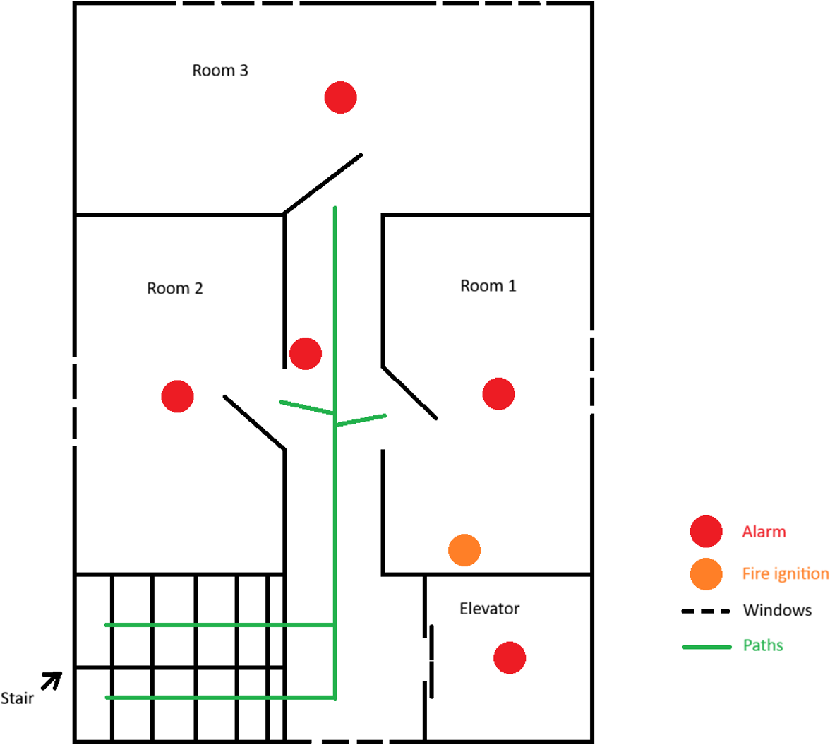
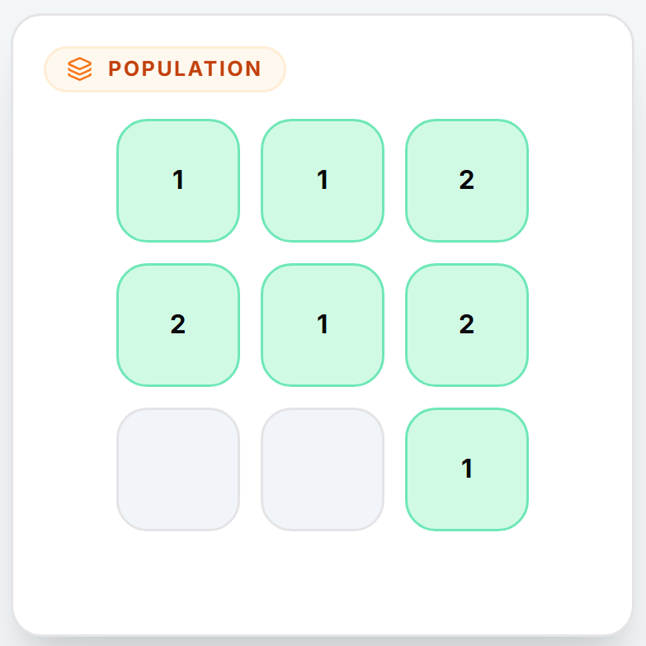

- Population Distribu- tion
- Property Value

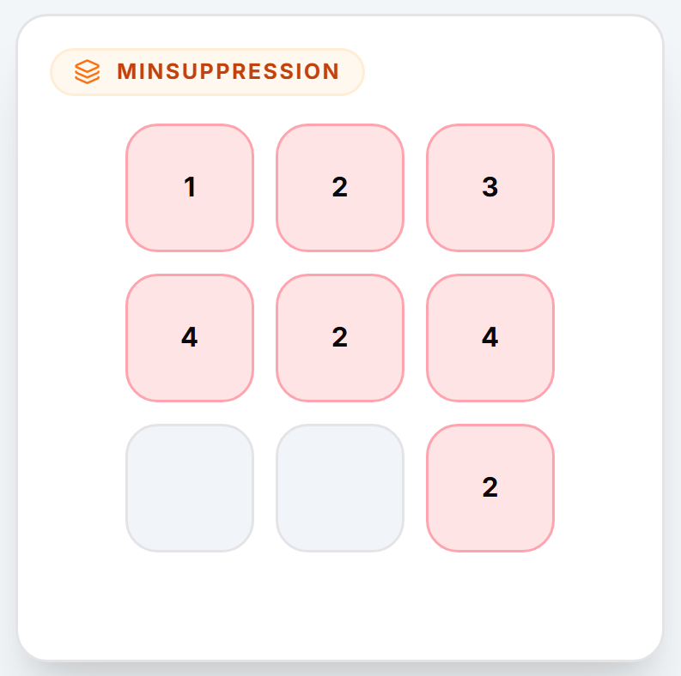

Figure 1. Layout of a floor of a small apartment in Ho Chi Minh City

To demonstrate the fundamental operation of the pro- posed optimization model, a simplified scenario represent- ing a single floor of a small apartment building is used as shown in Figure 1. The purpose of this demonstration is to validate that the outputs produced by the system comply with the model constraints and optimization objectives.
The floor is divided into a 3 × 3 grid of cells, where each cell represents a spatial zone within the building. This zone-based representation simplifies the modelling of fire spread, smoke propagation, and response team deployment.
- Minimum Suppression Rate Required
Figure 2. Cell parameters for the Case Study 1 demonstration scenario.
Based on the fire arrival time matrix (Figure 2(a)), the fire initially starts in cell 5, which becomes the first high- risk fire zone. Because smoke propagates faster than fire, cell 4 is also initially affected by smoke.
- Resource Allocation and Constraints: Three different
response team types are considered as shown in Table I. Each resource type has its own suppression rate, rescue rate, and deployment cost.
A brief description of the types:
  - Type A: basic fire suppression unit (low cost, moder- ate suppression capability)
  - Type B: fire brigade unit capable of both suppression and rescue operations
  - Type C: specialized response unit with balanced suppression and rescue capabilities
In real-world situations, these resource types could represent, for example:

  - Type A: hand crew firefighters
  - Type B: fire engines with rescue teams
  - Type C: aerial firefighting units or specialized rapid- response teams
The minimum suppression rate required to contain the fire in each cell is illustrated in Figure 2(e), while the total available deployment budget is 30 units.

Table I
Resource Teams and Their Capacities Over Time

Type Suppression Rate Rescue Rate Cost Availability

A 3 0 3 𝑡 = 0: 0
𝑡 = 1: 2
𝑡 = 2: 1

B 1 2 2 𝑡 = 0: 0
𝑡 = 1: 1
𝑡 = 2: 1

C 2 2 4 𝑡 = 0: 1
𝑡 = 1: 1
𝑡 = 2: 2

- Simulation Results: The optimal solution obtained from the model is illustrated in Figure 3. The model’s prioritization logic is observed as follows:
At the initial time step (𝑡 = 0), cell 5 is both a fire and smoke high-risk cell. Since only one Type C unit, which has the suppression rate of 2, is available, and the minimum suppression requirement of cell 5 is 4 (Figure 2(e), the model determines that deploying this unit to cell 5 would not successfully contain the fire, which is a wasteful deployment. Instead, it allocates the Type C unit to cell 4, which is under smoke risk but still accessible for early intervention, to rescue people because its rescue rate exceeds the requirement (2 > 1). Since the remaining resources are unavailable at this time step, no suppression action is performed on cell 5. Consequently, by the next period the fire continues to spread.
At 𝑡 = 1, cell 5 becomes fully burnt, and the fire spreads to neighboring cells 1, 2, 4, and 8. The model deploys one Type A unit and one Type B unit to cell 2, enabling both suppression and occupant rescue. However, cell 4 receives only a Type A unit, which has fire suppression capability but no rescue capability. Therefore, although the fire is partially controlled, the occupants in that cell cannot be rescued. During this period, cells 1 and 8 become fully burnt and smoked due to the continued fire spread.
At 𝑡 = 2, the fire reaches cells 0 and 3. Deployment of Type B (cell 0) and Type A+C (cell 3) provides sufficient capacity to contain the fire and halt further propagation.
- Performance Summary: The aggregated performance
metrics of the optimization model for this scenario are summarized in Table II.
In summary, this demonstration illustrates how the proposed optimization model dynamically allocates emer- gency response resources across space and time. The model generates recommendations for deploying response teams
Table II
Quantitative performance: Case Study 1

Objective | Description | Value
𝑂1 | Total population at risk | 3
𝑂2 | Property value lost | 1100
𝑂3 | Total deployment cost | 25

to specific cells in order to reduce the number of high-risk population zones, minimize property value losses caused by fire spread, and utilize response resources efficiently under budget and availability constraints.
The interactive visualization shown in Figure 3 highlights both the hazard propagation process and the results of suppression and rescue actions, providing a clear under- standing of how the model supports decision-making during emergency response operations.
- Case Study 2: Multi-Floor Accessibility and Resource Synchronization
To further evaluate the robustness of the proposed model in more complex spatial environments, a second scenario involving a two-floor building was conducted. Each floor is represented by a 3 × 3 grid, forming a multi-layer spatial structure. The model operates over discrete time steps
𝑇 = {0, 1, 2}, while incorporating various resource teams with different suppression and rescue capabilities.
  - Scenario Parameters: Figure 4 presents the envi- ronmental parameters used in this experiment, including fire arrival times, smoke propagation times, population distribution, property value, and minimum suppression requirements.
Each cell contains information describing when hazards arrive, the number of occupants present, and the economic value associated with that location. The minimum sup- pression matrix indicates the suppression effort required to fully contain a fire within a cell.
  - Resource Configuration: The emergency response sys- tem includes six different resource types, each representing specialized firefighting or rescue teams. Table III summa- rizes their suppression and rescue capacity, deployment cost, and availability across time.
Resources A, B, and C provide suppression and rescue capabilities from the ground similar to the first example, while resources D, E, and F provides ideal capabilities but from the air.
  - Simulation Results: Figures 5 and 6 illustrate the optimal deployment strategy generated by the model across time for both floors.
At the initial time step (𝑡 = 0), the model deploys a limited set of resources due to early availability constraints. Tactical placement focuses on containing initial hazards and rescuing occupants in high-risk zones.
At 𝑡 = 1, additional units become available, enabling a coordinated response across both floors. The optimization algorithm prioritizes areas with high population density

Table III
Resource Teams and Their Capacities Over Time

Type Suppression Rate Rescue Rate Cost Availability

A 3 0 3 𝑡 = 0: 0
𝑡 = 1: 2
𝑡 = 2: 1

B 1 2 2 𝑡 = 0: 0
𝑡 = 1: 1
𝑡 = 2: 1

C 2 2 4 𝑡 = 0: 1
𝑡 = 1: 1
𝑡 = 2: 2

D 3 0 6 𝑡 = 0: 0
𝑡 = 1: 2
𝑡 = 2: 1

E 1 2 4 𝑡 = 0: 0
𝑡 = 1: 1
𝑡 = 2: 1

F 2 2 8 𝑡 = 0: 1
𝑡 = 1: 1
𝑡 = 2: 2

and high property value while ensuring that minimum suppression requirements are satisfied.
By 𝑡 = 2, sufficient suppression capacity has been deployed to stabilize the spreading hazards. Remaining resources are allocated to rescue operations and reinforce- ment in vulnerable zones to prevent further escalation.
  - Performance Summary: The aggregated performance metrics of the optimization model for this scenario are summarized in Table IV.

Table IV
Quantitative performance: Case Study 2

Objective | Description | Value
𝑂1 | Total population at risk | 5
𝑂2 | Property value lost | 1800
𝑂3 | Total deployment cost | 51

These results demonstrate that the proposed optimiza- tion framework effectively coordinates resource allocation across multiple floors while respecting budget constraints, accessibility limitations, and dynamic hazard propagation. The model successfully balances competing objectives by prioritizing life safety, protecting valuable assets, and minimizing unnecessary deployment costs.
- Model Validation
The validation of the proposed model was conducted using a close-to-realistic scenario based on the building layout presented in [9], as illustrated in Figure 7.
Due to practical limitations and the infeasibility of implementing and testing the system in a real-world fire emergency environment, a simulation environment was developed to emulate the behavior of the building during a fire incident.
The floor layout is divided into cells according to the building structure, including the locations of rooms, corridors, walls, and alarms. Each cell represents a spatial unit where fire spread, smoke propagation, and rescue operations may occur. The cells are indexed sequentially starting from the top-left corner of the grid, with indices ranging from 0 to 6 × 7 − 1 = 41. The resulting indexing scheme is shown in Table V.

Table V
7×6 Indexing Matrix (0 to 41)

0 | 1 | 2 | 3 | 4 | 5
6 | 7 | 8 | 9 | 10 | 11
12 | 13 | 14 | 15 | 16 | 17
18 | 19 | 20 | 21 | 22 | 23
24 | 25 | 26 | 27 | 28 | 29
30 | 31 | 32 | 33 | 34 | 35
36 | 37 | 38 | 39 | 40 | 41

The simulation time is divided into discrete times, rep- resenting the progression of the fire incident. Each period corresponds to a fixed time interval after the initial ignition. In the visualization matrices, these time intervals are denoted as 𝑡 = 0, 1, 2, 3, and 4. It is assumed that both fire and smoke propagation rates remain constant throughout the simulation, meaning that the cell size does not change across periods. Consequently, the predicted fire arrival times, smoke arrival times, and population distributions remain fixed for each cell during the simulation.
Population distribution varies across the building layout, reflecting typical human occupancy patterns. In particular, population density is slightly higher in rooms where most people tend to congregate, compared other spaces such as corridors and transitional areas contain fewer people.
To initialize the scenario, five matrices are defined to represent the environmental and operational conditions. These matrices describe the fire arrival time, smoke arrival time, population distribution, asset value, and minimum suppression rate required for each cell. The matrices are presented in Figure 8(a)-(e).
According to the fire arrival time matrix, the fire ignites from the cell with a value equal to 0 and subsequently spreads to neighboring cells over time.
In this validation scenario, it is assumed that there are six different resource types of response teams: three suppression-oriented teams and three rescue-oriented teams. Each resource type is characterized by its suppression capa- bility, rescue capability, deployment cost, and availability over time. Their parameters are given in Table VI. The total operational budget is limited up to 500.
The accessibility constraint is defined such that all response operations can only be performed by ground crews. Consequently, all six resource types are considered ground- based units and can only access cells that are reachable through the building’s floor layout. In the accessibility matrix, cells that can be accessed by ground crews are marked with a value of 0. In contrast, inaccessible areas

Table VI
Resource Teams and Their Capacities Over Time

Type Suppression Rate Rescue Rate Cost Availability

A 3 0 8 𝑡 = 0: 1
𝑡 = 1: 2
𝑡 = 2: 1
𝑡 = 3: 2
𝑡 = 4: 2

B 5 1 18 𝑡 = 0: 1
𝑡 = 1: 2
𝑡 = 2: 0
𝑡 = 3: 1
𝑡 = 4: 2

C 7 1 35 𝑡 = 0: 0
𝑡 = 1: 2
𝑡 = 2: 0
𝑡 = 3: 1
𝑡 = 4: 2

D 0 2 7 𝑡 = 0: 1
𝑡 = 1: 2
𝑡 = 2: 1
𝑡 = 3: 1
𝑡 = 4: 3

E 0 3 16 𝑡 = 0: 0
𝑡 = 1: 1
𝑡 = 2: 2
𝑡 = 3: 2
𝑡 = 4: 1

F 1 5 37 𝑡 = 0: 0
𝑡 = 1: 1
𝑡 = 2: 0
𝑡 = 3: 1
𝑡 = 4: 2

(including structural barriers, non-operational spaces, areas with no population, or locations without alarm coverage) are represented by a value of -1.
During each simulation period, the optimization frame- work determines how available response teams should be allocated across the grid cells. The objective is to minimize the number of vulnerable individuals exposed to fire and smoke hazards while simultaneously reducing property loss and maintaining deployment costs within the available budget.
The resulting optimal strategies given by the model across the five time steps for this problem are illustrated in Figure 9(a)-(e).
At 𝑡 = 0, the system detects the initial ignition point and evaluates the potential fire and smoke spread across the grid. Since the incident has just started, there are just three teams available for suppressing the fire and rescuing people, but their total suppression capability is limited and cannot meet the minimum suppression rate required for cell 31 at t = 0, which is 15, so no tactical resources are deployed yet. The system therefore focuses on predicting hazard propagation and identifying high-risk cells that may require intervention in the subsequent period.
At 𝑡 = 1, the optimization model begins allocating re- sponse teams to critical cells where fire and smoke intensity,
as well as population, are high. Multiple suppression teams are deployed to contain the active fire regions at cells 26, 32, and 38, while rescue-oriented teams are positioned to protect the vulnerable occupants. To be more specific, one type B unit is deployed to cell 26, another type B unit and one type C unit are deployed to cell 32, and finally, two type A units and another type C unit are deployed to cell 38. As a result, the three cells are successfully suppressed, and a number of individuals are rescued from high-risk areas. Cells 25 and 30 are unfortunately burnt and smoked due to limited resources availability and suppression capability. At 𝑡 = 2, the previous suppression actions significantly reduce the number of high-risk cells. Fire propagation is partially contained, resulting in a noticeable decrease in both fire-risk and smoke-risk zones. The cell with index 20 has the minimum suppression rate requirement of 4. The available crews at this time only have the maximum suppression rate of only 3; therefore, by the end of t = 2, this cell is burnt and smoked, and that also increases the
vulnerable population by 1.
At 𝑡 = 3, additional hazard areas emerge due to re- maining fire intensity and smoke spread. The optimization model reacts by reallocating available resources to two out of three newly threatened cells, which are cells 13 and 15. Suppression teams are deployed again to contain the fire, while rescue teams continue to evacuate individuals located in affected areas. Cell 13 receives help from four units of four different resource types, which are A, B, C, and E, while cell 15 receives help from 1 unit of type A and one unit of type B to suppress the fire and rescue people. Cell 14 does not receive any support, so by the end of t = 3, it is completely damaged.
Finally, at 𝑡 = 4, the emergency situation stabilizes as the remaining fire sources are controlled. Cells 7, 8, and 9 receive support from teams as shown in Figure 9(e)
. No additional cells are burned or smoked, and several previously threatened cells are successfully protected by the end of t = 4. The final system indicators on the top show that a portion of the population has been safely rescued while limiting the spread of fire and minimizing property losses.
The aggregated performance metrics of the optimization model for this scenario are summarized in Table VII.

Table VII
Quantitative performance: Case Study 3

Objective | Description | Value
𝑂1 | Total population at risk | 8
𝑂2 | Property value lost | 1260
𝑂3 | Total deployment cost | 336

In summary, the model provides optimal recommenda- tions for allocating the available resources of response teams across specific cells, with the objective of reducing both the total population at risk and the total cells burned, while still maintaining a reasonable total cost of operation. It

also prevents the fire from spreading to the rest of the floor, helping to further minimize damage to property and people.
- Conclusion
Our work introduce MORAv2, an adaptation of the original framework for wildfire to indoor fire emergencies. Via that transitioning, we successfully integrate a new layer of “rescue” people with a new factor of “smoke”. Our implementation utilizes a three-phase lexicographic optimization that prioritize human life over property loss or deployment cost. To further enhance the practicality of our work, we develop an interactive web for users to provide their custom scenario and visualize the optimal allocation in real time. Despite the potential of our work, we acknowledge its main limitation of deterministic nature via time-step simulation and simplified modeling. To further utilize our work, further work need to be done on stochastic modeling to address uncertainty and IoT sensor data for better optimization.
- Appendix
Here we provide additional details and supplementary materials that support the main content of the paper. This includes figures, input for each case study, and any other relevant information that may be useful for readers who wish to delve deeper into the methodology and results.

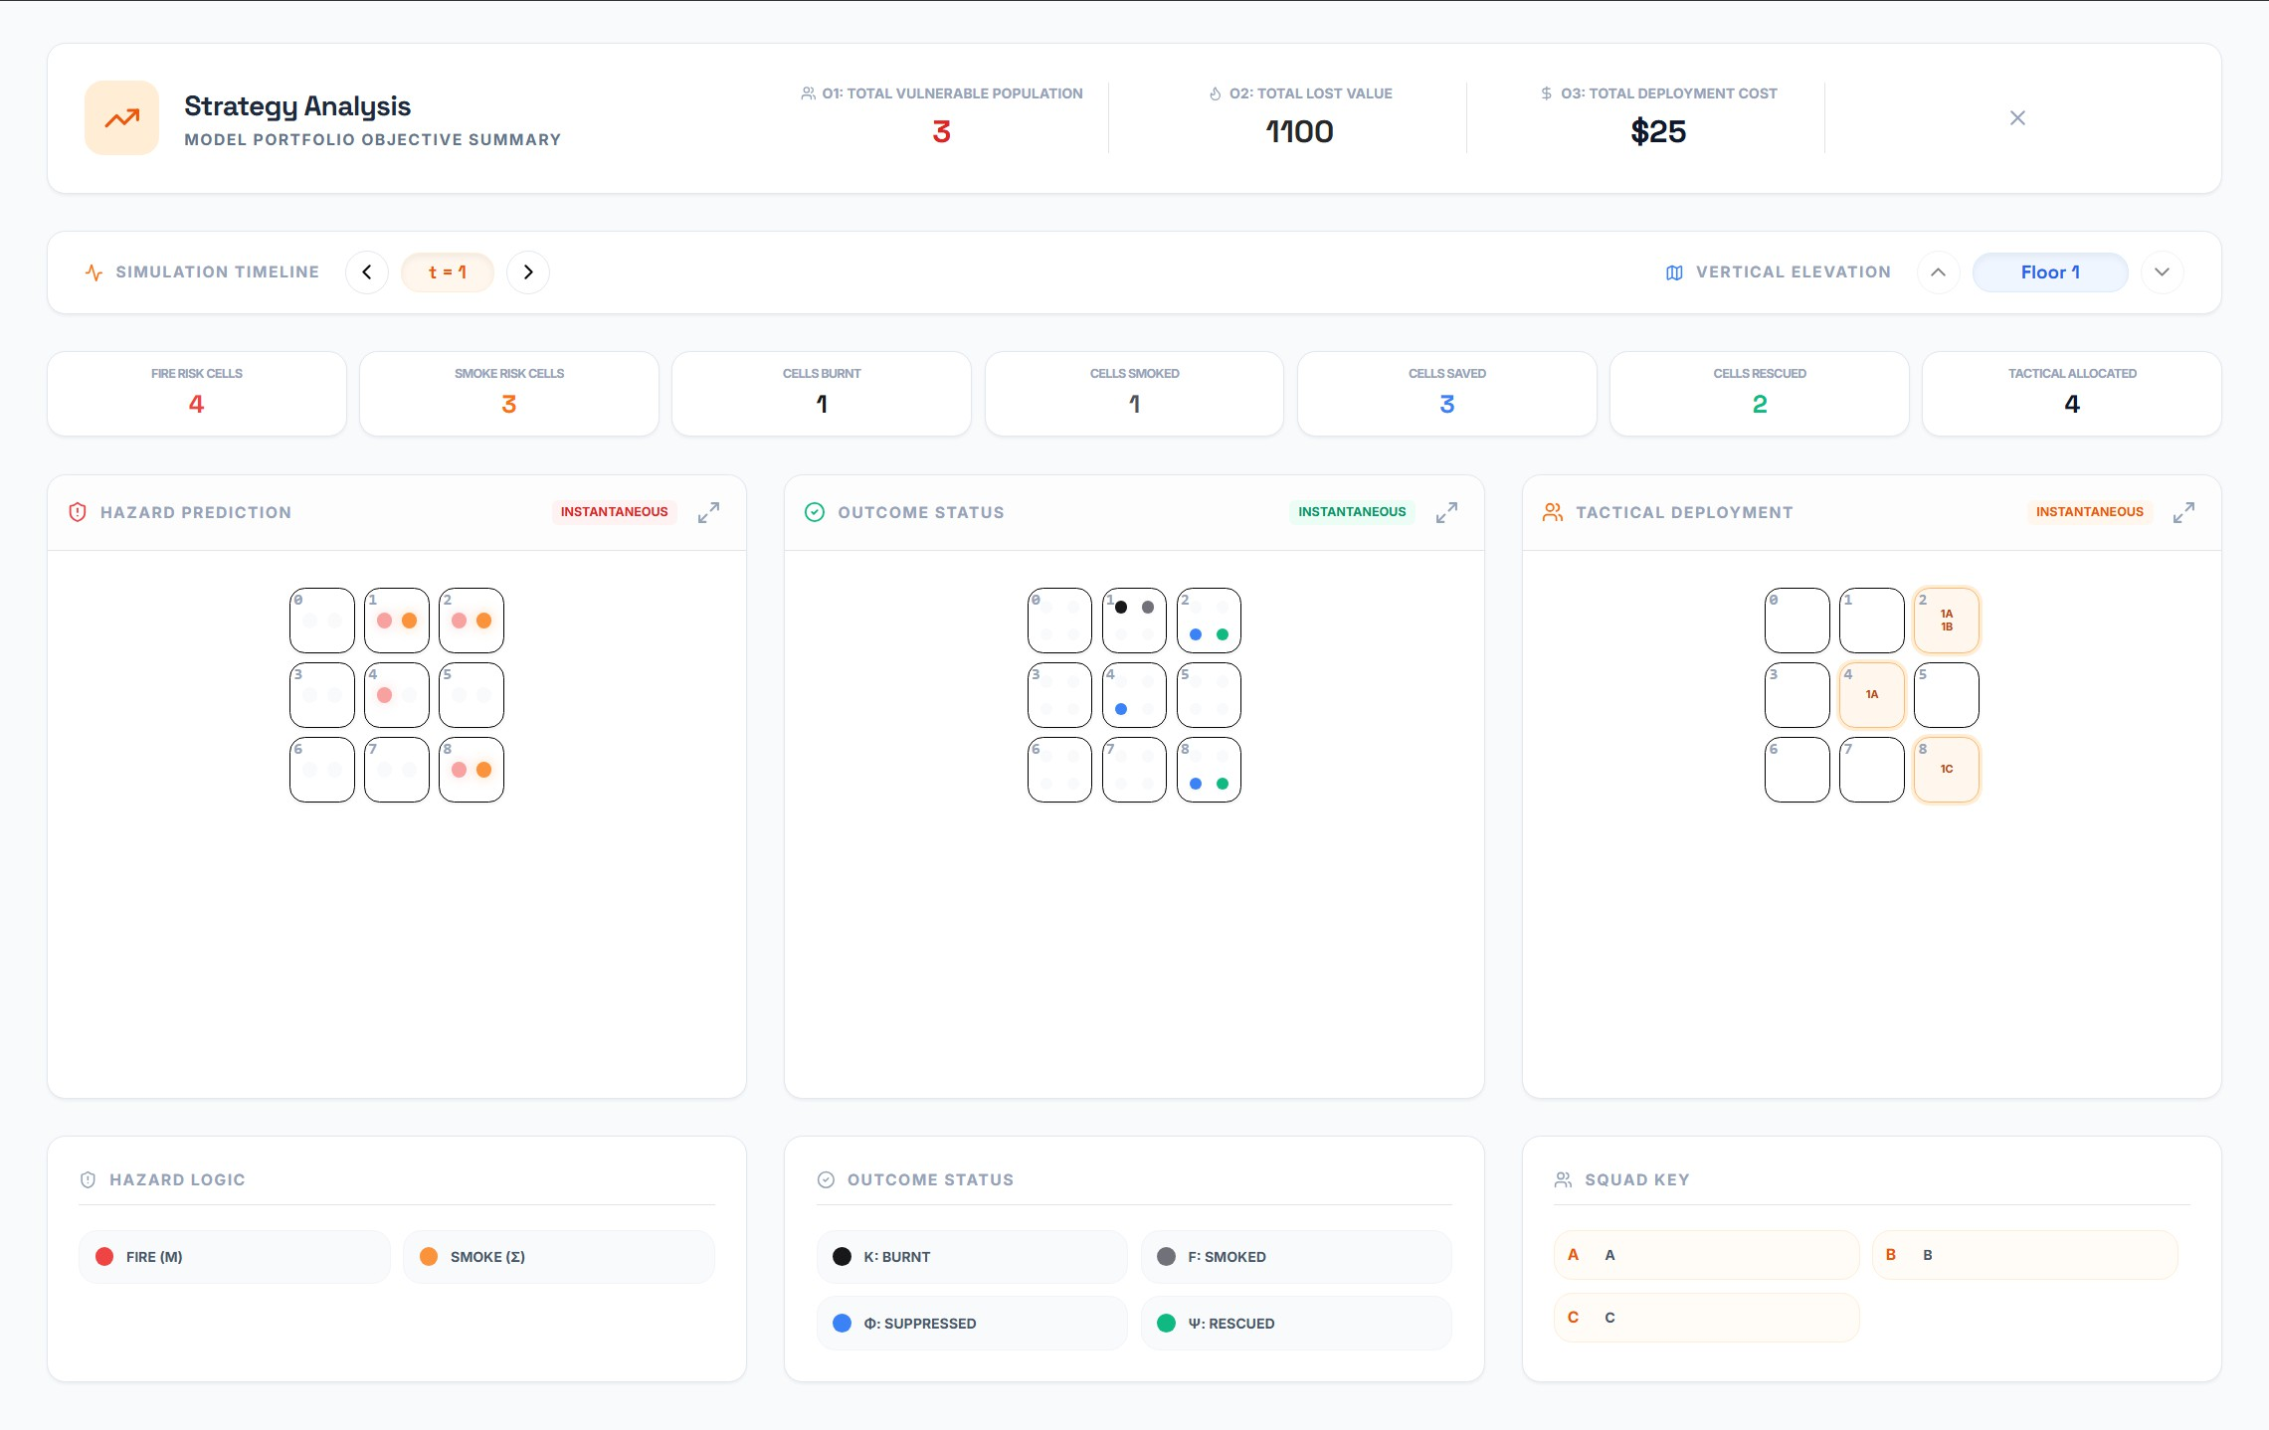
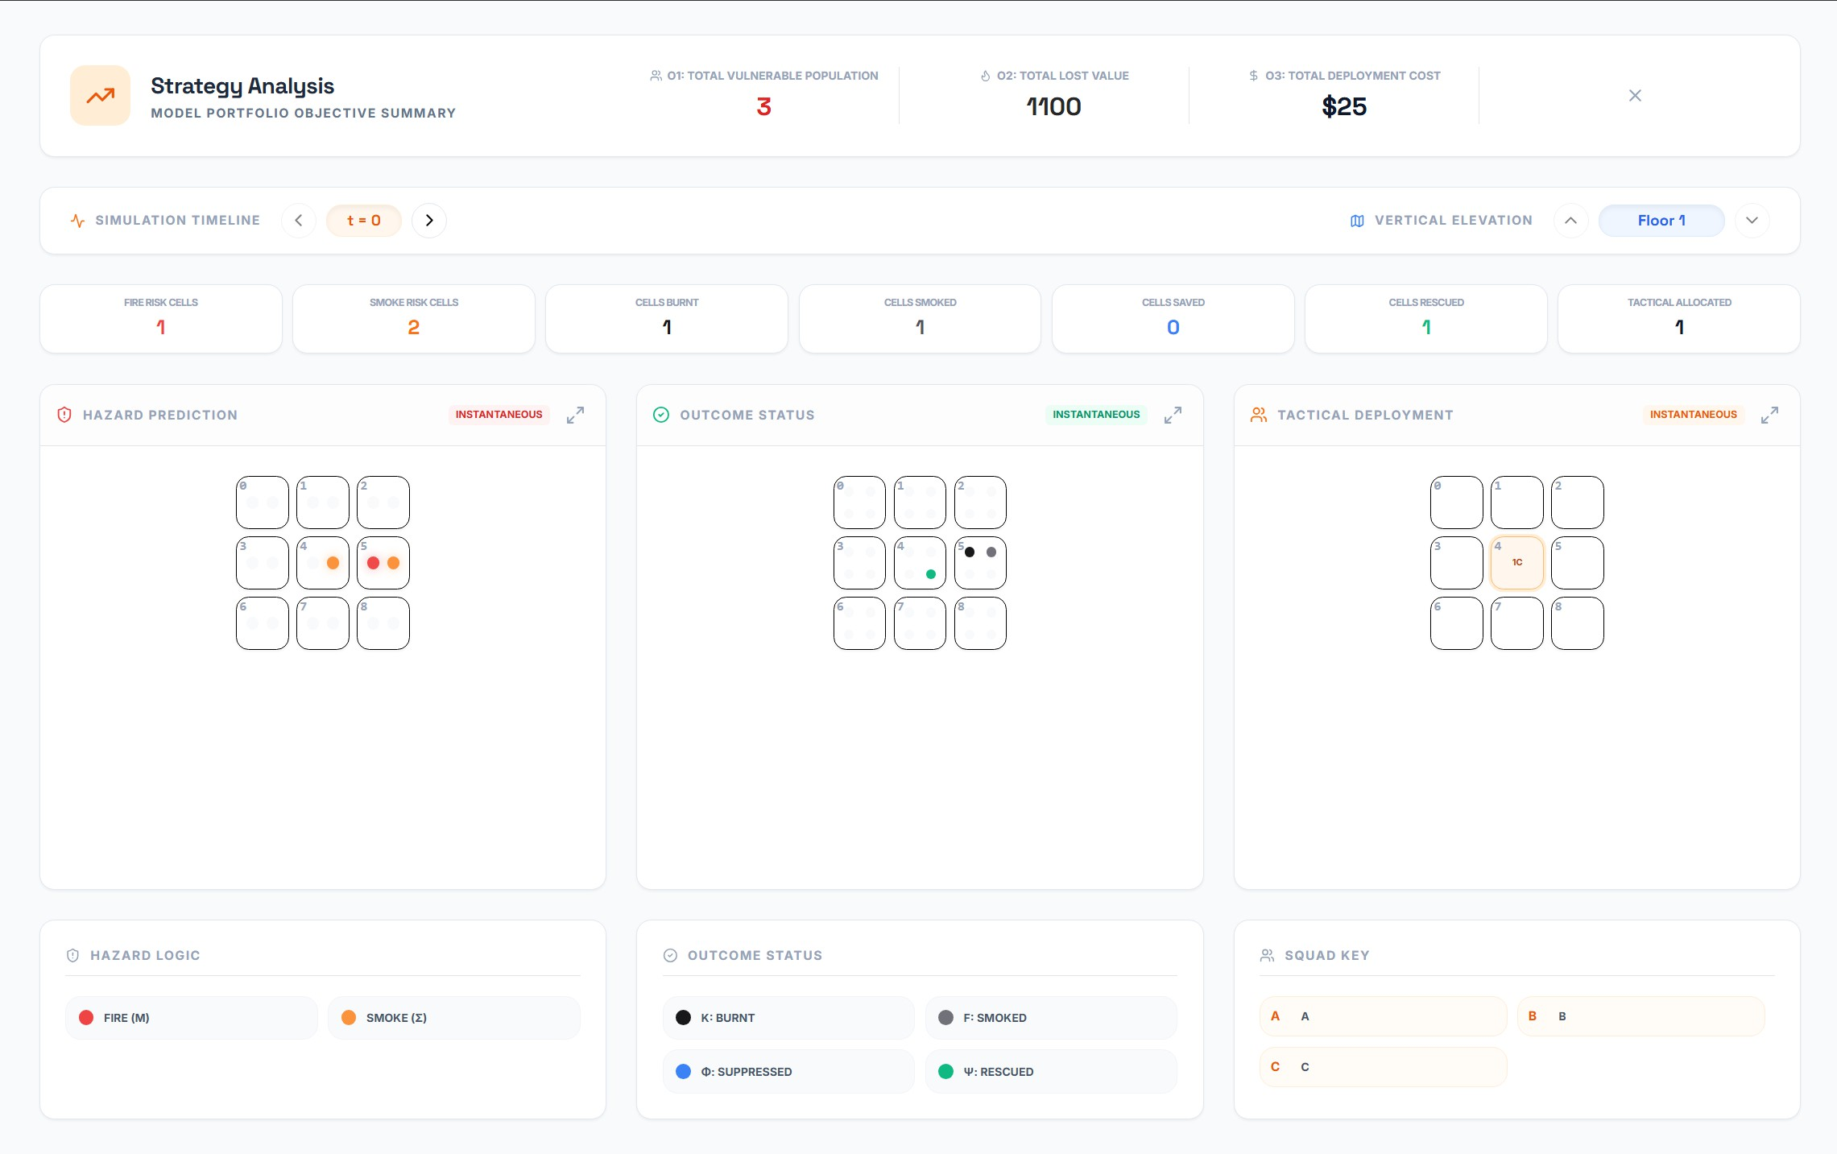
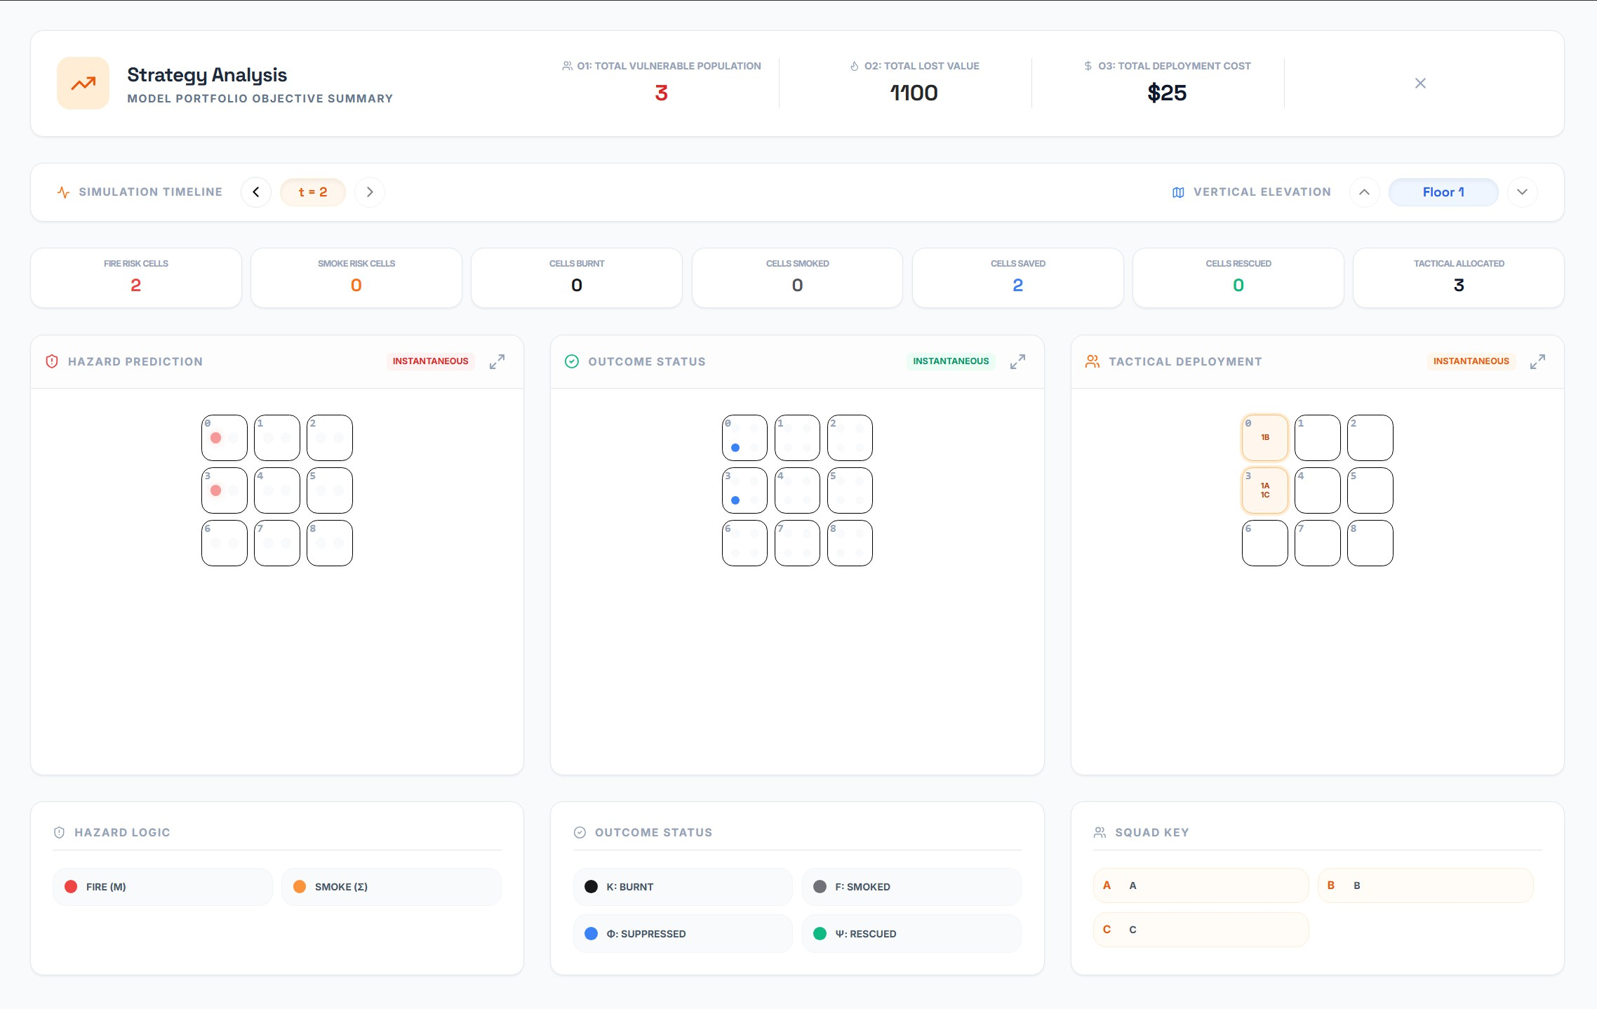
(a) 𝑡 = 0 Allocation (b) 𝑡 = 1 Allocation (c) 𝑡 = 2 Allocation Figure 3. Simulation results across time steps showing hazard prediction, outcome status, and tactical deployment.

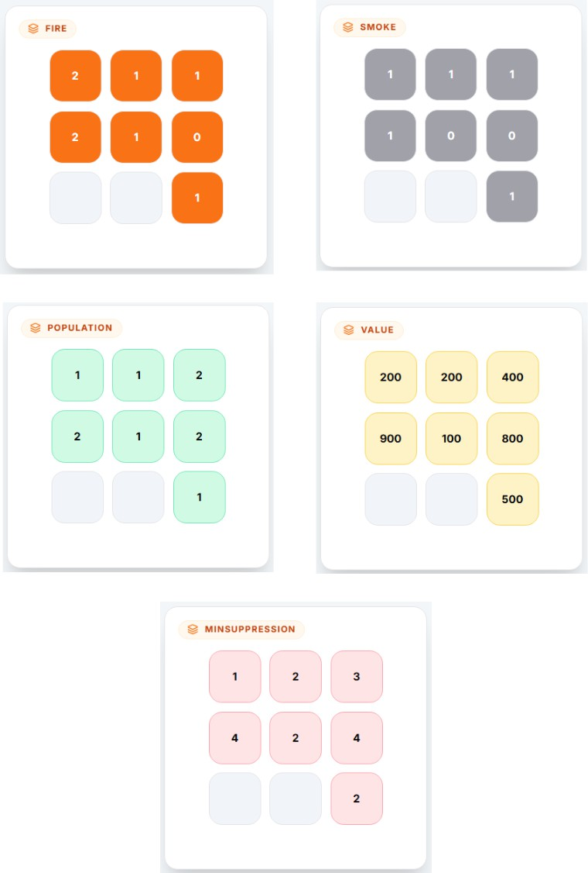
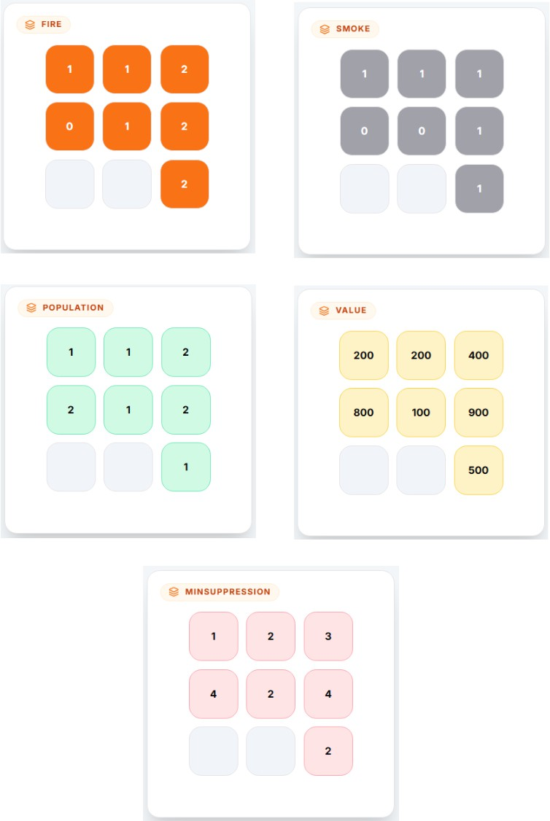

(a) Floor 0 Parameters (b) Floor 1 Parameters Figure 4. Environmental parameters for the two-floor case study.

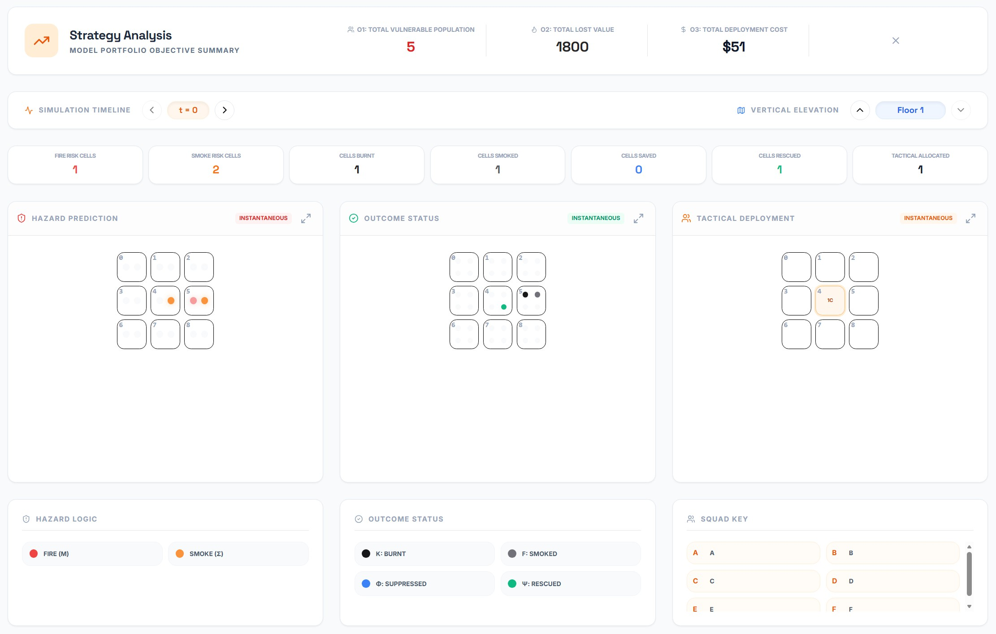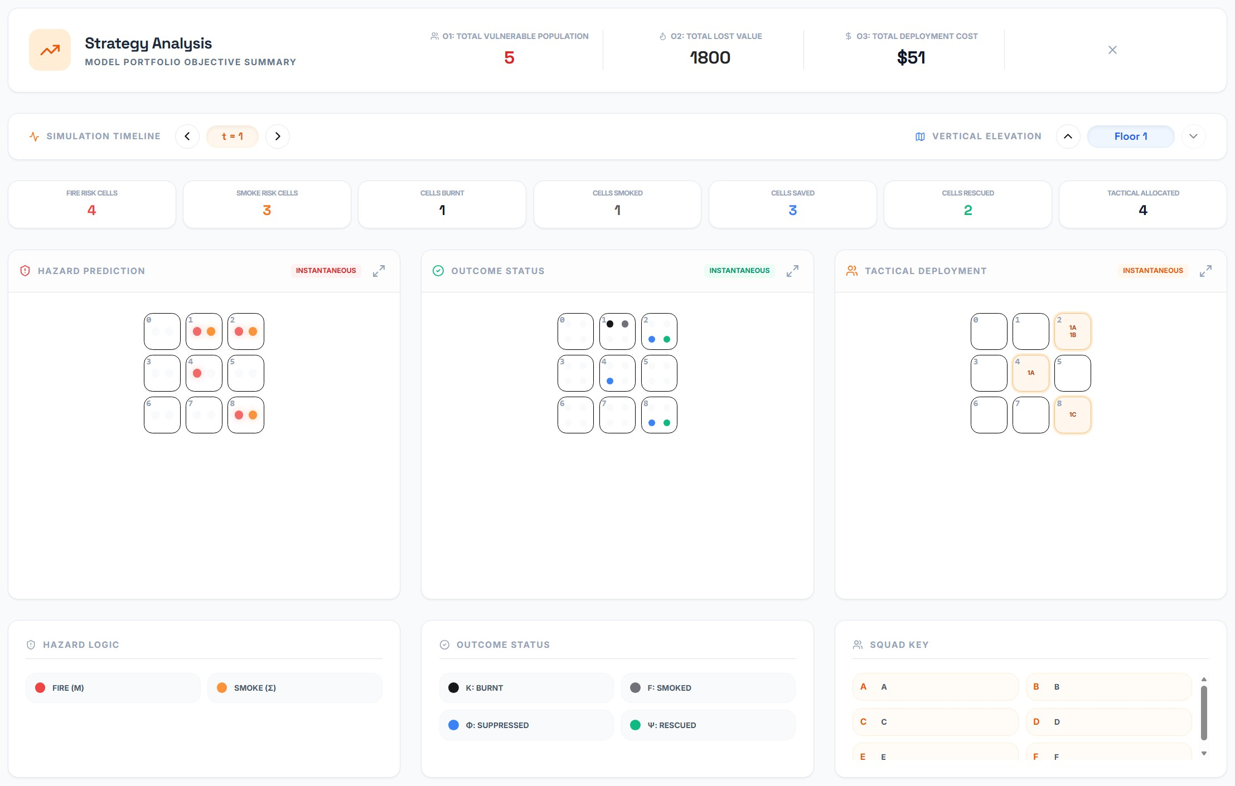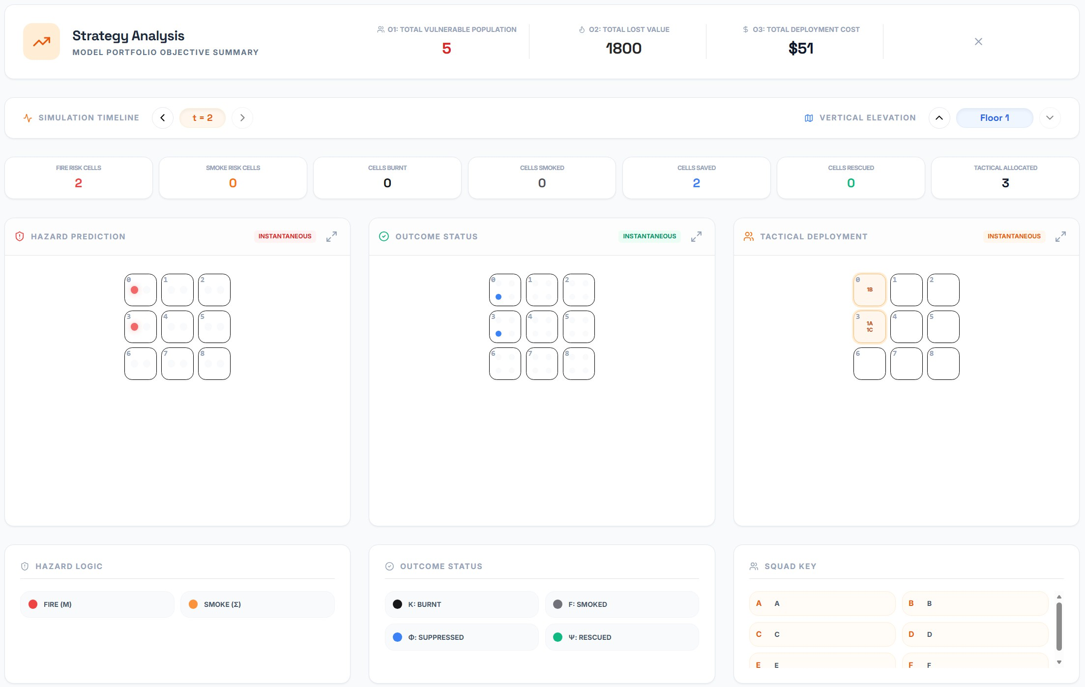
(a) 𝑡 = 0 (b) 𝑡 = 1 (c) 𝑡 = 2
Figure 5. Simulation results for Floor 0 showing hazard prediction, outcome status, and tactical deployment across time.

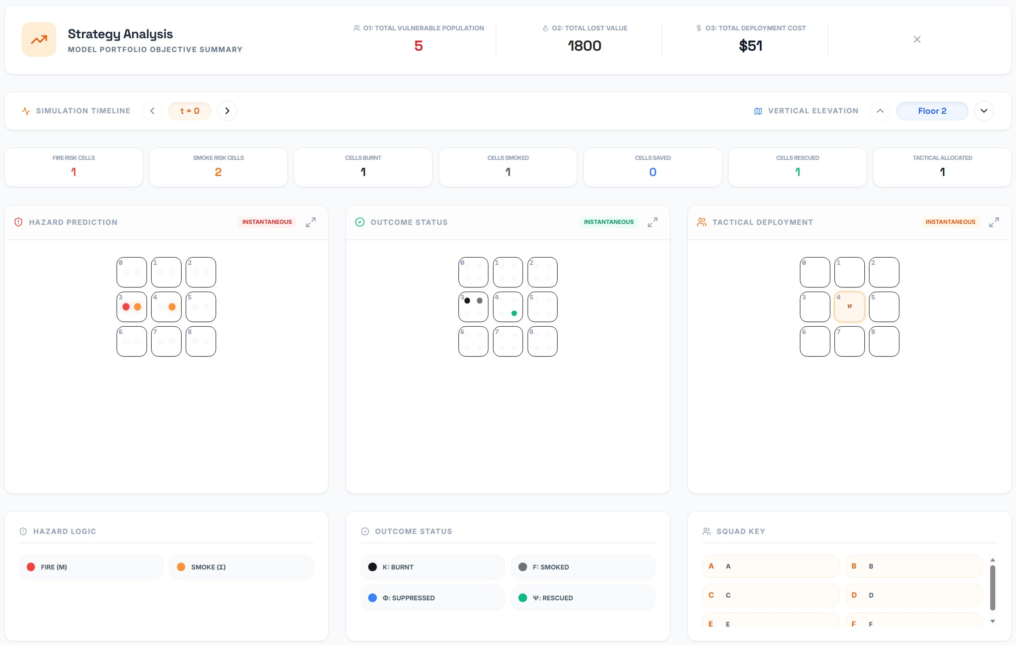
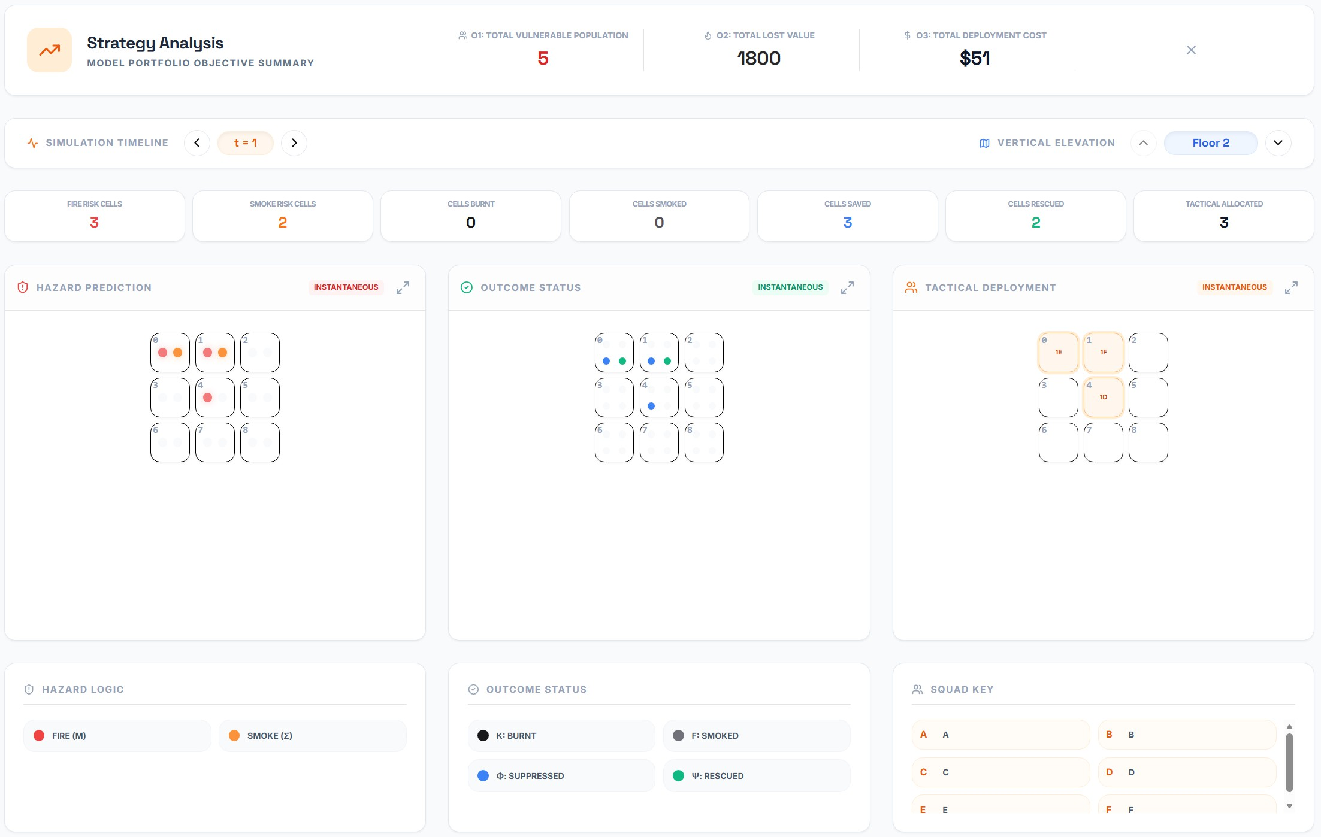
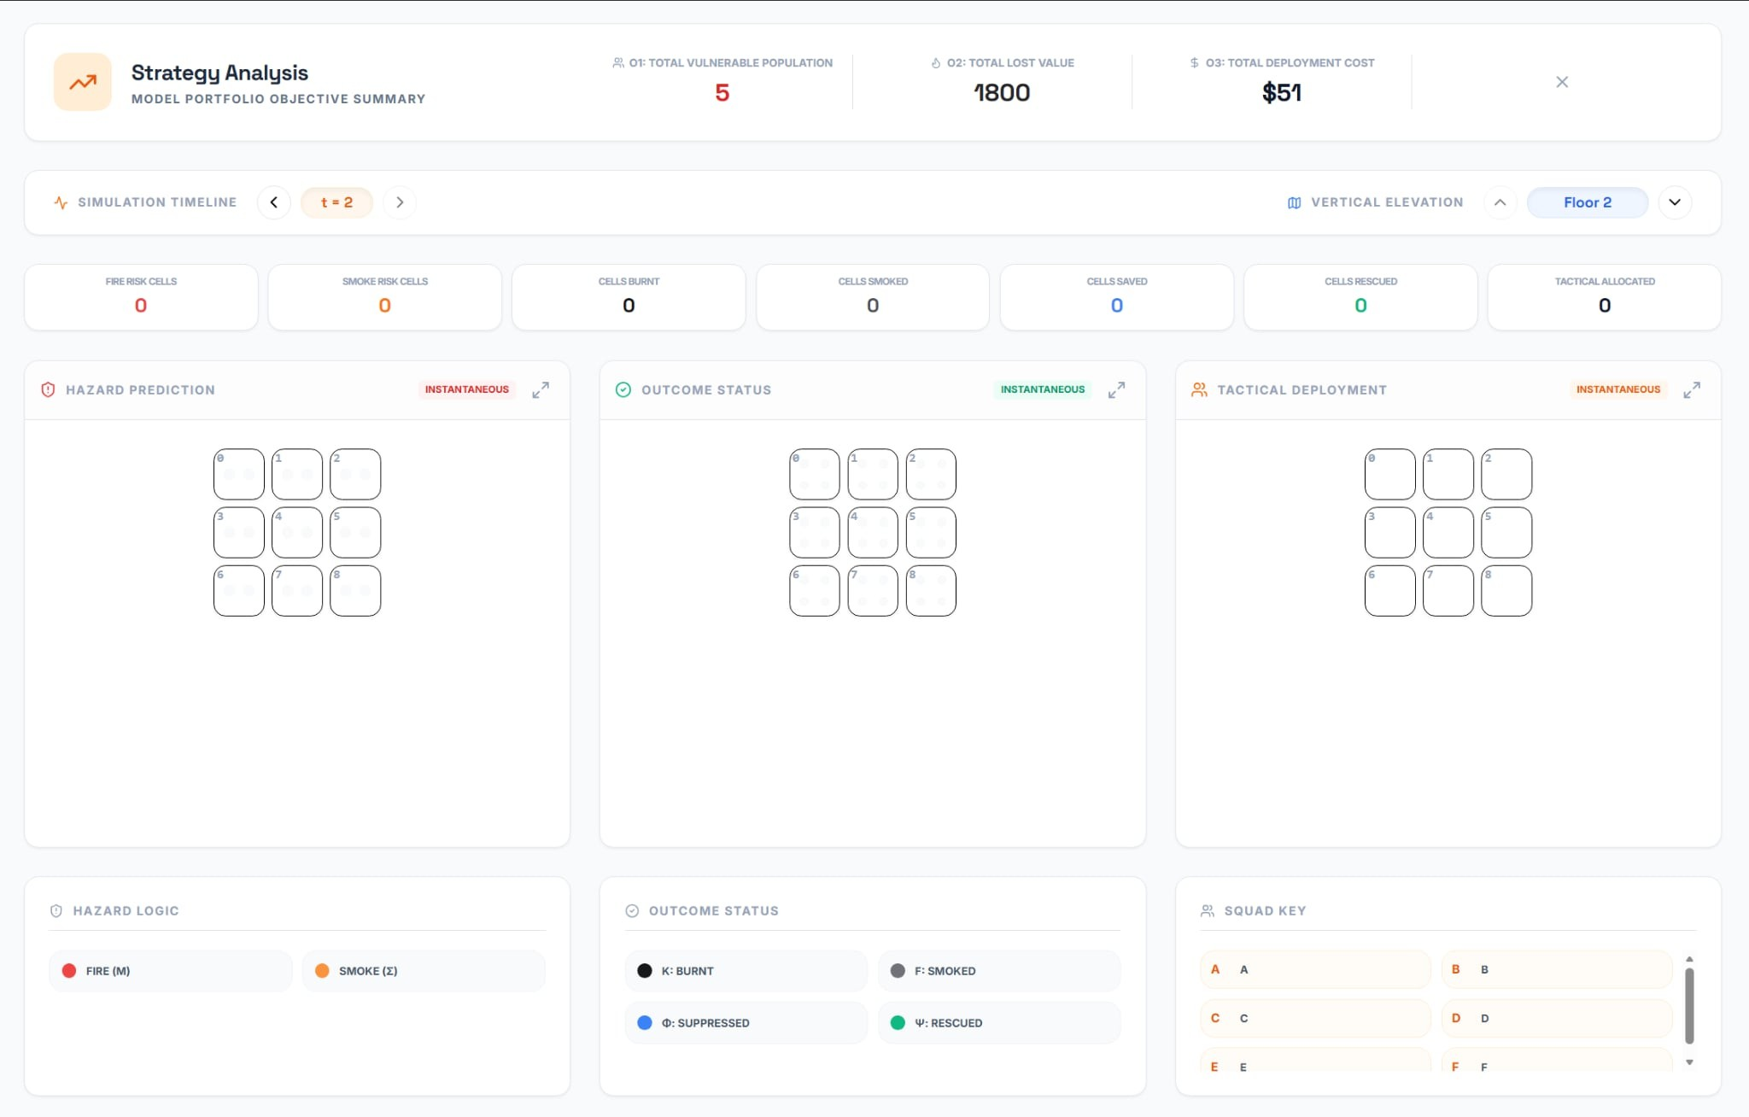
(a) 𝑡 = 0 (b) 𝑡 = 1 (c) 𝑡 = 2
Figure 6. Simulation results for Floor 1 showing hazard prediction, outcome status, and tactical deployment across time.

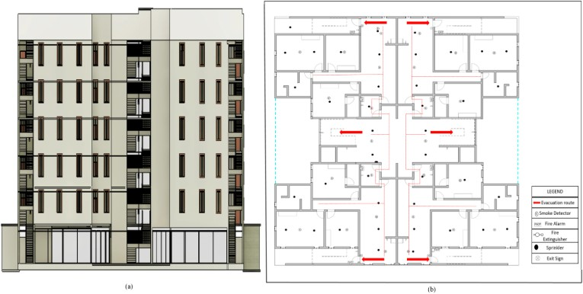

Figure 7. Building layout used for the simulation scenario.

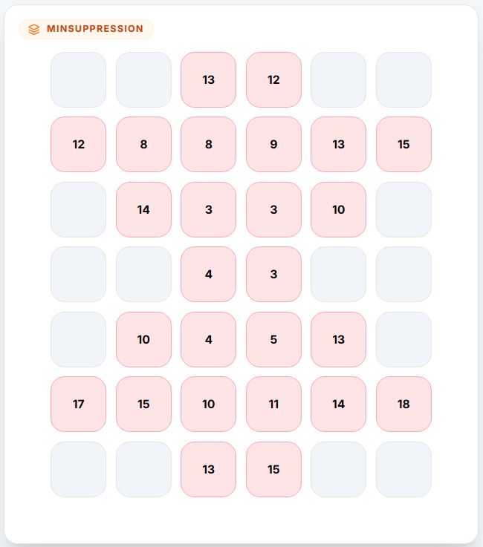

(a) Fire Arrival Time (b) Smoke Arrival Time (c) Population Distribu-
tion
(d) Property Value (e) Min. Suppression

Figure 8. Input matrices for the validation scenario.




(a) 𝑡 = 0 (b) 𝑡 = 1 (c) 𝑡 = 2


(d) 𝑡 = 3 (e) 𝑡 = 4
Figure 9. Optimal deployment strategies: hazard prediction, outcome status, and tactical allocation across time steps.

1 {
2 "num_floors":1,
3 "grid_size":[3,3],
4
5 "resources":["A","B","C"],
6 "suppression_rates":[3,1,2],
7 "rescue_rates":[0,2,2],
8 "squad_costs":[3,2,4],
9
10 "inventory":[[0,2,1],[0,1,1],[1,1,2]],
11
12 "accessibility":[[[0,0,0],[0,0,0],[-1,-1,0]]],
13
14 "fire_map":[[[2,2,2],[2,1,0],[-1,-1,3]]],
15
16 "smoke_map":[[[1,1,1],[1,0,0],[-1,-1,2]]],
17
18 "population_map":[[[1,1,2],[2,1,2],[0,0,1]]],
19
20 "value_map":[[[200,200,400],[800,100,900],[0,0,500]]],
21
22 "min_suppression_required":[[[1,2,3],[4,2,4],[0,0,2]]],
23
24 "total_budget":30,
25 "M":[0,0,0],
26 "Tset":[0,1,2]
27 }

Listing 1. Input configuration for the first demonstration case

1 {
2 "num_floors":2,
3 "grid_size":[3,3],
4
5 "resources":["A","B","C","D","E","F"],
6 "suppression_rates":[3,1,2,3,1,2],
7 "rescue_rates":[0,2,2,0,2,2],
8 "squad_costs":[3,2,4,6,4,8],
9
10 "inventory":[
11 [0,2,1],
12 [0,1,1],
13 [1,1,2],
14 [0,2,1],
15 [0,1,1],
16 [1,1,2]
17 ],
18
19 "accessibility":[
20 [[0,0,0],[0,0,0],[-1,-1,0]],
21 [[1,1,1],[1,1,1],[-1,-1,1]]
22 ],
23
24 "fire_map":[
25 [[2,2,2],[2,1,0],[-1,-1,3]],
26 [[2,2,2],[0,1,2],[-1,-1,3]]
27 ],
28
29 "smoke_map":[
30 [[1,1,1],[1,0,0],[-1,-1,2]],
31 [[1,1,1],[0,0,1],[-1,-1,2]]
32 ],
33
34 "population_map":[
35 [[1,1,2],[2,1,2],[0,0,1]],
36 [[1,1,2],[2,1,2],[0,0,1]]
37 ],
38
39 "value_map":[
40 [[200,200,400],[900,100,800],[0,0,500]],
41 [[200,200,400],[800,100,900],[0,0,500]]
42 ],
43
44 "min_suppression_required":[
45 [[1,2,3],[4,2,4],[0,0,2]],
46 [[1,2,3],[4,2,4],[0,0,2]]
47 ],
48
49 "total_budget":80,
50 "M":[0,0,0,1,1,1],
51 "Tset":[0,1,2]
52 }

Listing 2. Input configuration for the second demonstration case

1 | {
2 | "num_floors":1,
3 | "grid_size":[7,6],
4
5 | "resources":["A","B","C","D","E","F"],
6 | "suppression_rates":[3,5,7,0,0,1],
7 | "rescue_rates":[0,1,1,2,3,5],
8 | "squad_costs":[8,18,35,7,16,37],
9
10 | "inventory":[
11 | [1,2,1,2,2],
12 | [1,2,0,1,2],
13 | [0,2,0,1,2],
14 | [1,2,1,1,3],
15 | [0,1,2,2,1],
16 | [0,1,0,1,2]
17 | ],
18
19 | "accessibility":[[
20 | [-1,-1,0,0,-1,-1],
21 | [0,0,0,0,0,0],
22 | [-1,0,0,0,0,-1],
23 | [-1,-1,0,0,-1,-1],
24 | [-1,0,0,0,0,-1],
25 | [0,0,0,0,0,0],
26 | [-1,-1,0,0,-1,-1]
27 | ]],
28
29 | "fire_map":[[
30 | [-1,-1,6,6,-1,-1],
31 | [7,6,5,5,6,7],
32 | [-1,6,4,4,6,-1],
33 | [-1,-1,3,4,-1,-1],
34 | [-1,1,2,5,7,-1],
35 | [1,0,1,6,7,8],
36 | [-1,-1,2,7,-1,-1]
37 | ]],
38
39 | "smoke_map":[[
40 | [-1,-1,4,4,-1,-1],
41 | [5,5,4,4,5,5],
42 | [-1,5,3,3,5,-1],
43 | [-1,-1,2,2,-1,-1],
44 | [-1,1,2,3,5,-1],
45 | [1,0,1,4,5,5],
46 | [-1,-1,2,4,-1,-1]
47 | ]],
48
49 | "population_map":[[
50 | [0,0,1,1,0,0],
51 | [2,1,2,1,2,2],
52 | [0,3,1,1,2,0],
53 | [0,0,1,1,0,0],
54 | [0,3,1,1,2,0],
55 | [1,2,2,3,1,2],
56 | [0,0,1,2,0,0]
57 | ]],
58
59 | "value_map":[[
60 | [0,0,120,180,0,0],
61 | [600,250,150,200,300,650],
62 | [0,700,30,40,600,0],
63 | [0,0,30,30,0,0],
64 | [0,400,50,80,600,0],
65 | [500,300,250,300,450,800],
66 | [0,0,350,400,0,0]
67 | ]],
68
69 | "min_suppression_required":[[
70 | [0,0,13,12,0,0],
71 | [12,8,8,9,13,15],
72 | [0,14,3,3,10,0],
73 | [0,0,4,3,0,0],
74 | [0,10,4,5,13,0],
75 | [17,15,10,11,14,18],
76  77 | [0,0,13,15,0,0]  ]],
78
79 | "total_budget":500,
80 | "M":[0,0,0,0,0,0],
81 | "Tset":[0,1,2,3,4]
82 | }
Listing 3. Input configuration for the validation case

- Acronyms
AHP Analytic Hierarchy Process
CRITIC Criteria Importance Through Intercriteria Correlation
DEA Data Envelopment Analysis
DSS Decision Support System
ERF Effective Response Force
GreyGNN-MARL Grey Wolf-Optimized Graph
Neural Network Multi-Agent Reinforcement Learning
HBiF Human Behavior in Fires
ILP Integer Linear Programming
IoT Internet of Things
IP Integer Programming
IRI Improved Risk Index
MCDM Multi-Criteria Decision Making
MDHF-VRPTW-SPD Multi-Depot Heterogeneous
Fleet Vehicle Routing Problem with Time Windows and Simultaneous Pickup and Delivery
M/G/∞ M/G/∞ queueing model (general arrival, general service, infinite servers)
MILP Mixed-Integer Linear Programming
MORA Multicriteria Optimal Resource Allocation
MORAv2 MORAv2 (Proposed Adaptation of MORA for Building Fire Emergencies)
NSGA-III Non-dominated Sorting Genetic Algorithm III
PTS Pathfinder and Tunicate Swarm Algorithm
RAFD Resource Allocation in Fire Departments
SFS Spherical Fuzzy Sets
Acknowledgment
We would like to express their sincere thanks and deepest gratitude to Dr. Dinh Hai Dung for his invaluable guidance, insightful feedback, and continuous support throughout the development of this research. His expertise and encouragement greatly contributed to shaping the ideas and improving the quality of this work.
We also appreciate the academic environment and resources provided by the faculty and staff, which made it possible to conduct this research effectively. Their support and dedication to fostering learning and innovation are sincerely acknowledged.
Finally, we would like to thank all colleagues and peers who offered constructive discussions and encouragement during the course of this study.
References
- F. K. Varolgüneş, “Typology-specific gaps in building fire safety: A scientometric review of technologies, functions, and research trends,” MDPI Fire, 2025.
- E. R. E. D. K. Erica Kinkel, C. Natalie van der Wal, “Gaps in human behaviour in fires research: A scoping review,” Springer Nature, 2025.
- G. R. Shile He, Jianfeng Zhou, “A dynamic decision framework for improving tank fire emergency decision-making using influ- ence diagrams and micro-economics,” Journal of Loss Prevention in the Process Industries, 2026.
- K. W. Yuqi Hang, “Optimising calculation logic in emergency management: A framework for strategic decision-making,” MDPI Systems, 2026.
- P. E.-C. Milad K. Eslamzadeh, António Grilo, “Resource allo- cation in fire departments (rafd): A literature review,” MDPI, 2022.
- V. V. O. B. Yossi Luzon, Opher Baron, “On designing a fire emergency vehicle fleet,” Manufacturing & Service Operations Management, 2025.
- T. G. C. Alper Şen, Ismail Önden, “A gis approach to fire station location selection.”
- J. Smith, “Modeling fire evolution: knowledge graph approach,”
Taylor Francis Online, 2025.
- U. I. Abdullahi, W. Zhang, Y. Cao, and G. Irankunda, “Integrating iot technology for fire risk monitoring and assessment in residential building design,” Buildings, vol. 15, no. 8, p. 1346, 2025. [Online]. Available: https://www.mdpi.com/2075- 5309/15/8/1346
- H. C. L. OrpTheofanis Orphanoudakis, Christos Betzelos, “Mora: A multicriteria optimal resource allocation and decision support toolkit for wildfire management,” MDPI Algorithms, 2025.
- J. B. P. M. A. J. Kennedy Korkola, Melanie Wheatley, “A compar- ative analysis of wildfire initial attack containment objectives and modelling strategies in ontario, canada,” International Journal of Wildland Fire, 2024.
- Z. W. T. L. W. L. Jinyong Tang, Xinxin Zhang, “Research on optimal strategy of different fire rescue tasks based on oxygen consumption,” Frontier in Physiology, 2025.
- T. Li, J. Sun, and L. Fei, “Application of multiple- criteria decision-making technology in emergency decision- making: Uncertainty, heterogeneity, dynamicity, and interaction,” Mathematics, vol. 13, no. 5, 2025. [Online]. Available: https://www.mdpi.com/2227-7390/13/5/731
- A. A. Hadeer Mahmoud, “Spherical fuzzy mcdm for risk assess- ment of natech,” Neutrosophic and Information Fusion, 2023.
- N. G. Mutlu, “Risk assessment using neutrosophic pert-fmea,” 2025.
- A. A. Hadeer Mahmoud, “Spherical fuzzy multi-criteria decision- making approach for risk assessment of natech,” Neutrosophic and Information Fusion, 2023.
- N. G. Mutlu, “A risk assessment method using neutrosophic pert-fmea,” 2025.

- K. D. Vaira, “Improving fire station turnout time through discrete event simulation.”
- H. L. Jin Li, Hongying Song, “Fuel replenishment problem of heterogeneous fleet in initiative distribution mode,” MDPI Sustainability, 2025.
- E. D. G. L. Ziru Lin, Xiaofeng Xu, “Optimizing task assignment and routing operations with a heterogeneous fleet of unmanned aerial vehicles for emergency healthcare services,” 2025.
- S. E. D. Katherine E. Brown, “Gaps in artificial intelligence research for rural health in the united states: A scoping review,” Journal of the American Medical Informatics Association, 2025.
- P. D. Parul Dubey, “Bridging spatiotemporal wildfire prediction and decision modeling using transformer networks and fuzzy inference systems,” MethodsX, 2025.
- N. B. A. J. G. K. Casey Grant, Anthony Hamins, “Research roadmap for smart fire fighting,” National Institute of Standards and Technology, Tech. Rep., 2015.
- X. W. H. Z. C. Z. Zhijun Gao, Meng Zhang, “Integrated pts fire evacuation path planning algorithm,” Journal for Control, Measurement, Electronics, Computing and Communications, 2025.
- K. X. T. T. Rui Li, He Wang, “Multi-objective optimization design of integrated pump station based on nsga-iii,” Water Supply, 2024.
- E. R. E. D. K. Erica Kinkel, C. Natalie van der Wal, “Gaps in human behaviour in fires research: A scoping review,” Springer Nature, 2025.

All links were last followed on March 12th, 2026.

