University of Warsaw

Faculty of Economic Sciences

**Working Paper**

**Drivers of the level of Covid-19 vaccination in Poland**

Warsaw Econometric Challenge

*Presented by:*

Nhan Nguyen – University of Warsaw

Nhu Ho – University of Warsaw

Tung Le – University of Warsaw

Cuong Vo – Warsaw School of Economics

Warsaw, May 2024

# Summary

This research aims to analyze the drivers of the level of COVID-19 vaccination in Poland. The research investigates the impact of various reasons on the decision of whether or not taking the vaccination from the perspective of the citizen. It asks the three main questions about the covid strategies aspects: whether the size of municipalities/cities matter, whether the division between eastern and western Poland makes a difference and is there any variation in vaccination rates among different age groups? Following the data provided by the Faculty of Economic and Sciences, the authors try to answer these questions thoroughly.

# Abstract

This study looks at the factors impacting COVID-19 vaccination rates in Poland, with an emphasis on municipality/city size, geographical inequalities, and age group differences. The study uses data from the Faculty of Economics and Sciences to give insights into citizens' vaccination decision-making processes. The findings indicate that, while municipality/city size and regional inequalities may not be solely responsible for vaccination rates, socioeconomic variables and neighborhood impacts play important roles. Overall, the study stresses the complexity of the factors that influence vaccination behavior and the significance of focused measures for improving vaccine uptake and effectively combating the pandemic in Poland.

Table of Contents

Summary 2

Abstract 2

Introduction 4

1. Literature Review: Sociodemographic Factors Influencing COVID-19 Vaccination Rates 5

1.1. Urbanization 5

1.2. Regional Disparities 5

1.3. Age Groups: 6

1.4. Neighborhood Effect on Vaccination Behavior 7

2. Methodology 7

2.1. Correlation 7

2.2. Linear regression 8

3. Data 8

4. Results 8

4.1. The Impact of Municipality/City Size 10

4.2. A division between eastern and western Poland 11

4.3. Variation in vaccination rates among different age groups 14

4.4. Neighborhood effects and the contagious nature of vaccination propensity 16

5. Conclusions 18

Reference 19

# Introduction

Numerous strategies exist for implementing effective Covid-19 vaccination programs, with vaccine deployment emerging as one of the most promising. Many nations have actively promoted vaccination among their citizens, aiming for a high rate of full vaccination coverage. Poland stands out as a country with notably high vaccination rates. This paper seeks to uncover the key factors contributing to Poland's success in managing the COVID-19 pandemic. The main question is: What were the drivers of the level of COVID-19 vaccination in Poland.

In that context, the paper addresses three main hypotheses:

(i) The size of municipalities/ cities affects the vaccination rate.

(ii) There is the division between eastern and western Poland for the vaccination rate

(iii) There is a variation in vaccination rates among different age groups.

Besides, the paper also focus on some extra questions:

(vi) Which variable exerts the greatest influence in large cities, rural areas, and mixed regions?

(v) What are the links between political views and vaccination rates?

(vi) Is there a neighborhood effect? Is the propensity to vaccinate contagious?

The structure of the paper is as follows: Section 1 provides a literature overview of implementing covid strategies. Section 2 describes the data set used in this study. Section 3 explains the implementation of the strategy. Section 4 presents the empirical result. Section 5 presents the conclusion.

## Literature Review: Sociodemographic Factors Influencing COVID-19 Vaccination Rates

The COVID-19 pandemic has highlighted the importance of vaccination in preventing the spread of infectious illnesses and reducing their impact on public health. Understanding the factors influencing vaccination rates is critical for developing efficient vaccine distribution and uptake methods. This literature review looks at current data on several socio-demographic characteristics that may influence vaccination rates during the COVID-19 pandemic.

### Urbanization

During the COVID-19 epidemic, researchers looked at the link between metropolitan size and vaccination rates. Larger localities can benefit from improved infrastructure, healthcare resources, and communication networks, resulting in greater vaccination rates. In contrast, smaller localities may have logistical difficulties in vaccination delivery and access to healthcare services. Based on Ma and Monnat's (2022) research, watching and assessing this document gives a thorough grasp of the link between urban growth and COVID-19 immunization rates. The study not only verifies a well-known phenomena - that vaccination rates are lower in rural counties than in urban ones - but it also goes further, comparing immunization rates across different types of rural counties.

As a result of this research, one component of assessing the document might underline the significance of metropolitan area/city scale in determining COVID-19 immunization rates. Based on the study's findings, it is possible to suggest the following hypothesis:

**Hypothesis 1**: The scale of urban areas/cities plays a significant role in shaping COVID-19 vaccination rates, with larger urban areas/cities typically having higher vaccination rates compared to rural and smaller urban areas

### Regional Disparities

Recent research has shown that immunization rates and geopolitical considerations have a substantial influence on regional differences in COVID-19 results. Vilches et al. (2022) emphasized the significance of rapid vaccination programs. Despite this trend, their data indicate that expanded immunization efforts would have equivalent or perhaps greater per capita impacts in southern regions than in northern states.

Similarly, Shkolnikov et al. (2023) investigated East-West discrepancies in life expectancy during the COVID-19 epidemic. Their findings revealed a worsening East-West life expectancy divide, with Eastern European nations seeing higher life expectancy reductions, particularly in 2021. The trajectory of extra mortality varied dramatically between the East and West, with Eastern nations seeing minor excess mortality until the fall of 2020.

Building on these findings, it is possible to assume that vaccination rates differ across Poland's Eastern and Western areas, with surrounding nations playing a role. Specifically, the Eastern area, bordering Ukraine and Belarus, may have lower immunization rates than the Western region, which shares borders with Germany. This disparity in vaccination rates might be ascribed to surrounding nations' effect on cross-border travel, connectivity, and faith in government and healthcare institutions.

Thus, the discrepancies in vaccination rates between Poland's Eastern and Western areas may be impacted by neighboring nations' vaccination efforts and public health initiatives, resulting in diverse COVID-19 findings.

**Hypothesis 2:** Disparities in vaccination rates may exist between Eastern and Western regions of Poland

### Age Groups:

Understanding the relationship between age and vaccine acceptability is critical. However, current research paints a more complicated picture. Wang et al. (2021) did a comprehensive study and found that the relationship between age and vaccine tolerance is not always clear. According to their findings, other characteristics may play a larger influence. Similarly, Lazarus et al. (2020) discovered significant variability in vaccine acceptability among nations, indicating that age alone may not be sufficient to explain variances. These findings underscore the importance of social and psychological elements, as well as faith in science and authority, which varies by age and geographic area. Based on these results, we offer a null hypothesis:

**Hypothesis 3**: The decision to vaccinate against COVID-19 is not influenced just by one's age.

### Neighborhood Effect on Vaccination Behavior

Karashiali et al. (2023) conducted a qualitative research to investigate the impact of social networks on COVID-19 vaccine attitudes and uptake. Their findings emphasize the idea of social contagion and the importance of trust, knowledge, and exposure in social networks (Karashiali et al., 2023). According to the study, people are more inclined to follow immunization practices recommended by trustworthy sources such as family and friends. Additionally, the perceived knowledge and integrity of information sources, especially healthcare experts, has a substantial impact on judgments. Exposure to good or negative vaccination attitudes in social networks adds to the contagion effect. Building on them, we offer the following hypothesis:

**Hypothesis 4:** There is a neighborhood effect, in which the willingness to vaccinate against COVID-19 is contagious among local populations. Individuals who live near together are more likely to affect one another's vaccination attitudes and actions via social contagion mechanisms.

## Methodology

### Correlation

Correlation serves as a statistical tool to gauge the relationship between two variables. Various coefficients are employed for this purpose. Notably, the correlation coefficient, which spans from -1 to +1, is widely used to denote the direction of the relationship. When two variables exhibit a positive correlation, the coefficient is positive; conversely, in the case of a negative correlation, the coefficient is negative. A coefficient of 0 signifies no correlation between the variables.

### Linear regression

In statistics, linear regression is a statistical model which estimates the linear relationship between the dependent variables and one or more other independent variables. Linear-regression models are relatively simple and provide an easy-to-interpret mathematical formula that can generate predictions. A linear regression model assumes that the relationship between the dependent variable *y* and the vector of regressors x is linear followed by the equation:

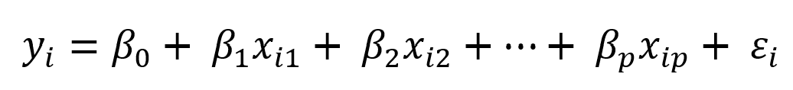

i = 1, 2, …, n

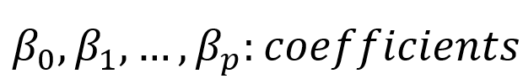

## Data

The research utilizes a dataset comprising characteristics of Polish municipalities, consisting of 100 variables and 2,477 observations. The primary variable under examination is the percentage of inhabitants fully vaccinated against COVID-19, sourced from the Polish Ministry of Health for the year 2021. Additionally, other variables are sourced from the Local Data Bank of Statistics Poland for the year 2020. Furthermore, the study incorporates data from Poland's counties, encompassing 12 variables and 380 observations.

## Results

Our main variable is “Percent vaccinated”. Below is the distribution of the target variable.

|  |  |  |  |  |  |  |  |  |
| --- | --- | --- | --- | --- | --- | --- | --- | --- |
|  | count | mean | std | min | 25% | 50% | 75% | max |
| %_vaccinated | 2,477 | 52.16 | 7.87 | 25.60 | 47.50 | 52.80 | 57.50 | 79.50 |

Additionally, we conducted correlation analyses between the target variable "Percent Vaccinated" and the remaining variables. Presented below is a summary of the most positively and negatively correlated findings:

|  |  |
| --- | --- |
| Most Positive Correlations |  |
| revenues_per_capita_PIT | 0.567301 |
| entities_registered_per_10k_persons | 0.520885 |
| installations_bathroom | 0.404143 |
| installations_central_heating | 0.403375 |
| urbanization_rate | 0.398975 |

|  |  |
| --- | --- |
| Most Negative Correlations |  |
| persons_per_appartment | -0.423180 |
| forests_area | -0.403692 |
| persons_per_room | -0.360355 |
| unemployment_rate_m | -0.226878 |
| unemployment_rate | -0.218215 |

### The Impact of Municipality/City Size

The null hypothesis **(hypothesis 1)** is that: the size of municipalities/cities matters. Alternative hypothesis is that size of municipalities/cities does not matter.

We use the variable “"area_km2" as the representative for the size of the municipalities/cities.

We perform the regression between the dependent variable "percent_vaccinated" and "area_km2".

Here is the summary of the result:

Not only that, to determine the size of municipalities/cities, we also take into account the population density (total area divided by the total population)

From these two above tables, it can easily be seen that the R-squareds are really low, 0.008 and 0.055, respectively. Meaning that the area variable and density variable are not able to explain the vaccination rate.

Not only that, we also perform the correlation test, which indicates negative correlation between the percentage vaccination and area variable, with the amount of -0.091558.

Hence, our null hypothesis **(hypothesis 1)** is rejected. It fails to conclude that the size of municipalities/cities affect the vaccination rate.

### A division between eastern and western Poland

We divide Poland based on the historical partitions, including: austrian, prussian and russian.

Based on the dataset, we used spatial data in order to divide the municipalities into 3 partitions as the picture below:

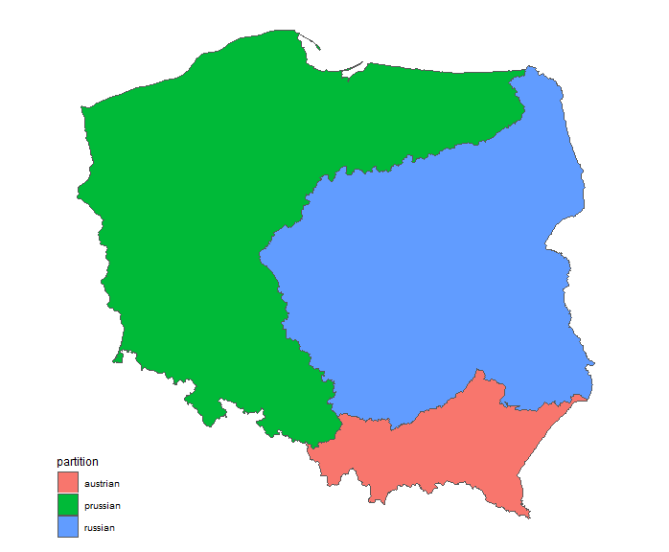

We generate new dataset using spatial dataset as mapping to create the partition and calculate the average vaccinated percent using weighted average (based on population table)

Then, we calculate the average of the fully vaccinated rate based on each region.

|  |  |  |  |  |  |
| --- | --- | --- | --- | --- | --- |
| Partition | Population | Weighted pop vaccinated | Net scholarization amount | Revenue per capita PIT | Avg. vaccinated percent |
| austrian | 6,853,846 | 3,569,817 | 37,491 | 296,965 | 52% |
| russian | 17,111,020 | 10,061,301 | 108,144 | 882,976 | 59% |
| prussian | 18,513,078 | 11,053,651 | 96,862 | 917,181 | 60% |

We've observed a positive correlation between the average vaccination rate and the revenue per capita from Personal Income Tax (PIT). Evidently, as the revenue per capita PIT rises, so does the average vaccination rate.

In summary, we reject the **Hypothesis 2** based on the number above, we did not see any significant difference between Eastern and Western of Poland, but in contrast, we can see the remarkable difference between three partitions (russian/ Prussian vs austrian)

### Variation in vaccination rates among different age groups

Based on the dataset, we can generate the data table for showing the population and vaccinated population of each group ages.

|  |  |  |  |  |  |
| --- | --- | --- | --- | --- | --- |
| Group ages | Amount | Vaccinate | Percent of total | Percent of vaccinated | Percent of Vaccinated in total |
| 0-4 | 2,129,692 | 1,234,643 | 5.014% | 5.002% | 58.0% |
| 5-9 | 2,184,237 | 1,262,019 | 5.142% | 5.113% | 57.8% |
| 10-14 | 2,281,947 | 1,311,288 | 5.372% | 5.312% | 57.5% |
| 15-19 | 1,956,947 | 1,115,254 | 4.607% | 4.518% | 57.0% |
| 20-24 | 2,165,807 | 1,247,804 | 5.099% | 5.055% | 57.6% |
| 25-29 | 2,669,512 | 1,561,683 | 6.284% | 6.327% | 58.5% |
| 30-34 | 3,134,697 | 1,836,800 | 7.380% | 7.441% | 58.6% |
| 35-39 | 3,590,893 | 2,104,832 | 8.454% | 8.527% | 58.6% |
| 40-44 | 3,422,976 | 2,002,775 | 8.058% | 8.113% | 58.5% |
| 45-49 | 2,991,944 | 1,738,319 | 7.044% | 7.042% | 58.1% |
| 50-54 | 2,531,979 | 1,455,614 | 5.961% | 5.897% | 57.5% |
| 55-59 | 2,571,940 | 1,474,820 | 6.055% | 5.975% | 57.3% |
| 60-64 | 2,962,892 | 1,717,147 | 6.975% | 6.956% | 58.0% |
| 65-69 | 2,769,527 | 1,622,228 | 6.520% | 6.572% | 58.6% |
| 70-74 | 2,124,918 | 1,250,336 | 5.002% | 5.065% | 58.8% |
| 75_79 | 1,133,108 | 664,057 | 2.668% | 2.690% | 58.6% |
| 80_84 | 964,183 | 562,909 | 2.270% | 2.280% | 58.4% |
| Other | 890,745 | 522,244 | 2.097% | 2.116% | 58.6% |

Based on the table above, we can visualize the chart in order to see the distribution and variance between each group age.

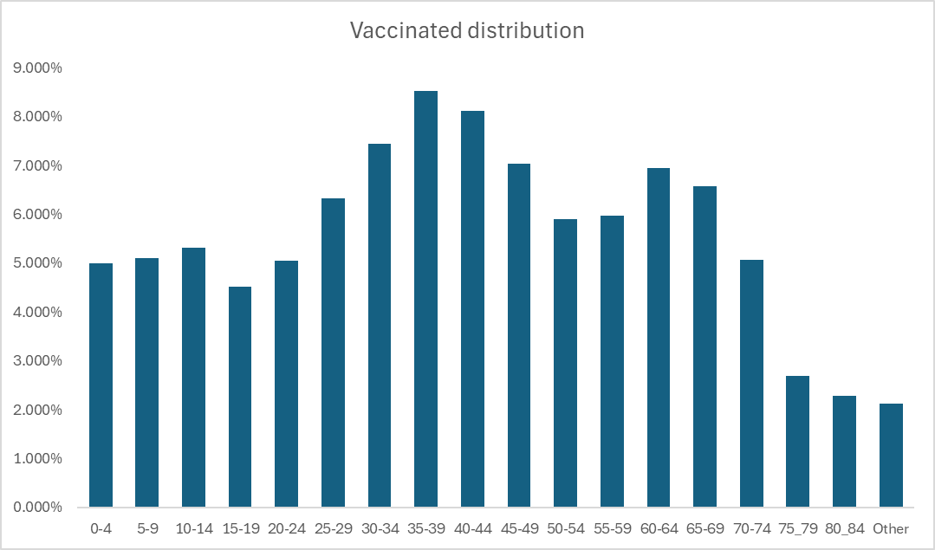

As you can see in this distribution chart, the group age between 25 to 49 years old have the highest percentage in the total vaccinated population.

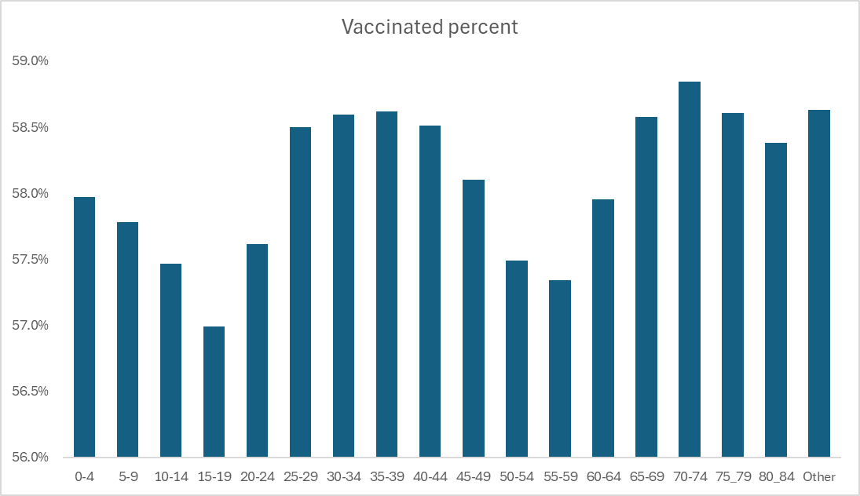

In vaccinated percent chart, we can see that, the vaccinated percent distributed between 56% to 59% and there is no significant variance between each group ages.

Hence, we conclude that we reject ***Hypothesis 3*** which the decision to vaccinate against COVID-19 is not influenced just by one's age.

### Neighborhood effects and the contagious nature of vaccination propensity

After performing maximum likelihood, we kept factors that influenced vaccination selection. The parameter estimations are given below:

|  |  |  |  |  |  |
| --- | --- | --- | --- | --- | --- |
| **Analysis of Maximum Likelihood Estimates** | | | | | |
| **Parameter** | **DF** | **Estimate** | **Error** | **t Value** | **Pr > |t|** |
|  |  |  |  |  |  |
| Intercept | 1 | 74.4056 | 9.4045 | 7.91 | <.0001 |
| appartments_per_1000_persons | 1 | -0.0352 | 0.00991 | -3.55 | 0.0004 |
| entities_registered_per_10k_pers | 1 | 0.00238 | 0.000584 | 4.08 | <.0001 |
| forests_area | 1 | -0.00204 | 0.00022 | -9.24 | <.0001 |
| installations_bathroom | 1 | -0.3063 | 0.1298 | -2.36 | 0.0185 |
| installations_central_heating | 1 | 0.105 | 0.0381 | 2.76 | 0.0059 |
| installations_network_gas | 1 | -0.0371 | 0.00671 | -5.53 | <.0001 |
| installations_toilet | 1 | 0.4881 | 0.1515 | 3.22 | 0.0013 |
| installations_watersupply | 1 | -0.1646 | 0.0755 | -2.18 | 0.0294 |
| persons_per_appartment | 1 | -12.9788 | 1.3507 | -9.61 | <.0001 |
| persons_per_room | 1 | 20.944 | 4.0936 | 5.12 | <.0001 |
| population_density | 1 | -0.00193 | 0.000576 | -3.35 | 0.0009 |
| revenues_per_capita_PIT | 1 | 0.00883 | 0.000746 | 11.84 | <.0001 |
| unemployment_rate_m | 1 | -0.3994 | 0.0744 | -5.37 | <.0001 |

The findings of the maximum likelihood analysis show that numerous critical characteristics, each linked with an estimate, contribute to the inclination to vaccinate against COVID-19, emphasizing neighborhood impacts and the infectious nature of vaccination attitudes. Particularly, increased apartment density, as measured by "*Appartments_per_1000_persons,*" is associated with lower vaccination rates (-0.0352 estimate), possibly due to social dynamics or access limits in highly populated locations. In contrast, locations with a higher number of registered organizations per 10,000 people (*entities_registered_per_10k_pers*) are more likely to vaccinate (0.00238 estimate), demonstrating that a strong community infrastructure has a beneficial impact on vaccination behavior.

Furthermore, overcrowding in living situations, as measured by *"Persons_per_appartment*" and *"Persons_per_room*," tends to influence vaccination tendency. This shows that limited access to healthcare services and information in densely populated regions may lead to lower vaccination rates. Furthermore, increased population density (*population_density*) is related to a lower vaccination propensity (-0.00193 estimate), highlighting the difficulties in organizing effective vaccination programs or addressing the particular social dynamics seen in highly populated districts.

Finally, socioeconomic factors such as *"Revenues_per_capita_PIT*" and "*Unemployment_rate_m*" play important roles. Higher per capita revenues (0.00883) and lower unemployment male rates (-0.3994) are connected with a higher willingness to vaccinate. This demonstrates the impact of economic stability on vaccination behavior, with better income and employment stability potentially leading to increased access to healthcare services and faith in vaccinations.

In conclusion, our findings support **Hypothesis 4**, which suggests a neighborhood impact in which COVID-19 vaccination willingness spreads among local communities. Being nearby improves the chance of influencing one another's immunization attitudes and actions via social contagion mechanisms. This emphasizes the significance of community-specific initiatives in increasing vaccination rates and combating the pandemic successfully.

## Conclusions

In conclusion, our findings give insight about why people in Poland choose to get vaccinated against COVID-19. We discovered that vaccination rates are influenced by factors such as where people reside (urban or rural), regional disparities, and their age.

While large cities have greater vaccination rates, we observed that other factors, such as affluence, accessibility to healthcare, and community closeness, also have a role. Surprisingly, we found no significant variations in immunization rates between Eastern and Western Poland. However, when we looked at smaller sections of the country, we saw differences.

We also investigated how age influences immunization. While certain age groups receive more vaccinations than others, we discovered that it is not simply age that influences vaccination rates; other factors also play a role. Finally, we discovered that people's vaccination decisions can be impacted by their social circles and communities. This implies that if your friends and neighbors are vaccinated, you may be more inclined to do so as well.

# Reference

Vilches, T. N., Sah, P., Moghadas, S. M., Shoukat, A., Fitzpatrick, M. C., Hotez, P. J., ... & Galvani, A. P. (2022). COVID-19 hospitalizations and deaths averted under an accelerated vaccination program in northeastern and southern regions of the USA. *The Lancet Regional Health–Americas*, *6*.

<https://doi.org/10.1016/j.lana.2021.100147>

Karashiali, C., Konstantinou, P., Christodoulou, A., Kyprianidou, M., Nicolaou, C., Karekla, M., … Kassianos, A. P. (2023). A qualitative study exploring the social contagion of attitudes and uptake of COVID-19 vaccinations. Human Vaccines & Immunotherapeutics, 19(2). <https://doi.org/10.1080/21645515.2023.2260038>

Wang, Q., Yang, L., Jin, H., & Lin, L. (2021). Vaccination against COVID-19: A systematic review and meta-analysis of acceptability and its predictors. *Preventive medicine*, *150*, 106694. <https://doi.org/10.1016/j.ypmed.2021.106694>

Lazarus, J. V., Wyka, K., Rauh, L., Rabin, K., Ratzan, S., Gostin, L. O., … El-Mohandes, A. (2020). Hesitant or Not? The Association of Age, Gender, and Education with Potential Acceptance of a COVID-19 Vaccine: A Country-level Analysis. Journal of Health Communication, 25(10), 799–807. <https://doi.org/10.1080/10810730.2020.1868630>

Vilches, T. N., Sah, P., Moghadas, S. M., Shoukat, A., Fitzpatrick, M. C., Hotez, P. J., ... & Galvani, A. P. (2022). COVID-19 hospitalizations and deaths averted under an accelerated vaccination program in northeastern and southern regions of the USA. *The Lancet Regional Health–Americas*, *6*.

<https://doi.org/10.1016/j.lana.2021.100147>

Ma, Y.S., and Monnat, Sh.M. (2022). Rural-urban and within-rural differences in COVID-19 vaccination rates. The Journal of Rural Health, 38(4). <https://doi.org/10.1111/jrh.12625>

Shkolnikov, V. M., Timonin, S., Jdanov, D., Medina-Jaudes, N., Islam, N., & Leon, D. A. (2023). East-West mortality disparities during the COVID-19 pandemic widen the historical longevity divide in Europe: an international comparative study. *medRxiv*, 2023-11. <https://doi.org/10.1101/2023.11.08.23298275>