 | FPT ACADEMY INTERNATIONAL  FPT – APTECH COMPUTER EDUCATION

Centre Name: ACE-HCMC-2-FPT.
Address: 590 Cach Mang Thang 8, District 3, Ho Chi Minh City, Viet Nam.

OnlineBanking

Supervisor: | Mr. Dinh Vu Quoc Trung
Semester: | 3
Batch No: | T1.1712.E0
Group No: | 5
Order: | Full name | Roll No.
1. | DANG HUU NHAN | STUDENT1053421
2. | NGUYEN HONG PHUONG | STUDENT1086373
3. | NGUYEN THI THUY TRANG | STUDENT1081669
4. | NGUYEN DINH THAI | STUDENT1081263

March 2019

This is to certify that

Mr. Dang Huu Nhan

Mr. Nguyen Hong Phuong

Ms. Nguyen Thi Thuy Trang

Mr. Nguyen Dinh Thai

have successfully designed and developed :

OnlineBanking

Submitted by:
Dinh Vu Quoc Trung

Date of Issue: ________

Authorized Signature: ___________

Table of Contents

REVIEW I 4
I. ACKNOWLEDGEMENT 5
II. PROBLEM DEFINITION 6
i. Introduction 6
ii. Existing Scenario 6
iii. Requirement Specification 6
TASK SHEET REVIEW 1 9
REVIEW II 10
III. Architecture & Design of the Project 11
i. View layer: 11
ii. Model layer: 11
iii. Controller layer: 11
IV. Algorithms - Flowchart: 12
V. Flow Diagram 19
VI. Use - Case Diagram 24
VII. Class Diagram 27
VIII. Sequence Diagram 28
IX. Entity–Relationship Design (ERD) 34
TASK SHEET REVIEW II 35
REVIEW 3 36
I. DATABASE DESIGN 37
II. GUI DESIGN 43
III. 52
TASK SHEET REVIEW III 59

REVIEW I

ACKNOWLEDGEMENT

We would like to acknowledge all those who have given support and help us make the project a success.

We wish to express our deep gratitude to all teachers who have been devoting their lives to teach us how to stand-alone and walk ahead.

We are grateful to our families who take care and encourage us even though we are successful or failed, also to our friends who are always care of us. They never leave us alone and always look forward to us when we are on any road of the life.

We are much thankful to the entire staff and chairpersons at the Head Office of Aptech Worldwide, Aptech – Vietnam, and FPT – Aptech Center who have been organizing and looking after our studying course.

There are no words to show our appreciation for teachers of FPT Aptech Centre who have been organizing and looking after us during our studying course to finish this project. Our special thanks Mr Dinh Vu Quoc Trung who works day by day to teach and guide us ,e-Project Team at the Head Office who instruct and help us.

Finally, we would like to offer many thanks to all our schoolfellows for their valuable suggestions.

We would like to thank sincerely!

Group 5 – FPT Aptech.

PROBLEM DEFINITION

Introduction
Nowadays services of bank have been improved and more convenient thanks to the development of Technology. As a result, Online Banking became the most popular service in both payment and transaction. In order to satisfy the high demand of customers, online banking system must be faster and efficent. Therefore, an effective and secure program needs to be implemented.

Existing Scenario

This Application enables us to transfer money and perform other transaction even there is no necessary to fill a form at the bank counter, i.e we can directly check our Balance Enquiry, transfer funds to another account in the same bank. In addition, online banking supports us to request for cheque book or stop payment of cheques as needed. All these tasks will be performed safely as this application secures our account, only customers having a valid User Id and Password could access banking system.

Requirement Specification

Customer Requirement Specification:

1.1. Administrator
Administrator will have ability of managing:
- User information.
- User accounts management.
- Reply the specific question from user.

1.2. Customer

User will have abilities:

  - Login/logout.
  - View their profile.
  - Fund transfer.
  - View their accounts by detail.
  - View monthly/annual report and print.
  - Change their current address .
  - View list of her/his accounts, balance enquiry and last ‘n’ number of transactions detail of each accounts.
  - Request cheque book / stop payment of cheque.

1.3. Guest

Guest will have abilities:
- View web page info.

Hardware / Software Requirements

2.1. Server Requirements

Hardware

Component | Requirement
CPU | Processor type: Core i5 or faster  Processor speed: Recommended: 2.0 GHz or faster
OS | Microsoft Windows Server 2012 with IIS
Memory (RAM) | RAM:  Minimum: 2GB  Recommended: 4 GB or more
Hard Drive | Free space:  Minimum: 400 MB  Recommended: 50 GB or more  Maximum: Operating system maximum

Software

Component | Requirement
Microsoft Visual Studio Community | 2017
Microsoft .NET Framework | Version 4.6.1
RDBMS | Microsoft SQL Server 2014 or more

2.2. Client Requirements

Hardware
Component | Requirement
CPU | Processor type: Core i5 or faster  Processor speed:  Recommended: 1.0 GHz or faster
OS | Window
Memory (RAM) | RAM:  Minimum: 512 MB  Recommended: 1 GB or more  Maximum: Operating system maximum
Hard Drive | Free space: Minimum: 10 MB

Software
Component | Requirement
Web Browser | Chrome 70 or Higher with JavaScript enable

TASK SHEET REVIEW 1
Project Ref.No: 5 | Project Tittle: OnlineBanking | Date of Preparation of Activity Plan:
No | Task | Actual Start Date | Actual  Days | Team Mates Names | Status
01 | Acknowledgment | 19,March,2019 | 3 | All Members | Completed
02 | Problem Definition | 19,March,2019 | 3 | All Members | Completed
03 | Customer Requirement | 19,March,2019 | 3 | All Members | Completed
04 | Hardware/Software | 19,March,2019 | 3 | All Members | Completed
05 | Task sheet | 19,March,2019 | 3 | All Members | Completed

Date: March 22, 2019 | Prepare By: Group 5 | Approved By: Faculty
Date: March 22, 2019 | Team Leader  Dang Huu Nhan | Dinh Vu Quoc Trung

REVIEW II

I. Architecture & Design of the Project
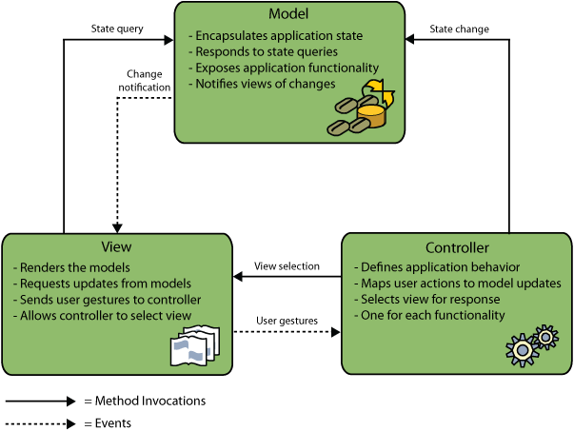

View layer:
View is a user interface. View display data using model to the user and also enables them to modify the data.. View layer used to receive a request and response to User. Technology: Razor, HTML, CSS, JavaScript, Ajax, Jquery and Bootstrap.

Model layer:
Is mainly working as the bridge between Controller layer and View layer. Model represents shape of the data and business logic. It maintains the data of the application. Model objects retrieve and store model state in a database.

Controller layer:
Controller handles the user request. Typically, user interact with View, which in-turn raises appropriate URL request, this request will be handled by a controller. The controller renders the appropriate view with the model data as a response.

Algorithms - Flowchart:
Process
Start/End
Database
Decision
Data
Program Flow

Main flow for customers
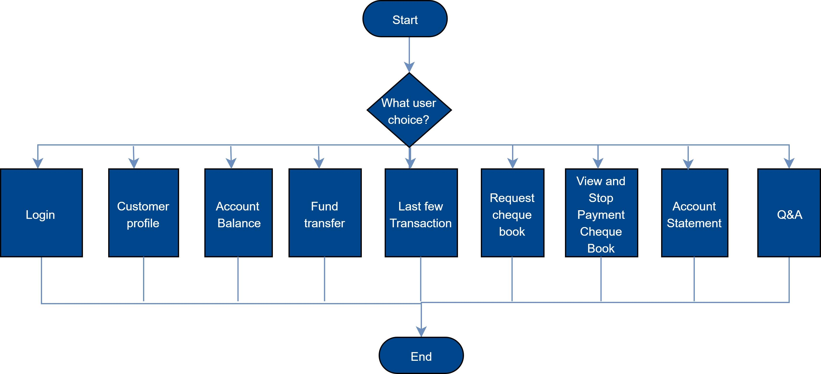

Login process (For Customers)
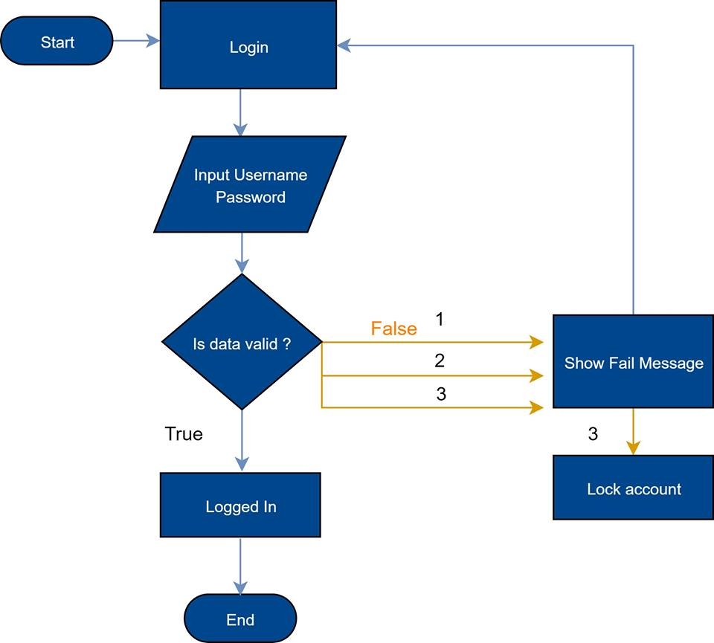

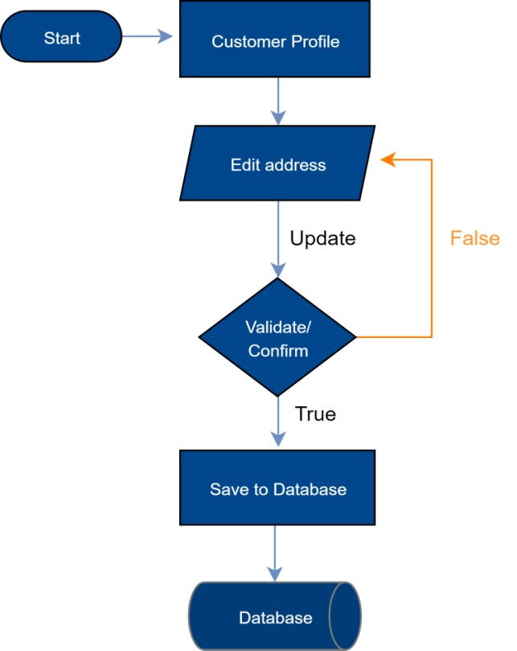
Update Profile (For Customers)

Logout process (For Customers and Admins)
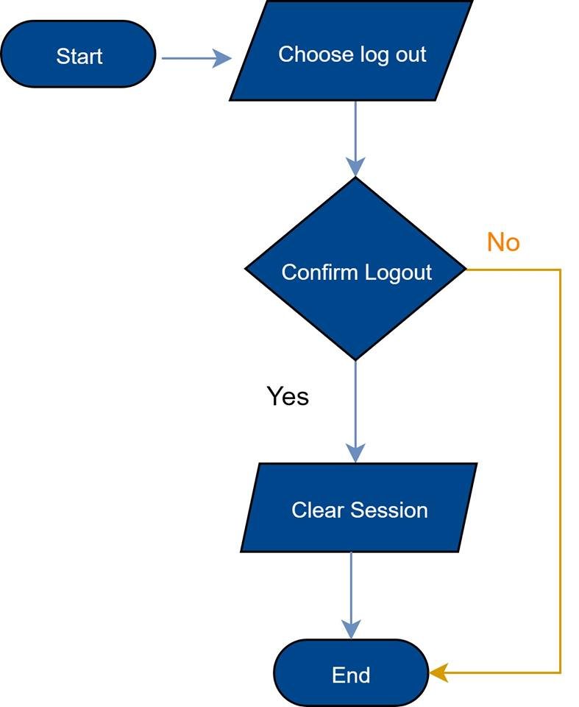

Customers transfer fund

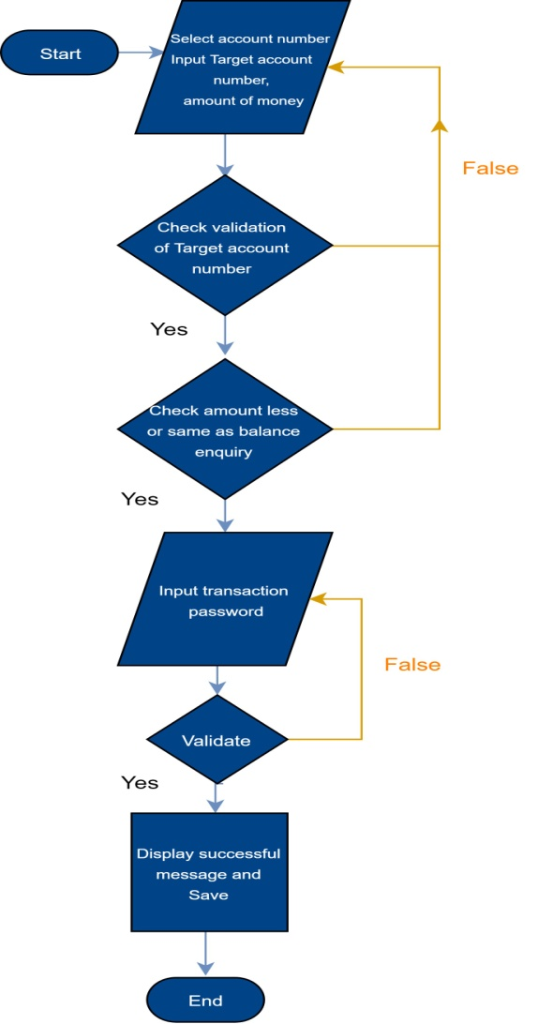

Insert Users (For admin only)
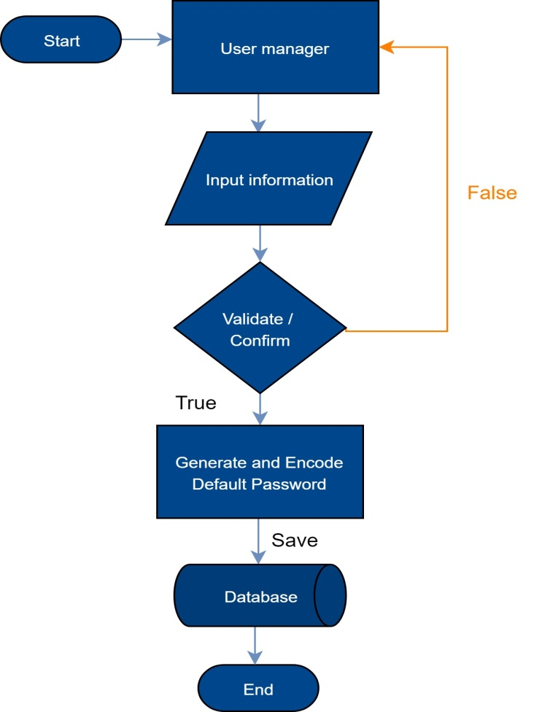

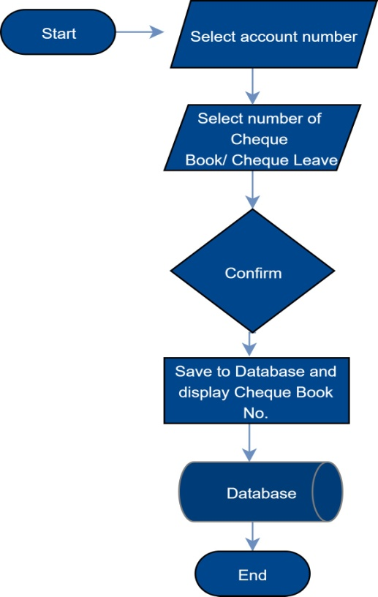
Request Cheque Book (For Customers)

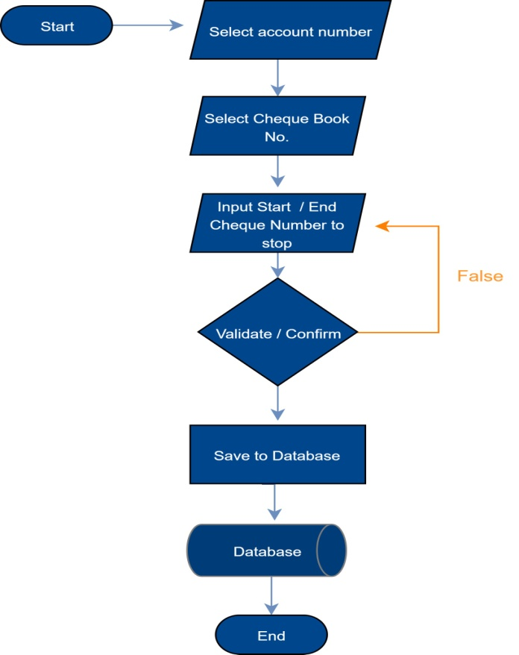
Stop Cheque Book Payment (For Customers)

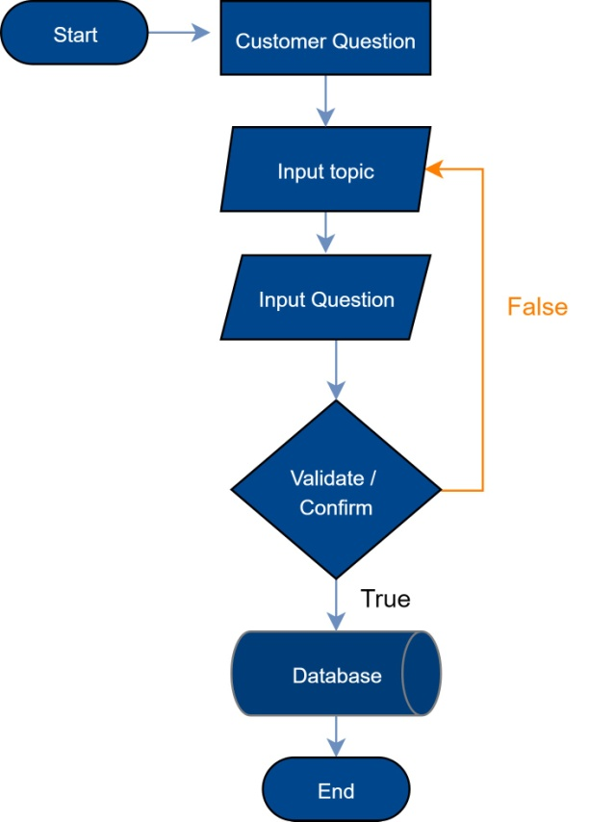
Write Customers’s questions (For Customer)

Reply Customers’s questions (For Admin)

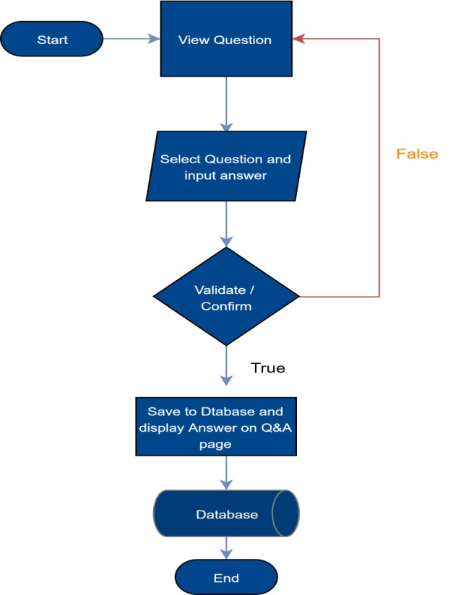

Flow Diagram
Define: Data Flows Diagram (DFD) describes the information flow in the system. The next step of system analysis is to consider in detail the information necessary for the implementation for functions discussed above and the one necessary for the improvement of the functions. Modelling tool frequently used for this purpose is DFD. DFD will support 4 main activities:
Analysis: DFD is used to determine requirement of users.
Design: DFD is used to map out plan and illustrate solution to analysis and users while designing a new system.
Communication: one of the strength of DFD is its simplicity and ease to understand to analysts and users.
Document: DFD is used to provide special description of requirement and system design. DFD provide an overview of key functional components of the system but it does not provide any detail on these components. We have to use other tools like database dictionary, process specification to get an idea of which information will be exchanged and how.

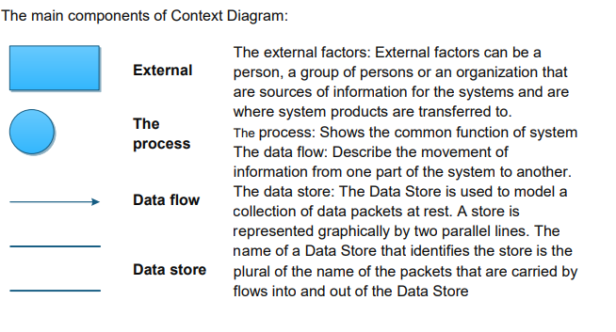

Context Level Diagram
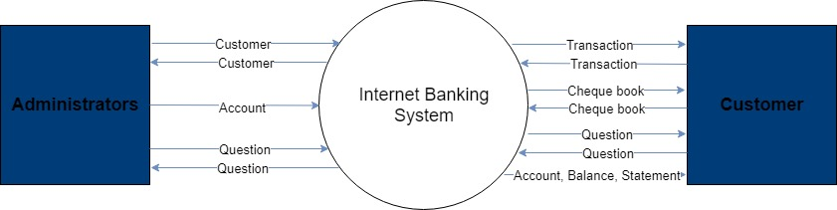

Level 0 DFD
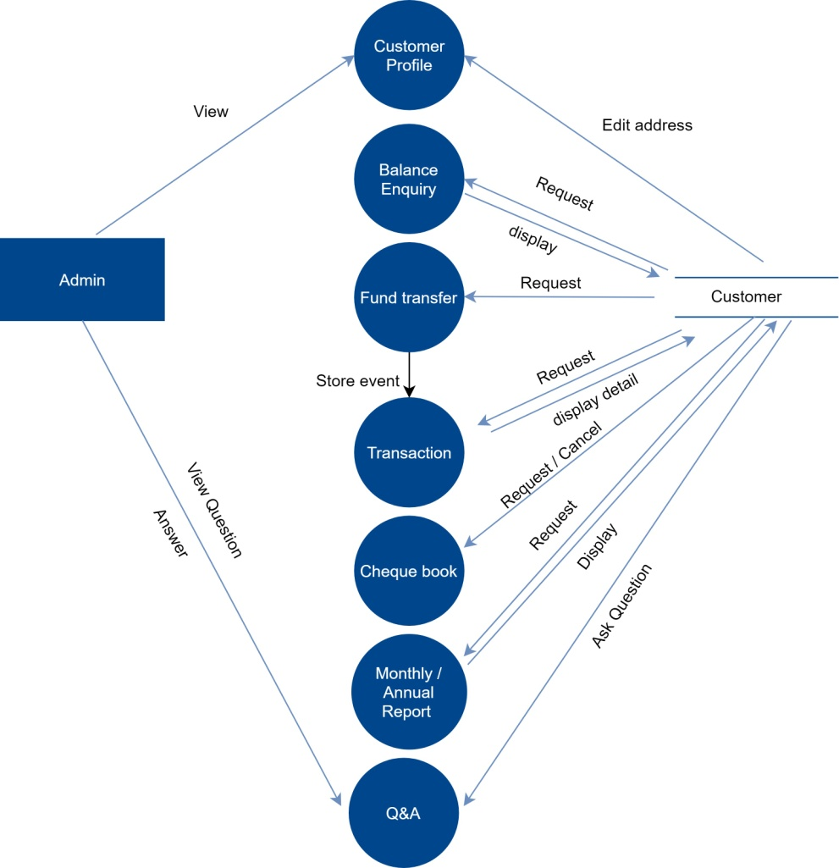

Level 1 DFD
3.1 Administrators manage customers
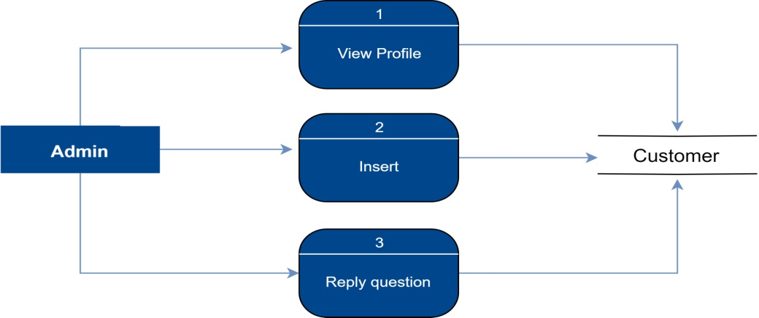

3.2 Customers edit address

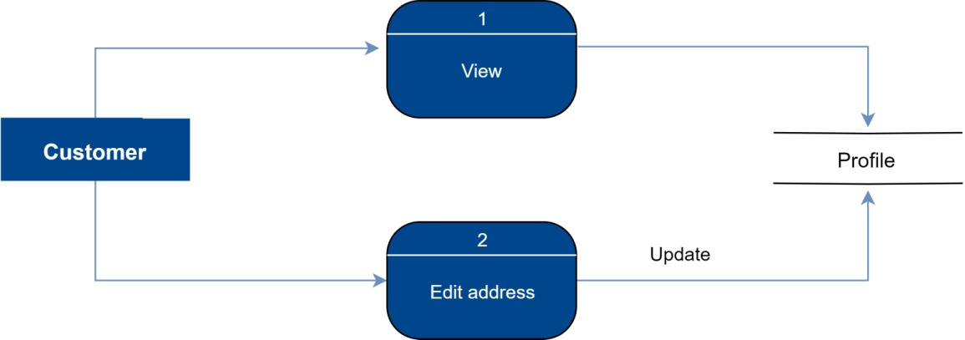
3.3 Customers view balance enquiry

3.4 Customers transfer funds
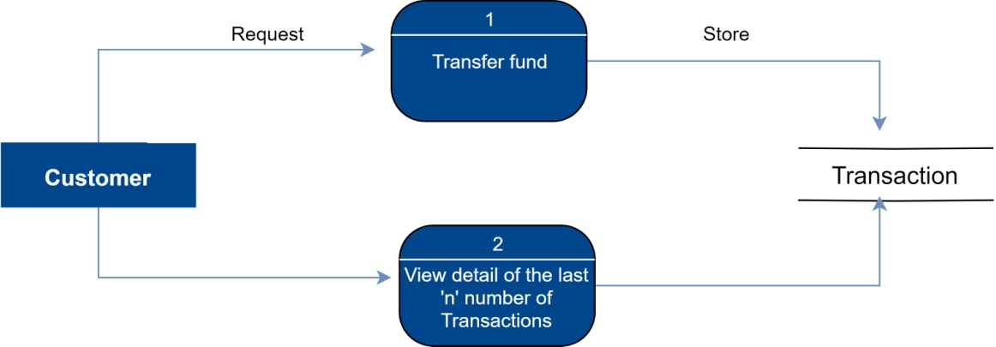

3.5 Customers request and cancel Cheque book
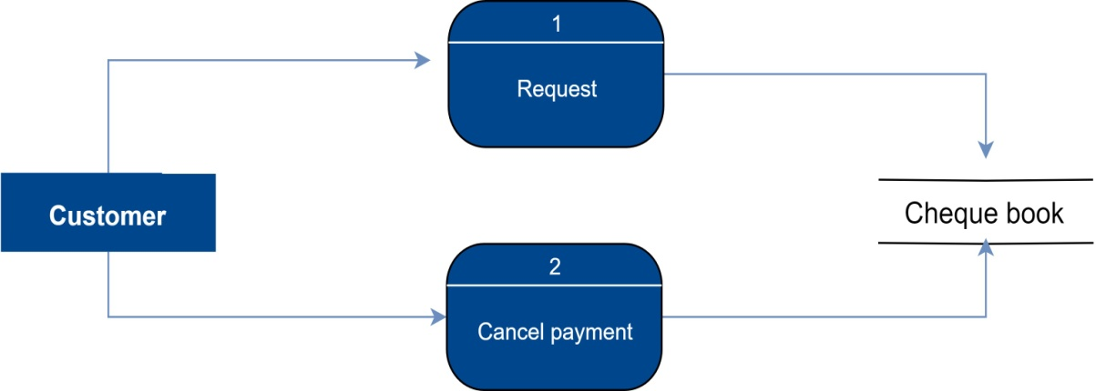

3.6 Customers request Monthly/Annual statement

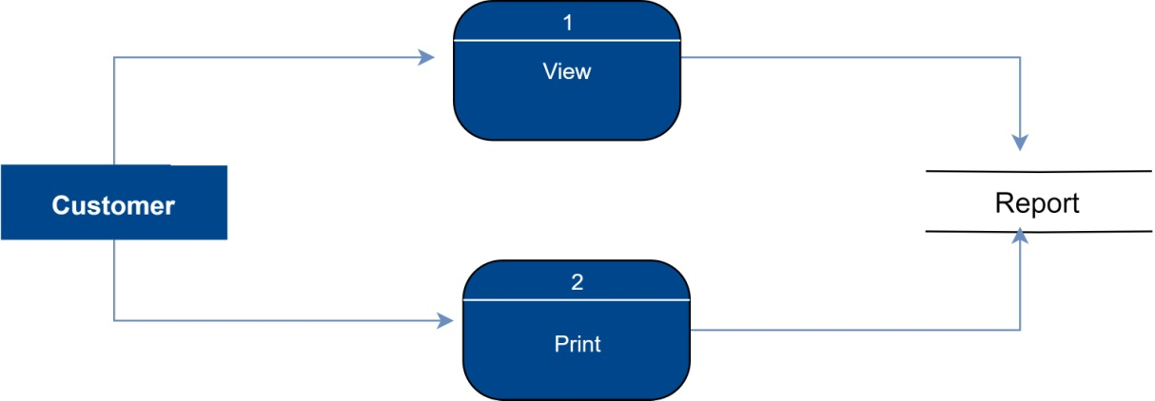

3.7 Customers question Admin
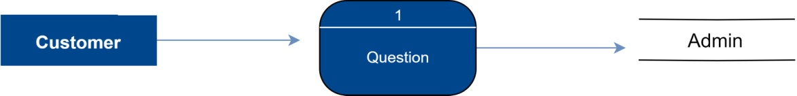

Use - Case Diagram

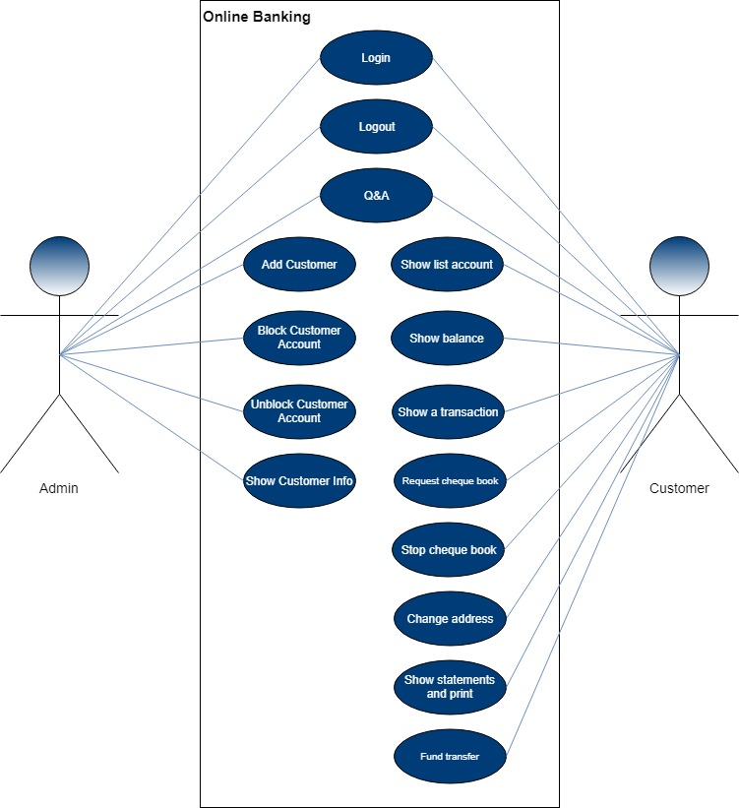

Admin Use Case

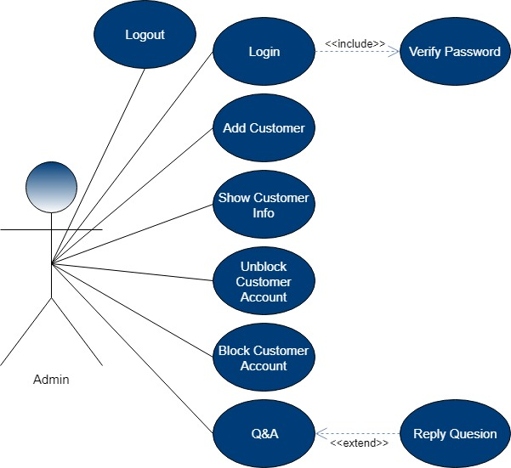

Customer Use Case

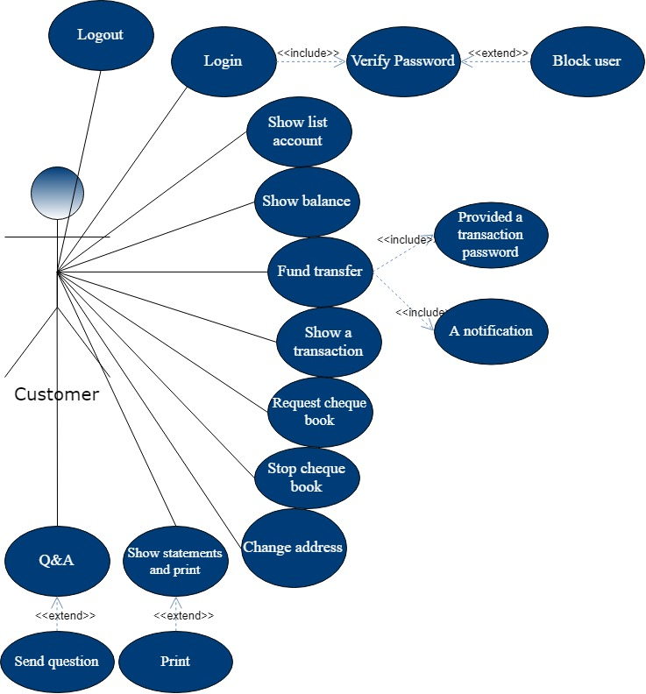

Class Diagram
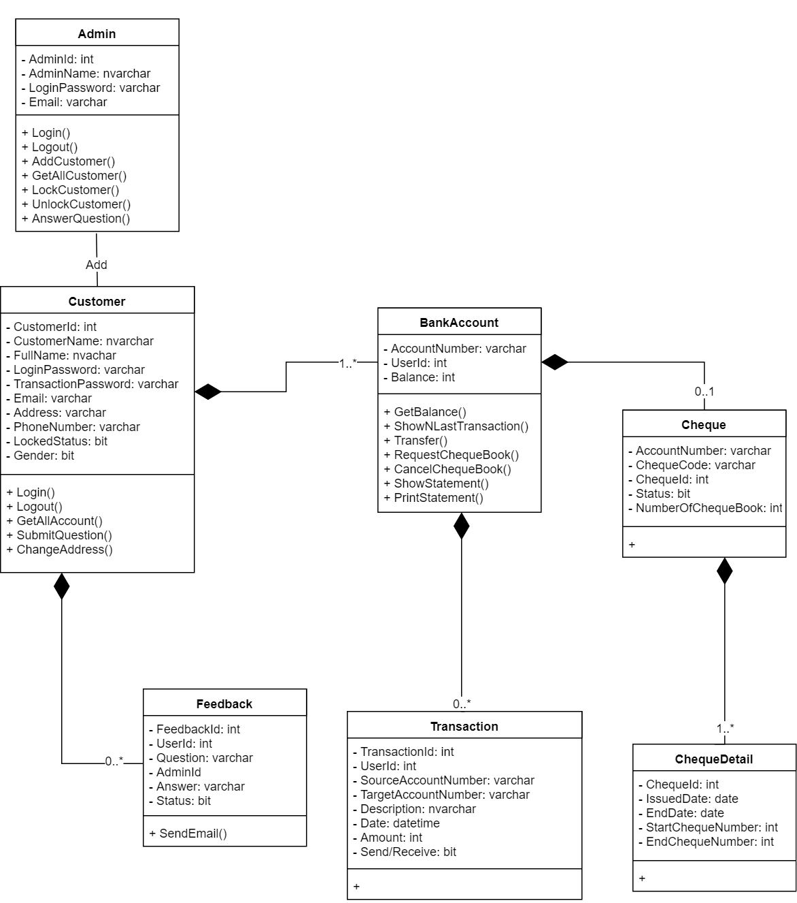

Sequence Diagram

Login
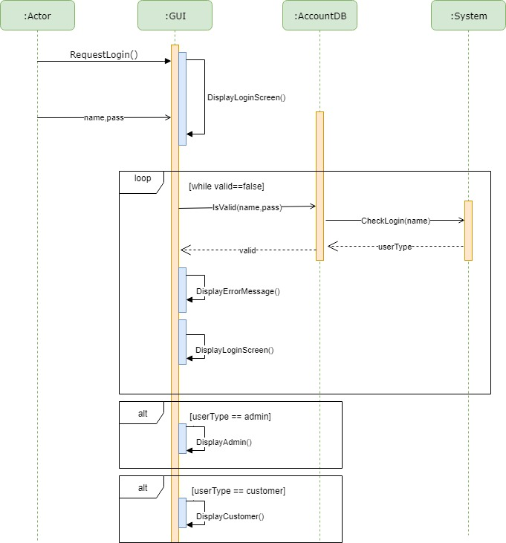

Logout

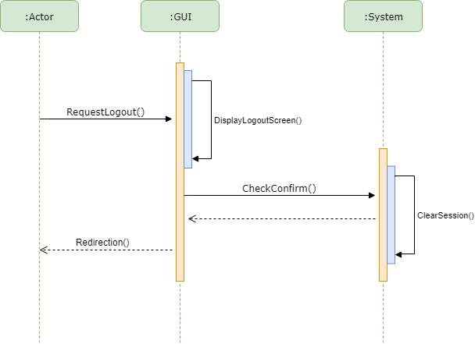

Show Customer’ Profile

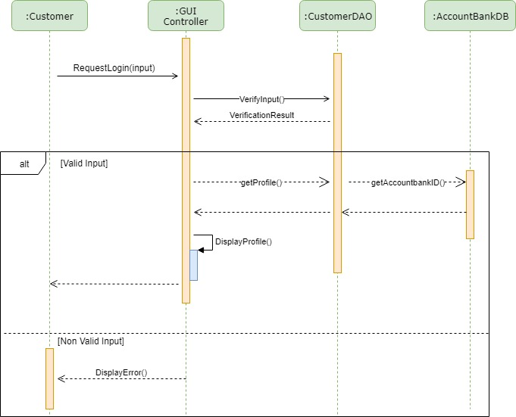

Add Customer

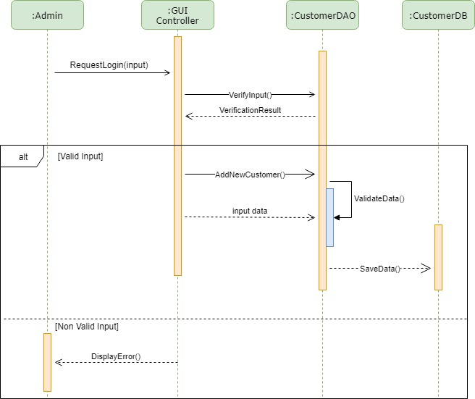

Show list account

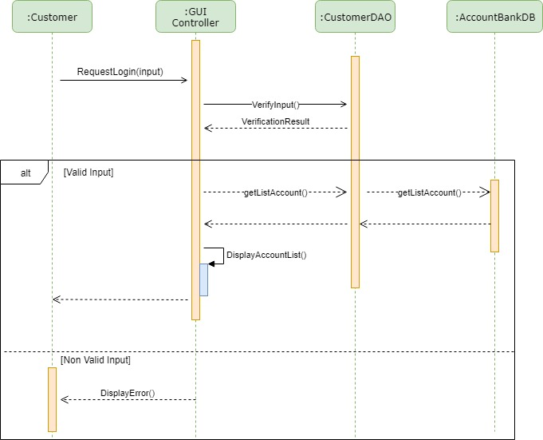

Funds Transaction

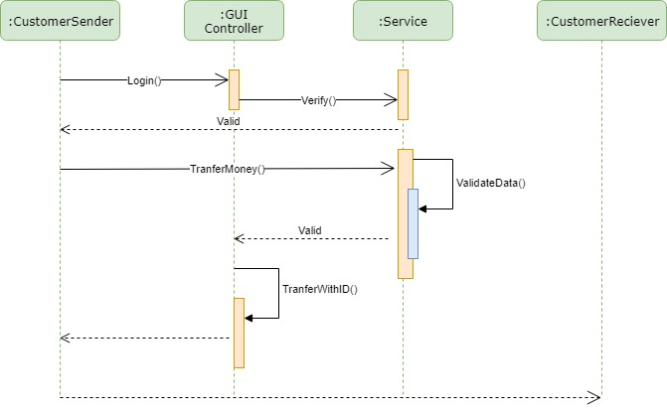

Entity–Relationship Design (ERD)

TASK SHEET REVIEW II
Project Ref.No: 5 | Project Tittle: OnlineBanking | Date of Preparation of Activity Plan:
No | Task | Actual Start Date | Actual  Days | Team Mate Names | Status
01 | Architecture & Design of Project | 22,March,2019 | 5 | Nguyen Thi Thuy Trang | Completed
02 | Algorithms – Data Flow Chart | 22,March,2019 | 5 | Nguyen Thi Thuy Trang | Completed
03 | Flow Diagram | 22,March,2019 | 5 | Nguyen Dinh Thai | Completed
04 | Use Case Diagram | 22,March,2019 | 5 | Nguyen Dinh Thai | Completed
05 | Class Diagram | 22,March,2019 | 5 | Nguyen Hong Phuong | Completed
06 | Sequence Diagram | 22,March,2019 | 5 | Dang Huu Nhan | Completed
07 | Entity–Relationship Design | 22,March,2019 | 5 | Nguyen Hong Phuong | Completed
08 | Task Sheet | 22,March,2019 | 5 | Dang Huu Nhan | Completed

Date: March 27, 2019 | Prepare By: Group 5 | Approved By: Faculty
Date: March 27, 2019 | Team Leader  Dang Huu Nhan | Dinh Vu Quoc Trung

REVIEW 3

DATABASE DESIGN

Database Design Diagram

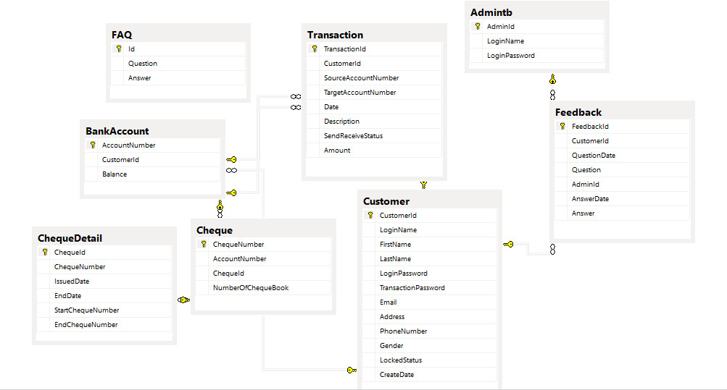

Database Structure

2.1 Table Admin
Field Name | Data Type | Null | Default | Key | Field-Ref | Description
Id | INT | No | IDENTITY(1,1) | PK |  | Admin Id
Name | VARCHAR(20) | No |  |  |  | Login name
LoginPassword | VARCHAR(50) | No |  |  |  | Login password

2.2 Table Customer
Field Name | Data Type | Null | Default | Key | Field-Ref | Description
Id | INT | No | IDENTITY(1,1) | PK |  | Customer Id
CreatedBy | INT | No |  | FK | Admins.Id | Admin Id
Name | VARCHAR(20) | No |  |  |  | Login name
FullName | VARCHAR(40) | No |  |  |  | Customer’s full name
LoginPassword | VARCHAR(50) | No |  |  |  | Login password
TransactionPassword | VARCHAR(50) | No |  |  |  | Transaction password
Email | VARCHAR(20) | No |  |  |  | Customer’s email
Address | VARCHAR(50) | No |  |  |  | Customer’s address
PhoneNumber | VARCHAR(14) | No |  |  |  | Customer’s phone number
Gender | BIT | Yes |  |  |  | Customer’s gender
LockedStatus | BIT | No |  |  |  | Customer’s status (lock or unlock)

2.3 Table BankAccount
Field Name | Data Type | Null | Default | Key | Field-Ref | Description
AccountNumber | VARCHAR(30) | No |  | PK |  | Account number
CustomerId | INT | No |  | FK | Customers.Id | Id of customer this account belong to
Balance | INT | No |  |  |  | Balance of account

2.4 Table Cheque
Field Name | Data Type | Null | Default | Key | Field-Ref | Description
ChequeNumber | VARCHAR(30) | No |  | PK |  | Cheque number
AccountNumber | VARCHAR(30) | No |  | FK | BankAccounts.AccountNumber | Bank account this cheque belongs to
NumberOfChequeBook | INT | No |  |  |  | Number of cheque books issue

2.5 Table ChequeDetail
Field Name | Data Type | Null | Default | Key | Field-Ref | Description
TransactionId | BIGINT | No | IDENTITY(1,1) | PK |  | Transaction Id
CustomerId | VARCHAR(30) | No |  | FK |  | Cheque number
IssuedDate | DATE | No |  |  |  | Day this cheque was issued
EndDate | DATE | Yes |  |  |  | Day this cheque book was cancel
StartChequeNumber | INT | No |  |  |  | Begin number of this cheque book
EndChequeNumber | INT | No |  |  |  | End number of this cheque book

2.6 Table Transactions
Field Name | Data Type | Null | Default | Key | Field-Ref | Description
AccountNumber | VARCHAR(30) | No | IDENTITY(1,1) | PK |  | Account number
CustomerId | INT | No |  | FK | Customers.Id | Id of customer this transaction belongs to
SourceAccountNumber | VARCHAR(30) | No |  |  |  | Send from this account
TargetAccountNumber | VARCHAR(30) | No |  |  |  | Send to this account
Date | DATE | No |  |  |  | Time this transfer successful
Description | VARCHAR(90) | No |  |  |  | Content of this transaction
Amount | INT | No |  |  |  | Amount of money has been transfer

2.7 Table FAQ
Field Name | Data Type | Null | Default | Key | Field-Ref | Description
id | INT | No | IDENTITY(1,1) | PK |  | Faqs Number
Question | TEXT | No |  | FK |  | Sample Questions
Answer | TEXT | No |  |  |  | Sample Answers

2.8 Table Feedback
Field Name | Data Type | Null | Default | Key | Field-Ref | Description
FeedbackID | INT | No | IDENTITY(1,1) | PK |  | Feedback number
CustomerId | INT | No |  | FK | Customers.Id | Id of customer this Feedback belongs to
QuestionDate | Datetime | No |  |  |  | Date sent question
Question | TEXT | No |  |  |  | Content of Question
AdminID | INT | No |  | FK | Feedback.id
Answer | TEXT | No |  |  |  | Content of Answer

GUI DESIGN

Login
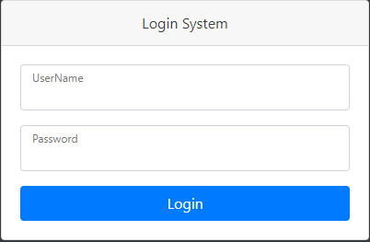
1
2
3
No | Name | Type | Validation | Event | Description | Status
1 | Username | Input | Not null |  | Customer’ User name | Enable
2 | Password | Input | Not null |  | Customer’ password | Enable
3 | Login | Button |  | Click | Login to customer’ page | Enable

Account Number List and Account Balance
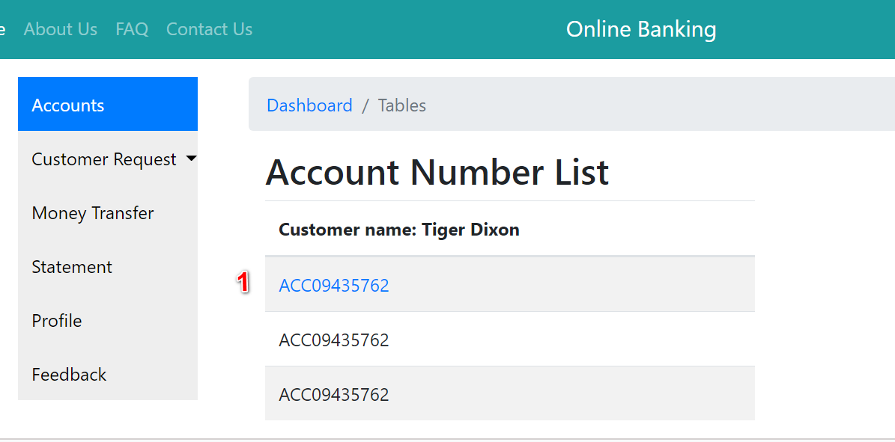
Interface for Desktop

No | Name | Type | Validation | Event | Description | Status
1 | txtAccountNumber | Hyper Link |  | Click | URL To Action Account Balance | Enable
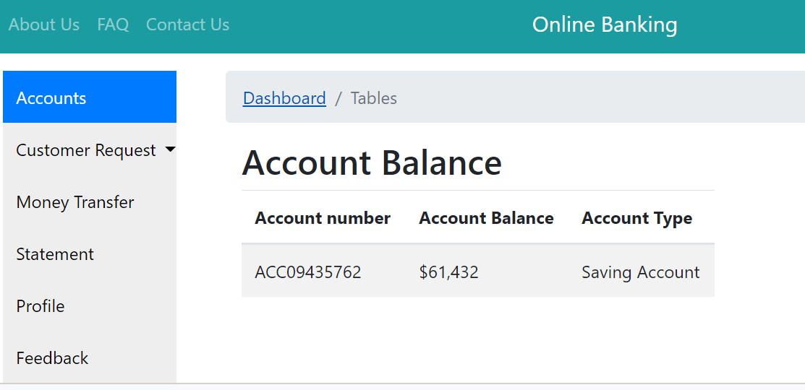

Last few of Transaction
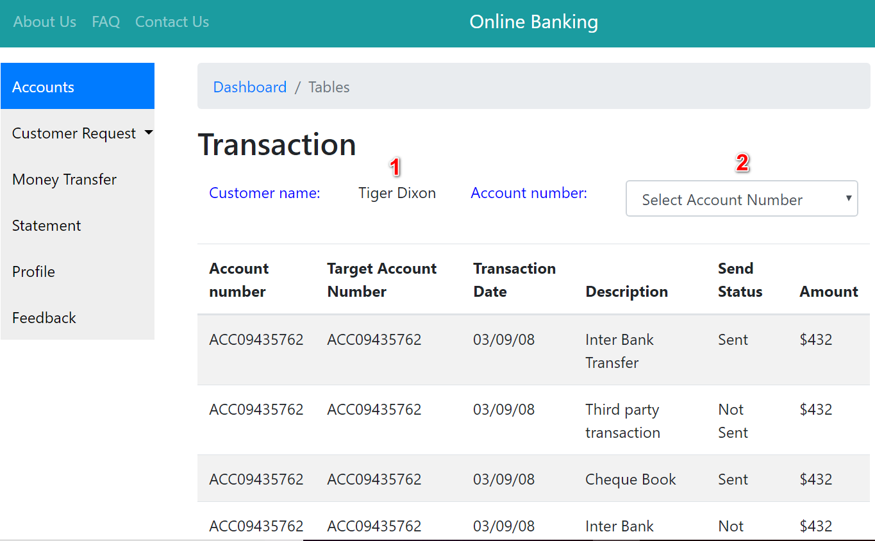
Interface for Desktop

No | Name | Type | Validation | Event | Description | Status
1 | txtLoginName | Text | Not null |  | Show Login Name | Enable
2 | slcAccountNumber | DropdownList | Not null |  | Select Account Number | Enable

Request Cheque Book and List of Request Cheque Book
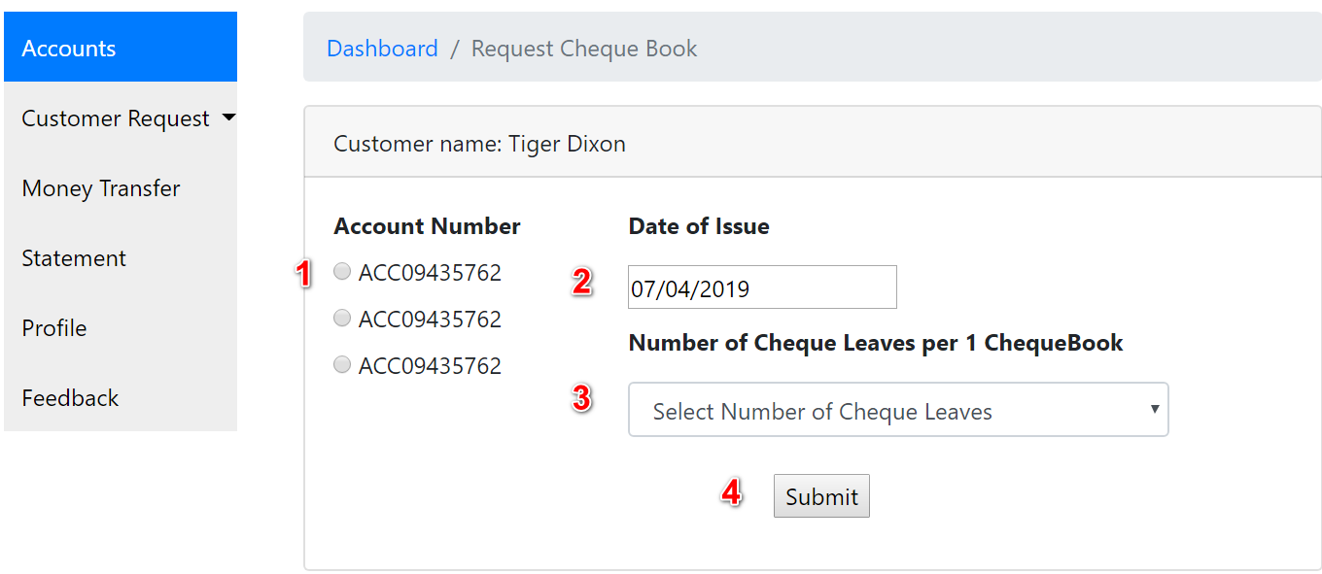
Interface for Desktop

No | Name | Type | Validation | Event | Description | Status
1 | AccountNumber | Radion Button |  |  | Choose Account Number | Enable
2 | txtIssuedDate | Textbox |  |  | Show Date of Issued Cheque Book | Enable
3 | slcNumberCheque Leaves | DropdownList |  |  | Select Number of Cheque Leaves | Enable
4 | btnSubmit | Submit Button |  | Click | Submit this form | Enable
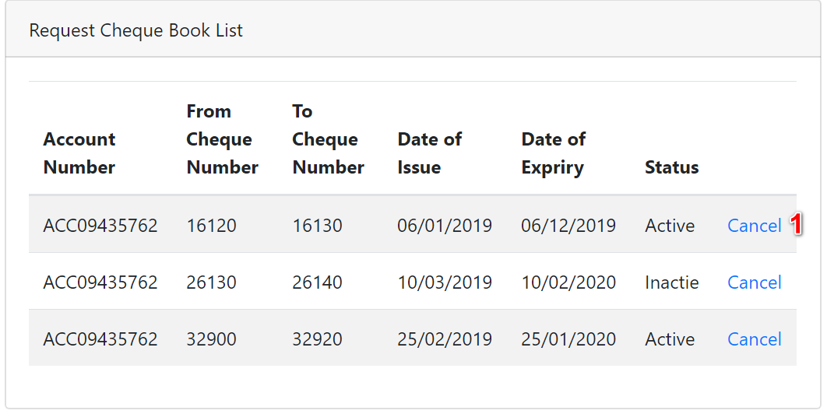
No | Name | Type | Validation | Event | Description | Status
1 | Cancel | Hyper Link |  | Click | URL To Stop Cheque Payment | Enable

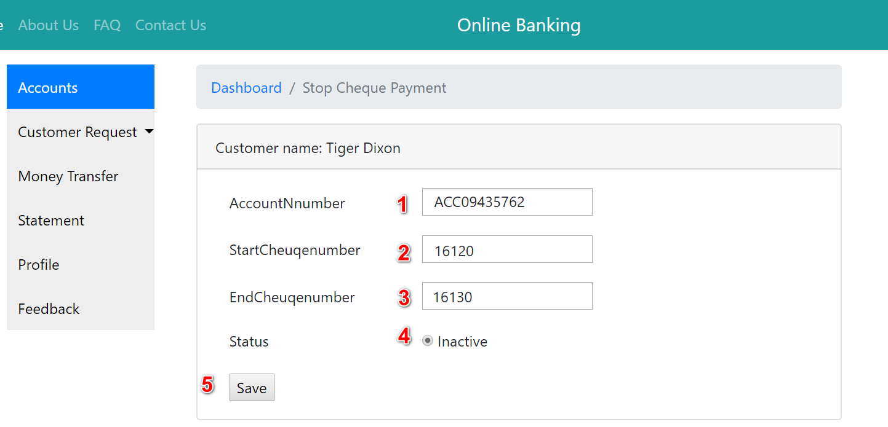
Stop Cheque Book and Notification

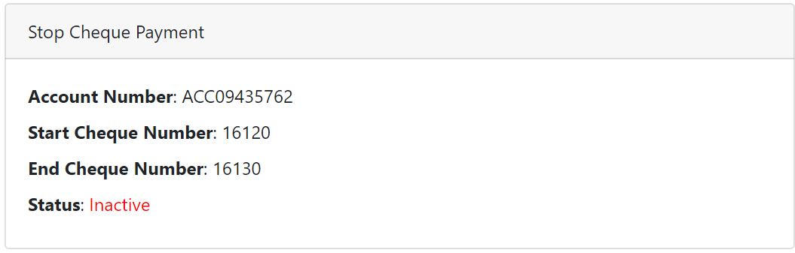

No | Name | Type | Validation | Event | Description | Status
1 | radAccountNumber | Textbox |  |  | Show AccountNumber | Disable
2 | slcStartChequeNumber | Textbox |  |  | Show StartChequeNumber | Disable
3 | slcEndChequeNumber | Textbox |  |  | Show EndChequeNumber | Textbox
4 | radStatus | Radio Button |  |  | Choose Inactive | Enable
5 | btnSave | Submit Button |  | Click | Submit this form | Enable

Edit Profile
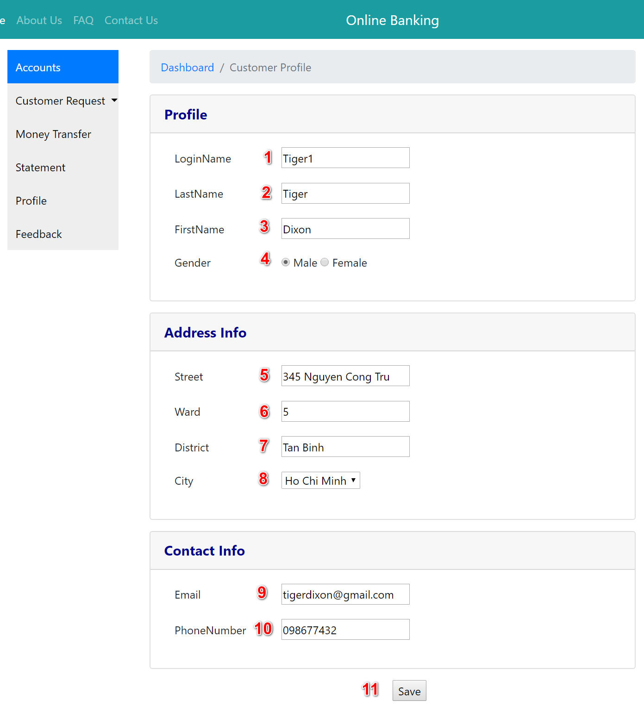
Interface for Desktop

No | Name | Type | Validation | Event | Description | Status
1 | txtLoginName | Textbox |  |  | Show Login name | Disable
2 | txtFirstName | Textbox |  |  | Show First name | Disable
3 | txtLastName | Textbox |  |  | Show Last name | Disable
4 | radGender | Radion Button |  |  | Choose Gender | Enable
5 | txtStreet | Textbox | Not null |  | Input Address number, Street | Enable
6 | txtWard | Textbox | Not null |  | Input Ward | Enable
7 | txtDistrict | Textbox | Not null |  | Input District | Enable
8 | slcCity | Dropdown List | Not null |  | Choose City | Enable
9 | txtEmail | Textbox | Not null  Length<50 |  | Input Email | Enable
10 | txtPhoneNumber | Textbox | Not null  Only number |  | Input Phone number | Enable
11 | btnSave | Submit button |  |  | Submit this form

Fund transfer page
Interface for Desktop
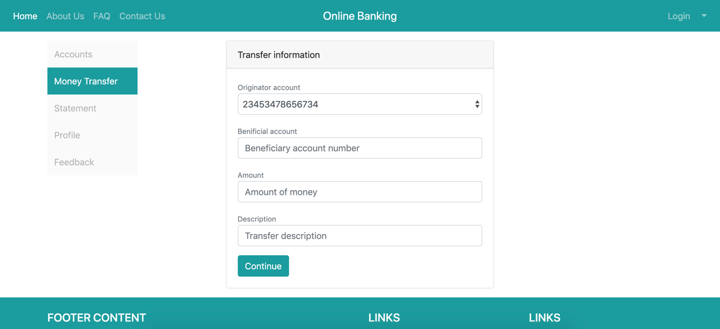
2
3
4
6
5
1
Interface for Mobile
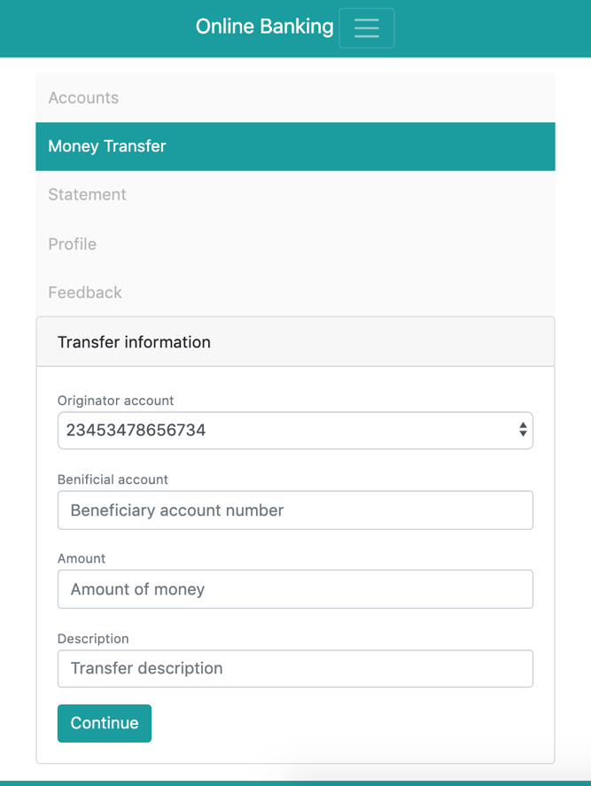

1
2
3
4
6
5

No | Name | Type | Validation | Event | Description | Status
1 | MoneyTransfer | Hyperlink |  | Click | Go to Money Transfer page | Enable
2 | slcSourceAccount | Dropdown list | Not null |  | Chose source account | Enable
3 | txtDesAccount | Textbox | Not null |  | Enter destination account | Enable
4 | txtAmount | Textbox | Not null, number |  | Amount transfer | Enable
5 | txtDes | Textarea | Not null |  | Transfer description | Enable
6 | btnContinue | Button |  | Click | Go to confirm page | Enable

Show statement

Interface for Desktop
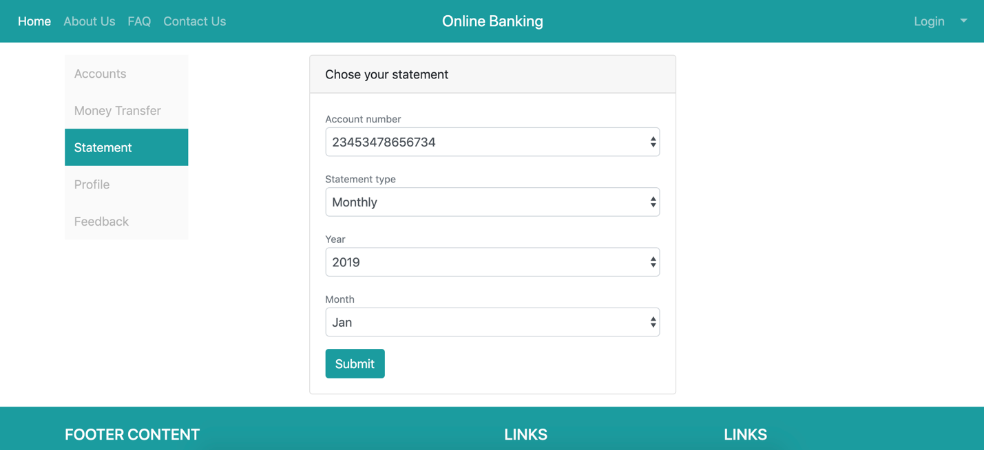

1
2
3
5
6
4

Interface for Mobile
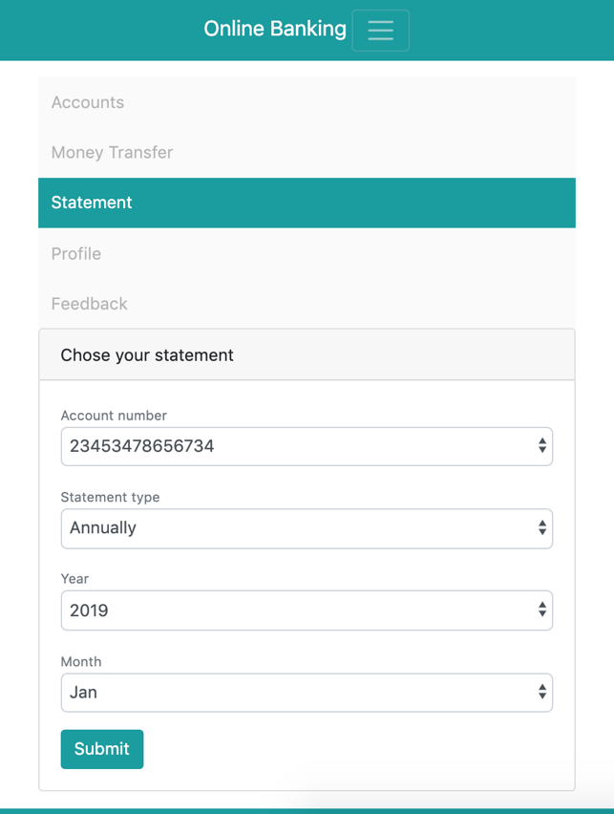

1

2

3
4

5
6

No | Name | Type | Validation | Event | Description | Status
1 | Statement | Hyperlink |  | Click | View statement | Enable
2 | slcAccount | Dropdown list | Not null |  | Chose bank account | Enable
3 | slcStatementType | Dropdown list | Not null |  | Chose statement type | Enable
4 | slcYear | Dropdown list | Not null |  | Chose year | Enable
5 | slcMonth | Dropdown list | Not null |  | Chose month | Enable
6 | btnSubmit | Button |  | Click | View statement | Enable

Print monthly statement

Interface for Desktop
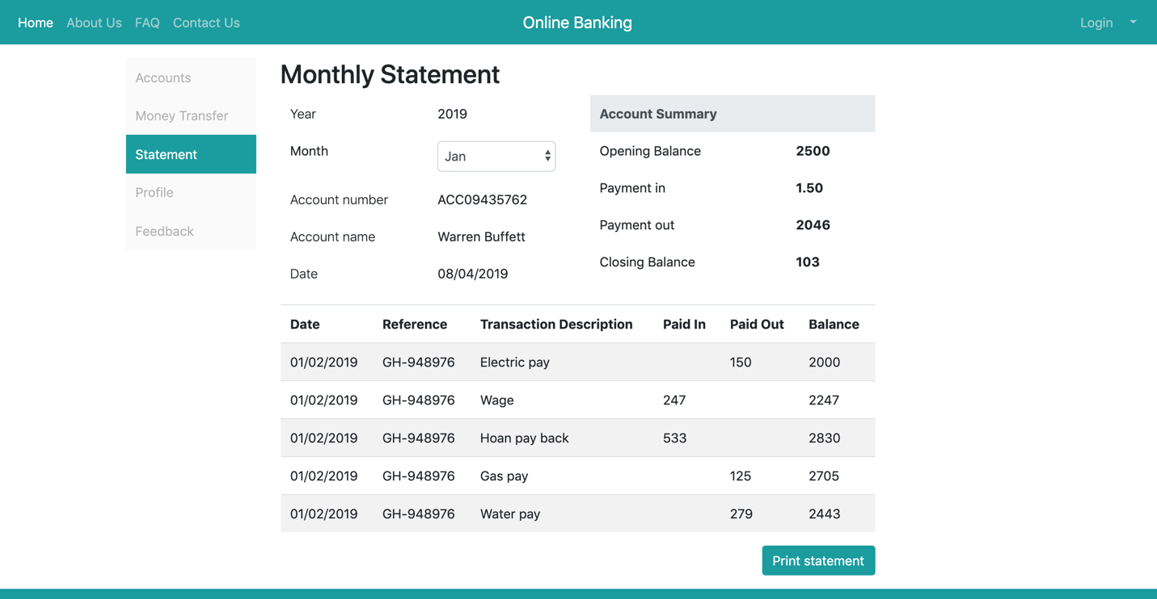

1

2

No | Name | Type | Validation | Event | Description | Status
1 | slcMonth | Dropdown list | Not null |  | Chose month | Enable
2 | btnPrint | Button | Not null |  | Print this statement | Enable

Interface for Desktop
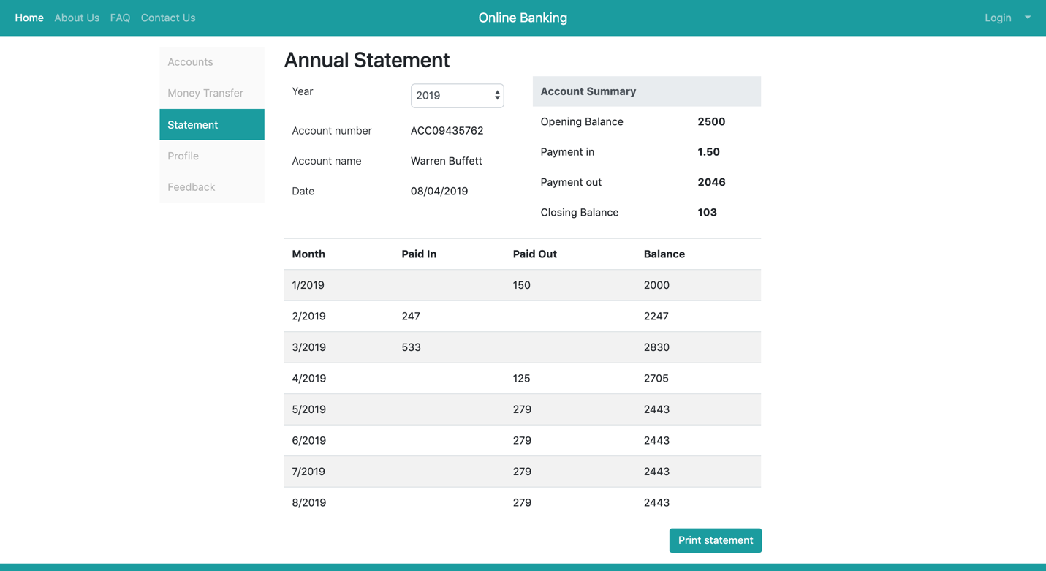

1

2

No | Name | Type | Validation | Event | Description | Status
1 | slcYear | Dropdown list | Not null |  | Chose year | Enable
2 | btnPrint | Button | Not null |  | Print this statement | Enable

Homepage Admin
1
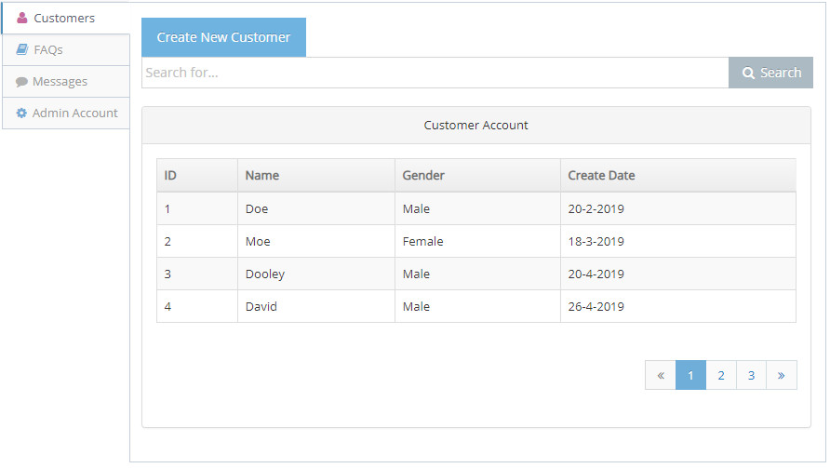
2
3
4
5
6
7

No | Name | Type | Validation | Event | Description | Status
1 | Customer | Hyperlink |  | Click | View Customer’ Detail page | Enable
2 | FAQs | Hyperlink |  | Click | View FAQs page | Enable
3 | Message | Hyperlink |  | Click | View Message page | Enable
4 | Admin Account | Hyperlink |  | Click | View list account admin | Enable
5 | btnCreate | Button |  | Click | Go to add customer page | Enable
6 | btnSearch | Button |  | Click | Fillter customer’ account | Enable
7 | accountCus | table |  | Click | Go to detail customer account | Enable

Add Customer
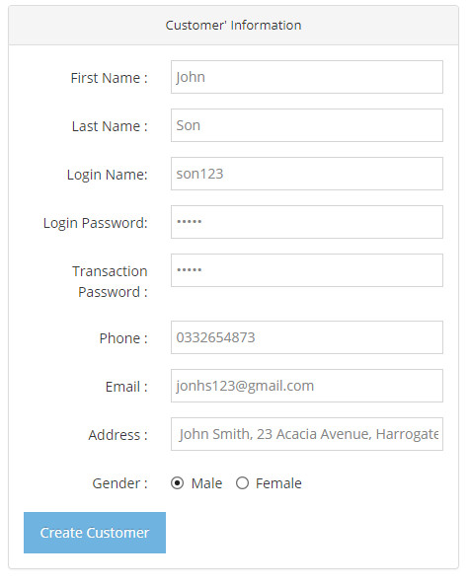
1
3
2
4
5
6
7
8
9
10

No | Name | Type | Validation | Event | Description | Status
1 | firstName | Input | Not null | Click | Input customer’’ information | Enable
2 | lastName | Input | Not null | Click | Input customer’’ information | Enable
3 | loginName | Input | Not null | Click | Input customer’’ information | Enable
4 | loginpassword | Input | Not null | Click | Input customer’’ information | Enable
5 | passtransaction | Input | Not null | Click | Input customer’’ information | Enable
6 | phone | Input | Not null | Click | Input customer’’ information | Enable
7 | email | Input | Not null | Click | Input customer’’ information | Enable
8 | address | Input | Not null | Click | Input customer’’ information | Enable
9 | genrder | Radio Button | Not null | Click | Select customer’ gender | Enable
10 | addCustomer | Buttom |  | Click | Add Customer | Enable

TASK SHEET REVIEW III

Project Ref.No: 5 | Project Tittle: OnlineBanking | Date of Preparation of Activity Plan:
No | Task | Actual Start Date | Actual  Days | Team Mate Names | Status
01 | Database Design Diagram & Database Structure | 29,March,2019 | 10 | Nguyen Hong Phuong | Completed
02 | Contact Us Page
03 | Funds Transfer
04 | View Statement
05 | Home page , FAQs page | 29,March,2019 | 10 | Dang Huu Nhan | Completed
06 | Add / Search Customer
07 | Block/UnBlock Customer
08 | Manager FAQs Content
09 | Reply Customer’ Question
10 | About Us page | 29,March,2019 | 10 | Nguyen Dinh Thai | Completed
11 | Login / Logout System
12 | Show / Edit Customer’ profile |  |  | Nguyen Dinh Thai | Completed
13 | Sent Customer’ Question
14 | Terms & Condition page /  Privacy & Security page |  |  | Nguyen Thi Thuy Trang | Completed
15 | Show List Account
16 | Request/ Stop Cheque Book
17 | Show n Transaction

Date: April 8, 2019 | Prepare By: Group 5 | Approved By: Faculty
Date: April 8, 2019 | Team Leader  Dang Huu Nhan | Dinh Vu Quoc Trung

