

University of Greenwich ID Number: 001340609

FPT Student ID Number: GCD220183

Module Code: COMP1841

Module Assessment Title:

Lecturer Name: Pham Thanh Son

Submission Date:

Table of Contents

I. Introduction 1

II. System Development 1

1. Design of the Pages and Navigation Structure 1

2. Database Design and Data Diagrams 4

III. Discussion of Technology Used 5

IV. Legal, Social, and Ethical Considerations 5

1. Legal Considerations 6

2. Social Considerations 6

3. Ethical Considerations 6

V. Overview of the System 6

1. "Sign up and Log in" Page 7

2. "Home" Page 8

3. "Add Question" Page 12

4. "Profile" Page 13

5. "Contact Us" Page 15

VI. Testing Schedule and Validation 16

VII. Conclusion 17

VII. Reference 17

# **I. Introduction**

This project aims to develop a simple student Q&A platform using PHP and MySQL. The system allows students to post, edit, and delete questions related to their coursework, functioning as a basic CRUD (Create, Read, Update, Delete) application. By using PHP Data Objects (PDO), the project ensures secure and efficient interaction with the database.

The primary focus is on creating a functional and user-friendly web application that meets the core requirements of relational database design, data integrity, and secure coding practices. In addition, the project addresses key legal and ethical issues such as accessibility and data protection (GDPR). This report details the development process, the technologies used, and the testing performed to ensure system reliability and usability.

# **II. System Development**

## 1. Design of the Pages and Navigation Structure

The development of the student Question and Answer platform began with the design of a user-friendly and accessible front-end interface. Using HTML5 and Bootstrap, the platform ensures a consistent layout across all pages, with a clear navigation structure that allows students to view, post, edit, and delete questions. The homepage displays a list of questions, while additional pages provide forms for creating and managing posts and user profiles. The back-end of the system is powered by PHP, with PDO used for secure interaction with a MySQL relational database. The database is designed to maintain relationships between tables, including 'account', 'module', question', 'image', and 'comments', ensuring referential integrity. For example, each post is linked to both a user and a module, enabling proper data management. The platform also includes a contact form, allowing students to reach out to the system administrator. Throughout the development, attention was given to creating a scalable system that could be easily expanded in future iterations, while also ensuring compliance with accessibility standards and data protection regulations.

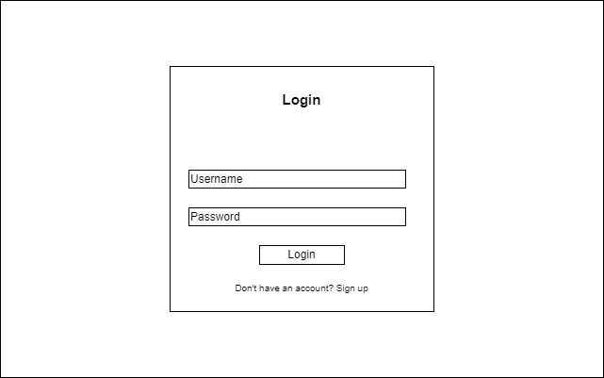

*"Log in" Page*

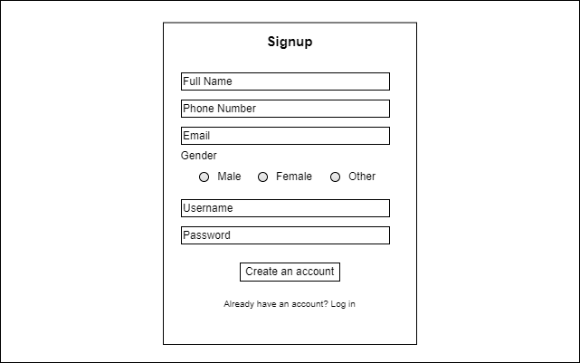

*"Sign up" Page*

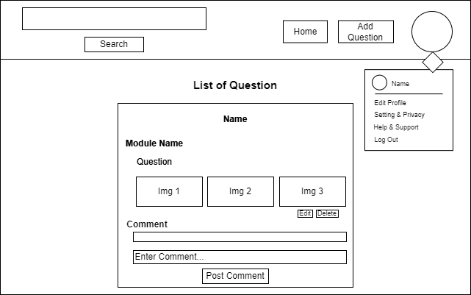

*"Home" Page*

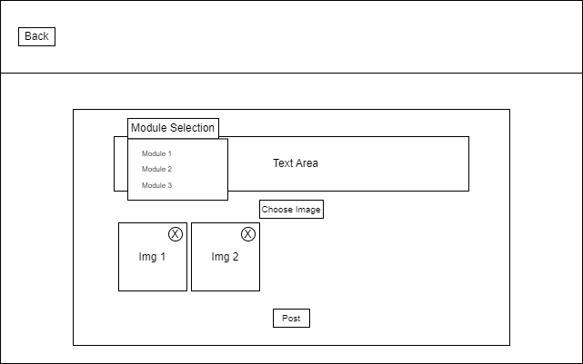

*"Add Question" Page*

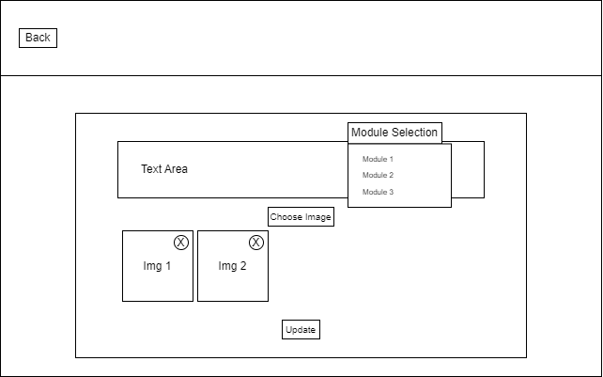

*"Edit Question" Page*

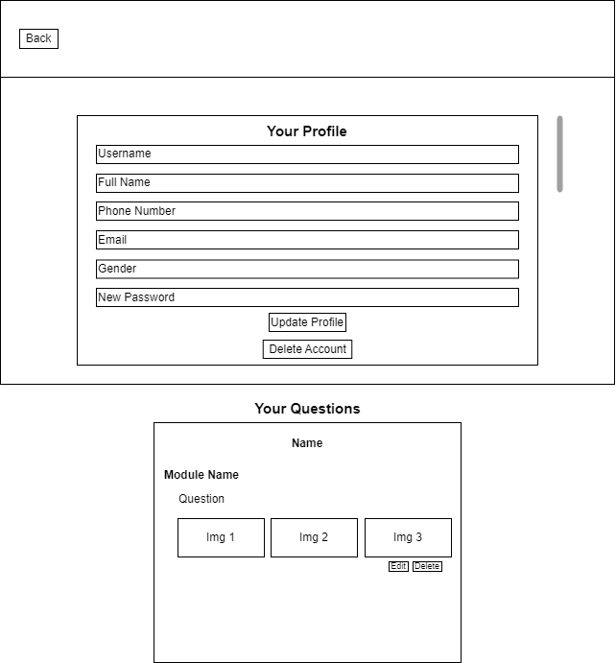

*"Profile" Page*

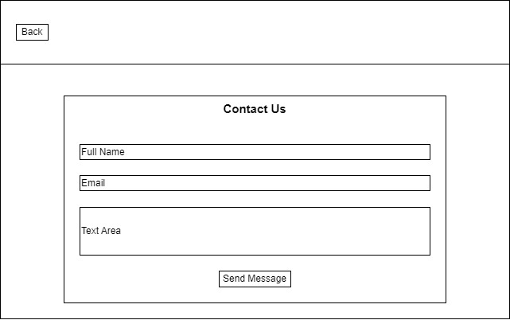

*"Contact Us" Page*

## 2. Database Design and Data Diagrams

The database for the student Question and Answer platform was designed with relational integrity in mind, ensuring that data is consistently linked and organized. The main tables include 'account', 'module', question', 'image', and 'comments'. The 'account' table stores details: 'id', 'fullname', 'phonenumber', 'email', 'gender', 'username', and 'password'. The 'module' table stores the information about different courses modules, such as 'id' and 'module_name'. The 'question' table captures the content of student questions, with fields like 'id', 'user_id', 'module_id', 'question_text', and 'time_post'. 'image' table stores the images that student post with questions, like 'id', 'question_id', and 'image_link'. The 'comments' table contains responses or answers to the posted questions, it includes 'id', 'question_id', 'username', 'comment_text', and 'time_post'. Relationships between these tables are established using foreign keys: for example, the 'user_id' in the 'question' table references the 'id' in the 'account' table, linking each post to its author. Similarly, the 'module_id' connects each post to a specific module. This design ensures that posts are properly attributed and organized, and the relational structure allows for efficient querying and data management across the system.

*Relationship between tables*

# **III. Discussion of Technology Used**

The development of the student Question and Answer platform involved the integration of multiple technologies to build a functional, secure, and interactive system. Each technology was chosen with specific purposes in mind, from database management to user interface enhancements.

HTML5 served as the backbone of the platform, providing a semantic structure for the content and layout of the website. It allowed the use of modern input types and built-in validation attributes to improve user experience and ensure that forms were both functional and accessible.

For database interactions, PHP was utilized as the server-side scripting language, responsible for processing user requests and dynamically generating content. PHP Data Objects (PDO) was chosen over other database interaction methods due to its support for prepared statements, which are essential for preventing SQL injection attacks. This ensured that all interactions between the web application and the database were secure and efficient. PDO’s flexibility also allowed for a smooth and scalable integration with the MySQL database.

MySQL was employed to store and manage the platform's data. The relational database structure allowed for the efficient organization of data across multiple tables (e.g., users, posts, modules), ensuring that relationships between data entities were properly maintained. Foreign keys were used to link posts with users and modules, ensuring data integrity and enabling complex queries to retrieve relevant information.

While Bootstrap was primarily used to include icons for the website, these icons were essential for enhancing the visual appeal and usability of the platform. Icons were used in various places such as navigation elements, contributing to a more intuitive user interface.

CSS3 was applied to style the platform, customizing the appearance beyond the default settings. CSS was used to control the layout, colors, fonts, and spacing, ensuring a consistent and visually appealing design across all pages. The combination of Bootstrap icons and custom CSS helped achieve a professional look and feel without relying heavily on a CSS framework for layout and grid systems.

JavaScript played a significant role in enhancing the interactivity and functionality of the website. It was used to implement client-side validation, providing immediate feedback to users when entering form data. This reduced the number of invalid submissions reaching the server, improving both the user experience and system performance. JavaScript was also employed for dynamic content updates and additional user interface enhancements, such as previewing images before uploading them as part of a post.

# **IV. Legal, Social, and Ethical Considerations**

When developing the student Question and Answer platform, several important legal, social, and ethical considerations were taken into account to ensure compliance with best practices in web development.

## 1. Legal Considerations

A significant legal aspect is the platform's alignment with data protection regulations, specifically the General Data Protection Regulation (GDPR) (European Commission, 2021). As personal data like usernames and email addresses are collected, it is critical to handle this data responsibly. Although passwords are not yet hashed in this version of the platform, future iterations will implement password hashing to comply with GDPR's data security requirements (Welling and Thomson, 2017). Additionally, personal data will be protected to prevent unauthorized access, and users will be given the option to request the deletion of their data, complying with the "right to be forgotten" (European Commission, 2021).

Furthermore, the platform ensures compliance with accessibility laws, making it usable for individuals with disabilities. This includes adherence to the Web Content Accessibility Guidelines (WCAG) by implementing accessible design features such as proper labeling of form inputs, alternative text for images, and a responsive design that can be navigated using assistive technologies (W3C, 2018).

## 2. Social Considerations

The platform is designed to foster a positive and supportive community for students to collaborate on academic tasks. A key social consideration is the prevention of harmful behaviors, such as cyberbullying. The platform allows users to report inappropriate content, and moderation features will be implemented in future updates to ensure a safe space for learning (O'Keeffe et al., 2011).

The platform also takes into account social inclusion by making the system accessible to users with varying levels of technology and internet access. This includes optimizing performance for low-bandwidth environments and ensuring that the platform works well on different devices, including mobile phones (Goggin and Newell, 2003).

## 3. Ethical Considerations

From an ethical standpoint, the platform prioritizes user privacy and security. Although password hashing has not yet been implemented, plans are in place to ensure that sensitive information like passwords will be properly encrypted in future versions to protect against potential data breaches (Clarke and Knake, 2010). Additionally, all data submissions are validated to prevent malicious input and to safeguard the integrity of the system.

Transparency is a fundamental ethical principle upheld by the platform. Users will be clearly informed about how their data is collected, stored, and used. The platform will also implement a privacy policy and terms of service to ensure users are fully aware of their rights and the platform's policies (Schaub et al., 2017).

The platform takes care to ensure ethical content sharing. Users are encouraged to share only their original work or properly credited sources, preventing plagiarism and unauthorized use of copyrighted materials. In future updates, content moderation will be improved to further support this ethical standard (Lessig, 2004).

# **V. Overview of the System**

The student Q&A platform is a web-based application that allows students to post, edit, and delete questions related to their coursework. It functions as a simple Create, Read, Update, and Delete (CRUD) system, enabling users to create new posts, read and browse through existing posts, update them as needed, and delete them when no longer relevant. The platform features an intuitive user interface and a secure backend, developed using PHP with PDO for database interaction, and MySQL for storing data. The platform also includes basic user authentication features, allowing students to register for an account and log in to access the system. These functions are essential to ensure that only registered users can post, edit, and delete questions.

## 1. "Sign up and Log in" Page

New users register by providing their full name, phone number, email address, gender, username, and password. Although password hashing is not yet implemented, it will be integrated in future iterations to ensure that user passwords are securely stored in the database. During registration, form validation is applied to check required fields and ensure that the email format is valid. After a user successfully registers, their information is stored in the 'account' table, where the final password is hashed to protect against data breaches.

A registered user logs into the system by providing their username and password. The system checks these credentials against the credentials stored in the database and if they match, the user is granted access to their account. Once logged in, the user can access the Question and Answer platform to view posted questions, comment on posts, post their own questions, and more.

## 2. "Home" Page

The "Home" page displays a list of all questions submitted by students. Each post includes a title, question body, related module, and an optional image or screenshot. Posts can be edited or deleted by the user who created them, providing full control over their content. Navigation across the site is simplified by a consistent layout, with a navigation bar linking to key areas, such as post management and a contact form for contacting the system administrator.

Below each article, users can view or post related comments about the posted question.

The "Edit" feature allows users to modify their existing questions.

The "Delete" feature allows users to remove their questions from the platform.

The platform features a search functionality that allows users to easily find posts by entering relevant keywords.

## 3. "Add Question" Page

The "Post a Question" feature allows students to contribute new questions to the platform, facilitating a collaborative environment where students can seek help and share information. The question submission form on this page includes the following detailed information fields:

* Module: Option to select a relevant module from the available list, which helps to categorize the question appropriately.
* Content: Detailed description of the question or issue, providing enough context for others to understand and answer.
* Image: Optional field to upload an image or screenshot related to the question, which can help illustrate the issue better.

## 4. "Profile" Page

Users manage and edit their personal information through the platform's system, with basic information like username, email, etc. Each user's post is linked to their profile through foreign key relationships, ensuring that all contributions are properly credited.

Besides, there is also an account deletion function. When the user confirms deletion, everything related to the user, such as posted questions and comments, is deleted along with the account.

## 5. "Contact Us" Page

The contact form allows users to send messages to the system administrator, facilitating communication with the administrator without revealing the administrator's email address. The form includes fields for the user's name, email, and message, with validation to ensure the information submitted is complete and properly formatted.

# **VI. Testing Schedule and Validation**

|  |  |  |  |  |  |  |
| --- | --- | --- | --- | --- | --- | --- |
| Test Number | Description | Expect Output | Input | Output | Evidence | Result |
| 1 | Log in with the wrong username or password | No log in | Enter the wrong username or password | Stay at "Log in" page | Evidence | PASS |
| 2 | Log in with correct username or password | Go to "Home" page | Enter the correct username or password | Go to "Home" page | Evidence | PASS |
| 3 | Sign up with an existing username | Show error message | Enter the existing username | Show error message | Evidence | PASS |
| 4 | Sign up with an existing email | Signed up successfully and went to "Log in" page | Enter the existing email | Signed up successfully and went to "Log in" page | Evidence | PASS |
| 5 | Hide and show the password | The password is showed when clicked and hidden when clicked again | Click on the eye icon | The password is showed and hidden | Evidence | PASS |
| 6 | Post question | Question posted | Go to "Add Question" section, select module, enter question, select image, and post | Question posted | Evidence | PASS |
| 7 | Edit question | Question edited | Click the "Edit" button on the post | Question edited | Evidence | PASS |
| 8 | Delete question | Question deleted | Click the "Delete" button on the post | Question deteled | Evidence | PASS |
| 9 | Comment below the question | The comment is displayed below the question | Enter comment and click the "Post Comment" button | The comment is displayed below the question | Evidence | PASS |
| 10 | Eidt profile | Profile updated | Click on the user imager, go to "Edit Profile", edit the information and click "Update Profile" button | A successful update message appears | Evidence | PASS |
| 11 | Delete account | Account did not delete | Click the "Delete Account" button and then select "Cancel" | A cancelation of account deletion message appears | Evidence | PASS |
| 12 | Delete account | Account deleted | Click the "Delete Account" button and then select "OK" | The account is deleted and returns to the "Log in" page | Evidence | PASS |
| 13 | Feedback to admin | The email is sent to the admin's email | Enter name, email, and content to respond to, click the "Send Message" button | Email is sent to the admin's email | Evidence | PASS |
| 14 | Log out of the website | Return to the "Log in" page | Click the "Log Out" in the user image | Return to the "Log in" page | Evidence | PASS |

# **VII. Conclusion**

# **VIII. Appendix**

# **IX. Reference**

1. Clarke, R. and Knake, R. K. (2010) *Cyber War: The Next Threat to National Security and What to Do About It*. New York: Ecco.
2. European Commission (2021) ‘General Data Protection Regulation (GDPR)’. Available at: <https://ec.europa.eu/info/law/law-topic/data-protection/eu-data-protection-rules_en> (Accessed: 10 August 2023).
3. Goggin, G. and Newell, C. (2003) *Digital Disability: The Social Construction of Disability in New Media*. Lanham: Rowman & Littlefield.
4. Lessig, L. (2004) *Free Culture: How Big Media Uses Technology and the Law to Lock Down Culture and Control Creativity*. New York: Penguin Press.
5. O'Keeffe, G. S., Clarke-Pearson, K. and Council on Communications and Media (2011) ‘The Impact of Social Media on Children, Adolescents, and Families’, *Pediatrics*, 127(4), pp. 800–804.
6. Schaub, F., Balebako, R., Durity, A. L., and Cranor, L. F. (2017) ‘A Design Space for Effective Privacy Notices’, *USENIX Symposium on Usable Privacy and Security*, pp. 1-17. Available at: <https://www.usenix.org/conference/soups2017/proceedings/presentation/schaub> (Accessed: 10 August 2023).
7. W3C (2018) ‘Web Content Accessibility Guidelines (WCAG) 2.1’. Available at: <https://www.w3.org/TR/WCAG21/> (Accessed: 10 August 2023).
8. Welling, L. and Thomson, L. (2017) *PHP and MySQL Web Development*. 5th edn. Boston: Addison-Wesley.