Name: Dương Thiện Nhân
Roll number: CE190741

Screenshot 1: Screenshot of project in VsCode with the terminal command `npm run dev`. (Result display: “Connection successful”)

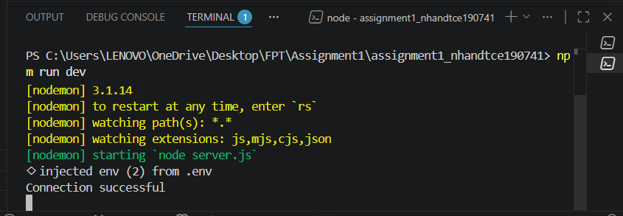

Screenshot 2: Screenshot of MongoDB Compass with database bug_reports

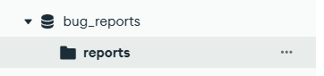

Screenshot 3: Test retrieving the full list of Reports (Result display emty: “[]”). Endpoint GET: http://localhost:8000/api/reports

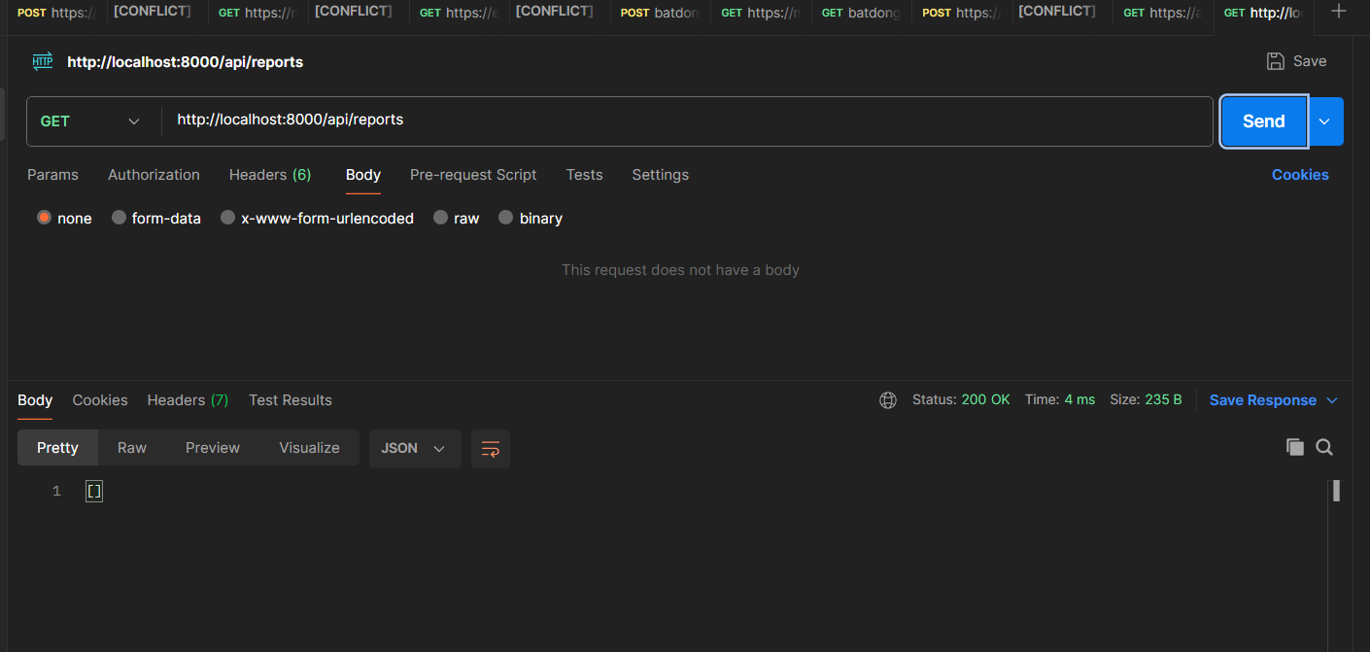
Screenshot 4: Test creating a new bug report.
Endpoint POST: http://localhost:8000/api/reports
With body:
{
"title": "Login bug",
"description": "User cannot login with correct password",
"severity": "high",
"status": "closed",
"project": "SDN302"
}

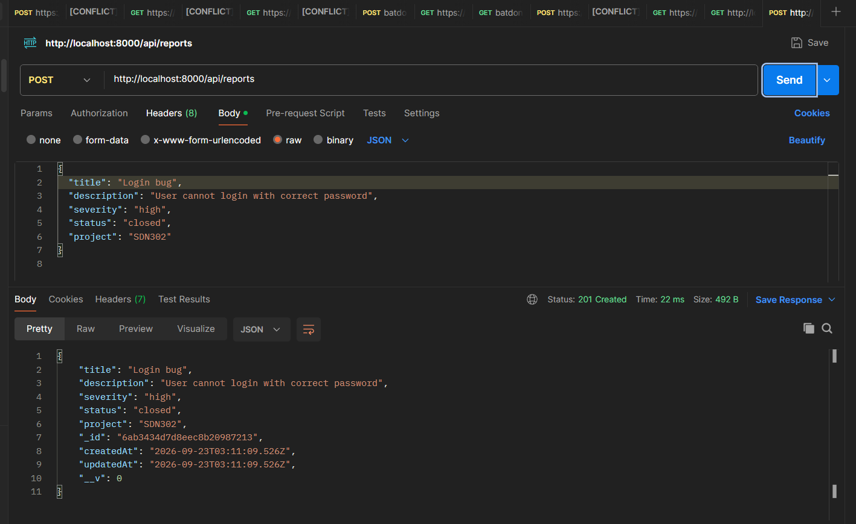
Screenshot 5: Test retrieving the list of Reports again (The results show the report that was just added). Endpoint GET: http://localhost:8000/api/reports

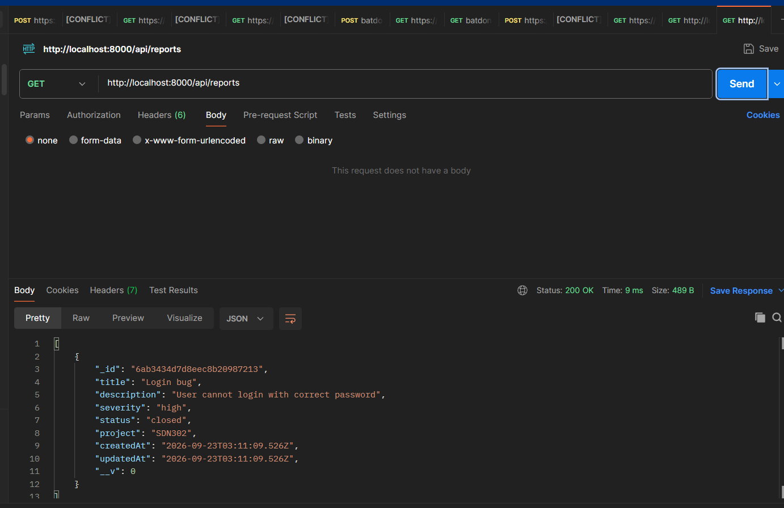

Screenshot 6: Test updating a report with status set to “open” using an ID that does not exist in the database. (Result display: “Report not found”)
Endpoint PUT: http://localhost:8000/api/reports/123
With body:
{
"status": "open",
}
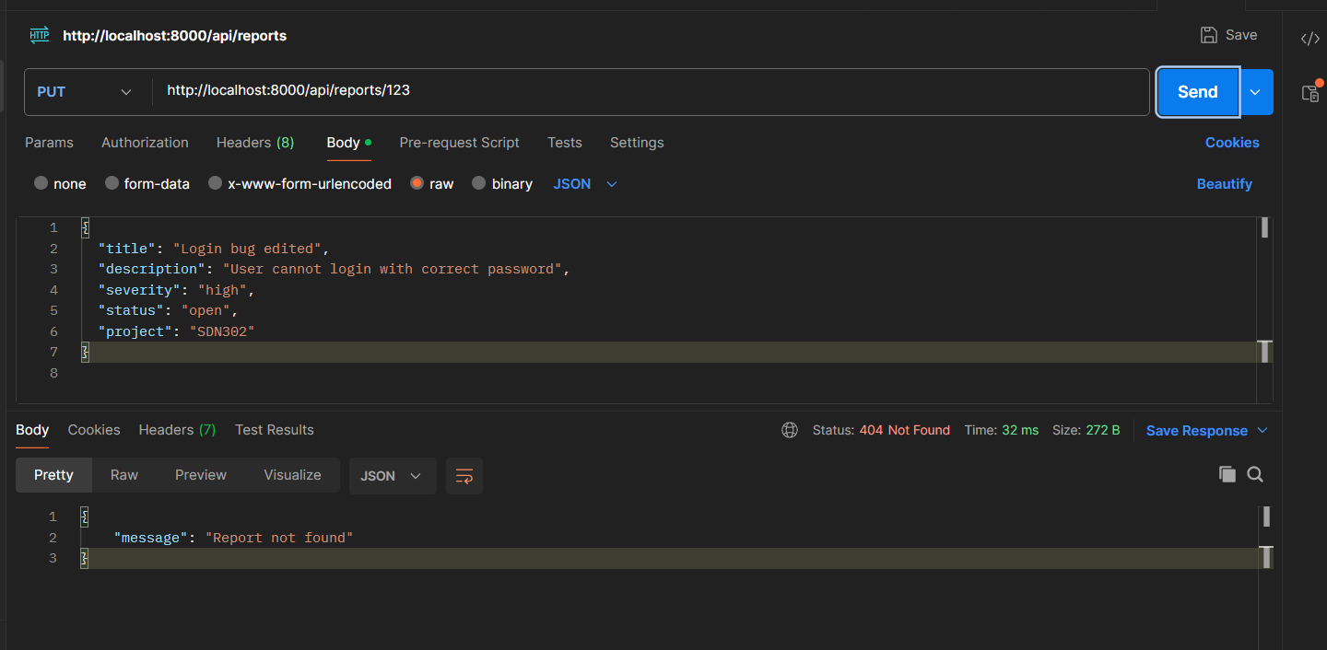

Screenshot 7: Test updating a report with status set to “open” using an ID that exists in the database.
With body:
{
"status": "open",
}

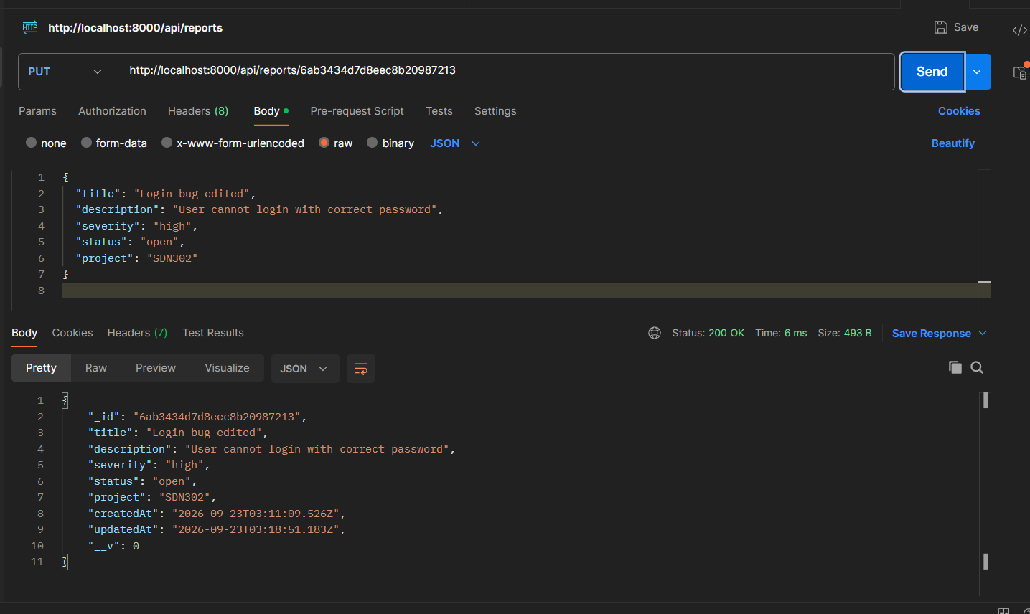
Screenshot 8: Test deleting a report using an ID that does not exist in the database. (Result display: “Report not found”). Endpoint DELETE: http://localhost:8000/api/reports/123

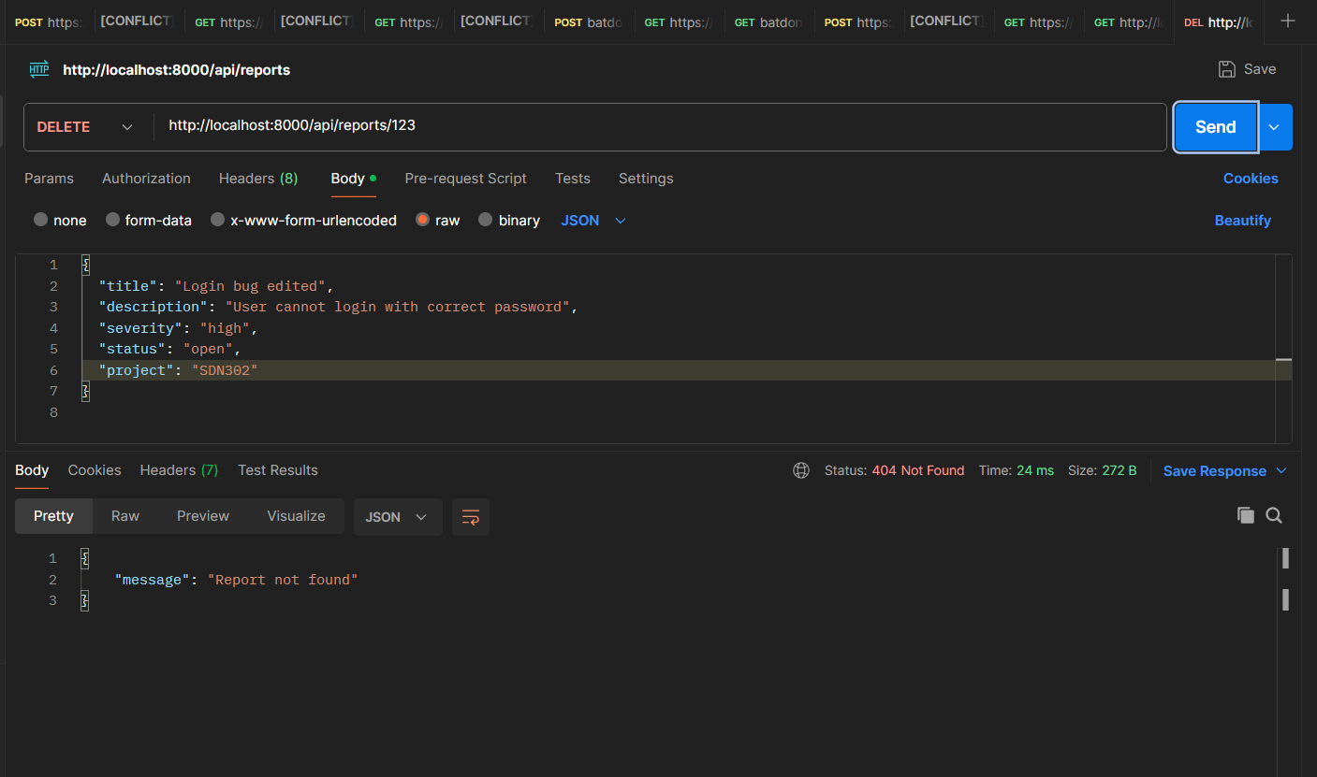

Screenshot 9: Test deleting a report using an ID that exists in the database. (Result display: “Report deleted successfully)

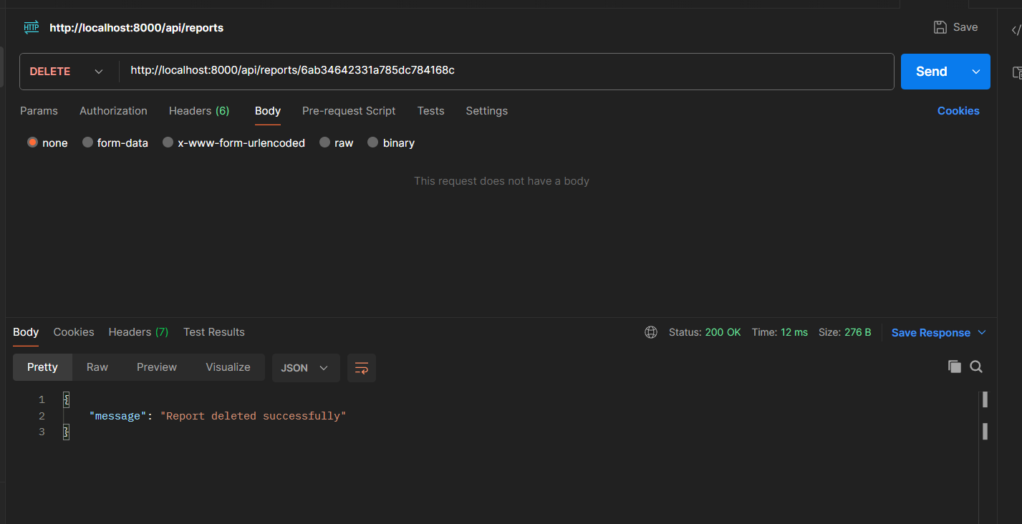

Screenshot 10: Test retrieving the list of Reports again (Result display emty: “[]”). Endpoint GET: http://localhost:8000/api/reports

