PRACTICAL EXAMINATION

Subject code: PRO192 – SPRING 2025 Duration: 85 minutes
Develop a Warehouse Product Management OOP applications with the following components and requirements:

Create an MVC console application in NetBeans:
  - Define the Product Class with the Following Attributes and Methods: (2 marks)
- Attributes:
  - productID (Unique identifier for the product)
  - name (Product name)
  - category (Product category)
  - quantity (Number of items available)
  - price (Unit price)
  - dateAdded (Date the product was added to the warehouse)
- Methods:
  - Constructors: Initialize product attributes.
  - Getter/Setter Methods: Provide access and modification of product details.
  - toString() Method: Return a string representation of product details.
  - Validation:
    - Ensure dateAdded follows the format "dd/MM/yyyy".
    - Ensure the dateAdded is not in the future.
  - Method getProductAge(): Return the age of the product in the warehouse based on dateAdded.
- Define the ProductList Class with the Following Attributes and Methods :(3 marks)
+ List of products
+ Read text file to load data for ProductList – ProductData.txt is provided. (If the data is incorrect the skip is not added to the list.).
+ Add new products to List
+ Sort products ascending by quantity
+ Search products by different criteria
    - Search by name.
    - Search by category.
+ Delete products that have been in storage over 2 years.
- Develop Products Management class for application. (4 marks)
+ The application menu for execution includes:
  - Display all products.
  - Sort products by quantity.
  - Search products (by name, category).
  - Add a new product.
  - Delete products that have been in storage for ≥ 2 years.
+ Products search includes :
  - Search by product name.
  - Search by product category.

2. Technical requirements(1 mark):
+ Create a model package contains Product and ProductList classes.
+ Create a view package contains Menu class.
+ Create a controller package contains ProductManagement class.
Note:

1. If the student wants to separate view and controller, the student can let the input and output-related methods into the ProductView class. In that case, the view package will contain both the Menu and ProductView classes.
- Students must strictly follow all requirements as described above for marking. Any modification of the requirement details is not allowed and will receive no marks!
- Students must submit the project folder (that created in Netbean), submitting any other file formats (such as .doc, .txt…) will receive 0 points.
User interface of application as sample images below:
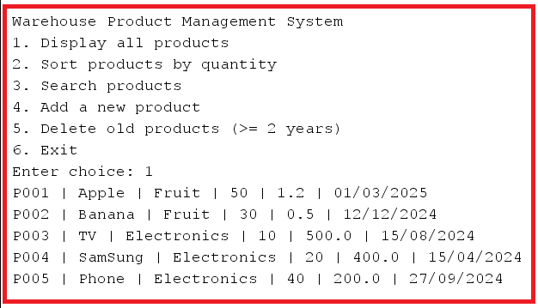  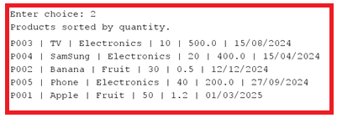 | 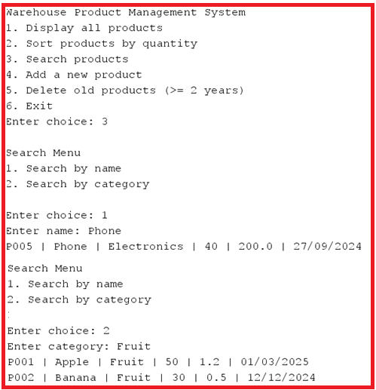

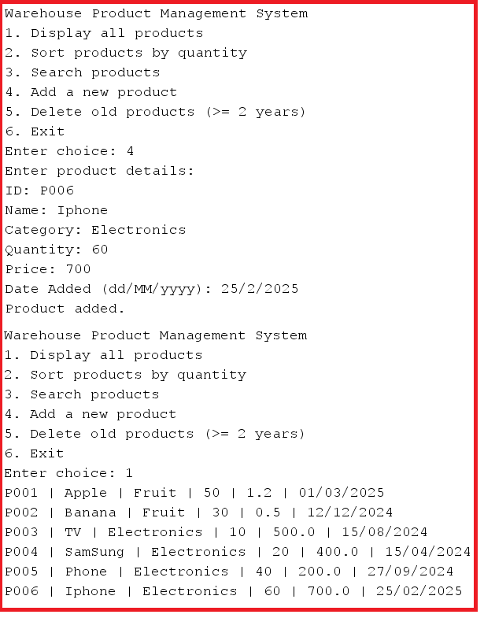 | 