PRACTICAL EXAMINATION | Code: | PRO192 – Su 2024
 | Duration: | 85 minutes

Title
Develop Candidate Management OOP application with the following components and requirements.
Requirements
Guidelines for program design: following the MVC pattern is required.
- The Candidate and CandidateList classes act as models, the CandidateManager class contains the main method which acts as the controller, and the Menu and CandidateListView act as the view.
- Other classes can be added optionally.
1. (2 marks) Define a class Candidate with the following attributes and methods
Attributes:
- id: Stores a unique ID to identify the candidate.
- name: Stores the name of the candidate.
- dateOfBirthday: Stores the age of the candidate.
- grades: Stores the grade of the candidate.
- email: Stores the email of the candidate.
Methods:
• Constructors, getters, and setters.
• override toString.
2. Define the CandidateList class manages the list of candidates and CandidateListView manages inputting and outputting information in the candidate list.
The CandidateList class needs to contain the following methods:
a. (2 mark) Loads the list of candidates from a file "candidates_input.txt" and stores in List <Candidate>.
The format of the file "candidates_input.txt" is as follows:
C1, John Doe, 01-01-2024, 7.5, johndoe@gmail.com
C2, Jane Smith, 05-01-2024, 9.0, janesmith@gmail.com
C3, Robert Johnson, 10-01-2024, 5.0, robertjohnson@gmail.com
C4, Emily Brown, 15-01-2024, 7.15, emilybrown@gmail.com
C5, Michael Wilson, 20-01-2024, 9.1, michaelwilson@gmail.com

b. (2 mark)
- (1 marks) Adds a new candidate to the list, check unique id before adding to list is required.
- (1 marks) Prompt the user to re-enter data if there are input errors,
- incorrect real numbers for the grades attribute.
- incorrect date format for dateOfBirthday attributes. The correct date format is: "dd-mm-yyyy".
c. (1 mark) Search candidates based on candidate name.
d. (1 mark) Delete a candidate based on candidate id.
e. (1 mark) Display all candidates sorted descending by grades.

3. (1 mark) Displays the menu of available functionalities for the user in question 2a, 2b, 2c, 2d, 2e.
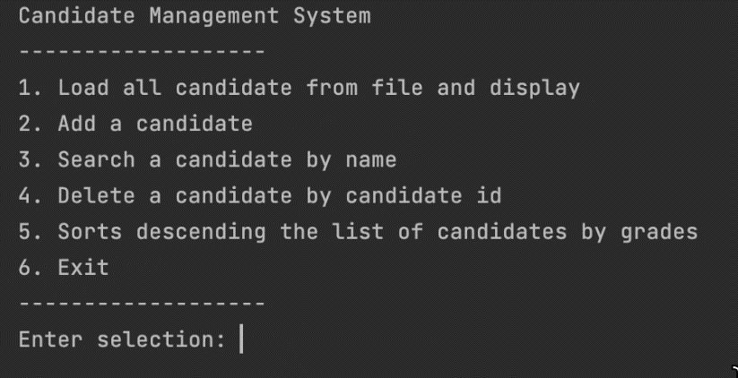
Hint: An abstract Menu class is provided for use in the development this application.
Notice: Students must strictly follow all requirements as described above for marking. Any modification of the requirement details is not allowed and will receive no marks!

