PRO192- Practice Exam – SU24 13/07/2024
Duration: 85 minutes
Develop an Electricity Bill Management OOP application with the following components and requirements
- Create MVC console application in NetBean:
  - Define class Bill with the following attributes and methods: (1.5 marks)
+ Id (int), customerName (string), amount (double), dueDate (Date).
+ Constructors, get/set(), toString() (in where display the Date attribute in the format “dd/MM/yyyy”).
Note: No IO console is used in this model class
  - Define class ListBill to manage the list of electricity bills has the following methods: (3.0 marks)
+ Read text file to load data for ListBill –Electricitybill.txt is provided (1.0 mark)
+ Method that can add a new bill (check this bill id does not exist in the list is required) (0.5 mark)
+ Method that can delete a Bill by any criteria (0.5 mark)
+ Method that can get a list of unpaid bills (0.5 mark)
+ Method that can get the largest amount of bill (0.5 mark)
Note: No IO console is used in this model class
  - Develop BillManagement class to run the application (4.0 marks)
+ Main menu for application includes: Display all bills, Add a new bill, Delete a bill, Find largest amount bill, List of unpaid bills, Quit (0.5 mark)
Hint: An abstract Menu class is provided for use in the application.
+ Display all electricity bills (0.5 mark)
+ Method for adding new bill from console (0.5 mark)
+ Method for deleting an existing bill by ID, Customer name, or Due date(1.5 mark)
+ Method for finding the largest amount bill in the list (0.5 marks)
+ Method for listing all unpaid bills (0.5 marks)
+ main() method to run the program
Note: This class allows interaction with user IO from the console.
- Technical requirements (1.5 marks):
+ Create a package model for Bill and ListBill class. (0.5 mark)
+ Create package view_controller for Menu and BillManagement class. (0.5 mark)
+ Please handle every exception for adding a new bill function, asking the user to re-enter for incorrect input data. (0.5 mark)
+ User view should be as follows:
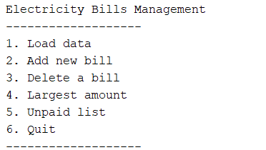
+ The list of bills may look like this:
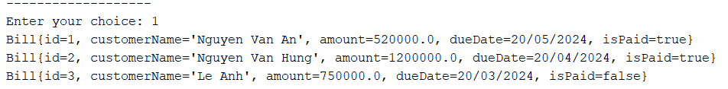
+ Delete menu should be as follows:
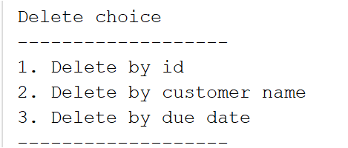
Notice: Student must strictly follow all requirements as described above for marking,
Any modification of the requirement detail is not allowed and will get no mark!
Students can use offline material on individual computers and define additional classes/methods for code optimization.

