PRO192- Practice Exam – FALL 23 05/11/2023
Duration : 85 minutes
Develop Patient management OOP application with following components and requirements
- Create MVC console application in NetBean:
  - Define class Patient with following attributes and methods: (2 marks)
+ PatientID, Full name, Date of birth, Phone.
+ Constructors, get/set(), toString()
+ Method for update phone number that require old and new number. Patients are allowed to update phone number if old number is correct
+ method implements Comparable interface that compare on date of birth
Note: No IO console used in this model class
  - Define class PatientList to manage list of patients has following methods: (4 marks)
+ Read text file to load data for PatientList – patient.csv is provided (1 mark)
+ Method that can search patient by any criteria (1 mark)
+ Method that can add new patient to the system with no duplicate phone number! (1 mark)
Note: No IO console used in this model class
  - Develop PatientManagement class to run the application (4 marks)
+ Main menu for application include: Display all patient, Search patient, Add patient, Update phone number, Quit (0.5 mark)
Hint: An abstract Menu class is provided for use in the application.
+ Display all patient sorted by date of birth (0.5 mark)
+ Method for adding new patient from console (1 mark)
+ Method for a staff to change phone number from console (1 mark)
+ Method for seaching patient with searching menu , [print out list of patient meet searching criteria] (1 marks)
+ main() method to run the program
Note: This class allows interaction with user IO from console.
- Technical requirements:
+ Create package model for Patient and PatientList class.
+ Create package view_controller for Menu and PatientManagement class.
+ Checking error for input data.
+ User view should be as follow:
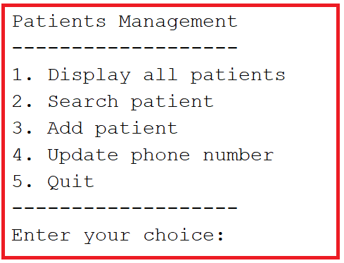
Seaching menu:
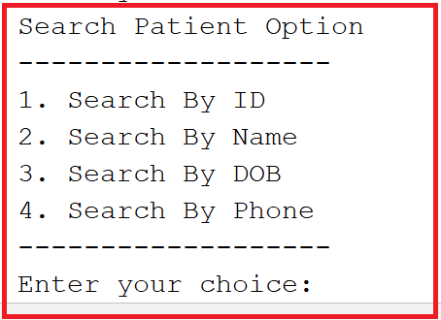
Notice: Student must strictly follow all requirements as describe above for marking,
Any modification the requirement detail is not allowed and will get no mark!
Student can use any offline material on individual computer and define additional class/method for code optimization.

