PRO192- Practice Exam – FALL 22 08/11/2022
Duration : 85 minutes
Develop Staff management OOP application with following components and requirements
- Create MVC console application in NetBean:
  - Define class Staff with following attributes and methods: (2 marks)
+ StaffID, Full name, Department, Password.
+ Constructors, get/set(), toString()
+ Method for change password that require old and new password. Staff are allowed to change new password if old password is correct
Note: No IO console used in this model class
  - Define class StaffList with following attributes and methods: (4 marks)
+ List of Staff
+ Read text file to load data for StaffList – staff.txt is provided (1 mark)
+ Method that can search staff by any criteria (1 mark)
+ Method that can remove a staff from the list(1 mark)
Note: No IO console used in this model class
  - Develop StaffManagement class for application (4 marks)
+ Main menu for application include: Display all staff, Search staff, Login, Change password (1 mark)
Hint: An abstract Menu class is provided for use in the application. Override method excecute()
+ Method for remove a staff (1 mark)
+ Method for a staff want to change password (1 mark)
+ Method for seaching staff with searching menu , [print out list of staff sorted by searching criteria] (1 marks)
+ main() method to run the program
Note: This class allows interaction with user IO from console.
- Technical requirements:
+ Create package model for Staff and StaffList class.
+ Create package view_controller for Menu and StaffManagement class.
+ Checking error for input data.
+ User interface as sample images below
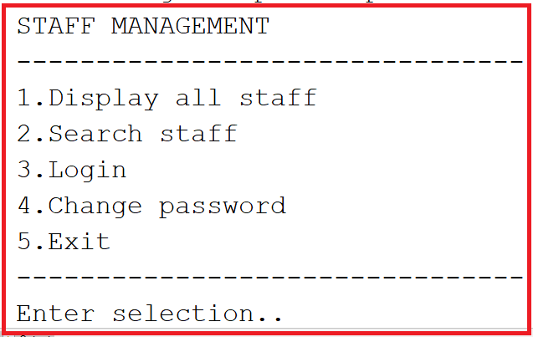
When choose search staff:
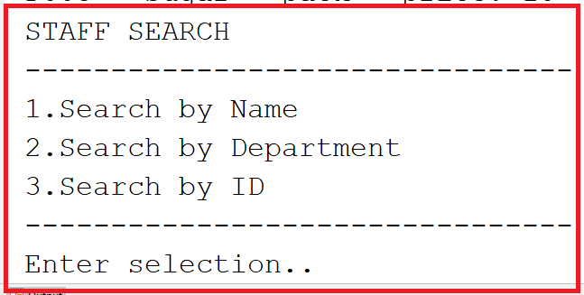
Notice: Student must strictly follow all requirements as describe above for marking,
Any modification the requirement detail is not allowed and will get no mark!

