PRO192- Practice Exam – SU24
Duration: 85 minutes
Develop Product management OOP application with the following components and requirements 1. Create an MVC console application in NetBeans:
- Define class Product with the following attributes and methods: (2 marks) + ProductID, ProductName, Category, Price, ProductDate. + Constructors, get/set(), toString() + Method for getdiscount(1 mark):
  - If the age of ProductDate is less than 1: no discount
  - If the age of ProductDate is less than 2: discount 20% price
  - If the age of ProductDate is bigger 2: discount 50% price
Note: No IO console is used in this model class
- Define class ProductList with the following attributes and methods: (3.5 marks) + List of Product
+ Read text file to load data for ProductList– product.txt is provided
+ Method that can search product by any criteria
+ Method sort products in descending order by price
+ Method Statistics on products of the same Category
Note: No IO console is used in this model class
- Develop ProductManagement class for application(3.5 marks)
❖ The main menu for the application includes: Displaying all products, display all promoted products, Searching products, Sorting lists of products, Statistic products of the same category.
Hint: An abstract Menu class is provided for use in the application. Override method execute() call the methods below:
+ Methods display all products can apply any product list
+ Methods display all promoted products
+ Method for searching product with searching menu allow user select search criteria
+ Call sort products in descending order by price + Call statistic products of the same category method  main() method to run the program.
Note: This class allows interaction with user IO from the console.
2. Technical requirements( 1 mark):
+ Create package model for Product and ProductList class, create package view for Menu, create package controller for ProductManagement class
+ Checking for ProductID has 4 characters and starts with "P" (Example: P001). Error message: "The ProductID is in wrong format (start P and has 4 chars)”. + User interface as sample images below:
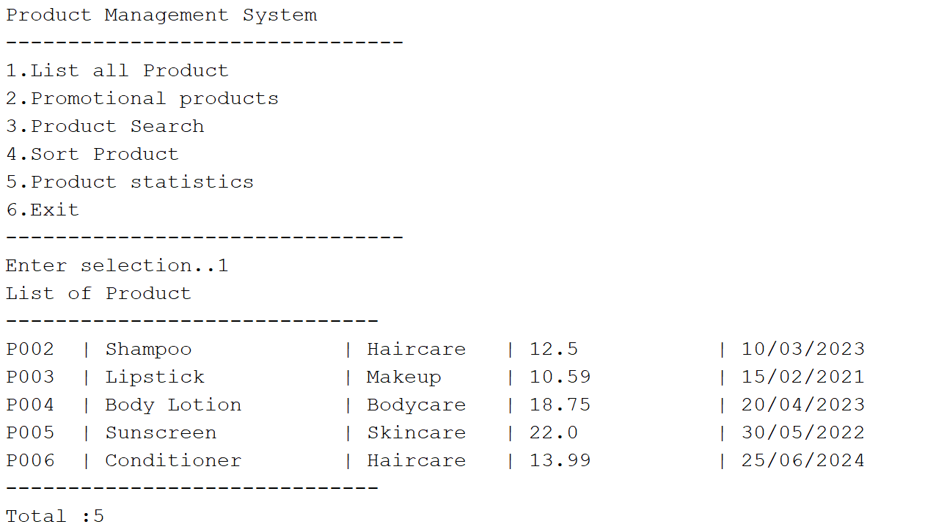

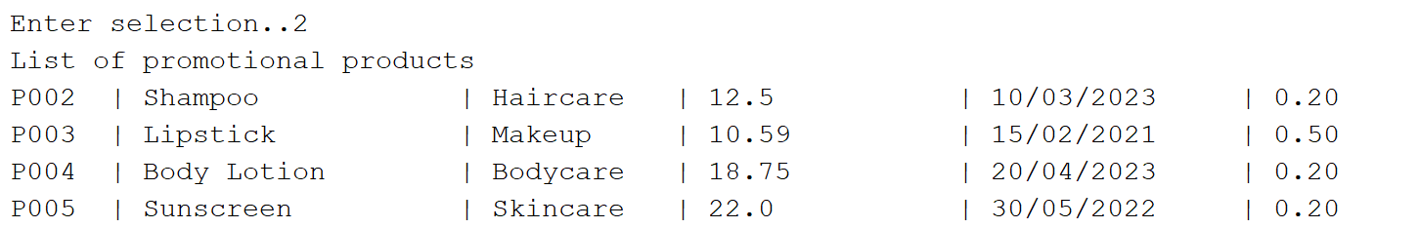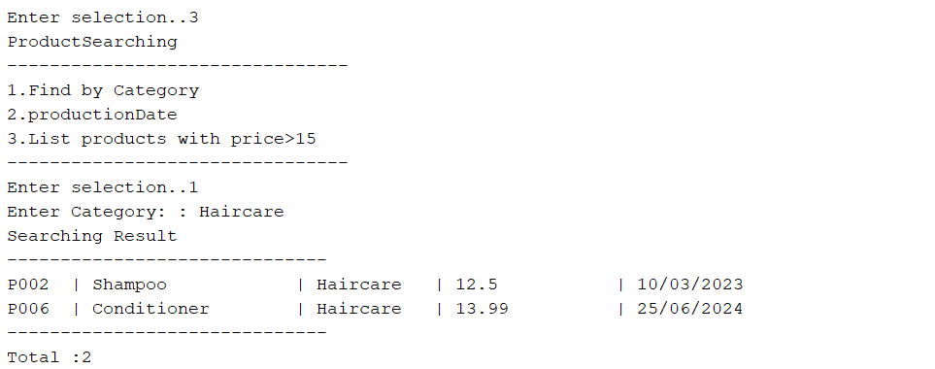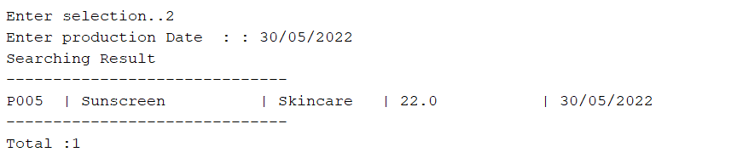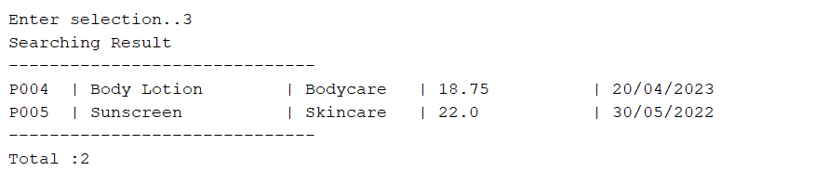

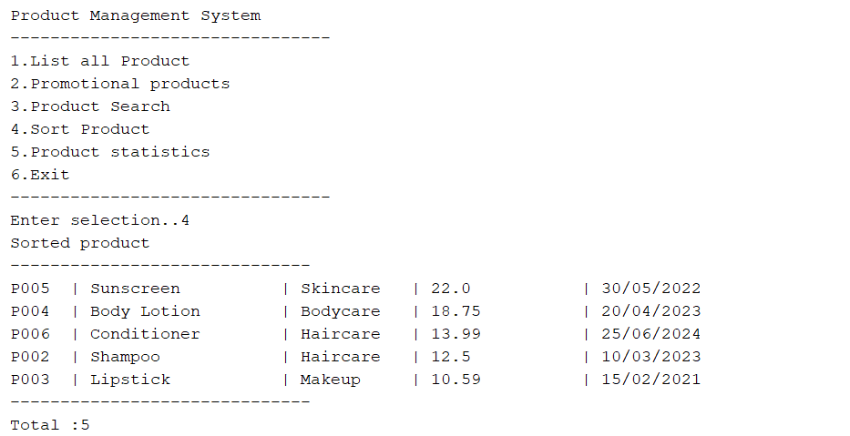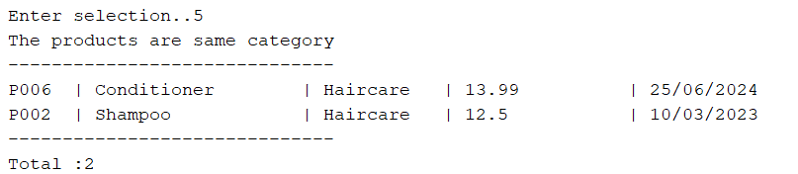

Notice:
- If the student wants to separate view and controller, the student can let the input and output-related methods into the ProductView class. In that case, the view package will contain both the Menu and ProductView classes.
- Student must strictly follow all requirements as described above for marking, Any modification of the requirement detail is not allowed and will get no mark!

