**PRO192- Practice Exam – FALL 23 05/11/2023**

Duration : 85 minutes

Develop Patient management OOP application with following components and requirements

1. **Create MVC console application in NetBean:**
   1. Define class Patient with following attributes and methods: **(2 marks)**  
      + PatientID, Full name, Date of birth, Phone.   
      + Constructors, get/set(), toString()   
      + Method for update phone number that require old and new number. Patients are allowed to update phone number if old number is correct  
      + method implements Comparable interface that compare on date of birth   
      ***Note****: No IO console used in this model class*
   2. Define class PatientList to manage list of patients has following methods: **(4 marks)**  
      + Read text file to load data for PatientList – patient.csv is provided (1 mark)   
      + Method that can search patient by any criteria (1 mark)  
      + Method that can add new patient to the system with no duplicate phone number! (1 mark)  
      ***Note****: No IO console used in this model class*
   3. Develop PatientManagement class to run the application **(4 marks)**  
      + Main menu for application include: Display all patient, Search patient, Add patient, Update phone number, Quit (0.5 mark)   
      Hint: An abstract Menu class is provided for use in the application.   
      + Display all patient sorted by date of birth (0.5 mark)  
      + Method for adding new patient from console (1 mark)  
      + Method for a staff to change phone number from console (1 mark)   
      + Method for seaching patient with searching menu , [print out list of patient meet searching criteria] (1 marks)  
      + main() method to run the program   
      **Note**: This class allows interaction with user IO from console.
2. **Technical requirements**:  
   + Create package **model** for Patient and PatientList class.  
   + Create package **view_controller** for Menu and PatientManagement class.  
   + Checking error for input data.  
   + User view should be as follow:  
   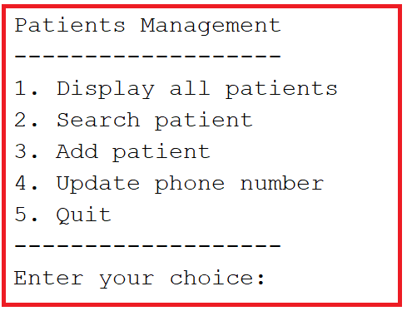  
   Seaching menu:  
   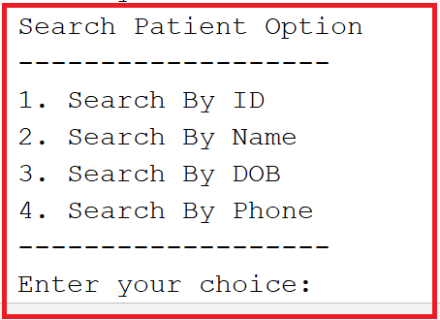  
   **Notice: Student must strictly follow all requirements as describe above for marking,   
   Any modification the requirement detail is not allowed and will get no mark!**

**Student can use any offline material on individual computer and define additional class/method for code optimization.**