AE065 SPRING 2026
Instructor: Domenic Gulla
Informational Interview Project
Due Tuesday, April 21, 2026

Do not delete any information on this page.
Name: Nhan Ngoc Thach Date: April 21, 2026

Part 1 – Position:
1) Look up a job title you are interested in on the Occupational Information Network (O*Net):
https://www.onetonline.org/ or the Bureau of Labor Statistics: http://www.bls.gov/. Salary.com is also a good resource.
These resources allow you to pull up national statistics/information about almost any
job, so search for information to answer these questions:
a. What is the salary range for this job?
$112,590 per year
$54.13 per hour
b. What skills are necessary?
- Data analysis skills
- Programming skills (such as Python and SQL)
- Statistical and mathematical knowledge
- Problem-solving skills
- Data visualization skills
- Communication skills
c. What is the national job outlook for this kind of position? (are employees in high or
low demand based on the outlook?)
*(If you can’t find a specific title or the job is in another country, see if you can reword it or generalize it OR explain why you think you can’t find it and how you might investigate this in other places)
- The job outlook for data scientists is 34% growth from 2024 to 2034, which is much faster than average.
- This means there is high demand for this position in the future.
2) Now find this position in a city of your choice. Write down the names of 2 companies that employ this type of position. If you do not find any, try a different position.
a. Mass General Brigham

b. Boston Children’s Hospital
c. Org/Job 1:
Qualifications:
- Bachelor’s degree in data science, computer science, or a related field
- Experience with SQL and Excel
- Knowledge of healthcare data
- Strong analytical and problem-solving skills

d. Org/Job 2:
Qualifications:
- Degree in data analytics or a related field
- Experience with Python or data visualization tools
- Attention to detail
- Good communication skills

Part 2 - Employer:
- Choose an employer from Part 1 you are interested in and go to their website.
Mass General Brigham

- List 3 facts you could discuss with the employer in a telephone conversation or an interview.
This might include their mission, a new program, or how many people they serve a year.
Their annual report, a ‘press room’ or publications page, and even the bios of senior staff and
the external links page are all good places to get an overview and a sense of any organization.
- Fact 1: Mass General Brigham is one of the largest healthcare systems in Massachusetts.
- Fact 2: The organization provides healthcare services to millions of patients each year.
- Fact 3: It focuses on research, education, and patient care.
- Turn one of these facts into a ‘strong’ question for the interview
How does Mass General Brigham use data analytics to improve patient outcomes and support decision-making in healthcare services?

Part 3 – Research:
- Find an alternate source of information on the web for one of the employers or jobs included in your report (Part 1 or 2): Get one piece of info from any of the options below and write it below the research option you chose (a, b, or c).
Write down some of the info you find:
a) LinkedIn – If you have a LinkedIn account, look for connections or groups on LinkedIn with that company (if you don’t have one, make it a goal to attend one of the workshops this semester or peruse the site to make one. They have tutorials.)
b) Look in LOCAL papers online for a news /business article about or involving the company and summarize what you find:
c) Google the company for forums linked to it: shareholder sites, investor boards, articles,

https://www.linkedin.com/company/mass-general-brigham/
- The LinkedIn page shows that Mass General Brigham has over 10,000 employees and more than 166,000 followers. It also shows that 146 school alumni work at this organization.

Part 4 – Information interview request & result:

- Choose one of the jobs you found and get the basic information you need for your contact/follow up file:
email, phone number, website url, and a potential name of a person to contact (including title)
Please pass in with informational interview request and summary of the results of your interview. If you do not get a response, you can request an interview with another person/company that you feel can provide an informational interview useful to your career/study goals.
- Name: Kaushik Ghosh
- Title: Professor
- Organization: Suffolk University
- LinkedIn: https://www.linkedin.com/in/kg7719/
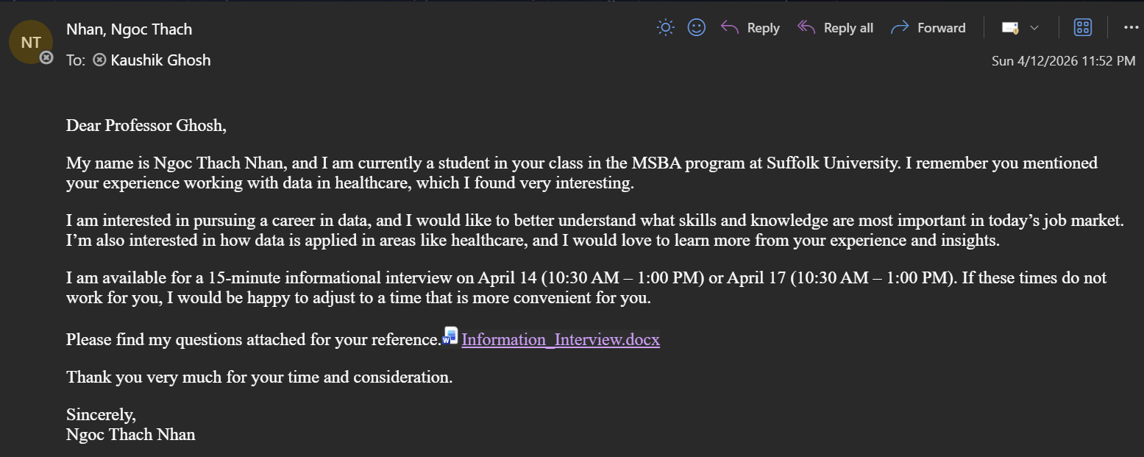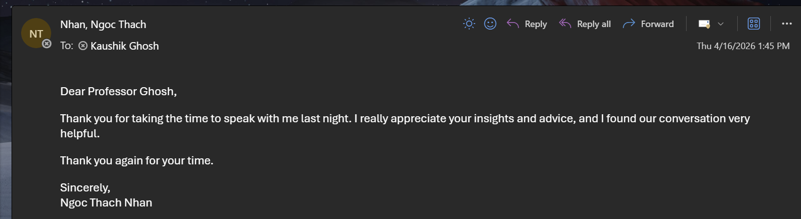
- An informational interview was conducted with Professor Ghosh, who has experience in data-related research and analytics.
- During the interview, he explained that his work with data began during his early research, when he needed to use statistical software to analyze data for academic studies.
- He noted that one surprising aspect of working with data is that the same dataset can be interpreted in multiple ways, depending on the analytical approach used.
- Regarding entry-level skills, he emphasized the importance of understanding the problem, having business knowledge, and developing strong problem-solving abilities, especially in the context of increasing use of AI.
- For those interested in healthcare data without a healthcare background, he indicated that it is acceptable to start without prior domain knowledge. He suggested beginning with public datasets, such as CMS datasets, and exploring available healthcare data resources online to build experience.

