Figures

Nhan Nguyen

2020 M09 9

## Figures

## Loading required package: here

## here() starts at D:/TGX/GitHub/lncRNA-EPI

## DOX_Tox_240_2 IDA_The_240_3   
## 1312.99 4522.99

## Loading required package: S4Vectors

## Loading required package: stats4

## Loading required package: BiocGenerics

## Loading required package: parallel

##   
## Attaching package: 'BiocGenerics'

## The following objects are masked from 'package:parallel':  
##   
## clusterApply, clusterApplyLB, clusterCall, clusterEvalQ,  
## clusterExport, clusterMap, parApply, parCapply, parLapply,  
## parLapplyLB, parRapply, parSapply, parSapplyLB

## The following objects are masked from 'package:stats':  
##   
## IQR, mad, sd, var, xtabs

## The following objects are masked from 'package:base':  
##   
## anyDuplicated, append, as.data.frame, basename, cbind, colnames,  
## dirname, do.call, duplicated, eval, evalq, Filter, Find, get, grep,  
## grepl, intersect, is.unsorted, lapply, Map, mapply, match, mget,  
## order, paste, pmax, pmax.int, pmin, pmin.int, Position, rank,  
## rbind, Reduce, rownames, sapply, setdiff, sort, table, tapply,  
## union, unique, unsplit, which, which.max, which.min

##   
## Attaching package: 'S4Vectors'

## The following object is masked from 'package:base':  
##   
## expand.grid

## Loading required package: IRanges

##   
## Attaching package: 'IRanges'

## The following object is masked from 'package:grDevices':  
##   
## windows

## Loading required package: GenomicRanges

## Loading required package: GenomeInfoDb

## Loading required package: SummarizedExperiment

## Loading required package: Biobase

## Welcome to Bioconductor  
##   
## Vignettes contain introductory material; view with  
## 'browseVignettes()'. To cite Bioconductor, see  
## 'citation("Biobase")', and for packages 'citation("pkgname")'.

## Loading required package: DelayedArray

## Loading required package: matrixStats

##   
## Attaching package: 'matrixStats'

## The following objects are masked from 'package:Biobase':  
##   
## anyMissing, rowMedians

##   
## Attaching package: 'DelayedArray'

## The following objects are masked from 'package:matrixStats':  
##   
## colMaxs, colMins, colRanges, rowMaxs, rowMins, rowRanges

## The following objects are masked from 'package:base':  
##   
## aperm, apply, rowsum

## converting counts to integer mode

## Warning in DESeqDataSet(se, design = design, ignoreRank): some variables in  
## design formula are characters, converting to factors

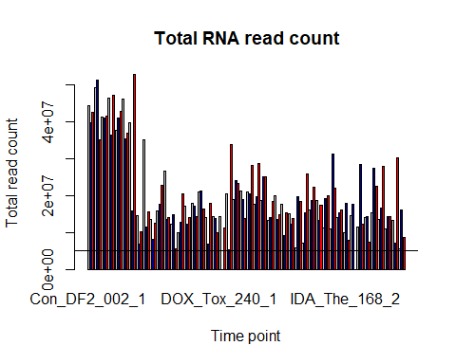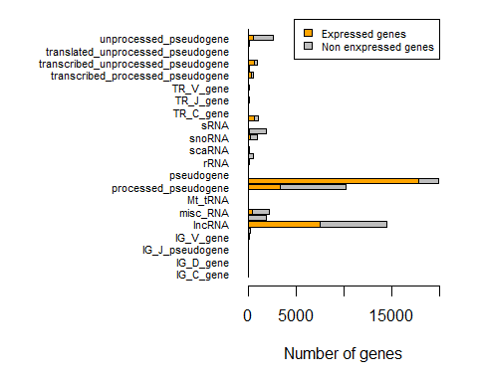 Figure 1: The proportion of gene expressed in each gene type in the RNA-seq data.

## PCA samples:

## Loading required package: ggplot2

## Welcome! Want to learn more? See two factoextra-related books at https://goo.gl/ve3WBa

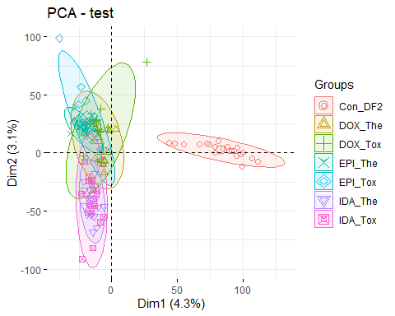 Figure 2: PCA of the samples

### expression:

##   
## Attaching package: 'plyr'

## The following object is masked from 'package:matrixStats':  
##   
## count

## The following object is masked from 'package:IRanges':  
##   
## desc

## The following object is masked from 'package:S4Vectors':  
##   
## rename

## The following object is masked from 'package:here':  
##   
## here

##   
## Attaching package: 'gridExtra'

## The following object is masked from 'package:Biobase':  
##   
## combine

## The following object is masked from 'package:BiocGenerics':  
##   
## combine

##   
## Attaching package: 'dplyr'

## The following object is masked from 'package:gridExtra':  
##   
## combine

## The following objects are masked from 'package:plyr':  
##   
## arrange, count, desc, failwith, id, mutate, rename, summarise,  
## summarize

## The following object is masked from 'package:matrixStats':  
##   
## count

## The following object is masked from 'package:Biobase':  
##   
## combine

## The following objects are masked from 'package:GenomicRanges':  
##   
## intersect, setdiff, union

## The following object is masked from 'package:GenomeInfoDb':  
##   
## intersect

## The following objects are masked from 'package:IRanges':  
##   
## collapse, desc, intersect, setdiff, slice, union

## The following objects are masked from 'package:S4Vectors':  
##   
## first, intersect, rename, setdiff, setequal, union

## The following objects are masked from 'package:BiocGenerics':  
##   
## combine, intersect, setdiff, union

## The following objects are masked from 'package:stats':  
##   
## filter, lag

## The following objects are masked from 'package:base':  
##   
## intersect, setdiff, setequal, union

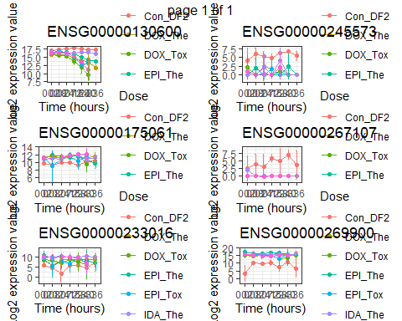

## [[1]]  
## NULL

Figure 3.A: Ovelaping DE lncRNAs in all ANT-treated samples

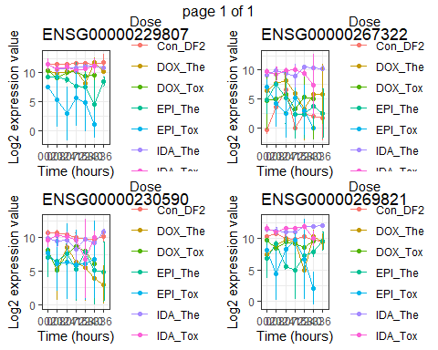

## [[1]]  
## NULL

Figure 3.B: DE lncRNAs in DOX, EPI, iDA

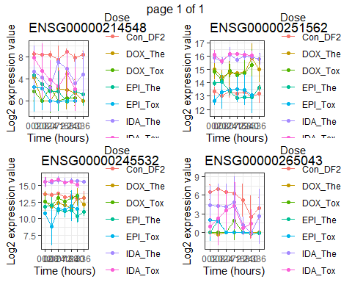

## [[1]]  
## NULL

Figure 3.C: DE lncRNAs in 2 of 3 ANT drugs