1. A programming praradigm centered around objects rather than functions
2. Object-oriented Programming: we combine a group of related variables and function into a unit => we call that unit an object

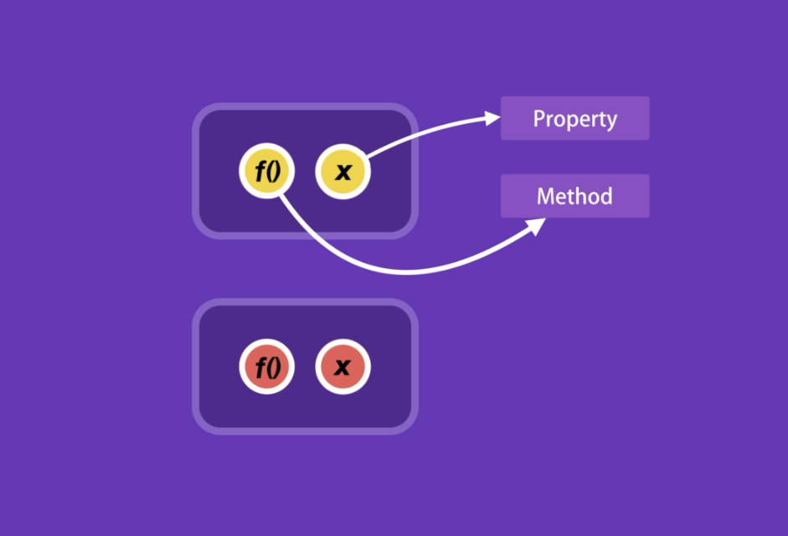

1. Every object in Javascript has a constructor property that returns the function that was used to construct or create that object
2. If you have a function, where you get constructor dynamically and you want to create an instance of an object based on that constructor then you have to reset the constructor property
3. Encapsulation:
   * We group related variables and functions that operate on them into objects
   * We encapsulate our variables and functions into objects

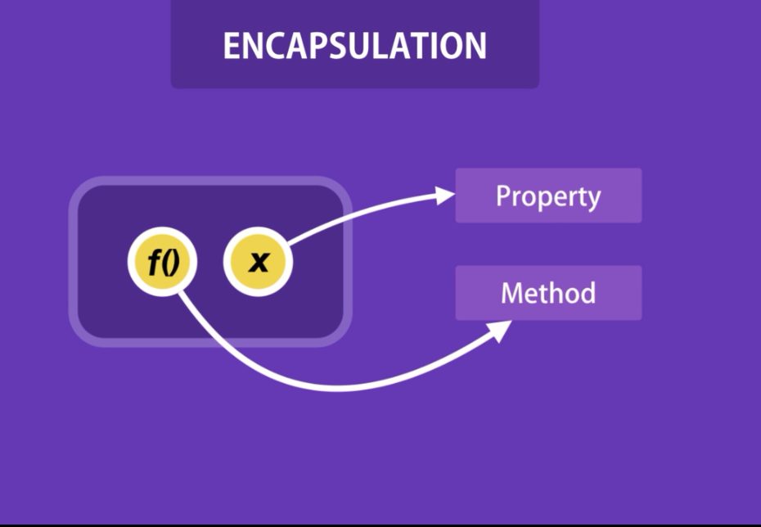

1. Abstracion:
   * Hiding the details and complexity, and showing only the essential parts
   * Hiding some of these properties and methods from the outside
   * Hiding the details and comlexity inside of the module

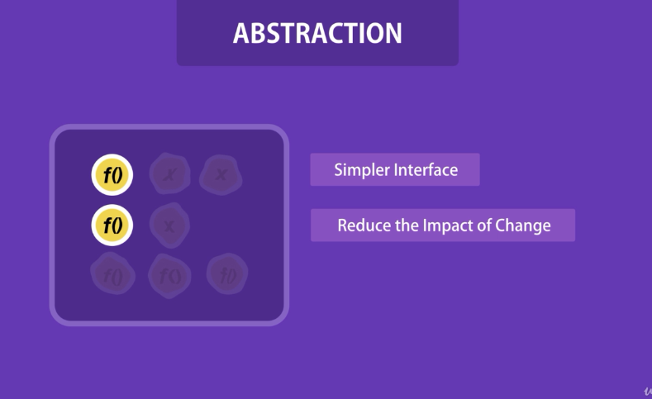

1. Inheritance:

* we can execute many forms of a method by using a single line of code
* help us eliminate redundant code

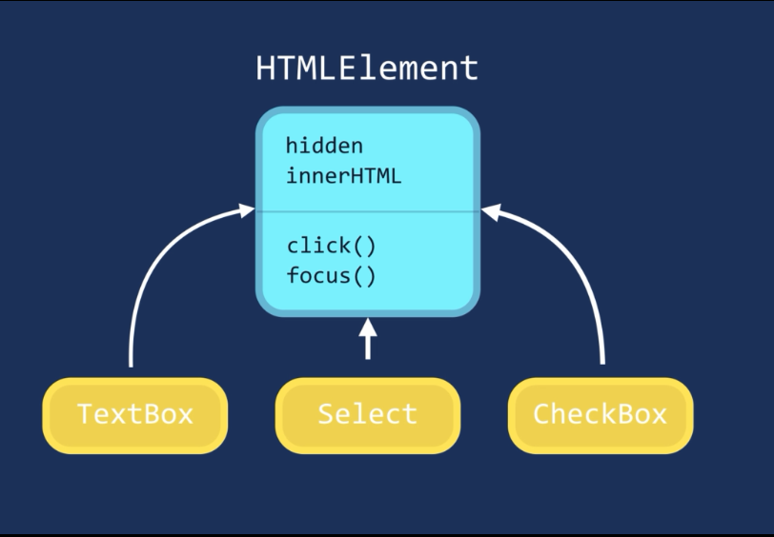

1. Polymorphism:
   * we can implement a render method in each of these objects, and the render method will behave differently depending on the type of the object we are referencing

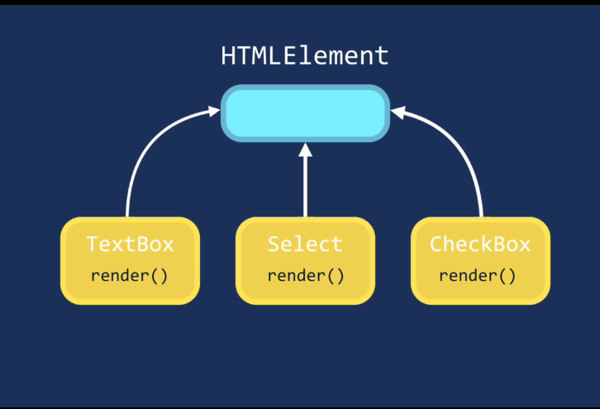

1. Benenifs of OOP

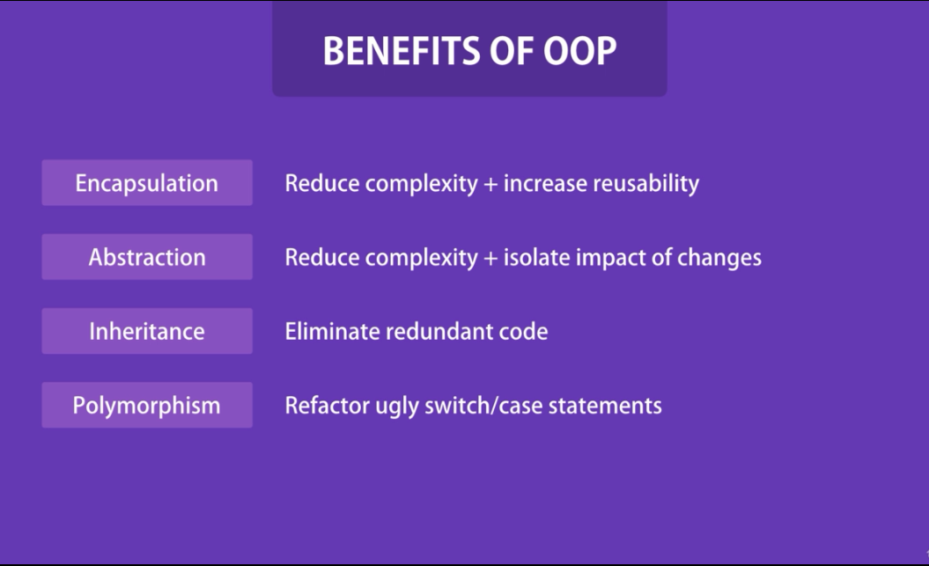

1. when we encapsulate our variables and functions into objects and use

Whe we use the new operator, three things happen:

* This new operator create a new object
* Sets this keyword to point to that object
* That new object will be return

**Note**: if we don’t use new keyword to instantiate a object => this will point to global object

1. In Classical object-oriented languages, we have two types of methods:
   * Instance methods
   * Static methods:
     1. are available on the class itself. Not the object instance. We often use them to create utility functions that are not specific to a given object
     2. To call a static method, we don’t have to create an instance class
2. Strict mode: by default body of classes are executed in the strict mode
3. Transpiler: is a tool that we give it our modern Javascript code and it will convert our Javascript code into code all of our browers can inderstand. Bable is an examle
4. Bundler: is reponsible for combining all our Javascript files into a single file, which we call a a bundle. The most popular is Webpack