Question 1:

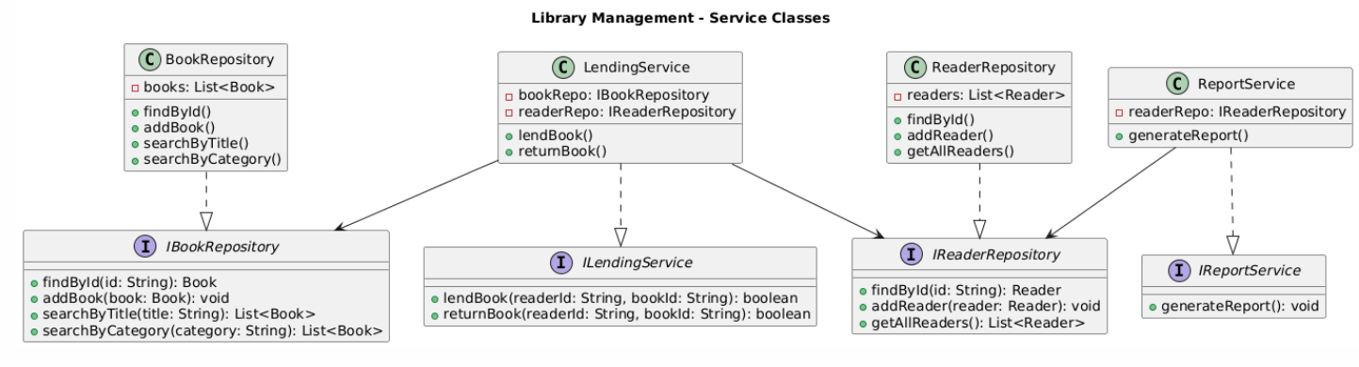
Question 3:

Application of SOLID Principles
The system fully applies SOLID principles to ensure maintainability and extensibility.
Each class has a single responsibility: Book and Reader manage data, LendingService handles borrowing logic, ReportService generates reports, and repositories manage storage, following SRP. The design is open for extension but closed for modification (OCP) because new types such as EBook can be added without changing existing services. All services depend on abstractions like IBookRepository and IReaderRepository instead of concrete classes, applying DIP. Interfaces are separated into small, focused contracts (ISP), and any subclass of Book can replace the base class without affecting the system, satisfying LSP.

Future Extensions
The system can be easily extended by adding new modules. Support for eBooks or magazines can be implemented through new classes without modifying current code. A ReservationService can be added to manage book reservations independently. Repositories can be replaced by database-based implementations, and a graphical or web interface can be built on top of existing services. These extensions demonstrate that the architecture is flexible and scalable.

