.



**VIETNAM’S HISTORY**

**Software Requirement Specification**

– Hanoi, August 2019 –

**Table of Contents**

I. Overview 3

1. Introduction 3

2. System Functions 4

3. Common Requirements 5

II. Functional Requirements 6

1. <<Feature Name 1>> 6

a. <<Function Name 1>> 6

b. <<Function Name 2>> 6

2. <<Feature Name 2>> 6

# I. Overview

## 1. Introduction

Web Vietnam’s History is for Vietnamese people to research Vietnamese History Event, Character, Item, Site. On this website people can read available information and can post a personal article and comment on others posts. We also have a game for users to play and get achievements about Vietnamese History. Website focuses on knowledge of Vietnamese History in high school.

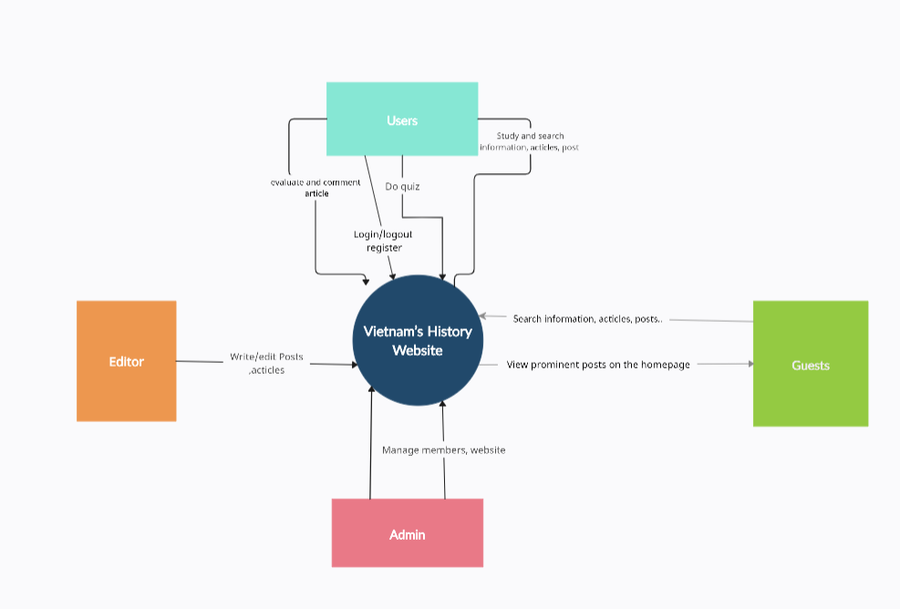>>

## 2. System Functions

#### a. Screen Flow

*[This part shows the system screens and the relationship among screens. You can draw the Screens Flow for the system in the form of diagram as below]*

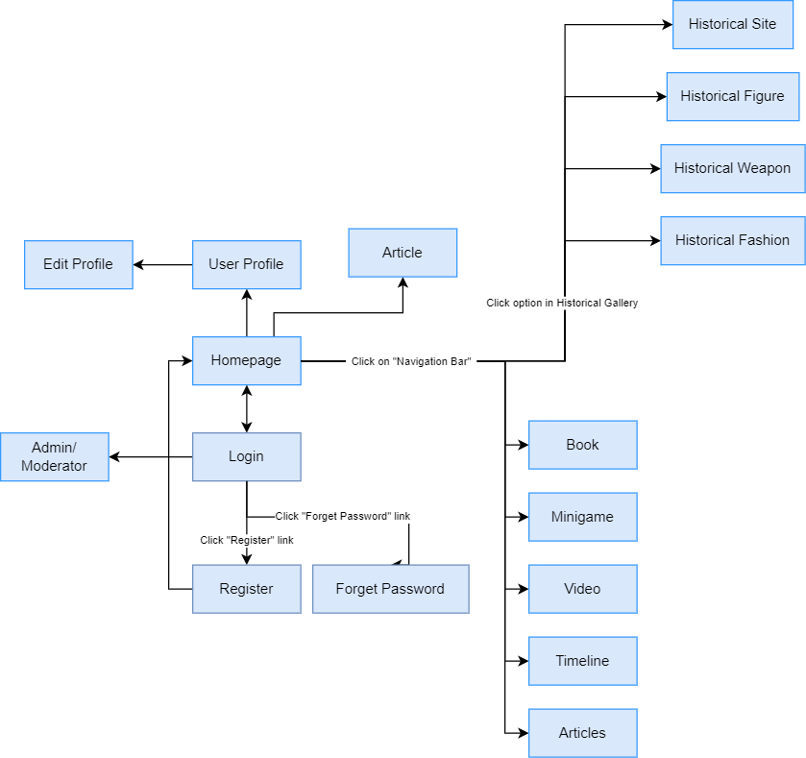

#### b. Screen Details

*[Provide the descriptions for the screens in the Screens Flow above]*

|  |  |  |  |
| --- | --- | --- | --- |
| **#** | **Feature** | **Screen** | **Description** |
| 1 | Authentication | Login | Members can login to write articles and comment the post |
|  | Authentication | Login by gg | Members can login by gg instead of enter username and pass |
| 2 | Authentication | Register | Guest can register a account |
| 3 | Authentication | Forget password | Members can reset passwords when they don’t remember |
|  | Post | Article | Members, moderators write A History Post (members must request) |
|  | Post | Article | Edit Post (members must request) |
|  | Comment | Article | Member comment after each article |
|  | Comment | Article | Filter toxic words. |
|  | Report | Article | Members, moderators report |
|  | Filter | Article, Video | Filter by period |
|  | Timelines | Home | Show the periods, dynasties, years and description about that period |
|  | Interactive maps | Home | Show 63 provinces/cities |
|  | Interactive maps | Home | Moving the mouse to any provinces/cities will show that province/city's information |
|  | Slides | Home | Show prominent articles. |
|  | Slides | Home | Edit, write post. |
|  | Sort | Article, Video, Historical Figure, Historical Site, Book | Sort by title, views |
|  | Search | Article, Video, Historical Figure, Historical Site, Book | Search articles, videos, characters, historical sites, books by title |
|  | Video | Video | Show videos |
|  | Video | Video | Click any video then will redirect that video + description |
|  | Article | Article | Show articles |
|  | Article | Article | Click any article then will transfer to this article |
|  | Manage article | Article | Moderators, members can add, delete, edit the article. Members must request. |
|  | Historical figure | Historical figure | Show Historical figures |
|  | Historical figure | Historical figure | Click any historical figure then will transfer to this historical figure |
|  | Filter | Historical figure | Filter by period, province |
|  | Historical item | Historical item | Show Historical items |
|  | Historical item | Historical item | Click any historical item then will transfer to this historical item |
|  | Filter | Historical item | Filter by period |
|  | Book | Book | Show books |
|  | Book | Book | Click any book then will transfer to this book |
|  | Filter | Book | Filter by period, price |
|  | historical site | historical site | Show Historical sites |
|  | historical site | historical site | Click any Historical site then will transfer to this historical site |
|  | Manage user | Admin | Admin can ban members, moderators |
|  | Update role | Admin | Change role from member to moderator and opposite. |
|  | Censor articles | Censorship | Moderator can accept or deny any posts |
|  | Change password | Edit profile | Members, Moderators can change new password |
|  | Update avatar | Edit profile | Members, Moderators can change new avt |

#### c. User Authorization

*[Provide the system roles authorization to the system features (down to screens, and event to the screen activities if applicable) in the table form as below – replace Role1, Role2,… with the specific system user role names]*

|  |  |  |  |  |
| --- | --- | --- | --- | --- |
| **Screen** | **Guest** | **Member** | **Admin** | **Moderator** |
| <<Screen Login>> |  |  |  |  |
| Login |  | X | X | X |
| Login with google |  | X | X | X |
|  |  |  |  |  |
| <<Screen Register>> |  |  |  |  |
| Register an account | X |  |  |  |
|  |  |  |  |  |
| <<Screen Forgot Password>> |  |  |  |  |
| Reset password |  | X | X | X |
|  |  |  |  |  |
| <<Screen Home>> |  |  |  | X |
| View Interactive maps | X | X |  | X |
| View timeline | X | X |  | X |
| View slider | X | X |  | X |
|  |  |  |  |  |
| <<Screen Article>> |  |  |  |  |
| Write an article |  | X |  | X |
| Edit article |  |  |  | X |
| Delete article |  |  |  | X |
| View articles | X | X |  | X |
| Filter articles by period | X | X |  | X |
| Search | X | X |  | X |
| Read the article | X | X |  | X |
| Comment |  | X |  |  |
| Reply comment. |  | X |  | X |
|  |  |  |  |  |
| <<Screen Historical Figure>> |  |  |  |  |
| View articles | X | X |  | X |
| Filter articles by period, province | X | X |  | X |
| Search | X | X |  | X |
| Read the article | X | X |  | X |
| Comment |  | X |  |  |
| Reply comment |  | X |  | X |
|  |  |  |  |  |
| <<Screen Historical Site>> |  |  |  |  |
| View articles about historical site | X | X |  | X |
| Search | X | X |  | X |
| Read the article | X | X |  | X |
| Sort by alphabet | X | X |  | X |
|  |  |  |  |  |
| <<Screen Book>> |  |  |  |  |
| View books | X | X |  | X |
| Filter books by period | X | X |  | X |
| Search | X | X |  | X |
| Read the article about book | X | X |  | X |
| Comment |  | X |  |  |
| Reply comment |  | X |  | X |
|  |  |  |  |  |
| <<Screen Admin>> |  |  |  |  |
| Manage user |  |  | X |  |
| Update role |  |  | X |  |
| Ban/Unban |  |  | X |  |
|  |  |  |  |  |
| <<Screen Article Request>> |  |  |  |  |
| Censor articles |  |  |  | X |
|  |  |  |  |  |
| <<Screen Edit profile>> |  |  |  |  |
| Edit members’ profile |  | X |  | X |
| Update avatar |  | X |  | X |
| Change password |  | X |  | X |

In which:

* ADMIN: This role can access with User status with key responsibility is prevent behaviours effected to the website
* MODERATOR: This role for management members requests to prevent invalid information from appearing

#### d. Non-Screen Functions

*[Provide the descriptions for the non-screen system functions, i.e batch/cron job, service, API, etc.]*

|  |  |  |  |
| --- | --- | --- | --- |
| **#** | **Feature** | **System Function** | **Description** |
| 1 | Authentication | Logout | User(member, admin, editor) can logout the account |
| 2 | Post | Delete Post | Editor can delete a post |
| 3 | Comprehension | Delete | Editor can delete any prominent articles, historical figures, historical sites, videos and books. |
| 4 | Article | Delete post | Editor can delete a post |
| 5 | Video | Delete video | Editor can delete a video |
| 6 | Historical figure | Delete post | Editor can delete a post |
| 7 | Historical site | Delete post | Editor can delete a post |
| 8 | Book | Delete post | Editor can delete a post |
| 9 | Admin | Manager user | Ban user |

## 3. Common Requirements

*<<fill here with all the common requirements...>>*

- Create a website about historical knowledge of Vietnam for everyone (including children, adults, teachers, ...)

- The home page should have articles, timelines about history and important typical historical figures.

- Admin must approve the articles, videos, and quiz about history before posting.

- Admin can update, delete information of articles, videos and quiz about history.

- Administrators must approve reader reviews of articles, videos and quizzes about history.

- Admin can ban members.

- Users can update their information.

- Users can login with their email or google.

- Users can search for articles, videos, books about history that they want to see.

- Users can use interactive maps to find information about history in cities faster.

# II. Functional Requirements

## 1. <<Feature Name 1>>

### a. <<Function Name 1>>

*[A function can be a screen or a non-screen function (listed in the part 5.1 above). In this part, you need to provide the details on the related function, focus on mentioning below information*

* *Function trigger: how this function is triggered (navigation path, a timing frequency, etc.*
* *Function description: actors/roles, purpose, interface, data processing, etc.*
* *Screen layout: mockup prototype of the screen, sample below is for Manage Products screen*

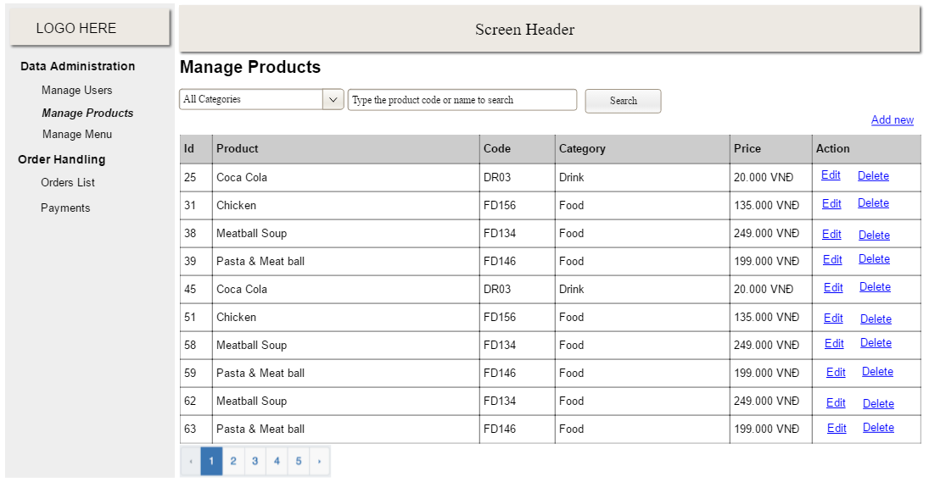

* *Function Details: provide explanation for the data, validation, business logics, functionalities (for both normal cases and abnormal cases), etc. of the function so that the reader can image how it work.*

*]*

### b. <<Function Name 2>>

…

## 2. <<Feature Name 2>>

…