JAVA PROJECT REPORT

<Pet Shop>

Module 61CSE215: Object Oriented Programming in JAVA

Trương Minh Khang – 104240725

Tạ Ngọc Lan – 104240157

Võ Hiếu Nhân– 104240013

Lecturer: Dr. Tran Hong Ngoc

I. INTRODUCTION
In this project, we investigate the business functions of the pet shop management system, and provide a desktop application supporting the shop manager and the sales staff in managing pets, products, customers and sales orders.
The details of our requirements are as follows:
- Each pet is one single animal, so it can be sold only once. After the sale, the pet must be marked as sold and must not appear in a new order.
- Each product (food, toys, accessories, ...) has a quantity in stock. A sale decreases the stock, and the system must refuse to sell more items than the stock. Products with 5 or fewer items left must be highlighted.
- Each order belongs to one customer and has one or more order lines (one pet, or a quantity of one product). The price is saved in the order line at the time of the sale, and the total of the order is the sum of the subtotals of its lines. All prices are in Vietnamese dong (VND).
- Pets, products and customers that appear in an order must not be deleted, so that the sales history is kept.
- Two kinds of employees use the software: the manager and the sales staff. Only the manager may delete data and view the revenue report.
- The software must check the input data and show a clear message when something is wrong.
This project provides the basic functions for the stakeholders/users as follows:
- Log in as a manager or as a sales staff.
- Input the pet information (name, species, breed, age, price, photo).
- Input the product information (name, category, price, stock).
- Input the customer information.
- Search pets (by name or breed, species, maximum price, availability), products and customers.
- Edit and delete pets, products and customers (delete: manager only).
- Input the sales order: choose a customer, add pets and products to the cart, and check out.
- Display the order history and the order details.
- Display the revenue report of a chosen period with a daily chart (manager only).
- Warn about products with low stock and show error messages for invalid data.
The users of the software and their functions are shown in Table 1, and the use cases are shown in Figure 1.
User role | Description | Functions
Manager | The owner of the shop. Responsible for the catalogue, the employees' work and the results of the shop. | All functions: log in; input, edit, search and delete pets, products and customers; input sales orders; display the order history; display the revenue report.
Sales staff | An employee who serves the customers in the shop. | Log in; input, edit and search pets, products and customers; input sales orders; display the order history. Cannot delete data and cannot open the revenue report.
Table 1. User roles of the Pet Shop Management System
Customers do not use the software. The manager or a sales staff enters the customer information and creates the orders for them.
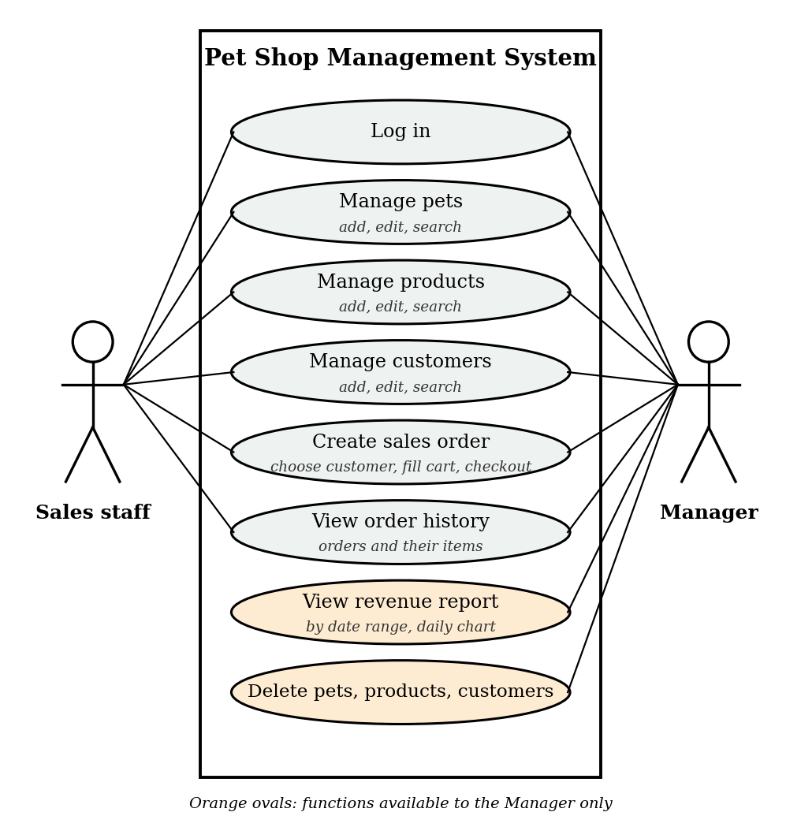
Figure 1. Use case diagram of the Pet Shop Management System
In this project, we use Java OOP for designing classes and applying the OOP such as encapsulation, inheritance, abstraction and polymorphism:
- Encapsulation
- Inheritance
- Abstraction
- Polymorphism

II. CLASS ANALYSIS
- Objects
One or two typical objects show each class of the system in Table 2, which keeps the table short
No | Object Name | State | Behaviours
1 | Milo (a pet) | Dog, Golden Retriever, 4 months old, 12,000,000 VND, available, has a photo file. | Can be sold while it is available (canSell); becomes sold after the sale (afterSale); creates its order line (toOrderLine).
2 | Rocky (a pet) | Dog, Poodle, 6 months old, 6,500,000 VND, already sold. | Cannot be sold again (canSell); gives the reason that it has already been sold (cannotSellMessage).
3 | Dry dog food 5kg (a product) | Category Food, 380,000 VND, 25 items in stock. | Can be sold when the stock is enough (canSell); its stock decreases after a sale (afterSale).
4 | Cat tree (a product) | Category Accessories, 890,000 VND, 4 items in stock (low stock). | Same as the other products; is highlighted as low stock (5 items or fewer).
5 | Nguyen Van An (a customer) | Phone 0901234567, email an.nguyen@example.com, address 12 Le Loi, District 1. | Is registered by the staff; places orders; tells its role (roleLabel).
6 | Nguyen Minh Quan (a manager) | User name admin, phone, email and address of the manager. | Logs in; tells its role (roleLabel); may view the revenue report (canViewReports); may delete data (canDelete).
7 | Tran Thu Ha (a sales staff) | User name staff, phone, email and address of the employee. | Logs in; tells its role (roleLabel); may not view the revenue report (canViewReports); may not delete data (canDelete).
8 | Order #16 | Created on 13/10/2026 at 09:09 for customer Nguyen Van An; 2 order lines. | Calculates its total, 12,380,000 VND (total); counts its items (itemCount); lists its order lines.
9 | Order line: Milo x 1 | A pet, Milo, quantity 1, unit price 12,000,000 VND. | Calculates its subtotal, 12,000,000 VND (subtotal).
10 | Order line: Dry dog food 5kg x 1 | A product, quantity 1, unit price 380,000 VND. | Calculates its subtotal, 380,000 VND (subtotal).
Table 2. List of objects (pets, products, customers, employees, orders)

Objects that have common states and behaviours are put into the same group. Table 3 shows three groups: sale items, people and sales records.
Group | Objects | Common states | Common behaviours
Sale items | Milo, Rocky (pets); Dry dog food 5kg, Cat tree (products) | Identity number, name, price.  Pets add: species, breed, age, availability, photo. Products add: category, stock. | Tell its kind (type); check whether it can be sold (canSell); give the reason when it cannot be sold (cannotSellMessage); give its new state after a sale (afterSale); create an order line for itself (toOrderLine).
People | Nguyen Van An (customer); Nguyen Minh Quan (manager); Tran Thu Ha (sales staff) | Identity number, name, phone, email, address.  Employees add: user name. | Tell its role (roleLabel). Employees also tell which functions they may use (canViewReports, canDelete).
Sales records | Order #16; its two order lines | Order: date and time, customer, order lines.  Order line: kind of item, item, quantity, unit price. | Order: calculate the total (total) and count the items (itemCount). Order line: calculate the subtotal (subtotal).
Table 3. Groups of objects with common states and behaviours

2. Classes
For each group we create classes. As this is the analysis stage, the attributes and functions are described without data types, return types or parameter lists.
2.1 Classes, attributes and functions
Class | Attributes | Functions
SaleItem *(abstract) | id; name; price | tell its kind (type); check whether it can be sold in a given quantity (canSell); give the reason why it cannot be sold (cannotSellMessage); give its new state after a sale (afterSale); create an order line (toOrderLine).
Pet * (extends SaleItem) | species; breed; age in months; availability; photo | gives its own version of type, canSell, cannotSellMessage and afterSale: a pet can be sold only once and only while it is available, and it becomes unavailable after the sale.
Product *(extends SaleItem) | category; stock | gives its own version of type, canSell, cannotSellMessage and afterSale: a product can be sold when the stock is enough, and the stock is decreased by the sold quantity after a sale.
Person (abstract) | id; name; phone; email; address | tell the role of the person (roleLabel).
Customer (extends Person) | no extra attribute | tell the role: customer (roleLabel).
Employee (abstract, extends Person) | user name | tell whether the employee may view reports (canViewReports); tell whether the employee may delete data (canDelete).
Manager (extends Employee) | no extra attribute | role: manager; may view reports; may delete data.
SalesStaff (extends Employee) | no extra attribute | role: sales staff; may not view reports; may not delete data.
Order | id; date and time; customer; order lines | calculate the total amount (total); count the items (itemCount).
OrderLine | kind of item; item id; item name; quantity; unit price | calculate the subtotal, unit price multiplied by quantity (subtotal).
ItemType (enumeration) | values: pet, product | tell whether an order line is about a pet or a product.
Table 4. Classes, attributes and functions

