DA NANG UNIVERSITY OF SCIENCE AND TECHNOLOGY
FACULTY OF ELECTRONICS AND TELECOMMUNICATION



FINAL REPORT
MICROPROCESSOR ENGINEERING
TOPIC:
AUTOMATIC DOOR LOCK

Group name: | RAS.Workaholics
Group members: | Nguyen Van Quy (106220232)  Trinh Anh Nhat (106220230)  Nguyen Trong Nhan (106220229)  Ho Nguyen Tam (106220233)
Academic supervisor: | M. Sc. Ho Viet Viet
Course class: | 22.44A

Da Nang, 2025

Link github: https://github.com/tiroin/Smart_Doorlock_ESP_IDF
- Introduction:
An automatic door lock is a modern security device designed to automatically lock and unlock a door without manual operation, enhancing both convenience and safety. This system helps prevent unauthorized access, protects property, and provides a higher level of security compared to traditional mechanical locks. Today, automatic door lock technology is widely applied in smart homes, hotels, offices, and access control systems due to its effectiveness and reliability. Therefore, the development of an automatic door lock system is highly essential.
This project aims to design and implement an automatic door lock system based on the ESP32-C3 microcontroller to enhance access control and security. The system supports multi-factor authentication using RFID cards and keypad input, provides visual and audible alerts for unauthorized access, displays real-time system status on an OLED screen, and enables remote monitoring through the ESP RainMaker platform for improved convenience and reliability.
- Hardware Schematic and Components Used and Functional Requirements:
Components used:
- Main MCU: ESP32-C3.
- Alarm Devices: 1 buzzer and 1 LED.
- Input Devices: 4x4 keypad and 1 push button.
- Display: OLED SSD1306 with I2C module.
- Sensors: MFRC-522 RFID module.
- Power Circuit: Step-down circuit.
- Door Locking Unit: 5V electric lock.
Functional Requirements:
- The system shall unlock the door when a valid RFID card and correct keypad password is provided.
- The system shall deny access and trigger buzzer and LED alarms after repeated incorrect authentication attempts or wrong password.
- The system shall display authentication results and lock status on the OLED screen.
- The system shall allow manual door unlocking via an internal push button.
- The system shall send door lock status notifications through the ESP RainMaker platform.

General block diagram:
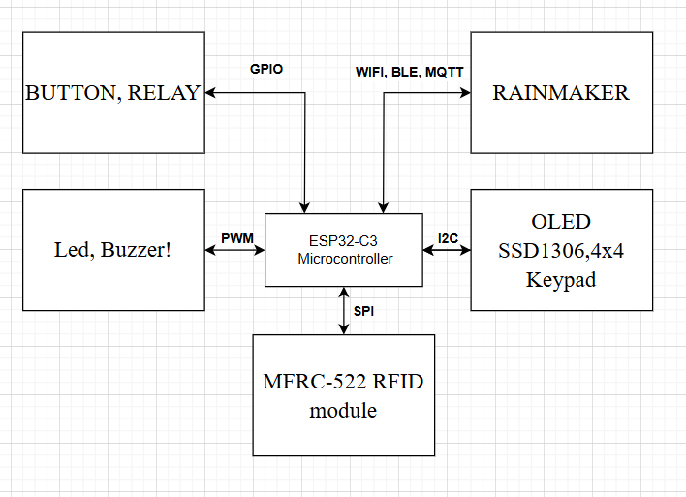
Figure 1. Overall block diagram of the automatic door lock system
Circuit diagram:
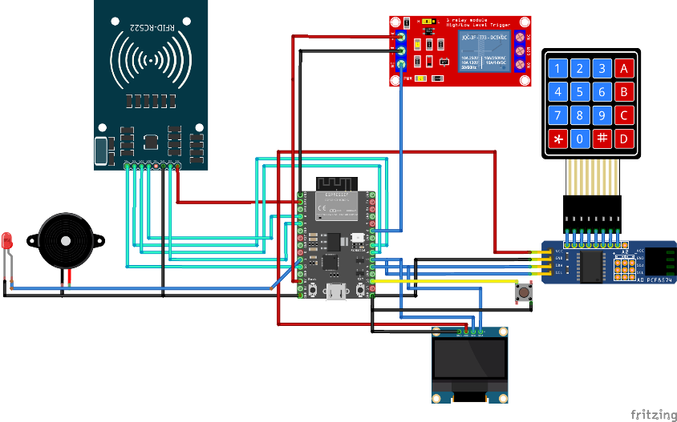
Figure 2. Hardware circuit schematic
Functions of the components:
• ESP32-C3 microcontroller: Acts as the central processing and control unit of the automatic door lock system, managing sensor data, executing decision-making logic, and controlling the lock status.
• Buzzer: Generates audible alarm signals to provide security warnings when abnormal events occur (e.g., incorrect password entry).
• LED status indicator: Flashes together with the buzzer to warn of unauthorized access attempts (e.g., repeated incorrect password input).
• 4x4 Keypad: Serves as the main password input device, allowing users to enter access codes to unlock the door. It can also be used to change or delete passwords.
• Push button: Functions as a manual control switch that enables quick door opening from the inside.
• OLED SSD1306 with I2C module: Displays real-time system information such as lock status, keypad input, and system messages, while minimizing GPIO usage through the I2C interface.
• MFRC-522 RFID module: Reads RFID/NFC cards for user authentication, providing an additional secure access method alongside keypad passwords.
• Step-down circuit: Converts and regulates the input voltage to levels required by the individual components, ensuring stable operation and electronic protection.
• 5V electric lock: Works as the physical locking mechanism controlled by the microcontroller, automatically locking or unlocking the door based on authentication results.
- Implementation:
Software tools used by the team:
- ESP-IDF (C/C++): Used for programming and controlling the entire automatic door lock system, including sensor processing, lock control, and peripheral communication.
- ESP RainMaker: Used to monitor the system status, such as door lock conditions and security alerts, and to send access notifications via the Internet.
- Draw.io: Used to design the block diagram, system flowchart, and overall structure of the automatic door lock system.
- Wokwi: Used to simulate the hardware connections, supporting circuit verification and serving as a visual tool for reporting purposes.
- Altium Designer: Used to design and develop the step-down circuit, including schematic creation and PCB layout to ensure stable power delivery for the system.
- Fritzing: Used to draw the breadboard wiring diagram and visually represent the system's hardware layout for demonstration and explanation.

Flowchart:
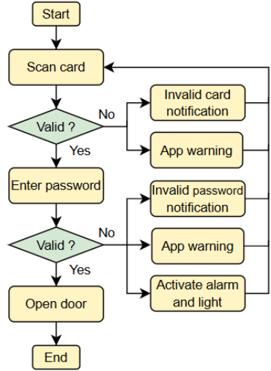
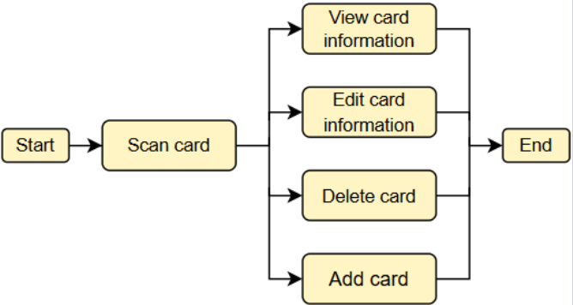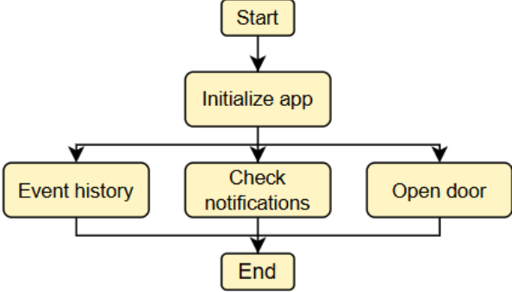
Figure 3. System flowchart (User, Admin and Rainmaker app)
Implemented circuit and RainMaker:
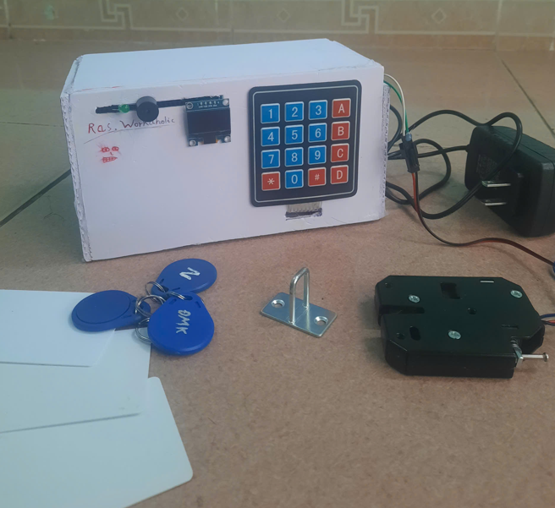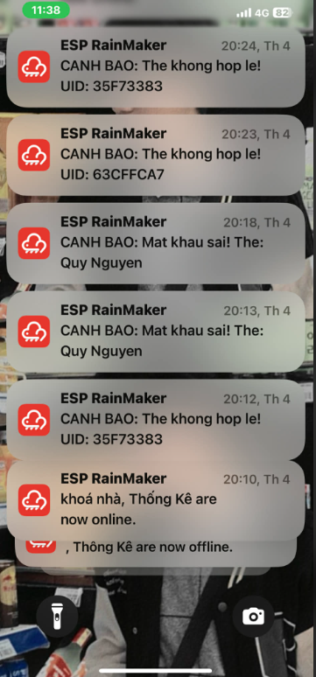
Figure 4. Implemented circuit and RainMaker
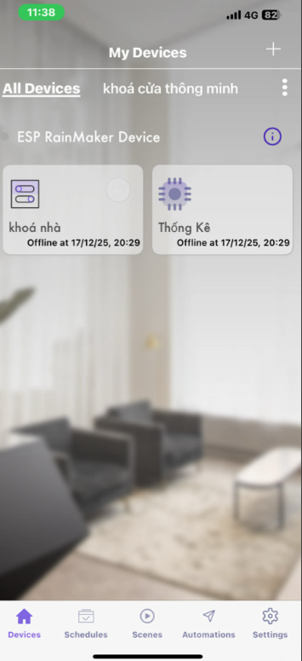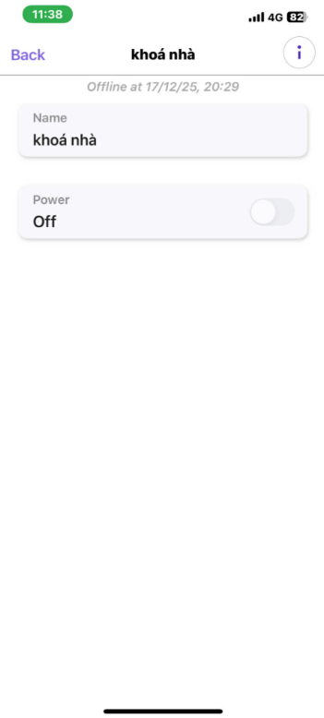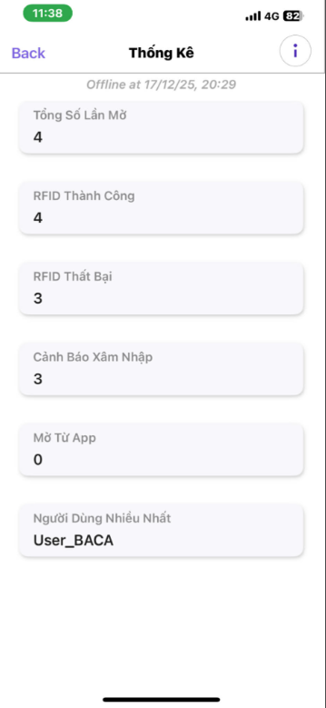
Figure 5. RainMaker Notification Interface
- Conclusion:
In conclusion, the automatic door lock system offers a modern and reliable solution for access control and security enhancement. By integrating the ESP32-C3 microcontroller with sensors and electronic components, the system can intelligently detect user activity and accurately control the locking mechanism, improving both safety and convenience.
With practical applications in homes, offices, hotels, and other secured environments, this system demonstrates strong real-world potential. Overall, the design proves to be an efficient and valuable approach to modern security needs and provides a solid foundation for future IoT-based upgrades.
- References:
[1] Y. Yasouimo, “IoT-door-lock: IoT-based RFID access control using ESP32,” GitHub Repository, 2023.
[2] ESP32IO, “ESP32 – RFID/NFC Door Lock System,” ESP32 Tutorials, 2022.
[3] J. Nidup, “Automatic Door Lock Using RFID and ESP32,” Project Blog, 2022.

