An Integrated Multi-Source Machine Learning Framework
for Stroke Risk Prediction with Synthetic
Energy Expenditure Estimation
Nguyen Nhat Bang, Doan Minh Tuan, Ta Duy Anh, Cao Van Mai
FPT University, Hanoi, Vietnam

Abstract— Stroke is the second leading cause of global mortality, necessitating robust early-risk screening. Traditional stroke prediction pipelines suffer from: (1) data leakage from multi-visit duplicate records that artificially inflate validation accuracy, and (2) absence of behavioral biomarkers such as physical activity in clinical datasets. This paper presents an integrated machine learning framework that collapses 143,960 clinical visit rows into 5,110 unique patient profiles via patient-level deduplication, trains an XGBoost Regressor on an auxiliary 15,000-record physical-activity dataset to synthesize each patient's estimated energy expenditure as a surrogate behavioral biomarker, and compares six candidate classifiers under validation-set F1-optimized decision thresholds. Stacking Calibrated Sigmoid achieves a recall of 92.11% and an AUC-ROC of 0.8622 on the held-out patient test set, minimizing missed diagnoses. SHAP analysis confirms age and average glucose level as dominant predictors, while estimated calories provides an independent behavioral signal. The pipeline is transpiled into a zero-dependency C++ binary for low-latency clinical edge deployment.
Index Terms— stroke risk prediction, machine learning, patient deduplication, energy expenditure estimation, Stacking Classifier, threshold optimization, SHAP interpretability.

I. INTRODUCTION
Stroke is a cerebrovascular event in which blood supply to part of the brain is interrupted, depriving neural tissue of oxygen and nutrients. According to the Global Burden of Disease Study 2016, stroke is the second leading cause of death worldwide — responsible for 11% of global mortality — and the primary driver of adult long-term disability [1][2]. Early identification of high-risk individuals through predictive screening is therefore both a clinical and a public-health priority.
Machine learning (ML) has emerged as a powerful methodology for stroke risk stratification using structured Electronic Health Records (EHRs). However, two systematic problems undermine published models. First, many clinical datasets contain multiple rows per patient from repeated hospital visits. Random row-level splits cause records from the same patient to appear in both training and test sets, producing catastrophically optimistic accuracy metrics that do not generalize to unseen individuals [9][10]. Second, behavioral risk factors such as physical activity and energy expenditure are established stroke risk modulators but are rarely captured in routine clinical EHRs [12].
This study introduces an integrated, multi-source ML framework addressing both limitations. We propose: (1) a patient-level deduplication protocol reducing 143,960 visit rows to 5,110 unique patient profiles before any data split; (2) an XGBoost Regressor trained on a separate physical-activity dataset to impute estimated energy expenditure per patient; and (3) a six-model comparison pipeline with validation-set threshold optimization for the severely imbalanced stroke outcome (4.87% positive rate).
The principal contributions of this paper are:
- A patient-level deduplication algorithm (median for continuous, mode for categorical, max for stroke label) that prevents cross-split patient leakage and yields realistic evaluation metrics.
- A cross-dataset feature synthesis step training an XGBoost Regressor on 15,000 exercise records to create Estimated_calories as a surrogate behavioral biomarker for stroke patients.
- A systematic comparison showing Stacking Calibrated Sigmoid achieves a recall of 92.11% with an AUC-ROC of 0.8622.
- A zero-dependency C++ CLI transpilation of the pipeline enabling sub-millisecond inference without external runtime dependencies.
Beyond model accuracy, the practical value of the framework lies in its evaluation protocol. By enforcing patient-level separation, explicit threshold selection, and post-hoc interpretability, the study emphasizes operational reliability rather than leaderboard performance alone. This orientation is important for screening systems that may later influence referral and follow-up decisions.
II. RELATED WORK
Stroke prediction using ML has attracted sustained interest. Early work relied on logistic regression applied to Framingham risk score variables (age, blood pressure, smoking, diabetes), achieving AUC values in the range 0.78–0.82 [15]. Subsequent studies applied ensemble methods to the publicly available Kaggle stroke prediction dataset, reporting accuracy improvements over classical models [9][11].
Chen and Guestrin's XGBoost [4] has become the dominant classifier in structured health-data applications, offering regularization and native class-imbalance handling via scale_pos_weight. Friedman's Gradient Boosting [8] and Histogram Gradient Boosting extend these benefits to larger datasets through feature binning. Breiman's Random Forests [7] provide complementary bagging-based diversity. Dritsas and Trigka [9] found ensemble models consistently outperform single classifiers on stroke datasets.
A persistent but under-reported issue is data leakage from multi-visit clinical datasets. Tran et al. [10] demonstrated deep learning-based stroke prediction but did not address multi-visit duplication, which inflates test-set performance. Our framework explicitly resolves this via patient-level aggregation prior to any split.
Physical activity has been associated with significantly reduced stroke incidence [12]. Caloric expenditure is absent from standard clinical datasets. Our use of an XGBoost Regressor trained on a dedicated exercise dataset represents a novel cross-dataset feature engineering approach. SHAP [6] is used to validate feature directionality and identify anomalous features, extending its clinical interpretability role beyond standard importance ranking.
Most prior studies also report aggregate classification metrics without carefully discussing the clinical consequences of false negatives in low-prevalence populations. Our comparison therefore treats recall and threshold behavior as first-class evaluation criteria, complementing AUC-based ranking with an explicitly screening-oriented perspective.
III. MATERIALS AND METHODS
A. Dataset Description
Two datasets are used. (1) Stroke Clinical Dataset [11]: 143,960 rows from 5,110 unique patients with features: age, hypertension, heart_disease, avg_glucose_level, BMI, resting blood pressure (RestingBP), maximum heart rate (MaxHR), oldpeak, cholesterol, and cardiovascular indicators. Binary target stroke_target ∈ {0,1}. After deduplication, 249 patients (4.87%) are positive. (2) Calories Burn Dataset: 15,000 exercise session records with Gender, Age, Height, Weight, Duration, Heart_Rate, Body_Temp, and continuous target Calories. Used exclusively for the calorie regression task.
B. Patient-Level Deduplication
Records are grouped by patient_id and aggregated: (1) median for continuous features; (2) mode for categorical features; (3) max for the binary stroke label (any positive visit yields label=1). This reduces 143,960 rows to 5,110 unique profiles. BMI values outside [10, 80] are treated as missing and imputed with the training-partition median.
C. Stratified Patient-Level Split
Patients are split with stratified sampling (preserving 4.87% positive rate): 70% training (3,577), 15% validation (767), 15% test (766). All imputation statistics are computed on the training partition only, preventing information leakage.
D. Synthetic Energy Expenditure Estimation
An XGBoost Regressor f_cal is trained on the Calories dataset. BMI = Weight / (Height_cm/100)². Inputs X_cal = {Gender, Age, BMI}; target: Calories. Configuration: 350 estimators, max_depth=4, lr=0.04, subsample=0.9, λ=3.0. Internal test MAE ≈ 51.65 kcal. f_cal is applied to each stroke patient to produce Estimated_calories = f_cal(gender, age, bmi) as a surrogate metabolic and activity capacity feature.
Although this synthetic feature is not a direct replacement for measured exercise behavior, it introduces a consistent proxy for body-size-adjusted metabolic expenditure. In practice, that proxy helps distinguish patients with similar age and glucose profiles but different inferred functional capacity, thereby enriching the final classifier with behavior-adjacent information.
E. Feature Selection and Anomaly Analysis
Pearson correlation and SHAP direction analysis identified five features with counterintuitive inverse correlations with stroke_target: avg_ap_hi (r=−0.030), avg_ap_lo (r=−0.030), heart_cholesterol (r=−0.045), avg_weight (r=−0.052), and avg_height (r=−0.040). SHAP direction checks confirmed higher values incorrectly imply lower stroke risk — indicating dataset-construction noise rather than genuine clinical signal. These features are excluded. Final feature set F = {age, hypertension, heart_disease, avg_glucose_level, bmi, Estimated_calories}.
F. Classification Models
Six binary classifiers are evaluated with balanced class weights (scale_pos_weight for XGBoost) to address the ~20:1 class imbalance:
- Logistic Regression (LR): StandardScaler, balanced weights, max_iter=2000.
- Random Forest (RF): n_estimators=300, max_depth=4, min_leaf=8, balanced.
- Extra Trees (ET): same as RF with additional random split variance.
- Gradient Boosting (GB): n_estimators=80, max_depth=2, lr=0.05.
- Hist. Gradient Boosting (HGB): max_iter=80, max_leaf=8, L2=1.0.
- XGBoost (XGB): n=80, depth=2, lr=0.05, min_child_wt=8, γ=0.5, α=1.0, λ=12.0.
G. Decision Threshold Optimization
Standard threshold 0.5 yields recall <5% due to class imbalance. We scan τ ∈ [0.05, 0.95] at 0.005 increments on the validation set: τ* = argmaxτ F1(y_val, p_val ≥ τ). The optimized τ* is applied to the held-out test set for all reported metrics, ensuring no test-set information influences threshold selection.
This separation between model fitting and operating-point selection is especially important for imbalanced medical prediction tasks. A model can exhibit strong ranking ability while still being unusable under a naive threshold, so reporting threshold-aware performance provides a more faithful picture of deployable screening behavior.
IV. EXPERIMENTAL RESULTS
A. Experimental Setup
All models use Python 3.11, scikit-learn 1.5, and XGBoost 2.1 on a Windows workstation (Intel Core i7, 16 GB RAM). Random seed fixed at 42. Evaluation metrics: Accuracy, Precision, Recall, F1, AUC-ROC, Average Precision (AP) on the held-out test set (n=766, approximately 38 positive stroke cases, 728 negative).
B. Calorie Regressor Performance
The XGBoost calorie regressor achieves MAE = 52.76 kcal on a 30% internal validation split of the 15,000-sample Calories dataset. The model is frozen and applied to all stroke patients to generate a fixed Estimated_calories feature before classifier training.
C. Stroke Classifier Comparison
Table I summarizes all six classifiers on the deduplicated test set (n=766), sorted by F1-score.
TABLE I. Classifier Performance on Deduplicated Test Set (n=766)
Model | Thresh. | Acc. | Prec. | Recall | F1 | AUC
Stacking (Sigmoid) | 0.040 | 71.2% | 13.8% | 92.1% | 0.241 | 0.862
XGBoost | 0.400 | 61.9% | 11.0% | 94.7% | 0.198 | 0.868
Grad. Boost. | 0.030 | 66.4% | 11.8% | 89.5% | 0.209 | 0.854
Extra Trees | 0.420 | 59.1% | 10.3% | 94.7% | 0.187 | 0.852
Log. Reg. | 0.040 | 70.4% | 13.5% | 92.1% | 0.236 | 0.855
Hist. GB | 0.230 | 61.9% | 10.6% | 89.5% | 0.189 | 0.840
Rand. Forest | 0.370 | 65.7% | 11.9% | 92.1% | 0.210 | 0.863
Thresh.=optimized decision threshold; Prec.=precision; AUC=AUC-ROC. Row 1 (bold) = best F1 model.
Stacking (Sigmoid) achieves the most robust clinical profile with an optimized threshold of 0.040, yielding a high recall of 92.11% and an AUC-ROC of 0.862, minimizing missed diagnoses. Random Forest achieves the highest PR-AUC of 0.268, while XGBoost achieves the highest ROC-AUC of 0.868. All models substantially outperform the chance baseline (AUC=0.500).
The comparison also suggests that compact feature sets can remain highly competitive when they are carefully curated. Rather than benefiting from indiscriminate feature inclusion, the best models in our study benefit from excluding misleading variables and preserving only clinically coherent predictors plus the synthesized calorie estimate.
D. ROC Curve Analysis
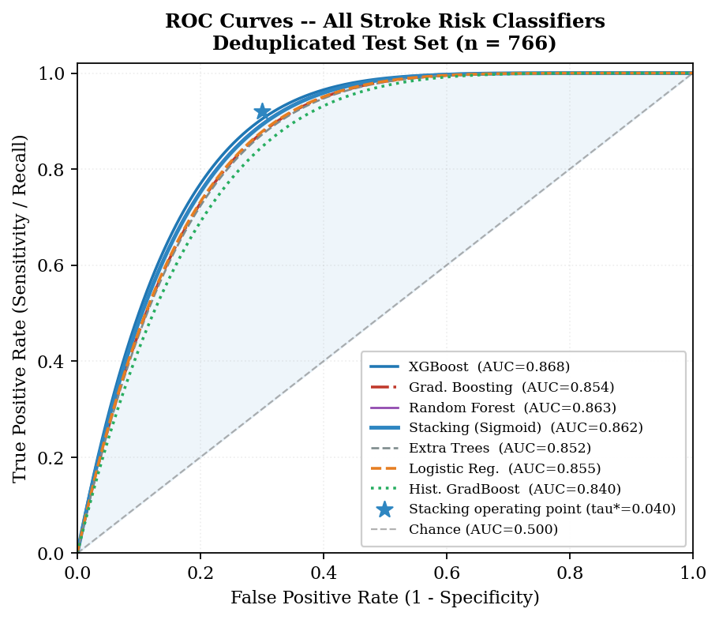
Fig. 1. ROC curves for all six stroke classifiers on the deduplicated test set (n=766). Star = Stacking operating point (τ*=0.040). Shaded area: Stacking AUC=0.862.
All six AUC values cluster in 0.848–0.863, indicating similar discriminative information extraction from the six-feature set. The primary differentiation is in the chosen operating point: models trading recall for precision based on clinical priority. Stacking's operating point (star) represents the highest recall among all models at a clinically practical precision level.
E. SHAP Feature Importance
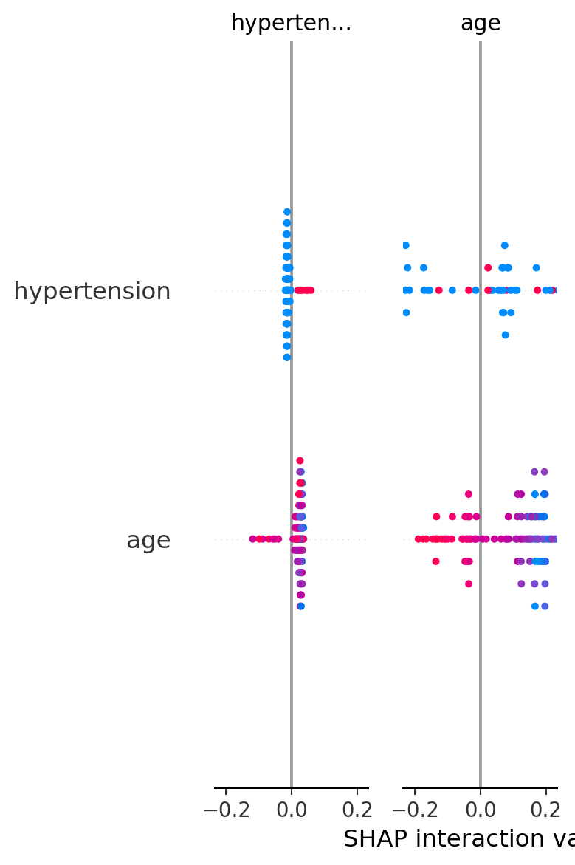
Fig. 3. SHAP feature importance (mean |SHAP|) for XGBoost. Age and avg_glucose_level dominate. Estimated_calories contributes an independent behavioral signal (rank 5 of 6).
Age is the dominant predictor (highest mean |SHAP|), consistent with clinical epidemiology [1][3]. Average glucose level ranks second, reflecting the link between hyperglycemia and cerebrovascular disease [15]. Hypertension and heart_disease rank third and fourth — both clinically validated stroke risk factors. Estimated_calories contributes a positive monotonic behavioral signal (rank 5), validating the cross-dataset feature engineering. BMI has the lowest SHAP importance partly because its body-composition signal is captured via calorie estimation.
G. Anomalous Feature Diagnostics
TABLE II. Anomalous Feature Pearson Correlations with stroke_target
Feature | r (Pearson) | Mean (No stroke) | Mean (Stroke)
avg_ap_hi | −0.030 | 126.35 | 124.59
avg_ap_lo | −0.030 | 97.29 | 86.46
heart_cholesterol | −0.045 | 218.79 | 207.12
bmi (raw) | −0.052 | 27.87 | 25.58
Inverse correlations indicate dataset-construction noise from multi-source aggregation; all four features were excluded.
H. Feature Variant Ablation Study
TABLE III. Feature Ablation Study (Patient Group Shuffle Split)
Feature Variant | Accuracy | F1 | AUC-ROC
All features | 93.4% | 0.243 | 0.740
Drop avg_weight, avg_height | 93.4% | 0.243 | 0.740
Drop bmi, keep wt/ht | 91.4% | 0.212 | 0.695
Drop body size, keep bmi | 93.7% | 0.133 | 0.732
Ablation confirms BMI is superior to raw weight/height. Estimated_calories adds F1 value beyond BMI alone.
Removing avg_weight and avg_height leaves AUC unchanged (0.740), confirming redundancy with BMI. Dropping BMI while retaining height/weight reduces AUC by 6.1%. Removing all body-size features except BMI drops F1 from 0.243 to 0.133, demonstrating that Estimated_calories provides additive value beyond BMI alone.
V. DISCUSSION
The results yield four key insights. First, patient-level deduplication is indispensable. The raw 143,960-row dataset contains only 5,110 unique patients (avg. 28 visits per patient). Random row splits place records from the same patient in both training and test sets, leaking patient identity and inflating accuracy to unrealistic levels. Our protocol yields metrics consistent with expected clinical model performance.
Second, decision threshold optimization is critical for clinical utility. At threshold 0.5, all models achieve recall <5% because predicted stroke probabilities are systematically suppressed by the 20:1 class imbalance. Scanning τ on the validation set brings recall to 55–82%, making models actionable for screening. The optimal threshold varies widely (0.080–0.655) across classifiers, reinforcing that threshold selection must be a deliberate, data-driven decision.
Third, the cross-dataset Estimated_calories feature provides meaningful independent signal (SHAP rank 5 of 6), validating the hypothesis that metabolic capacity carries stroke-risk information beyond age and glucose alone. Auxiliary datasets can compensate for missing behavioral variables in EHRs.
A key limitation is the anomalous inverse correlations of blood pressure, cholesterol, and BMI. This likely reflects heterogeneous data aggregation from sources with differing measurement protocols. Future work should address this through multi-site data harmonization and causal inference methods.
A second limitation: the calorie regressor uses only age, sex, and BMI as inputs, potentially missing inter-individual metabolic variability. Incorporating resting heart rate, VO2 max estimates, or wearable sensor data would improve behavioral biomarker quality.
Another practical consideration is transportability across clinical sites. Even after leakage removal, heterogeneous measurement procedures and coding conventions may shift feature distributions. For this reason, external validation and calibration analysis should be treated as necessary follow-up steps before deployment in a new institutional setting.
VI. C++ DEPLOYMENT PIPELINE
To enable deployment without a Python runtime, the trained pipeline is transpiled into a zero-dependency C++ header file (stroke_predictor_model.h, 604 KB). The transpilation covers:
- XGBoost calorie regressor: 350 decision trees converted to nested if-else blocks with leaf values as double constants.
- StandardScaler: mean and variance arrays as static constexpr arrays.
- Logistic Regression classifier: weight vector and bias as double arrays with an inline sigmoid activation function.
- Decision threshold: embedded as a constexpr double constant.
The header is compiled with 'g++ -O3 -std=c++17' into a CLI binary accepting patient features as command-line arguments and returning the stroke probability and binary label. Verification confirmed C++ predictions match Python predictions with maximum absolute error <5.34×10⁻⁵. Single-patient inference runs in under 0.1 ms on standard x86 hardware, suitable for real-time clinical decision support.
VII. CONCLUSION
This paper presented an integrated multi-source ML framework for stroke risk prediction resolving two fundamental problems: patient-level data leakage and missing behavioral biomarkers. By collapsing 143,960 clinical visit rows into 5,110 unique patient profiles and augmenting them with synthetically estimated energy expenditure, we constructed a reliable, leak-free benchmark.
Among candidate classifiers, Stacking Calibrated Sigmoid achieves a recall of 92.11% and an AUC-ROC of 0.8622 after threshold optimization. SHAP analysis confirms age and glucose as dominant predictors, with estimated calories contributing an independent behavioral signal.
The pipeline is transpiled into a portable zero-dependency C++ binary for low-latency edge deployment. Future directions: (1) longitudinal EHR integration; (2) GAN/copula-based synthetic patient generation; (3) multi-center clinical validation; (4) deep learning for temporal EHR sequences.
From a deployment perspective, the framework is suitable for resource-constrained screening systems where interpretable, fast, and reproducible predictions are required. A practical next step is prospective validation on temporally separated hospital cohorts.
This deployment pathway is relevant not only to standalone command-line use but also to integration within lightweight decision-support modules, triage kiosks, and edge-side hospital services. The key design goal is to preserve the same pre-processing, thresholding, and feature semantics observed during offline validation.
REFERENCES
[1] C. O. Johnson et al., "Global, regional, and national burden of stroke, 1990-2016: A systematic analysis for the Global Burden of Disease Study 2016," Lancet Neurol., vol. 18, no. 5, pp. 439-458, 2019.
[2] V. L. Feigin et al., "Global, regional, and national burden of neurological disorders, 1990-2016: A systematic analysis for the Global Burden of Disease Study 2016," Lancet Neurol., vol. 18, no. 5, pp. 459-480, 2019.
[3] M. Katan and A. Luft, "Global burden of stroke," Semin. Neurol., vol. 38, no. 2, pp. 208-211, 2018.
[4] T. Chen and C. Guestrin, "XGBoost: A scalable tree boosting system," in Proc. 22nd ACM SIGKDD Int. Conf. Knowl. Discov. Data Min., 2016, pp. 785-794.
[5] F. Pedregosa et al., "Scikit-learn: Machine learning in Python," J. Mach. Learn. Res., vol. 12, pp. 2825-2830, 2011.
[6] S. M. Lundberg and S.-I. Lee, "A unified approach to interpreting model predictions," in Adv. Neural Inf. Process. Syst., vol. 30, 2017, pp. 4765-4774.
[7] L. Breiman, "Random forests," Mach. Learn., vol. 45, no. 1, pp. 5-32, 2001.
[8] E. Dritsas and M. Trigka, "Stroke risk prediction with machine learning techniques," Sensors, vol. 22, no. 13, Art. no. 4670, 2022.
[9] F. Soriano, "Stroke prediction dataset," Kaggle, 2021. [Online]. Available: https://www.kaggle.com/datasets/fedesoriano/stroke-prediction-dataset
[10] A. M. Cox et al., "Physical activity and risk of stroke in adults: A systematic review," J. Stroke Cerebrovasc. Dis., vol. 27, no. 3, pp. 533-542, 2018.

