Optimization

*Optimization Problems in Construction Management*

**Introduction to Optimization Modeling**

* The three fundamental concerns in forming operations research models are

(a) the decisions open to decision makers,

(b) the constraints limiting decision choices, and

(c) the objectives making some decisions preferred to others.

Ba thành tố của 1 mô hình OR:

a) **Biến thiết kế** (những quyết định của bài toán) Ví dụ: lựa chọn dự án nào, chọn phương án thi công nào, chọn phướng án thiết kế nào?

b) Các **ràng buộc** của bài toán (Ví dụ: thời gian thi công, năng lực về vốn của công ty, số kỹ sư đang có, số công nhân đang có,…)

c) Hàm **mục tiêu** của mô hình (lợi nhuận của công ty, chi phí của 1 công tác, thời gian thi công của 1 công tác)

* In dealing with virtually any decision problem—engineering, management, or even personal—explicitly defining the decisions, constraints, and objectives helps to clarify the issues.
* **Optimization models** (also called mathematical programs) represent problem choices as decision variables and seek values that maximize or minimize objective functions of the decision variables subject to constraints on variable values expressing the limits on possible decision choices.

Các **mô hình tối ưu** **hóa** (Optimization models): bao gồm các biến thiết kế và có mục tiêu là tìm ra các giá trị của BTK sao cho giá trị của hàm mục tiêu được **tối đa hóa** (lợi nhuận) hoặc **tối thiểu** **hóa** (**chi phí**, **thời gian** TC).

* A **feasible solution** is a choice of values for the decision variables that satisfies all constraints. Optimal solutions are feasible solutions that achieve objective function value(s) better than those other feasible solutions.

**Giải pháp** (**biến TK**) khả thi: là 1 tập hợp các giá trị của biến thiết kế mà thỏa mãn tất cả các ràng buộc.

* Decision Variables: Variables in optimization models represent the decisions to be taken
* Variable-type constraints specify the domain of definition for decision variables: the set of values for which the variables have meaning.
* Main constraints of optimization models specify the restrictions and interactions, other than variable type, that limit decision variable values.
* Objective functions in optimization models quantify the decision consequences to be maximized or minimized.
* The standard statement of an optimization model has the form:

**min** or **max** **objective function**(s)

**s.t.**  **main constraints**

**variable-type constraints**

where “s.t.” stands for “subject to.”

For instance,

Min 

s.t. 



Question 1. A contractor needs to dump 118 tons of construction waste. It has two types of truck: A and B. Truck A’s capability is 6 tons/trip. Truck B’s capability is 4 tons/trip. The cost of truck A and B is 120,000 and 90,000 per trip, respectively. The total number of trips cannot exceed 30. Find the optimal number of trips for each type of truck.

a. Formulate the optimization problem.

b. Find the optimal solution using Excel

**Biến thiết kế**: x1 và x2 là số lượt xe A và xe B.

**Các ràng buộc**:

RB1: x1 + x2 <= 30

RB2: 6x1 + 4x2 >= 118

RB3: x1,x2 are integer (số nguyên)

RB4: x1, x2 >= 0 (positive)

**Hàm mục tiêu**:

Min f(x1,x2) = 120x1 + 90x2

Xác định 3 yếu tố của bài toán tối ưu (biến TK, hàm MT, các ràng buộc)

**Decision variable**: Let x1 and x2 be the number of trips of truck A and B.

Objective function Min f(x1,x2) = 120,000x1 + 90,000x2

Constraints:

g1(x1, x2) = x1*6 + x2*4 >= 118

g2(x1, x2) = x1 + x2 <= 30

x1, x2 >= 0

x1, x2 are integer.

Solution

Let x1 and x2 denote the number of trips of truck A and B, respectively.

Min 

s.t.





x1 and x2 ≥ 0

x1 and x2 are integers.

**Linear Programming (quy hoạch tuyến tính)**

* An optimization model is a linear program (or LP) if it has continuous variables, a single linear objective function, and all constraints are linear equalities or inequalities (Rardin 2017). An exemplary linear programming problem is given by:

Max 

s.t.





x1 and x2 ≥ 0

* We use the graphical method to solve the above linear programming problem as follows:

Step 1: Draw the feasible region as follows:

(Vẽ miền các phương án khả thi là tập hợp các phương án khả thi)

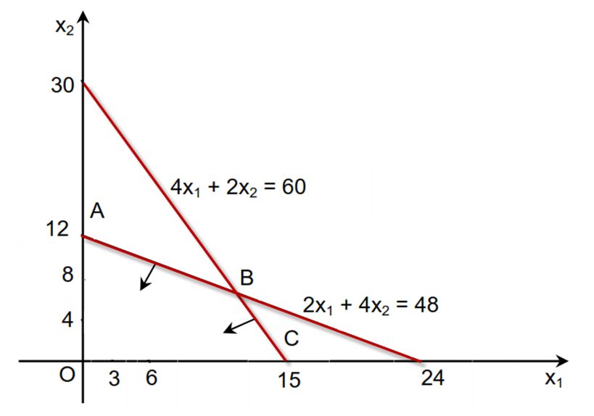

**Step 2**: Inside the feasible region, we find (x1, x2) so that f = 8x1 + 6x2 is maximized. We move the line of [8x1 + 6x2 = a] to each intersections of the feasible region to inspect the objective function value.

(Trong miền khả thi, tìm (x1, x2) sao cho z = 8x1 + 6x2 có giá trị max. Dùng phương pháp đồ thị sau:

+Dịch chuyển song song hàm 8x1 + 6x2 = a

+Ta vẽ đường thẳng: 8x1 + 6x2 = 24 (d1) ở mức a = 24 (cho thuận tiện). (d1) đi qua (0,4) và (3,0).)

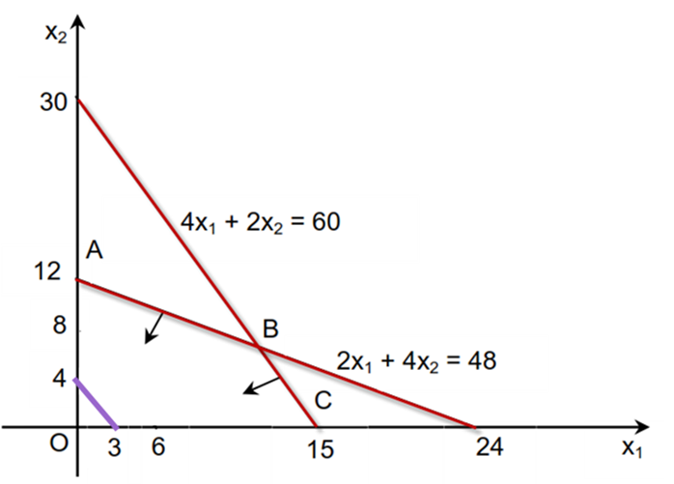

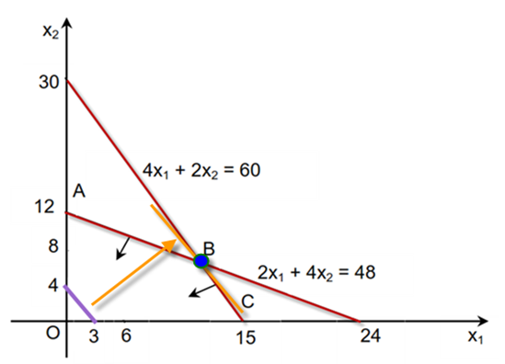

* The optimal solution is always one of the intersections on the boundary of the feasible region.

**Midterm Test**

**Question 1.** A project needs to invest $ 600 and bring in $ 670 after 2 year. Know that the current bank interest rate is 12%. Should we invest in the project?

Question 2. The management of A company is considering to purchase an equipment. The equipment cost is $6500 and will increase annual cash inflow by $2400. The useful life of the equipment is 7 years. After 6 years, it will have no salvage value. With *i* = 12%, should the company purchase the equipment?

**Question 3**.

Duration of A = 3 day. Duration of B = 1 day. Duration of C = 2 day.

Duration of D = 3 day. Duration of E = 2 day. Duration of F = 1 day.

Duration of G = 2 day.

Compute the ES, EF, LS, and LF of all activities.

**Question 4**.

Given the information of a high-rise building project as follows:

|  |  |  |  |  |  |
| --- | --- | --- | --- | --- | --- |
| Activity Name | Total Required Work (Man-hour) | Crewsize (Man) | Minimum Buffer Time (Day) | Total Working Unit | Working time per day (hour) |
| Column Formwork installation | 640 | 20 | 0 | 4 | 8 |
| Column Rebar placing | 960 | 30 | 1 | 4 | 8 |
| Column Concrete pouring | 1280 | 40 | 1 | 4 | 8 |
| Column Formwork stripping | 640 | 20 | 2 | 4 | 8 |
| Beam-Slab Formwork installation | 1920 | 60 | 1 | 4 | 8 |
| Beam-Slab Rebar placing | 1280 | 40 | 1 | 4 | 8 |
| Beam-Slab Concrete pouring | 2560 | 80 | 1 | 4 | 8 |
| Beam-Slab Formwork stripping | 1600 | 50 | 7 | 4 | 8 |
| Finishing | 1280 | 40 | 1 | 4 | 8 |

a. Compute activity rates and required time buffers.

b. Draw the project schedule. Compute the total project duration?

**Question 5.**

|  |  |  |
| --- | --- | --- |
| Year | Quarter | Material cost |
| 2019 | Q1 | 1200 |
|  | Q2 | 1500 |
|  | Q3 | 1400 |
|  | Q4 | 1000 |
| 2020 | Q1 | 1100 |
|  | Q2 | 1450 |
|  | Q3 | 1400 |
|  | Q4 | 950 |
| 2021 | Q1 | 900 |
|  | Q2 | 1200 |
|  | Q3 | 1000 |
|  | Q4 | 800 |

1. Built the time series forecasting model.
2. Forecast the material cost in 2021

**Question 6 .**

Develop a VBA program for constructing a simple linear regression model.

Requirements:

A button to load a matrix of x

A button to load a matrix of y

A button to compute b0 and b1

A button to compute the predicted value y_p of a new xi.

Test the program with the following data:

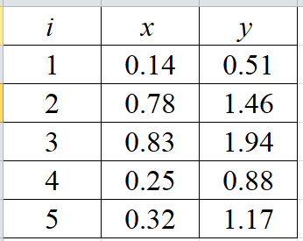

**Question 7**. A company produces two products A and B. Information regarding these products are given by:

|  |  |  |
| --- | --- | --- |
| Information | A | B |
| Profit / 1 unit (1,000,000 VND) | 2 | 3 |
| Number of material X / unit | 1 | 2 |
| Number of material Y / unit | 4 | 3 |
| Number of working hour / unit | 1 | 2 |

In the company's warehouse, there are 50 materials X and 80 materials Y. The maximum number of working hours in a week is 100 hours. Determine the number of products A and B produced in a week so that the company profits are maximum.

a. Formulate the optimization problem

b. Solve the problem using Excel Solver.

**Question 8.**

A company considers the implementation of investments for 6 construction projects, profit (VND billion) and estimated investment requirement (VND billion) for each project is shown in the following table:

|  |  |  |  |  |  |  |
| --- | --- | --- | --- | --- | --- | --- |
| Project | 1 | 2 | 3 | 4 | 5 | 6 |
| Cost | 10 | 8 | 12 | 7 | 6 | 11 |
| Profit | 2.5 | 1.1 | 1.8 | 1.3 | 0.7 | 3.2 |

Knowing the capital capacity of this company is 40 billion VND. Establish mathematical models to optimize the selection of company's investment projects.

**Question 9**.

A company that provides ready-mixed concrete must distribute concrete at the same time for 3 projects. Projects A, B, and C have demand of 200, 350, and 400 m3 of concrete per week. The company provides ready-mixed concrete with 3 mixing stations P1, P2, and P3. The capacity of the 3 stations is 250, 400, and 350 m3 of concrete / week. The transport cost of 1 m3 of concrete from each station to the jobsite of each project is shown in the following table:

|  |  |  |  |
| --- | --- | --- | --- |
|  | Project A | Project B | Project C |
| Plant 1 | 10 | 5 | 7 |
| Plant 2 | 6 | 7 | 10 |
| Plant 3 | 5 | 8 | 9 |

Determine the amount of concrete produced at each station and supply to each project.

**Question 10.**

A manager needs to assign 4 employees to different working shifts in the next 3 days. Each day is divided into 3 shifts.

The estimated demand of each shift is given by:

|  |  |  |  |  |  |  |  |  |  |
| --- | --- | --- | --- | --- | --- | --- | --- | --- | --- |
|  | Day 1 | | | Day 2 | | | Day 3 | | |
|  | Shift 1 | Shift 2 | Shift 3 | Shift 1 | Shift 2 | Shift 3 | Shift 1 | Shift 2 | Shift 3 |
| Demand | 2 | 3 | 3 | 2 | 3 | 2 | 3 | 3 | 2 |

The cost of employment per shift is $10. Given that no employee has to works in more than 2 consecutive shifts. Determine the optimal shift assignment.

**Special Question**

Develop a VBA program for constructing a multiple linear regression model.

Requirements:

A button to load a matrix of x

A button to load a matrix of y

A button to compute b0, b1,.. and bD

A button to compute the predicted value y_p of a new xi.

Test the program with the following data:

|  |  |  |
| --- | --- | --- |
| **X1** | **X2** | **Actual Y** |
| 1.864 | -0.843 | 4.014 |
| 1.546 | 1.320 | 3.069 |
| 1.836 | -0.757 | 4.001 |
| 2.074 | -0.428 | 4.592 |
| 0.672 | 1.438 | 1.224 |
| 1.504 | 1.097 | 3.147 |
| 2.367 | 1.675 | 4.391 |
| -2.075 | -1.587 | -4.406 |
| 2.817 | -1.204 | 5.698 |
| -0.307 | -1.571 | -0.854 |
| -2.084 | 0.302 | -3.695 |
| 1.619 | -0.757 | 3.566 |
| -0.224 | -0.892 | -0.186 |
| -0.500 | 0.535 | -0.585 |
| 1.423 | -1.674 | 2.506 |
| 1.825 | 0.381 | 4.106 |
| 0.802 | 1.399 | 1.517 |
| 1.313 | -1.556 | 2.399 |