**LSHADE-SVM-SVD for Detection of Concrete Surface Voids – Console Program**

**Step 1**: Prepare the data file (.csv) e.g. DataSet_L-SHADE-SVM-SVD.csv (it is noted that the negative class is denoted as 0 and the positive class is denoted as 1)

**Step 2**: Open the file **L-SHADE-SVM-SVD**



**Step 3**: Type the file location, e.g. F:/ DataSet_L-SHADE-SVM-SVD.csv and press Enter

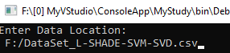

**Step 4**: Prediction performance is reported as follows:

