**Evaluation**

**Student code: DE160252**

**Student name: Tran Dinh Trieu**

- Take a photo of MainActivity:

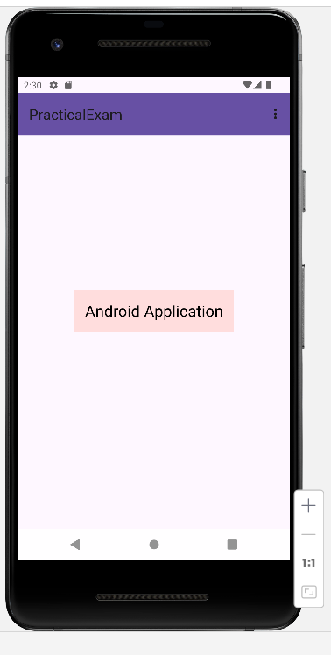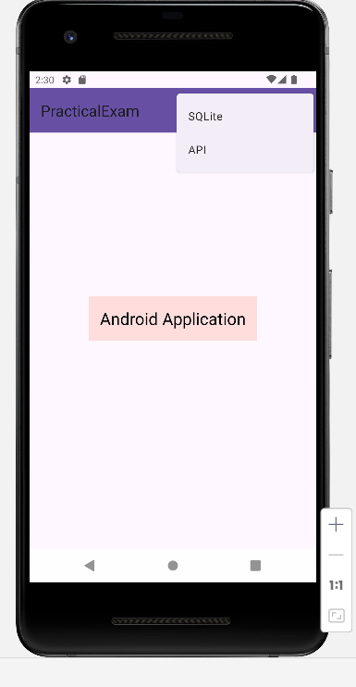

- Take a photo of SQLiteActivity:

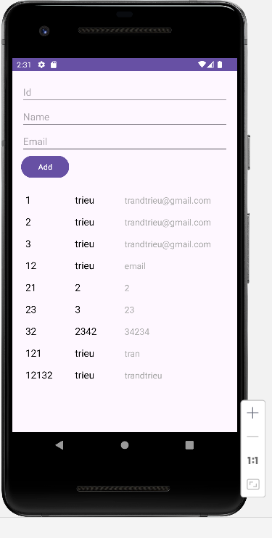

- Take a photo of ApiActivity:

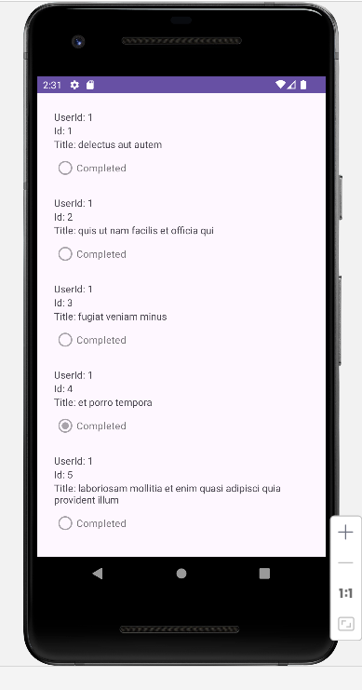

|  |  |  |
| --- | --- | --- |
| **Evaluation** | | |
| **Task** | **Self-assessment score** | **Notes** |
| **1. Create Project: (0.25)** | 0.25 |  |
| **2. Main activity: (1)** | 1 |  |
| **3. SQLiteActivity: (4.75)** | 4.75 |  |
| Database *(1.25)* | 1.12 |  |
| Validate data *(0.5)* | 0.5 |  |
| Add data *(1.5)* | 1.5 |  |
| Display data on RecyclerView *(1.5)* | 1.5 |  |
| **4. ApiActivity: (4)** |  |  |
| Check and request Internet permission *(1.5)* | 0.5 |  |
| Load data from Api and display data on RecyclerView *(2.5)* | 2.5 |  |
|  | **Total:9** |  |