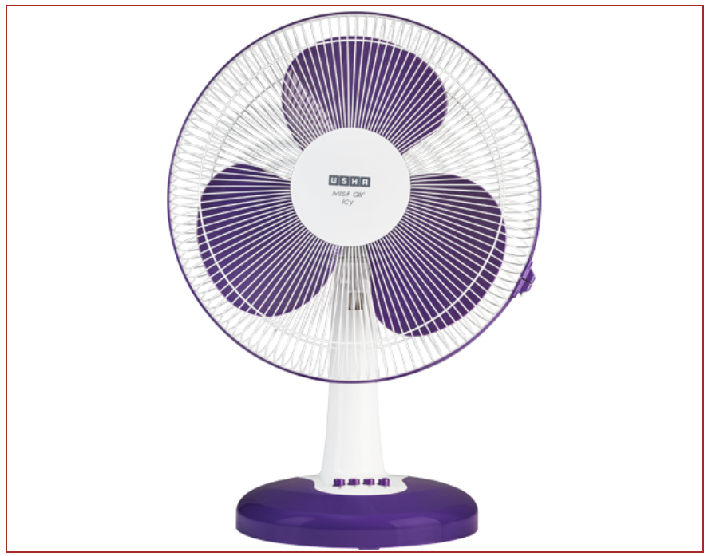

## LINETTO SERIES PURPLE

⭐⭐⭐⭐⭐ (110 reviews)

* Table Fans
* Color: Purple
* Country of Origin: China
* Warranty: 1 year on-site; motor & LED: 5 years

$30.00

Information

So compact that it can be placed anywhere. Can be carried from room to room. Compact yet powerful. Adjust speed for comfort. Optionally choose from 3 speed levels - low, medium or high. The speed can be adjusted using the switch on the fan. The device can create a pleasant cool breeze at all times. In case of abnormal operation, the thermal fuse and current fuse will trip to stop the fan. Two times more reliable, providing peace of mind.

Description

|  |  |
| --- | --- |
| Fan Color | Purple |
| Fan Type | Table Fans |
| Country of Origin | China |
| Series Number | 24 |
| Fan Height | 400-700 mm |
| Fan mode indicator | LED display |
| Remote Control | Include |
| IP rating | ⭐⭐⭐⭐⭐ |
| Number of Blades | 3 |
| Mount Type | Universal |
| Input Power and Required Breaker | 2.6/20 W |
| Operating Temperature | 32 to 104°F |
| Current (min/max speed) | 0.037/0.25 A |
| Warranty | 1 year on-site; motor & LED: 5 years |