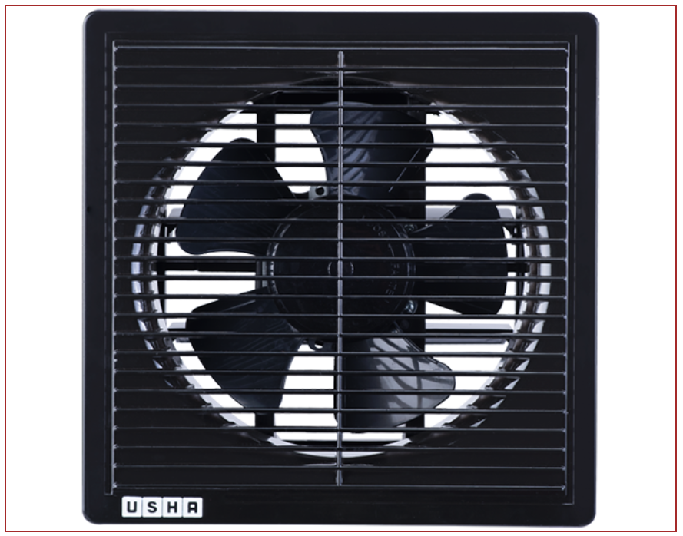

## STRIKER SERIES BLACK

⭐⭐⭐⭐⭐ (150 reviews)

* Exhaust Fans
* Color: Black
* Country of Origin: USA
* Warranty: 3 year on-site; motor & LED: 5 years

$20.00

Information

Super low noise: Molded housing and fan surface minimizes noise from the fan and motor escaping to the outside. This technology can also reduce operating noise to an incredibly low level thanks to “Resonant Noise Absorption” operation, creating a quiet environment. Energy saving: The fan is compatible with a DC (Direct Current) motor to reduce power consumption and save energy. DC motors increase in temperature less than AC (Alternating Current) motors, so the recalibration time of DC motors is relatively longer.

Description

|  |  |
| --- | --- |
| Fan Color | Black |
| Fan Type | Exhaust Fans |
| Country of Origin | USA |
| Series Number | 30 |
| Fan Height | 400-500 mm |
| Fan mode indicator | LED display |
| Remote Control | Include |
| IP rating | ⭐⭐⭐⭐⭐ |
| Number of Blades | 5 |
| Mount Type | Universal |
| Input Power and Required Breaker | 2.6/20 W |
| Operating Temperature | 30 to 120°F |
| Current (min/max speed) | 0.037/0.25 A |
| Warranty | 3 year on-site; motor & LED: 5 years |