**TEXAS ADULT DRIVER EDUCATION CERTIFICATE** **CONTROL NO.**

***{{CONTROL_NUMBER}}***

**DPS COPY *(Type or print legibly in black ink)***

**DRIVER EDUCATION COURSE EXCLUSIVELY FOR ADULTS**

❒ **Driver Education Provider** ❒ **Private School** ❒ **Duplicate** (Original Control # )

❒ **Public School** ❒ **Education Service Center** ❒ **College/University**

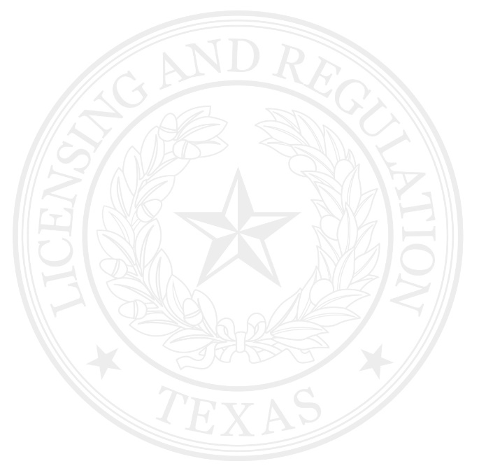

❒ 6 hour classroom course. Completion: / / ❒ 6 hour online course Completion: / /

❒ Has taken and passed the Class C-Road Rules and Class C-Road Signs examinations

{{ROAD_RULE}}

{{ROAD_SIGN}}

**Please indicate Grade with a “P” for pass or numeric grade:** Road Rules ____________ Road Signs _____________

❒ Must take Class C-Road Rules and Class C-Road Signs examinations at the Department of Public Safety.  
❒ Must take vision examination at the Department of Public Safety.

{{FIRST_NAME}}

{{LAST_NAME}}

Name: , Date of Birth: / / ❒ Male ❒ Female

Last First MI

***I hereby certify that the person indicated has completed and passed a six-hour driver education course exclusively for adults approved by the Texas Department of Licensing and Regulation.***

{{TDLR_NUMBER}}

{{SCHOOL_NAME}}

________________ ____________________________________________

Signature of Driver Education Instructor TDLR Number Name of School

{{EDUCATOR_NUMBER}}

{{DATE_ISSUED}}

Signature (or Signature Stamp) of Chief School Official Driver Education School Number Date Issued

WARNING: Submitting this certificate to the Department of Public Safety without completing the course hours indicated or intentional falsification of information is a crime and will be prosecuted. The adult driver education certificate is a government record as defined under Texas Penal Code, §37.01(2). Any misrepresentation by the applicant or person issuing the certificate may result in suspension or revocation of instructor credentials or program approval and/or criminal prosecution**.**

If you have reason to believe that the minimum requirements are not being met at this driving school, please contact Texas Department of Licensing and Regulation, 920 Colorado St, Austin, TX 78701; or call (512) 463-6599. All complaints must be made in writing.

**UNLAWFUL IF REPRODUCED OR ALTERED – INVALID IF TDLR SEAL IS NOT VISIBLE**

**ADEE-1317 (9-1-15)**

**TEXAS ADULT DRIVER EDUCATION CERTIFICATE** **CONTROL NO.**

**SCHOOL COPY *(Type or print legibly in black ink)***

**DRIVER EDUCATION COURSE EXCLUSIVELY FOR ADULTS**

❒ **Driver Education School** ❒ **Private School** ❒ **Duplicate** (Original Control # )

❒ **Public School** ❒ **Education Service Center** ❒ **College/University**

❒ 6 hour classroom course. Completion: / / ❒ 6 hour online course. Completion: / /

❒ Has taken and passed the Class C-Road Rules and Class C-Road Signs examinations

**Please indicate Grade with a “P” for pass or numeric grade:** Road Rules ____________ Road Signs _____________



❒ Must take Class C-Road Rules and Class C-Road Signs examinations at the Department of Public Safety.  
❒ Must take vision examination at the Department of Public Safety.

Name: , Date of Birth: / / ❒ Male ❒ Female

Last First MI

***I hereby certify that the person indicated has completed and passed a six-hour driver education course exclusively for adults approved by the Texas Department of Licensing and Regulation.***

________________ ____________________________________________

Signature of Licensed Driver Education Instructor TDLR Number Name of School

Signature (or Signature Stamp) of Chief School Official Driver Education School Number Date Issued

WARNING: Submitting this certificate to the Department of Public Safety without completing the course hours indicated or intentional falsification of information is a crime and will be prosecuted. The adult driver education certificate is a government record as defined under Texas Penal Code, §37.01(2). Any misrepresentation by the applicant or person issuing the certificate may result in suspension or revocation of instructor credentials or program approval and/or criminal prosecution**.**

If you have reason to believe that the minimum requirements are not being met at this driving school, please contact Texas Department of Licensing and Regulation, 920 Colorado St, Austin, TX 78701; or call (512) 463-6599. All complaints must be made in writing.

**UNLAWFUL IF REPRODUCED OR ALTERED – INVALID IF TDLR SEAL IS NOT VISIBLE**

**ADEE-1317 (9-1-15)**