**C. Report No. 3 Software Requirement Specification**

**1. User Requirement Specification**

**1.1 Customer Requirement**

Customer needs to register an account before he or she can access the system through the mobile application. Customer is allowed to use these features:

* Search for barber
* Get information and location of barbers
* Add favorite barber
* Make reservation for a haircut
* Check in at barber shop
* Give feedback after the haircut
* Make complaints
* Cancel booking
* Manage wallet
* Get hairstyles suggestion

**1.2 Barber Requirement**

Barber accesses the system through barber’s mobile application. Barber have the following features:

* Get bookings from customer
* Shift bookings
* Checkout to get payment
* Cancel booking
* Make complaints
* Access haircut history
* Update profile
* Manage schedules
* Manage services
* Manage wallet
* Manage busy time
* Get hair styles and manage hair skills

**1.3 Staff Requirement**

* Manage barbers
* Manage customers
* Resolve complaints
* Manage hairstyles
* Get statistic
* Configure system

**1.4 System Handler**

* Make haircut reminder periodically
* Provide hairstyle suggestion for customer

**2. System Requirement Specification**

**2.1 External Interface Requirement**

**2.1.1 User Interface**

The customer’s mobile application user interface will be in Vietnamese and provide the following components:

* Intuitive navigation functions.
* Customer registration and user login page.
* Plain text field and button to search for barber.
* An area for presenting barber’s information.
* Slot’s information and button for book.
* An area for personal profile
* Map view to search barber
* Check in button
* Area to show haircut billing

The barber’s mobile application user interface will be in Vietnamese and provide the following components:

* Intuitive navigation functions.
* User registration and user login page.
* Popup to show customer’s booking request information and button confirm or cancel
* An area for presenting booking information and checkout button.
* An area to present haircut history and feedback

The web administration user interface will be in English and contain the following components:

* Guest page.
* Pages for staff to manage partners and their information.
* Pages for staff view transaction details.

**2.1.3 Software Interface**

The BetaFace API provides face recognition services, result in JSON and XML format. These services are fully describe at the website <https://www.betafaceapi.com/wpa/index.php/documentation>

Google Map API provides location services, result in JSON format. These services are fully describe at the website <https://developers.google.com/maps/documentation/javascript/tutorial>

**2.1.4 Communication Protocol**

Use HTTP protocol 1.1 for communication between web services and web

application or mobile device application that consumes the services.

**2.2 System Overview Use Case**

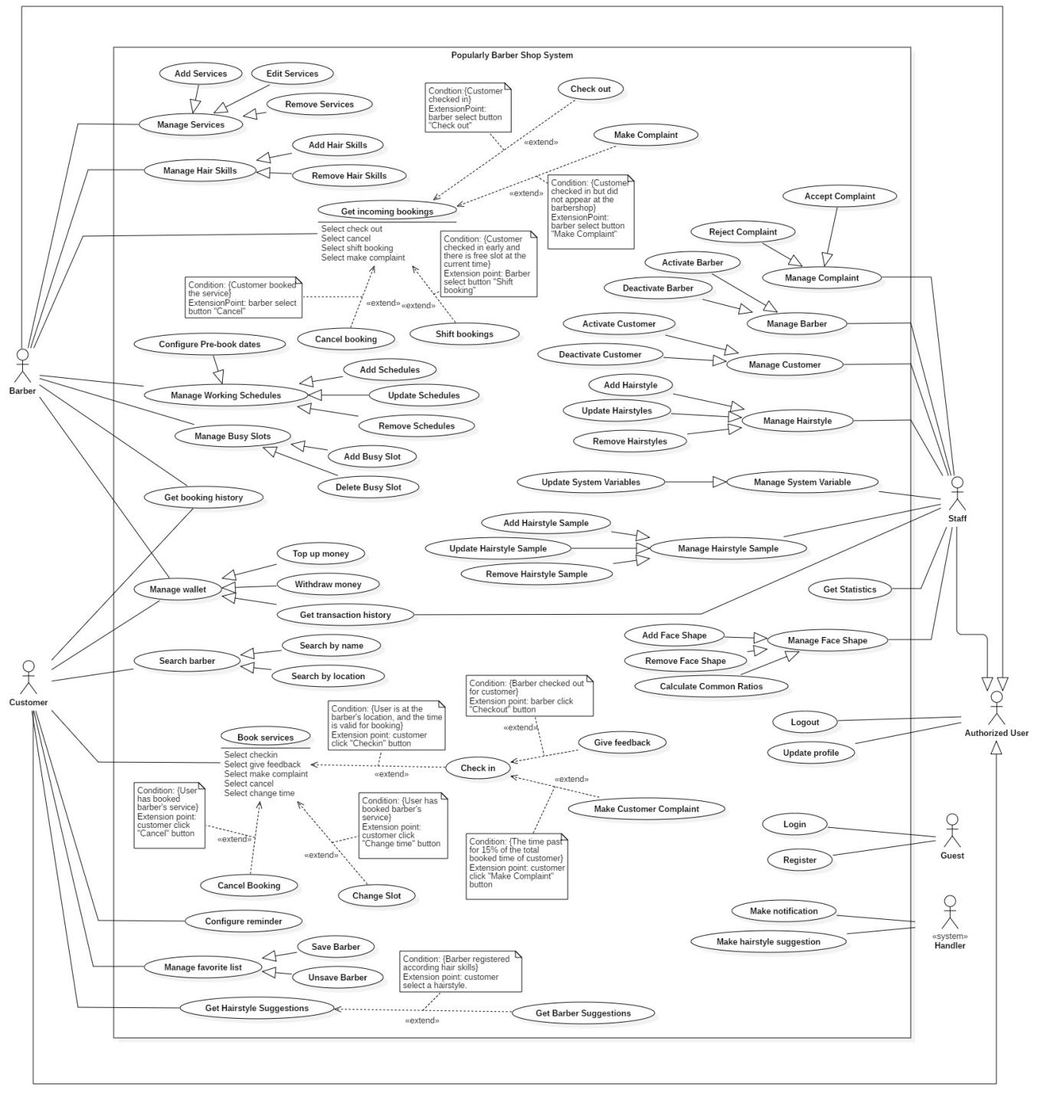

*Figure 3 - System Overview Use Case*

**2.3 List of Use Case**

**2.3.1 <Barber > Overview Use Cases**

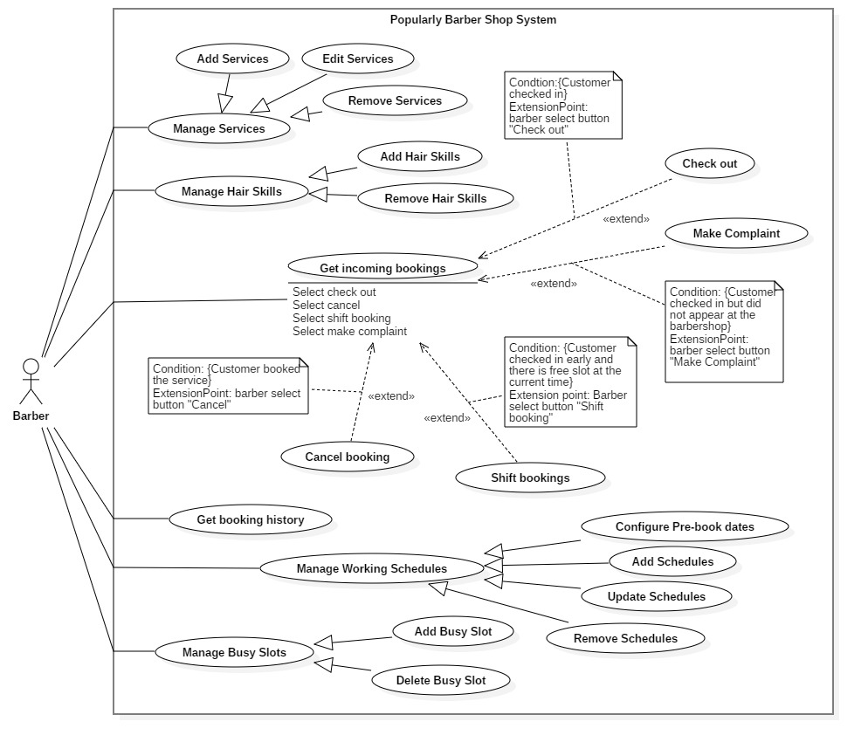

*Figure 4 <Barber> Overview Use Case*

*Figure 6 <Barber> Edit Services*

**2.3.1.1 <Lecturer> Enroll (L01)**

|  |  |  |  |
| --- | --- | --- | --- |
| **USE CASE – B05** | | | |
| **Use Case No.** | L01 | **Use Case Version** | 2.0 |
| **Use Case Name** | Enroll | | |
| **Author** | ThienVN | | |
| **Date** | 24/02/2020 | **Priority** | Medium |
| **Actor:**   * Lecturer.   **Summary:**   * This use case allows lecturer to enroll in the lecturer application.   **Goal:**   * Lecturer can enroll in the system. After enroll successfully, lecturer can do practical exam.   **Triggers:**   * Lecturer send enroll request.   **Preconditions:**   * Lecturer must be contained in the system.   **Post Conditions:**   * **Success:** Lecturer enroll in the system * **Fail:** Show error message.   **Main Success Scenario:**   |  |  |  | | --- | --- | --- | | Step | Actor Action | System Response | | 1 | Lecturer go to log in view | System requires identity information from Lecturer:  - Enroll key: free text input, required, length 3-100 | | 2 | Lecturer input information |  | | 3 | Lecturer send request to enroll in the system | Lecturer will enroll in the system with lecturer role.  [Exception 1]  [Exception 2] |   **Alternative Scenario:** N/A  **Exceptions:**   |  |  |  | | --- | --- | --- | | No | Cause | System Response | | 1 | Lecturer input wrong enroll key | Show message: ”Wrong enroll key”. | | 2 | Lecturer input enroll key with wrong format | Show error message to ask user input correct required information. |   **Relationships:** N/A  **Business Rules:**   * Lecturer input enroll key provided and send enroll request to server. * Enroll key is encrypted before sent to server. * System display a list of practical exam that the lecturer is assigned after enrolled. | | | |

**2.3.1.13 <Lecturer> Download Practical Exam Template (L02)**

|  |  |  |  |
| --- | --- | --- | --- |
| **USE CASE – B13** | | | |
| **Use Case No.** | L02 | **Use Case Version** | 2.0 |
| **Use Case Name** | Download Practical Exam Template | | |
| **Author** | ThienVN | | |
| **Date** | 26/02/2020 | **Priority** | High |
| **Actor:**   * Lecturer.   **Summary:**   * This use case allows lecturer to download a practical exam template.   **Goal:**   * Download practical exam template. Practical exam template is used to import into the evaluation system.   **Triggers:**   * Lecturer send request to download practical exam template   **Preconditions:**   * User must log in into the system with role lecturer. * Practical exam must be contained in the system with status: active.   **Post Conditions:**   * **Success:** Return a practical exam template file. * **Fail:** Display error message.   **Main Success Scenario:**   |  |  |  | | --- | --- | --- | | Step | Actor Action | System Response | | 1 | Lecturer send request to get list practical exams | Display list practical exams  [Exception 1] | | 2 | Lecturer send request to download practical exam template | Return selected practical exam template  [Exception 2] |   **Alternative Scenario:** N/A  **Exceptions:**   |  |  |  | | --- | --- | --- | | Step | Cause | System Response | | 1 | System retrieves an empty list of available practical exam. | Display message: “Not found any available practical exam”. | | 2 | The download process encountered an error. | Error detail will be tracked in a log file.  Displays error message to notify head lecturer that create new test script failed. |   **Relationships:** N/A  **Business Rules:**   * System compress practical exam template to “.zip” file and return. * Practical exam template is a file formatted “*.zip” and used to import into the evaluate system by lecturer. * Practical exam file structure contains:   + List students of practical exam  + Evaluating sever  + Test script files | | | |

**2.3.1.2 <Lecturer> Get Practical Exam (L03)**

|  |  |  |  |
| --- | --- | --- | --- |
| **USE CASE – B06** | | | |
| **Use Case No.** | L03 | **Use Case Version** | 2.0 |
| **Use Case Name** | Get Practical Exam | | |
| **Author** | ThienVN | | |
| **Date** | 24/02/2020 | **Priority** | Medium |
| **Actor:**   * Lecturer.   **Summary:**   * This use case allows lecturer to get practical exam list that he/she is assigned.   **Goal:**   * Display list of assigned practical exam.   **Triggers:**   * Lecturer sends request to get practical exam list is assigned.   **Preconditions:**   * User must log in into system with role lecturer/Lecturer must enroll into the system.   **Post Conditions:**   * **Success:** Display the list of practical exams. * **Fail:** Show error message.   **Main Success Scenario:**   |  |  |  | | --- | --- | --- | | Step | Actor Action | System Response | | 1 | Send request to get list of practical exam . | Return list of practical exam.  Display list of practical exam.  [Exception 1] |   **Alternative Scenario:** N/A  **Exceptions:**   |  |  |  | | --- | --- | --- | | No | Cause | System Response | | 1 | The download process encountered an error. | Error detail will be tracked in a log file.  Displays error message to notify head lecturer that create new test script failed. |   **Relationships:** N/A  **Business Rules:**   * The list of all practical that the lecturer is assigned is displayed and arranged by date created descending. * Practical exam is displayed with states:   + DONE: This practical exam has been done  + NOT_EVALUATE: This practical exam has not been done yet  + ERROR: This practical exam have some error.   * Lecturer select a practical exam in list:   + Desktop application: A view is displayed base on the state of selected  practical exam.  + Web application: Download view is displayed. | | | |

**2.3.1.7 <Lecturer >Import practical exam template (L04)**

*Figure 11 <Barber> Configure Pre-book dates*

|  |  |  |  |
| --- | --- | --- | --- |
| **USE CASE – B07** | | | |
| **Use Case No.** | L04 | **Use Case Version** | 2.0 |
| **Use Case Name** | Import practical exam template | | |
| **Author** | ThienVN | | |
| **Date** | 09/02/2019 | **Priority** | Medium |
| **Actor:**   * Lecturer.   **Summary:**   * This use case allows lecturer to import a practical exam template.   **Goal:**   * Import a new practical exam template that supports to do a practical exam.   **Triggers:**   * Lecturer send import practical exam template request.   **Preconditions:**   * Lecturer must enroll in the system. * Practical exam template must be contained in the system with status: active and state “NOT_EVALUATE”.   **Post Conditions:**   * **Success:** Practical exam is imported successfully and display list student view. * **Fail:** Show error message.   **Main Success Scenario:**   |  |  |  | | --- | --- | --- | | Step | Actor Action | System Response | | 1 | Lecturer select a practical exam with state “NOT_EVALUATE” from practical exam list view | Display a file dialog for lecturer to select.  System require practical exam template file: “.zip” or “.rar”. | | 2 | Lecturer select a file |  | | 3 |  | Display a list of students in class assigned to this practical exam.  [Exception 1] |   **Alternative Scenario:** N/A  **Exceptions:**   |  |  |  | | --- | --- | --- | | No | Cause | System Response | | 1 | Lecturer select wrong file or wrong file format. | Show message box: “Can not import script”. |     **Relationships:** N/A  **Business Rules:**   * Selected practical exam must have state “NOT_EVALUATE”. * Practical exam template file format must be: “.zip” or “.rar”. * Selected practical template file is extracted into the system with:   + List students of practical exam  + Evaluating sever  + Test script files   * List of student in list student file which is extracted from practical exam template is displayed. | | | |

**2.3.1.8 <Lecturer > Get Practical Exam’s Student List (B04)**

|  |  |  |  |
| --- | --- | --- | --- |
| **USE CASE – B08** | | | |
| **Use Case No.** | L05 | **Use Case Version** | 2.0 |
| **Use Case Name** | Get Practical Exam’s Student List | | |
| **Author** | ThienVN | | |
| **Date** | 25/02/2020 | **Priority** | Medium |
| **Actor:**   * Lecturer.   **Summary:**   * This use case allows Lecturer to view list student of a practical exam.   **Goal:**   * Display list student of selected practical exam.   **Triggers:**   * Imported practical exam template or select practical exam template with state “DONE ” or “ERROR”.   **Preconditions:**   * Lecturer must log in into system. * Practical exam template of selected practical exam must exist in practical exam folder of lecturer application.   **Post Conditions:**   * **Success:** Display list student. * **Fail:** Show error message.   **Main Success Scenario:**   |  |  |  | | --- | --- | --- | | Step | Actor Action | System Response | | 1 | Lecturer imported practical exam template or select practical exam template with state “DONE ” or “ERROR” | Display list of student with information:  + Index of student  + Student code  + Student name  + Script code  + Submit time  + Evaluate time  + Index of student  + Result  + Total point  + Error  [Exception 1] |   **Alternative Scenario:** N/A  **Exceptions:**   |  |  |  | | --- | --- | --- | | No | Cause | System Response | | 1 | List student file is deleted from practical exam template. | Show message box: “Can not find list student in this practical exam”. |   **Relationships:** N/A  **Business Rules:**   * Get list student of selected practical exam. * The list of student is showed like the table below:  |  |  |  |  |  |  |  |  |  |  | | --- | --- | --- | --- | --- | --- | --- | --- | --- | --- | | NO | Student Code | Student Name | Script Code | Status | Submit Time | Evaluate Time | Result | Total point | Error |  * The results presented on this table will depend on whether the user selects the practical with a status of "done", "not evaluate" or "error". The system will filter the corresponding result on the available set. | | | |

**2.3.1.9 <Lecturer > Get student result (L06)**

|  |  |  |  |
| --- | --- | --- | --- |
| **USE CASE – B09** | | | |
| **Use Case No.** | L06 | **Use Case Version** | 2.0 |
| **Use Case Name** | Get student result | | |
| **Author** | ThienVN | | |
| **Date** | 25/02/2020 | **Priority** | Medium |
| **Actor:**   * Lecturer.   **Summary:**   * This use case allows Lecturer to get submission evaluated results.   **Goal:**   * Display submission evaluated result.   **Triggers:**   * Receive evaluated submission notification from the system.   **Preconditions:**   * Lecturer must enroll into the system. * Selected practical exam must have state “NOT_EVALUATE” or “ERROR”.   **Post Conditions:**   * **Success:** Student list will be updated with the evaluated result. * **Fail:** Do notupdate evaluated information in student list.   **Main Success Scenario:**   |  |  |  | | --- | --- | --- | | Step | Actor Action | System Response | | 1 |  | Return evaluated submission notification and information. | | 2 |  | Update information in student list with the evaluated result. |   **Alternative Scenario:** N/A  **Exceptions:** N/A  **Relationships:** N/A  **Business Rules:**   * Lecturer application listens to evaluated submission notification. * Student list is updated base on received evaluated submission   information:  + Status is set to “EVALUATED”  + Evaluate Time  + Result is number of correct answer on total question.  + Total point  + Error is set to “ERROR” if evaluated submission with error. | | | |

**2.3.1.10 <Lecturer> Publish Student Result(L07)**

|  |  |  |  |
| --- | --- | --- | --- |
| **USE CASE – B10** | | | |
| **Use Case No.** | L07 | **Use Case Version** | 2.0 |
| **Use Case Name** | Publish Student Result | | |
| **Author** | ThienVN | | |
| **Date** | 26/02/2020 | **Priority** | Medium |
| **Actor:**   * Lecturer.   **Summary:**   * This use case allows lecturer to publish student point to student.   **Goal:**   * Send evaluated point to student application.   **Triggers:**   * Lecturer send publish request.   **Preconditions:**   * Lecturer must enroll into the system. * Selected practical exam must have state “NOT_EVALUATE”.   **Post Conditions:**   * **Success:** Submission point is sent to student application. * **Fail:** Student’s view does not display student point.   **Main Success Scenario:**   |  |  |  | | --- | --- | --- | | Step | Actor Action | System Response | | 1 | Lecturer sends request to publish student point | Display message: “Publish successfully” |   **Alternative Scenario:** N/A  **Exceptions:** N/A  **Relationships:** N/A  **Business Rules:**   * System get connection of all student connected to lecturer. * Student point is sent to student through connection. * Student receives only his/her point. | | | |

**2.3.1.11 <Lecturer> Generate Student Report(L08)**

|  |  |  |  |
| --- | --- | --- | --- |
| **USE CASE – B11** | | | |
| **Use Case No.** | L08 | **Use Case Version** | 2.0 |
| **Use Case Name** | Generate Student Report | | |
| **Author** | ThienVN | | |
| **Date** | 26/02/2020 | **Priority** | Medium |
| **Actor:**   * Lecturer.   **Summary:**   * This use case allows lecturer to create a file report of evaluated student submission.   **Goal:**   * Create submission report file.   **Triggers:**   * Lecturer sends generate report request.   **Preconditions:**   * Lecturer must enroll into system.   **Post Conditions:**   * **Success:**  A submission report file is created. * **Fail:** submission report file is not created.   **Main Success Scenario:**   |  |  |  | | --- | --- | --- | | Step | Actor Action | System Response | | 1 | Lecturer sends generate report request. | Generate a report file. |   **Alternative Scenario:** N/A  **Exceptions:** N/A  **Relationships:** N/A  **Business Rules:**   * Report file is created at a directory that lecturer chooses. * All the information of list student is written in created report file. * Report file contains:   + Index of student  + Student code  + Student name  + Script code  + Submit time  + Evaluate time  + Index of student  + Result  + Total point  + Error | | | |

**2.3.1.12 <Lecturer> Re-Evaluate Submission(L09)**

|  |  |  |  |
| --- | --- | --- | --- |
| **USE CASE – B12** | | | |
| **Use Case No.** | L09 | **Use Case Version** | 2.0 |
| **Use Case Name** | Re-Evaluate Submission | | |
| **Author** | ThienVN | | |
| **Date** | 26/02/2020 | **Priority** | Medium |
| **Actor:**   * Lecturer.   **Summary:**   * This use case allows lecturer to re-evaluate submission.   **Goal:**   * Re-Submit and evaluate submission. Evaluated submission result will be updated with re-evaluated submission result.   **Triggers:**   * Lecturer send re-evaluate submission request.   **Preconditions:**   * Lecturer must enroll into system. * Selected practical exam must have state “ERROR”.   **Post Conditions:**   * **Success:** Show success message * **Fail:** Show error message.   **Main Success Scenario:**   |  |  |  | | --- | --- | --- | | Step | Actor Action | System Response | | 1 | Lecturer select a student from student list to re-evaluate | System displays confirm message: “Do you want to re-evaluate this submission” and requires lecturer to confirm. | | 2 | Lecturer confirm “Yes” to re-evaluate submission  [Alternative1] | Send selected submission to re-evaluate | | 3 |  | Return success message: “Submit successfully”  [Exception1] |   **Alternative Scenario:**   |  |  |  | | --- | --- | --- | | No | Actor Action | System Response | | 1 | Lecturer confirm “No” to re-evaluate submission | Back to student list view |   **Exception:**   |  |  |  | | --- | --- | --- | | No | Cause | System Response | | 1 | Can not connect to submission web service | Return success message: “Submit fail” |   **Relationships:** N/A  **Business Rules:**   * System get submission of selected student * Submission is uploaded to the system to re-evaluate * Lecturer application listens to evaluated submission notification. * Student list is updated base on received evaluated submission   information:  + Status is set to “EVALUATED”  + Evaluate Time  + Result is number of correct answer on total question.  + Total point  + Error is set to “ERROR” if evaluated submission with error.   * Evaluated submission result will be updated with re-evaluated submission   result. | | | |

**2.3.1.13** 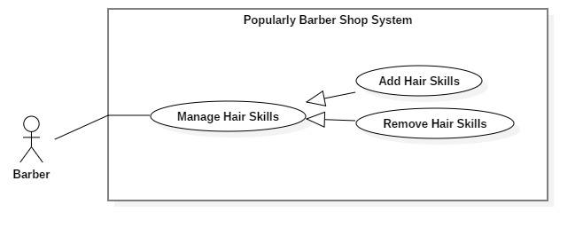

*Figure 17 <Barber> Manage Hair Skills*

|  |  |  |  |
| --- | --- | --- | --- |
| **USE CASE – B13** | | | |
| **Use Case No.** | B13 | **Use Case Version** | 2.0 |
| **Use Case Name** | Manage Hair Skills | | |
| **Author** | NhanLC | | |
| **Date** | 10/02/2019 | **Priority** | High |
| **Actor:**   * Barber.   **Summary:**   * This use case allows Barber to add or remove their hair skills.   **Goal:**   * Add or remove hair skills.   **Triggers:**   * Update the value of barber’s hair skills.   **Preconditions:**   * Barber must login into system and go to HairStyle screen.   **Post Conditions:**   * **Success:** Add or remove a barber’s hair skills. * **Fail:** Show error message.   **Main Success Scenario:**   |  |  |  | | --- | --- | --- | | Step | Actor Action | System Response | | 1 | Barber sends request to receive detail of hairstyle. | Display information of hairstyle screen. | | 2 | Barber choose the images that describes the hairstyle.  [Alternative 1] | Mark on the image that barber chooses | | 3 | Barber ends command to update by “Cập nhật” button.  [Alternative 2] | Show message: “Cập nhật thành công” and back to “HairStyle” screen |   **Alternative Scenario:**     |  |  |  | | --- | --- | --- | | No | Actor Action | System Response | | 1 | If barber want remove this image from his skills, choose image again | Unmark on the image that barber chooses | | 2 | Barber clicks “Hủy” button. | Back to “HairStyle” screen |   **Exceptions:**   |  |  |  | | --- | --- | --- | | No | Actor Action | System Response | | 1 | Barber edit time over period of selected slot | System shows error message to ask user input correct information. |   **Relationships:** Specialized from Manage Hair Style  **Business Rules:**   * Get information of hairstyle. | | | |

*Table 18 <Barber> Manage Hair Skills*

##### **2.3.1.14 <Barber> Get Bookings use case (B14)**

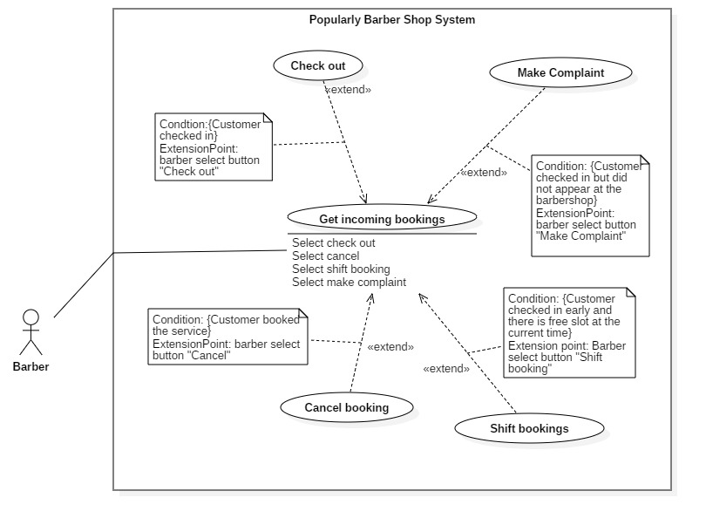

*Figure 19 <Barber> Get Incoming Bookings*

|  |  |  |  |
| --- | --- | --- | --- |
| **USE CASE – B14** | | | |
| **Use Case No.** | B14 | **Use Case Version** | 2.0 |
| **Use Case Name** | Get Incoming Bookings | | |
| **Author** | NamBM | | |
| **Date** | 10/02/2019 | **Priority** | High |
| **Actor:**   * Barber   **Summary:**   * This use case describes how to get barber’s bookings of a specific date.   **Goal:**   * Barber gets all the bookings by dates with full details and status.   **Triggers:**   * Barber selects Home icon in barber’s application.   **Preconditions:**   * Barber has already logged in the system. * Barber has defined the working schedule and haircut services.   **Post Conditions:**   * **Success**: Barber gets all the bookings of the selected date. * **Fail**: System sends error message.   **Main Success Scenario:**   |  |  |  | | --- | --- | --- | | Step | Actor Action | System Response | | 1 | Barber sends request to get all bookings of the current date  [Alternative 1] | Displays a list of all bookings of barber of the requested date, with details and color status.  [Alternative 2] |   **Alternative Scenario:**   |  |  |  | | --- | --- | --- | | **No** | **Cause** | **System Response** | | 1 | Barber selects a specific date and sends request to get all bookings of that date. | Displays a list of all bookings of barber of the requested date, with details and color status. [Alternative 2] | | 2 | There is no booking on the date that barber has sent request for. | Displays message “Bạn chưa có lịch hẹn nào trong ngày này” |   **Exceptions:** N/A  **Relationships:** N/A  **Business Rules:**   * Get all the bookings with state “Booked” or “Checked in” of the given date. * Update bookings state, remove suspended ones if exists. * Add all bookings to result list. * Get the working schedules of barber in that date, combine with bookings to calculate free times and add free times to the result list. * Sort the result list by time. | | | |

*Table <Barber> Get Incoming Bookings*

##### **2.3.1.15 <Barber> Checkout (B15)**



*Figure 20 <Barber> Check out*

|  |  |  |  |
| --- | --- | --- | --- |
| **USE CASE – B15** | | | |
| **Use Case No.** | B15 | **Use Case Version** | 2.0 |
| **Use Case Name** | Check out | | |
| **Author** | NamBM | | |
| **Date** | 10/02/2019 | **Priority** | High |
| **Actor:**   * Barber   **Summary:**   * This use case describes how a barber checks out for a customer   **Goal:**   * Barber checked out for a customer to do the payment after barber had finished haircut services.   **Triggers:**   * Barber sends request to check out a specific customer   **Preconditions:**   * Customer checked in at the barbershop.   **Post Conditions:**   * **Success**: The customer is checked out and the payment is processed successfully. * **Fail**: System displays error message.   **Main Success Scenario:**   |  |  |  | | --- | --- | --- | | Step | Actor Action | System Response | | 1 | Barber takes photo and inserts surcharges if needed, then sends request to check out booking | Displays successful message  [Exception 1] |   **Alternative Scenario:** N/A  **Exceptions:**   |  |  |  | | --- | --- | --- | | **No** | **Cause** | **System Response** | | 1 | Surcharge amount exceeds the current balance of customer (if payment method is wallet) | Display error to barber application |   **Relationships:** Extend from Get Incoming Bookings  **Business Rules:**  After the barber provided haircut services for a customer, he or she will check out for that customer:   * Barber takes photo of customer’s haircut, and input surcharge if needed. * The booking state will turn from “Checked in” into “Checked out”. * The system processes payments:   + Transfers money to barber’s wallet if payment was in wallet.   + Reminds barber to check enough amount of cash if payment was in cash | | | |

*Table <Barber> Check out*

##### **2.3.1.16 <Barber> Make Complaint (B16)**



*Figure 21 <Barber> Make Complaint*

|  |  |  |  |
| --- | --- | --- | --- |
| **USE CASE – B16** | | | |
| **Use Case No.** | B16 | **Use Case Version** | 2.0 |
| **Use Case Name** | Make Complaint | | |
| **Author** | NamBM | | |
| **Date** | 10/02/2019 | **Priority** | Medium |
| **Actor:**   * Barber   **Summary:**   * This use case describes how barber report a fraud customer   **Goal:**   * Barber reports a customer for his fraud behavior.   **Triggers:**   * Barber sends request to report a customer   **Preconditions:**   * Customer checked in at the barbershop.   **Post Conditions:**   * **Success**: The booking is cancelled and the barber received the deposit from customer. * **Fail**: System displays error message.   **Main Success Scenario:**   |  |  |  | | --- | --- | --- | | Step | Actor Action | System Response | | 1 | Barber sends request to report a specific customer with reason and photos as evidences. | Displays message “Yêu cầu của bạn đã gửi thành công. Xin vui lòng chờ phản hồi từ quản trị viên hệ thống.”  [Alternative 1] [Alternative 2] |   **Alternative Scenario:**   |  |  |  | | --- | --- | --- | | **No** | **Cause** | **System Response** | | 1 | The administrator accepts the request from the barber. | Displays message “Quản trị viên đã chấp nhận báo cáo của bạn về hành vi gian lận của khách hàng” | | 2 | The administrator rejects the request from the barber. | Displays message “Báo cáo của bạn không hợp lệ” |   **Exceptions:** N/A  **Relationships:** Extend from Get Incoming Bookings  **Business Rules:**  When a customer has checked in the barbershop but disappeared at the shop, this could be considered as a fraud behavior.   * After the complaint request has been sent, the system administrator will collect and examine evidence about the absence of the customer, to decide whether this request will be accepted or rejected. * Evidence includes customer locations from the checked-in time to the current time. * If the request is accepted, the booking will be considered cancelled by customer, its state changed into “Customer cancelled”, and the barber will receive the booking deposit. * If the request is rejected, the booking will remain unchanged. | | | |

*Table <Barber> Make Complaint*

##### **2.3.1.17 <Barber> Cancel booking (B17)**



*Figure 22 <Barber> Cancel booking*

|  |  |  |  |
| --- | --- | --- | --- |
| **USE CASE – B17** | | | |
| **Use Case No.** | B17 | **Use Case Version** | 2.0 |
| **Use Case Name** | Cancel Booking | | |
| **Author** | NamBM | | |
| **Date** | 10/02/2019 | **Priority** | High |
| **Actor:**   * Barber   **Summary:**   * This use case describes how barber cancel a booking   **Goal:**   * Barber cancels a booking in unwanted situations.   **Triggers:**   * Barber sends request to cancel a booking   **Preconditions:**   * The booking has not been checked out or cancelled by customer.   **Post Conditions:**   * **Success**: The booking is cancelled and the customer received the deposit from barber. * **Fail**: System displays error message.   **Main Success Scenario:**   |  |  |  | | --- | --- | --- | | Step | Actor Action | System Response | | 1 | Barber sends request to cancel a specific booking | Displays a popup with message “Bạn sẽ bị trừ tiền cọc là 10,000 đồng. Bạn có chắc muốn hủy cuộc hẹn này?” and two button “Đồng ý” and “Thoát” | | 2 | Barber selects button “Đồng ý”  [Alternative 1] | Display message “Cuộc hẹn với khách hàng đã hủy” and navigate to Home screen |   **Alternative Scenario:**   |  |  |  | | --- | --- | --- | | **No** | **Cause** | **System Response** | | 1 | Barber selects button “Thoát” | Hide the popup and back to the screen showing booking details |   **Exceptions:** N/A  **Relationships:** Extend from Get Incoming Bookings  **Business Rules:**  In some unwanted situations, the barber needs to cancel a booking.   * Deposit from customer will be returned, and an amount of money will be transfered from barber’s wallet into customer’s wallet as a compensation. | | | |

*Table <Barber> Cancel booking*

##### **2.3.1.18 <Barber> Shift Bookings (B18)**



*Figure 23 <Barber> Shift bookings*

|  |  |  |  |
| --- | --- | --- | --- |
| **USE CASE – B18** | | | |
| **Use Case No.** | B18 | **Use Case Version** | 2.0 |
| **Use Case Name** | Shift Bookings | | |
| **Author** | NamBM | | |
| **Date** | 10/02/2019 | **Priority** | High |
| **Actor:**   * Barber   **Summary:**   * This use case describes how a barber shifts bookings of customers who has checked in the shop   **Goal:**   * Barber shifts the bookings time to create more available time for other customers to book.   **Triggers:**   * Barber sends request to shift a specific booking time   **Preconditions:**   * Customer checked in at the barbershop.   **Post Conditions:**   * **Success**: The time of a booking is adjusted. * **Fail**: System displays error message.   **Main Success Scenario:**   |  |  |  | | --- | --- | --- | | Step | Actor Action | System Response | | 1 | Barber sends request to shift a specific booking | Displays successful message and refresh the view of current schedule  [Exception 1] |   **Alternative Scenario:** N/A  **Exceptions:**   |  |  |  | | --- | --- | --- | | **No** | **Cause** | **System Response** | | 1 | The target time has been booked by another customer | Display message “Không thể thực hiện dời lịch cho khách” and refresh the view of current schedule. |   **Relationships:** Extend from Get Incoming Bookings  **Business Rules:**   * Determine the booking that needs to be shifted (A). If (A) does not have “Checked in” state, then do nothing. * Get the free time standing previous (A). * If no free time found, do nothing. * If a free time found, switch the start time of that free time with (A), and update to the state history database. | | | |

*Table <Barber> Shift Bookings*

##### **2.3.1.18 <Customer> Overview Use Cases**

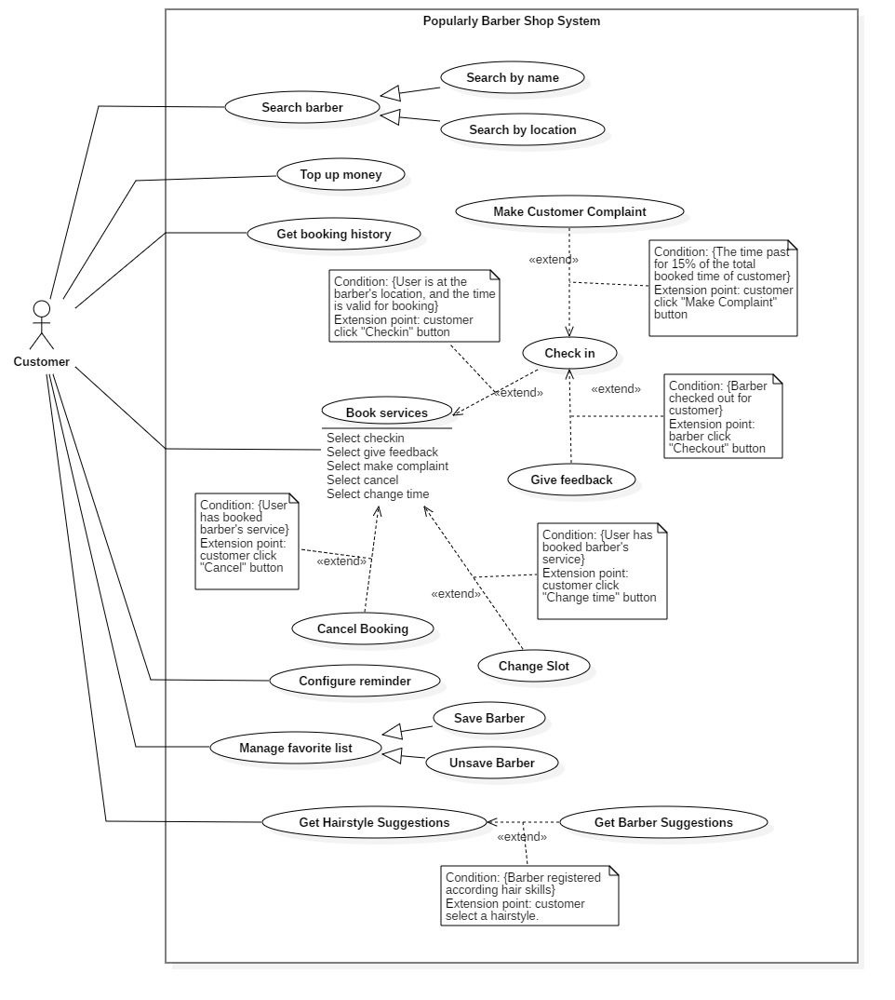

*Figure 24 <Customer> Overview Use Case*

**2.3.2.1 <Customer> Search by location (C01)**

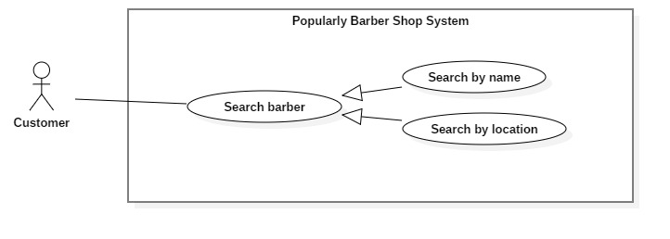

*Figure 25 <Customer> Search by location*

|  |  |  |  |
| --- | --- | --- | --- |
| **USE CASE – C01** | | | |
| **Use Case No.** | C01 | **Use Case Version** | 2.0 |
| **Use Case Name** | Search by location | | |
| **Author** | Nguyễn Hữu Thiện | | |
| **Date** | 09/02/2019 | **Priority** | High |
| **Actor:**   * Customer   **Summary:**   * This use case describes how does customer search barber by location   **Goal**   * To search barber by location   **Triggers:**   * Guest send search command and current location   **Preconditions:**   * Data have already existed.   **Post Conditions:**   * **Success**: Show list of available barbers. * **Fail**: Error is tracked in log file   **Main Success Scenario:**   |  |  |  | | --- | --- | --- | | Step | Actor Action | System Response | | 1 | Customer send search command with current location  [Alternative 1] | System get customer location and display barber in range to customer  [Alternative 2] |   **Alternative Scenario:**   |  |  |  | | --- | --- | --- | | **No** | **Cause** | **System Response** | | 1 | Customer input address to search | System get location from provided address and display barber in range to customer [Alternative 2] | | 2 | Customer retrieves an empty list of service. | Display message “Không tìm thấy thợ cắt tóc gần bạn”. |   **Exceptions:** N/A  **Relationships:** Specialized from Search barber  **Business Rules:**   * Get current location of customer. * Find barbers whose location is close to customer. | | | |

*Table <Customer> Search by location*

**2.3.2.1 <Customer> Search by name(C02)**

*Figure 26 <Customer> Search by name*

|  |  |  |  |
| --- | --- | --- | --- |
| **USE CASE – C01** | | | |
| **Use Case No.** | C02 | **Use Case Version** | 2.0 |
| **Use Case Name** | Search by name | | |
| **Author** | Nguyễn Hữu Thiện | | |
| **Date** | 09/02/2019 | **Priority** | High |
| **Actor:**   * Customer   **Summary:**   * This use case describes how does customer search barber by name   **Goal**   * To search barber by name   **Triggers:**   * Guest send search command and search value   **Preconditions:**   * Data have already existed.   **Post Conditions:**   * **Success**: Show list of available barbers. * **Fail**: Error is tracked in log file   **Main Success Scenario:**   |  |  |  | | --- | --- | --- | | Step | Actor Action | System Response | | 1 | Customer send search command with search value | System return list of barbers whose name contains search value  [Alternative 1] |   **Alternative Scenario:**   |  |  |  | | --- | --- | --- | | **No** | **Cause** | **System Response** | | 1 | Customer retrieves an empty list of service. | Display message “Không tìm thấy thợ cắt tóc gần bạn”. |   **Exceptions:** N/A  **Relationships:** Specialized from Search barber  **Business Rules:**   * Customer finds barbers by their name. | | | |

*Table <Customer> Search by name*

**2.3.2.3 <Customer> Book services (C03)**

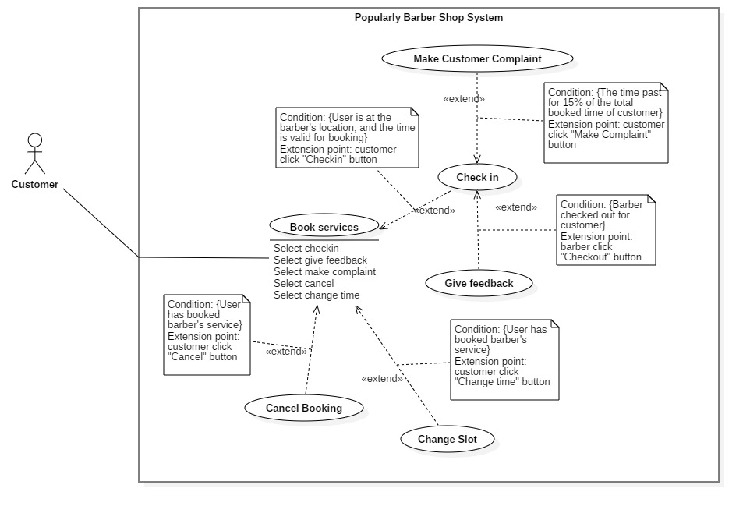

*Figure 27 <Customer> Book services*

|  |  |  |  |
| --- | --- | --- | --- |
| **USE CASE – C03** | | | |
| **Use Case No.** | C03 | **Use Case Version** | 2.0 |
| **Use Case Name** | Book services | | |
| **Author** | Nguyễn Hữu Thiện | | |
| **Date** | 03/04/2019 | **Priority** | High |
| **Actor:**   * Customer   **Summary:**   * This use case describes how does customer book barber’s service   **Goal**   * Customer created a booking with barber they wants.   **Triggers:**   * Customer sends book command   **Preconditions:**   * Barber defined working schedule and services.   **Post Conditions:**   * **Success**: Customer books schedule with services of a barber. * **Fail**: Display error message.   **Main Success Scenario:**   |  |  |  | | --- | --- | --- | | Step | Actor Action | System Response | | 1 | Customer sends request to book services of barber | Display list of barber’s services with full details | | 2 | Customer selects services of barber, chooses payment method, and sends request to choose time | Calculate available times based on selected services and display for customer to choose | | 3 | Customer selected time and confirm booking | Display success message: “Đặt lịch thành công”  [Exception 1]  [Exception 2] |   **Alternative Scenario: N/A**  **Exceptions:**   |  |  |  | | --- | --- | --- | | **No** | **Cause** | **System Response** | | 1 | Selected time is not available | Display available times for customer. | | 2 | Customer’s wallet not enough for the deposit | Display message: “Số dư ví không đủ để đặt lịch, vui lòng nạp thêm tiền vào ví.” |   **Relationships:** N/A  **Business Rules:**  To make a booking with barbers, customer must selects target barber and selects the services they provides. The system will calculate available slots for customer as follow:   * Get schedules of barber as total available time (1) * Get all incoming bookings and busy slots of barber as busy time (2) * Get traveling time from customer location to barber address using Google Map API (3) * Exclude (2) and (3) from (1) to get current available time of barber * From selected services, calculate the total serving time. * Divide current available time by total serving time to produce available slots. Return result to customer to let them select.   After selecting slot and payment method, customer confirm to make booking:   * Save data of booking into system. * Process payment according to payment method that customer has chosen.   + If payment is in cash, an amount of money will be captured as reservation fee, and will be refunded when barber checks out booking.   + If payment is by wallet, system will capture the total fee in advanced, then transfer to barber at the checkout moment. * In case there was somebody has booked the slot before the customer, system will suggest other slots for customer | | | |

*Table <Customer> Book services*

**2.3.2.4 <Customer> Cancel booking (C04)**



*Figure 28 <Customer> Cancel booking*

|  |  |  |  |
| --- | --- | --- | --- |
| **USE CASE – C04** | | | |
| **Use Case No.** | C04 | **Use Case Version** | 2.0 |
| **Use Case Name** | Cancel booking | | |
| **Author** | Nguyễn Hữu Thiện | | |
| **Date** | 03/04/2019 | **Priority** | High |
| **Actor:**   * Customer   **Summary:**   * This use case describes how customer cancel booked schedule.   **Goal**   * To cancel booking   **Triggers:**   * Customer sends cancel booked schedule.   **Preconditions:**   * Schedule was booked by customer. * Customer has not checked in yet.   **Post Conditions:**   * **Success**: Booking is cancelled. * **Fail**:   + Send fail message   + Error is tracked in log file.   **Main Success Scenario:**   |  |  |  | | --- | --- | --- | | Step | Actor Action | System Response | | 1 | Customer send cancel booking. | Display success message: “Hủy lịch hẹn thành công”. |   **Alternative Scenario:** N/A  **Exceptions:**   |  |  |  | | --- | --- | --- | | **No** | **Cause** | **System Response** | | 1 | The cancel process encountered an error | Display fail message: “Hủy lịch hẹn không thành công”.  Error detail will be tracked in a log file |   **Relationships:** Extend from Book services  **Business Rules:**  After customer confirm cancel booking, the system will:   * Set booking state to be cancelled by customer. * Release booked slot and charge compensation fee on customer | | | |

*Table <Customer> Cancel booking*

**2.3.2.5 <Customer> Check in (C05)**



*Figure 29 <Customer> Check in*

|  |  |  |  |
| --- | --- | --- | --- |
| **USE CASE – C05** | | | |
| **Use Case No.** | C05 | **Use Case Version** | 2.0 |
| **Use Case Name** | Check in | | |
| **Author** | Nguyễn Hữu Thiện | | |
| **Date** | 09/02/2019 | **Priority** | High |
| **Actor:**   * Customer   **Summary:**   * This use case describes how customer checks in after booking.   **Goal**   * Customer checked in at the barber shop and starts waiting.   **Triggers:**   * Customer send check in command   **Preconditions:**   * Schedule was booked by customer. * Customer must be close to the barber location at schedule time.   **Post Conditions:**   * **Success**: Customer check in success and booking change to check in. * **Fail**: Error is tracked in log file.   **Main Success Scenario:**   |  |  |  | | --- | --- | --- | | Step | Actor Action | System Response | | 1 | Customer send check in command | Display success message: “Check in thành công”.  [Alternative 1] |   **Alternative Scenario:**   |  |  |  | | --- | --- | --- | | **No** | **Cause** | **System Response** | | 1 | Customer is not close to barber location. | Display message “Check in không thành công!”. |   **Exceptions:**   |  |  |  | | --- | --- | --- | | **No** | **Cause** | **System Response** | | 1 | System cannot get customer’s location | Show error message: “Đã xảy ra lỗi trong quá trình check in”.  Error detail will be tracked in a log file |   **Relationships:** Extend from Book services  **Business Rules:**   * Get checkin command and customer’s location. * Change state booking to check in when:   + Customer’s location is close to booked barber location.   + The check-in time is on booked date and must not exceed a certain minutes. * If booking is overtime without being checked-in, it will be cancelled and customer lost the deposits. | | | |

*Table <Customer> Check in*

**2.3.2.6 <Customer> Give feedback (C06)**



*Figure 30 <Customer> Give feedback*

|  |  |  |  |
| --- | --- | --- | --- |
| **USE CASE – C06** | | | |
| **Use Case No.** | C06 | **Use Case Version** | 2.0 |
| **Use Case Name** | Give feedback | | |
| **Author** | Nguyễn Hữu Thiện | | |
| **Date** | 03/04/2019 | **Priority** | High |
| **Actor:**   * Customer   **Summary:**   * This use case describes how customer feedback after using barber’s services   **Goal**   * To feedback barber’s service   **Triggers:**   * Customer send feedback   **Preconditions:**   * Barber checked out for customer.   **Post Conditions:**   * **Success**: Customer’s feedback is saved. * **Fail**: Error is tracked in log file.   **Main Success Scenario:**   |  |  |  | | --- | --- | --- | | Step | Actor Action | System Response | | 1 | Customer send feedback | Display success message: “Gửi đánh giá thành công”.  [Exception 1] |   **Alternative Scenario:** N/A  **Exceptions:**   |  |  |  | | --- | --- | --- | | Step | Actor Action | System Response | | 1 | Internet failed. | Display success message: “Gửi đánh giá không thành công”. |   **Relationships:** Extend from Check in  **Business Rules:**   * Get feedback details of customer. * Feedback’s of barber is save in database. | | | |

*Table <Customer> Give feedback*

**2.3.2.7 <Customer> Report barber (C07)**



*Figure 31 <Customer> Make complaint*

|  |  |  |  |
| --- | --- | --- | --- |
| **USE CASE – C07** | | | |
| **Use Case No.** | C07 | **Use Case Version** | 2.0 |
| **Use Case Name** | Make complaint | | |
| **Author** | Nguyễn Hữu Thiện | | |
| **Date** | 03/04/2019 | **Priority** | High |
| **Actor:**   * Customer   **Summary:**   * This use case describes how customer report after booking   **Goal**   * To report barber   **Triggers:**   * Customer send report   **Preconditions:**   * The time passed for 15% of the total booked time of customer.   **Post Conditions:**   * **Success**: Barber’s report is sent to system. * **Fail**: Send error message   **Main Success Scenario:**   |  |  |  | | --- | --- | --- | | Step | Actor Action | System Response | | 1 | Customer sends request to report barber for latency | Display success message: “Gửi thông báo thành công”.  [Alternative 1] [Alternative 2] |   **Alternative Scenario:**   |  |  |  | | --- | --- | --- | | **No** | **Cause** | **System Response** | | 1 | The administrator accepts the request from the barber. | Displays message “Quản trị viên đã chấp nhận báo cáo của bạn về hành vi của thợ” | | 2 | The administrator rejects the request from the barber. | Displays message “Báo cáo của bạn không hợp lệ” |   **Exceptions:** N/A  **Relationships:** Extend from Check in  **Business Rules:**   * Get report from customer.. * Save report in database * Notified report to staff. * Send notification for customer when staff approve or reject complaint. | | | |

*Table <Customer> Make complaint*

**2.3.2.8 <Customer> Configure reminder (C08)**

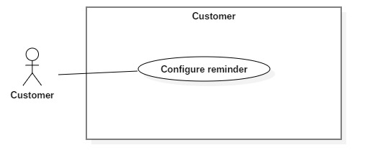

*Figure 32 <Customer> Configure reminder*

|  |  |  |  |
| --- | --- | --- | --- |
| **USE CASE – C08** | | | |
| **Use Case No.** | C08 | **Use Case Version** | 2.0 |
| **Use Case Name** | Configure reminder | | |
| **Author** | Nguyễn Hữu Thiện | | |
| **Date** | 03/04/2019 | **Priority** | High |
| **Actor:**   * Customer   **Summary:**   * This use case describes how customer configure remind scheduler.   **Goal**   * To configure remind scheduler time.   **Triggers:**   * Customer send configure command   **Preconditions:** N/A  **Post Conditions:**   * **Success**: Customer’s configuration is updated. * **Fail**: Display error message for customer   **Main Success Scenario:**   |  |  |  | | --- | --- | --- | | Step | Actor Action | System Response | | 1 | Customer inputs time duration for reminder to remind haircut and sends request | Update configuration and display message “Cập nhật thành công” |   **Alternative Scenario:** N/A  **Exceptions:** N/A  **Relationships:** Specialized from Configure reminder  **Business Rules:**   * Get change information from customer * Check customer’s selected slot available and location. * Update configuration for customer | | | |

*Table <Customer> Configure reminder*

**2.3.2.9 <Customer> Suggest hair style (C09)**

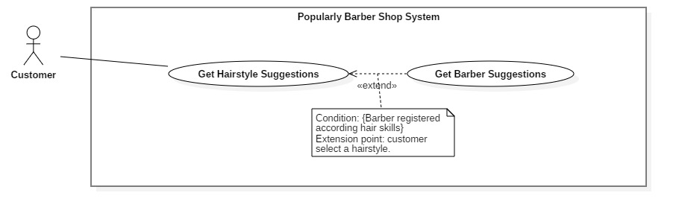

*Figure 33 <Customer> Suggest hairstyle*

|  |  |  |  |
| --- | --- | --- | --- |
| **USE CASE – C09** | | | |
| **Use Case No.** | C09 | **Use Case Version** | 2.0 |
| **Use Case Name** | Suggest hairstyle | | |
| **Author** | Nguyễn Hữu Thiện | | |
| **Date** | 09/02/2019 | **Priority** | High |
| **Actor:**   * Customer   **Summary:**   * This use case describes how customer suggested hair style..   **Goal**   * Customer seen hairstyle fit with their face shape   **Triggers:**   * Authorized user sends image to the server.   **Preconditions:**   * Customer taken front of their face.   **Post Conditions:**   * **Success**: Show a list of hairstyle. * **Fail**: Show error message and error is tracked in log file.   **Main Success Scenario:**   |  |  |  | | --- | --- | --- | | Step | Actor Action | System Response | | 1 | Customer taken portrait picture and send request to get suggestion. | List of hair style with name and photo  [Exception 1] |   **Alternative Scenario:N/A**  **Exceptions:**   |  |  |  | | --- | --- | --- | | **No** | **Cause** | **System Response** | | 1 | System cannot detect face in the photo | Display error “Có lỗi xảy ra” |   **Relationships: N/A**  **Business Rules:**   * Customer take a picture must contain their face. * System get facial point of customer face and use it to calculate which face shape customer have. * From face shape system return list of hairstyle image with name then show it for customer. | | | |

*Table <Customer> Suggest hairstyle*

**2.3.2.10 <Customer> Save favorite barber (C10)**

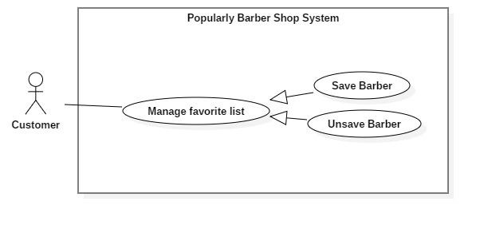

*Figure 34 <Customer> Save favorite barber*

|  |  |  |  |
| --- | --- | --- | --- |
| **USE CASE – C10** | | | |
| **Use Case No.** | C10 | **Use Case Version** | 2.0 |
| **Use Case Name** | Save favorite barber | | |
| **Author** | Nguyễn Hữu Thiện | | |
| **Date** | 09/02/2019 | **Priority** | High |
| **Actor:**   * Customer   **Summary:**   * This use case describes how customer save favorite barber.   **Goal**   * Customer save bookmark for barber   **Triggers:**   * Authorized user choose barber for bookmark .   **Preconditions:**   * Customer selected barber.   **Post Conditions:**   * **Success**: Bookmark barber with customer . * **Fail**: Show error message and error is tracked in log file.   **Main Success Scenario:**   |  |  |  | | --- | --- | --- | | Step | Actor Action | System Response | | 1 | Customer send request to bookmark barber | Show success save favorite barber message.  [Exception 1] |   **Alternative Scenario:N/A**  **Exceptions:**   |  |  |  | | --- | --- | --- | | **No** | **Cause** | **System Response** | | 1 | System cannot find barber | Display error “Thêm ưa thích không thành công” |   **Relationships: N/A**  **Business Rules:**   * Customer selected barber and choose to save favorite. * Add barber information into favorite list | | | |

*Table <Customer> Save favorite barber*

**2.3.2.11 <Customer> Unsave favorite barber (C10)**



*Figure 35 <Customer> Unsave favorite barber*

|  |  |  |  |
| --- | --- | --- | --- |
| **USE CASE – C11** | | | |
| **Use Case No.** | C11 | **Use Case Version** | 2.0 |
| **Use Case Name** | Unsave favorite barber | | |
| **Author** | Nguyễn Hữu Thiện | | |
| **Date** | 09/02/2019 | **Priority** | High |
| **Actor:**   * Customer   **Summary:**   * This use case describes how customer unsave favorite barber.   **Goal**   * Customer unsave bookmark for barber   **Triggers:**   * Authorized user choose barber for unsave bookmark   **Preconditions:**   * Barber has been saved to favorite.   **Post Conditions:**   * **Success**: Unsave bookmark barber . * **Fail**: Show error message and error is tracked in log file.   **Main Success Scenario:**   |  |  |  | | --- | --- | --- | | Step | Actor Action | System Response | | 1 | Customer send request to unsave bookmark barber | Show success unsave favorite barber message.  [Exception 1] |   **Alternative Scenario:N/A**  **Exceptions:**   |  |  |  | | --- | --- | --- | | **No** | **Cause** | **System Response** | | 1 | System cannot find barber | Display error “Hủy ưa thích không thành công” |   **Relationships: N/A**  **Business Rules:**   * Customer selected bookmark barber and choose to unsave favorite. * Remove barber from favorite list. | | | |

*Table <Customer> Unsave favorite barber*

**2.3.2.12 <Customer> Change Slot (C12)**



*Figure 36 <Customer> Change slot*

|  |  |  |  |
| --- | --- | --- | --- |
| **USE CASE – C12** | | | |
| **Use Case No.** | C12 | **Use Case Version** | 2.0 |
| **Use Case Name** | Change slot | | |
| **Author** | Nguyễn Hữu Thiện | | |
| **Date** | 19/04/2019 | **Priority** | High |
| **Actor:**   * Customer   **Summary:**   * This use case describes how customer change slot after booking   **Goal**   * To change cutting’s time.   **Triggers:**   * Customer send request change slot   **Preconditions:**   * Customer have booking and current time not exceed permissive time.   **Post Conditions:**   * **Success**: Booking slot changed. * **Fail**: Show error message and error is tracked in log file.   **Main Success Scenario:**   |  |  |  | | --- | --- | --- | | Step | Actor Action | System Response | | 1 | Customer sends request to change slot of selected booking | Display success message: “Đổi giờ thành công”.  [Alternative 1] |   Alternative Scenario:   |  |  |  | | --- | --- | --- | | **No** | **Cause** | **System Response** | | 2 | The change slot is not available | Displays message “Đổi giờ không thành công” |   **Exceptions:** N/A  **Relationships:** Extend from Book services  **Business Rules:**   * Customer can change slot of booking which not exceed permitted time (Default is current time early than booking time 2 hours). * After customer send request, system checks for slot available then update time of the booking. | | | |

*Table <Customer> Change slot*

##### **2.3.3 <Staff> Overview Use Cases**

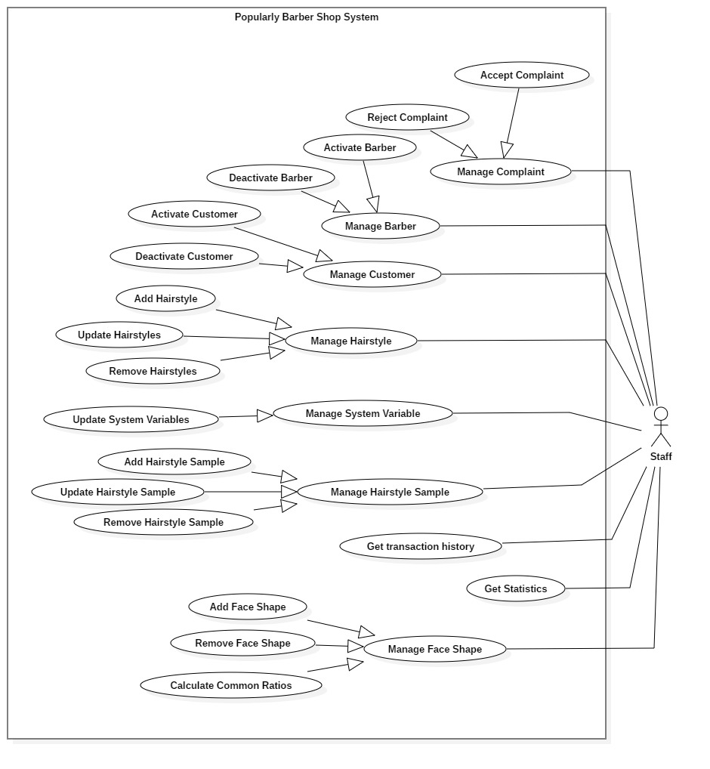

*Figure 37 <Staff> Overview Use Case*

###### **2.3.3.1 <Staff> Activate Barber (S01)**

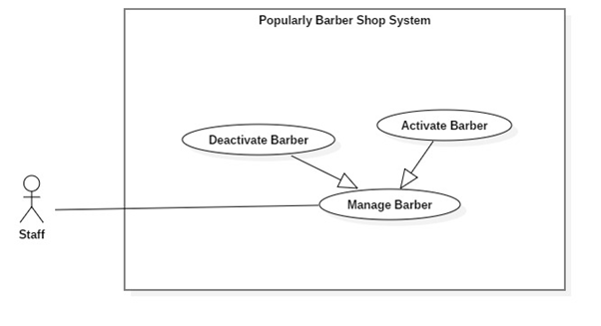  
*Figure 38 <Staff> Activate Barber*

|  |  |  |  |
| --- | --- | --- | --- |
| **USE CASE – S01** | | | |
| **Use Case No.** | S01 | **Use Case Version** | 2.0 |
| **Use Case Name** | Activate Barber | | |
| **Author** | Trần Phước Tiến | | |
| **Date** | 10/02/2019 | **Priority** | Low |
| **Actor:**   * Head lecturer   **Summary:**   * This use case describes how staff activates barber account.   **Goal:**   * Staff activates barber account.   **Triggers:**   * Staff send activate barber command to server   **Preconditions:**   * Barber account is existing in system and state is “Deactivated”. * Log in the system with role staff.   **Post Conditions:**   * **Success**: Barber account is “Activated”. * **Fail**: Error is tracked in log file.   **Main Success Scenario:**   |  |  |  | | --- | --- | --- | | Step | Actor Action | System Response | | 1 | Staff gets list of barbers. | Show list of barbers.  [Alternative 1] | | 2 | Staff selects the deactivated barber in the list. | Show details of barber. | | 3 | Staff send activate barber command. | Activated barber account and display message “Activate barber successfully.”  [Exception 1] |   **Alternative Scenario:**   |  |  |  | | --- | --- | --- | | **No** | **Cause** | **System Response** | | 1 | System retrieves an empty list of barber. | Show message “No data available in table” |   **Exceptions:**   |  |  |  | | --- | --- | --- | | **No** | **Cause** | **System Response** | | 1 | The activate barber process encountered an error. | Error detail will be tracked in a log.  Display message “Activate barber unsuccessfully”. |   **Relationships:** Generalize from Manage Barber  **Business Rules:**   * Staff accesses to manage barber page to get all barbers (A). * Staff chooses each line at A to get details. * Selected barber is deactivated: Activate barber. * Barber account will be activated and saved in storage. | | | |

*Table <Staff> Activate Barber*

###### **2.3.3.2 <Staff> Deactivate Barber (S02)**



*Figure 39 <Staff> Deactivate Barber*

|  |  |  |  |
| --- | --- | --- | --- |
| **USE CASE – S02** | | | |
| **Use Case No.** | S02 | **Use Case Version** | 2.0 |
| **Use Case Name** | Deactivate Barber | | |
| **Author** | Trần Phước Tiến | | |
| **Date** | 10/02/2019 | **Priority** | Low |
| **Actor:**   * Staff   **Summary:**   * This use case describes how staff deactivates barber account.   **Goal:**   * Staff deactivates barber account.   **Triggers:**   * Staff send deactivate barber command to server   **Preconditions:**   * Barber account is existing in system and state is “Activated”. * Log in the system with role staff.   **Post Conditions:**   * **Success**: Barber account is “Deactivated”. * **Fail**: Error is tracked in log file.   **Main Success Scenario:**   |  |  |  | | --- | --- | --- | | Step | Actor Action | System Response | | 1 | Staff gets list of barbers. | Show list of barbers.  [Alternative 1] | | 2 | Staff selects the activated barber in the list. | Show details of barber. | | 3 | Staff send deactivate barber command. | Deactivated barber account and display message “Deactivate barber successfully.”  [Exception 1] |   **Alternative Scenario:**   |  |  |  | | --- | --- | --- | | **No** | **Cause** | **System Response** | | 1 | System retrieves an empty list of barber. | Show message “No data available in table” |   **Exceptions:**   |  |  |  | | --- | --- | --- | | **No** | **Cause** | **System Response** | | 1 | The deactivate barber process encountered an error. | Error detail will be tracked in a log.  Display message “Deactivate barber unsuccessfully”. |   **Relationships:** Generalize from Manage Barber  **Business Rules:**   * Staff accesses to manage barber page to get all barbers (A). * Staff chooses each line at A to get details. * Selected barber is activated: Deactivate barber. * Barber account will be deactivated and saved in storage. | | | |

*Table <Staff> Deactivate Barber*

###### **2.3.3.3 <Staff> Activate Customer (S03)**

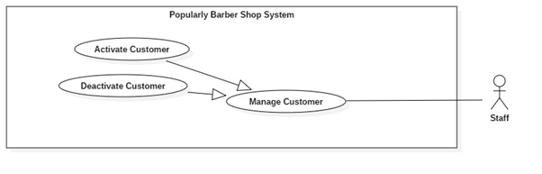

*Figure 40 <Staff> Activate Customer*

|  |  |  |  |
| --- | --- | --- | --- |
| **USE CASE – S03** | | | |
| **Use Case No.** | S03 | **Use Case Version** | 2.0 |
| **Use Case Name** | Activate Customer | | |
| **Author** | Trần Phước Tiến | | |
| **Date** | 10/02/2019 | **Priority** | Low |
| **Actor:**   * Staff   **Summary:**   * This use case describes how staff activates customer account.   **Goal:**   * Staff activates customer account.   **Triggers:**   * Staff send activate customer command to server   **Preconditions:**   * Customer account is existing in system and state is “Deactivated”. * Log in the system with role staff.   **Post Conditions:**   * **Success**: Customer account is “Activated”. * **Fail**: Error is tracked in log file.   **Main Success Scenario:**   |  |  |  | | --- | --- | --- | | Step | Actor Action | System Response | | 1 | Staff gets list of customers. | Show list of customers.  [Alternative 1] | | 2 | Staff selects the deactivated customer in the list. | Show details of customer. | | 3 | Staff send activate barber command. | Activated customer account and display message “Activate customer successfully.”  [Exception 1] |   **Alternative Scenario:**   |  |  |  | | --- | --- | --- | | **No** | **Cause** | **System Response** | | 1 | System retrieves an empty list of customer . | Show message “No data available in table” |   **Exceptions:**   |  |  |  | | --- | --- | --- | | **No** | **Cause** | **System Response** | | 1 | The activate customer process encountered an error. | Error detail will be tracked in a log.  Display message “Activate customer unsuccessfully”. |   **Relationships:** Generalize from Manage Barber  **Business Rules:**   * Staff accesses to manage customer page to get all customers(A). * Staff chooses each line at A to get details. * Selected customer is deactivated: Activate customer . * Customer account will be activated and saved in storage. | | | |

*Table <Staff> Activate Customer*

###### **2.3.3.4 <Staff> Deactivate Customer (S04)**



*Figure 41 <Staff> Deactivate Customer*

|  |  |  |  |
| --- | --- | --- | --- |
| **USE CASE – S04** | | | |
| **Use Case No.** | S04 | **Use Case Version** | 2.0 |
| **Use Case Name** | Deactivate Customer | | |
| **Author** | Trần Phước Tiến | | |
| **Date** | 10/02/2019 | **Priority** | Low |
| **Actor:**   * Staff   **Summary:**   * This use case describes how staff deactivates customer account.   **Goal:**   * Staff deactivates customer account.   **Triggers:**   * Staff send deactivate customer command to server   **Preconditions:**   * Customer account is existing in system and state is “Activated”. * Log in the system with role staff.   **Post Conditions:**   * **Success**: Customer account is “Deactivated”. * **Fail**: Error is tracked in log file.   **Main Success Scenario:**   |  |  |  | | --- | --- | --- | | Step | Actor Action | System Response | | 1 | Staff gets list of customers. | Show list of customers.  [Alternative 1] | | 2 | Staff selects the activated customer in the list. | Show details of customer. | | 3 | Staff send deactivate customer command. | Deactivated customer account and display message “Deactivate customer successfully.”  [Exception 1] |   **Alternative Scenario:**   |  |  |  | | --- | --- | --- | | **No** | **Cause** | **System Response** | | 1 | System retrieves an empty list of customer. | Show message “No data available in table” |   **Exceptions:**   |  |  |  | | --- | --- | --- | | **No** | **Cause** | **System Response** | | 1 | The deactivate customer process encountered an error. | Error detail will be tracked in a log.  Display message “Deactivate customer unsuccessfully”. |   **Relationships:** Generalize from Manage Customer  **Business Rules:**   * Staff accesses to manage barber page to get all customers (A). * Staff chooses each line at A to get details. * Selected customer is activated: Deactivate customer . * Customer account will be deactivated and saved in storage. | | | |

*Table <Staff> Deactivate Customer*

###### **2.3.3.5 <Staff>Add Face Shape (S05)**

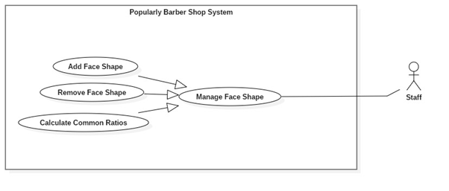

*Figure 42 <Staff> Add Face Shape*

|  |  |  |  |
| --- | --- | --- | --- |
| **USE CASE – S05** | | | |
| **Use Case No.** | S05 | **Use Case Version** | 2.0 |
| **Use Case Name** | Add Face Shape | | |
| **Author** | Trần Phước Tiến | | |
| **Date** | 10/02/2019 | **Priority** | Medium |
| **Actor:**   * Staff   **Summary:**   * This use case describes how staff adds new a face shape.   **Goal:**   * Staff adds new face shape and save to storage.   **Triggers:**   * Staff sends add face shape command to the server.   **Preconditions:**   * Log in the system with role staff.   **Post Conditions:**   * **Success**: New face shape is save in storage. * **Fail**: Error is tracked in log file.   **Main Success Scenario:**   |  |  |  | | --- | --- | --- | | **Step** | **Actor Action** | **System Response** | | 1 | Staff send add face shape command.. | Required information for new face shape:  - “Face shape name”: text input, max length 20 characters.  - “Description”: text input, max length 256 characters .  System saves new face shape information.  Display message “Add face shape successfully.”  [Exception 1] |   **Alternative Scenario:** N/A  **Exceptions:**   |  |  |  | | --- | --- | --- | | **No** | **Cause** | **System Response** | | 1 | The create process encountered an error. | Error detail will be tracked in a log file.  Display message “Add face shape unsuccessfully.” |   **Relationships:** Generalize from Manage Face Shape.  **Business Rules:**   * Staff add new face shape. * New face shape is saved in storage. | | | |

*Table <Staff> Add Face Shape*

###### **2.3.3.6 <Staff>Remove Face Shape (S07)**



*Figure 43 <Staff> Remove Face Shape*

|  |  |  |  |
| --- | --- | --- | --- |
| **USE CASE – S06** | | | |
| **Use Case No.** | S06 | **Use Case Version** | 2.0 |
| **Use Case Name** | Remove Face Shape | | |
| **Author** | Trần Phước Tiến | | |
| **Date** | 10/02/2019 | **Priority** | Medium |
| **Actor:**   * Staff   **Summary:**   * This use case describes how staff removes a face shape.   **Goal:**   * Staff removes new face shape and save to storage.   **Triggers:**   * Staff sends remove face shape command to the server.   **Preconditions:**   * Face shape is existed. * Log in the system with role staff.   **Post Conditions:**   * **Success**: Face shape is remove from storage. * **Fail**: Error is tracked in log file.   **Main Success Scenario:**   |  |  |  | | --- | --- | --- | | **Step** | **Actor Action** | **System Response** | | 1 | Staff gets list of face shape. | Show list of face shape.  [Alternative 1] | | 2 | Staff send remove hair style command. | System remove face shape information.  Display message “Remove hairstyle successfully.”  [Exception 1] |   **Alternative Scenario:**   |  |  |  | | --- | --- | --- | | **No** | **Cause** | **System Response** | | 1 | System retrieves an empty list of face shape. | Display message “No data available in table.” |   **Exceptions:**   |  |  |  | | --- | --- | --- | | **No** | **Cause** | **System Response** | | 1 | The remove process encountered an error. | Error detail will be tracked in a log file.  Display message “Remove face shape unsuccessfully.” |   **Relationships:** Generalize from Manage Face Shape.  **Business Rules:**   * Staff accesses to manage face shape page to get all face shape (A). * Staff remove face shape from (A). * Face shape is removed from storage. | | | |

*Table <Staff> Remove Face Shape*

###### **2.3.3.7 <Staff>Calculate Common Ratios (S07)**



*Figure 44 <Staff> Calculate Common Ratios*

|  |  |  |  |
| --- | --- | --- | --- |
| **USE CASE – S07** | | | |
| **Use Case No.** | S07 | **Use Case Version** | 2.0 |
| **Use Case Name** | Calculate Common Ratios | | |
| **Author** | Trần Phước Tiến | | |
| **Date** | 10/02/2019 | **Priority** | High |
| **Actor:**   * Staff   **Summary:**   * This use case describes how staff calculates ratios of a face shape.   **Goal:**   * Staff calculates face shape common ratios and save to storage.   **Triggers:**   * Staff sends calculate face shape command to the server.   **Preconditions:**   * Face shape is existed. * Face shape has hairstyle samples. * Log in the system with role staff.   **Post Conditions:**   * **Success**: Face shape common ratios is calculated and save in storage. * **Fail**: Error is tracked in log file.   **Main Success Scenario:**   |  |  |  | | --- | --- | --- | | **Step** | **Actor Action** | **System Response** | | 1 | Staff send calculate common ratios command. | System calculate common ratio of face shape.  Display message “Calculate common ratios successfully.”  [Exception 1] |   **Alternative Scenario:** N/A  **Exceptions:**   |  |  |  | | --- | --- | --- | | **No** | **Cause** | **System Response** | | 1 | The calculate process encountered an error. | Error detail will be tracked in a log file.  Display message “Calculate common ratios unsuccessfully.” |   **Relationships:** Generalize from Manage Face Shape.  **Business Rules:**   * Staff accesses to manage face shape page to get all face shape (A). * Staff chooses each line at A to get details. * Staff send calculate common ratios. * Common ratios of face shape is calculated and save in storage. | | | |

*Table <Staff> Calculate Common Ratios*

###### **2.3.3.8 <Staff> Add Hairstyle (S08)**

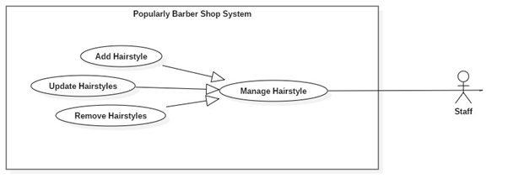

*Figure 45 <Staff> Add Hairstyle*

|  |  |  |  |
| --- | --- | --- | --- |
| **USE CASE – S08** | | | |
| **Use Case No.** | S08 | **Use Case Version** | 2.0 |
| **Use Case Name** | Add Hairstyle | | |
| **Author** | Trần Phước Tiến | | |
| **Date** | 10/02/2019 | **Priority** | Medium |
| **Actor:**   * Staff   **Summary:**   * This use case describes how staff adds new a hairstyle.   **Goal:**   * Staff add new hairstyle and save to storage.   **Triggers:**   * Staff sends add hairstyle command to the server.   **Preconditions:**   * Log in the system with role staff.   **Post Conditions:**   * **Success**: New hair style is save in storage. * **Fail**: Error is tracked in log file.   **Main Success Scenario:**   |  |  |  | | --- | --- | --- | | **Step** | **Actor Action** | **System Response** | | 1 | Staff send add hairstyle command. | System saves new hair style information.  Display message “Add hairstyle successfully.”  [Exception 1] |   **Alternative Scenario:** N/A  **Exceptions:**   |  |  |  | | --- | --- | --- | | **No** | **Cause** | **System Response** | | 1 | The create process encountered an error. | Error detail will be tracked in a log file.  Display message “Add new hairstyle unsuccessfully.” |   **Relationships:** Generalize from Manage Hairstyle.  **Business Rules:**   * Staff add new hairstyle. * New hairstyle is saved in storage. | | | |

*Table <Staff> Add Hairstyle*

###### **2.3.3.9 <Staff>Update Hairstyle (S09)**



*Figure 46 <Staff> Update Hairstyle*

|  |  |  |  |
| --- | --- | --- | --- |
| **USE CASE – S09** | | | |
| **Use Case No.** | S09 | **Use Case Version** | 2.0 |
| **Use Case Name** | Update Hairstyle | | |
| **Author** | Trần Phước Tiến | | |
| **Date** | 10/02/2019 | **Priority** | Medium |
| **Actor:**   * Staff   **Summary:**   * This use case describes how staff updates a hairstyle.   **Goal:**   * Staff update hairstyle information and save to storage.   **Triggers:**   * Staff send update hairstyle command to the server.   **Preconditions:**   * Log in the system with role staff. * Hairstyle is existed.   **Post Conditions:**   * **Success**: New hairstyle information is save in storage. * **Fail**: Error is tracked in log file.   **Main Success Scenario:**   |  |  |  | | --- | --- | --- | | **Step** | **Actor Action** | **System Response** | | 1 | Staff gets list of Hairstyle. | Show list of hairstyles  [Alternative 1] | | 2 | Staff selects hairstyle in the list. | Show details of hairstyles. | | 3 | Staff send update hairstyle command. | System saves hairstyle information.  Display message “Update hairstyle successfully.”  [Exception 1] |   **Alternative Scenario:**   |  |  |  | | --- | --- | --- | | **No** | **Cause** | **System Response** | | 1 | System retrieves an empty list of hairstyle. | Display message “No data available in table.” |   **Exceptions:**   |  |  |  | | --- | --- | --- | | **No** | **Cause** | **System Response** | | 1 | The update process encountered an error. | Error detail will be tracked in a log file.  Display message “Update hairstyle unsuccessfully.” |   **Relationships:** Generalize from Manage Hairstyle.  **Business Rules:**   * Staff accesses to manage hairstyle page to get all hairstyles (A). * Choose each line at A to get details. * Staff update hairstyle information. * New hairstyle information is saved in storage. | | | |

*Table <Staff> Update Hairstyle*

###### **2.3.3.10 <Staff>Remove Hairstyle (S10)**



*Figure 47 <Staff> Remove Hairstyle*

|  |  |  |  |
| --- | --- | --- | --- |
| **USE CASE – S10** | | | |
| **Use Case No.** | S10 | **Use Case Version** | 2.0 |
| **Use Case Name** | Remove Hairstyle | | |
| **Author** | Trần Phước Tiến | | |
| **Date** | 10/02/2019 | **Priority** | Medium |
| **Actor:**   * Staff   **Summary:**   * This use case describes how staff removes a hairstyle.   **Goal:**   * Staff removes hairstyle from storage.   **Triggers:**   * Staff send remove hairstyle command to the server.   **Preconditions:**   * Log in the system with role staff. * Hairstyle is existed.   **Post Conditions:**   * **Success**: Hairstyle is removed from storage. * **Fail**: Error is tracked in log file.   **Main Success Scenario:**   |  |  |  | | --- | --- | --- | | **Step** | **Actor Action** | **System Response** | | 1 | Staff gets list of Hairstyle. | Show list of hairstyles  [Alternative 1] | | 2 | Staff send remove hair style command. | System remove hair style information.  Display message “Remove hairstyle successfully.”  [Exception 1] |   **Alternative Scenario:**   |  |  |  | | --- | --- | --- | | **No** | **Cause** | **System Response** | | 1 | System retrieves an empty list of hairstyle. | Display message “No data available in table.” |   **Exceptions:**   |  |  |  | | --- | --- | --- | | **No** | **Cause** | **System Response** | | 1 | The remove process encountered an error. | Error detail will be tracked in a log file.  Display message “Remove hairstyle unsuccessfully.” |   **Relationships:** Generalize from Manage Hairstyle.  **Business Rules:**   * Staff accesses to manage hairstyle page to get all hairstyles (A). * Staff remove hairstyle. * Hairstyle is removed from storage. | | | |

*Table <Staff> Remove Hairstyle*

**2.3.3.11 <Staff> Add Hairstyle Sample (S11)**

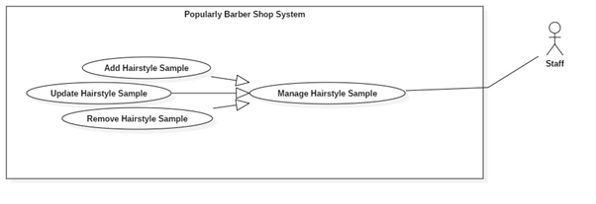

*Figure 48 <Staff> Add Hairstyle Sample*

|  |  |  |  |
| --- | --- | --- | --- |
| **USE CASE – S11** | | | |
| **Use Case No.** | S1 | **Use Case Version** | 2.0 |
| **Use Case Name** | Add Hairstyle Sample | | |
| **Author** | Trần Phước Tiến | | |
| **Date** | 10/02/2019 | **Priority** | Medium |
| **Actor:**   * Staff   **Summary:**   * This use case describes how staff adds new a hairstyle sample.   **Goal:**   * Staff add new hairstyle sample and save to storage.   **Triggers:**   * Staff send add hairstyle sample command to the server.   **Preconditions:**   * Log in the system with role staff.   **Post Conditions:**   * **Success**: New hairstyle sample is save in storage. * **Fail**: Error is tracked in log file.   **Main Success Scenario:**   |  |  |  | | --- | --- | --- | | **Step** | **Actor Action** | **System Response** | | 1 | Staff gets list of Hairstyle. | Show list of hairstyles  [Alternative 1] | | 2 | Staff selects hairstyle in the list. | Show details of hairstyles. | | 3 | Staff send add hair style sample command. | System saves new hair style sample information.  Display message “Add hairstyle sample successfully.”  [Exception 1] |   **Alternative Scenario:**   |  |  |  | | --- | --- | --- | | **No** | **Cause** | **System Response** | | 1 | System retrieves an empty list of hairstyle. | Display message “No data available in table.” |   **Exceptions:**   |  |  |  | | --- | --- | --- | | **No** | **Cause** | **System Response** | | 1 | The create process encountered an error. | Error detail will be tracked in a log file.  Display message “Add new hairstyle sample unsuccessfully.” |   **Relationships:** Generalize from Manage Hairstyle Sample.  **Business Rules:**   * Staff accesses to manage hairstyle page to get all hairstyles (A). * Choose each line at A to get details. * Staff add new hairstyle sample for hairstyle. * New hairstyle sample is saved in storage. | | | |

*Table <Staff> Add Hairstyle Sample*

###### **2.3.3.12 <Staff>Update Hairstyle Sample (S12)**



*Figure 49 <Staff> Update Hairstyle Sample*

|  |  |  |  |
| --- | --- | --- | --- |
| **USE CASE – S12** | | | |
| **Use Case No.** | S12 | **Use Case Version** | 2.0 |
| **Use Case Name** | Update Hairstyle Sample | | |
| **Author** | Trần Phước Tiến | | |
| **Date** | 10/02/2019 | **Priority** | Medium |
| **Actor:**   * Staff   **Summary:**   * This use case describes how staff updates a hairstyle sample.   **Goal:**   * Staff update new hairstyle sample and save to storage.   **Triggers:**   * Staff send update hairstyle sample command to the server.   **Preconditions:**   * Log in the system with role staff. * Hairstyle sample is existed.   **Post Conditions:**   * **Success**: New hairstyle sample information is save in storage. * **Fail**: Error is tracked in log file.   **Main Success Scenario:**   |  |  |  | | --- | --- | --- | | **Step** | **Actor Action** | **System Response** | | 1 | Staff gets list of Hairstyle. | Show list of hairstyles  [Alternative 1] | | 2 | Staff selects hairstyle in the list. | Show details of hairstyles. | | 3 | Staff send update hair style sample command. | System saves hairstyle sample information.  Display message “Update hairstyle sample successfully.”  [Exception 1] |   **Alternative Scenario:**   |  |  |  | | --- | --- | --- | | **No** | **Cause** | **System Response** | | 1 | System retrieves an empty list of hairstyle. | Display message “No data available in table.” |   **Exceptions:**   |  |  |  | | --- | --- | --- | | **No** | **Cause** | **System Response** | | 1 | The update process encountered an error. | Error detail will be tracked in a log file.  Display message “Update hairstyle sample unsuccessfully.” |   **Relationships:** Generalize from Manage Hairstyle Sample.  **Business Rules:**   * Staff accesses to manage hairstyle page to get all hairstyles (A). * Choose each line at A to get details. * Staff update hairstyle sample information. * New hairstyle sample information is saved in storage. | | | |

*Table 50 <Staff> Update Hairstyle Sample*

###### **2.3.3.13 <Staff>Remove Hairstyle Sample (S13)**



*Figure 51 <Staff> Remove Hairstyle Sample*

|  |  |  |  |
| --- | --- | --- | --- |
| **USE CASE – S13** | | | |
| **Use Case No.** | S13 | **Use Case Version** | 2.0 |
| **Use Case Name** | Remove Hairstyle Sample | | |
| **Author** | Trần Phước Tiến | | |
| **Date** | 10/02/2019 | **Priority** | Medium |
| **Actor:**   * Staff   **Summary:**   * This use case describes how staff removes a hairstyle sample.   **Goal:**   * Staff removes hairstyle sample from storage.   **Triggers:**   * Staff send remove hairstyle sample command to the server.   **Preconditions:**   * Log in the system with role staff. * Hairstyle sample is existed.   **Post Conditions:**   * **Success**: Hairstyle sample is removed from storage. * **Fail**: Error is tracked in log file.   **Main Success Scenario:**   |  |  |  | | --- | --- | --- | | **Step** | **Actor Action** | **System Response** | | 1 | Staff gets list of Hairstyle. | Show list of hairstyles  [Alternative 1] | | 2 | Staff send remove hair style command. | System remove hair style information.  Display message “Remove hairstyle successfully.”  [Exception 1] |   **Alternative Scenario:**   |  |  |  | | --- | --- | --- | | **No** | **Cause** | **System Response** | | 1 | System retrieves an empty list of hairstyle. | Display message “No data available in table.” |   **Exceptions:**   |  |  |  | | --- | --- | --- | | **No** | **Cause** | **System Response** | | 1 | The remove process encountered an error. | Error detail will be tracked in a log file.  Display message “Remove hairstyle sample unsuccessfully.” |   **Relationships:** Generalize from Manage Hairstyle Sample.  **Business Rules:**   * Staff accesses to manage hairstyle page to get all hairstyles (A). * Choose each line at A to get details. * Staff remove hairstyle sample information. * Hairstyle sample is removed from storage. | | | |

*Table <Staff> Remove Hairstyle Sample*

###### **2.3.3.14 <Staff>Approve Complaint (S14)**

*Figure 52 <Staff> Approve Complaint*

|  |  |  |  |
| --- | --- | --- | --- |
| **USE CASE – S14** | | | |
| **Use Case No.** | S14 | **Use Case Version** | 2.0 |
| **Use Case Name** | Approve Complaint | | |
| **Author** | Trần Phước Tiến | | |
| **Date** | 10/02/2019 | **Priority** | Medium |
| **Actor:**   * Staff   **Summary:**   * This use case describes how staff approves complaint.   **Goal:**   * Staff approves complaint.   **Triggers:**   * Authorized user sends complaint to the server.   **Preconditions:**   * The slot is already booked. * Customer checked in. * Log in the system with role staff.   **Post Conditions:**   * **Success**: Complaint is approved and send approved notification to initiator. * **Fail**: Error is tracked in log file.   **Main Success Scenario:**   |  |  |  | | --- | --- | --- | | **Step** | **Actor Action** | **System Response** | | 1 | Staff gets list of complaint. | Show list of complaints order by state and create date.  [Alternative 1] | | 2 | Staff selects complaint in the list. | Show details of complaint. | | 3 | Staff approve selected complaint. | Approving complaint and display message “Approve complaint successfully.”  [Exception 1] |   **Alternative Scenario:**   |  |  |  | | --- | --- | --- | | **No** | **Cause** | **System Response** | | 1 | System retrieves an empty list of complaint. | Display message “No data available in table.” |   **Exceptions:**   |  |  |  | | --- | --- | --- | | **No** | **Cause** | **System Response** | | 1 | The approve process encountered an error. | Error detail will be tracked in a log file and display message “Approve complaint unsuccessfully”. |   **Relationships:** Generalize from Manage Complaint..  **Business Rules:**   * Staff accesses to manage complaint page to get all complaint (A). * Staff chooses each line at A to get details. * Initiator is barber: Reject when check time does not exceed “Khách được trễ tối đa” time of booking time. * Initiator is customer: Reject when check time exceed “Khách được trễ tối đa” time of booking time. * When approve, system will send notification for both customer and barber. Approve complaint information will be changed state to “Approved”. * Deposit will be transferred to initiator. | | | |

*Table <Staff> Approve Complaint*

###### **2.3.3.15 <Staff>Reject Complaint (S15)**

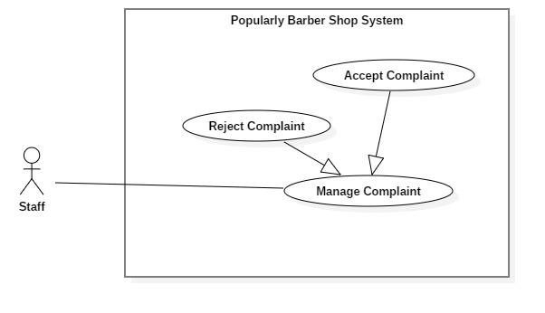

*Figure 53 <Staff> Reject Complaint*

|  |  |  |  |
| --- | --- | --- | --- |
| **USE CASE – S15** | | | |
| **Use Case No.** | S15 | **Use Case Version** | 2.0 |
| **Use Case Name** | Reject Complaint | | |
| **Author** | Trần Phước Tiến | | |
| **Date** | 10/02/2019 | **Priority** | Medium |
| **Actor:**   * Staff   **Summary:**   * This use case describes how staff rejects complaint.   **Goal:**   * Staff rejects complaint.   **Triggers:**   * Authorized user sends complaint to the server.   **Preconditions:**   * The slot is already booked. * Customer checked in. * Log in the system with role staff.   **Post Conditions:**   * **Success**: Complaint is rejected and send reject notification to initiator. * **Fail**: Error is tracked in log file.   **Main Success Scenario:**   |  |  |  | | --- | --- | --- | | **Step** | **Actor Action** | **System Response** | | 1 | Staff gets list of complaint. | Show list of complaints order by state and create date.  [Alternative 1] | | 2 | Staff selects complaint in the list. | Show details of complaint. | | 3 | Staff reject selected complaint. | Reject complaint reason is required.  - Reason: input text max length 256 characters  Rejecting complaint and display message “Reject complaint successfully.”  [Exception 1] |   **Alternative Scenario:**   |  |  |  | | --- | --- | --- | | **No** | **Cause** | **System Response** | | 1 | System retrieves an empty list of complaint. | Display message “No data available in table.” |   **Exceptions:**   |  |  |  | | --- | --- | --- | | **No** | **Cause** | **System Response** | | 1 | The reject process encountered an error. | Error detail will be tracked in a log file and display message “Reject complaint unsuccessfully.” |   **Relationships:** Generalize from Manage Complaint.  **Business Rules:**   * Staff accesses to manage complaint page to get all litigations (A). * Choose each line at A to get details. * Reject complaint with reason. | | | |

*Table <Staff> Reject Complaint*

###### **2.3.3.16 <Staff> Update System Variable (S16)**



*Figure 54 <Staff> Update System Variable*

|  |  |  |  |
| --- | --- | --- | --- |
| **USE CASE – S16** | | | |
| **Use Case No.** | S16 | **Use Case Version** | 2.0 |
| **Use Case Name** | Update System Variable | | |
| **Author** | Trần Phước Tiến | | |
| **Date** | 10/02/2019 | **Priority** | Medium |
| **Actor:**   * Staff   **Summary:**   * This use case describes how staff update system variable value.   **Goal:**   * The new system variable value is saved.   **Triggers:**   * Staff send update system variable command.   **Preconditions:**   * Log in the system with role staff. * System variable is existed.   **Post Conditions:**   * **Success**: New system variable value is updated in system and saved in storage. * **Fail**: Error is tracked in log file.   **Main Success Scenario:**   |  |  |  | | --- | --- | --- | | **Step** | **Actor Action** | **System Response** | | 1 | Staff gets list of system variable. | Show list of system variables  [Alternative 1] | | 2 | Staff selects system variable in the list. | Show details of system variable. | | 3 | Staff send update system variable command without save to database.  [Alternative 2] | System update new system variable value.  Display message “Update system variable successfully.”  [Exception 1] |   **Alternative Scenario:**   |  |  |  | | --- | --- | --- | | **No** | **Cause** | **System Response** | | 1 | System retrieves an empty list of variable. | Display message “No data available in table.” |   **Exceptions:**   |  |  |  | | --- | --- | --- | | **No** | **Cause** | **System Response** | | 1 | The saving process encountered an error. | Error detail will be tracked in a log file and display message “Update system variable unsuccessfully.”” |   **Relationships:** Generalize from Manage Complaint.  **Business Rules:**   * Staff accesses to manage system variable page to get all system variables (A). * Choose each line at A to get details. * Staff update system variable value. * New system variable value is updated in system and saved in storage. | | | |

*Table <Staff> Update System Variable*

###### **2.3.3.17 <Staff> Get Statistics (S17)**

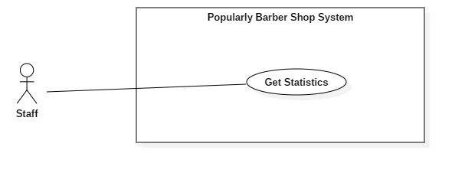

*Figure 55 <Staff> Get Statistic*

|  |  |  |  |
| --- | --- | --- | --- |
| **USE CASE – S17** | | | |
| **Use Case No.** | S17 | **Use Case Version** | 2.0 |
| **Use Case Name** | Get statistics | | |
| **Author** | Trần Phước Tiến | | |
| **Date** | 10/02/2019 | **Priority** | Low |
| **Actor:**   * Staff   **Summary:**   * This use case describes how staff get statistic.   **Goal:**   * Show statistic information.   **Triggers:**   * Staff sends get statistic request.   **Preconditions:**   * Log in the system with role staff.   **Post Conditions:**   * **Success**: Show statistic information. * **Fail**: Error is tracked in log file.   **Main Success Scenario:**   |  |  |  | | --- | --- | --- | | **Step** | **Actor Action** | **System Response** | | 1 | Staff sends get statistic request. | Show statistic information. |   **Alternative Scenario:** N/A  **Exceptions:** N/A  **Relationships:** N/A  **Business Rules:**   * Staff accesses to get statistic. * System show statistic information. | | | |

*Table <Staff> Get Statistic*

**2.3.4 <System Handler> Overview Use Cases**

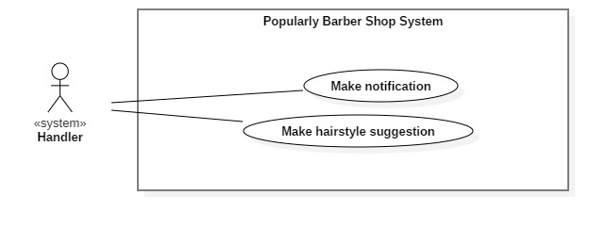

*Figure 56 <System Handler> Overview Use Case*

**2.3.4.1 <System Handler> Make notification**

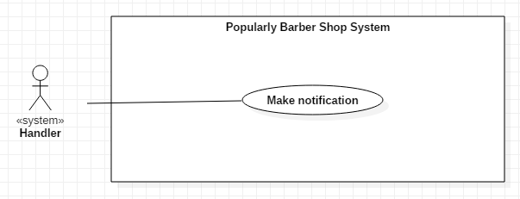

*Figure 57 <System Handler> Make Notification*

|  |  |  |  |
| --- | --- | --- | --- |
| **USE CASE – S04** | | | |
| **Use Case No.** | H01 | **Use Case Version** | 2.0 |
| **Use Case Name** | Make notification | | |
| **Author** | NamBM | | |
| **Date** | 09/02/2019 | **Priority** | High |
| **Actor:**   * System Handler   **Summary:**   * This use case describes how system handler makes notification to user devices.   **Goal**   * The notification is sent to user devices.   **Triggers:**   * There is a state change of entities associated to users, such as booking changes, wallet balance changes...   **Preconditions:**   * User logged in the system with mobile device.   **Post Conditions:**   * **Success**: Notification has been sent to user devices. * **Fail**: Notification information is not saved and error is tracked in log file.   **Main Success Scenario:**   |  |  |  | | --- | --- | --- | | Step | Actor Action | System Response | | 1 | Handler retrieves information of changed entities. | Create notification record and return to handler.. | | 2 | Handler determine devices  of user and send notification | System save notification information into database and real-time database and return action result  [Exception 1] |   **Alternative Scenario:** N/A  **Exceptions:**   |  |  |  | | --- | --- | --- | | **No** | **Cause** | **System Response** | | 1 | The saving process encountered an error. | Error detail will be tracked in a log file and display message “The system failed to make notification.” |   **Relationships:** N/A  **Business Rules:**   * When the information of a booking changed, system makes notification to involved users. * System saves notification information to database and a real-time database for auto-synchronization. | | | |

*Table <System Handler> Make Notification*

**2.3.4.2 <System Handler> Make hairstyle suggestion**

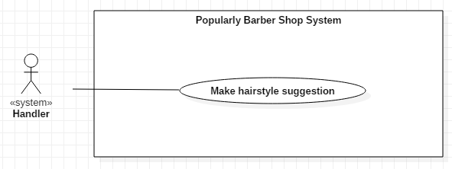

*Figure 58 <System Handler> Make hairstyle suggestion*

|  |  |  |  |
| --- | --- | --- | --- |
| **USE CASE – S04** | | | |
| **Use Case No.** | H02 | **Use Case Version** | 2.0 |
| **Use Case Name** | Make hairstyle suggestion | | |
| **Author** | NamBM | | |
| **Date** | 09/02/2019 | **Priority** | High |
| **Actor:**   * System Handler   **Summary:**   * This use case describes how system handler makes hairstyle suggestion to user.   **Goal**   * The hairstyle suggestion is made for user.   **Triggers:**   * User make request for hairstyle suggestion   **Preconditions:**   * User logged in the system with mobile device.   **Post Conditions:**   * **Success**: Hairstyle suggestion is made for user. * **Fail**: Hairstyle suggestion cannot be made and error is tracked in log file.   **Main Success Scenario:**   |  |  |  | | --- | --- | --- | | Step | Actor Action | System Response | | 1 | Handler retrieves photo of user’s face. | Return user photo. | | 2 | Handler get facial landmarks coordinates from user photo | System makes request to 3rd-party face recognition services and return result.  [Exception 1] | | 3 | Handler retrieve face shapes data from database | System returns all face shapes with ratios that had been calculated from collected face data. | | 4 | Handler calculate facial ratios of user’s face and compare to all face shape data to determine user’s face shape.  Handler get hairstyles associated with that face shape. | System returns hairstyles of requested face shape. |   **Alternative Scenario:** N/A  **Exceptions:**   |  |  |  | | --- | --- | --- | | **No** | **Cause** | **System Response** | | 1 | The face recognition services can not detect facial landmarks from user’s photo | Error detail will be tracked in a log file and display message “The system failed to make suggestion.” |   **Relationships:** N/A  **Business Rules:**  To determine whether a hairstyle is suitable for a men, it is important to determine his face shape first. Based on the user’s face shape, system will provide suggestions from existing data.   * User takes photo of their direct face. * Handler uses 3rd-party face recognition services to get facial landmark coordinates, and calculate ratios that features user’s face. * Handler compares those ratios with exist data to determine the face shape of user. * Handler return hairstyles that is suitable with user’s face shape (these hairstyles are defined manually in advanced). | | | |

*Table <System Handler> Make hairstyle suggestion*

**3. Software System Attribute**

**3.1 Usability**

- Customers can discover to use the mobile application within 5 minutes.

- Barbers can learn to use the mobile application within less than 1 day of training.

- Staff shall need less than 1 week of training to be competently with the system.

**3.2 Availability**

- Server running 24/7

**4. Conceptual Diagram**

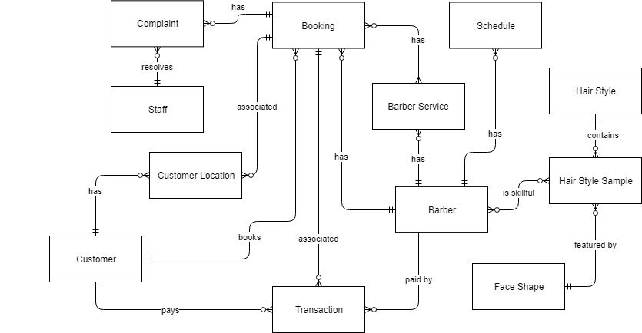

*Figure 59 Conceptual Diagram*

|  |  |
| --- | --- |
| **Entity Data dictionary: describe content of all entities** | |
| **Entity Name** | **Description** |
| Staff | Contain information of a staff, including UserId, FullName, Role, ActivatedTime |
| Barber | Contain information of a barber, including UserId, FullName, Address, Phone, Longitude, Latitude |
| Customer | Contain information of a customer, including UserId, FullName, Address, Phone |
| Schedule | Describe working schedules that barber defined, including StartHour, EndHour, RepetitionType, Repetition. |
| Barber Service | Describe haircut service that barber provides, including Name, Price, Duration |
| Booking | Contains information of a booking created between customer and barber, including barber ID, Booked Time, Booked Services |
| Customer Location | Describe locations of customer associated with a booking, including Longitude, Latitude, Time, Booking ID. When customers check-in at barber shop, the system will start tracking customers’ location until they check-out. This locations will be stored as evidence for the presence of the customer, and will be used to resolve future complaints if needed. |
| Complaint | Describe complaints occured between Customer and Barber in a booking, including Sender ID, Reason, Complaint Photos |
| Transaction | Describe transactions associated with a booking, including Sender, Receiver, Amount, Currency, Time, Booking ID |
| Hair Style | Describe hairstyles, including Name, Description, DifficultyRate |
| Face Shape | Describe face shapes, including Name, Description, Facial Ratios |
| Hair Style Sample | Describe all samples of a hairstyle, including Name, Description, Photo, Hairstyle ID |

*Table Conceptual Diagram*