

CAPSTONE PROJECT REPORT
Report 3 – Software Requirement Specification

– Ho Chi Minh, August 2026 –

Table of Contents

I. Record of Changes 3
II. Software Requirement Specification 4
1. Product Overview 4
2. User Requirements 4
2.1 Actors 4
2.2 Use Cases 6
2.2.1 Diagram(s) 6
2.2.2 Descriptions 10
3. Functional Requirements 14
3.1 System Functional Overview 14
3.1.1 Screens Flow 14
3.1.2 Screen Descriptions 14
3.1.3 Screen Authorization 17
3.1.4 Non-Screen Functions 19
3.1.5 Entity Relationship Diagram 20
4. Non-Functional Requirements 23
4.1 External Interfaces 23
4.2 Quality Attributes 23
4.2.1 Usability 24
4.2.2 Reliability 24
4.2.3 Performance 24
5. Requirement Appendix 24
5.1 Business Rules 24
5.2 Common Requirements 26
5.3 Application Messages List 26

I. Record of Changes
Date | A*  M, D | In charge | Change Description
2026-08-14 | A | Vo Trong Nhan (Member) | Initiated Report 3 based on the official Software Requirement Specification template; drafted Product Overview and User Requirements (Actors).
2026-08-15 | A | Doan Trong Khoi (Member) | Detailed Use Cases (2.2) covering the full ETR workflow: accounts, learners, courses, classes, enrollments, attendance, assessment, evidence, ETR lifecycle, amendment, export and audit.
2026-08-15 | A | Tran Trong Nhan (Member) | Documented Functional Requirements (3.1): screens flow, screen descriptions, screen authorization matrix and non-screen system functions.
2026-08-16 | A | Nguyen Huu Nhat Trieu (Leader) | Added Non-Functional Requirements (4), External Interfaces and Quality Attributes; reviewed requirement completeness against the implemented system.
2026-08-17 | M | Vo Trong Nhan (Member) | Cross-checked every section against the implemented ETR system (roles, screens, APIs, business rules incl. Auditor role, Amendment workflow, Excel imports, export jobs, certificate expiry tracking); fixed actor list, UC numbering, authorization matrix and business rules.
*A - Added M - Modified D - Deleted

II. Software Requirement Specification

1. Product Overview
The Electronic Training Record (ETR) System is a centralized, web-based platform for managing aviation training records for an aviation training academy. The system digitalizes the training-record process from learner enrollment and training execution through evidence verification, ETR approval, record locking, and audit access.
Currently, training records are managed through paper forms, separate Excel files, scanned documents, shared folders, and email. This creates fragmented records and makes it harder to maintain consistent information, verify evidence, track completion, and prepare records for audit review. The ETR System addresses these problems through a centralized and traceable electronic workflow and is focused on training-record management rather than full Learning Management System (LMS) delivery.
The system supports the training-record lifecycle, including user and role management (RBAC), learner and training-structure management, enrollment with automatic ETR generation, session and attendance management, assessment and practical-checklist results, evidence management and QA verification, subject result publication/sign-off, ETR validation and submission, QA review, final approval and record locking, controlled amendment handling, retake history with carry-over of previously satisfied subjects, dashboards, audit trails, certificate-expiry tracking and notifications, bilingual interface support, and PDF/Excel/training-package exports.
Seven user roles interact with the system: Administrator, Academic Staff (Training Coordinator), Instructor, QA Staff, Training Manager, Auditor, and Student (Learner). Access rights are assigned according to each role’s responsibilities, maintaining separation between training-data entry, quality verification, final approval, system administration, and independent audit access.
The system is implemented as a single-page web application (React) backed by a RESTful API (ASP.NET Core) and a centralized SQL Server database. Evidence files are uploaded directly to Cloudinary, while the backend stores the related evidence metadata. The application is deployed as a web solution and accessed through modern browsers.

2. User Requirements

2.1 Actors
Primary actors
NO | Actor | Description
1 | Administrator | Manages user accounts, roles, departments and system configuration; reviews audit logs and can reopen completed ETR records when a controlled correction is required. records, and can perform administrative overrides (e.g., Admin force unlock) when business rules require it.
2 | Academic Staff (Training Coordinator) | Manages learner profiles, courses, subjects, classes, sessions and enrollments; supports evidence management, ETR submission, imports/exports and certificate-expiry monitoring.
3 | Instructor | Manages assigned classes and sessions; records attendance, assessments and practical-checklist results; publishes subject results and manages training evidence.
4 | QA Staff | Verifies or rejects evidence, reviews submitted ETRs, returns records for correction, and searches/exports training records and audit information.
5 | Training Manager | Monitors training status, performs final ETR approval and locking, and manages amendment/unlock decisions.
6 | Auditor | Performs independent read-only compliance review of locked ETRs, approval history, audit logs, advanced search results and export packages.
7 | Student (Learner) | Views personal ETR status, attendance, assessment results, certificate validity and training history, and manages the personal profile.

2.2 Use Cases

2.2.1 Diagram(s)
The use case diagram groups all system functionality around the eight actors. The core workflow is a chain of custody: Academic Staff creates the learner, course, class and enrollment (which auto-generates the ETR); Instructor records attendance, assessment and evidence, then signs off subject results; QA Staff verifies evidence and the ETR; Training Manager approves and freezes the ETR; Auditor reads the final locked record and exports audit packages; Student views only his/her own records; Management Viewer monitors dashboards; Administrator manages accounts and can force-unlock or reopen records when required.
Use cases are organized into the following groups: (1) Authentication & Account Management; (2) Learner & Organization Management (departments, courses, subjects, classes, sessions, enrollments); (3) Training Execution (attendance, assessment, practical checklists, evidence, subject sign-off); (4) ETR Lifecycle (validation, submission, verification, return, approval, freezing, reopening, force unlock); (5) Amendment Workflow; (6) Quality & Audit (retake history, audit logs, advanced search, dashboards); (7) Reporting & Export; (8) Student Portal.
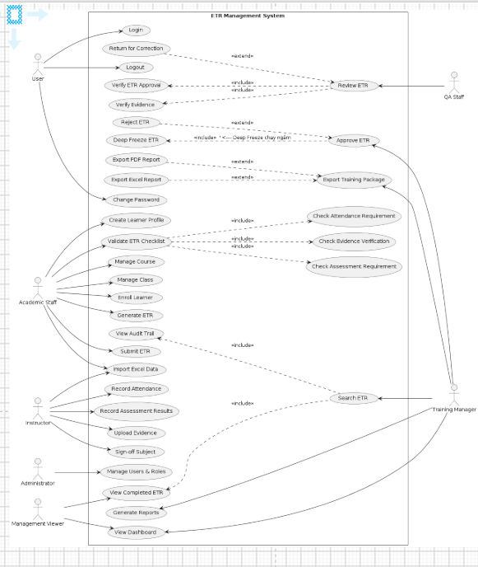
Figure 2-1. Use Case Diagram VẼ Lại

2.2.2 Descriptions
ID | Use Case | Primary Actor(s) | Goal | Description
UC-01 | Login | All Users | Access the ETR system securely. | Users authenticate with username and password; the system issues a JWT token and enforces role-based access.
UC-02 | Logout | All Users | End the current session. | Users securely log out and the authentication token is invalidated.
UC-03 | Change Password | All Users | Update account password. | Users change their own password after verifying the current password.
UC-04 | Create User Account | Administrator | Create a new user account. | Administrator creates an account for a system user (staff, learner or viewer).
UC-05 | View User Account | Administrator | View user account information. | Administrator views account details, status and assigned role.
UC-06 | Update User Account | Administrator | Modify user account information. | Administrator updates account details such as contact information and status.
UC-07 | Deactivate User Account | Administrator | Disable user access. | Administrator deactivates an account without deleting it.
UC-08 | Assign User Role | Administrator | Assign system permissions. | Administrator assigns or changes user roles (RBAC).
UC-09 | Manage Department | Administrator, Academic Staff | Maintain departments. | Create, update and view organizational departments.
UC-10 | Create Learner | Academic Staff | Register a learner. | Academic Staff creates a new learner profile with a unique learner code.
UC-11 | View Learner Details | Academic Staff, Instructor, QA Staff, Training Manager, Auditor | View learner information. | Authorized users view learner profiles and training history.
UC-12 | Search Learner | Academic Staff, Instructor, QA Staff, Training Manager, Auditor | Find learner records. | Search learners by code, name, email or phone.
UC-13 | Update Learner | Academic Staff | Modify learner information. | Academic Staff updates learner profile records.
UC-14 | Create Course | Academic Staff | Create a training course. | Academic Staff creates a course with code, duration and status.
UC-15 | View Course Details | All Users (per role) | View course information. | Users view course details based on their permissions.
UC-16 | Update Course | Academic Staff | Modify course information. | Academic Staff updates course details and status.
UC-17 | Manage Subject | Academic Staff, Training Manager | Maintain subjects. | Create, update and view subjects; a course must have subjects configured before enrollment.
UC-18 | Create Training Class | Academic Staff | Create a training class. | Academic Staff schedules a new class with code, course, dates and status.
UC-19 | View Class Details | Academic Staff, Instructor, QA Staff, Training Manager, Auditor | View class information. | Users view class schedules, instructors and enrolled learners.
UC-20 | Update Training Class | Academic Staff | Modify class information. | Academic Staff updates class details and status (e.g., mark class Completed).
UC-21 | Assign Instructor | Academic Staff | Assign instructors to subjects/classes. | Academic Staff assigns instructors to class subjects (ClassSubject.InstructorAccountId).
UC-22 | Manage Sessions | Academic Staff, Instructor | Schedule class sessions. | Create and update training sessions (date, title, confirmed flag) for a class.
UC-23 | Enroll Learner | Academic Staff | Register learners into classes. | Academic Staff enrolls a learner; the system auto-generates the ETR record and subject results.
UC-24 | Record Attendance | Instructor | Record learner attendance. | Instructor records attendance for each training session (status per session).
UC-25 | Confirm Session | Instructor | Confirm a training session. | Instructor confirms a session; attendance rates are recalculated from confirmed sessions.
UC-26 | Import Attendance (Excel) | Instructor, Administrator | Bulk-import attendance. | Upload an Excel attendance sheet; the system validates with a dry-run before committing.
UC-27 | View Attendance | Academic Staff, Instructor, QA Staff, Auditor | View attendance records. | Authorized users review learner attendance and rates.
UC-28 | Record Assessment | Instructor | Record assessment results. | Instructor records scores and pass/fail outcomes for assessments.
UC-29 | Record Practical Checklist | Instructor | Record practical checklist results. | Instructor records practical evaluation results; published results become immutable.
UC-30 | Import Assessment (Excel) | Instructor, Administrator | Bulk-import assessment results. | Upload an Excel assessment sheet; the system validates with a dry-run before committing.
UC-31 | View Assessment Result | Academic Staff, Instructor, QA Staff, Auditor | View assessment outcomes. | Authorized users review learner assessment results.
UC-32 | Upload Evidence | Instructor, Academic Staff | Upload supporting documents. | Users upload attendance sheets, assessment forms, certificates and other evidence (JPG/JPEG/PNG/GIF/WEBP/PDF, max 10 MB).
UC-33 | View Evidence | Academic Staff, Instructor, QA Staff, Auditor | View uploaded evidence. | Authorized users review evidence files linked to an ETR.
UC-34 | Download Evidence | Academic Staff, Instructor, QA Staff, Auditor | Download evidence files. | Users download evidence files for review or audit.
UC-35 | Verify Evidence | QA Staff | Verify evidence validity. | QA Staff verifies evidence as valid; a QA user cannot verify evidence uploaded by the same account.
UC-36 | Reject Evidence | QA Staff | Reject invalid evidence. | QA Staff rejects evidence with a comment; status changes to Rejected.
UC-37 | Bulk Verify Evidence | QA Staff | Verify multiple evidence files at once. | QA Staff selects multiple files and verifies them in one operation.
UC-38 | View ETR Checklist | Academic Staff, Instructor, QA Staff | Review ETR completeness. | The system validates all mandatory components (completion requirements) and shows a checklist.
UC-39 | Submit ETR | Academic Staff, Instructor | Submit ETR for review. | A user submits a completed ETR; the system pre-validates completion requirements before submission.
UC-40 | Verify ETR | QA Staff | Verify a submitted ETR. | QA Staff reviews the ETR, verifies it, or returns it for correction with comments.
UC-41 | Return ETR for Correction | QA Staff | Return an incomplete ETR. | QA Staff returns the ETR; its status changes to Returned for Correction.
UC-42 | Approve ETR (Complete) | Training Manager | Approve and freeze a verified ETR. | Training Manager approves the ETR; it becomes Completed and its data is frozen (read-only).
UC-43 | Reopen ETR | Administrator | Reopen a completed/locked record. | Administrator reopens a completed ETR when a legitimate correction is required.
UC-44 | Force Unlock ETR | Administrator | Admin-only unlock of locked records. | Administrator force-unlocks a locked ETR when an amendment is not applicable.
UC-45 | Sign Off Subject Result | Instructor | Sign off a graded subject result. | Instructor signs off subject results that have been evaluated; missing sign-offs block ETR completion.
UC-46 | Request Amendment (Unlock) | Instructor, Academic Staff | Request unlocking a subject/record for correction. | Users submit an amendment request for a completed/locked subject; the request records the reason.
UC-47 | Approve / Reject Amendment | Training Manager, Administrator | Decide on amendment requests. | Training Manager or Administrator approves (unlocks) or rejects the request.
UC-48 | View Retake History | QA Staff, Instructor, Training Manager, Academic Staff, Administrator | View retake records. | The system auto-creates retake history for failed assessments; authorized users review it.
UC-49 | View Role Dashboard | All Users | Monitor training activities. | Each role gets a purpose-built dashboard (Admin system stats, Training Manager/Auditor monthly trend, Academic low-attendance, QA evidence summary, Instructor classes, Student profile/certificates).

3. Functional Requirements

3.1 System Functional Overview

3.1.1 Screens Flow
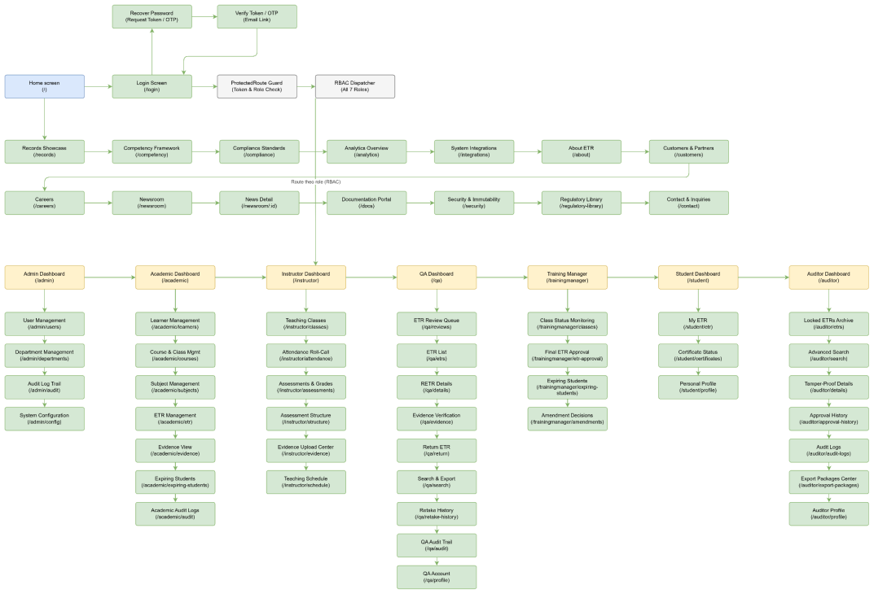
Figure 3-1. Screens Flow Diagram

3.1.2 Screen Descriptions

NO | Feature | Screen | Description
1 | User Authentication | Login & Reset Password Screen | Allows users to log in and request password recovery (token/OTP via email) with validation feedback.
2 | Dashboard | Role-Based Dashboard Screen | Provides role-specific statistics, pending actions and training status using live system data.
3 | User Profile | Profile Screen | Displays the signed-in user's profile information, role and account details.
4 | User Profile | Change Password Screen | Allows authenticated users to change their own password after verifying the current password.
5 | User Administration | User Management Screen | Administrator creates, updates and deactivates accounts, assigns roles/departments, and bulk-imports accounts through the validate-then-commit Excel flow (/Import/accounts).
6 | Organization | Department Management Screen | Administrator creates, updates and views departments.
7 | Learner Management | Learner List / Profile Screen | Academic Staff creates, views, updates and searches learner profiles and training history.
8 | Course Management | Course Management Screen | Academic Staff creates and updates courses and their training structure.
9 | Course Management | Subject Management Screen | Academic Staff creates, updates and views subjects, associates them with courses, and configures the passing score and minimum attendance rate for each subject.
10 | Class Management | Class Management Screen | Academic Staff creates and updates classes, assigns instructors by subject and monitors class status (Scheduled / In Progress / Completed).
11 | Enrollment Management | Enrollment Screen | Academic Staff enrolls learners into classes; successful enrollment automatically creates the ETR and subject-result records.
12 | Enrollment Management | Classes & Roster Import Screen | Academic Staff imports class and learner-roster data from Excel using the validate-then-commit flow (/import/classes-roster).
13 | Attendance Management | Attendance Recording Screen | Instructor records attendance per session for assigned classes (Present / Absent / Excused) and confirms sessions.
14 | Attendance Management | Attendance Import Screen | Instructor bulk-imports attendance from Excel with dry-run validation before commit.
15 | Assessment Management | Assessment Recording Screen | Instructor records theory scores and practical-checklist results; a retake must be authorized by an account different from the one recording the score, and published results become immutable.
16 | Assessment Management | Assessment Import Screen | Instructor bulk-imports assessment results from Excel with dry-run validation before commit.
17 | Evidence Management | Evidence Upload Screen | Instructor and Academic Staff upload supported evidence files (stored on Cloudinary) linked to subject results.
18 | Evidence Verification | Evidence Verification Screen | QA Staff verifies or rejects evidence; rejection requires a reason and verified evidence is immutable.
19 | ETR Management | ETR List / Search Screen | Authorized users locate ETR records according to their role permissions and filters.
20 | ETR Management | ETR Detail / Checklist Screen | Shows completion requirements, attendance, results, evidence, approval history and current status.
21 | ETR Workflow | Submit ETR Screen | Academic Staff submits an ETR after completion requirements are pre-validated.
22 | ETR Workflow | ETR Review Screen | QA Staff verifies a Submitted ETR or returns it for correction with a mandatory reason.
23 | ETR Workflow | Approval Screen | Training Manager performs final approval and locks the class/ETR; authorized Admin users may also use the Training Manager portal.
24 | Correction Workflow | Amendment Management Screen | Training Manager reviews and decides pending amendment/unlock requests.
25 | Correction Workflow | Reopen ETR Screen | Administrator reopens a Completed/Locked ETR with a recorded reason; the action is written to the Audit Trail.
26 | Quality | Retake History Screen | Shows automatically generated retake records for failed assessments, including score changes and authorization details, to authorized roles.
27 | Audit | Audit Trail Screen | Displays the append-only history of critical actions with timestamps and actors.
28 | Search | Advanced Search Screen | Provides Auditor-focused multi-criteria search across learners, courses, classes and locked ETR records.
29 | Export | Export Center Screen | Authorized users create export jobs, monitor status and download completed outputs (QA Search & Export and Auditor Export Packages).
30 | Student Portal | Student ETR / Certificate Screen | Student views own ETR status, results, attendance, certificate validity and training history in read-only mode, including carried-over versus retake-required subjects.
31 | Management | System Configuration Screen | Administrator maintains global parameters (security/token policies, maximum retake attempts, notification gateway), while subject-level passing scores, attendance minimums and practical-checklist templates are configured by authorized academic users.

3.1.3 Screen Authorization
ADM = Administrator AST = Academic Staff INS = Instructor MGR = Training Manager QA = QA Staff AUD = Auditor STD = Student

Screen / Screen Activity | ADM | AST | INS | MGR | QA | AUD | STD
Login & Reset Password | X | X | X | X | X | X | X
Role-Based Dashboard | X | X | X | X | X | X | X
User Profile | X | X | X | X | X | X | X
└ Change Password | X | X | X | X | X | X | X
User Management | X
└ Create / Update / Deactivate User | X
└ Assign Role | X
Department Management | X
Learner Management |  | X
└ View Learner |  | X | X | X | X | X
└ Search Learner |  | X | X | X | X | X
Course Management |  | X
└ View Course |  | X | X | X | X | X
Subject Management |  | X
Class Management |  | X
└ View Class |  | X | X | X | X | X
Session Management |  | X | X
Enrollment Management |  | X
└ View Enrollment |  | X | X | X | X | X
Classes & Roster Import |  | X
Attendance Recording |  |  | X
└ Confirm Session |  |  | X
└ Import Attendance (Excel) |  |  | X
└ View Attendance |  | X | X |  | X | X
Assessment Recording |  |  | X
└ Practical Checklist Result |  |  | X
└ Import Assessment (Excel) |  |  | X
└ View Assessment |  | X | X |  | X | X
Evidence Upload |  | X | X
└ View / Download Evidence |  | X | X |  | X | X
Evidence Verification |  |  |  |  | X
└ Bulk Verify |  |  |  |  | X
Subject Sign-off |  |  | X
ETR List / Search / Detail |  | X |  | X | X | X
└ View ETR Checklist |  | X |  | X | X | X
Submit ETR |  | X
Verify ETR |  |  |  |  | X
Return ETR for Correction |  |  |  |  | X
Approve ETR (Complete/Freeze) | X |  |  | X
Reopen ETR | X
Amendment Management |  |  |  | X
└ Approve / Reject Amendment |  |  |  | X
Retake History | X | X | X | X | X
Advanced Search |  |  |  |  |  | X
Audit Trail | X | X |  |  | X | X
Reports & Dashboard Analytics | X | X | X | X | X | X | X
Export Center (Export Jobs) |  | X |  |  | X | X
└ Download Export Package |  | X |  |  | X | X
Student Portal (Own ETR / Certificates) |  |  |  |  |  |  | X
Completion Requirements | X | X |  | X
Evidence Types / Practical Checklists | X | X
└ Language Switch / Activity Feed | X | X | X | X | X | X | X

3.1.4 Non-Screen Functions

NO | Feature | System Function | Description
1 | Enrollment Management | Auto-Generate ETR | Automatically creates the learner ETR course record and subject results when an enrollment succeeds.
2 | Attendance Management | Attendance Rate Calculator | Recalculates attendance from confirmed sessions and flags learners below the 80% threshold.
3 | Assessment Management | Retake History Generator | Creates retake-history entries for failed assessments and carries forward previously satisfied subjects according to the retake rules.
4 | ETR Validation | Completion Validator | Checks mandatory submission requirements including attendance, subject status, sign-off, evidence and practical-checklist completion.
5 | Evidence Management | Missing Evidence Checker | Identifies missing mandatory evidence and reflects the result in the ETR completion checklist.
6 | Evidence Management | File Validation | Validates supported evidence formats and the maximum 10 MB file size.
7 | Workflow Management | ETR Status Workflow | Enforces valid ETR transitions: Draft → Submitted → Verified → Completed/Locked, with Return for Correction and Admin Reopen transitions.
8 | Approval Management | Freeze Completed ETR | Locks approved ETR data and prevents normal mutations after completion.
9 | Correction Management | Amendment Request Processor | Tracks controlled amendment/unlock requests for signed-off results and their decisions before final ETR completion.
10 | Audit Management | Audit Trail Logger | Records critical actions with actor, action and timestamp, including create, update, submit, verify, approve, reject, lock, unlock, import and export.
11 | Security | Role-Based Access Control | Enforces role permissions on screens, functions and API access; Auditor access is read-only.
12 | Import Management | Excel Import with Dry-Run | Validates attendance, assessment, account, and class/roster Excel imports before committing valid data.
13 | Export Management | Export Job Generator | Creates PDF, Excel and training-package export jobs and tracks their status.
14 | Certificate Management | Certificate Expiry Tracker | Tracks certificate validity and classifies certificates as Valid, Expiring Soon or Expired; expiry notifications use the configured schedule.
15 | Dashboard | Dashboard Statistics Generator | Provides role-specific dashboard statistics from live system data.
16 | Search | Advanced Search | Provides multi-criteria search for the Auditor compliance repository and supporting operational search functions where available.
17 | Cross-Cutting UX | Language & Activity Support | Persists Vietnamese/English language preference and exposes recent user activity through the notification/activity feed.

3.1.5 Entity Relationship Diagram
The core data model is centered on the ETR_Course_Record. The main entities and their relationships are:
- Account (User) – 1:1 – UserProfile (learner/staff profile); 1:N – AuditLog; 1:N – ApprovalHistory; 1:N – ExportJob.
- Department – 1:N – Account / UserProfile.
- Course – 1:N – Subject (via course subjects); 1:N – Class; a Course must have Subjects before enrollment.
- Class – 1:N – Session; 1:N – Enrollment; 1:N – ClassSubject (assigns InstructorAccountId per subject).
- Enrollment – N:1 – Class; N:1 – Account (learner); 1:1 – ETR_Course_Record (auto-generated on enrollment).
- ETR_Course_Record – 1:N – SubjectResult; 1:N – EvidenceFile; 1:N – ApprovalRequest; 1:N – ApprovalHistory; 1:N – AuditLog (ETRRecordId); 1:N – ExportJob (optional); has Status (Draft/Submitted/Verified/Completed/ReturnedForCorrection/Cancelled), IsLocked, ExpiryDate, CompletedAt.
- SubjectResult – N:1 – ETR; N:1 – Subject; holds AttendanceRate and Status (evaluated/signed-off); 1:1 – SubjectSignoff (optional).
- Assessment / PracticalChecklist – 1:N – AssessmentResult / PracticalChecklistResult (per learner).
- EvidenceFile – N:1 – ETR_Course_Record; N:1 – EvidenceType; N:1 – Account (uploader); has VerificationStatus (Verified/Rejected).
- ApprovalRequest – 1:N – ApprovalHistory (Submit/Review/Verify/Approve/Reject/Return with ActionAt and ActionByAccountId).
- AmendmentRequest – N:1 – SubjectResult/ETR; N:1 – Account (requester); decided by Training Manager/Admin.
- RetakeHistory – N:1 – SubjectResult/ETR; created automatically for failed assessments.
- CompletionRequirement – N:1 – Course/Subject; defines the mandatory checklist applied during ETR validation.
- ExportJob – N:1 – Account (requester); optional N:1 – ETR; tracks ExportType, Status, RequestedAt, CompletedAt.
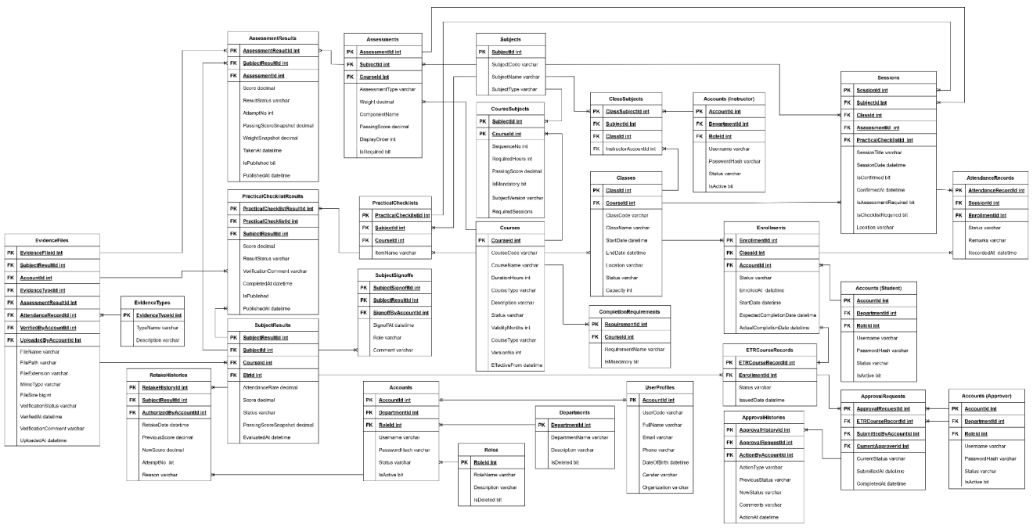
Figure 3-2. Entity Relationship Diagram
Integrity rules: an ETR is Completed only after verification and approval; approved ETRs are frozen (IsLocked) and become read-only; every state transition is persisted in ApprovalHistory and AuditLog to guarantee a full audit trail.

4. Non-Functional Requirements

4.1 External Interfaces

Interface | Description
Web Browser | The system is accessed through modern evergreen web browsers.
REST API | The React frontend communicates with the ASP.NET Core backend through HTTPS/JSON and JWT bearer authentication.
Cloudinary Upload API | Evidence files are uploaded directly from the browser to Cloudinary; the backend stores the resulting evidence metadata and URL.
SMTP / Email Service | The backend sends account-related and certificate-expiry notifications; email failures do not roll back the primary transaction.
Excel Import Interface | Attendance, assessment, account and class/roster data can be imported through validate-then-commit Excel flows.
File Export Interface | The system creates tracked PDF, Excel and training-package export jobs.
SQL Server Database | Training and workflow data are stored in a centralized relational SQL Server database.

4.2 Quality Attributes

Quality Attribute | Specification
Availability | The application should remain usable during normal operation and show a clear error state when backend services are unavailable.
Performance | API requests use a 20-second timeout (12 seconds for authentication); large lists are paginated and dashboards use aggregated live data.
Reliability | Critical actions preserve data integrity; failures show controlled error states rather than blank screens or crashes.
Security | JWT authentication, role-based route guards and backend authorization enforce permissions. Auditor access is read-only and destructive actions require confirmation or a reason.
Usability | Interfaces are role-oriented, provide clear outcome messages, support search/filtering and provide meaningful loading, empty and error states.
Maintainability | The application is organized into role-based modules and shared utilities, with automated tests available for supported modules.
Portability | The application targets modern evergreen browsers and is deployed as a web-based SPA.
Data Integrity | Validation prevents incomplete records from being submitted or approved; grading configuration is snapshotted and completed ETRs are immutable.
Auditability | Critical actions are recorded in an append-only audit trail and forbidden access attempts are flagged.
Localization | The interface supports Vietnamese and English with a persisted language preference.

4.2.1 Usability
US-01: The system shall provide role-oriented navigation and dashboards so users see functions relevant to their responsibilities.
US-02: Validation and business-rule errors shall be presented clearly; raw exceptions shall not be shown as the primary user feedback.
US-03: Search and filtering shall be available on major management and audit screens.
US-04: The interface shall support Vietnamese and English with a persisted language preference.
US-05: Major list and dashboard screens shall provide clear loading, empty and error states.
US-06: Interactive controls shall have clear labels and accessible names for icon-only actions.
US-07: The web interface shall support the target modern browser environment and project-defined responsive layouts.

4.2.2 Reliability

ID | Reliability Requirement
RE-01 | The system shall show a controlled error state when an API or list request fails, without crashing the page.
RE-02 | Required data shall be validated before save, import, submission or approval.
RE-03 | Completed/Locked ETR data shall remain immutable until the controlled Admin reopen path is used.
RE-04 | Critical actions shall be recorded in the audit trail with timestamp and actor information.
RE-05 | Email notification failures shall not roll back or fail the primary business transaction.
RE-06 | Excel bulk imports shall validate in dry-run mode before valid rows are committed.

4.2.3 Performance
ID | Performance Requirement
PE-01 | API requests shall use a 20-second timeout; authentication requests shall use a 12-second timeout.
PE-02 | List views shall use pagination rather than rendering unbounded result sets.
PE-03 | Role dashboards shall load summary metrics from the designated aggregated dashboard endpoint.
PE-04 | Export operations shall run as tracked jobs so users can monitor completion instead of blocking on long-running downloads.
PE-05 | Excel import validation shall run as a dry-run before commit so invalid rows are identified before data changes are applied.
PE-06 | Evidence files shall be uploaded directly to the configured evidence-storage provider rather than passing file bytes through the backend API.

5. Requirement Appendix

5.1 Business Rules

ID | Rule Definition
BR-001 | The minimum attendance rate for each subject required to submit an ETR is 80%.
BR-002 | The maximum number of assessment attempts allowed (including retakes/reassessments) is 3 attempts.
BR-003 | The attendance grace period after the class session date is 48 hours.
BR-004 | A learner cannot enroll if their user profile is incomplete.
BR-005 | A learner cannot enroll in the same class more than once.
BR-006 | A learner can have only one active ETR per course — an enrollment request is rejected if the learner is already in an active class of that course with an incomplete ETR.
BR-007 | A course must have at least one configured subject before a learner can enroll.
BR-008 | An enrollment record with an ETR in Completed/Locked status cannot be deleted.
BR-009 | Creating an enrollment record automatically creates the learner's ETR; there is no manual ETR creation process.
BR-010 | The class code must be unique; class codes belonging to soft-deleted classes may be reused.
BR-011 | A class cannot be marked as Completed while there are still unconfirmed attendance sessions.
BR-012 | The assigned InstructorAccountId must reference an account with the Instructor role.
BR-013 | Instructors are assigned per subject within a class through InstructorAssignments , rather than to the entire class.
BR-014 | The course code must be unique; codes belonging to soft-deleted courses may be reused.
BR-015 | A subject can be assigned to the same course only once.
BR-016 | Changing the course's ValidityMonths increases the VersionNo, allowing already-enrolled learners to continue being assessed against the previous course version.
BR-017 | The class start date and end date are required — the system defaults them to Today / Today + 30 days on the Frontend when they are left blank.
BR-018 | Assessment results are evaluated using the PassingScoreSnapshot recorded at the time of enrollment, not the current CourseSubject.PassingScore. Configuration changes do not retroactively affect already-enrolled learners.
BR-019 | The assessment Weight used for calculation is stored as a snapshot when the result is first recorded.
BR-020 | The result is considered Passed when score >= passingScore; an Exempted result is also considered to satisfy the completion requirement.
BR-021 | A published assessment result cannot be updated or republished.
BR-022 | Each assessment allows a maximum of 3 attempts (BR-002); any subsequent retake attempt is rejected.
BR-023 | A retake must be authorized by an account different from the account that entered the score; self-authorization is not allowed.
BR-024 | Recording an assessment result requires the learner to be currently enrolled in a class belonging to the assessment's course.
BR-025 | Attendance can only be recorded within 48 hours after the session date (BR-003); attendance recorded after this period requires intervention by Academic Staff.
BR-026 | Once the attendance record for a session has been finalized/confirmed, it becomes read-only and cannot be modified or deleted.
BR-027 | There must be exactly one attendance record per (session, enrollment); duplicate attendance records are rejected.
BR-028 | Attendance can only be recorded for a learner enrolled in the corresponding class.
BR-029 | Learners with an attendance rate below 80% are automatically displayed in the Low Attendance Monitoring list on the dashboard and Academic Staff/TM screens.
BR-030 | Each subject result must be signed off by the assigned instructor before the ETR can be submitted.
BR-031 | A request to adjust/reopen a signed-off result must include a reason.
BR-032 | Adjustment requests apply only to signed-off results; unsigned results can be edited directly. Adjustments are allowed only before the ETR reaches Completed status. Completed ETR records must go through the Admin Reopen process.
BR-033 | Only one pending adjustment request is allowed for each subject result at any given time.
BR-034 | Rejecting an adjustment request requires a comment; a decided request cannot be modified afterward.
BR-035 | A request to unlock a published result is redirected to the Training Manager.
BR-036 | Evidence files are uploaded directly from the browser to Cloudinary; the backend receives only JSON metadata (URL, publicId, fileName, mimeType, fileSize) and never receives file bytes.
BR-037 | Only the following file formats are allowed: .jpg, .jpeg, .png, .gif, .webp, .pdf, subject to the MIME-type whitelist. The Frontend blocks invalid files before any network request is made.
BR-038 | The stored fileUrl must be an absolute HTTPS URL.
BR-039 | Evidence is associated with the learner through SubjectResultId, rather than directly through the ETR ID.
BR-040 | Verified evidence is immutable and cannot be deleted by any role.
BR-041 | Evidence associated with a Completed/Locked ETR cannot be Verified or Rejected (ETR Locked).
BR-042 | Rejecting evidence requires a VerificationComment, and the reason is displayed to the uploader.
BR-043 | File downloads redirect to the Cloudinary URL. When exporting an evidence ZIP for an Auditor, unavailable files are skipped with a warning instead of causing the entire export process to fail.
BR-044 | ETR Submission Condition – Step 1: The learner's personal information/profile must be complete.
BR-045 | ETR Submission Condition – Step 2: The attendance rate for every subject must be at least 80% (BR-001).
BR-046 | ETR Submission Condition – Step 3: All subject results must have been signed off by the instructor.
BR-047 | ETR Submission Condition – Step 4: All evidence files must be Verified — at least one evidence file must be linked, and no evidence file may remain pending.
BR-048 | ETR Submission Condition – Step 5: All required subjects must be Passed or Exempted.
BR-049 | ETR Submission Condition – Step 6: All required practical checklists must be signed off and have a score greater than or equal to the passing threshold.
BR-050 | ETR Submission Condition – Step 7: The completion-condition processor must confirm that all specified mandatory requirements have been satisfied.
BR-051 | Only the following ETR status transitions are allowed: Submitted → Verified, Submitted → ReturnedForCorrection, and Verified → Completed. All other transitions are rejected.
BR-052 | Each ETR submission creates a new ApprovalRequest; previous requests are not modified. Only requests with Pending status can be updated or deleted.
BR-053 | Rejecting or returning an ApprovalRequest requires a comment.
BR-054 | When an ETR is approved, it transitions to Completed, IsLocked is set to true, a certificate is issued, and an audit log entry is created. A locked ETR rejects all modification operations.
BR-055 | Only an Admin can reopen a locked ETR, and a reason must be provided.
BR-056 | The Reopen operation can only be performed on ETR records that are currently locked.
BR-057 | The Username must be unique.
BR-058 | A user cannot deactivate or delete their own account, whether through soft deletion or hard deletion.
BR-059 | The department assigned to an account must exist in the system.
BR-060 | The account-creation notification email is sent after successful account creation; email delivery failure does not roll back or fail the account creation operation.
BR-061 | Login validation requires Username ≥ 3 characters and Password ≥ 6 characters. An unknown or expired token automatically causes the login session to be deleted.
BR-062 | The user's role determines their permissions and Portal routing. Admin and Training Manager share the TM Portal, while Auditor has GET-only/read-only access.
BR-063 | Name/code/email must be unique among active records for each entity; values from soft-deleted records may be reused.
BR-064 | Completing an ETR issues a certificate whose expiration date is calculated based on the course's versioned validity period snapshot.
BR-065 | Certificate-expiration notifications are automatically sent 3 days, 7 days, and 1 month before expiration.
BR-066 | Consecutive certificates are linked through PreviousRecordId, forming a verifiable certificate history.
BR-067 | The Auditor Portal does not support write/update/delete operations and is strictly GET-only/read-only. When exporting an evidence ZIP from Cloudinary, unavailable files are skipped with a warning.
BR-068 | Destructive or irreversible actions such as delete, soft delete, complete, sign-off, reopen, and return require explicit confirmation or a reason before execution.
BR-069 | All critical actions are recorded in an immutable, append-only audit trail, including the actor, action, timestamp, and old → new values. Denied access attempts are also logged as warnings.
BR-070 | Dashboards display live data directly from APIs; hard-coded or simulated statistics are prohibited. When an API error occurs, the UI displays 0 or — instead.

5.2 Common Requirements
ID | Common Requirement
CR-01 | Users must log in before using the system.
CR-02 | Users can only access functions based on their assigned role.
CR-03 | Required fields must be completed before saving data.
CR-04 | The system shall display success and error messages after user actions.
CR-05 | The system shall record important user activities in the audit log.
CR-06 | The system shall support searching and filtering records.
CR-07 | The system shall allow file uploads in supported formats (JPG, JPEG, PNG, GIF, WEBP, PDF).
CR-08 | The system shall allow exporting reports and ETR packages to PDF and Excel.
CR-09 | The system shall prevent unauthorized users from viewing or editing restricted data.
CR-10 | Role-based dashboards shall reflect each role's pending tasks and key statistics.

5.3 Application Messages List
NO | Message Code | Message Type | Context | Content
1 | MSG01 | Inline | No records found | No records found.
2 | MSG02 | Inline | Required field is empty | This field is required.
3 | MSG03 | Inline | Invalid login | Invalid username or password.
4 | MSG04 | Toast | Login successful | Login successful.
5 | MSG05 | Toast | Record created | Record created successfully.
6 | MSG06 | Toast | Record updated | Record updated successfully.
7 | MSG07 | Toast | Record deleted | Record deleted successfully.
8 | MSG08 | Toast | Evidence uploaded | Evidence uploaded successfully.
9 | MSG09 | Toast | ETR submitted | ETR submitted successfully.
10 | MSG10 | Toast | ETR approved | ETR approved successfully.
11 | MSG11 | Toast | ETR rejected | ETR rejected successfully.
12 | MSG12 | Inline | Missing required evidence | Please upload all required evidence before submitting.
13 | MSG13 | Inline | Unauthorized action | You do not have permission to perform this action.
14 | MSG14 | Toast | Report exported | Report exported successfully.
15 | MSG15 | Toast | Password changed | Password changed successfully.
16 | MSG16 | Inline | Duplicate enrollment | This learner is already enrolled in an active class for this course and has an ongoing ETR.
17 | MSG17 | Inline | No subjects configured | The course has no subjects configured; please configure subjects before enrollment.
18 | MSG18 | Inline | Export blocked | Cannot export the training package: the ETR is not in Completed status.
19 | MSG19 | Inline | Self-verification blocked | You cannot verify evidence uploaded by your own account.
20 | MSG20 | Inline | Checklist published | This practical checklist result is already published and cannot be edited.
21 | MSG21 | Inline | Unconfirmed sessions | Cannot complete the class while sessions are still unconfirmed.
22 | MSG22 | Inline | Record locked | This ETR record is Completed/Locked and cannot be modified; contact an Administrator to unlock it.
23 | MSG23 | Inline | File too large | File exceeds the maximum allowed size of 10 MB.
24 | MSG24 | Inline | File type not allowed | File extension or content type is not allowed.
25 | MSG25 | Inline | Low attendance | Learner attendance is below the 80% minimum threshold.
26 | MSG26 | Inline | Import validation | The Excel import contains invalid rows; please review the dry-run result before committing.
27 | MSG27 | Inline | Session expired | Your session has expired. Please log in again.

