

CAPSTONE PROJECT REPORT
Report 4 – Software Design Document

– Ho Chi Minh, August 2026 –

Table of Contents
Table of Contents 2
I. Record of Changes 2
II. Software Design Document 4
1. System Design 4
1.1 System Architecture 4
1.2 Package Diagram 6
1.2.1 Front-end Package Diagram 6
1.2.2 Back-end Package Diagram 7
2. Database Design 9
Table Descriptions 10
3. Detailed Design 12
3.1 Authentication & Authorization 12
3.2 Enrollment & ETR Generation 14
3.3 ETR Lifecycle: Submit → Verify → Approve 15
3.4 Evidence Management & Verification 17
3.5 Amendment (Unlock) Workflow 18
3.6 Audit Logs & Training Package Export 19

I. Record of Changes
Date | A*  M, D | In charge | Change Description
2026-08-14 | A | Vo Trong Nhan (Member) | Initiated Report 4 from the official Software Design Document template; drafted System Architecture (1.1).
2026-08-15 | A | Doan Trong Khoi (Member) | Added Package Diagrams (1.2): Front-end (React) and Back-end (ASP.NET Core Clean Architecture) with package descriptions.
2026-08-15 | A | Tran Trong Nhan (Member) | Documented Database Design (2): entity list, relationships and table descriptions from the actual EF Core model.
2026-08-16 | A | Nguyen Huu Nhat Trieu (Leader) | Added Detailed Design (3): class diagram, sequence diagrams and ETR state machine for the core workflows.
2026-08-17 | M | Vo Trong Nhan (Member) | Cross-checked every section against the implemented codebase (projects, services, entities, controllers); corrected table list and diagram details.
2026-09-21 | M | Nguyen Huu Nhat Trieu (Leader) | Synchronized architecture metrics (27 controllers, 13 enums), updated Package Diagram dependencies, refreshed Database Design (ERD & Table Descriptions with Attachments, CompletionRequirements, AmendmentRequests, and AuditLogs).
*A - Added M - Modified D - Deleted

II. Software Design Document

1. System Design

1.1 System Architecture
The ETR System follows a classic three-tier web architecture: a single-page React front-end, a RESTful ASP.NET Core back-end organized in Clean Architecture layers, and a centralized SQL Server database. The front-end is deployed on Vercel and the back-end on Microsoft Azure; the API is the single entry point for all business logic and data access.
The back-end is split into four projects following Clean Architecture, with dependencies pointing inward:
- ETR.Domain – the innermost layer, containing 30 entity definitions (including BaseEntity) and 13 domain enums (governing account, enrollment, ETR, attendance, and evaluation lifecycles). It has no dependencies on other layers or external libraries.
- ETR.Application – contains core business logic: 23 application services, their interfaces, comprehensive DTOs, the ComplianceEvaluator rule engine, and domain exceptions.
- ETR.Infrastructure – persistence and external concerns: AppDbContext (EF Core 8), concrete repositories, Unit of Work pattern, BCrypt password hashing, TokenService (JWT authentication), and MailKit SMTP email delivery.
- ETR.API – the presentation layer: 27 RESTful controllers exposing endpoints to the frontend, background jobs (CertificateExpiryNotificationJob), custom middleware (GlobalExceptionHandler, CurrentUserService), and host bootstrapping configurations.
Authentication uses JWT bearer tokens (issuer/audience/lifetime/signing-key validation). Every controller action is protected with role-based authorization attributes (e.g. [Authorize(Roles = "Admin,Academic,QA,Audit,Instructor")]). A global exception handler converts unhandled exceptions into ProblemDetails responses, and the compliance interceptor ensures every critical data change is persisted to the AuditLog automatically.
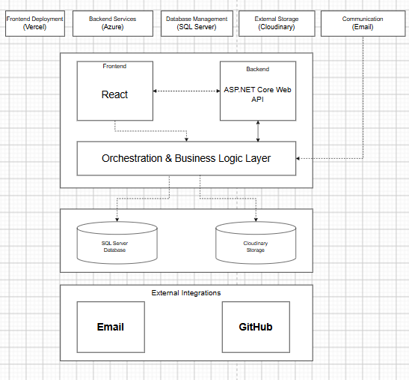
Figure 1-1. System Architecture

1.2 Package Diagram

1.2.1 Front-end Package Diagram
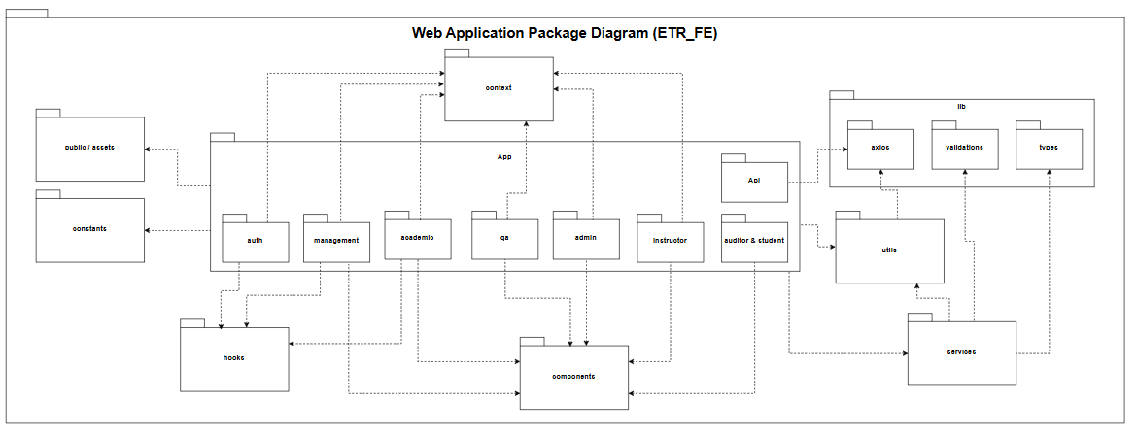
Figure 1-2. Front-end Package Diagram
No | Package | Description
01 | App (Pages) | Contains all role-based views and screen workflows, including auth, academic, instructor, qa, admin, management, and auditor & student. Each page aggregates reusable UI components, consumes shared contexts, and triggers domain services to render role-specific interfaces.
02 | App.Api | Encapsulates endpoint-specific API caller definitions mapped directly to backend controller routes.
03 | Context | Manages global application states, including authentication session state (AuthContext), user claims/roles, and multi-language translation providers across the UI.
04 | Components | Contains modular and reusable UI building blocks such as custom tables, action modals, confirmation dialogs, notification toasts, and pagination controls used across multiple pages.
05 | Services | Implements domain-specific frontend business logic, bridging the UI views with API endpoints to fetch, manipulate, and mutate training record entities.
06 | Utils | Houses cross-cutting utility functions, data formatting helpers (date, strings, status badges), and the core Axios client instance (api.js) configured with automatic JWT interceptors and error handling.
07 | Hooks | Encapsulates reusable custom React hooks for stateful UI logic, such as debounced search filters, dynamic form bindings, and modal visibility management.
08 | Constants | Stores system-wide immutable values, including operational status enums, role definitions, standard error messages, and application route paths.
09 | Lib | Wraps third-party client libraries and cross-cutting specifications, including axios networking instances, client-side data schema validations, and global TypeScript/data types.
10 | Public / Assets | Stores uncompiled static resources, including institutional logos, document templates, favicons, and graphic assets.

1.2.2 Back-end Package Diagram
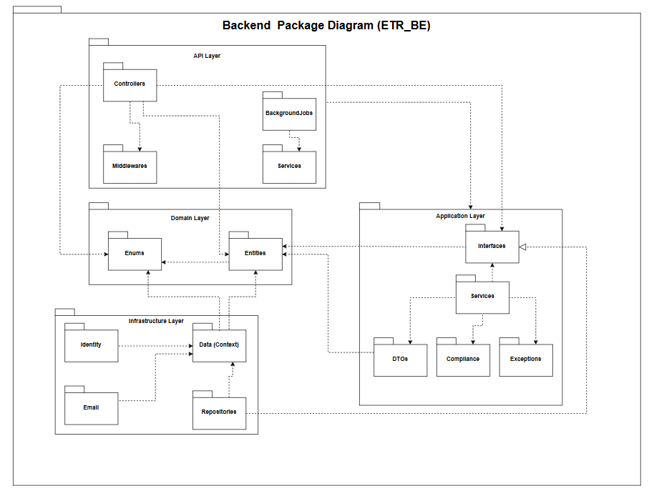
Figure 1-3. Back-end Package Diagram
No | Package | Description
01 | ETR.API.Controllers | Exposes RESTful HTTP endpoints that receive client requests, validate payloads, and delegate execution to application service interfaces.
02 | ETR.API.Middlewares | Intercepts HTTP request/response pipelines to handle global exception handling, structured request logging, and JWT authentication challenge management.
03 | ETR.API.BackgroundJobs | Executes recurring background tasks and asynchronous batch processing for scheduled notifications and periodic record compliance updates.
04 | ETR.API.Services | Provides host-level presentation services and dependency injection configuration modules required to bootstrap the web API runtime
05 | ETR.Application.Interfaces | Defines domain service abstractions and repository contract interfaces (e.g., IUnitOfWork, IETRCourseRecordRepository), fulfilling the Dependency Inversion Principle.
06 | ETR.Application.Services | Implements core use cases, business validation logic, orchestration flows, and report generation workflows.
07 | ETR.Application.DTOs | Encapsulates Data Transfer Objects used for API request/response payloads, isolating domain entities from outer presentation layers
08 | ETR.Application.Compliance | Houses institutional compliance rule engines and audit assessment algorithms governing training records.
09 | ETR.Application.Exceptions | Defines custom domain and application exception classes for centralized fault handling and descriptive API responses.
10 | ETR.Infrastructure.Data | Implements Entity Framework Core database contexts (AppDbContext), entity configurations, and database connection lifecycles.
11 | ETR.Infrastructure.Repositories | Implements abstract repository interfaces and Unit of Work patterns for concrete SQL Server data access and querying.
12 | ETR.Infrastructure.Identity | Manages user identity verification, password hashing with BCrypt, and security token issuance (TokenService).
13 | ETR.Infrastructure.Email | Implements notification delivery interfaces via SMTP/MailKit for automated verification and audit alerts.
14 | ETR.Infrastructure.Migrations | Contains EF Core database schema migration scripts versioning the underlying relational database structure.
15 | ETR.Domain.Entities | Contains enterprise business entities (e.g., Course, Class, TraineeRecord, Evidence) representing core domain data models.
16 | ETR.Domain.Enums | Defines domain enumeration types representing domain-level statuses, evaluation grades, and role classifications.

1.2.3 Package Dependencies & Interface Implementations
The system enforces strict Clean Architecture layering through explicit project references and interface implementations:
Interface Realizations (-|>):
- [ETR.API.Services] -|> [ETR.Application.Interfaces]
- [ETR.Application.Services] -|> [ETR.Application.Interfaces]
- [ETR.Infrastructure.Repositories] -|> [ETR.Application.Interfaces]
- [ETR.Infrastructure.Identity] -|> [ETR.Application.Interfaces]
- [ETR.Infrastructure.Email] -|> [ETR.Application.Interfaces]
Internal Backend Dependencies (->):
- [ETR.API.Controllers] -> [ETR.Application.Interfaces], [ETR.Application.DTOs], [ETR.Domain.Entities], [ETR.Domain.Enums]
- [ETR.API.Middleware] -> [ETR.Application.Exceptions]
- [ETR.API.BackgroundJobs] -> [ETR.Application.Interfaces], [ETR.Domain.Entities], [ETR.Domain.Enums]
- [ETR.Application.Services] -> [ETR.Application.Interfaces], [ETR.Application.DTOs], [ETR.Application.Compliance], [ETR.Application.Exceptions], [ETR.Domain.Entities], [ETR.Domain.Enums]
- [ETR.Application.Compliance] -> [ETR.Domain.Entities], [ETR.Domain.Enums], [ETR.Application.DTOs]
- [ETR.Infrastructure.Repositories] -> [ETR.Infrastructure.Data], [ETR.Application.Interfaces], [ETR.Domain.Entities], [ETR.Domain.Enums]
- [ETR.Infrastructure.Data] -> [ETR.Domain.Entities], [ETR.Domain.Enums]
- [ETR.Infrastructure.Identity] -> [ETR.Application.Interfaces], [ETR.Domain.Entities]
- [ETR.Domain.Entities] -> [ETR.Domain.Enums]
Frontend-to-Backend Inter-layer Communication:
- [ETR_FE (Utils/api.js)] -> [ETR.API.Controllers] (via HTTP REST APIs with JWT Bearer Authorization)

2. Database Design
The database is a relational SQL Server schema managed by EF Core. The model is centered on the ETR_Course_Record: enrolling a learner into a class auto-generates the ETR record and one SubjectResult per subject; attendance, assessment, evidence and sign-off data accumulate on the record; approval and amendment history plus the audit log provide full traceability. Approved records are frozen (IsLocked) and become read-only.

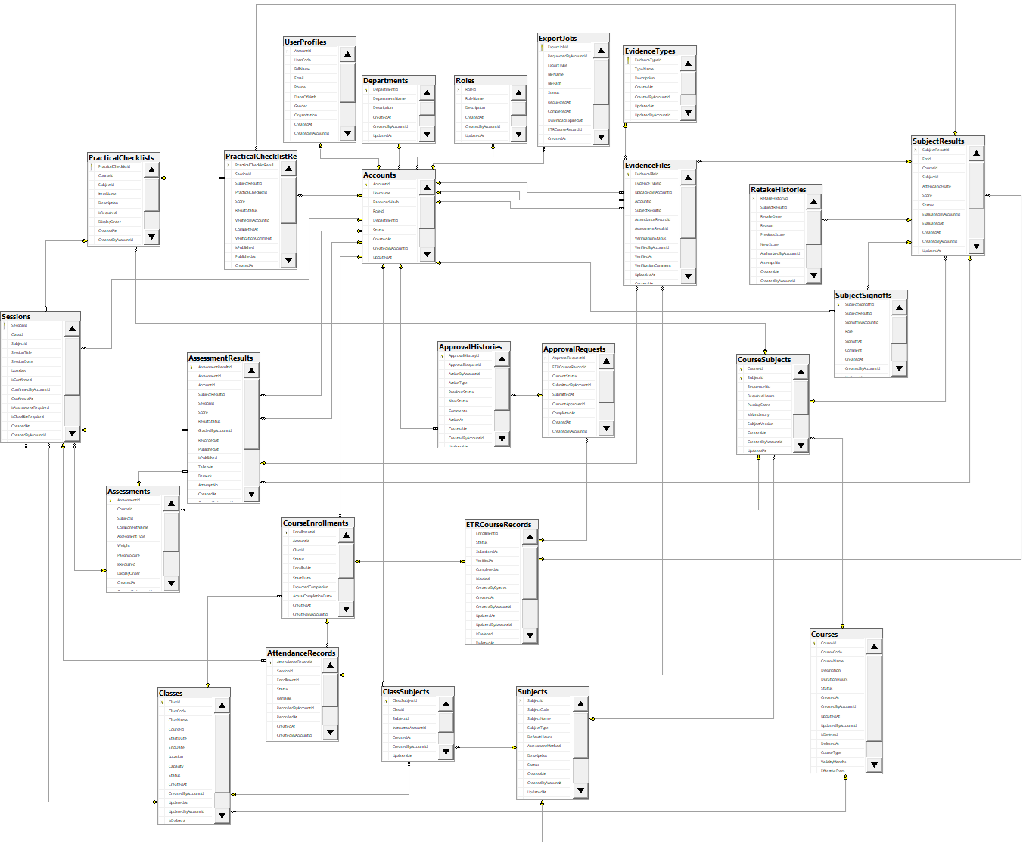
Figure 2-1. Database Design

Table Descriptions

No | Table | Description
01 | Roles | Defines system access roles governing permission scopes and functionality access across the application.  -Primary keys: RoleId  -Foreign keys: CreatedByAccountId, UpdatedByAccountId  .
02 | Accounts | Stores system authentication credentials, active account statuses, and foreign key references linking each user to their designated Role and Department.  -Primary keys: AccountId  -Foreign keys: RoleId, DepartmentId, CreatedByAccountId, UpdatedByAccountId
03 | UserProfiles | Houses extended biographical and personal details of users mapped directly to system accounts.  -Primary keys: AccountId  -Foreign keys: AccountId, CreatedByAccountId, UpdatedByAccountId
04 | Departments | Stores organizational unit and departmental structures within the institution to which accounts belong.  -Primary keys: DepartmentId  -Foreign keys: CreatedByAccountId, UpdatedByAccountId
05 | Courses | Represents master training programs, tracking course metadata, total duration hours, validity periods, and lifecycle states.  -Primary keys: CourseId  -Foreign keys: CreatedByAccountId, UpdatedByAccountId
06 | Subjects | Represents standalone academic or technical training modules, containing syllabus codes, training hours, and assessment modes.  -Primary keys: SubjectId  -Foreign keys: CreatedByAccountId, UpdatedByAccountId
07 | CourseSubjects | Junction entity mapping curriculum subjects into specific courses with sequencing orders, mandatory criteria, and passing thresholds.  -Primary keys: CourseId, SubjectId  -Foreign keys: CourseId, SubjectId, CreatedByAccountId, UpdatedByAccountId
08 | Assessments | Defines component evaluation criteria and formal examinations under a specific course and subject.  -Primary keys: AssessmentId  -Foreign keys: CourseId, SubjectId, CreatedByAccountId, UpdatedByAccountId
09 | PracticalChecklists | Defines itemized practical competency rubrics and task criteria required during specialized training sessions.  -Primary keys: PracticalChecklistId  -Foreign keys: CourseId, SubjectId, CreatedByAccountId, UpdatedByAccountId
10 | Classes | Represents specific cohort deliveries of a course, detailing scheduled timelines, classroom venues, and execution statuses.  -Primary keys: ClassId  -Foreign keys: CourseId, CreatedByAccountId, UpdatedByAccountId
11 | ClassSubjects | Links scheduled classes with their curriculum subjects, assigning designated instructors to deliver each module.  -Primary keys: ClassSubjectId  -Foreign keys: ClassId, SubjectId, InstructorAccountId, CreatedByAccountId, UpdatedByAccountId
12 | Sessions | Tracks scheduled class training sessions, recording timetables, locations, and linked evaluation rubrics.  -Primary keys: SessionId  -Foreign keys: ClassId, SubjectId, ConfirmedByAccountId, AssessmentId, PracticalChecklistId, CreatedByAccountId, UpdatedByAccountId
13 | Enrollments | Tracks trainee registration records into specific classes, monitoring enrollment progress lifecycles and completion dates.  -Primary keys: EnrollmentId  -Foreign keys: AccountId, ClassId, CreatedByAccountId, UpdatedByAccountId
14 | AttendanceRecords | Records individual trainee attendance logs for scheduled sessions, capturing presence statuses and justification remarks.  -Primary keys: AttendanceRecordId  -Foreign keys: SessionId, EnrollmentId, RecordedByAccountId, CreatedByAccountId, UpdatedByAccountId
15 | ExportJobs | Manages background queue tasks processing downloadable ETR dossier documents and exported audit packages.  -Primary keys: ExportJobId  -Foreign keys: RequestedByAccountId, ETRCourseRecordId, CreatedByAccountId, UpdatedByAccountId
16 | ETRCourseRecords | Represents the master Electronic Training Record dossier per enrollment, managing multi-tier review and verification states.  -Primary keys: ETRCourseRecordId  -Foreign keys: EnrollmentId, PreviousRecordId, CreatedByAccountId, UpdatedByAccountId
17 | SubjectResults | Aggregates subject-level performance metrics per trainee, tracking total attendance rates, cumulative scores, and completion statuses.  -Primary keys: SubjectResultId  -Foreign keys: EtrId, CourseId, SubjectId, EvaluatedByAccountId, CarriedOverFromSubjectResultId, CreatedByAccountId, UpdatedByAccountId
18 | AssessmentResults | Stores trainee assessment outcomes, recording raw marks, attempt numbers, grading timestamps, and evaluation statuses.  -Primary keys: AssessmentResultId  -Foreign keys: AssessmentId, AccountId, SubjectResultId, SessionId, GradedByAccountId, CreatedByAccountId, UpdatedByAccountId
19 | PracticalChecklistResults | Captures evaluation records of trainee practical skill checklists, including verification scores, evaluator feedback, and publish statuses.  -Primary keys: PracticalChecklistResultId  -Foreign keys: SessionId, SubjectResultId, PracticalChecklistId, VerifiedByAccountId, CreatedByAccountId, UpdatedByAccountId
20 | SubjectSignoffs | Tracks formal sign-off endorsements for completed subjects executed by authorized academic authorities.  -Primary keys: SubjectSignoffId  -Foreign keys: SubjectResultId, SignoffByAccountId, CreatedByAccountId, UpdatedByAccountId
21 | EvidenceType | Master catalog categorizing supported physical and digital compliance evidence types.  -Primary keys: EvidenceTypeId  -Foreign keys: CreatedByAccountId, UpdatedByAccountId
22 | EvidenceFiles | Manages uploaded digital compliance records, linking evidence entries to attendance, assessment, or dossier entities.  -Primary keys: EvidenceFileId  -Foreign keys: EvidenceTypeId, UploadedByAccountId, AccountId, SubjectResultId, AttendanceRecordId, AssessmentResultId, VerifiedByAccountId, CreatedByAccountId, UpdatedByAccountId
23 | RetakeHistories | Maintains an immutable audit log of reassessment attempts, recording score deltas, retake justifications, and authorizing supervisors.  -Primary keys: RetakeHistoryId  -Foreign keys: SubjectResultId, AuthorizedByAccountId, CreatedByAccountId, UpdatedByAccountId
24 | ApprovalRequests | Tracks formal submission approval workflows for training dossiers across evaluation checkpoints.  -Primary keys: ApprovalRequestId  -Foreign keys: ETRCourseRecordId, SubmittedByAccountId, CurrentApproverId, CreatedByAccountId, UpdatedByAccountId
25 | ApprovalHistories | Stores sequential decision steps, reviewer remarks, and transition states throughout an approval workflow lifecycle.  -Primary keys: ApprovalHistoryId  -Foreign keys: ApprovalRequestId, ActionByAccountId, CreatedByAccountId, UpdatedByAccountId

3. Detailed Design

3.1 Authentication & Authorization
Authentication is implemented with JWT bearer tokens. The involved classes are: AuthController (login/logout/change-password endpoints), AccountService (validates credentials and returns the account with its role), ITokenService/JwtTokenService (issues the signed JWT), CurrentUserService (resolves the current account id and role from the token principal), and the JWT bearer middleware configured in Program.cs (issuer/audience/lifetime/signing-key validation). A rate limiter (AuthPolicy: 5 requests/minute per IP) protects the sensitive auth endpoints against brute-force attacks.
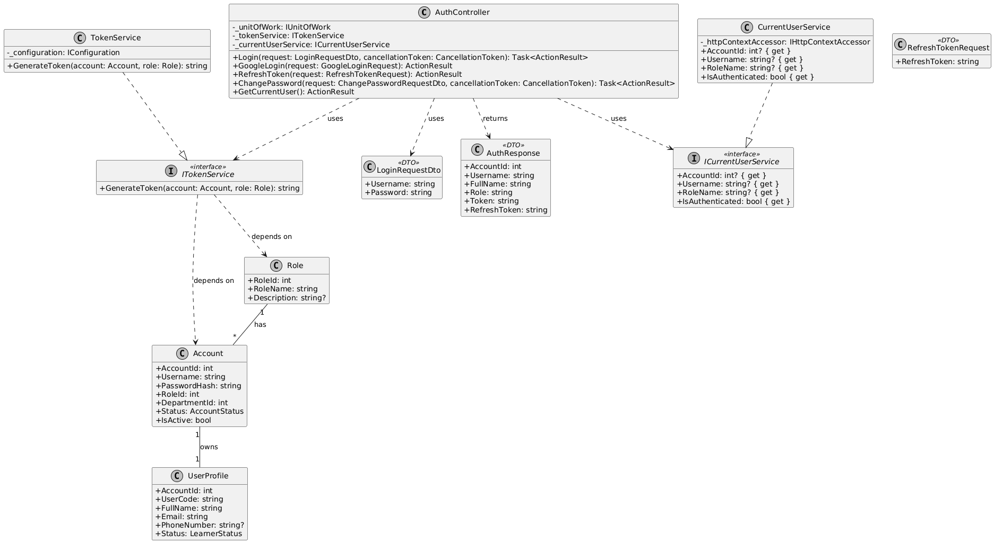
Figure 3-1. Class Diagram – Authentication & Authorization
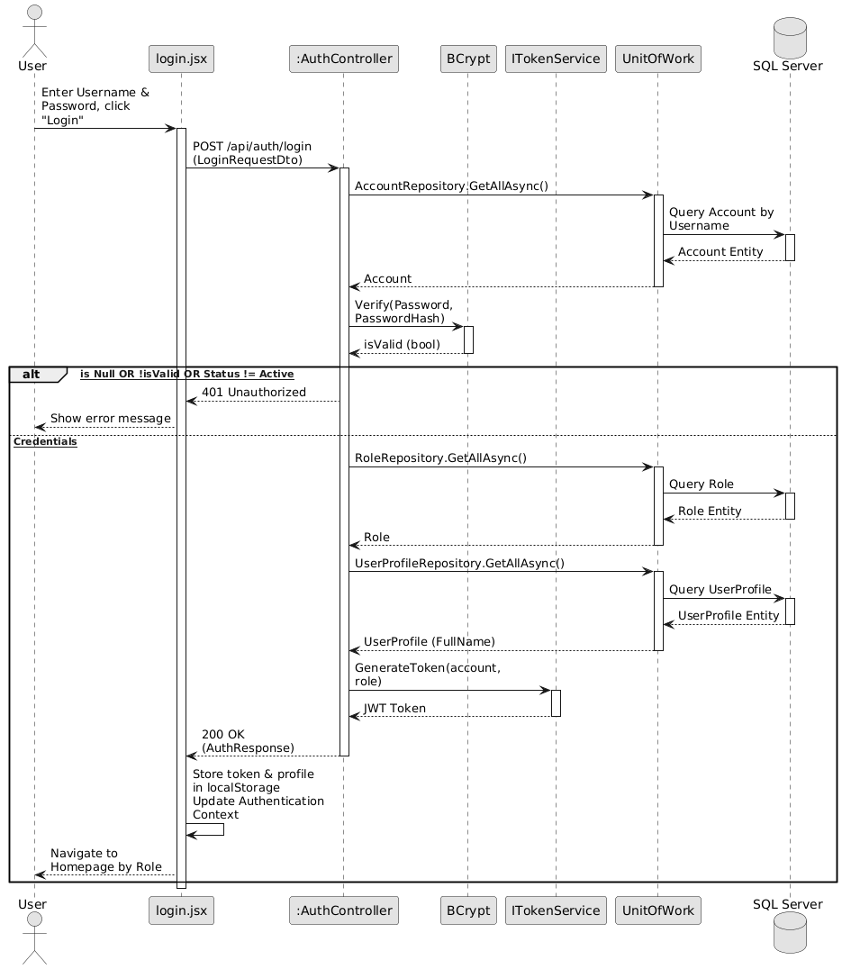
Figure 3-2. Sequence Diagram – Authentication & Authorization

3.2 Class Creation & Auto-Provisioning
The class creation process is managed by the ClassesController and ClassService. To guarantee data consistency, the entire workflow is wrapped in a database transaction (BeginTransactionAsync). The service validates the course existence and class code uniqueness before persisting the Class entity. It then iterates through instructor assignments, verifying the instructor role, and maps them via ClassSubject. Crucially, the system executes an auto-provisioning mechanism: based on the RequiredSessions configuration of each subject, it automatically generates empty Session stubs (IsConfirmed = false) to prepare the class schedule. The transaction concludes by automatically writing to the AuditLog.

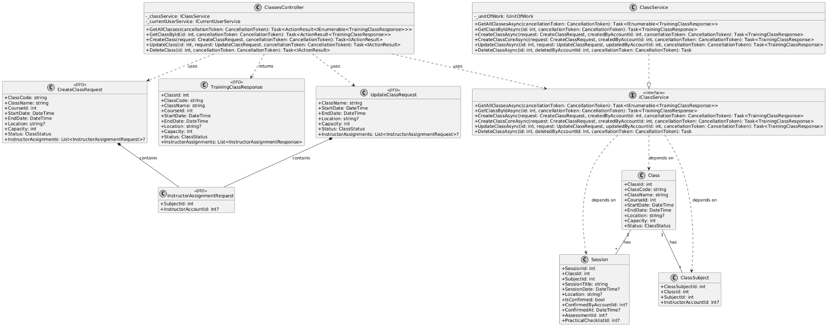
Figure 3-3. Class Diagram – Class Creation & Auto-Provisioning

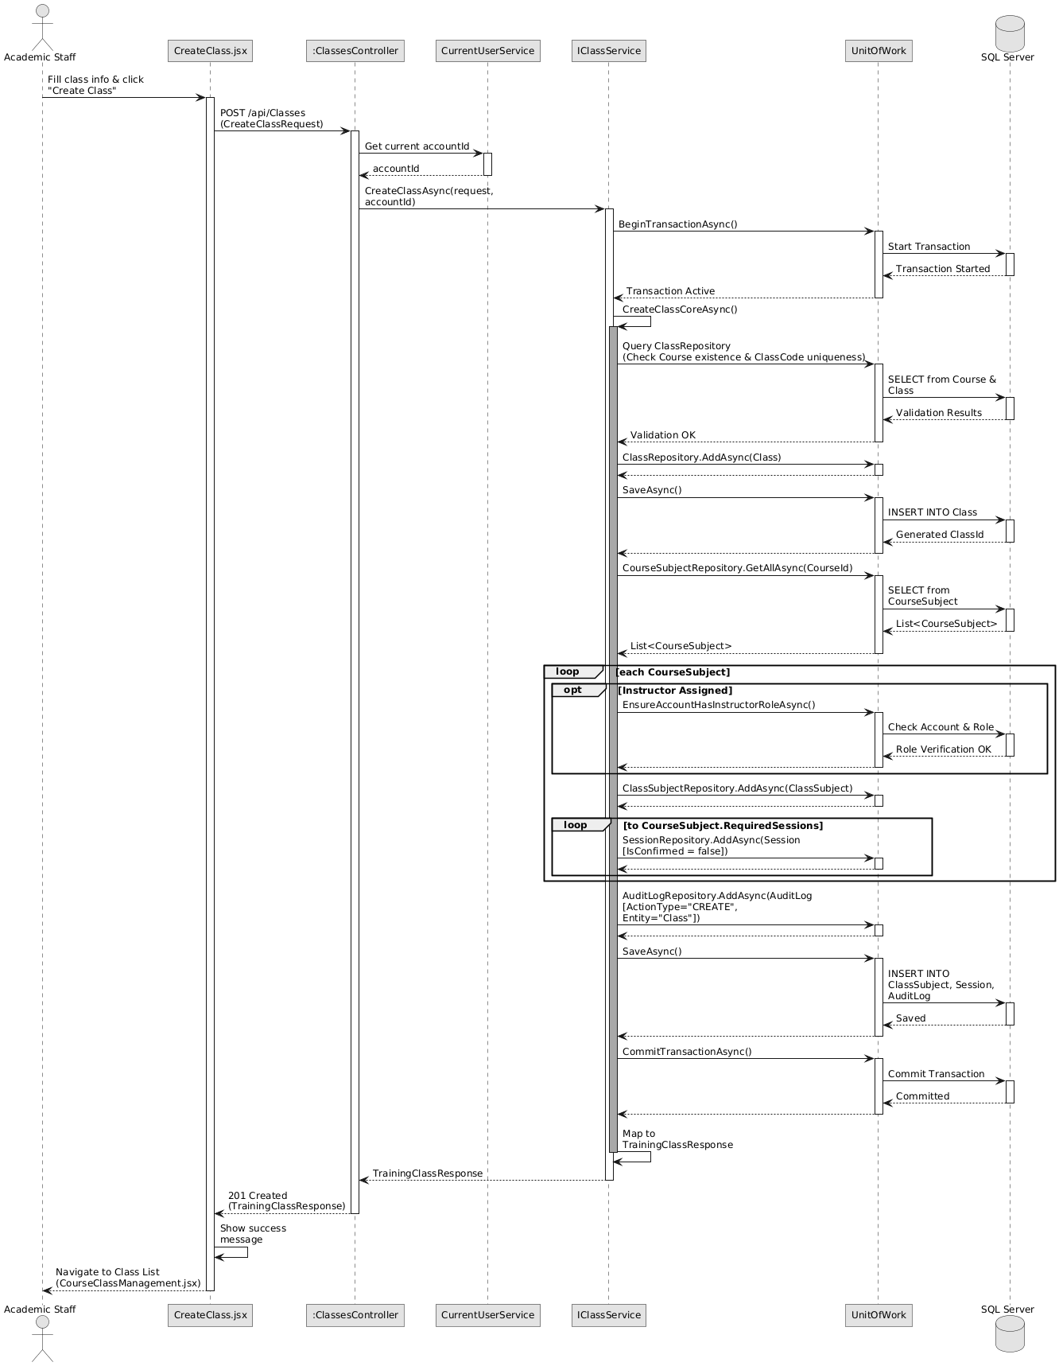
Figure 3-4. Sequence Diagram – Class Creation & Auto-Provisioning

3.3 Enrollment & ETR Auto-Generation
Enrollment operations are handled by the EnrollmentsController and EnrollmentService. The service enforces strict aviation compliance gates, notably the "Single Active ETR" rule, preventing learners from having overlapping active records for the same course. Upon validation, a single transaction generates the CourseEnrollment and automatically scaffolds the ETRCourseRecord (Status = "InProgress", IsLocked = false). The system evaluates a "Retake Rule": it either inherits past SubjectResult data for previously passed subjects or initializes new pending SubjectResult stubs containing a snapshot of the current passing score.
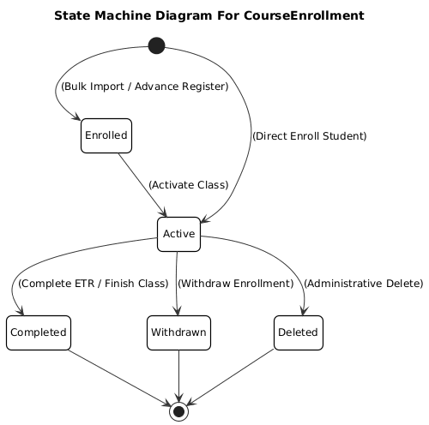

Figure 3-5. State Machine Diagram – Course Enrollment Lifecycle
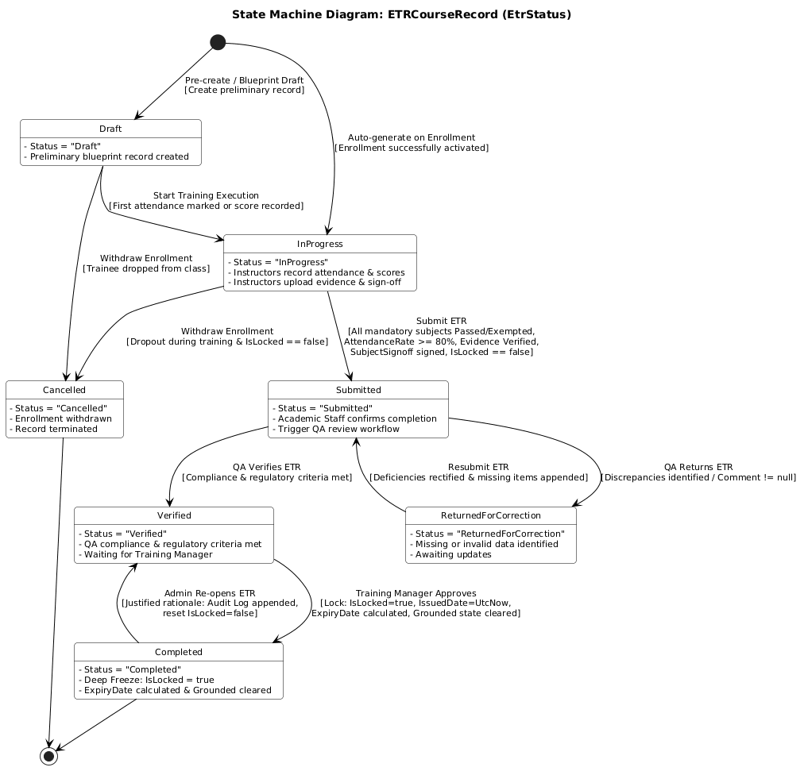

Figure 3-6. State Machine Diagram – ETR Lifecycle
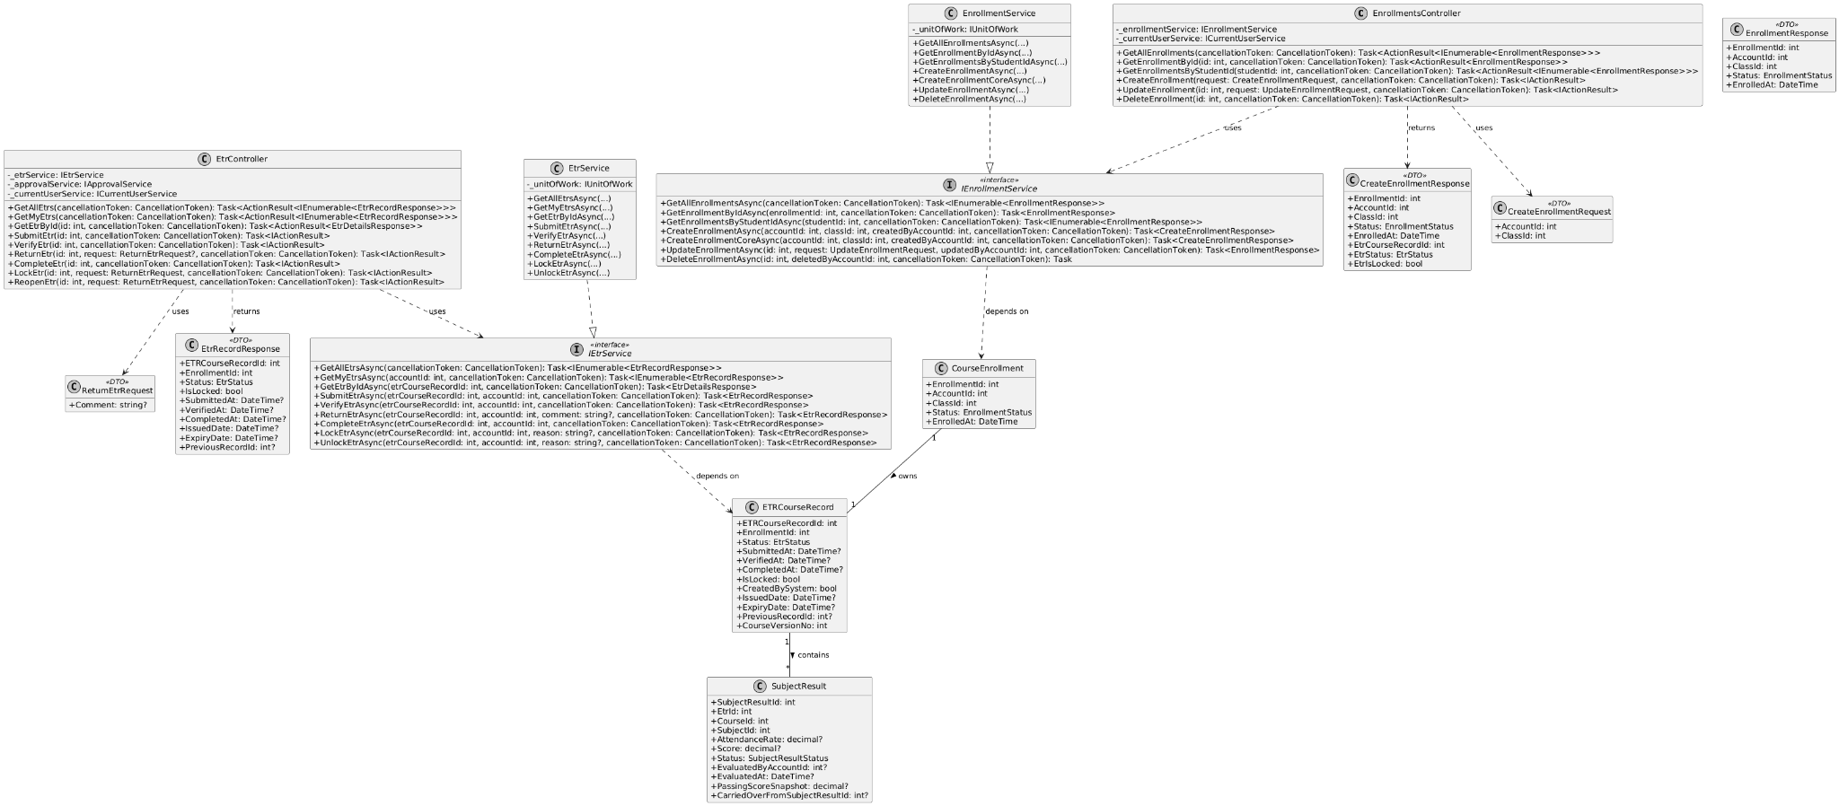
Figure 3-7. Class Diagram – Enrollment & ETR Entities
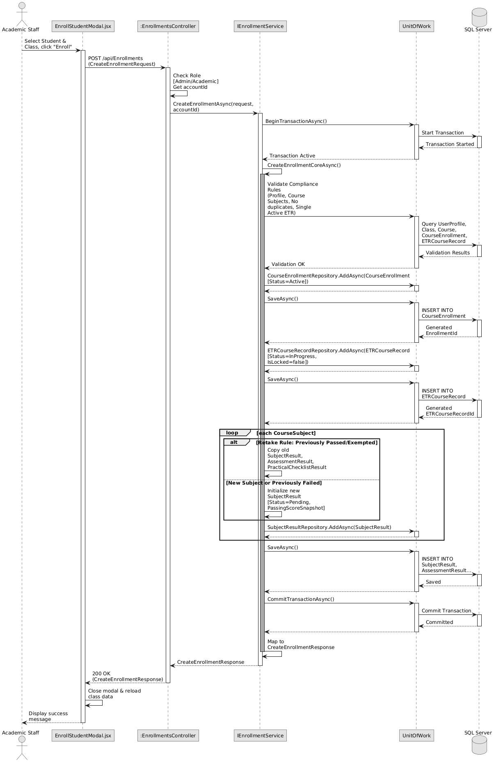
Figure 3-8. Sequence Diagram – Enrollment & ETR Auto-Generation

3.4 Attendance Recording & Auto-Calculation
Attendance tracking relies on the AttendanceController and AttendanceService. The service applies an "Immutability Validator" to ensure the targeted ETR is active and not locked. After validating the session and the instructor's class ownership, it persists the AttendanceRecord. Immediately within the same transaction, the service invokes an internal recalculation engine (RecalculateAttendanceRateAsync) which aggregates the learner's present sessions against the mandatory requirements and dynamically updates the aggregate AttendanceRate percentage on the SubjectResult.
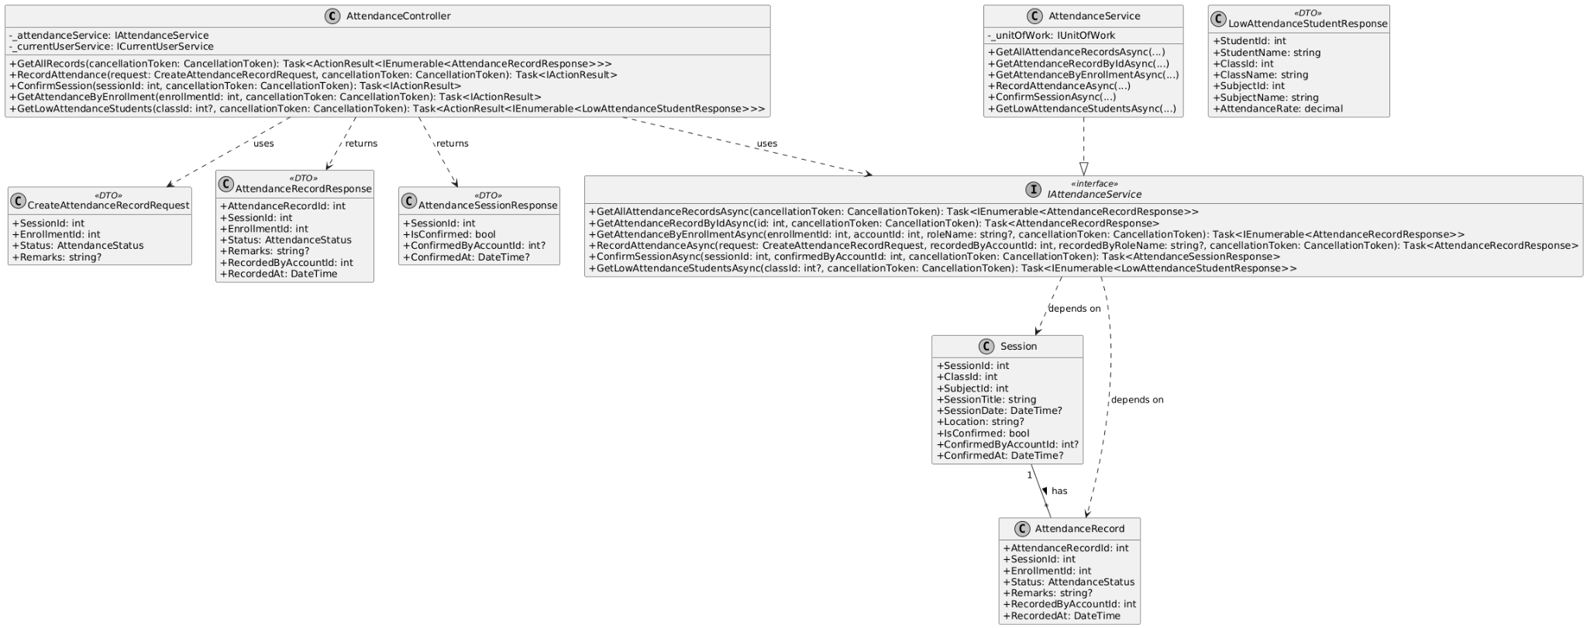
Figure 3-9. Class Diagram – Attendance Recording & Auto-Calculation
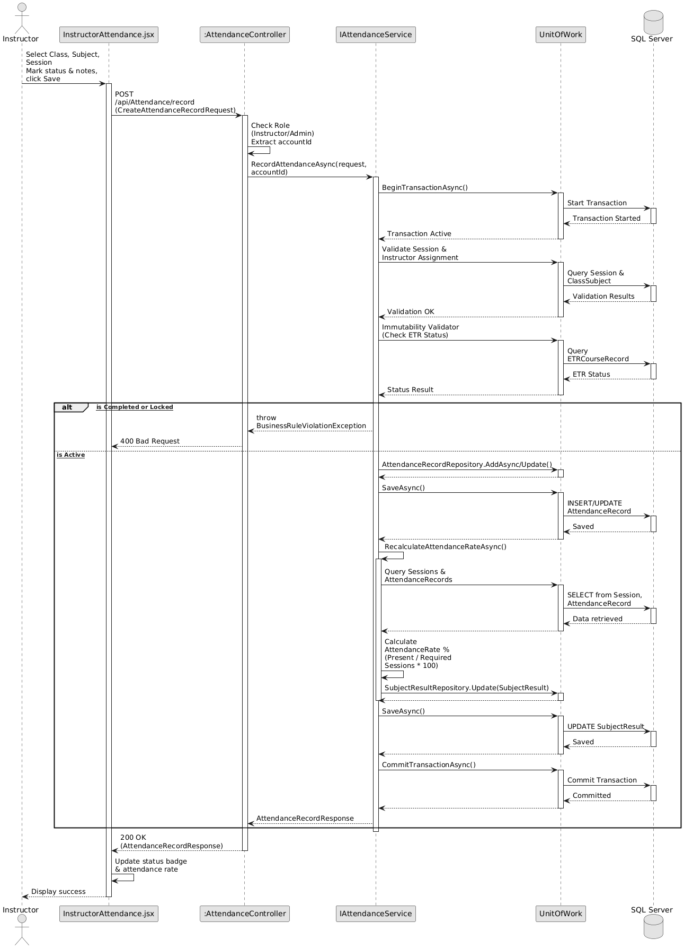
Figure 3-10. Sequence Diagram – Attendance Recording & Auto-Calculation

3.5 Assessment Grading & Subject Sign-off
This module is orchestrated by the AssessmentResultsController, SubjectSignoffController, and AssessmentResultService. For grading, the service validates ETR mutability, records the score, and automatically recalculates the overall SubjectResult.Score based on component weights. For subject sign-off, the service enforces four rigid Compliance Gates: AttendanceRate >= 80%, Practical Checklist passed, Evidence Files uploaded, and Total Score >= PassingScoreSnapshot. If all gates pass, the system generates a SubjectSignoff record containing the digital signature timestamp and officially transitions the subject status to "Passed".
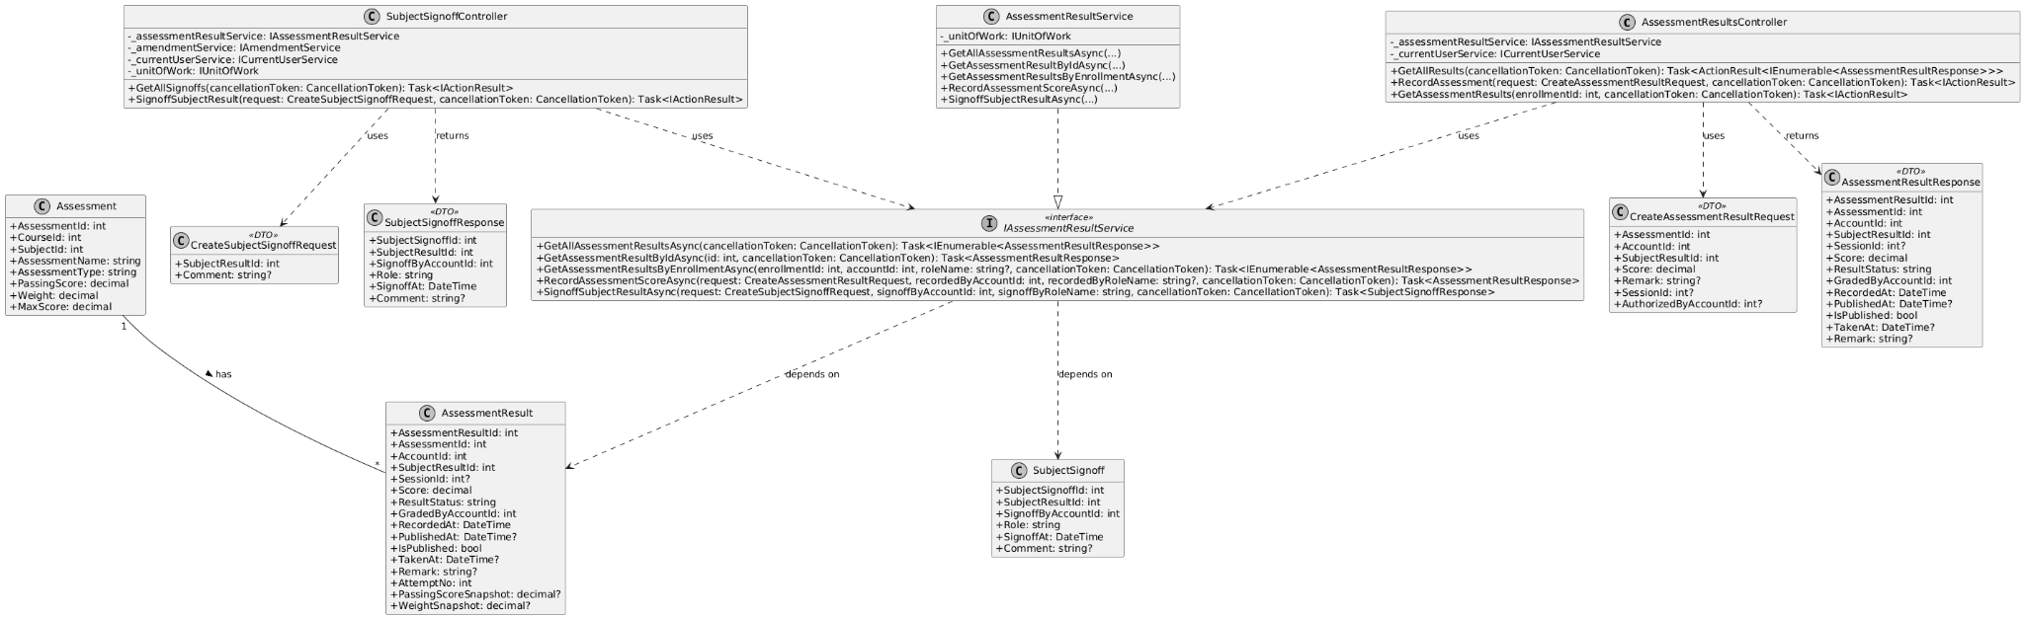
Figure 3-11. Class Diagram – Assessment Grading & Subject Sign-off
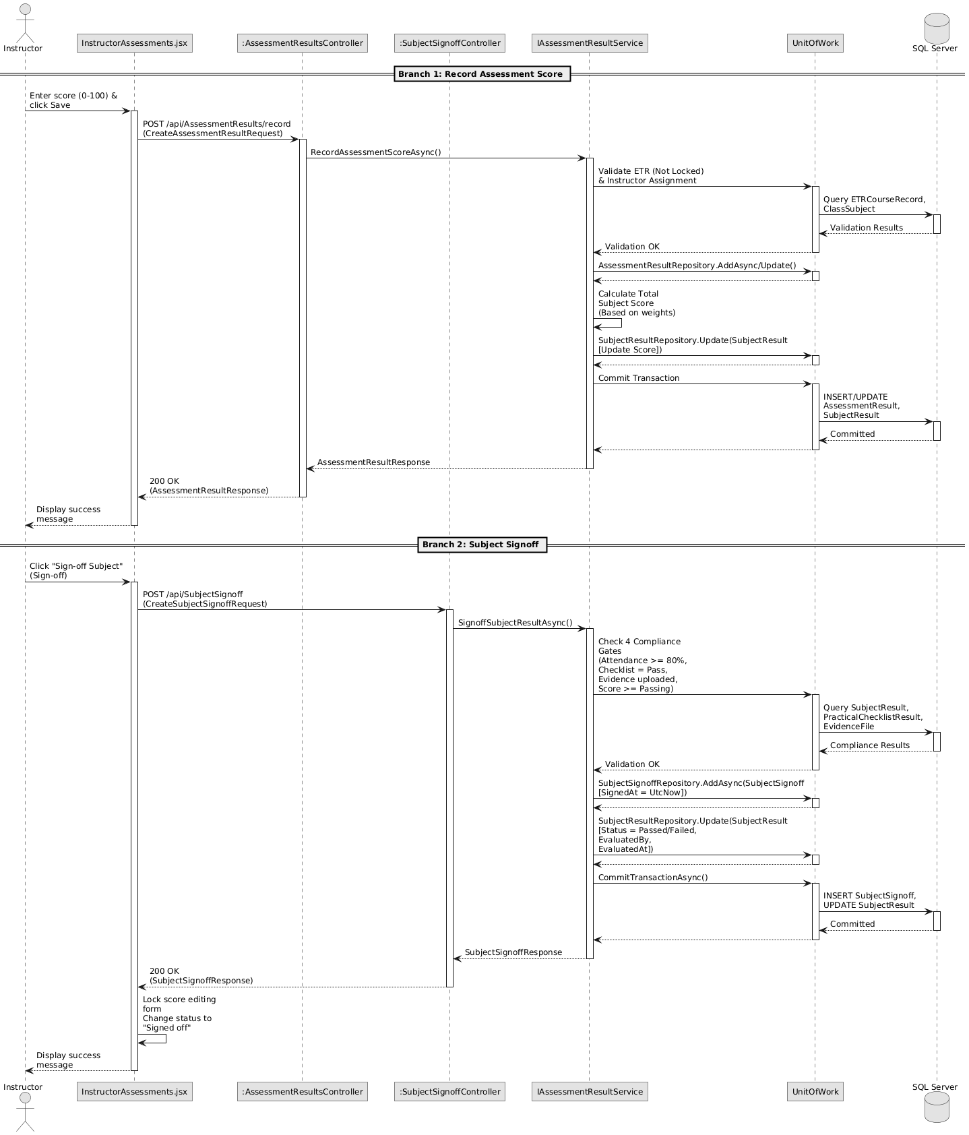
Figure 3-12. Sequence Diagram – Assessment Grading & Subject Sign-off

3.6 Evidence Upload & QA Verification
Evidence management utilizes the EvidencesController, EvidenceService, and a third-party Cloudinary integration. During Phase 1 (Upload), the frontend uploads binary files securely to Cloudinary, while the API stores the returned metadata, mapping it to an EvidenceFile (VerificationStatus = "Pending") and an Attachment entity. In Phase 2 (QA Verification), the service strictly enforces a "Separation of Duties" business rule (EnsureVerifierDidNotUploadEvidence), preventing the uploader from approving their own evidence. Verification actions automatically trigger updates to the EvidenceFile status and generate permanent AuditLog entries.
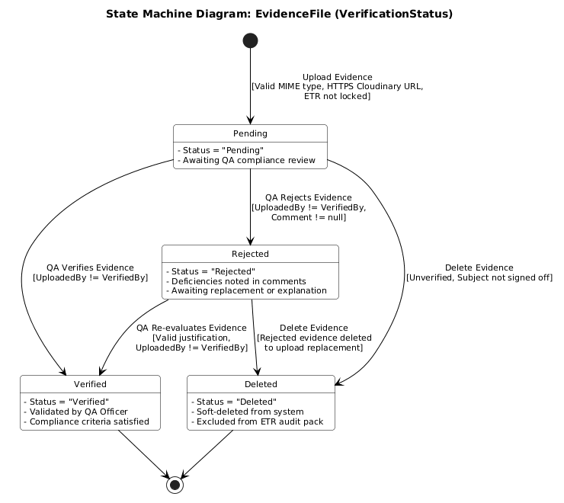
Figure 3-13. State Machine Diagram – Evidence File Lifecycle
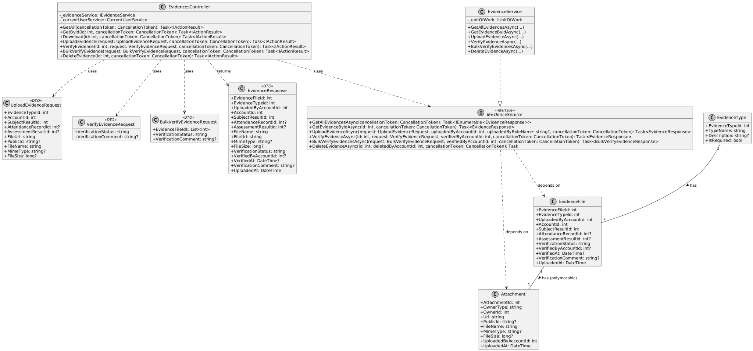
Figure 3-14. Class Diagram – Evidence Upload & Verification
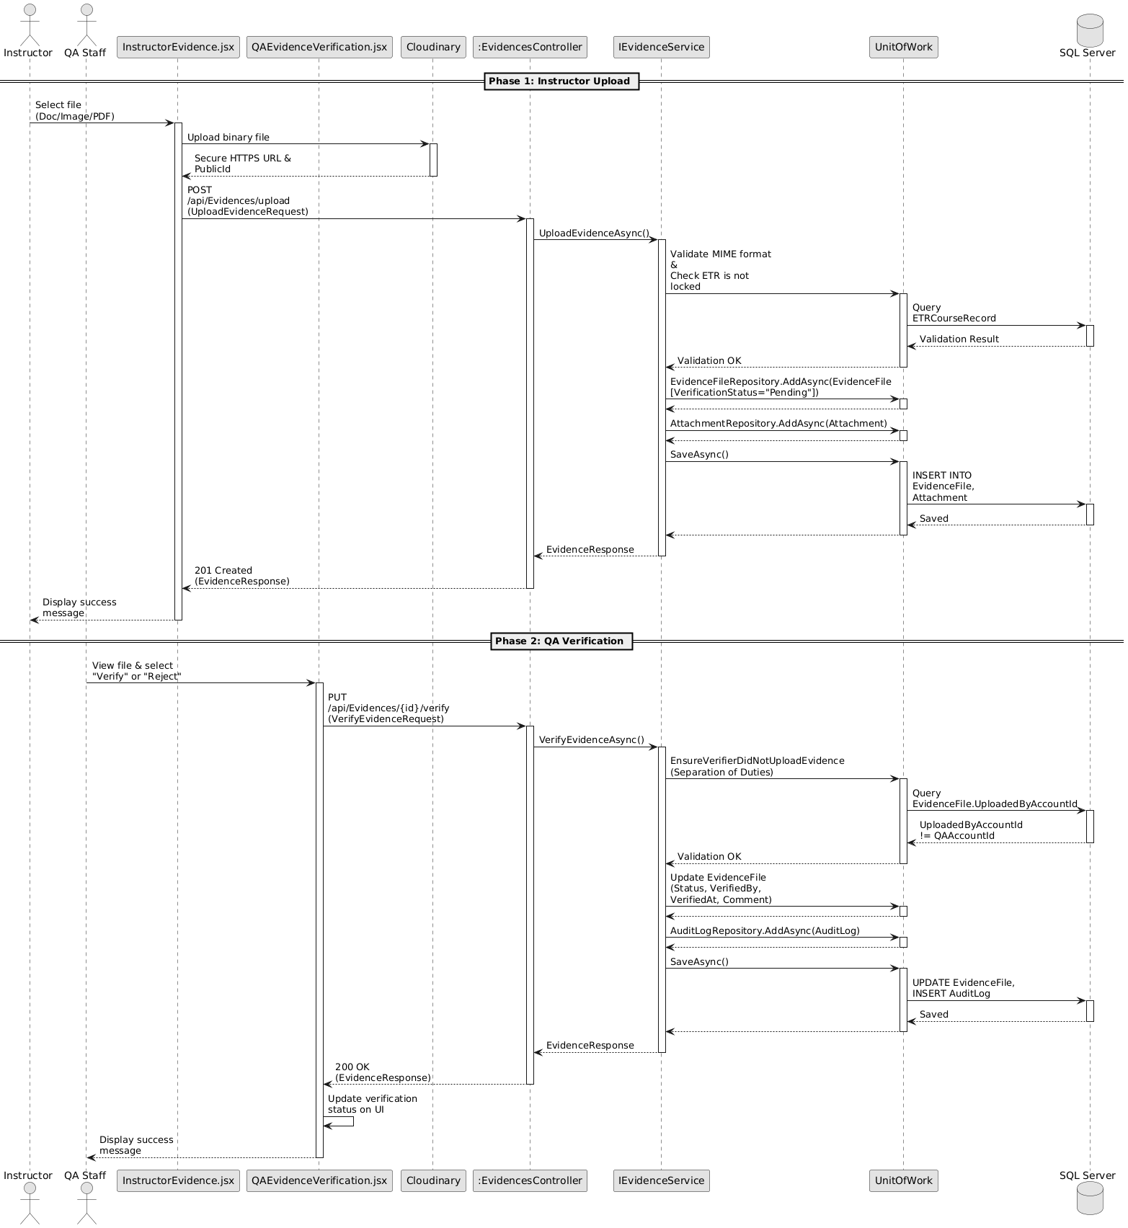
Figure 3-15. Sequence Diagram – Evidence Upload & QA Verification

3.7 ETR Approval Lifecycle & Deep Freeze
The macro-lifecycle of an ETR is driven by the EtrController, ApprovalsController, EtrService, and ApprovalService. The workflow transitions through a structured state machine via ApprovalRequest entities: Submission (by Academic Staff), Verification (by QA), and Final Approval (by the Training Manager). Upon final approval, the service executes a "Deep Freeze" mutation (CompleteEtrAsync): it forcefully sets ETRCourseRecord.Status = Completed, toggles IsLocked = true to permanently disable further edits, applies the completion timestamp, and writes an immutable COMPLETED action to the AuditLog before committing the transaction.
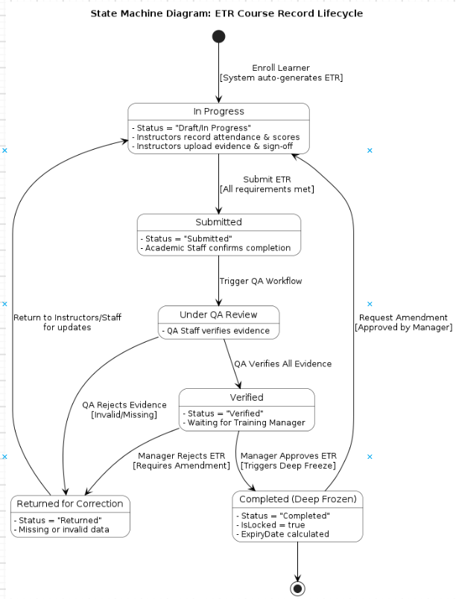
Figure 3-16. State Machine Diagram – ETR Course Record Lifecycle

To manage this complex transition, the system utilizes a dedicated ApprovalRequest entity. The following micro state machine details the specific workflow and status transitions of an Approval Request as it bounces between Academic Staff, QA Staff, and the Training Manager.
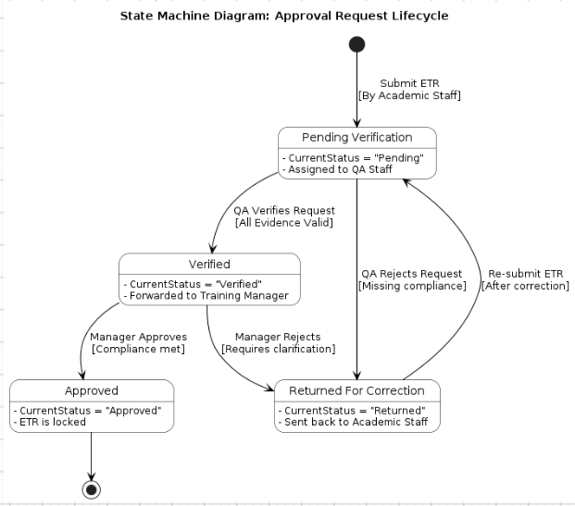
Figure 3-17. State Machine Diagram – Approval Request Lifecycle
The final ETR approval workflow is orchestrated by the ApprovalService. When a Training Manager initiates approval via ApprovalController, the system enforces a strict security role check (requiring "TrainingManager" or "Admin" roles). The service updates the ApprovalRequest, adds an ApprovalHistory row, and invokes CompleteEtrAsync. This triggers the ETR Pre-Validation Compliance Checks: the ETR status must be "Verified", all mandatory subjects must be "Passed/Exempted", and all attached EvidenceFiles must be "Verified". Upon passing, the system executes the "Deep Freeze" data mutation: setting ETR.Status = "Completed", locking the record (IsLocked = true), calculating the certificate ExpiryDate, and updating the CourseEnrollment.ActualCompletionDate. A permanent AuditLog is automatically generated before the transaction commits.
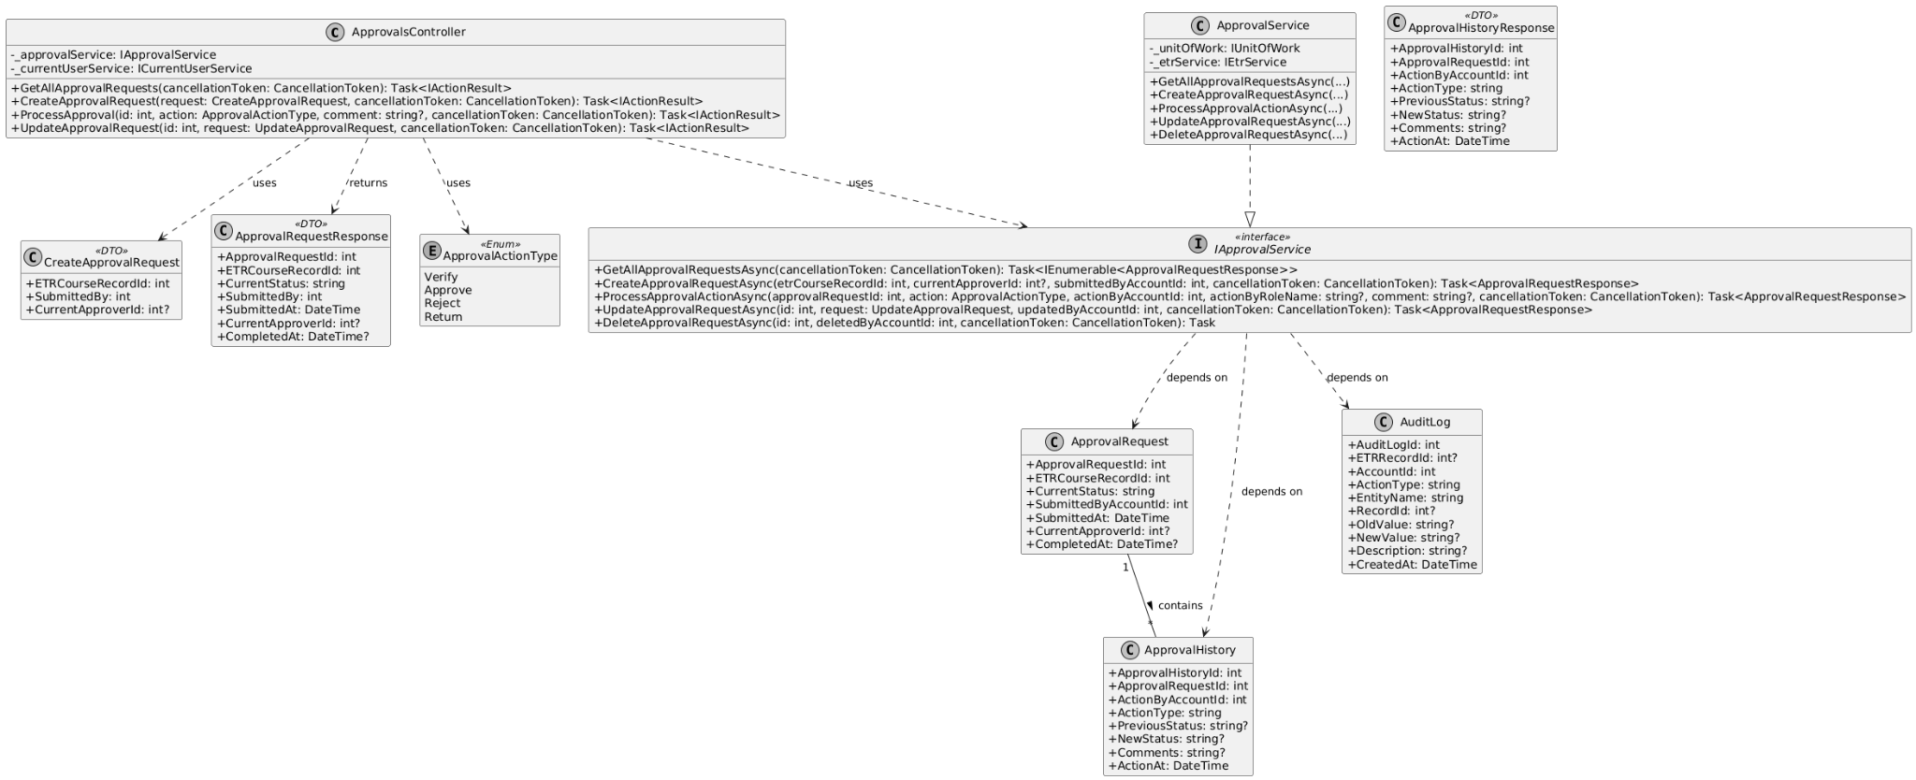
Figure 3-18. Class Diagram – Manager Approval & ETR Deep Freeze
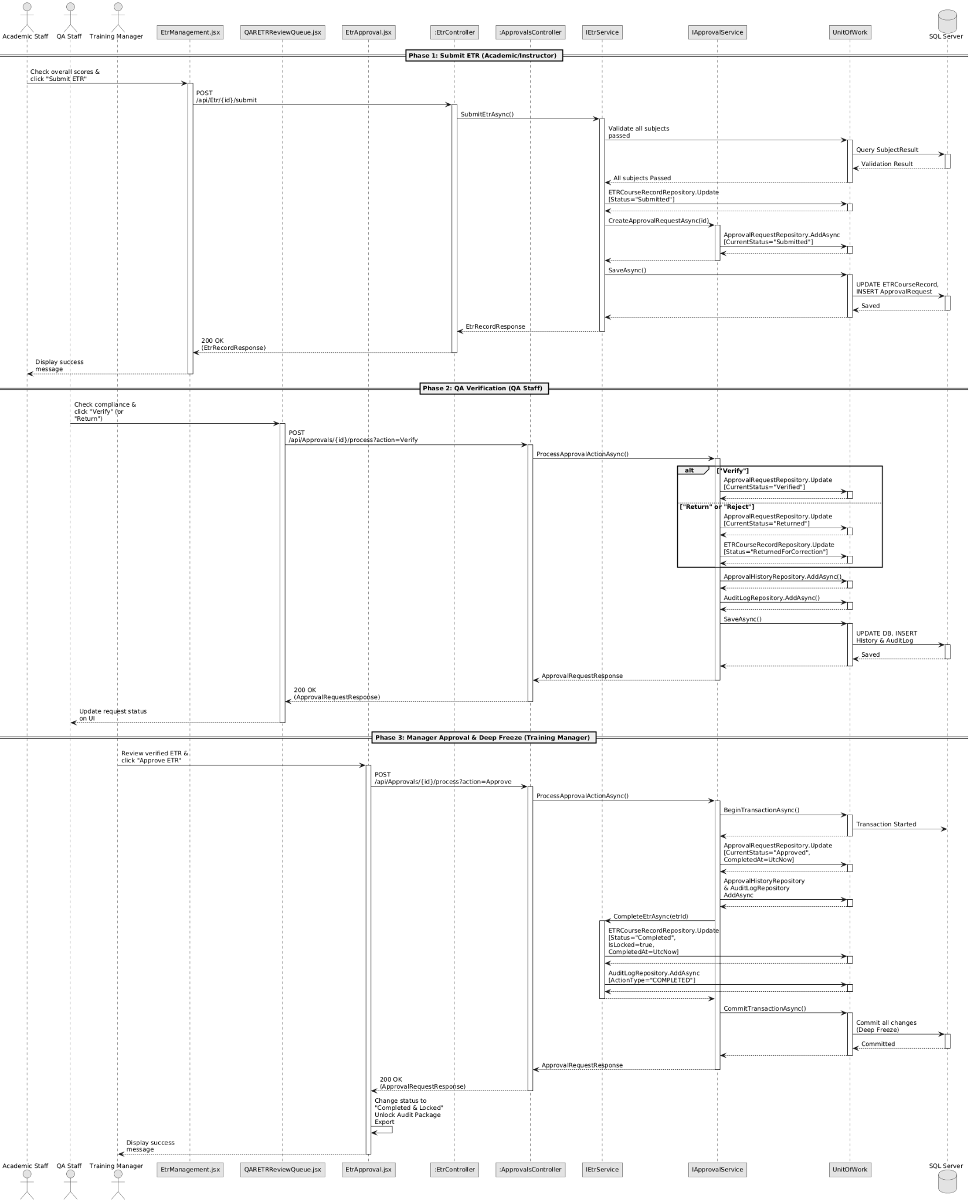
Figure 3-19. Sequence Diagram – ETR Approval Lifecycle & Deep Freeze

3.8 Audit Logs & Training Package Export
Export functionalities are managed by the ExportsController and ExportService. The service first enforces a "Completion Gate," throwing a BusinessRuleViolationException if the requested ETR is not fully completed. Upon passing, it aggregates massive relational datasets (User, Class, Subjects, Evidence, ApprovalHistory). The system dynamically generates an ETR Summary PDF and Audit History PDF (via QuestPDF), alongside a detailed Excel spreadsheet (via ClosedXML) in-memory. It then fetches binary evidence files from Cloudinary, bundles everything into a physical ZIP archive on the server, and creates a tracked ExportJob for the Auditor to download.
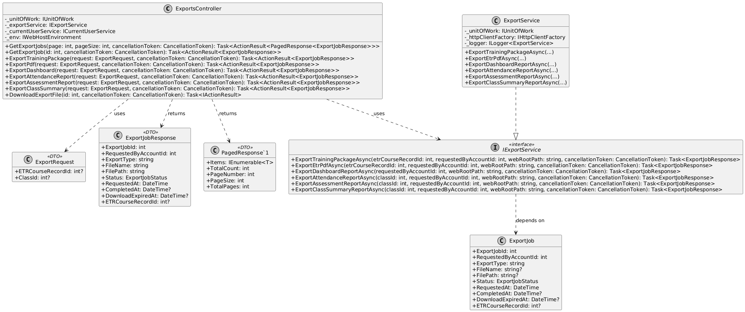
Figure 3-20. Class Diagram – Training Package Export & Audit Logging
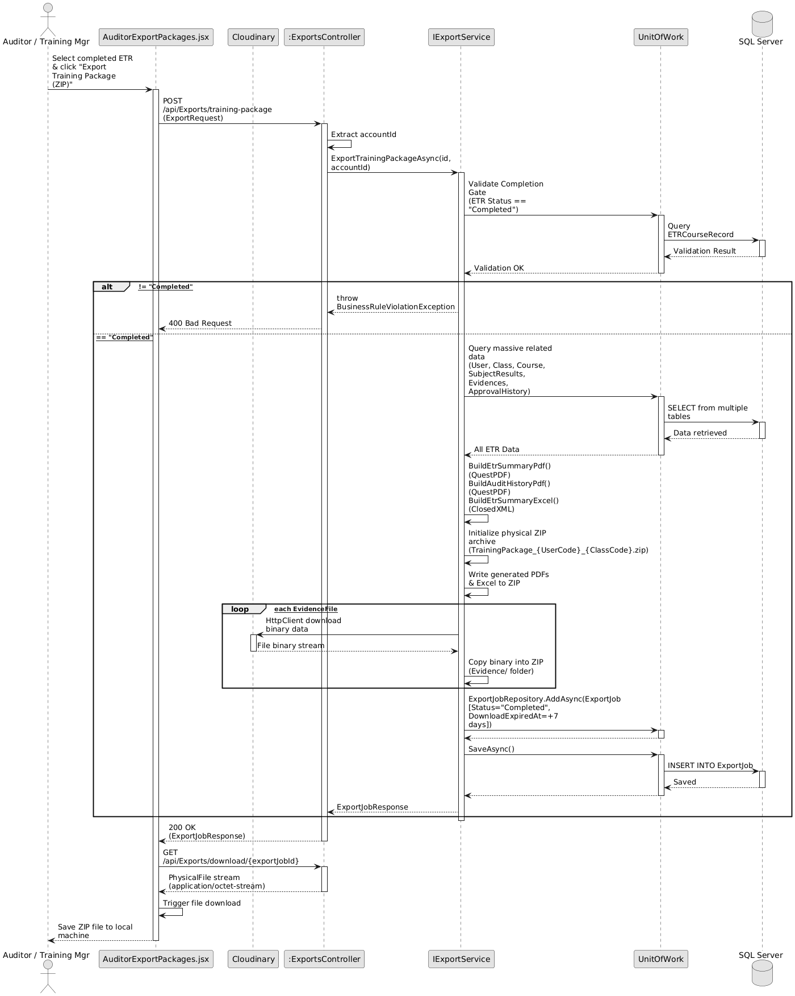
Figure 3-21. Sequence Diagram – Audit Logs & Training Package Export

