
CAPSTONE PROJECT REPORT
Report 6 – Software User Guides
AeroMetric Aviation Systems — ETR (Electronic Training Record) Platform
– Ho Chi Minh, August/September 2026 –

Table of Contents
I. Record of Changes 3
II. Release Package & User Guides 3
1. Deliverable Package 3
2. Installation Guides 4
2.1 System Requirements 4
2.2 Installation Instruction 5
3. User Manual 6
3.1 Overview 6
3.2 Workflow 1 — Login & Account Access 7
3.3 Workflow 2 — Learner, Course & Class Management 7
3.4 Workflow 3 — Instructor: Classes, Attendance, Assessments & Evidence 8
3.5 Workflow 4 — Academic: ETR Management & Submission to QA 9
3.6 Workflow 5 — QA: Evidence Verification, ETR Review & Returns 9
3.7 Workflow 6 — Training Manager: ETR Final Approval 10
3.8 Workflow 7 — Student: View ETR, Certificates & Profile 11
3.9 Workflow 8 — Auditor: Compliance Repository, Search & Export 11
Appendix A — API Endpoint Reference (main routes) 12
Appendix B — System Administration (Admin portal) 13

I. Record of Changes
Date | A*  M, D | In charge | Change Description
August 2026 | A | Project Team | Initial release of the ETR Software User Guides.
*A - Added M - Modified D - Deleted

II. Release Package & User Guides

1. Deliverable Package
No. | Deliverable Item | Description
1 | Project Schedule/Tracking | Project schedule and progress tracking materials.
2 | Project Backlog | Project backlog and planned work items.
3 | Source Codes | ETR frontend source code and related application resources.
4 | Database Script(s) | Database schema, seed and supporting scripts.
5 | Final Report Document | Final capstone project report.
6 | Test Cases Document | Functional and end-to-end test cases.
7 | Defects List | Recorded defects and resolution status.
8 | Issues List | Known issues, limitations and follow-up items.
9 | Slide | Project presentation slides.

2. Installation Guides

2.1 System Requirements
The ETR frontend is a React single-page application built with Vite and deployed against an Azure backend API.
Component | Requirement | Notes
Node.js | ^20.19.0 or >=22.12.0 | Required to run the Vite 8 development server and build tooling. Node >=24 is also supported.
npm | Bundled with Node.js (>=10) | Package manager used to install dependencies.
Git | Any recent version | Required to clone the repository and to drive Vercel deployments from a git push.
Browser | Modern evergreen browser | Chrome, Edge, Firefox, Safari latest; no legacy browser support.

Application Configuration
Item | Value / Notes
Frontend framework | React ^19.2.6 with react-dom
Build tool | Vite ^8.0.12 + @vitejs/plugin-react ^6.0.1
Routing | react-router-dom ^7.18.0
Styling | SCSS (sass-embedded), plus Tailwind via CDN (index.html)
Utilities | react-icons, xlsx (Excel parsing/preview)
Backend API | Deployed Azure Web App (DEPLOY-ONLY mode)
Data storage (browser) | localStorage — auth token, user profile, remembered username, language preference, per-account activity log

Environment Variables
Variable | Purpose | Example
VITE_API_URL_DEPLOY | Base URL of the deployed backend API. Used for all requests (dev and production). | https://etrmanagement-be-xxxxxxxx.southeastasia-01.azurewebsites.net/api
VITE_APP_TITLE | Informational application title. | ETR Aviation Training Portal
VITE_APP_ENV | Informational environment label. | development

2.2 Installation Instruction

Step 1 - Clone the repository: git clone <repository-url> ETR_FE, then run cd ETR_FE.

Result: The frontend source is available locally.

Step 2 - Install dependencies with npm install.

Result: Project packages are installed.

Step 3 - Configure environment variables if a local override is required by creating a gitignored .env.local from .env.example.

Result: The frontend uses the configured environment values.

Step 4 - Run npm run dev.

Result: The Vite development server starts and provides a local frontend URL.

Step 5 - Build the application with npm run build; use npm run preview to preview the production build.

Result: A production-ready dist build is created and can be previewed locally.

Step 6 - Run the available quality checks when required: npm run lint, npm run test:e2e, and npx vitest run.

Result: Linting and automated tests provide feedback before release.

Step 7 - For Vercel deployment, connect the repository, set the build command to npm run build and the output directory to dist.

Result: A successful push to the linked deployment branch can trigger a production build.

3. User Manual

3.1 Overview
The ETR (Electronic Training Record) platform centralizes the entire aviation training record lifecycle in one secure, role-based application. It replaces paper-based training records with a digital dossier that moves through controlled approval stages from enrollment and evidence collection, to quality-assurance verification, to final management sign-off, and finally into a locked, audit-ready compliance repository.
User Roles and Portals
Role | Portal URL | Responsibility
Admin | /admin | User, department, audit and system configuration management
Academic | /academic | Learners, courses/classes, subjects, ETR workflow management, expiring certificates
Instructor | /instructor | Class rosters, attendance, assessments, evidence upload, teaching schedule
QA (Quality Assurance) | /qa | Evidence verification, ETR review queue, returns, audit trail
Training Manager | /trainingmanager | Analytics dashboard, ETR final approval, class status, expiring certificates
Student | /student | Personal overview, own ETR dossier, certificates, profile
Auditor | /auditor | Read-only compliance repository, advanced search, approval history, export packages
Admin accounts can also enter the Training Manager portal (/trainingmanager) to approve or reopen ETRs.
Authentication Model
- Login is performed via POST /auth/login with a username and password. No demo accounts exist all credentials and data come from the real API.
- The token and user profile are stored in localStorage. After a successful login the user is redirected to their role portal.
- Sessions are protected by ProtectedRoute guards, automatic expiry checks, 401/403 handling and request timeouts.
- The interface supports bilingual switching (Vietnamese ↔ English) via the language toggle in the top bar of every portal.
Global Interface
- Sidebar navigation, role-specific menu.
- Top bar, back button, breadcrumb, notifications and language switcher.
- Content area, active page rendered by react-router.
- Log out button at the bottom of every sidebar; clears the session and returns to login.

3.2 Workflow 1 — Login & Account Access
Purpose: Provide every user with secure, role-aware entry to the platform and a mechanism to recover a forgotten password.
Before You Start

*You must have an active ETR account and valid login credentials.

*For password recovery, the email address must be registered to the account.

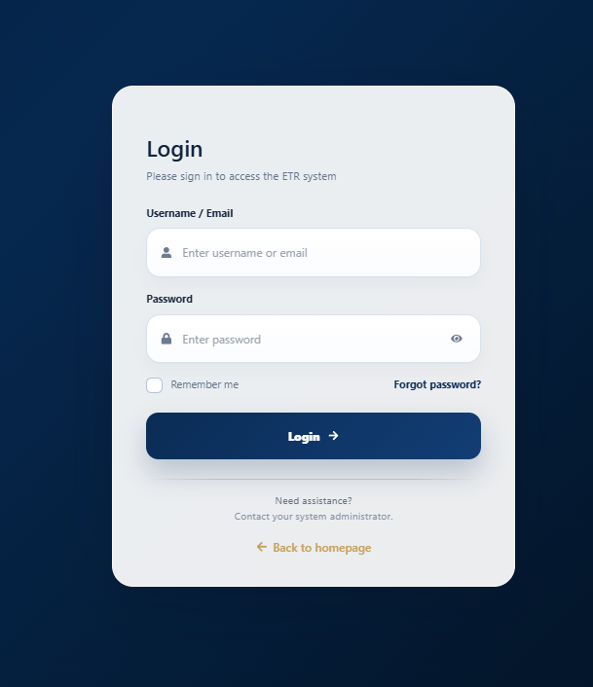
Logging in

Step 1 - Open the application URL and click Sign In.

Step 2 - Enter your username/email and password.

Step 3 - Select Remember me only when you want the application to remember the username on the device.

Step 4 - Click Login. The system validates the credentials and opens the role portal.

Recovering a forgotten password
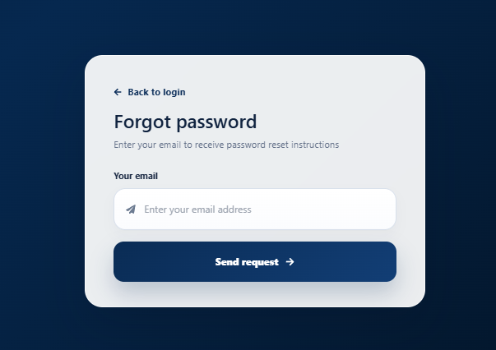
Step 1 - Click Forgot password on the login page.

Step 2 - Enter the email address registered to the account.

Step 3 - Click Send and follow the password-reset process provided by the system.

Logging out
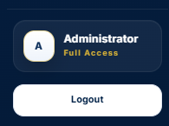

Click Đăng xuất / Sign Out at the bottom of the sidebar. The current client session is cleared and the application returns to the login page.

Session expiry : When the authentication token expires, the application clears the session and returns the user to the login screen. A 401 response also triggers sign-out handling.

3.3 Workflow 2 — Learner, Course & Class Management
Purpose: Let Academic staff (and, where relevant, Admin) build the training structure the ETR system depends on: learners, courses, classes, subjects and enrollments. Creating an enrollment triggers automatic ETR creation.
Before You Start

*Use an Academic Staff account with the required management permission.

*A subject and course/class structure should exist before enrollment.

Managing learners (Academic)
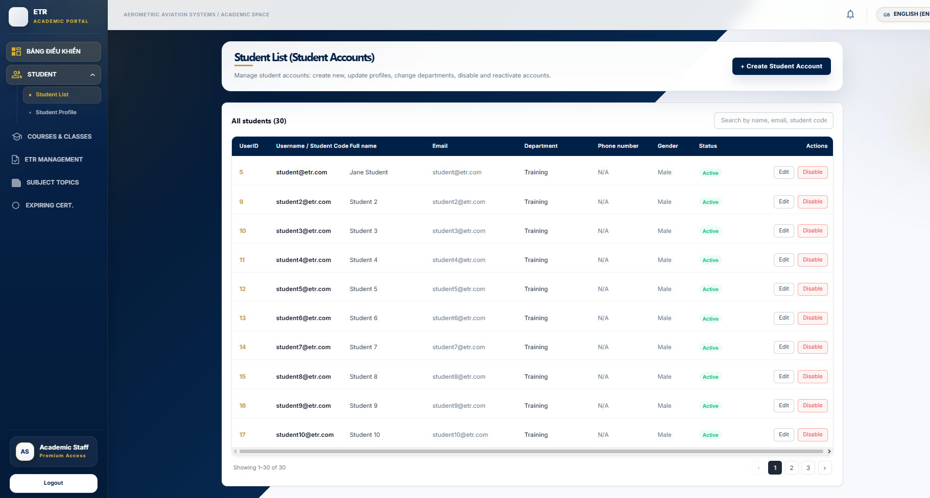
Step 1 - Open HỌC VIÊN (Learners) from the Academic portal.

Step 2 - Use search and available filters to locate a learner.

Step 3 - Use row actions to view the learner profile, edit learner details, or start an enrollment action.

Managing courses & classes
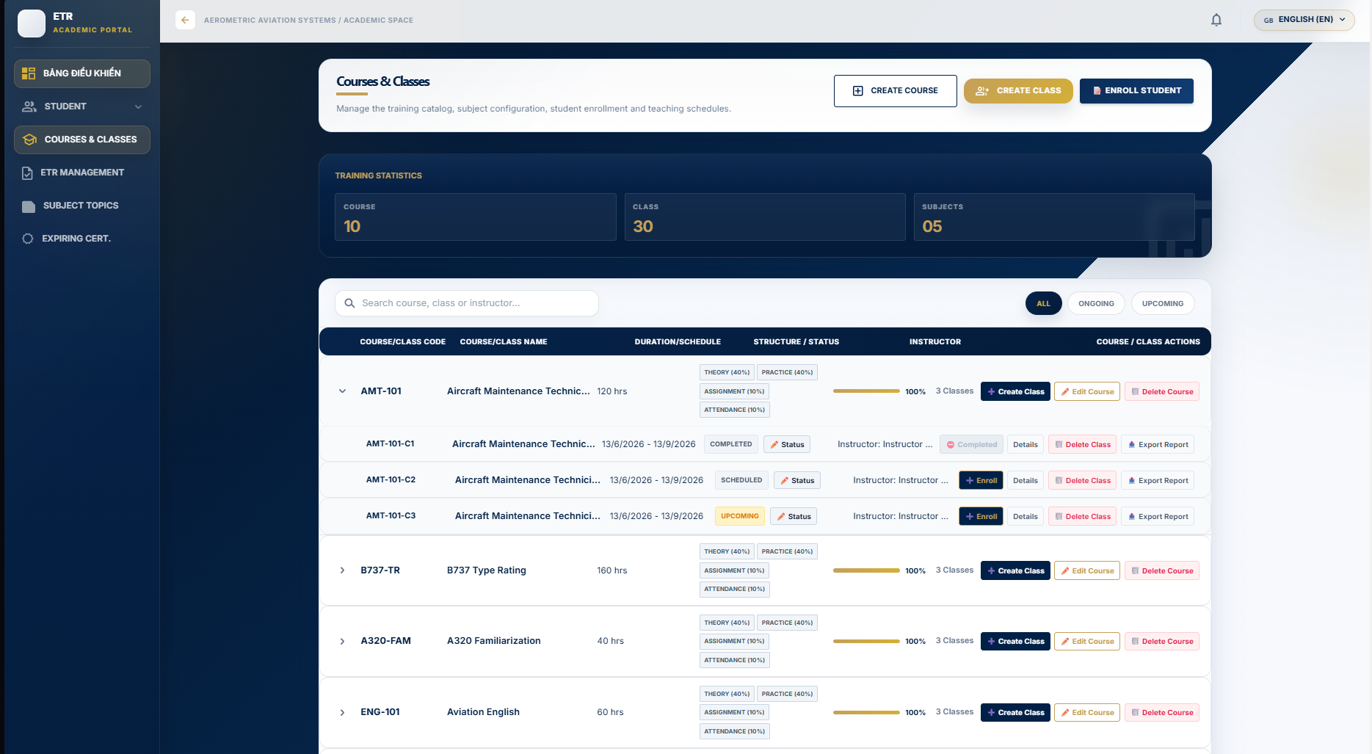
Step 1 - Open KHÓA & LỚP HỌC (Courses & Classes).

Step 2 - Create or edit a course using its name, code, and description.

Step 3 - Create or edit a class using the class identifier, name, subject, dates, room, trainee count and class type.

Step 4 - Use enrollment actions to add learners and the class-status action to maintain the class lifecycle.

Managing subjects
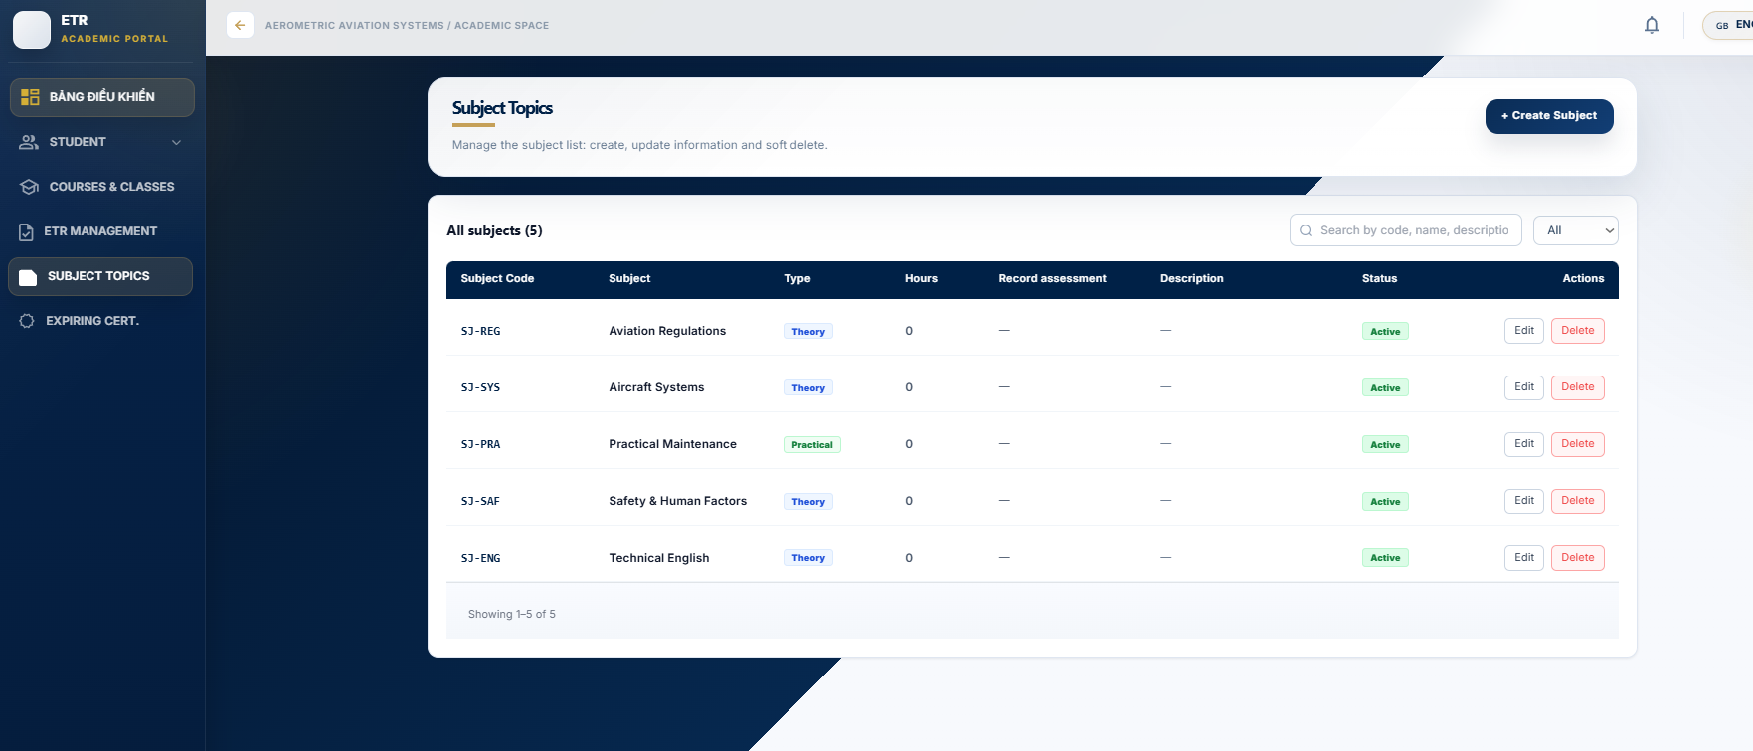
Step 1 - Open CHỦ ĐỀ MÔN HỌC (Subjects).

Step 2 - Use Add or Edit to maintain the subject name, code, and pass score.
Resulting ETR creation
- When a learner is enrolled, the backend automatically generates an ETR for them. The TẠO MỚI ETR button is effectively a lookup + refresh of this auto-generated record.

3.4 Workflow 3 — Instructor: Classes, Attendance, Assessments & Evidence
Purpose: Give instructors everything they need to run a class end-to-end: see rosters, mark attendance, record assessment scores, lock scores, and collect evidence attached to a learner’s ETR.
Before You Start

The class must be assigned to your instructor account.

Learners must already be enrolled in the class before attendance or assessment entry.

Viewing my classes & schedule
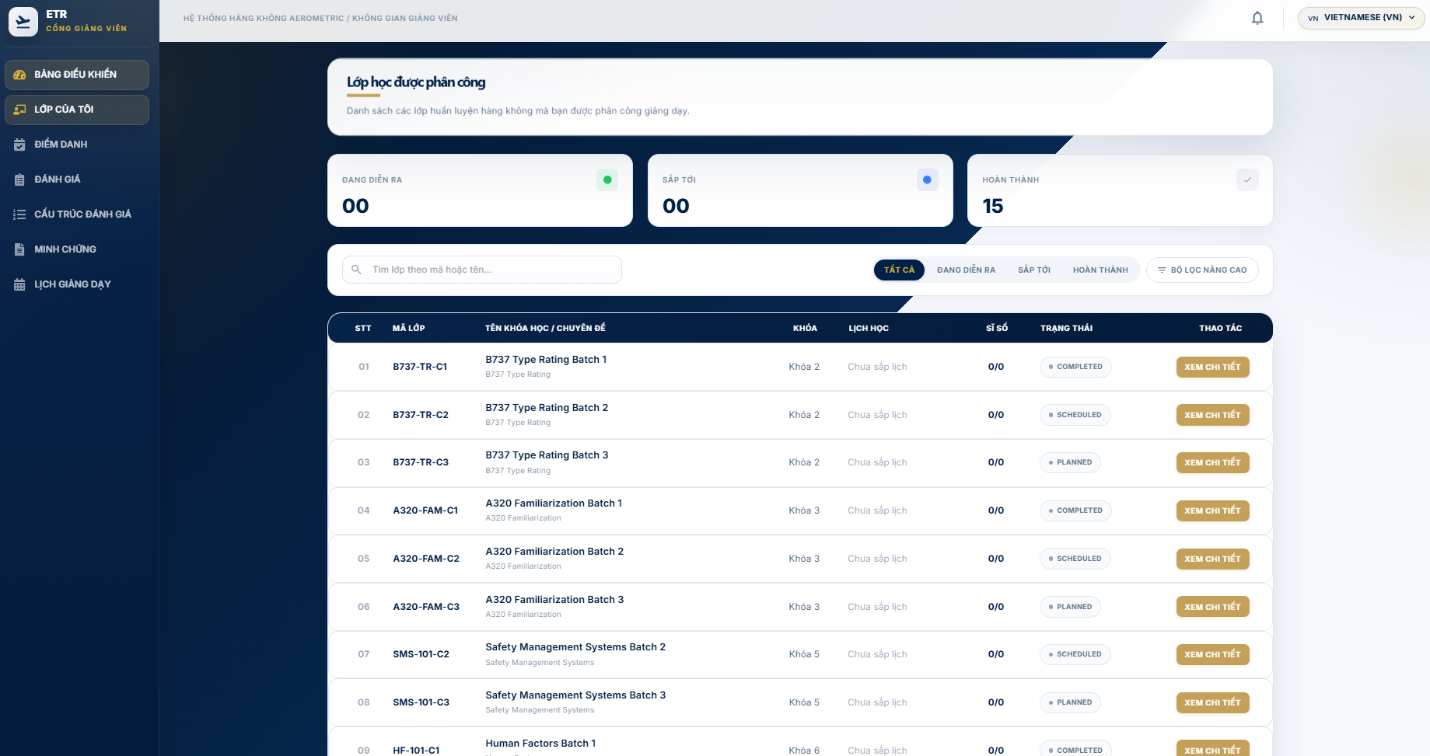
- Open BẢNG ĐIỀU KHIỂN (Dashboard) for a summary of classes, students, sessions and pending grades.
- LỚP CỦA TÔI (My Classes) lists assigned classes with rosters and shortcuts.
- LỊCH GIẢNG DẠY (Schedule) shows the teaching calendar.

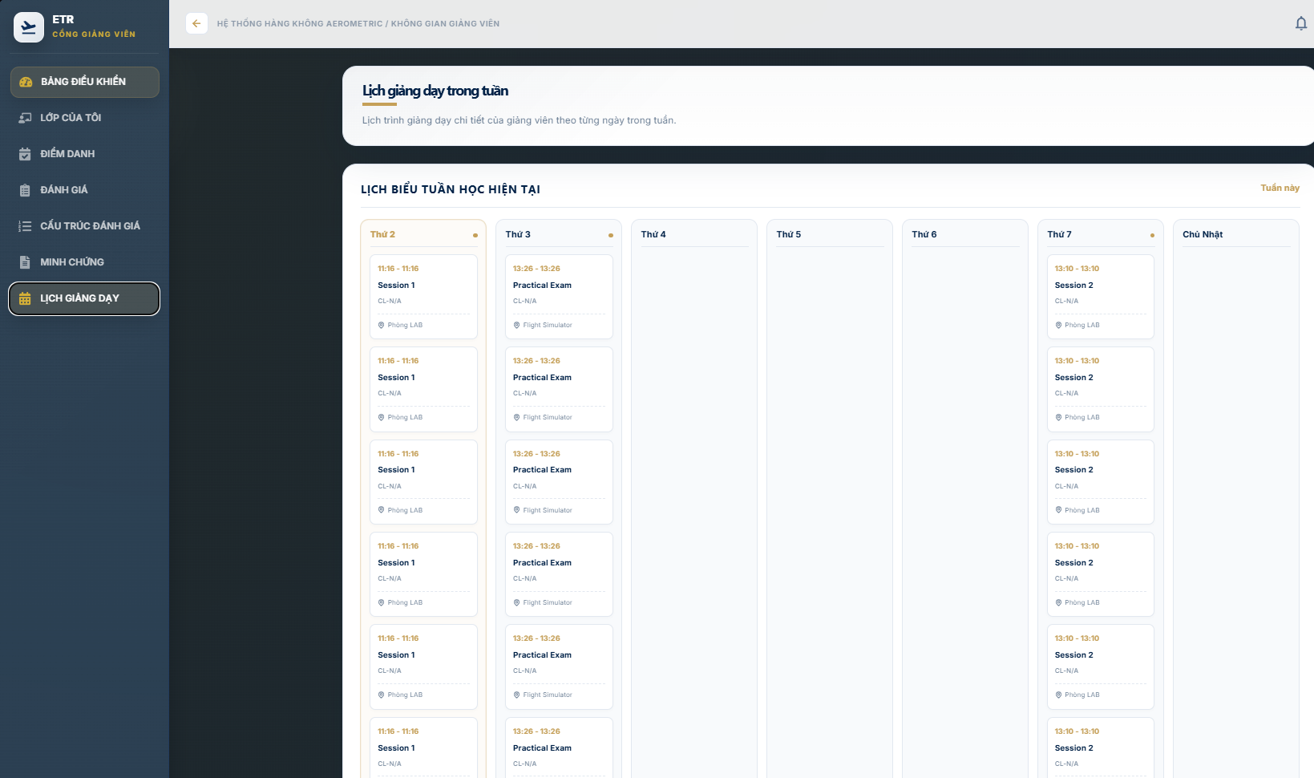

Marking attendance
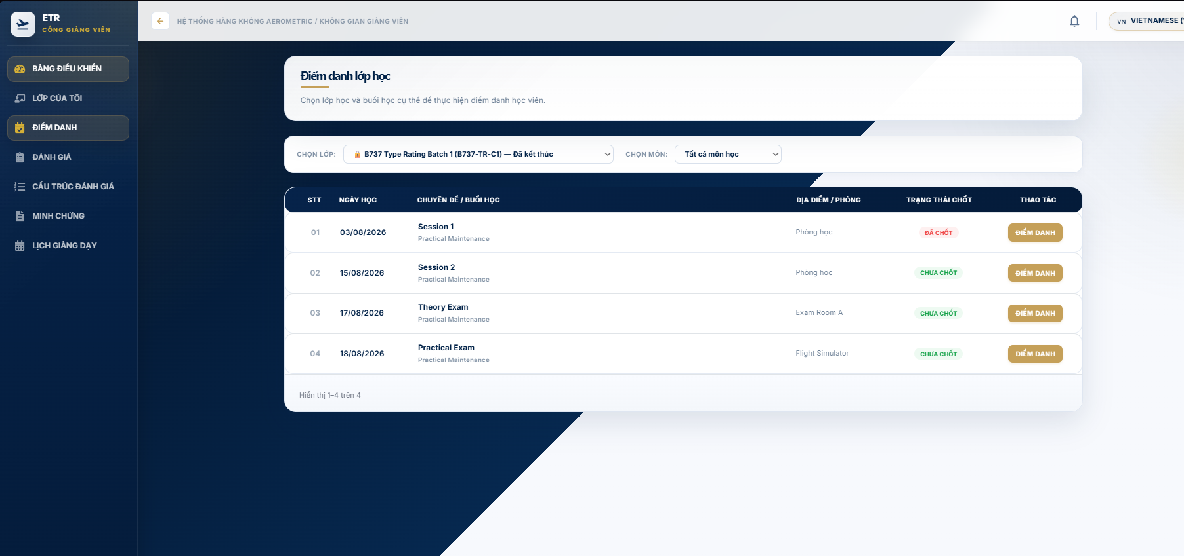
Step 1 - Open ĐIỂM DANH (Attendance).

Step 2 - Select the assigned class and training session.

Step 3 - Mark each learner using the available attendance status.

Step 4 - Click Save to store the session attendance.

The ETR attendance rate is calculated from confirmed session data. The completion checklist requires an attendance rate of at least 80% per subject.

Recording assessments & publishing scores
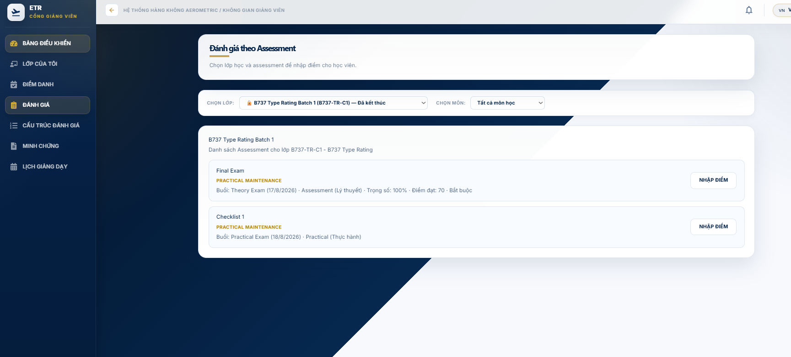
Step 1 - Open ĐÁNH GIÁ (Assessments).

Step 2 - Select the class/subject and enter the learner assessment results.

Step 3 - Review the score against the configured pass criteria and save the results.

Step 4 - When the results are ready, use Chốt điểm / Publish to publish the assessment and

practical checklist results

Uploading evidence
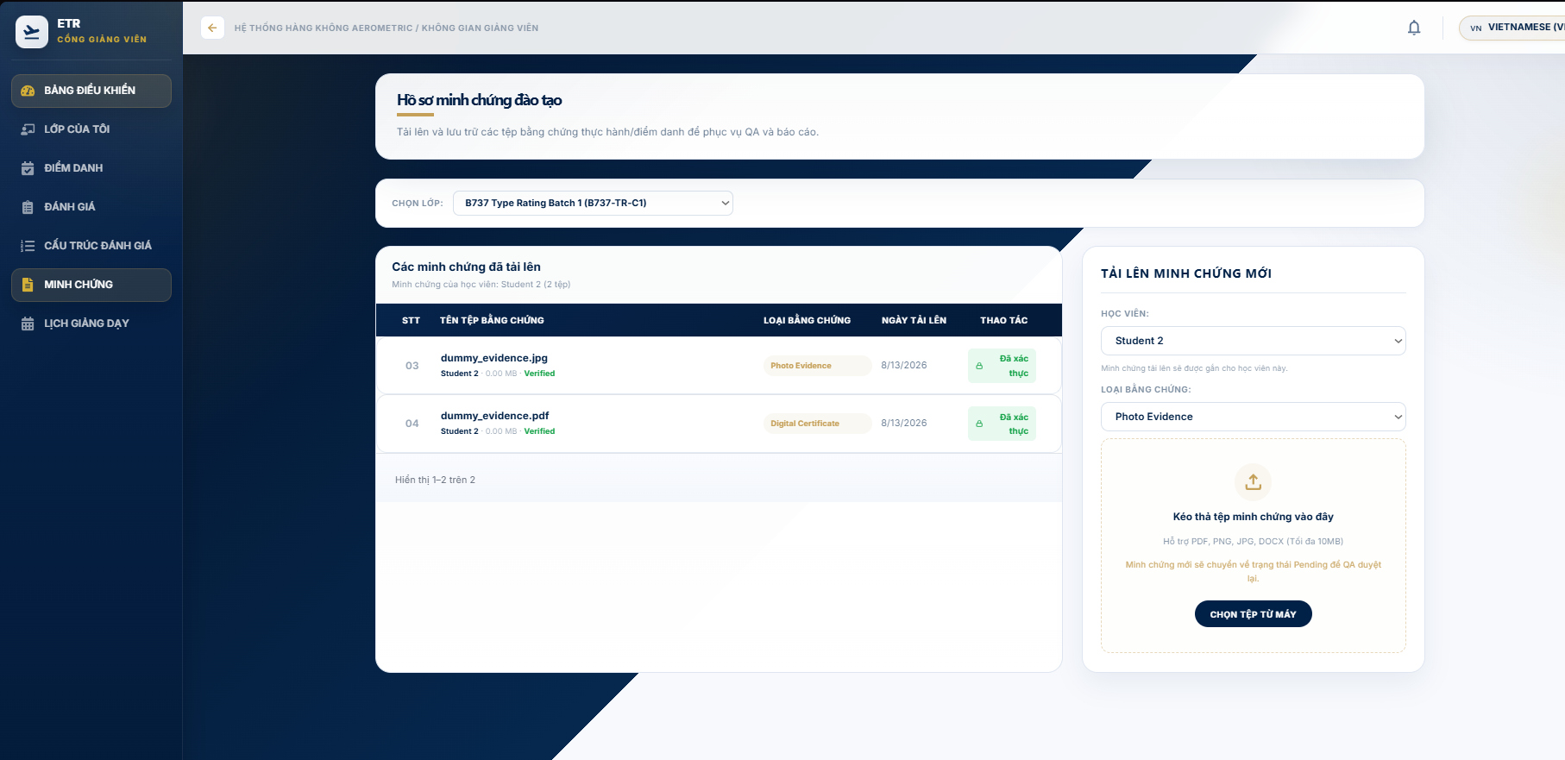

Step 1 - Open MINH CHỨNG (Evidence).

Step 2 - Select the class, learner, and evidence type.

Step 3 - Choose a supported file and upload it. The documented file limit is 10 MB for PDF, PNG, JPG, and DOCX files.

Step 4 - The uploaded file enters Pending status for QA verification.

Evidence that is rejected can be corrected and re-uploaded according to the reason provided by QA. Files already verified are protected from normal deletion

3.5 Workflow 4 — Academic: ETR Management & Submission to QA
Purpose: Let Academic staff monitor every ETR, manage its evidence, check the four-step completeness checklist, and submit verified-ready records to QA.
Completeness Checklist
- Personal info — always verified.
- Attendance — complete when every subject result has attendanceRate >= 80.
- Test results — complete when every assessment and practical checklist result is published.
- Evidence — complete when every evidence file for the ETR is Verified.
ETR management
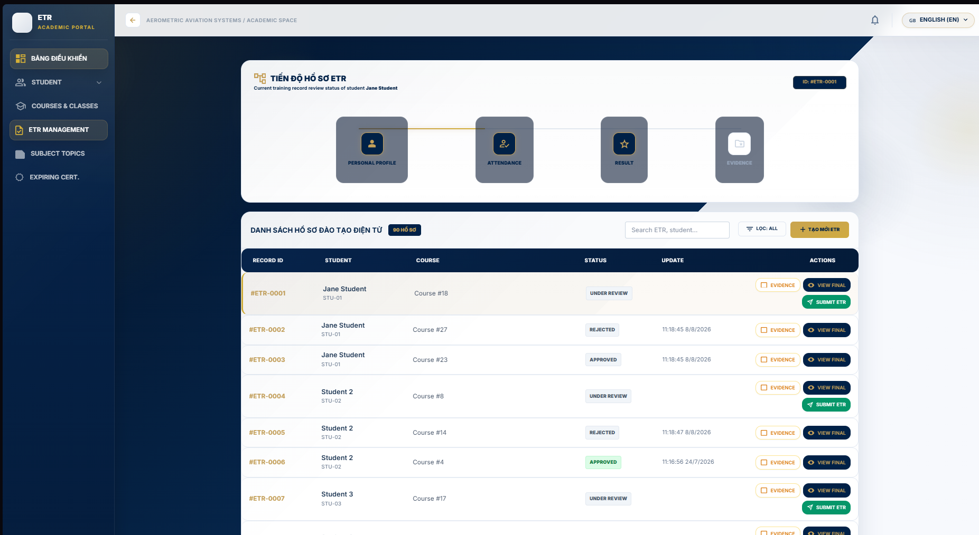
Step 1 - Open QUẢN LÝ ETR (ETR Management).

Step 2 - Search for the learner/ETR and review the progress or completeness indicators.

Step 3 - Open the evidence area to review file status, QA badges, and available actions.

Step 4 - When the completion requirements are satisfied, click SUBMIT ETR.

Step 5 - Use VIEW FINAL when a printable ETR summary is required.

Expected result: the ETR is submitted into the QA review workflow. The audit trail records the submission action with the actor and time.

Audit Trail
- The Audit Trail table at the bottom logs all changes with time, actor, action and content.

3.6 Workflow 5 — QA: Evidence Verification, ETR Review & Returns
Purpose: Give QA staff the tools to validate evidence integrity, review ETR dossiers before acceptance, return incomplete records for correction, and keep an immutable audit trail.
Before You Start

Evidence is reviewed from the pending evidence queue.

ETR review is performed on records that have been submitted to QA

Verifying evidence
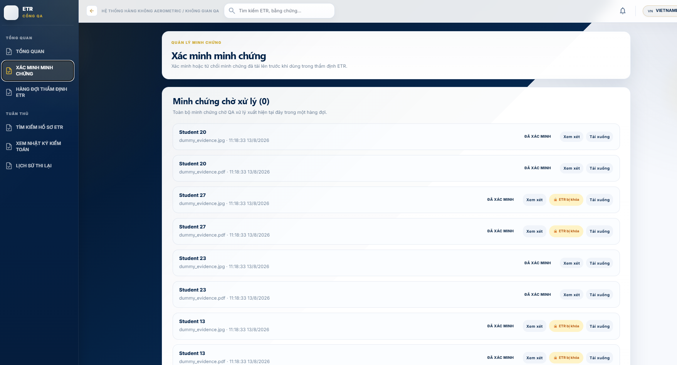
Step 1 - Open VERIFY EVIDENCE.

Step 2 - Review the files shown in Pending Evidence.

Step 3 - Open Review to inspect the evidence.

Step 4 - Click Verify to accept the evidence, or Reject and provide a reason.

Completed or locked ETRs do not expose the normal evidence verification actions

Reviewing ETRs
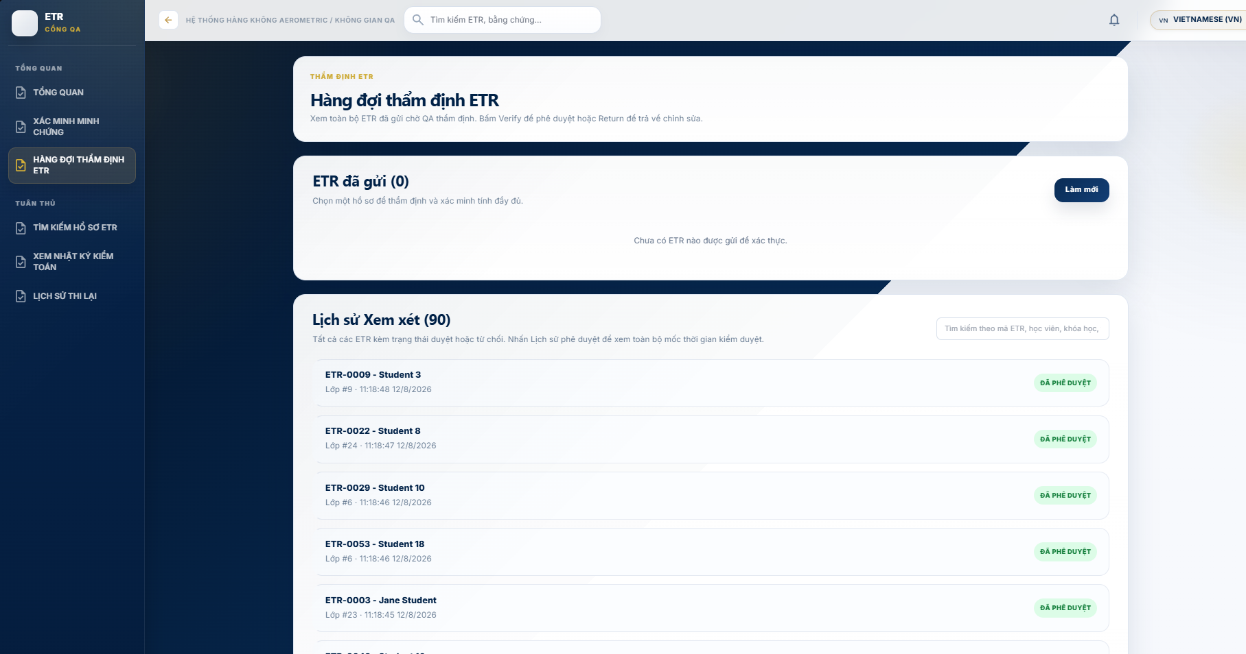
Step 1 - Open ETR REVIEW QUEUE.

Step 2 - Select a submitted ETR and choose View Details.

Step 3 - Review the ETR sheet and approval history.

Step 4 - Click Verify ETR when the record satisfies the QA review criteria.

Returning records
Step 1 - Select the submitted ETR that requires correction.

Step 2 - Choose a common return reason or enter a specific reason.

Step 3 - Click Send Back.

Step 4 - The record returns to the correction workflow for the responsible staff member.

Search, audit trail & retake history
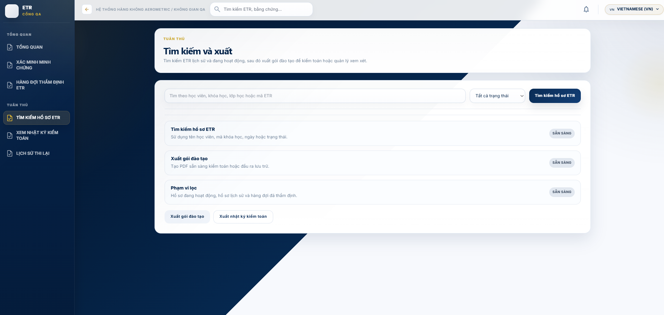 *SEARCH ETR RECORDS provides search and export options for training records.

- VIEW AUDIT TRAIL shows recorded QA actions and their timestamps/actors.

- RETAKE HISTORY shows retake or retest history for the learner and subject.

Expected result: a verified ETR proceeds to the Training Manager approval queue; a returned ETR remains

available for correction and resubmission.

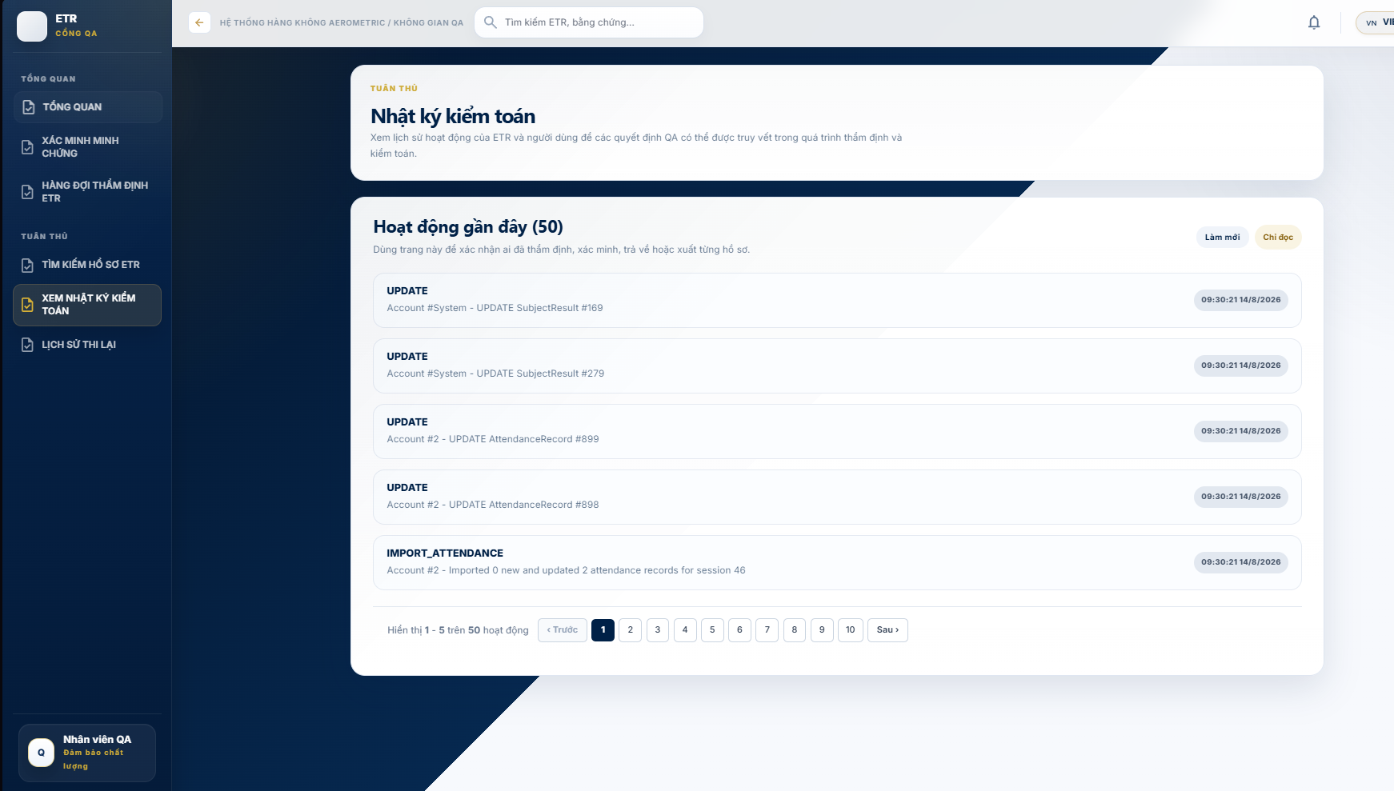
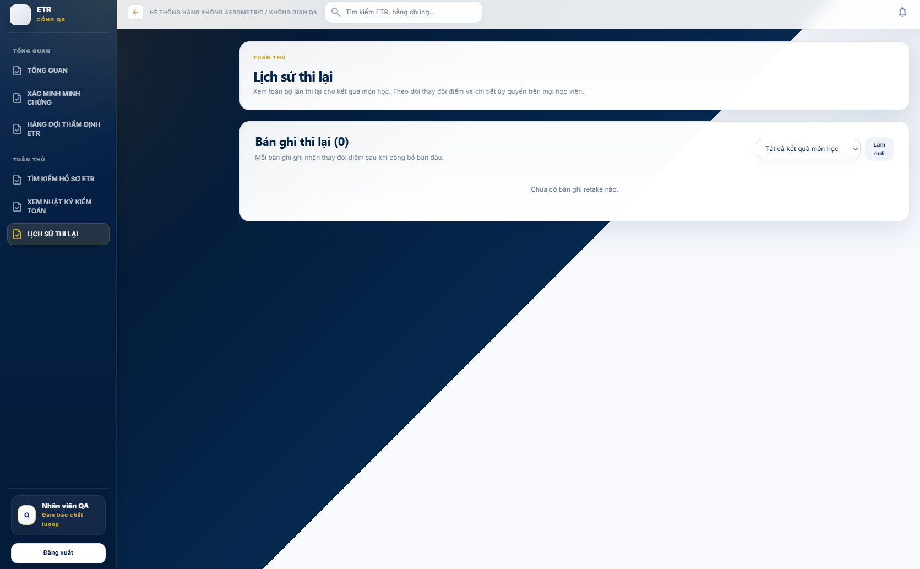.

3.7 Workflow 6 — Training Manager: ETR Final Approval
Purpose: Provide final authority sign-off on QA-verified records. This is the last approval gate before an ETR becomes a permanent, locked certificate record.
Before You Start

The ETR must have passed QA review and be available in the final approval queue.

Analysing the dashboard
- ANALYTICS DASHBOARD shows the ETR approval funnel, completion statistics and expiring-certificate alerts.
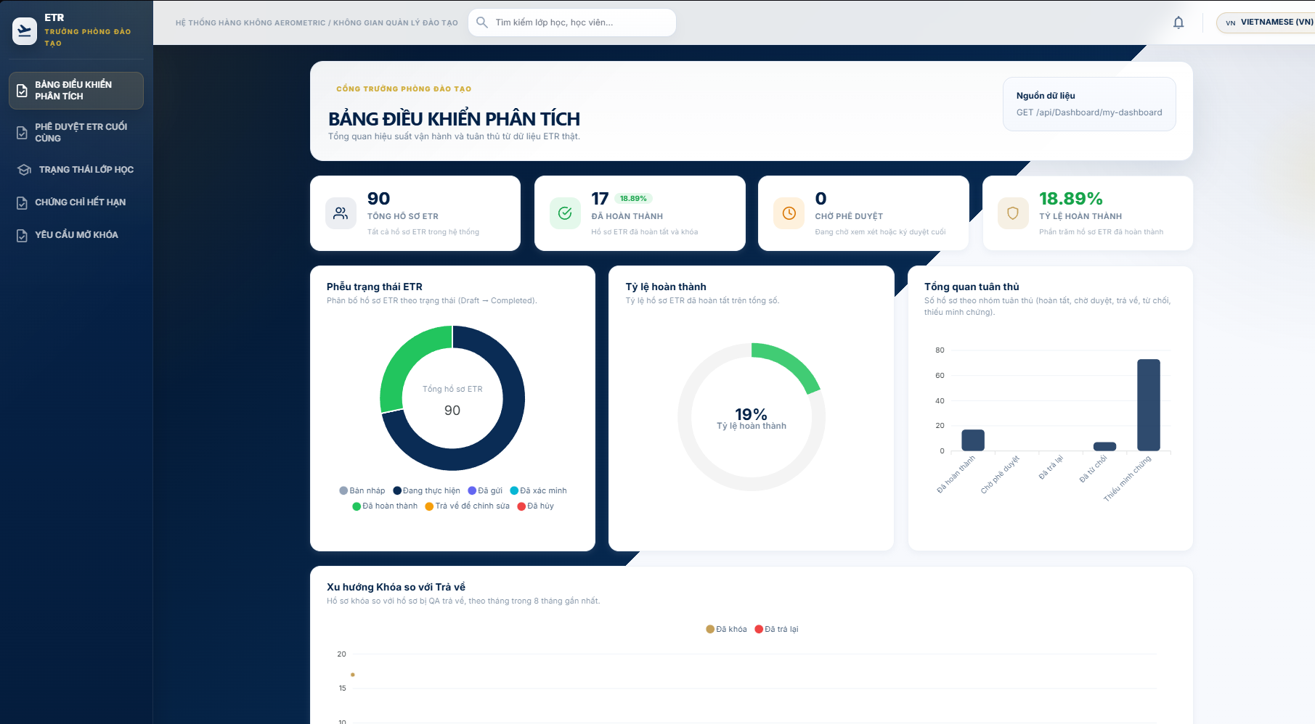
Approving ETRs
- Open ETR FINAL APPROVAL (/trainingmanager/etr-approval). 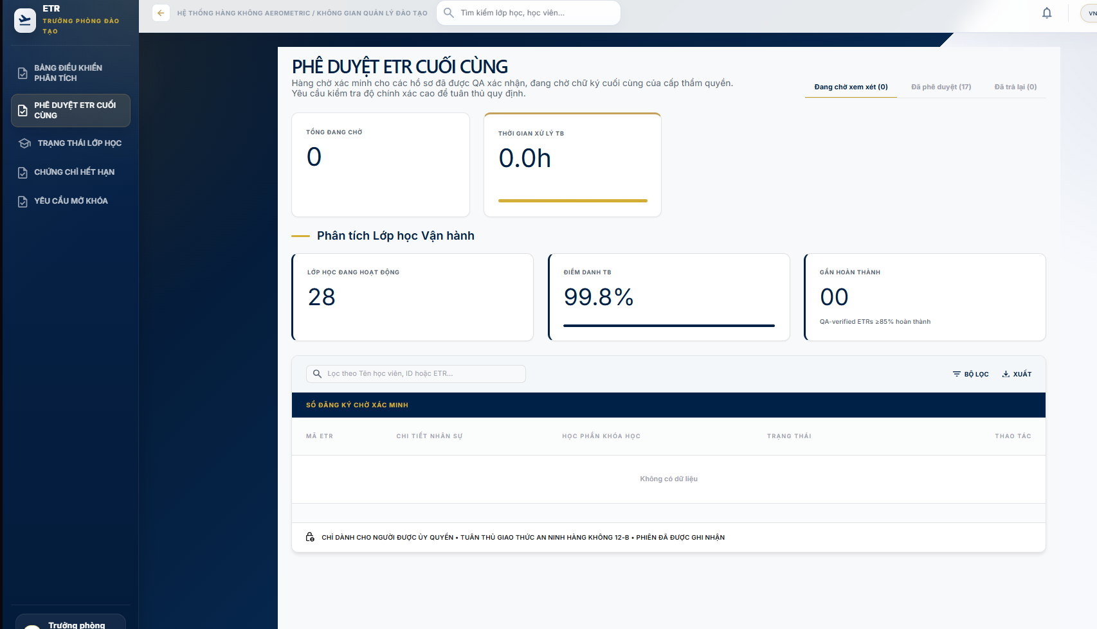
Step 1 - Open ETR FINAL APPROVAL.

Step 2 - Select a record from Pending Review.

Step 3 - Use HISTORY or the details action to inspect the trainee information, assessment results, and QA verification history.

Step 4 - Click APPROVE ETR.

Step 5 - Confirm with Sign off & Approve.

Expected result: the system records the final approval, updates the certificate/approval status, records the action in the audit log, and locks the completed ETR against normal modification.

Reopening a completed record (Admin only)
- In the Approved tab, Admin accounts see REOPEN.
- Enter the reason and confirm. The ETR returns to in-progress.
Class status & expiring certificates
- TRẠNG THÁI LỚP HỌC provides a class progress overview.
- CHỨNG CHỈ HẾT HẠN shows learners whose certificates expire within a window.

3.8 Workflow 7 — Student: View ETR, Certificates & Profile
Purpose: Give learners read-only visibility of their own training records, certificate status and personal profile, including password change.
Overview
- TỔNG QUAN (Dashboard) shows enrolled classes, ETR status summary, certificate expiries and upcoming sessions.
My ETR
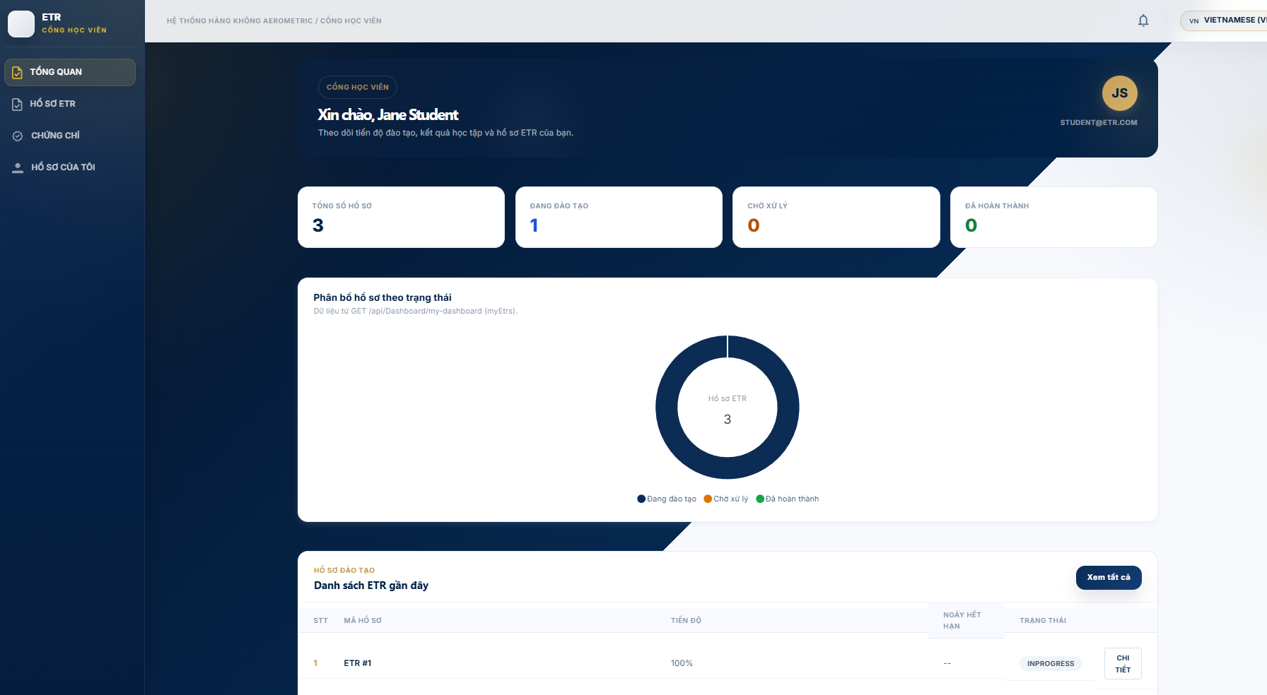
- Open HỒ SƠ ETR (My ETR).
- Use Danh sách ETR and Lịch sử đào tạo tabs.
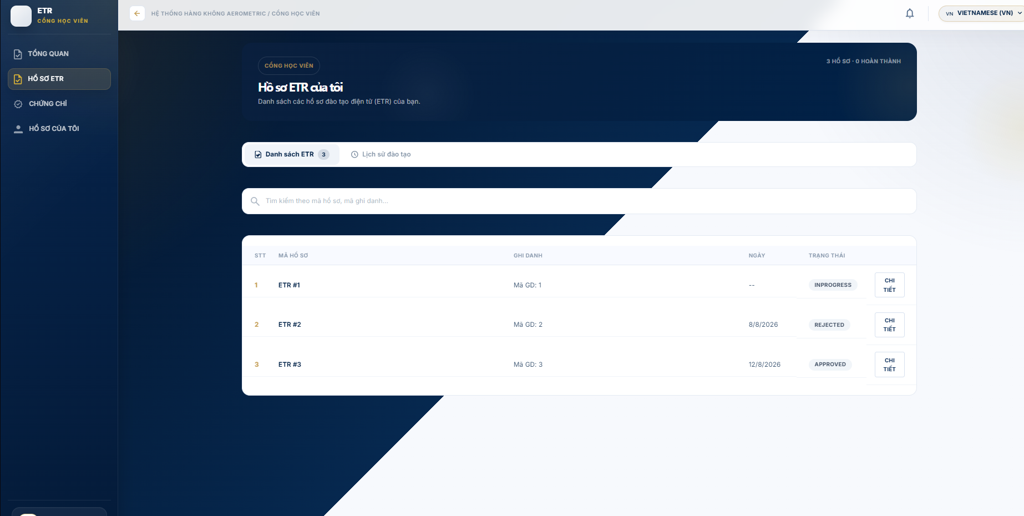
- Open Chi tiết to view record info, subject results, evidence chips and audit trail.
- Completed records are marked completed and permanently locked.
Certificates
- CHỨNG CHỈ (Certificates) lists certificate status with validity/expiry badges and download options.
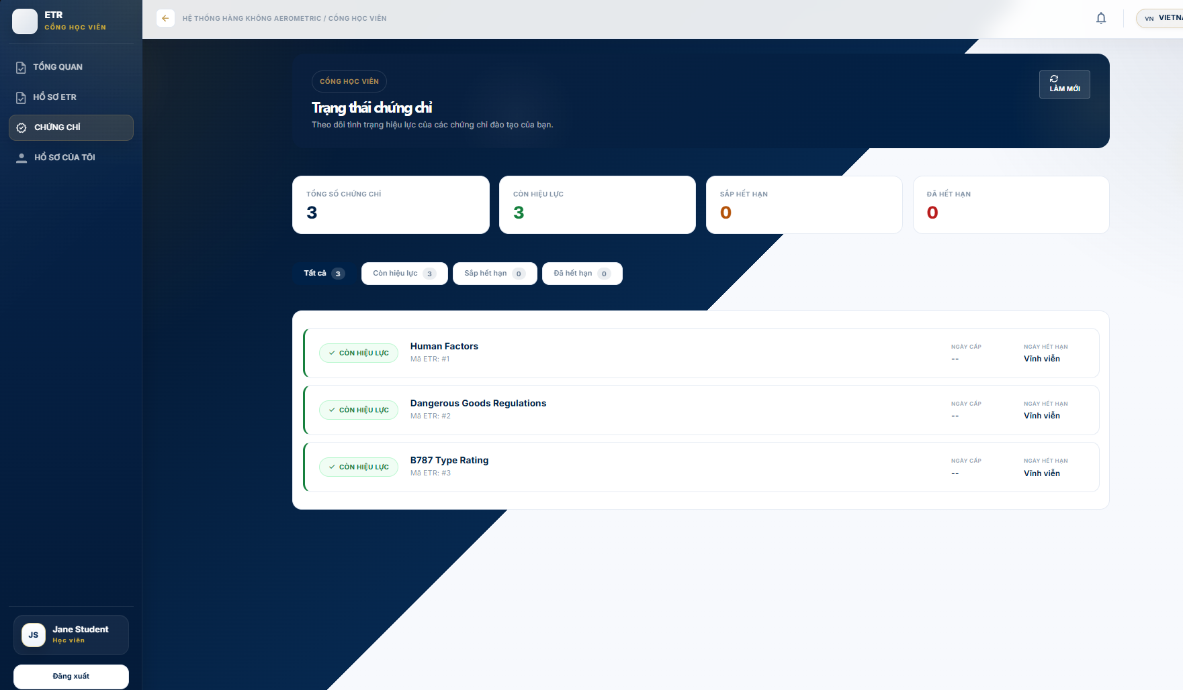
Profile
- HỒ SƠ CỦA TÔI (My Profile) shows learner details and a change-password form.
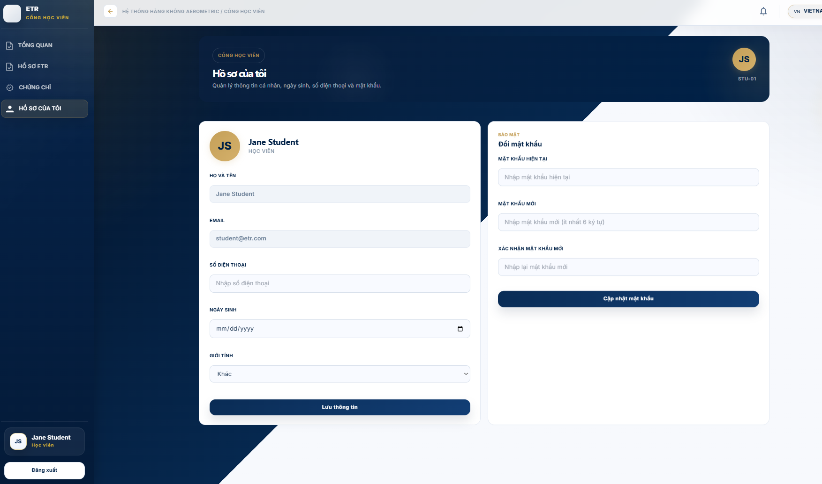

3.9 Workflow 8 — Auditor: Compliance Repository, Search & Export
Purpose: Provide an independent, read-only compliance view for auditors: browse the locked ETR repository, run advanced searches, verify approval chains, inspect audit logs, and export regulatory packages. No write actions are exposed.
Access Restrictions

Auditor functions are read-only. No create, update, delete, verify, approve, or reopen actions are provided.

The repository focuses on completed/locked ETR records and their associated history

Dashboard
- DASHBOARD shows KPIs (total locked records, compliance rate, pending audit, packages exported) plus recently locked records, recent audit events and recent export history.
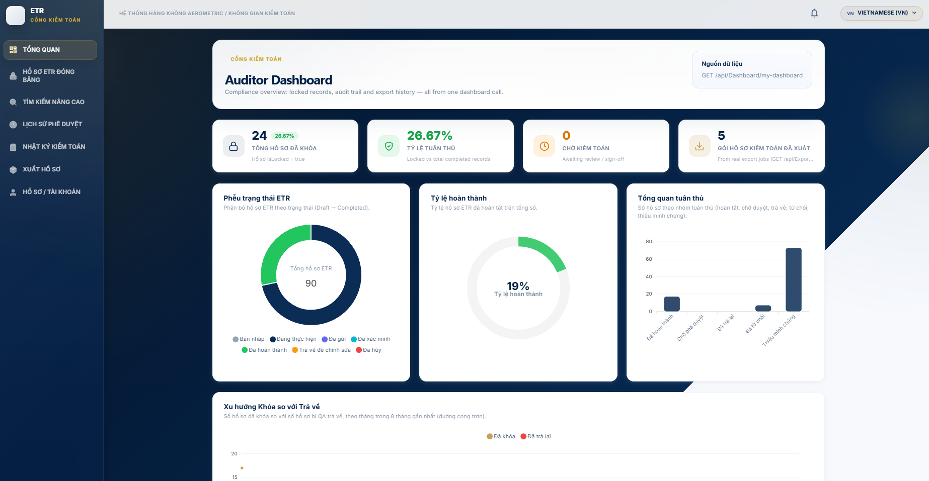
Browsing locked records
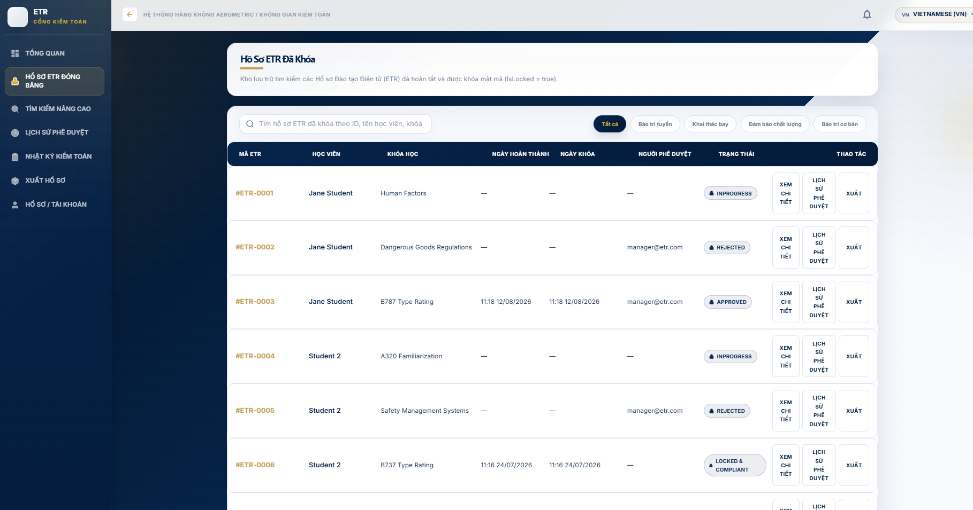
Step 1 - Open LOCKED ETR RECORDS.

Step 2 - Search or filter the available locked records.

Step 3 - Select a record to inspect its details and audit information

Advanced search
- ADVANCED SEARCH combines learner, course, class, ETR ID, completion date, locked date and lock status.
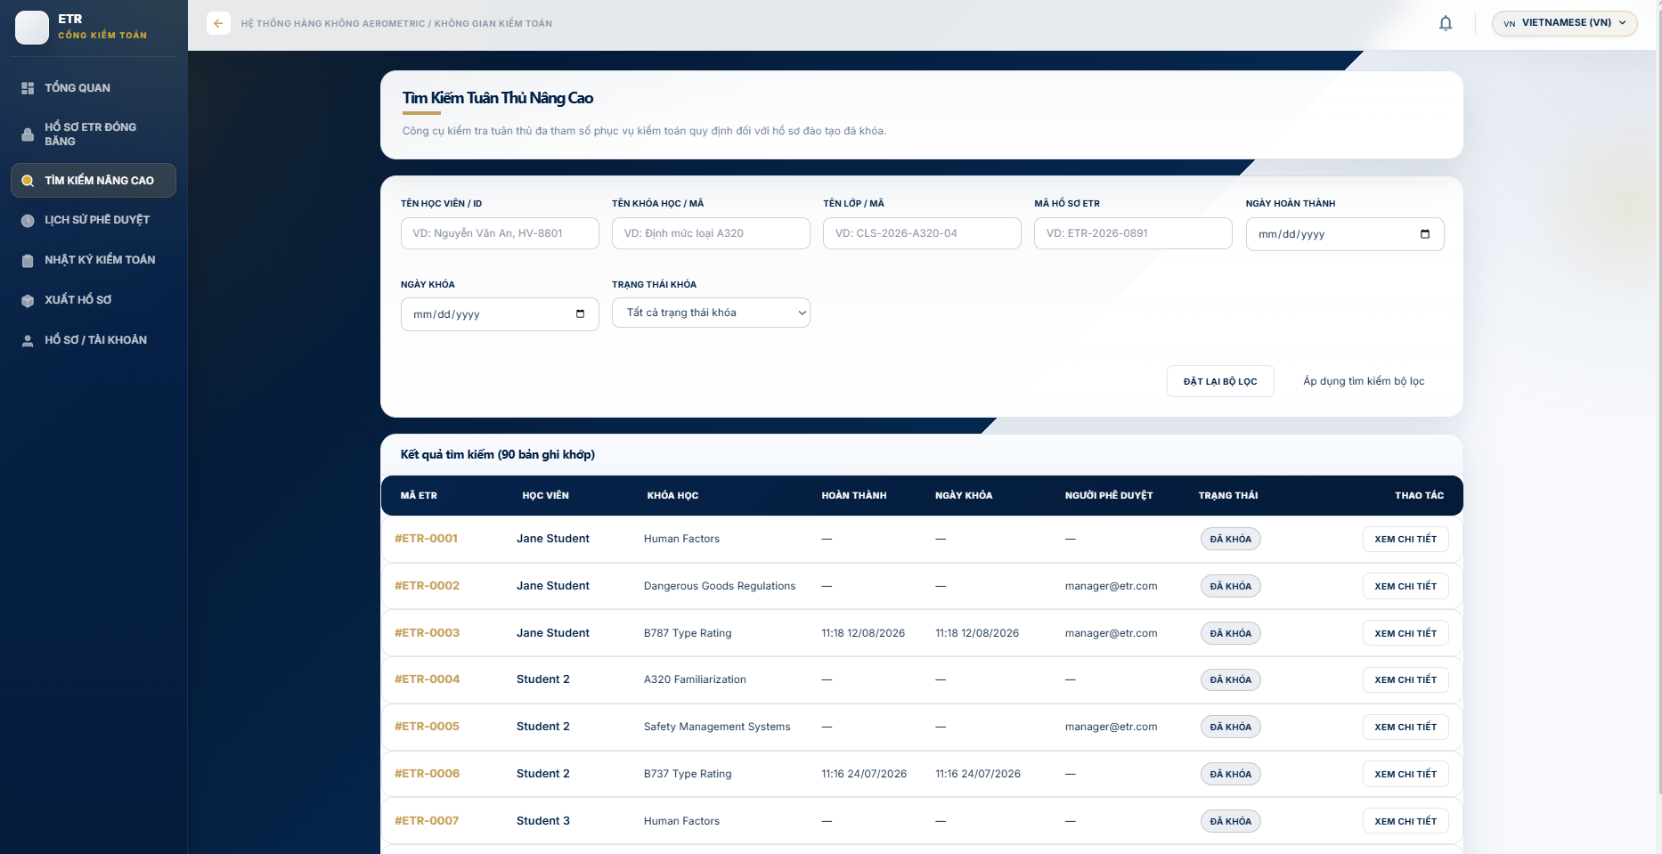
ETR details dossier
- ETR DETAILS presents six tabs: Learner Information, Attendance, Assessment Results, Training Evidence (SHA-256 VERIFIED MATCH), Approval History and Audit Trail. Use Export Dossier PDF for a printable copy.
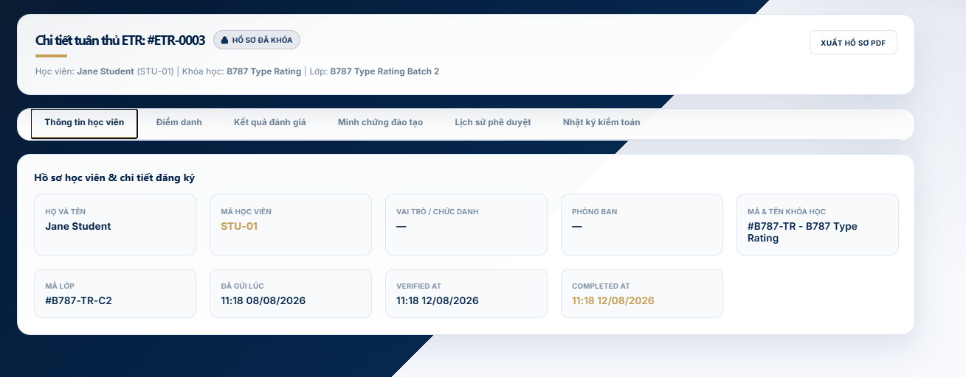
Approval history
- APPROVAL HISTORY shows the five-step approval sequence: Academic → QA → Training Manager → System Locked → Audited, with a detailed execution log timeline.
Audit logs
- AUDIT LOGS is an immutable audit trail with search and module filters. Results flagged FORBIDDEN are highlighted.

Export packages
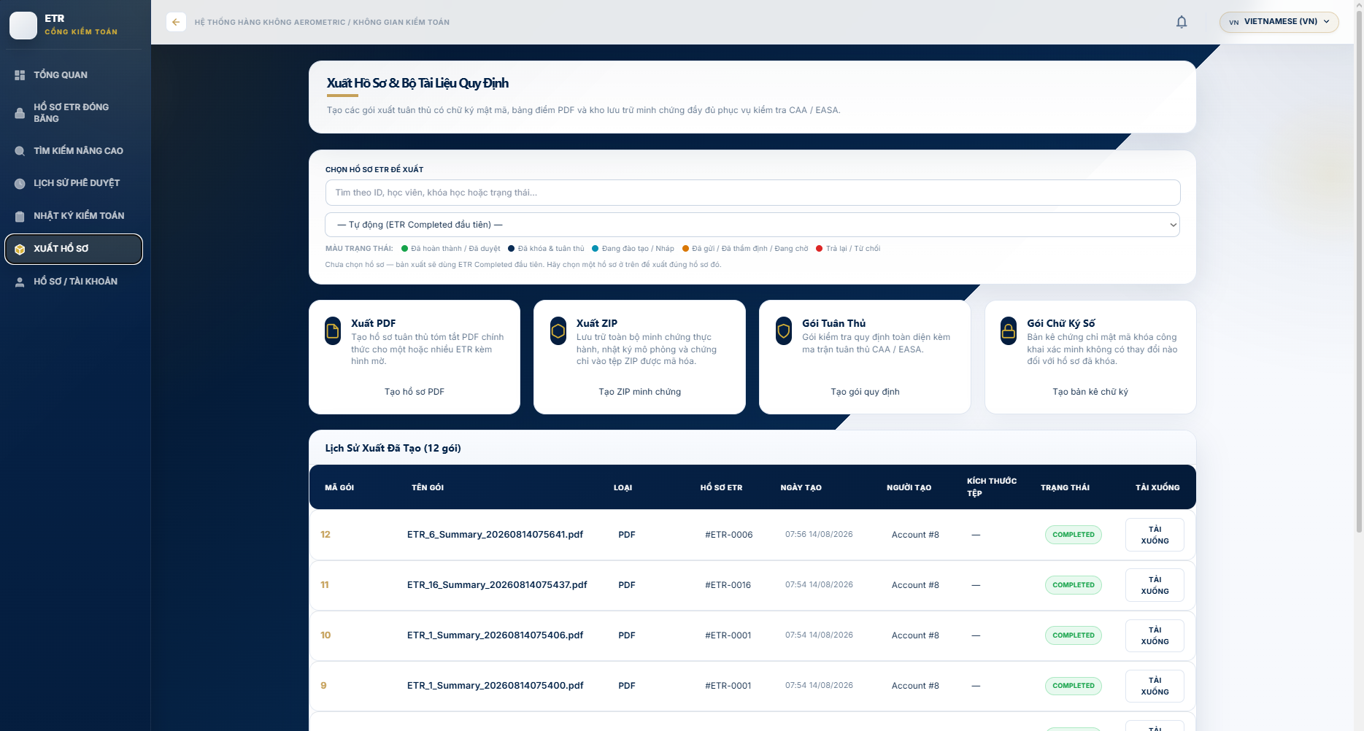
Step 1 - Select the required export type from the available export options.

Step 2 - Generate the export package.

Step 3 - Open export history and download the completed package

Appendix A — API Endpoint Reference (main routes)
Action | Endpoint | Method
Login | /auth/login | POST
Forgot password | /auth/forgot-password | POST
List ETRs | /Etr | GET
ETR detail | /Etr/{id} | GET
Submit ETR to QA | /Etr/{id}/submit | POST
QA verify ETR | /Etr/{id}/verify | POST
QA return ETR | /Etr/{id}/return | POST
Complete ETR (fallback) | /Etr/{id}/complete | POST
Reopen ETR (Admin) | /Etr/{id}/reopen | POST
Student own ETRs | /Etr/my-etr | GET
Student training history | /Etr/student/{accountId}/history | GET
List evidence | /Evidences | GET
Upload evidence | /Evidences/upload | POST
Verify/reject evidence | /Evidences/{id}/verify | PUT
Download evidence | /Evidences/{id}/download | GET
Approval requests | /Approvals | GET
Approve ETR | /Approvals/{approvalRequestId}/process?action=Approve | POST
Audit log | /Audit, /Audit/{id}, /Audit/search?query= | GET
Auditor exports | /Exports/pdf, /Exports/training-package, /Exports/dashboard, /Exports/download/{id} | POST/GET

Appendix B — System Administration (Admin portal)
Page | Description
DASHBOARD | System overview with KPI cards and user/class/ETR tables
USER MANAGEMENT | Create/edit/delete user accounts, assign roles, search
DEPARTMENT MANAGEMENT | Manage departments (e.g., Line Maintenance, Flight Operations, QA, Base Maintenance)
AUDIT LOG | System audit trail of user actions
SYSTEM CONFIG | Global settings: system name, thresholds, exam pass score, ETR validity days, security options

