

CAPSTONE PROJECT REPORT
Report 1 – Project Introduction

– Ho Chi Minh, August 2026 –
Table of Contents
I. Record of Changes 3
II. Project Introduction 4
1. Overview 4
1.1 Project Information 4
1.2 Project Team 4
2. Product Background 4
3. Existing Systems 4
3.1 Current Manual Process (Paper, Excel, PDF & Email) 4
4. Business Opportunity 5
5. Software Product Vision 5
6. Project Scope & Limitations 6
6.1 Major Features 6
6.2 Limitations & Exclusions 8

I. Record of Changes
Date | A*  M, D | In charge | Change Description
2026-06-01 | A | Nguyen Huu Nhat Trieu (Leader) | Initiated the Report 1 document structure, defined Project Information (1.1), and assigned team member roles (1.2).
2026-06-02 | A | Vo Trong Nhan (Member) | Drafted Section 2 (Product Background) and Section 4 (Business Opportunity) based on aviation training challenges.
2026-06-03 | A | Doan Trong Khoi (Member) | Documented Section 3 (Existing Systems) and formulated Section 5 (Software Product Vision) for the centralized ETR platform.
2026-06-04 | A | Tran Trong Nhan (Member) | Detailed Section 6 (Project Scope & Limitations), listing Major Features (FE-01 to FE-35) and Exclusions (LI-01 to LI-04), ( EX-01 to EX-09)
2026-06-05 | M | Nguyen Huu Nhat Trieu (Leader) | Reviewed the entire Report 1, finalized formatting, cross-checked scope limitations, and approved the document.
2026-08-14 | M | Vo Trong Nhan (Member) | Reviewed Report 1 against the implemented system and restructured it to follow the official report template: corrected Project Information placeholders and heading styles, rewrote Section 3 (Existing Systems) in Link/Description/Pros/Cons format, regrouped Major Features by role (FE-01 to FE-35), split 6.2 into Limitations/Exclusions, and updated the learner-access scope wording.
*A - Added M - Modified D - Deleted

II. Project Introduction

1. Overview

1.1 Project Information
- Project name: Electronic Training Record (ETR)
- Project code: SU26SE104_GSU48
- Group name: SU2026-GSU-ETR
- Software type: Web

1.2 Project Team
Full Name | Role | Email | Mobile
Ngo Dang Ha An | Lecturer
Nguyen Huu Nhat Trieu | Leader
Vo Trong Nhan | Member
Doan Trong Khoi | Member
Tran Trong Nhan | Member

2. Product Background
Currently, aviation training records are managed through a combination of paper documents, Excel spreadsheets, PDF files, and email. Training information is distributed across different files, folders, and locations, making it difficult to search, verify, update, and track records efficiently. This results in problems such as inconsistent data, duplicate or missing documents, limited visibility into training progress, and time-consuming audit preparation.
The Electronic Training Record (ETR) System is proposed as a centralized web-based platform to digitalize and streamline the management of aviation training records. The system supports key training activities, including learner profile management, enrollment, attendance, assessments, training evidence, verification, approval, reporting, and audit tracking.
The project is proposed by an Aviation Training Academy to address the limitations of the current manual process and improve the efficiency, accuracy, traceability, and accessibility of training records. The primary stakeholders include Academic Staff, Instructors, QA Staff, Training Managers, Administrators, Auditors, and authorized Management Viewers.

3. Existing Systems

3.1 Current Manual Process (Paper, Excel, PDF & Email)
- Link: N/A – Offline/manual process
- System Type: Manual and file-based record management
- Description:
Training records are currently managed using paper documents, Excel spreadsheets, PDF files, shared folders, and email. Learner profiles, attendance records, assessment results, and training evidence are stored separately and exchanged between staff or departments through manual processes. There is no centralized system for managing training records, tracking record status, or maintaining a consistent audit history.

Pros
- Familiar process for existing staff
- Does not require specialized software or system implementation
- Can continue operating without dependence on a centralized application

Cons
- Records are distributed across multiple files, folders, and physical locations
- Difficult to search, verify, update, and maintain historical records
- Risk of inconsistent, duplicated, outdated, or missing information
- Limited visibility into learner training progress and record completeness
- Manual coordination is required for verification and approval
- No centralized approval status or workflow tracking
- No consistent audit trail or change history
- Audit and compliance preparation is time-consuming and labor-intensive
- High dependency on individual staff knowledge and file organization

4. Business Opportunity
Currently, aviation training records are managed using a combination of paper documents, Excel files, scanned documents, shared folders, and manual processes. As the number of learners, courses, and training activities increases, managing these records becomes more complex and time-consuming. Staff may face difficulties in tracking learner progress, verifying training evidence, retrieving historical records, and preparing for audits.
The Electronic Training Record (ETR) System provides a centralized platform for managing learner information, course enrollment, attendance, assessment results, training evidence, and approval workflows. By digitalizing the training record process, the system reduces paperwork, improves data accuracy and traceability, and makes training records easier to manage and retrieve.
The ETR System also helps organizations monitor training progress, ensure record completeness, maintain a clear audit trail, and improve the efficiency of compliance reviews and audit preparation. Overall, the system supports the aviation industry's digital transformation by improving operational efficiency, regulatory compliance, and training record management.

5. Software Product Vision
The Electronic Training Record (ETR) System aims to provide a centralized, secure, and efficient platform for managing aviation training records throughout the entire training lifecycle. By replacing fragmented paper-based and manual processes, the system enables training organizations to maintain accurate, complete, and traceable training records while improving operational efficiency, regulatory compliance, and audit readiness.
The vision of the ETR System is to become a reliable digital solution that supports learners, instructors, training staff, quality assurance personnel, and management in maintaining training data with transparency and accountability. Through automation, centralized data management, and standardized workflows, the system helps organizations reduce administrative effort, improve record accessibility, and ensure that training records are always available for operational and compliance purposes.

6. Project Scope & Limitations
This section defines the scope and boundaries of the proposed Electronic Training Record (ETR) System. It identifies the main capabilities included in the project and clearly states the functions that are excluded from the current implementation. This establishes a common understanding among stakeholders and provides a basis for evaluating requirements and future change requests.

6.1 Project Scope
The Electronic Training Record (ETR) System is a centralized web-based platform for managing aviation training records and supporting the training record lifecycle from enrollment through completion and approval.
The system includes the following key capabilities:
- User account, role, and access management.
- Learner profile and training history management.
- Course, subject, class, and instructor assignment management.
- Learner enrollment management.
- Electronic Training Record (ETR) creation and management.
- Attendance and training session management.
- Assessment and practical checklist result management.
- Training evidence upload, verification, and management.
- ETR validation, submission, review, and approval workflows.
- Amendment and record correction workflows.
- Dashboard monitoring and training status tracking.
- Reporting and training record export.
- Audit trail and activity history management.
- Certificate status and expiry tracking.
The system supports the operational needs of Academic Staff, Instructors, QA Staff, Training Managers, Administrators, Auditors, and authorized Management Viewers. It is intended to improve the accuracy, traceability, accessibility, and efficiency of aviation training record management while supporting audit and compliance activities.

6.2 Project Limitations
The following functions are outside the scope of the current project:
- Online learning delivery, including e-learning and Learning Management System (LMS) functionality.
- Online examinations and automated examination grading.
- Integration with external aviation authority or regulatory systems.
- Native mobile applications for Android or iOS.
- Advanced analytics, predictive analytics, or AI-based recommendations.
- Learner-side payment processing or online course registration.
- Two-factor authentication (2FA) and advanced security mechanisms beyond the standard authentication and authorization implemented in the system.
Requirements that fall outside the defined scope will not be included in the current implementation. They may be considered as future enhancements or subsequent project phases, subject to business priorities and project constraints.

ID | Role | Module | Feature
F-01 | Administrator | User & Access Management | Manage user accounts, authentication, authorization and RBAC
F-02 | Administrator | System Administration | Manage departments and system configuration
F-03 | Administrator | System Monitoring | View platform statistics, dashboard and action items
F-04 | Administrator | Audit Management | View audit logs and activity history
F-05 | Academic Staff | Learner Management | Create, update, search and maintain learner profiles and training history
F-06 | Academic Staff | Course & Class Management | Manage courses, classes, subjects and instructor assignments
F-07 | Academic Staff | Enrollment Management | Enroll learners into courses/classes and manage enrollment records
F-08 | Academic Staff | Data Import & Export | Import learner/class data and export training-related reports
F-09 | Academic Staff | Learner Monitoring | Track learner training progress and expiring students
F-10 | Instructor | Class Management | View assigned classes and manage training session schedules
F-11 | Instructor | Attendance Management | Record attendance, confirm sessions and calculate attendance rates
F-12 | Instructor | Assessment Management | Record assessment results and practical checklist results
F-13 | Instructor | Training Evidence Management | Upload, download and manage training evidence
F-14 | Instructor | Subject Completion | Publish/sign off subject results
F-15 | QA Staff | Evidence Verification | Verify, reject and bulk-verify training evidence
F-16 | QA Staff | ETR Review | Review, verify and return ETR records for correction
F-17 | QA Staff | Compliance & History | View retake history and search/export training records
F-18 | Training Manager | Training Monitoring | Monitor class status and training dashboard
F-19 | Training Manager | ETR Approval | Approve ETR completion and freeze records
F-20 | Training Manager | Amendment Management | Approve or reject amendment/unlock requests
F-21 | Auditor | Advanced Search | Search learners, courses, classes and ETR records
F-22 | Auditor | Audit Review | View locked ETRs, approval history and audit logs
F-23 | Auditor | Audit Export | Export training record packages for audit/compliance
F-24 | Student / Learner | Personal Training Record | View own ETR status, assessment results and attendance
F-25 | Student / Learner | Certificate Management | View certificate status and validity
F-26 | Student / Learner | Profile Management | View and manage personal profile
F-27 | System | ETR Generation | Automatically generate ETR course records and subject results upon enrollment
F-28 | System | Attendance Calculation | Automatically calculate attendance rates from confirmed sessions
F-29 | System | Retake Tracking | Automatically create and maintain retake history for failed assessments
F-30 | System | ETR Validation | Pre-validate ETR completion requirements before submission
F-31 | System | Record Locking | Freeze completed ETR records and enforce immutability
F-32 | System | Audit Trail | Automatically record system changes, actions, timestamps and actors
F-33 | System | Bulk Import Processing | Validate and commit Excel bulk imports through dry-run workflow
F-34 | System | Export Processing | Generate PDF, Excel and training package export jobs
F-35 | System | Certificate Expiry Tracking | Track certificate expiry and trigger notification emails

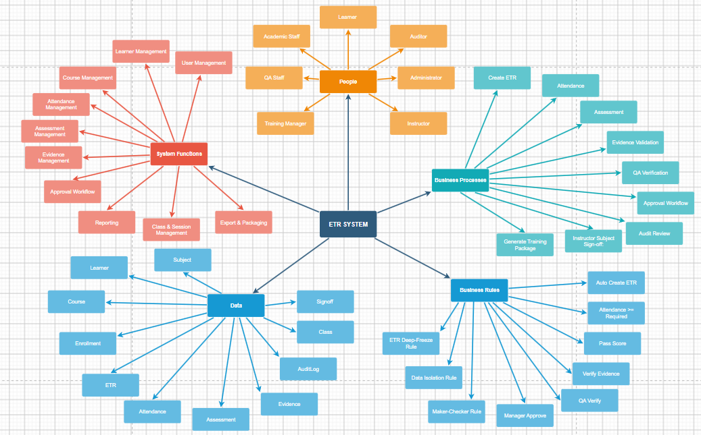

System Mind Map

6.2 Limitations & Exclusions

6.2.1 Limitations
LI-01 – The ETR System is a web-based solution and requires a stable network connection and system availability for users to access its functions.
LI-02 – Learner access is restricted to viewing their own training records, including ETR status, attendance, assessment results, and certificate information, and updating their personal profile. Learners cannot create, modify, verify, or approve official training records.
LI-03 – Legacy training records stored in paper documents, spreadsheets, scanned files, or other existing formats are not automatically migrated into the system. Any required migration must be performed through a separate manual or controlled data-import process.
LI-04 – The accuracy and completeness of training records depend on the quality of data entered by authorized users and the verification of submitted training evidence.
LI-05 – Access to training records and system functions is subject to role-based permissions and the user's assigned responsibilities.

6.2.2 Exclusions
EX-01 – Online learning delivery, virtual classrooms, and Learning Management System (LMS) functionality are excluded.
EX-02 – Online examinations, quiz delivery, and automated grading of examinations are excluded.
EX-03 – Integration with external aviation authorities, airlines, third-party training providers, or external training platforms is excluded.
EX-04 – Payment processing, training fee management, and learner-side course registration are excluded.
EX-05 – Advanced analytics, predictive analytics, and AI-based recommendations are excluded.
EX-06 – Multi-factor authentication (MFA) and advanced enterprise security integrations beyond the implemented authentication and authorization mechanisms are excluded.
EX-07 – Instructor payroll, human resource management, and other staff administration functions are excluded.
EX-08 – Public learner self-registration is excluded. Learner accounts are created and managed by authorized system users.
EX-09 – Native mobile applications for Android and iOS are excluded from the current project scope.

