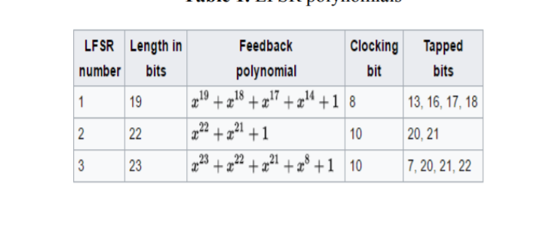

A5/1: Keystream

At each step: m = maj(x8, y10, z10)

Maj is major function

Base to major and rotate to right 1 bit, only it equal to m

X13 + x16+ x17+x18 = t

Rotate x1 -> x18

X0 = t

And streamkey is (x18, y22,z22) continue that step same as the length of key