TRƯỜNG ĐẠI HỌC
Khoa Cong nghe Thong tin
BAO CAO DO AN MON HOC
Lap trinh ADO.NET / ASP.NET Core
LUXE HAIR SALON
He thong Dat Lich Lam Toc Truc Tuyen
Cong nghe su dung:
ASP.NET Core 8.0 | SQL Server | Entity Framework Core 8 | JWT Authentication
Nam hoc: 2025-2026

CHƯƠNG 1: GIOI THIEU DE TAI

1.1. Đat van de
Trong boi canh kinh te dich vu phat trien manh me tai Viet Nam, nganh cham soc toc va lam dep dang chung kien su tang truong vuot bac. Tuy nhien, phan lon cac salon toc van dang van hanh theo phuong thuc truyen thong: khach hang phai truc tiep den cua hang hoac goi dien de dat lich, dan den nhieu bat tien nhu xep hang cho doi, kho quan ly lich hen va thieu thong tin minh bach ve dich vu.
Truoc thuc trang do, nhom thuc hien de tai "LUXE Hair Salon – He thong Dat Lich Lam Toc Truc Tuyen" nham xay dung mot nen tang so hoa toan bo quy trinh dat lich, quan ly nhan vien va theo doi doanh thu cho mot salon toc hien dai.

1.2. Muc tieu de tai

1.2.1. Muc tieu tong quat
Xay dung he thong dat lich lam toc truc tuyen da nen tang, phuc vu ba nhom nguoi dung chinh: Khach hang, Stylist va Quan tri vien, voi giao dien than thien va quy trinh nghiep vu chat che.

1.2.2. Muc tieu cu the
- Xay dung he thong dat lich truc tuyen da vai tro: Khach hang, Stylist va Quan tri vien.
- Ap dung kien truc API + MVC tach biet ro rang giua backend va frontend.
- Trien khai xac thuc bao mat voi JWT Bearer Token va Refresh Token.
- Tich hop cac bien phap bao mat hien dai: Rate Limiting, Audit Logging, Security Headers.
- Dam bao trai nghiem nguoi dung muot mat tren ca desktop va thiet bi di dong.

1.3. Pham vi va gioi han

1.3.1. Pham vi nghien cuu
He thong tap trung vao nghiep vu cot loi cua mot salon toc bao gom: Quan ly dich vu, Dat lich hen (ca khach da dang ky va khach vang lai), Quan ly lich lam viec cua stylist, Danh gia dich vu va Bao cao doanh thu.

1.3.2. Gioi han de tai
- Chua tich hop thanh toan truc tuyen (VNPay, MoMo)
- Chua co thong bao real-time (SignalR/WebSocket)
- Chua trien khai ung dung mobile rieng

CHƯƠNG 2: CONG NGHE SU DUNG

2.1. Tong quan cong nghe
Thanh phan | Cong nghe
Backend API | ASP.NET Core 8.0 Web API
Frontend | ASP.NET Core 8.0 MVC (Razor)
Co so du lieu | SQL Server + Entity Framework Core 8
Xac thuc | JWT Bearer + Refresh Token
Giao dien | CSS tuy chinh, Responsive
Bao mat | Rate Limiting, Audit Logging, Security Headers

2.2. ASP.NET Core 8.0 Web API
ASP.NET Core 8.0 la nen tang phat trien ung dung web da nen tang, ma nguon mo cua Microsoft. Du an LUXE Hair Salon ap dung kien truc phan lop ro rang: Controllers (xu ly HTTP), Services (business logic), DTOs (tach biet du lieu), va Middleware (xu ly xuyen suot).

2.3. Entity Framework Core 8 & SQL Server
Entity Framework Core (EF Core) la ORM chinh thuc cua Microsoft cho .NET, cho phep anh xa cac lop C# thanh bang trong SQL Server. Du an su dung Code-First approach voi EF Core Migrations va Data Seeding.

2.4. Xac thuc JWT Bearer + Refresh Token
JSON Web Token (JWT) la tieu chuan mo (RFC 7519) de truyen thong tin xac thuc. He thong su dung: Access Token (15 phut) cho truy cap tai nguyen va Refresh Token (7 ngay) de lam moi khong can dang nhap lai.

2.5. Bao mat ung dung web
Bien phap bao mat | Mo ta | Co che thuc hien
Rate Limiting | Gioi han 100 requests/phut/client | RateLimitingMiddleware
Audit Logging | Ghi log POST/PUT/DELETE | AuditLogMiddleware
Security Headers | Ngan chan XSS, Clickjacking | X-Content-Type, X-Frame-Options
Password Hashing | Ma hoa mat khau mot chieu | BCrypt voi salt tu dong
SQL Injection Prevention | Truy van an toan | EF Core Parameterized Queries

CHƯƠNG 3: PHAN TICH YEU CAU HE THONG

3.1. Yeu cau chuc nang

3.1.1. Nhom chuc nang Khach hang (Customer)
STT | Chuc nang | Mo ta chi tiet
1 | Xem trang chu | Landing page voi hero banner, danh sach dich vu noi bat
2 | Dang ky tai khoan | Tao tai khoan moi voi validation email, DT, mat khau
3 | Dang nhap / Dang xuat | Xac thuc JWT, luu session
4 | Dat lich 3 buoc | Chon dich vu | Stylist & Gio | Xac nhan
5 | Dat lich khach vang lai | Dat lich khong can dang nhap
6 | Xem lich cua toi | Danh sach lich hen ca nhan, loc theo trang thai
7 | Huy lich hen | Huy lich chua duoc xac nhan
8 | Gui danh gia | Danh gia 1-5 sao sau khi hoan thanh

3.1.2. Nhom chuc nang Stylist (Staff)
STT | Chuc nang | Mo ta chi tiet
1 | Dashboard ca nhan | Hien thi lich hen trong ngay, thong ke
2 | Cap nhat trang thai lich | Xac nhan/Hoan thanh lich duoc gan

3.1.3. Nhom chuc nang Quan tri vien (Admin)
STT | Chuc nang | Mo ta chi tiet
1 | Dashboard tong quan | Thong ke lich hen, doanh thu thang
2 | Quan ly lich hen | Xem, loc, duyet va doi trang thai
3 | Quan ly dich vu (CRUD) | Them, sua, xoa dich vu
4 | Quan ly nhan vien | Xem danh sach stylist
5 | Bao cao & Thong ke | Doanh thu, top dich vu, nhan vien

3.2. Yeu cau phi chuc nang
- Hieu suat: He thong phuc vu toi thieu 100 requests/phut/client
- Bao mat: Tuan thu tieu chuan OWASP Top 10
- Kha dung: Giao dien responsive, tuong thich mobile va desktop
- Bao tri: Kien truc phan lop ro rang, code theo nguyen tac SOLID
- Tinh nhat quan: Su dung Unique Constraints, Foreign Keys va transaction

CHƯƠNG 4: THIET KE HE THONG

4.1. Kien truc tong the
He thong LUXE Hair Salon duoc thiet ke theo mo hinh API + MVC (tach biet Backend va Frontend), giao tiep qua giao thuc REST voi JWT Bearer Token. Luong du lieu di qua ba lop chinh:
- Lop 1 (Presentation): Trinh duyet gui HTTP Request den ASP.NET Core MVC Web
- Lop 2 (Application): MVC Web goi REST API thong qua HttpClient kem JWT Token
- Lop 3 (Data): API truy van SQL Server thong qua Entity Framework Core 8

4.2. Cau truc du an
Project | Vai tro | Cong nghe chinh
HairSalonVN.API | REST API Backend – xu ly business logic | ASP.NET Core 8 Web API, EF Core 8
HairSalonVN.Web | MVC Frontend – giao dien nguoi dung | ASP.NET Core 8 MVC, Razor
HairSalonVN.Database | Data Layer – entity, migration, seeder | EF Core 8, SQL Server, Fluent API
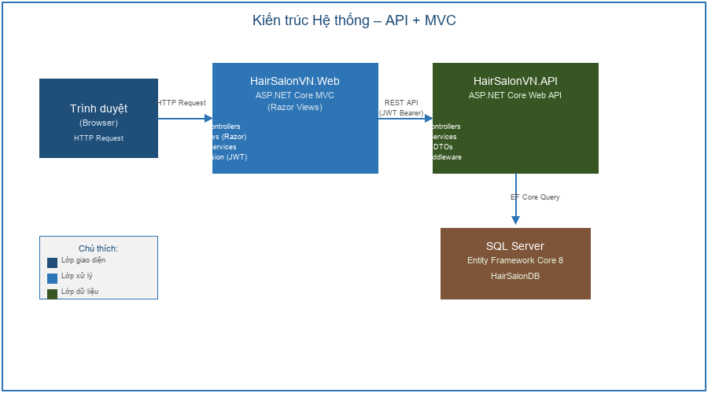
Hinh 4.1: Kien truc tong the he thong - API + MVC

4.3. So do Use Case
He thong co 4 actor chinh va 17 use case duoc phan chia theo vai tro. Khach vang lai (Guest) khong can dang nhap van co the dat lich – day la tinh nang quan trong giup tang ti le chuyen doi.
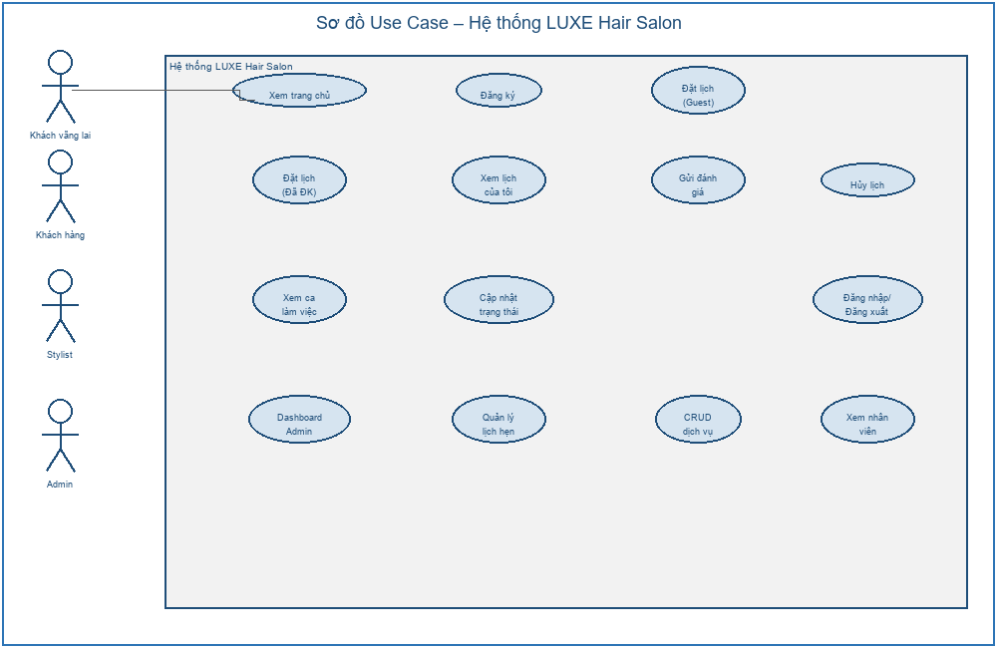
Hinh 4.2: So do Use Case toan he thong (4 actors, 17 use cases)

4.4. So do Lop (Class Diagram)
Domain model bao gom 9 entity chinh. Entity Appointment la trung tam cua he thong, lien ket voi User (CustomerId), Staff (StaffId), Service (ServiceId), Review va Payment.
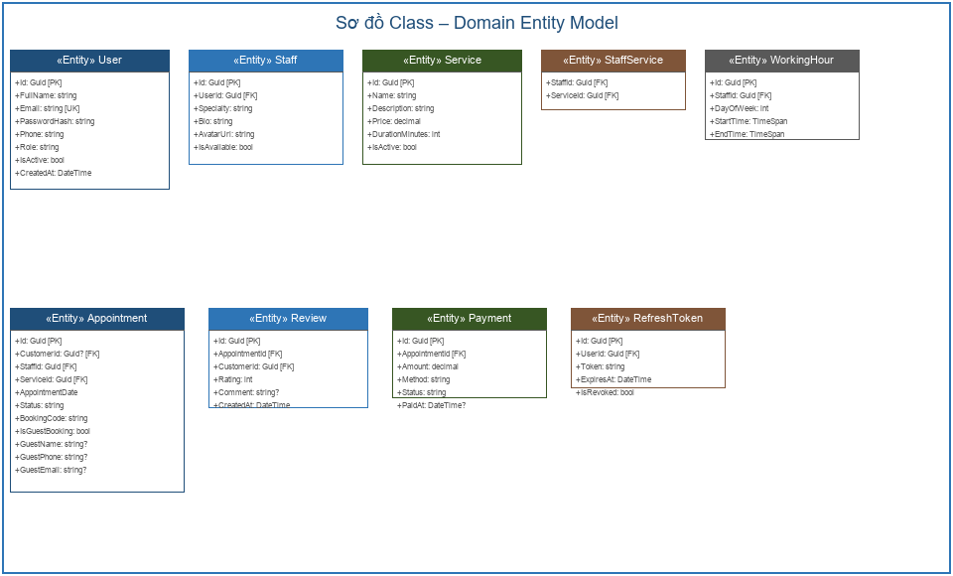
Hinh 4.3: So do Class - Domain Entity Model

4.5. So do ERD
He thong co 9 bang du lieu voi cac moi quan he duoc thiet ke chat che:
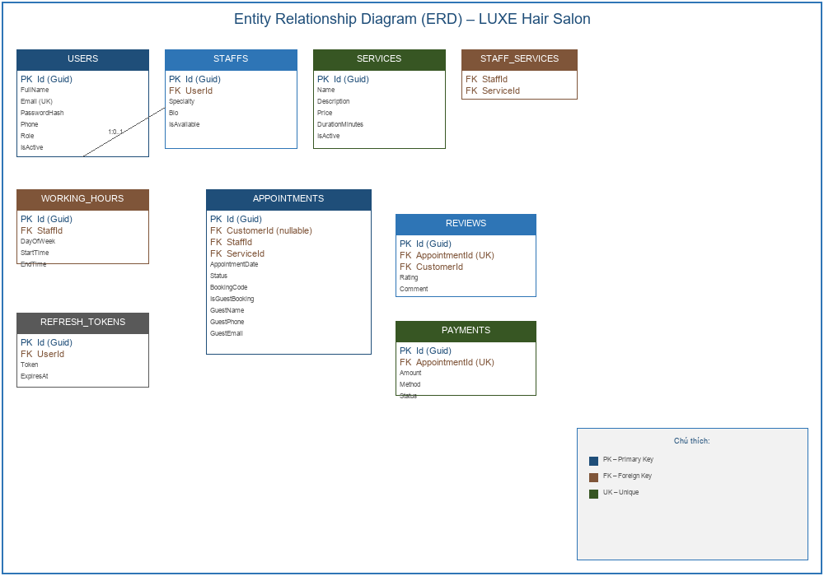
Hinh 4.4: Entity Relationship Diagram (ERD) - 9 bang du lieu

4.6. So do Sequence - Luong Dat Lich
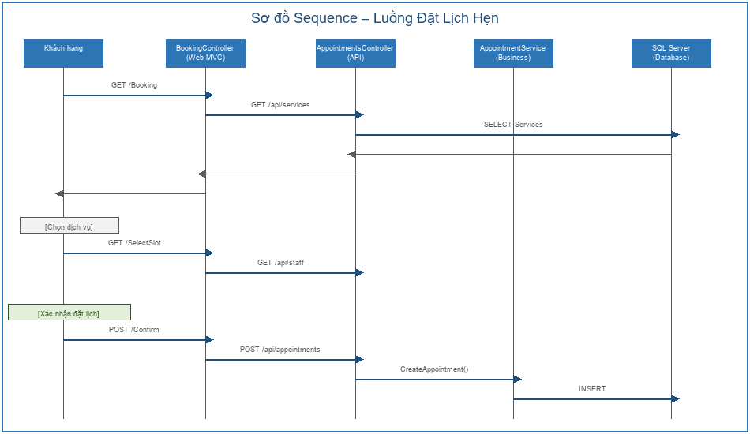
Hinh 4.5: So do Sequence - Luong dat lich hen (3 buoc)

4.7. Kien truc Bao mat
Authentication Flow: User gui POST /api/auth/login voi email va password. API xac minh bang BCrypt, tao JWT Access Token (15 phut) va Refresh Token (7 ngay). Refresh Token duoc luu trong bang RefreshTokens de ho tro thu hoi.

CHƯƠNG 5: THIET KE API ENDPOINTS

5.1. Authentication API
Method | Endpoint | Mo ta | Xac thuc
POST | /api/auth/register | Dang ky tai khoan moi | Khong
POST | /api/auth/login | Dang nhap, nhan Access + Refresh Token | Khong
POST | /api/auth/refresh | Lam moi Access Token | Khong
POST | /api/auth/logout | Dang xuat, thu hoi Refresh Token | Bearer JWT
GET | /api/auth/me | Lay thong tin user hien tai | Bearer JWT

5.2. Services API
Method | Endpoint | Mo ta | Xac thuc
GET | /api/services | Danh sach tat ca dich vu | Khong
GET | /api/services/{id} | Chi tiet mot dich vu | Khong
POST | /api/services | Tao dich vu moi | Admin
PUT | /api/services/{id} | Cap nhat dich vu | Admin
DELETE | /api/services/{id} | Xoa dich vu | Admin

5.3. Appointments API
Method | Endpoint | Mo ta | Xac thuc
GET | /api/appointments/available-slots | Khung gio trong | Khong
POST | /api/appointments/guest | Tao lich khach vang lai | Khong
GET | /api/appointments/my | Lich cua toi | Customer
POST | /api/appointments | Tao lich hen | Customer
PUT | /api/appointments/{id}/status | Cap nhat trang thai | Staff/Admin
GET | /api/appointments | Tat ca lich hen | Admin

CHƯƠNG 6: TRIEN KHAI VA THU NGHIEM

6.1. Moi truong phat trien
Thanh phan | Phien ban / Cong cu
Framework | .NET 8 SDK
IDE | Visual Studio 2022 / VS Code
Database | SQL Server 2022 (LocalDB/Express)
API Testing | Swagger UI, Postman
Version Control | Git

6.2. Cau truc Database Schema
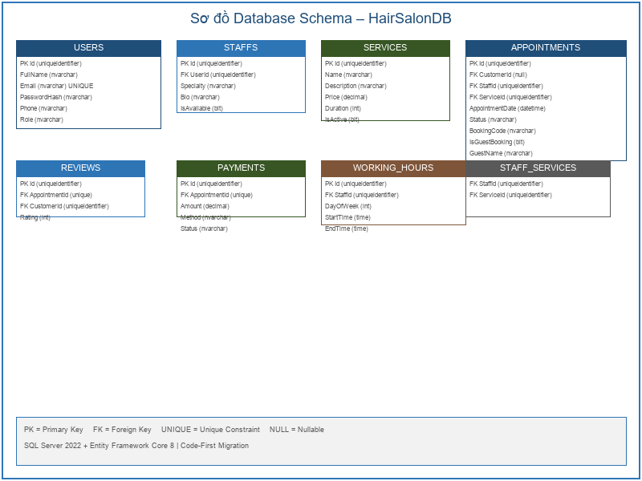
Hinh 6.1: So do Database Schema - HairSalonDB

6.3. Luong giao dien nguoi dung
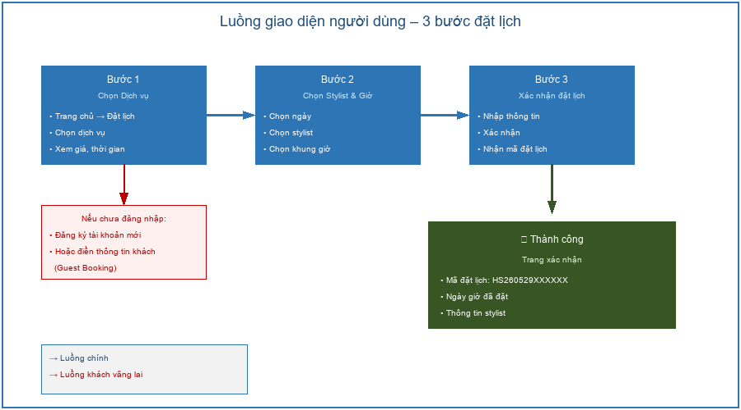
Hinh 6.2: Luong giao dien nguoi dung - 3 buoc dat lich

6.4. Huong dan cai dat va chay

Buoc 1: Chuan bi co so du lieu
cd HairSalonVN.API && dotnet ef database update --project ../HairSalonVN.Database

Buoc 2: Khoi chay API
# Terminal 1: cd HairSalonVN.API && dotnet run | http://localhost:7098

Buoc 3: Khoi chay Web
# Terminal 2: cd HairSalonVN.Web && dotnet run | http://localhost:7126

6.5. Tai khoan demo
Vai tro | Email | Mat khau | Chuyen mon
Admin | admin@luxehair.vn | Admin@123 | Toan quyen quan tri
Stylist | tai.nguyen@luxehair.vn | Staff@123 | Cat & Nhuom
Stylist | nam.tran@luxehair.vn | Staff@123 | Uon & Duei
Khach hang | mai.pham@gmail.com | Customer@123 | Tai khoan thu nghiem

6.6. Cac luong nghiep vu chinh

Luong 1: Dat lich khach vang lai
- Truy cap http://localhost:7126 | Click "Dat lich ngay"
- Buoc 1: Chon dich vu (VD: Cat Toc Nam - 150.000d)
- Buoc 2: Chon ngay, he thong tu dong tai Stylist, chon khung gio trong
- Buoc 3: Dien Ho ten va DT | Submit | Nhan ma dat lich

Luong 2: Admin quan ly va duyet lich hen
- Dang nhap admin@luxehair.vn / Admin@123
- Dashboard: Xem tong quan so lich hen Pending, doanh thu thang
- Lich hen: Duyet chuyen trang thai Pending | Confirmed

6.7. Ket qua thu nghiem
Project | Ket qua | Warnings | Errors
HairSalonVN.API | Thanh cong | 8 | 0
HairSalonVN.Web | Thanh cong | 0 | 0

CHƯƠNG 7: KET LUAN VA HUONG PHAT TRIEN

7.1. Ket qua dat duoc
- Xay dung hoan chinh he thong dat lich truc tuyen voi 3 vai tro nguoi dung va 17 use case
- Trien khai kien truc API + MVC tach biet ro rang, de bao tri va mo rong
- Ap dung xac thuc JWT (Access Token 15 phut + Refresh Token 7 ngay)
- Tich hop day du cac lop bao mat: Rate Limiting, Audit Logging, Security Headers, BCrypt
- Ho tro Guest Booking – cho phep khach chua dang ky dat lich ngay lap tuc
- Toan bo project build thanh cong voi 0 Error tren ca API va Web

7.2. Han che
- Chua tich hop cong thanh toan truc tuyen (VNPay, MoMo)
- Chua co thong bao real-time (SignalR/WebSocket) khi lich hen duoc duyet
- Chua trien khai unit test va integration test day du
- Chua ho tro da ngon ngu (i18n)

7.3. Huong phat trien tuong lai
- Tich hop cong thanh toan VNPay/MoMo cho dat lich truc tuyen
- Them thong bao real-time bang SignalR khi trang thai lich hen thay doi
- Trien khai ung dung mobile (Flutter/React Native) tich hop voi REST API
- Xay dung he thong goi y Stylist dua tren lich su dat lich (Machine Learning)
- Dua len cloud (Azure/AWS) voi CI/CD pipeline tu dong

7.4. Tai lieu tham khao
1. Microsoft. (2024). ASP.NET Core documentation. https://docs.microsoft.com/aspnet/core
2. C# Corner. (2026). Best Practices for Building Web APIs in ASP.NET Core.
3. Code Maze. (2024). ASP.NET Core Web API Best Practices.
4. Entity Framework Core Documentation. (2024). https://docs.microsoft.com/ef/core
5. OWASP Foundation. (2025). OWASP Top Ten Security Risks. owasp.org
--- Het ---

