VIETNAM GENERAL CONFEDERATION OF LABOR
TON DUC THANG UNIVERSITY
FACULTY OF INFORMATION TECHNOLOGY



HUYNH NGOC NHI – 523H0066
NGUYEN THI ANH THU – 523H0100

FINAL REPORT

REAL-TIME CHAT & VIDEO CALL PLATFORM

FULL-STACK SOFTWARE DEVELOPMENT

HO CHI MINH CITY, 2026
VIETNAM GENERAL CONFEDERATION OF LABOR
TON DUC THANG UNIVERSITY
FACULTY OF INFORMATION TECHNOLOGY



HUYNH NGOC NHI – 523H0066
NGUYEN THI ANH THU – 523H0100

FINAL REPORT

REAL-TIME CHAT & VIDEO CALL PLATFORM

FULL-STACK SOFTWARE DEVELOPMENT

Advised by
MSc. Vu Dinh Hong

HO CHI MINH CITY, 2026
ACKNOWLEDGEMENT

We would like to express our sincere gratitude to Ton Duc Thang University and the Faculty of Information Technology for providing a high-quality academic program, especially the Application Development Using NodeJS course within the Software Engineering major, which has given us the opportunity to learn, practice, and apply modern backend development techniques.
We are particularly grateful to MSc. Vu Dinh Hong, the course instructor, for his dedicated teaching, valuable guidance, and continuous support throughout the learning process and the completion of this project.
As this is our first time conducting a project for this course, there may inevitably be shortcomings in our report. We respectfully hope to receive constructive feedback from you so that we may continue improving in the future.
We wish you good health, happiness, and continued success.
Sincerely,
Ho Chi Minh city, 10th April 2026
Author
(Signature and full name)

Huỳnh Ngoc Nhi

Nguyen Thi Anh Thu

DECLARATION OF AUTHORSHIP
We hereby declare that this is our own project and is guided by MSc. Vu Dinh Hong; The content research and results contained herein are central and have not been published in any form before. The data in the tables for analysis, comments and evaluation are collected by the main author from different sources, which are clearly stated in the reference section.
In addition, the project also uses some comments, assessments as well as data of other authors, other organizations with citations and annotated sources.
If something wrong happens, we’ll take full responsibility for the content of my project. Ton Duc Thang University is not related to the infringing rights, the copyrights that We give during the implementation process (if any).

Ho Chi Minh city, 10th April 2026
Author
(Signature and full name)

Huynh Ngoc Nhi

Nguyen Thi Anh Thu

TABLE OF CONTENT
CHAPTER 1. INTRODUCTION 1
1.1 Background and Motivation 1
1.2 Objectives of the project 3
1.3 Scope of the project 3
1.4 Research methodology 4
1.5 Practical significance 7
CHAPTER 2. THEORETICAL BACKGROUND 8
2.1 Introduction to WebSocket 8
2.2 Fundamental Principle of WebSocket 11
2.3 WebSocket Architecture and Workflow 12
2.4 Properties of WebSocket 15
2.5 WebSocket Event Handlers 17
2.6 WebSocket Methods 18
2.7 Comparison of WebSocket with Other Communication Methods 18
2.8 Pros and Cons of WebSocket 19
2.9 Libraries and Frameworks Supporting WebSocket 21
2.10 Applications of WebSocket 22
2.11 Technologies Used in the KittaChat Project 23
CHAPTER 3. REQUIREMENT ANALYSIS 25
3.1 Functional Requirement 25
3.2 Non-functional requirement 27
3.3 Use-case Diagram for KittaChat Real-time Chat System 28
CHAPTER 4. SYSTEM DESIGN 29
4.1 System Architecture 29
4.2 Database Design 30
4.3 User Interface Design 32
4.4 API Design 37
CHAPTER 5. SYSTEM DEPLOYMENT 39
5.1 Development Environment and Tools 39
5.2 Source Code Structure 39
5.3 Database Deployment 41
CHAPTER 6. DEVELOPMENT AND EVALUATION 42
6.1 Testing Strategy 42
6.2 Test Account 42
6.3 Test Case and Testing Result 43
CHAPTER 7. CONCLUSION 44
7.1 Achieved Results 44
7.2 Advantages and Disadvantages 44
7.3 Future Development Directions 46
REFERENCES 48

LIST OF FIGURES
Figure 1 Internal Communication 2
Figure 2 Statistics on Messenger users for communication in Vietnam in 2025 2
Figure 3 Monthly active users of the Zalo application in Vietnam up to Q3 2025 2
Figure 4 WebSocket connection workflow 13
Figure 5 Use-case Diagram for the system 28
Figure 6 MVC model 29
Figure 7 Entity Relationship Diagram for The KittaChat 31
Figure 8 Relational Data Model for the KittaChat 31
Figure 9 UI Login Account 33
Figure 10 UI Register Account 34
Figure 11 UI Chat when there is no conversation 34
Figure 12 UI Chat with Text Message, Picture and Emoji 35
Figure 13 UI Forgot Password 35
Figure 14 UI Reset Password 36
Figure 15 UI Create Group Chat 36
Figure 16 UI Profile Management Interface 37
Figure 17 Source Code Structure 41

LIST OF TABLES
Table 1 WebSocket Connection States – readyState 15
Table 2 WebSocket Event Handlers 17
Table 3 WebSocket Methods 18
Table 4 Comparison of WebSocket with Other Communication Methods 19
Table 5 Basic user functions 25
Table 6 Real-time chat function 27
Table 7 API design 38
Table 8 Test Account 42
Table 9 Test case and Testing Result 43

ABBREVIATIONS

API | Application Programming Interface
CSS | Cascading Style Sheets
HTML | HyperText Markup Language
HTTP | HyperText Transfer Protocol
IDE | Integrated Development Environment
JSX | JavaScript XML
RESTful APIs | Representational State Transfer APIs
TCP | Transmission Control Protocol
UI | User Interface

INTRODUCTION

Background and Motivation
In recent years, web applications have increasingly required real-time interaction to improve user experience and system responsiveness. Applications such as online chat systems, collaborative platforms, and live notification services demand instant data updates and continuous communication between clients and servers.
However, traditional HTTP communication follows a request–response model, where the client must repeatedly send requests to receive updated information. This approach leads to unnecessary latency, increased network overhead, and inefficient resource usage, making it unsuitable for real-time applications.
To address these limitations, WebSocket was introduced as a communication protocol that enables persistent, bidirectional communication over a single TCP connection. With WebSocket, both the client and the server can actively send data at any time, significantly reducing delay and improving interaction efficiency.
Motivated by the growing demand for real-time web applications and the need to better understand modern communication technologies, this project focuses on studying and applying WebSocket through the development of a real-time chat system. The project aims to demonstrate how WebSocket can overcome the limitations of traditional HTTP and support efficient real-time communication in practical web applications.
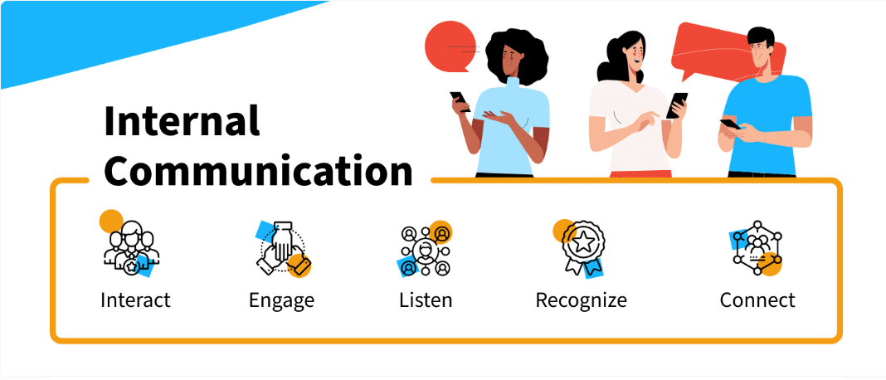
Figure 1 Internal Communication
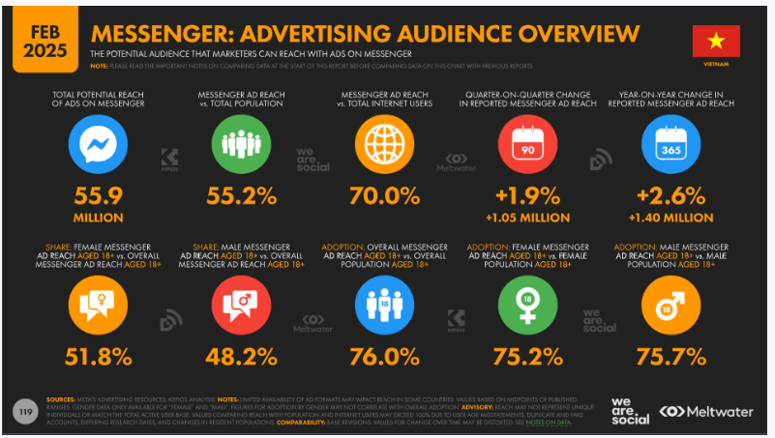
Figure 2 Statistics on Messenger users for communication in Vietnam in 2025
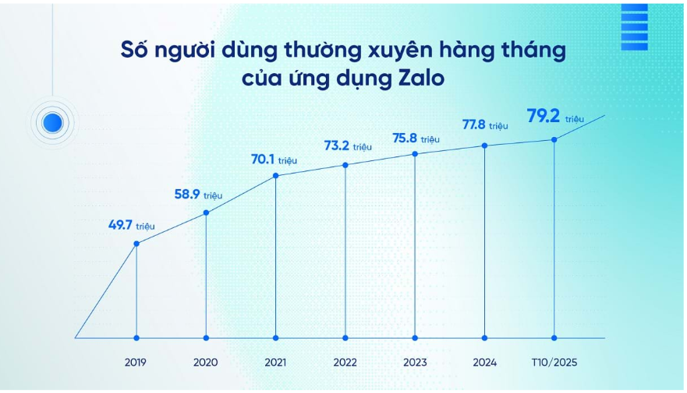
Figure 3 Monthly active users of the Zalo application in Vietnam up to Q3 2025

Objectives of the project
The objective of the KittaChat project is to design and implement a real-time web-based chat system using the WebSocket communication protocol, demonstrating continuous and bidirectional communication between the client and the server.
The system aims to provide essential features of a modern chat application, including user registration and authentication, real-time one-on-one messaging, image sharing, and dynamic user status updates such as online/offline states. All interactions are synchronized instantly through WebSocket without requiring page reloads or repeated HTTP requests.
In addition, the project focuses on applying secure authentication techniques, session management, and a user-friendly interface to ensure smooth and reliable communication. Through this implementation, the project demonstrates the practical effectiveness of WebSocket technology in developing efficient and responsive real-time web applications, while also serving as a foundation for future extensions such as voice or video communication.

Scope of the project
The scope of this study focuses on investigating the WebSocket communication protocol and applying it to develop a real-time web-based Chat Application named KittaChat. The implementation is limited to the following core components and functional aspects:
- Functional limitations
This project focuses on implementing the core features of a real-time chat application using WebSocket technology. The system supports user registration, login, password recovery, real-time synchronization of the online user list, one-on-one messaging, and the ability to exchange text messages, emojis, and images instantly.
At the current stage, the system does not support advanced communication features such as voice messages, video calls, video file sharing, or sending multiple file types. Group chat functionality is limited and does not include advanced management features. Additionally, large-scale user management and multimedia streaming are beyond the scope of this project.
These limitations allow the project to focus on demonstrating the fundamental principles of WebSocket-based real-time communication, while leaving room for future extensions and enhancements.
- Technological scope: The application is developed using Node.js in combination with Socket.IO to handle real-time, bidirectional communication between the client and the server. MongoDB is employed as the primary database to store essential user information, group chat and authentication data. A simple session-based authentication mechanism is used, and the system does not include advanced security features or complex performance optimization techniques, as the focus remains on demonstrating the practical use of WebSocket in building a lightweight real-time communication system.

Research methodology
To conduct research on the topic of WebSocket, our team combined theoretical research with practical implementation using the following methods:
- Theoretical Research: We referred to official WebSocket documentation, reputable technical sources, and specialized articles to study key concepts such as the WebSocket communication model, handshake mechanism, frame structure, and differences between WebSocket and traditional HTTP communication. Additionally, we reviewed materials related to session management and real-time data handling to support the implementation of KittaChat.

- Frontend Development
For the frontend, the team used ReactJS to build two main interface sections:
- The account management interface, including user registration, login, and basic authentication handling.
- The chat interface, featuring the online user list, message display area, and input panel.
ReactJS enabled real-time UI updates by integrating Socket.IO client to receive messages, track user status changes, and synchronize data instantly. Basic CSS styling was applied to create a clean and user-friendly interface.
- Backend Development
- NodeJS: Implemented the server-side logic, including authentication, session handling, and routing.
- Socket.IO: Managed real-time bidirectional communication, broadcasting events such as user status, incoming messages, and file transmissions.
- Real-time event handlers were developed to synchronize online users, manage chat sessions, and guarantee immediate message delivery without page reloads.
- Database Design
MongoDB is chosen as the primary database for the KittaChat system due to its flexibility and suitability for real-time applications. The database is used to store user account information, authentication credentials, chat messages, group chat data, and basic session-related information.

- Agile Development Process
The project was developed using the Agile methodology, dividing the work into short sprints (typically 1–2 weeks). Each sprint focused on a specific task, such as:
- Sprint 1: User Interface Design
Designing the main user interfaces, including the login and registration screens, account management interface, and the real-time chat layout. This sprint focused on usability, clarity, and creating a user-friendly experience similar to modern chat applications.
- Sprint 2: Backend Development and Authentication
Implementing backend functionalities using Node.js, including user authentication, account management, and database integration with MongoDB. This sprint also focused on handling user sessions and preparing the server for real-time communication.
- Sprint 3: Real-Time Communication and WebSocket Integration
Integrating WebSocket (Socket.IO) to enable real-time messaging, online user synchronization, and user status management. This sprint ensured that messages, images, and files could be exchanged instantly and that user states were updated dynamically across all connected clients.
At the end of each sprint, the team reviewed progress, conducted testing, and made necessary adjustments. This iterative approach ensured flexibility and improved the overall efficiency of the development process.

Practical significance
The implementation of KittaChat demonstrates the practical application of WebSocket technology in building a real-time communication system. The system allows users to register, log in, reset passwords, and manage personal information such as display name and activity status.
KittaChat supports real-time messaging, including text, emojis, and image sharing, along with interactive features such as typing indicators, read receipts, online/offline status, and group chat creation. These features closely resemble modern messaging applications and significantly enhance user experience through instant updates without page reloads.
Through this project, students gain hands-on experience in integrating authentication, real-time communication, database storage, and dynamic user interfaces. The system also serves as a foundation for future extensions such as advanced group management and message history, making it highly relevant for both academic study and real-world web application development.

THEORETICAL BACKGROUND

Introduction to WebSocket

What is WebSocket?
WebSocket is a powerful communication protocol that enables full-duplex, bidirectional data exchange between a web client and a server over a single, persistent TCP connection. This design fundamentally differs from the traditional HTTP protocol.
Unlike HTTP, which follows a request response model where the client must repeatedly send requests to retrieve updated information, WebSocket allows both the client and the server to actively send data to each other at any time. This capability provides a smooth and efficient real-time communication experience for users without requiring page reloads.

Intuitive analogy for understanding WebSocket

Restaurant Analogy Overview
To further illustrate the difference between WebSocket and traditional HTTP communication, a practical real-life analogy can be drawn from the experience of dining at a restaurant:
- WebSocket $=$ Two – Way Radio Communication
Imagine a modern restaurant with a two-way communication device:
- As soon as you sit down, the kitchen connects to you through a two-way radio system.
- The kitchen can instantly notify you about the status of your order.
- You can also send information back immediately when needed.
This mirrors WebSocket’s continuous, full-duplex communication, where both sides can send and receive data at any time without needing to wait for a new request.

- HTTP $=$ Traditional Table Service
- You must call the waiter each time you need an update.
- If you want to know whether your food is ready, you must ask first.
- If you want to add or modify any item in your order, you must call the waiter again.
- The waiter only responds when you actively make a request.
- During peak hours, you may have to wait a long time before receiving any update.
This behavior reflects the request–response model of HTTP, where the client must repeatedly ask the server “Is there anything new yet?”, resulting in delays and inefficiency for real-time applications.

Communication Analogy Overview
Alternatively, a simple comparison based on communication can also be used:
- WebSocket $=$ A telephone line
- Both sides can speak and listen simultaneously
- Communication is continuous without interruption.
- No need to wait between messages, either party can send information whenever needed.
- Ideal for real-time, interactive communication
This mirrors WebSocket’s ability to maintain a persistent connection and support instant, bidirectional data flow.
- HTTP $=$ Sending letters
- You must wait for a response after each request
- Communication is one-directional at a time
- Not suitable for continuous updates
- Create delays when frequent updates are needed
This illustrates why HTTP struggles to support continuously updating systems such as Chat Applications or live data dashboards.
- Why is WebSocket ideal?
Because of its full-duplex nature, WebSocket is perfect for requiring applications continuous, real-time interaction, such as:
- Chat system
- Online multiplayer games
- Real-time financial dashboard
- Live notification system

Role of WebSocket in Real-Time Applications
WebSocket plays a critical role in enabling real-time communication in modern web applications. Its primary function is to provide a persistent, full-duplex communication channel between the client and the server, allowing data to be exchanged instantly without repeated request–response cycles.
In real-time applications, such as chat systems, online gaming platforms, live notification services, and real-time dashboards, data must be delivered immediately when changes occur. WebSocket allows the server to actively push updates to clients as soon as new data is available, ensuring minimal latency and timely synchronization.
By maintaining a continuous connection, WebSocket reduces network overhead and eliminates the need for frequent HTTP polling. This improves application performance, lowers server load, and provides smoother user experience.
In the KittaChat system, WebSocket is responsible for real-time message delivery, instant user status updates, and continuous synchronization between connected users. These features demonstrate WebSocket’s essential role in building responsive, interactive, and scalable real-time web applications.

Fundamental Principle of WebSocket
WebSocket is designed based on several fundamental principles that enable efficient and real-time communication between a client and a server.

Persistent Connection
WebSocket establishes a long-lived connection between the client and the server after the initial handshake. Unlike traditional HTTP communication, which creates a new connection for each request, WebSocket maintains a single TCP connection throughout the session. This allows continuous data exchange without repeated connection setup.

Full-Duplex Communication
WebSocket supports full-duplex communication, meaning that both the client and the server can send and receive data simultaneously. Neither side needs to wait for a request before transmitting information, enabling instant and interactive communication.

Bidirectional Communication
Both the client and the server can actively initiate data transmission at any time. This bidirectional capability allows servers to push updates directly to clients, eliminating the need for polling mechanisms.

Event-Driven Communication Model
WebSocket communication is event-driven. Data is transmitted in response to events such as user actions or server-side updates, making it suitable for real-time applications where immediate responses are required.

Lightweight Data Transmission
After the connection is established, WebSocket exchanges data using lightweight frames instead of full HTTP messages. This reduces protocol overhead, improves transmission efficiency, and minimizes network traffic.

WebSocket Architecture and Workflow

WebSocket Architecture
The WebSocket architecture consists of several key components that work together to establish and maintain a persistent, bidirectional communication channel:
- Client
The client is typically a web browser or mobile application that initiates the WebSocket connection. It sends the initial handshake request and communicates with the server using WebSocket frames once the connection is established.
- Server
The WebSocket server receives the handshake request, upgrades the connection from HTTP to WebSocket, and manages all subsequent communication. It is responsible for handling multiple concurrent connections, broadcasting messages, and pushing updates to clients.
- HTTP Upgrade Mechanism
WebSocket begins as a standard HTTP request. During the handshake, the client sends an Upgrade header requesting the transition to the WebSocket protocol. If the server accepts, the connection is upgraded, and a persistent TCP channel is established.
- Subprotocols
WebSocket supports optional subprotocols that define higher-level communication rules. These subprotocols allow applications to implement structured messaging patterns.
- Message Framing
After the connection is established, data is transmitted using lightweight WebSocket frames. These frames can contain text or binary data and are significantly smaller than traditional HTTP messages, reducing overhead and improving performance.

WebSocket Connection Workflow
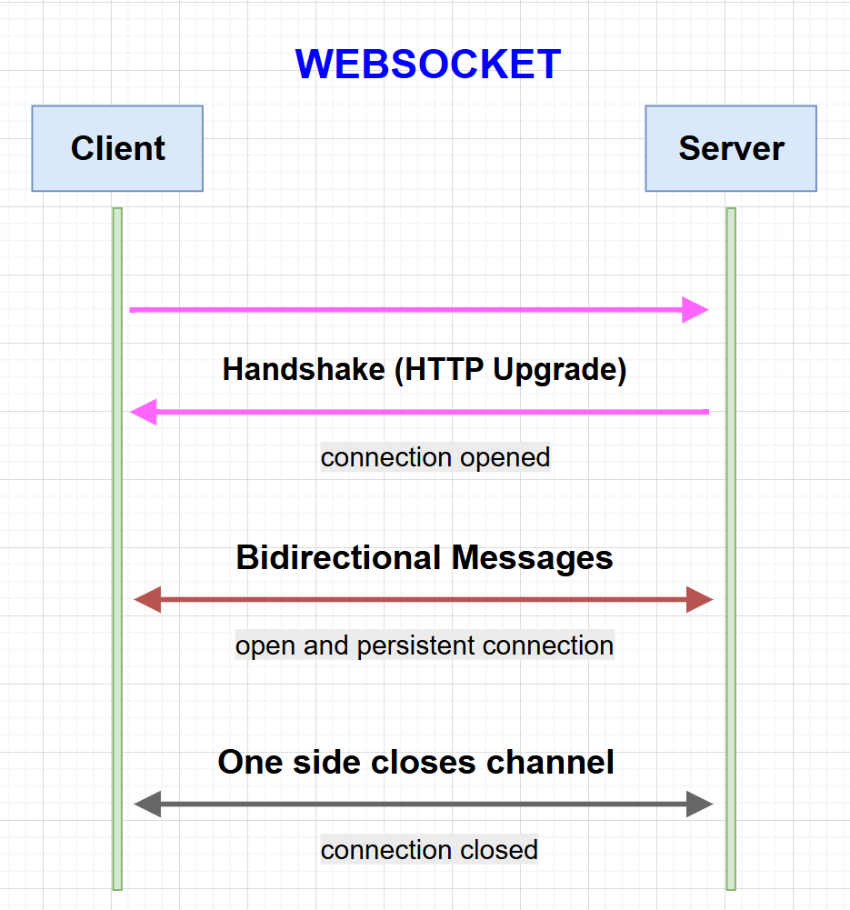
Figure 4 WebSocket connection workflow

The WebSocket workflow describes the sequence of steps involved in establishing, using, and closing a WebSocket connection:
- Step 1: Client Sends HTTP Handshake Request
The client initiates a WebSocket connection by sending a special HTTP request to the server. This request includes the Upgrade header, indicating the intention to upgrade the communication protocol from HTTP to WebSocket.
- Step 2: Server Accepts Protocol Upgrade
If the server supports WebSocket, it responds with the HTTP status code 101 “Switching Protocols”. This response confirms that the server has accepted the request and agreed to switch the protocol to WebSocket.
- Step 3: Establishment of Persistent WebSocket Connection
After the handshake is successfully completed, the initial HTTP connection is replaced by a persistent WebSocket connection. This connection remains open for the duration of the session, allowing continuous communication.
- Step 4: Real-Time Data Exchange Using Frames
Once the connection is established, data is transmitted between the client and the server using WebSocket frames. These frames may contain text (UTF-8) or binary data, enabling efficient and low-overhead data transmission.
- Step 5: Connection Termination
The WebSocket connection remains active until either the client or the server sends a close frame. This allows the connection to be terminated gracefully, ensuring that system resources are properly released.

Properties of WebSocket

WebSocket Connection States - readyState
The readyState property represents the current state of a WebSocket connection. It allows developers to check whether the connection is being established, is open, or has been closed. The possible values of this property are defined as follows:
State name | ReadyState Value | Description
CONNECTING | 0 | - The connection has been created but is not yet established.  - The WebSocket handshake process is still in progress.  - Data cannot be sent at this stage.  $→$ Client is trying to connect to the server.
OPEN | 1 | - The connection is successfully established.  - Data can be sent and received normally.  - This is the active communication state.  $→$ Client and server are connected and can communicate in real time.
CLOSING | 2 | - The connection is in the process of being closed.  - A closed frame has been sent or received, but the connection is not fully terminated yet.  $→$ The connection is shutting down gracefully.
CLOSED | 3 | - The connection has been completely closed.  - No further data can be sent or received.  $→$ Communication has ended.
Table 1 WebSocket Connection States – readyState

- Why is it important?
- Avoid sending data before the connection is ready
- Handle disconnections properly
- Implement reconnection logic
- Improve application stability

WebSocket Data Buffer – bufferedAmount
The bufferedAmount property represents the amount of data, in bytes, that has been queued for transmission but has not yet been sent over the WebSocket connection. When data cannot be sent immediately, it is queued in the buffer, causing the bufferedAmount value to increase.
Once the data transmission is completed, bufferedAmount gradually decreases and returns 0, indicating that all data has been successfully sent. Monitoring this property allows developers to control data flow, prevent excessive data transmission at once, and avoid network congestion or performance degradation.
Understanding the bufferedAmount property helps developers:
- Monitor the amount of unsent data
- Control data transmission rate
- Preventing network congestion
- Improve application stability

WebSocket URL
The url property represents the address of the WebSocket server that the client is currently connected to. This property is read-only and is automatically set when the WebSocket connection is established.
The url property is useful for verifying the endpoint of the active connection and ensuring that the client is communicating with the correct WebSocket server.

WebSocket Protocol
The protocol property returns the subprotocol selected between the client and the server during the WebSocket handshake process, if any. Subprotocols are optional and are used when multiple communication formats or application-level protocols are supported.
This property is particularly useful in complex systems where different types of messages or services are handled through specific subprotocols.

WebSocket Extensions
The extensions property contains a list of WebSocket extensions that have been accepted by the server. These extensions may provide additional functionalities such as data compression or performance optimization.
In most basic WebSocket applications, this property is rarely used. However, it can be useful in advanced systems that require enhanced performance or additional protocol features.

WebSocket Event Handlers
Event | Description | Purpose
onopen | Triggered when the WebSocket connection is successfully established | Initialize data or notify connection status
onmessage | Triggered when a message is received from the server | Handle real-time data and messages
onclose | Triggered when the WebSocket connection is closed | Release resources or implement reconnection logic
onerror | Triggered when an error occurs during communication | Detect and handle connection errors
Table 2 WebSocket Event Handlers

WebSocket Methods
Method | Description
send(data) | Sends text or binary data from the client to the server
close() | Close the WebSocket connection gracefully
Table 3 WebSocket Methods

Comparison of WebSocket with Other Communication Methods
Aspect | Traditional HTTP | HTTP Polling | Long Polling | WebSocket
Communication model | Request–Response | Repeated client requests | Client waits for server response | Full-duplex, bidirectional
Connection type | Short-lived connection | Frequent open/close connections | Temporarily open connection | Persistent connection
Data transmission | Client must request each update | Client requests at fixed intervals | Server responds once per request | Server and client push data anytime
Latency | High | High | Medium | Very low
Network overhead | High | Very high | Medium | Low
Bandwidth efficiency | Low | Low | Medium | High
Real-time capability | Not suitable | Limited | Acceptable | Highly suitable
Server resource usage | Low | High | Medium | Optimized for real-time
Scalability for real-time apps | Poor | Poor | Moderate | Good
Typical use cases | Websites, REST APIs | Simple periodic updates | Notifications | Chat systems, online games
Table 4 Comparison of WebSocket with Other Communication Methods
Conclusion
WebSocket outperforms traditional HTTP-based communication methods in real-time scenarios. Its ability to maintain a continuous bidirectional connection makes it an ideal solution for applications requiring frequent updates and low latency, such as real-time Chat Applications, multiplayer games, and live data monitoring systems.

Pros and Cons of WebSocket

Pros
WebSocket offers several significant advantages over traditional HTTP communication, especially for real-time applications:
- Full-duplex communication: Both the client and the server can send and receive data at any time without waiting for requests, improving interaction efficiency and making WebSocket suitable for real-time applications.
- Persistent connection: A single TCP connection is maintained throughout the session, eliminating the need to repeatedly establish new connections.
- Low latency: Since data can be pushed directly from the server to the client, significantly reducing response time compared to HTTP polling.
- Fast response time: Maintaining an open connection enables quicker data transmission and more efficient communication than traditional HTTP.
- Bandwidth Efficiency: WebSocket frames are lightweight, reducing packet size and the number of request-response exchanges compared to HTTP. As a result, less data is transmitted, leading to reduced network traffic and bandwidth usage.
- Improved user experience: Applications feel smoother and more responsive, especially in chat systems, online games, and live dashboards.

Cons
Despite its strengths, WebSocket also has several limitations that must be considered:
- Security concerns if misconfigured: Improper authentication or authorization can expose real-time channels to attacks.
- Limited support in older browsers: Although WebSocket is supported by most modern browsers, some older browsers may not support it fully, which should be considered when developing applications for a wide range of users.
- Firewall and proxy compatibility issues: Some older firewalls or proxy servers may block or interfere with WebSocket connections, potentially causing connection problems or performance degradation in certain network environments.
- More complex implementation: WebSocket requires additional logic for connection management, error handling, and reconnection.
- State management complexity: Since WebSocket connections are long-lived, managing user sessions and connection states becomes more challenging compared to stateless HTTP communication.
- Scalability challenges: Maintaining a large number of persistent connections can be resource-intensive and requires careful server-side design.
- Lack of built-in reconnection mechanisms: When a WebSocket connection is interrupted due to network issues or server failures, the application must implement its own logic to detect and restore the connection.
- Not suitable for all applications: For simple, infrequent data exchange, traditional HTTP may be more efficient and easier to implement.

Libraries and Frameworks Supporting WebSocket
There are many libraries and frameworks that support WebSocket, making it easier to develop real-time applications across different platforms:
- Socket.IO: A popular JavaScript library that provides a simple and high-level API for real-time communication. It supports fallback mechanisms when WebSocket is unavailable and simplifies event handling and connection management. Socket.IO is especially suitable for beginner developers and rapid application development.
- ws (Node.js): A high-performance WebSocket library for Node.js that offers a low-level API and excellent scalability. It is suitable for applications that require fine-grained control and optimized performance.
- Autobahn|Python: A powerful WebSocket library for Python that supports advanced features and multiple protocols, making it suitable for complex real-time systems.
- SignalR (.NET): A real-time communication library for .NET applications that simplifies the integration of WebSocket-based features and automatically handles connection management.
The choice of library or framework depends on the programming language, project requirements, and developer experience. In this project, Socket.IO is chosen due to its ease of use, reliability, and strong support for real-time communication in Node.js environments.

Applications of WebSocket
WebSocket is widely used in many application domains thanks to its ability to provide low-latency, real-time communication:
- Chat Applications: Enables instant message delivery and real-time interaction between users.
- Online Games: Synchronizes game states and player interactions in real time.
- Stock Market Monitoring: Provides live updates of stock prices and market indicators in real time (e.g., Yahoo Finance).
- Real-Time Dashboards: Continuously display system metrics, performance data, or sensor information without page reloads.
- Notifications: Allows the system to push notifications to users immediately when a new event occurs, such as system alerts, new messages, or status updates. WebSocket enables instant delivery without requiring users to refresh the page or repeatedly send requests.
- Collaboration Applications: Enables multiple users to work on the same document, project, or workspace simultaneously in real time. WebSocket ensures that changes made by one user are immediately synchronized and reflected for all other users, supporting smooth and efficient collaboration.

Technologies Used in the KittaChat Project
In the development of the KittaChat real-time chat system, the following key technologies were applied. Each technology was selected based on its suitability for real-time communication, ease of integration, scalability, and compatibility with WebSocket-based applications.
- Backend Technologies
- NodeJS: Used as the backend runtime environment. Its non-blocking, event-driven architecture enables efficient handling of multiple concurrent WebSocket connections.
- Express.js: A lightweight web framework used to handle HTTP requests such as user registration, login, and session initialization before establishing WebSocket connections.
- Socket.IO: A JavaScript library built on top of WebSocket that enables real-time, bidirectional communication between clients and the server. It simplifies event handling, broadcasting, and connection management.
Reason for selection: Node.js and Socket.IO integrate seamlessly and are ideal for building real-time systems. Socket.IO also provides additional features such as automatic reconnection and fallback support, making the system more reliable.
- Frontend technologies
- ReactJS: is primarily used to render and manage the user interface of the KittaChat system. It is responsible for displaying the chat layout, account management screens, message lists, and user status updates. React dynamically updates the interface when new data is received from the WebSocket server without requiring page reloads.
- JSX (HTML – like syntax): JSX is used within React components to define the structure of the chat interface and account-related views. These JSX elements are rendered into standard HTML in the browser.
- Tailwind CSS: is used for styling the frontend using utility-first CSS classes. It controls layout, spacing, colors, and typography, ensuring a clean, responsive, and user-friendly chat interface.
- JavaScript: handles client-side logic and integrates with Socket.IO Client to send, receive, and display real-time messages and updates from the backend server.
Reason for selection: ReactJS is lightweight for UI rendering and works well with real-time data. It allows the interface to update efficiently based on WebSocket events while keeping the frontend logic simple and focused on presentation.
- Database Technology
MongoDB is used as the database management system for the KittaChat system. It is responsible for storing user account information as well as chat message history exchanged between users. MongoDB’s document-oriented data model allows flexible storage of chat data, making it suitable for handling unstructured or semi-structured information such as messages and file references. The database integrates smoothly with Node.js, enabling efficient data retrieval and storage in real-time environments.
Reason for selection: MongoDB is lightweight, scalable, and well-suited for real-time web applications. Its JSON-like document structure matches naturally with JavaScript-based systems, making it an appropriate choice for storing user accounts and chat history in KittaChat.
- Development Tools
- Visual Studio Code (VS Code): Used as the primary code editor for frontend and backend development.
- Node Package Manager (npm): Used to manage dependencies such as ReactJS, Socket.IO, and Express.js.
- Google Chrome: Used for testing, debugging, and monitoring real-time WebSocket communication.

REQUIREMENT ANALYSIS

Functional Requirement

Basic user functions
ID | Function name | Input | Output | description
FR-01 | User Registration | Email and password | New user account | Allows users to create an account to access the system
FR-02 | User Login | Email and password | User session | Allows users to authenticate and access chat features
FR-03 | User Logout | Logout request | Session terminated | Allows users to safely exit the system
FR-04 | Forgot Password | Email | Password reset OTP/link | Helps users recover access to their accounts
FR-05 | Profile Management | Avatar, Display name, Status | Updated profile | Allows users to manage personal profile information
FR-06 | Search Users | Search keyword | User list | Allow users to find other users
Table 5 Basic user functions

Real-time chat function
ID | Function name | Input | Output | Description
FR-07 | Send Real-time Message | Message content | Delivered message | Send messages instantly using WebSocket
FR-08 | Receive Real-time Message | Incoming message | Displayed message | Displays messages immediately without page reload
FR-09 | Online / Offline Status | User connection state | Status update | Shows real-time user availability
FR-10 | Typing Indicator | Typing event | “User is typing…” | Displays typing status in real time
FR-11 | Read Receipts | Message read event | Read/Unread status | Indicates whether messages have been read
FR-12 | Send Files & Images or Emojis | File or image or emojis | Delivered file | Allows sharing files, images, and emojis
FR-13 | One-on-One Chat | Selected user | Private chat session | Enables private conversations between two users
FR-14 | Group Chat | Group selection | Group chat session | Allows multiple users to chat together
FR-15 | Create Group Chat | Group name, members | New group created | Allows users to create chat groups
FR-16 | Store Chat History | Message data | Saved chat records | Stores message history for later viewing
FR-17 | Message Notifications | New message event | Notification alert | Notifies users of new incoming messages
Table 6 Real-time chat function

Non-functional requirement

Performance
KittaChat is a real-time Chat Application, therefore system performance is a critical requirement. Messages must be delivered instantly with minimal latency to ensure smooth communication between users. The system should be able to handle multiple users sending and receiving messages simultaneously without causing noticeable delays or system slowdown.

Reliability and Stability
The system must maintain stable WebSocket connections during normal operation. When unexpected events occur, such as network interruptions or browser closures, the system should handle these situations gracefully by updating user status correctly and releasing unused resources. This ensures that the system remains consistent and reliable during long-term usage.

Security
Security is an essential requirement of the KittaChat system. User authentication must be enforced before accessing chat functionalities. User passwords must be securely stored using hashing techniques to protect sensitive information. The system should prevent unauthorized access and ensure that only authenticated users can send or receive messages.

Usability
The user interface of KittaChat should be simple, intuitive, and easy to use. Users should be able to perform basic actions such as registering, logging in, and chatting without requiring extensive instructions. The chat interface must respond smoothly to user interactions to provide a comfortable real-time communication experience.

Scalability and Maintainability
The system should be designed in a way that supports future expansion. New features such as group chat, notifications, or additional real-time functionalities should be integrated without major changes to the existing architecture. Additionally, the codebase should be well-organized and maintainable to facilitate future development and improvements.

Use-case Diagram for KittaChat Real-time Chat System
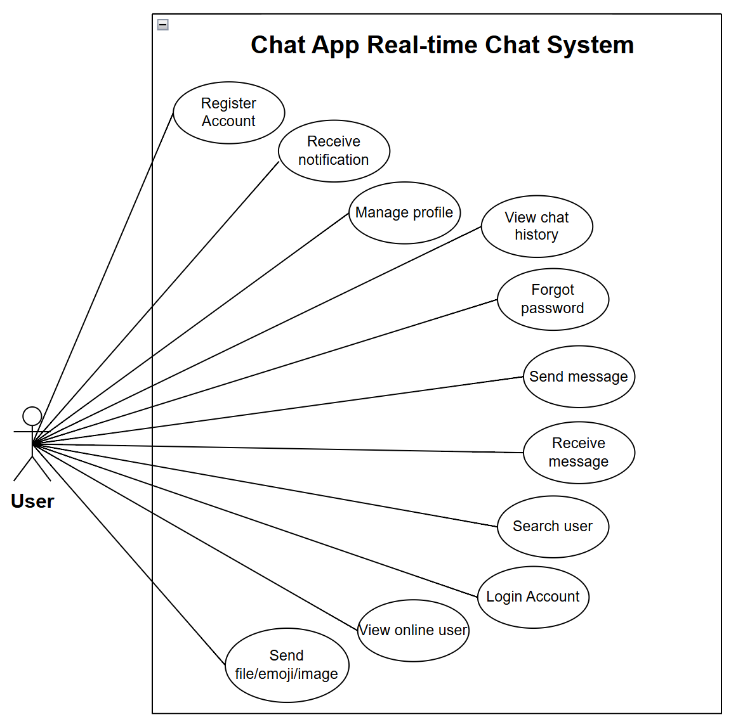
Figure 5 Use-case Diagram for the system

SYSTEM DESIGN

System Architecture
The KittaChat system is designed following a Client–Server architecture, where the frontend and backend are separated to improve scalability and maintainability.
On the server side, the application adopts the Model–View–Controller (MVC) architectural pattern to clearly separate concerns, improve maintainability,
and support real-time communication using WebSocket
  - View (Client - ReactJS): Implemented using ReactJS, responsible for rendering the user interface and handling user interactions.
  - Controller (Server – Node.js & Express): Implemented using Node.js and Express, processes RESTful API requests and manages real-time communication via WebSocket.
  - Model (MongoDB & Mongoose): MongoDB is used to store user accounts, chat messages, and group data. Mongoose models define data schemas and manage database interactions.
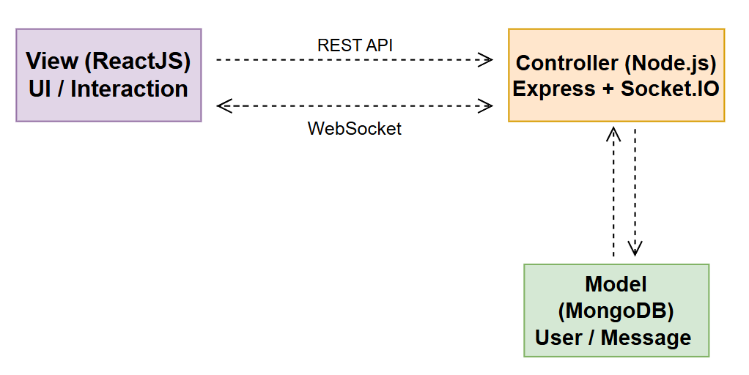
Figure 6 MVC model

Database Design
The KittaChat system uses MongoDB, a NoSQL database, as its primary data storage solution. Reasons for choosing MongoDB:
- MongoDB is well-suited for real-time applications where data structures may change frequently.
- It provides high scalability and flexibility, which is important for chat systems with a large number of users and messages.
- MongoDB integrates seamlessly with Node.js through Mongoose, simplifying data modeling and database operations.
- The document-based structure efficiently stores user profiles, messages, and group information.

Entity Relationship Diagram – ERD
Based on the system requirements and the ERD, the database consists of three main entities: Users, Messages, and Groups.
- Users: Stores information about registered users in the system.
- Messages: Stores all chat messages exchanged between users, including one-on-one and group conversations.
- Groups: Stores all chat messages exchanged between users, including one-on-one and group conversations.
Relationships Between Entities:
- Users – Messages
A User can send zero or many Messages.
Each Message is sent by exactly one User.
→ This represents a one-to-many relationship, where one user may create multiple messages, but each message has only one sender.

- Users – Groups
A User can belong to zero or many Groups.
A Group must have one or many Users as members.
→ This represents a many-to-many relationship, where users can join multiple groups, and each group consists of multiple users.
- Groups – Messages
A Group can contain zero or many Messages.
Each Message belongs to exactly one Group.
→ This represents a one-to-many relationship, where a group can have multiple messages, but each message is associated with a single group.
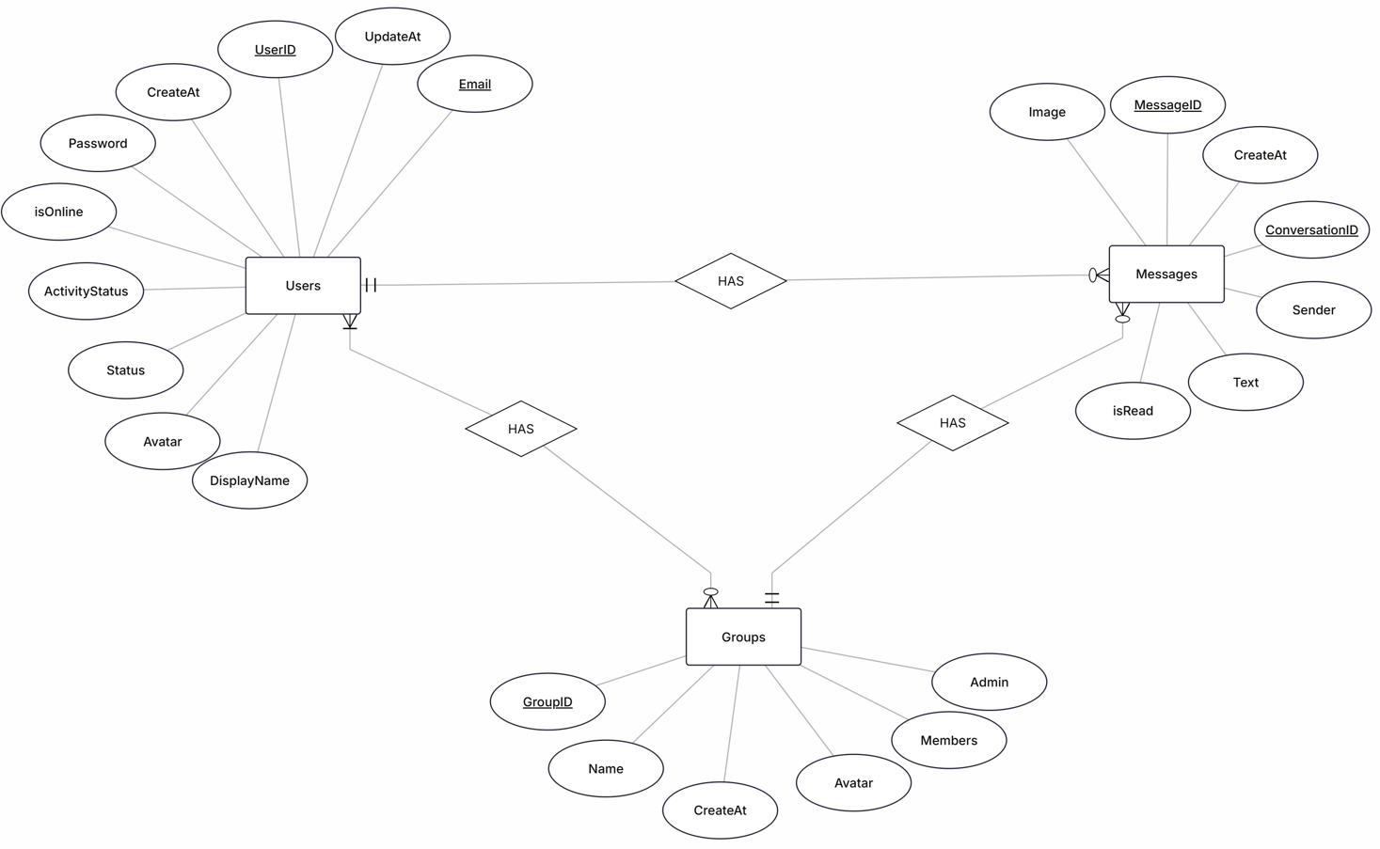
Figure 7 Entity Relationship Diagram for The KittaChat

Relational Data Model – RDM
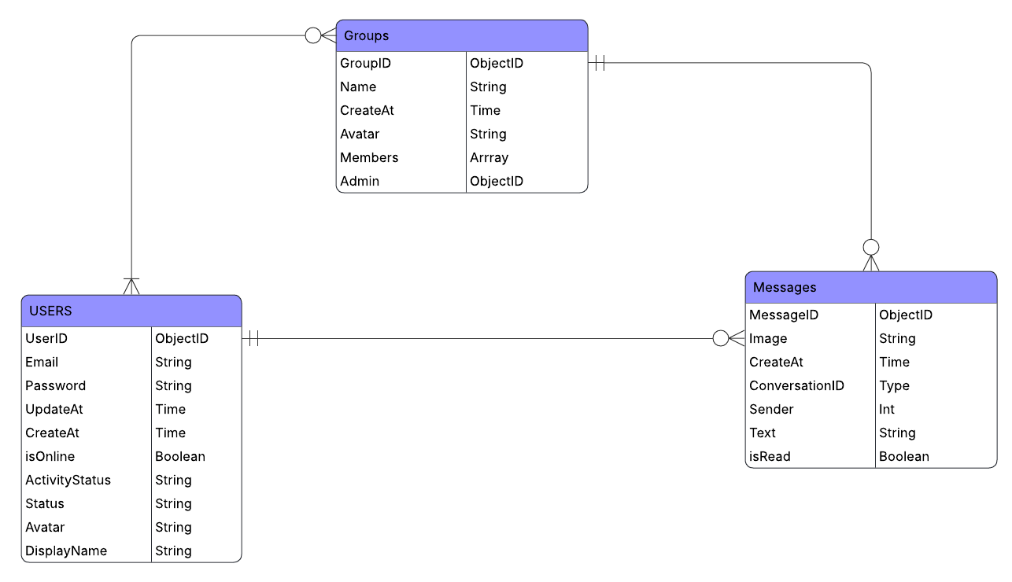
Figure 8 Relational Data Model for the KittaChat

User Interface Design

Interface Layout
The KittaChat system provides a simple and intuitive user interface designed for real-time communication.
The main screens of the system include:
- Login & Register screen: Allows users to create an account and authenticate.
- Profile management screen: Enables users to update personal information such as avatar and display name.
- Chat interface: Displays the list of conversations, chat messages, and real-time interactions.
- Group chat screen: Allows users to create and manage group conversations

User Flow
The user flow of the KittaChat system describes how users interact with the application from authentication to real-time communication.
- User Authentication
  - The user accesses the system and chooses to register a new account or log in with existing credentials.
  - After successful authentication, the user is redirected to the main chat interface.
- Account Management
  - The user can access the profile management screen to update personal information such as avatar and display name.
  - Changes are saved and reflected immediately in the system.
- Finding and Connecting with Users
  - The user can search for other users and add them as friends.
  - The system displays the online/offline status of users in real time.
- Chat Interaction
  - The user selects a conversation or starts a new chat.
  - Messages are sent and received in real time using WebSocket.
  - The system displays typing indicators, read status, and message notifications.
- Group Chat
  - The user can create a group chat, add or remove members, and manage group information.
  - Group messages are synchronized in real time for all members.
- Logout
  - The user can log out, ending the session securely.

User Interface
- Login Account Interface
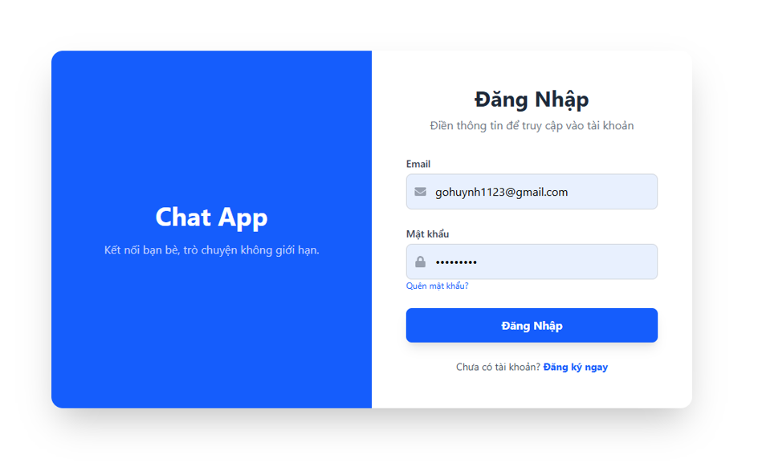
Figure 9 UI Login Account

- Register Account Interface
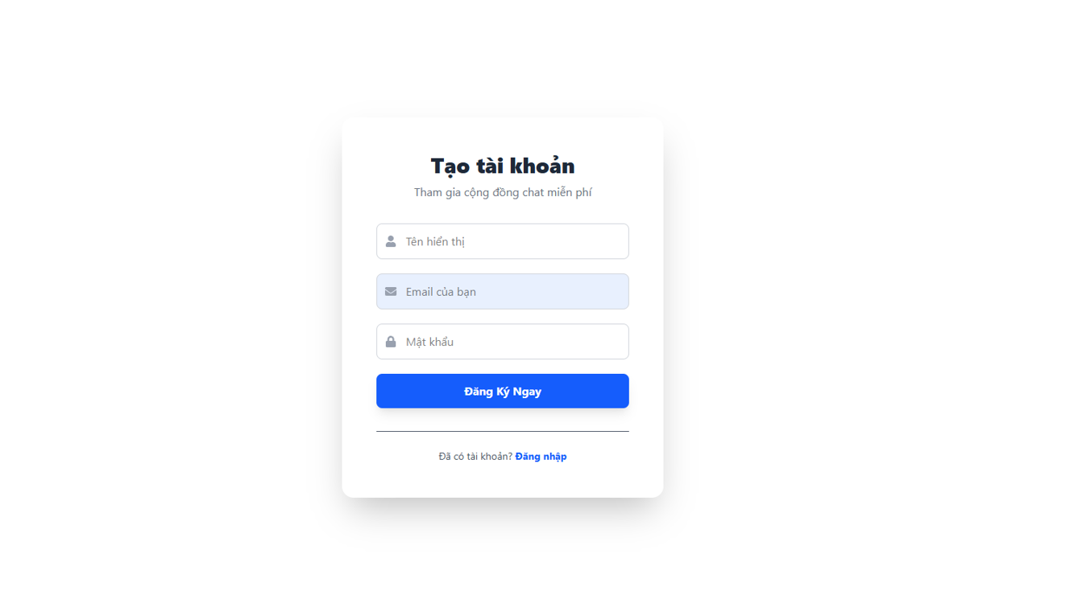
Figure 10 UI Register Account
- Chat Interface
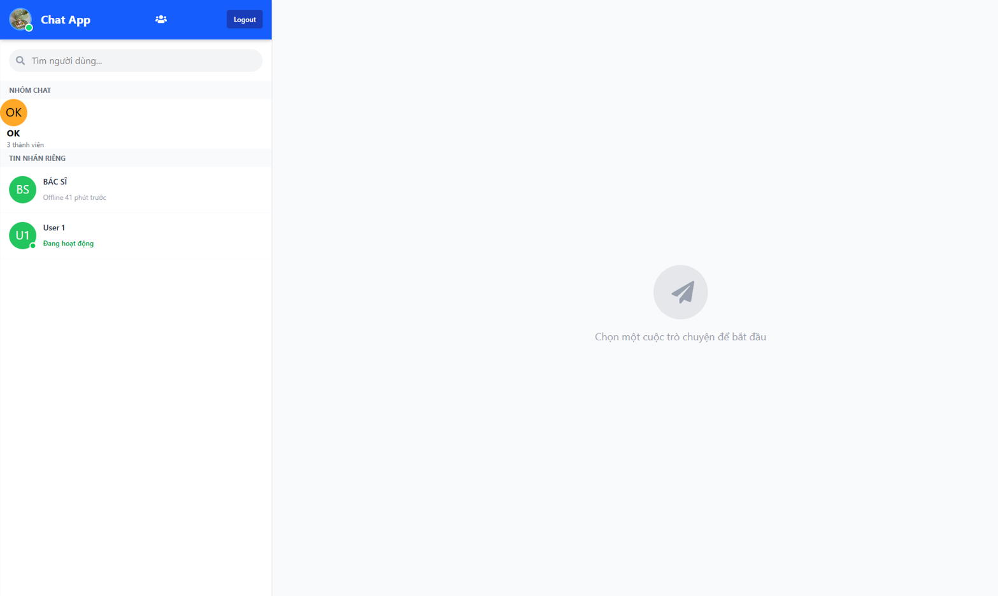
Figure 11 UI Chat when there is no conversation
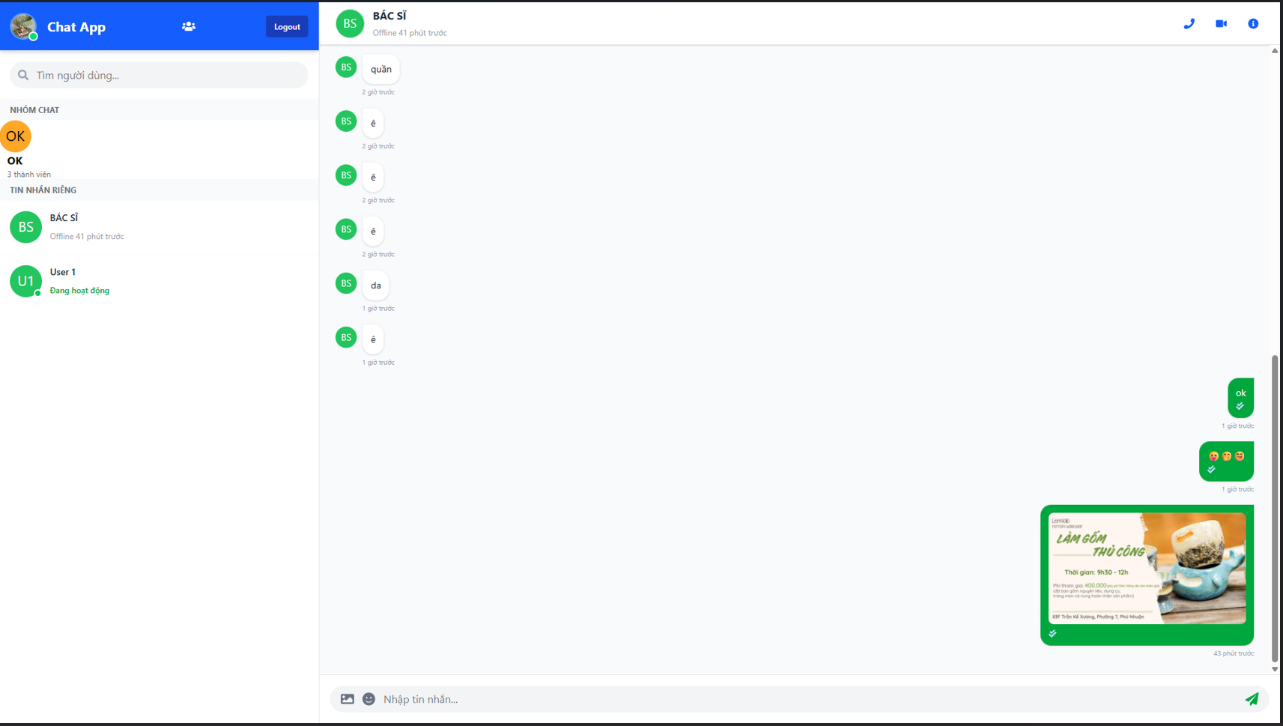
Figure 12 UI Chat with Text Message, Picture and Emoji
- Forgot and Reset Password Interface
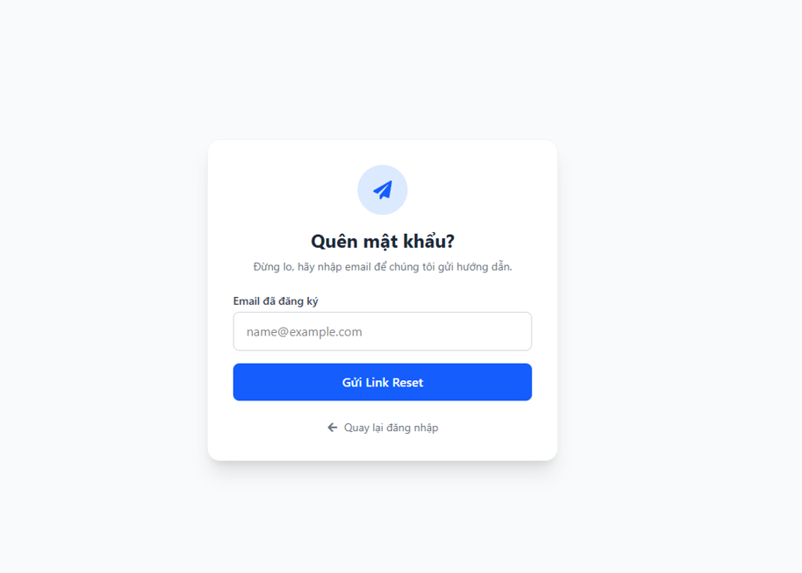
Figure 13 UI Forgot Password
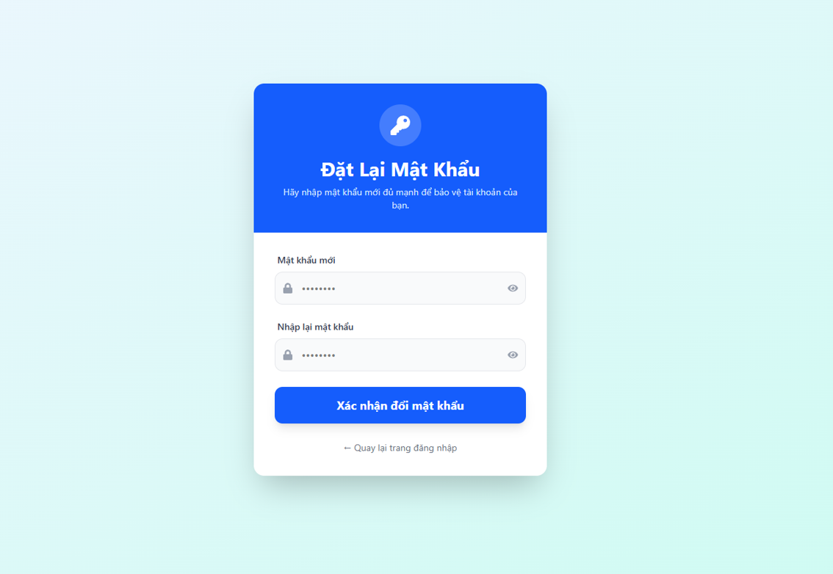
Figure 14 UI Reset Password
- Create Group Chat Interface
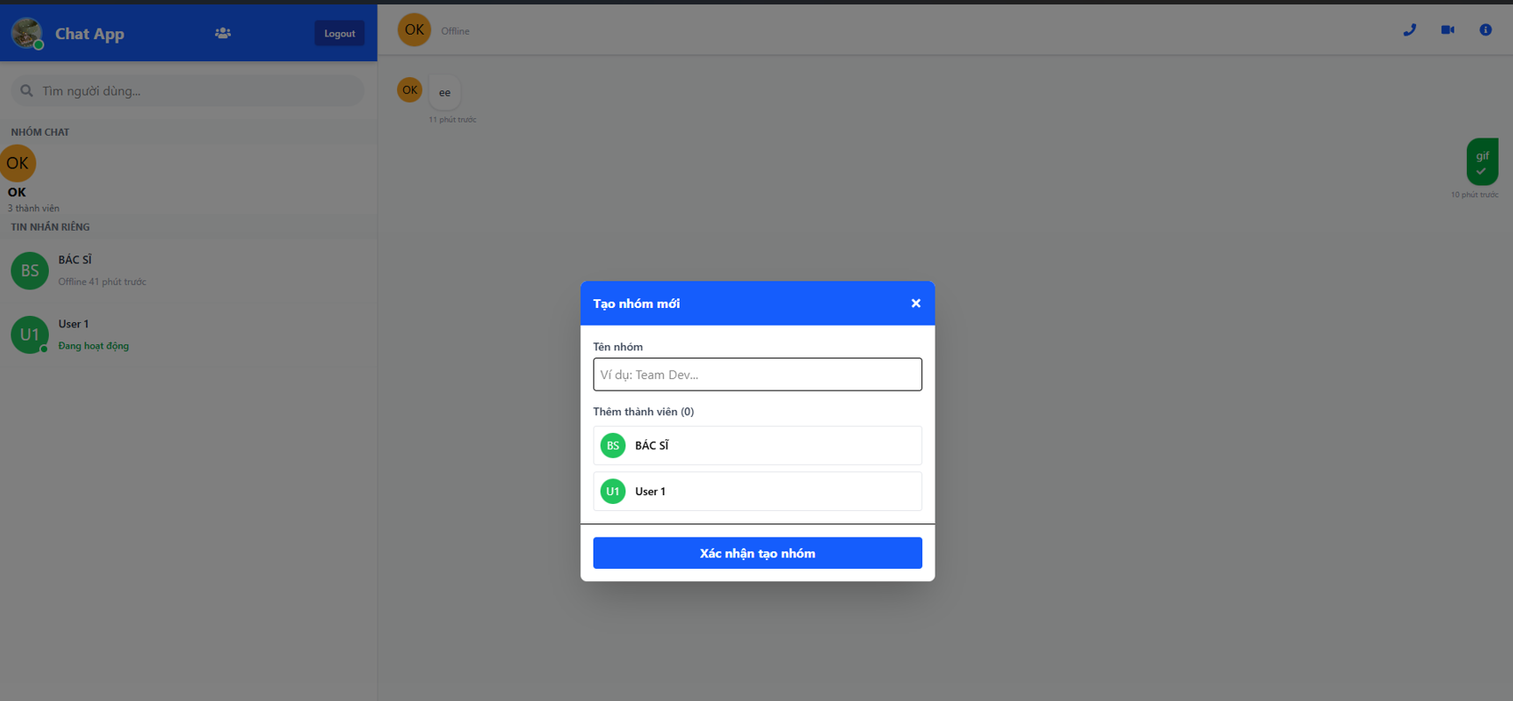
Figure 15 UI Create Group Chat

- Manage Profile Interface
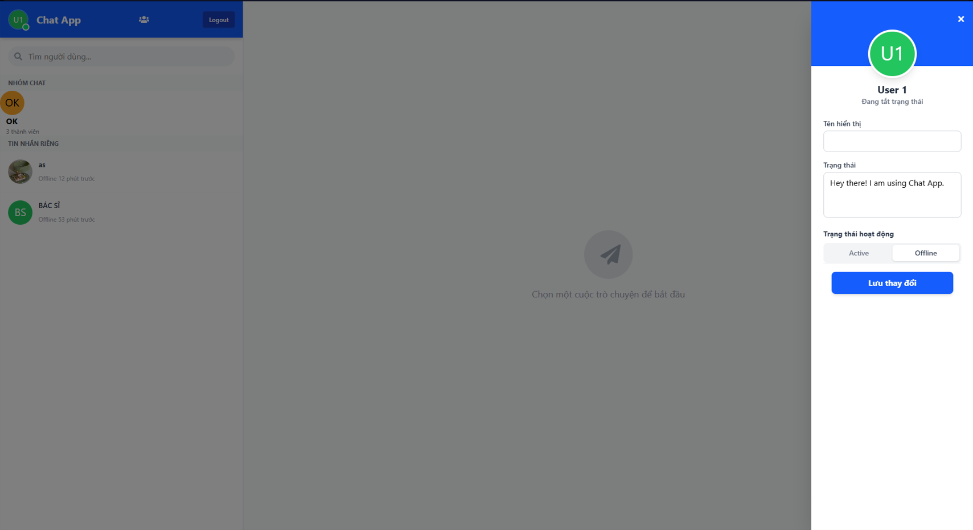
Figure 16 UI Profile Management Interface

API Design
This section presents the RESTful APIs of the KittaChat system, supporting user management, authentication, messaging, and group communication via standard HTTP methods.
Function | Method | URL | Description
Get User Profile | GET | http://localhost:3000/api/users/profile | Retrieve information of the currently logged-in user.
Update User Profile | PUT | http://localhost:3000/api/users/profile | Update user profile information such as avatar and display name.
Get All Users | GET | http://localhost:3000/api/users | Retrieve the list of all registered users.
Registering New User | POST | http://localhost:3000/api/auth/register | Create a new user account using email and password.
User Login | POST | http://localhost:3000/api/auth/login | Authenticate user credentials and create a login session.
Forgot Password | POST | http://localhost:3000/api/auth/forgot-password | Send a password reset request to the user.
Reset Password | POST | http://localhost:3000/api/auth/reset-password/:token | Reset the user password using a verification token.
Create New Group | POST | http://localhost:3000/api/groups | Create a new chat group.
Get My Groups | GET | http://localhost:3000/api/groups | Retrieve all chat groups that the user belongs to.
Create/Send Message | POST | http://localhost:3000/api/messages | Send a text message to a user or a group.
Get Chat History (Between 2 users or Group) | GET | http://localhost:3000/api/messages/:userId1/:userId2 | Retrieve chat history between two users or within a group.
Upload Image/File | POST | http://localhost:3000/api/messages/upload | Upload and send images or files in the chat.
Table 7 API design

SYSTEM DEPLOYMENT

Development Environment and Tools
The KittaChat system was developed using common and reliable tools suitable for building real-time web applications with WebSocket technology.
The development environment for the system is as follows:
    - IDE: Used as the main development environment for both frontend and backend development due to its flexibility and strong extension support.
    - Nodejs: Used as the backend runtime environment to handle server-side logic and real-time communication.
    - Git and GitHub: Applied for source code version control and team collaboration during the development process.
    - Node Package Manager: Used to manage project dependencies and required libraries.
    - MongoDB: Used as the database system to store user account information and chat message history. MongoDB was chosen for its flexibility and suitability for real-time applications.
    - Google Chrome: Used for testing user interfaces and verifying real-time WebSocket communication.

Source Code Structure
The source code structure is organized in a logical manner to facilitate expansion and maintenance:
- Client (client/): The frontend is developed using ReactJS and is responsible for rendering the user interface and handling user interactions.
  - components/: Contains reusable UI components such as chat boxes, message items, and user lists.
  - pages/: Includes main application pages such as login, registration, chat interface, and account management.
  - services/: Handles communication with the backend via REST APIs and WebSocket.
  - utils/: Stores shared utility functions.
  - Core files like App.jsx and main.jsx manage application initialization and routing.
This modular structure helps keep the frontend code organized and easy to maintain.
- Server (server/): The backend is built with Node.js and Express and follows the MVC (Model – View – Controller) architecture.
  - controllers/: Implements business logic for authentication, user management, messaging, and group chat.
  - models/: Defines data schemas (User, Message, Group) and manages database operations using MongoDB and Mongoose.
  - routes/: Defines RESTful API endpoints and maps requests to corresponding controllers.
  - middlewares/: Contains middleware functions such as authentication and file upload handling.
  - uploads/: Stores uploaded images and files exchanged during chat sessions.
This source code organization ensures clear separation of concerns, improves code readability, and supports the development of a real-time chat system using WebSocket.
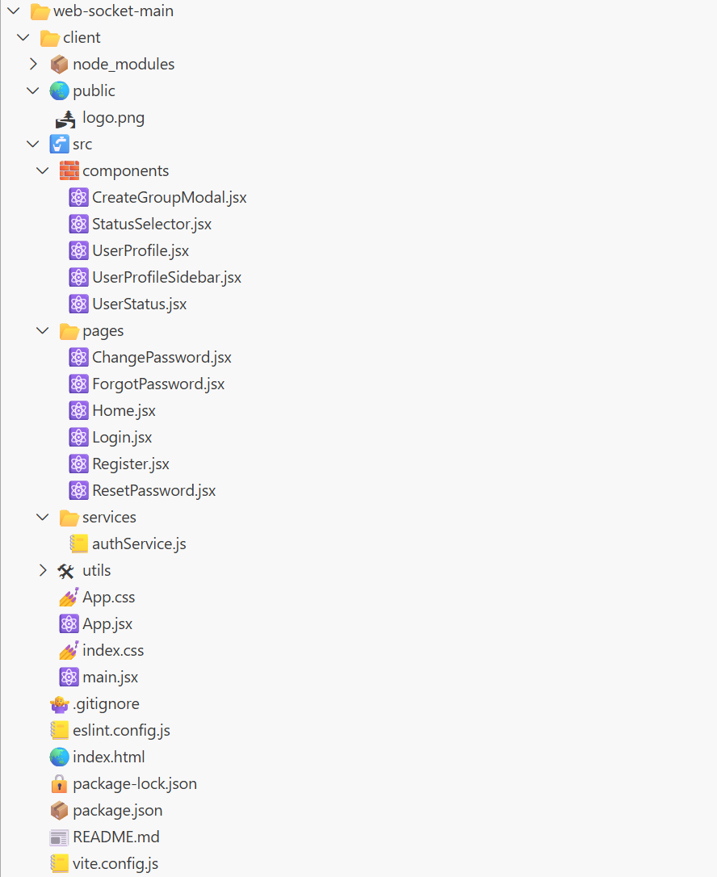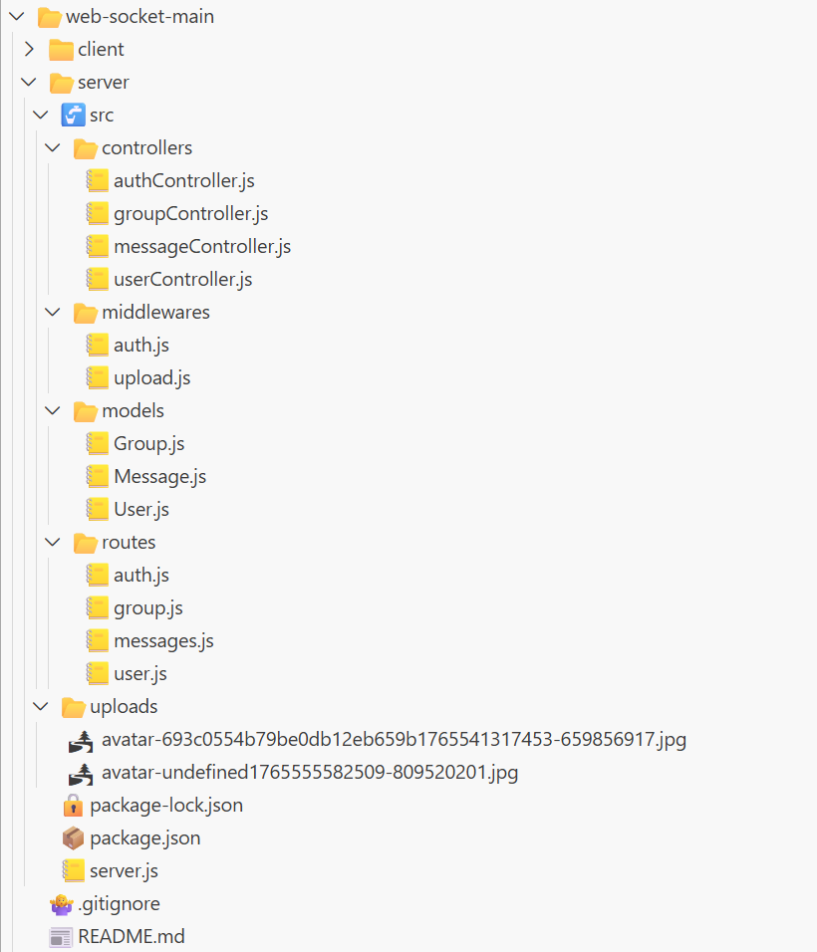
Figure 17 Source Code Structure

Database Deployment
MongoDB is used as the primary database for the KittaChat system. During the development phase, the database is deployed using MongoDB Atlas, a cloud-based NoSQL database service, which provides high availability and easy scalability.
The database stores essential data including user accounts, authentication information, chat messages, and group chat data. Mongoose is used as an Object Data Modeling library to define schemas, validate data, and manage interactions between the application and MongoDB.
The backend server connects to MongoDB through a secure connection string stored in environment variables to ensure data security. This deployment approach allows the system to manage real-time data efficiently while remaining flexible for future scaling and production deployment.

DEVELOPMENT AND EVALUATION

Testing Strategy
To ensure that the KittaChat system operates correctly and meets the defined requirements, multiple testing strategies were applied throughout the development process. The testing approach includes unit testing, integration testing, and system testing to validate both individual components and the overall system behavior.
- Unit Testing: focused on core functionalities such as user authentication, profile management, real-time messaging (text, emoji, image), group creation, and group chat communication. Each function was tested independently to ensure correct behavior and data consistency.
- Integration Testing: verified the interaction between the frontend, backend, WebSocket services, and MongoDB database. The system successfully handled authentication, real-time messaging, and data synchronization across components.
- System Testing: Evaluates the complete system to confirm that all functional requirements are satisfied in real-world usage scenarios.

Test Account
Email | Password
test1@gmail.com | 123456
test2@gmail.com | 123456
gohuynh1123@gmail.com | 123456
Table 8 Test Account

Test Case and Testing Result
TestID | Function | Input | Expect Output | Result
TC01 | User Registration | Email, password | Account created successfully | Pass
TC02 | User Registration | Email, password less than 6 characters | Error message | Pass
TC03 | User Login | Correct email & password | User logged in and redirected to chat | Pass
TC04 | User Login | Incorrect email or password | Error message | Pass
TC05 | Reset Password | Valid reset token | Password updated successfully | Pass
TC06 | Update Profile | New avatar or display name | Profile updated correctly | Pass
TC07 | Send Text Message | Text message | Message delivered in real time | Pass
TC08 | Send Image | Image file | Image displayed in chat instantly | Pass
TC09 | Send emoji | Emoji icon | Emoji sent and displayed correctly | Pass
TC10 | Create Group Chat | Group name, members | Group created successfully | Pass
TC11 | Group Messaging | Message in group chat | Message delivered to all members | Pass
Table 9 Test case and Testing Result

CONCLUSION

Achieved Results
The KittaChat project successfully achieved its primary objectives of designing and implementing a real-time web-based chat application using WebSocket technology. The system supports user registration, login, password reset, and profile management, allowing users to manage their personal information effectively.
In addition, the application provides real-time one-on-one and group messaging features, including text messages, emojis, and image sharing. User presence information such as online status and typing indicators is synchronized instantly through WebSocket communication.
Chat history is stored and retrieved using MongoDB, ensuring data persistence and consistency.
Moreover, the adoption of the Agile development model and clear task distribution among team members contributed significantly to the project’s timely completion and maintainable code structure, paving the way for future feature expansion.
Overall, the project demonstrates the effectiveness of WebSocket in enabling low-latency, bidirectional communication and meets the functional requirements defined at the beginning of the study.

Advantages and Disadvantages

Advantages
- User-friendly Interface
The system is designed with a simple, intuitive, and responsive user interface using ReactJS.
Users can easily perform actions such as logging in, managing profiles, and chatting in real time without requiring technical knowledge. Clear layouts and smooth interactions enhance overall usability.
- Real-time Communication with WebSocket
The application utilizes WebSocket technology to enable full-duplex, real-time communication between clients and the server.
Messages, typing indicators, read receipts, and online status updates are delivered instantly, providing a smooth and responsive chat experience.
- Efficient Data Transmission
By maintaining persistent WebSocket connections, the system reduces unnecessary HTTP requests and minimizes network overhead.
This results in lower latency, faster message delivery, and improved performance compared to traditional request–response communication models.
- Secure Authentication and Session Management
User accounts are protected through password hashing and session-based authentication.
The system ensures secure access control and maintains consistent login states during real-time interactions.
- Persistent Data Storage
MongoDB is used to store user information, chat history, and group data.
This ensures data persistence, reliable retrieval, and supports future feature expansion.
- Modular and Scalable Architecture
The system follows a modular MVC-based architecture, separating frontend, backend logic, and database layers.
This design simplifies maintenance, supports scalability, and allows future enhancements such as voice calls, video calls, and advanced file sharing without major structural changes.

Disadvantages
- Limited Platform Support
The current system is implemented as a web-based application and is only accessible through web browsers.
It does not yet provide native mobile applications for Android or iOS, which may limit user convenience on mobile devices.
- No Support for Voice and Video Communication
The system currently focuses on text-based real-time messaging and image sharing.
Advanced communication features such as voice calls and video calls have not been implemented.
- Limited File Sharing Capabilities
Although image sharing is supported, the system does not yet allow sending multiple file types such as videos, audio files, or large documents
- Scalability Constraints
Maintaining a large number of persistent WebSocket connections may place increased load on the server.
Additional optimization and distributed architecture are required to support large-scale deployments.

Future Development Directions
In the future, the KittaChat system can be further enhanced and expanded to improve functionality, usability, and scalability.
First, native mobile applications for Android and iOS can be developed to provide better user experience on mobile devices and increase system accessibility. This will allow users to communicate more conveniently anytime and anywhere.
Second, advanced communication features such as voice calls and video calls can be integrated to support richer real-time interaction. This enhancement would make the system more comparable to modern messaging platforms.
Third, the file-sharing module can be extended to support multiple file types, including videos, audio files, and large documents, improving flexibility in communication.
Additionally, system performance and scalability can be improved by applying load balancing, message queues, and distributed server architectures to handle a large number of concurrent WebSocket connections.
Finally, further security enhancements such as end-to-end encryption, multi-factor authentication, and improved access control mechanisms can be implemented to ensure safer real-time communication.

REFERENCES

[1] WebSocket and Its Difference from HTTP
[2] What is WebSocket - How it Works - An Introduction
[3] Socket.IO

