**Subject: PRF192- PFC**

**Workshop 04**

**Part 1: Use notebook**

**Exercise 1** (1 mark) : Explain outputs:

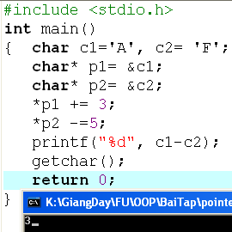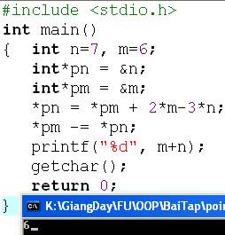

We have *pn = 7; *pm = 6 We have *p1 = A; *p2= F.

*pn = 6 + 2*6 - 3*7 = -3 (= new n) *p1 = *p1 + 3 = 65 + 3 = 68 (=new c1)

*pm = *pm - *pn = 6 – (-3) = 9 (= new m) *p2 = *p2 – 5 = 70 – 5 = 65 (=new c2)

new m + new n = 9 + (-3) = 6 new c1 - new c2 = 68 – 65 = 3

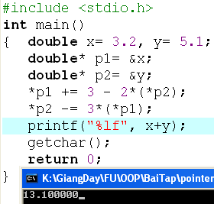

We have *p1 = 3.2; *p2 = 5.1

*p1 = *p1 + 3 – 2*(*p2) = 3.2 + 3 – 2*(5.1) = -4 (= new x)

*p2 = *p2 – 3*(*p1) = 5.1 – 3*(-4) = 17.1 (=new y)

x + y = 17.1 + (-4) = 13.1

**Exercise 2** (1 mark) : What are outputs:

int n=7,m=8;

int* p1= &n, *p2=&m;

*p1 +=12-m+ (*p2);

*p2 = m + n- 2*(*p1);

printf(“%d”, m+n);

What is the output?

Output is 8

int n=7,m=8;

int* p1= &n, *p2=&m;

*p1 +=12-m+ (*p2);

*p2 = m + n- 2*(*p1);

printf(“%d”, m+n);

What is the output?

Output is 8

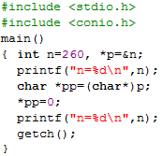

Output:

n = 260

n = 256

**Exercise 3** (2 mark) : Walkthroughs

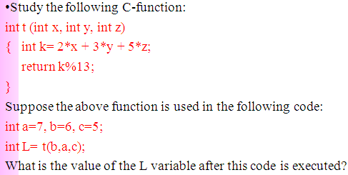

(2*7 + 3*6 + 5*5) = 57. Then 57/13 = 4 with 5 remainder.

**So L = 5**

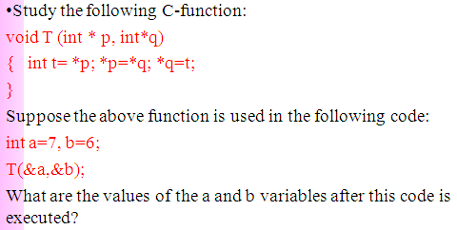

t = *p (=6)

*p = *q (=7) . **So a = 7**

*q = t (=6). **So b = 6**

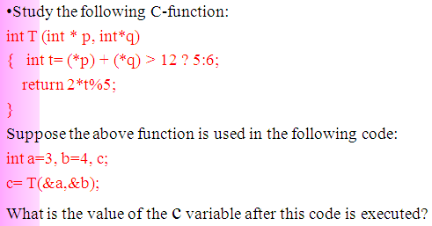

We have (*p) + (*q) = 3 + 4 = 7 < 12. So int t = 6.

return 2*6%5 = 2 to T. So c = 2.

**Part 2: Develop a program using simple menu**

**Program 1(3 marks):**

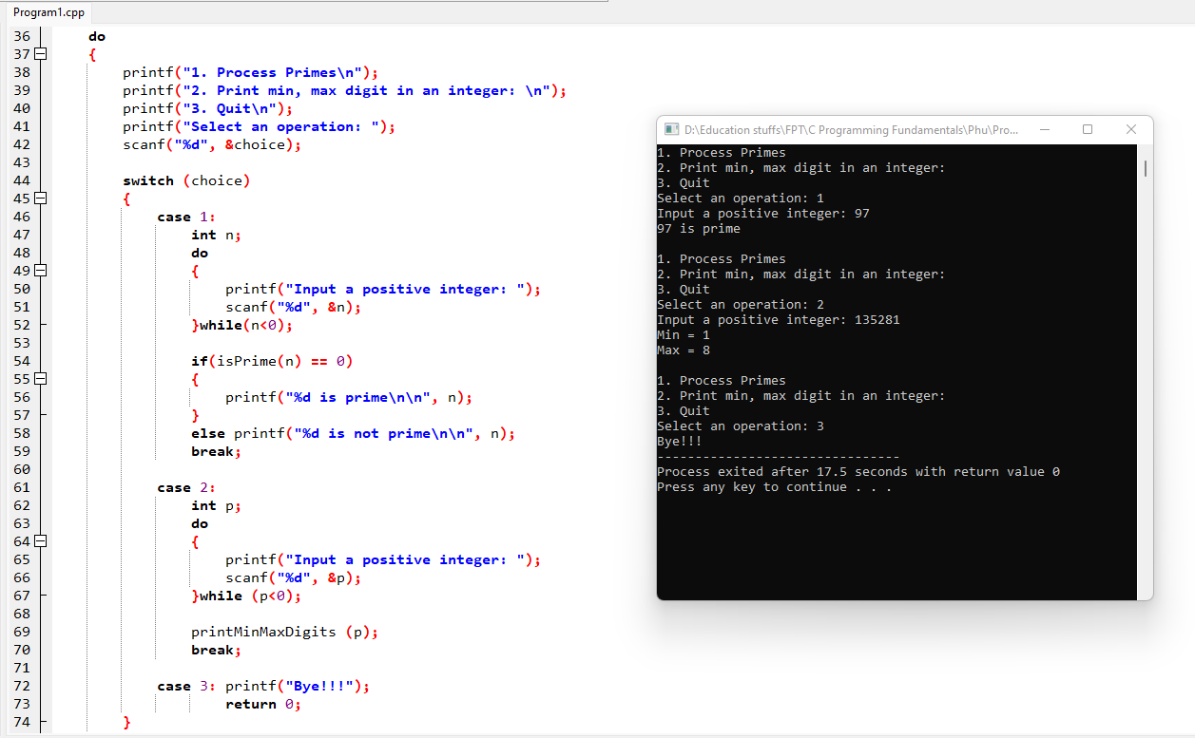

**Program 2(3 marks):**

