**MINISTRY OF EDUCATION AND TRAINING**

**HO CHI MINH UNIVERSITY OF TECHNOLOGY AND EDUCATION**

**FACULTY FOR HIGH QUALITY TRAINING**

**--------------------**



**IT-PROJECT**

**SELLING SHOES WEBSITE**

**Instructor: Mai Anh Thơ**

**Student: Nguyễn Nhiêu Thịnh 19110003**

**Trần Thị Thanh Thanh 19110123**

**Ho Chi Minh City, December 2022**

**Acknowledgment**

We express our sincere thanks to **Mrs.Mai Anh Tho**, Who guided and helped us through this semester for the project. She gave us suggestions and guidance to solve and complete the project, she helped us to understand about this subject and know how to write report. Thanks to her, our project has been succeed because of her dedicated guidance.

Project has been made during 15 weeks, just enough to satisfy the request of this subject and complete it, there are many errors in our project and it might be extremely not good, which is inevitable. So, we are looking forward to receiving all the comments of teacher so that help our knowledge better and try to do better for the following subject.

Sincerely thanks.

**Preface**

After completing this course, we have learned many things from making real website such as e-commerce website. Now, we can tackle and handle a project and how we work together in one group. If we practice much and having some expertise in the field, then we will be able to survive smartly in today’s competitive environment.

The effort to write the report is a partial fulfilment to complete the course. In this report, we tried our best to represent all the content that we have learned during time making the program. I divided each of the topics as an individual chapter to reflect the entire topic more prominently and clearly. In reference, I have used the citation method in the entire report. Finally, I am very hopeful that the structure and topic of the report will be a useful material for all the reader, especially to the user

**I. Project description**

1. **Objectives**

The selling shoes website like a e-commerce website that allow users to access and buy shoes. This website we integrate payment methods such as Paypal for users by online payment. The manager can update and manage the product which they provided for user in the website.

1. **User benefits**

- User can pay for their product by online payment.

- The UI is easy for the user can use.

- Users can read description of shoes to decide whether the shoes they love most.

- There is cart that user can store product inside it if they want to buy another pair of shoe or not to buy now.

**II. Task Assignment**

|  |  |  |
| --- | --- | --- |
| Student’s name | Evaluate contribution | Taskwork |
| Nguyễn Nhiêu Thịnh | 100% | - Create and connect to database classes  - Manage cart  - Product Detail  -Back-End  -Amin Dashboard |
| Trần Thị Thanh Thanh | 100% | - Login, register page  - Homepage(index page)  -Front-End |

**III. Design**

**1.Database**We used MongoDB for database: 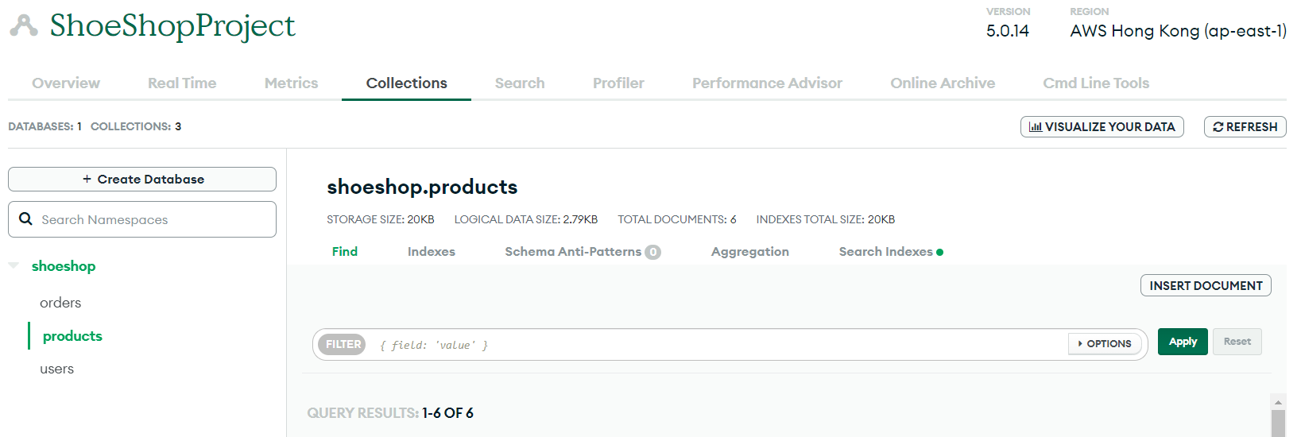

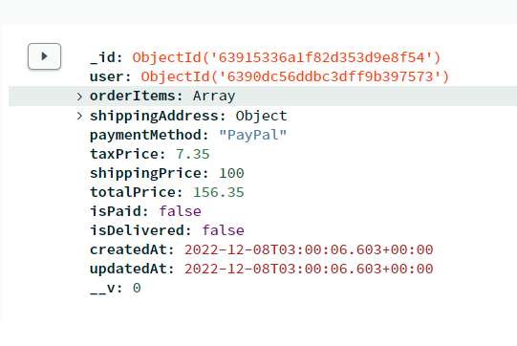 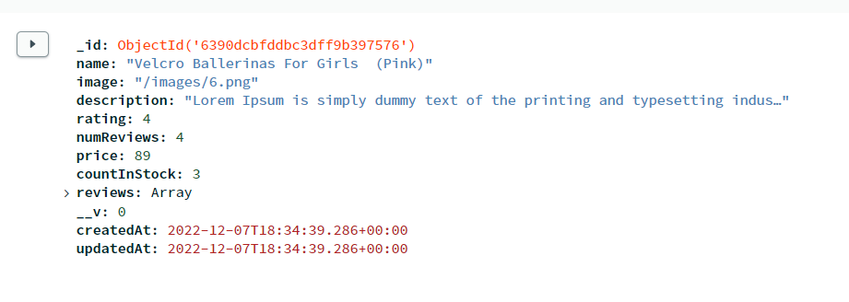

**2.Database connections**

We are using link that MongoDB provided for connection database

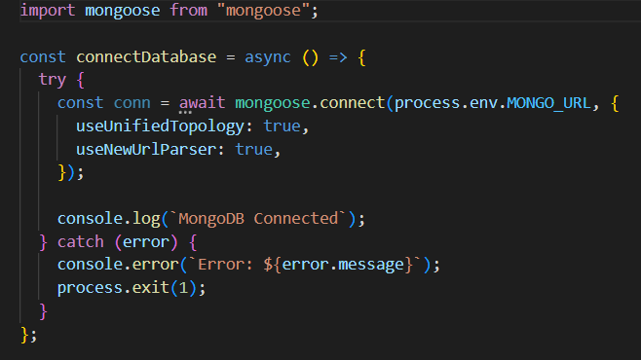



**3.Model**

The project is include three part: Client, Server and admin’s Dashboard

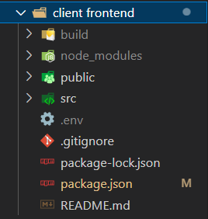

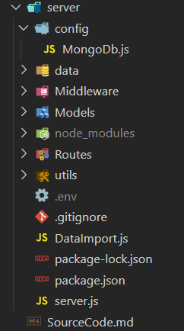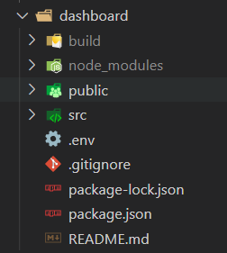

**4.Function of website**

**4.1 Login-register:**

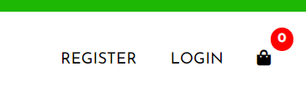

When click on button “Login” or “Register”, Login and Register will pop up for user to login or register

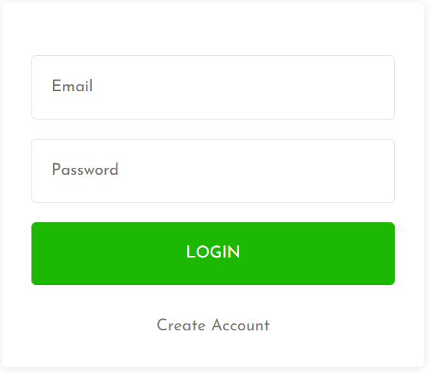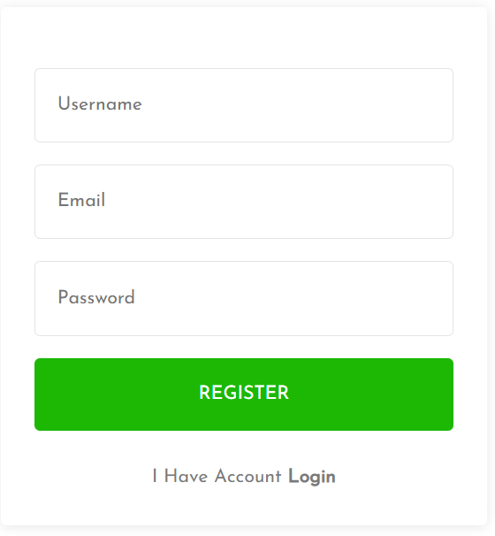

This function will find in database the name user and check the password. If this information user types in this form is right that mean same with username and password in database, the controller call to the page logged in, If they are incorrect, the system would display an error:

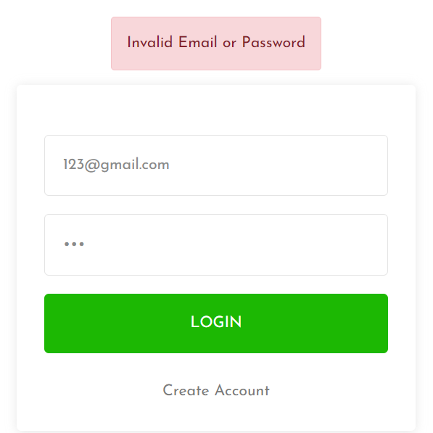

Server login’s code:

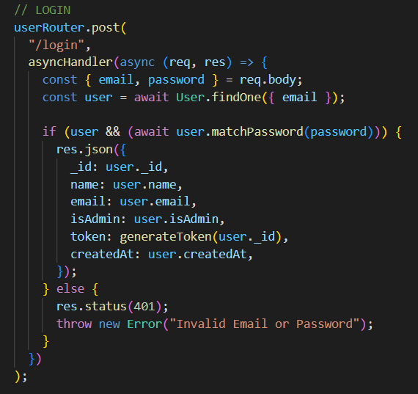

Server register’s code:

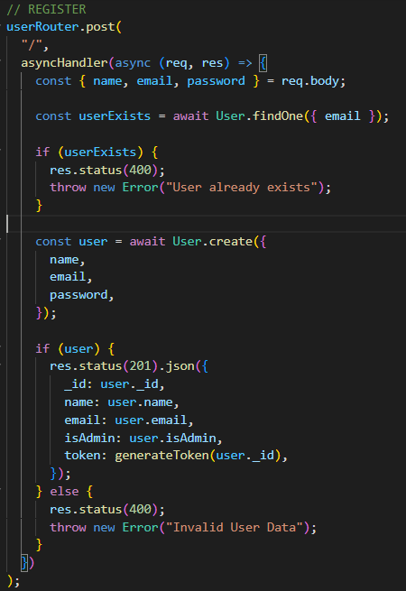

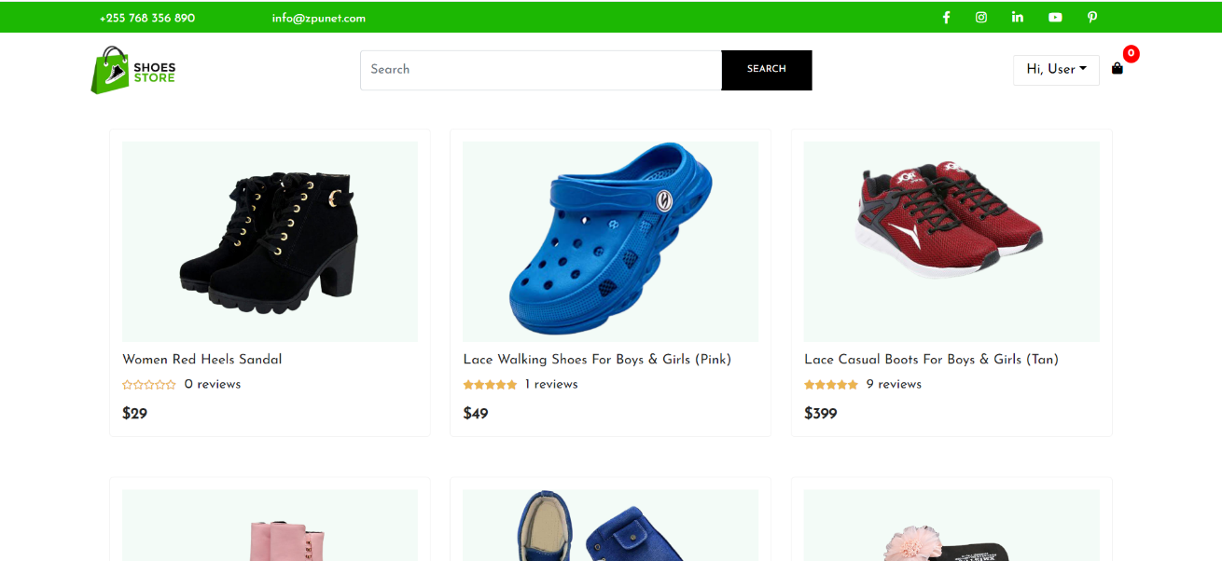This is homepage after log in:

**4.2 Header**

Header is used to connect with another pages by clicking on button on this.

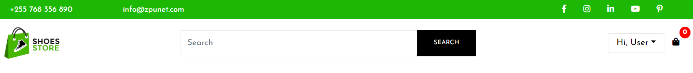

*(Header bar)*

In this bar, we can return Home page by the logo in the left.

In the middle is Search function, which is used to search for product

Next, we can view user profile or log out

Cart is for having what you like and add into

**4.3 Home page**

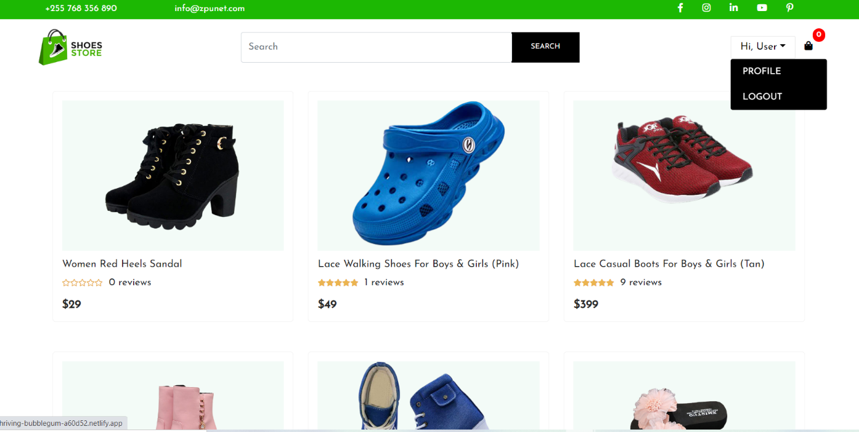

This is homepage after logging in, which content all product in shop

The code for this:

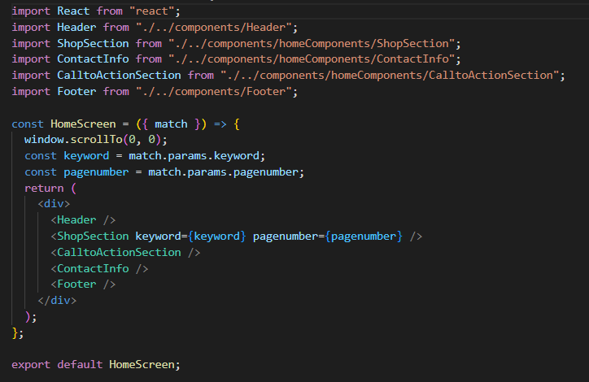

When we click on image, we would be moved to the link of the product we choose for detail and add it into cart.

It is easily for users when they want to buy the product and they want to read description first.

**4.4 List Product (Category)**

A part of code for list of products:

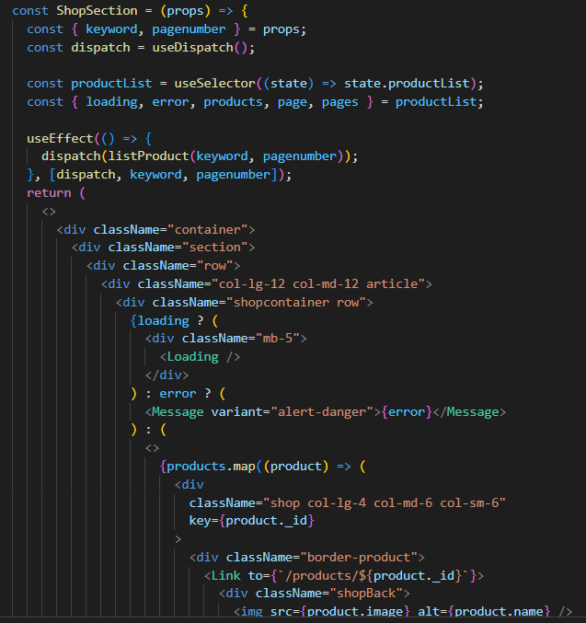

A part of code for single product page:

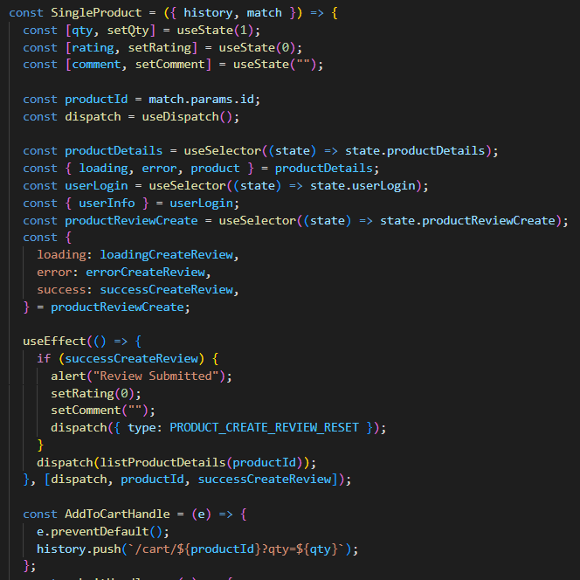

**4.5 View item page**

When click into view item it would take Id product then web will display the detail of item. Where show the detail of the item. In the below of shoes description there is function: Add to cart.

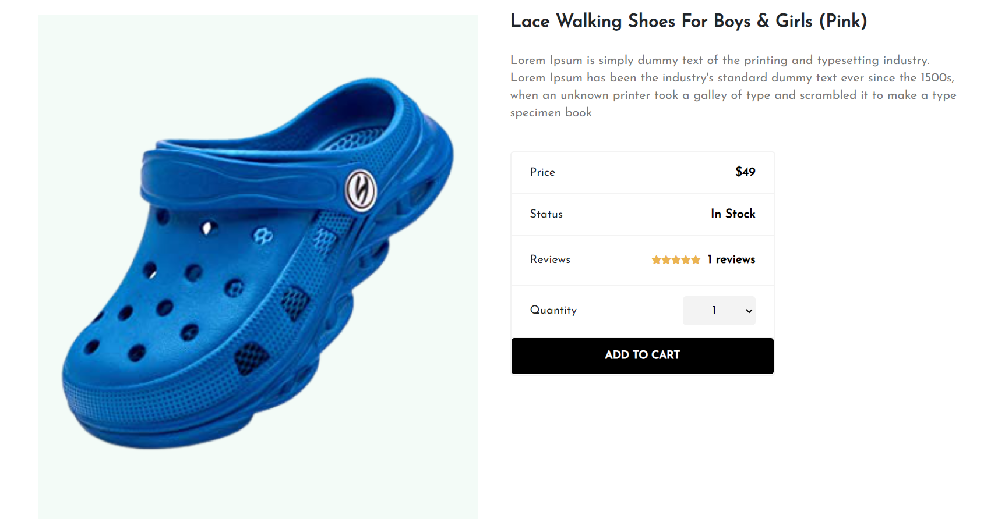

We can add some review to the product:

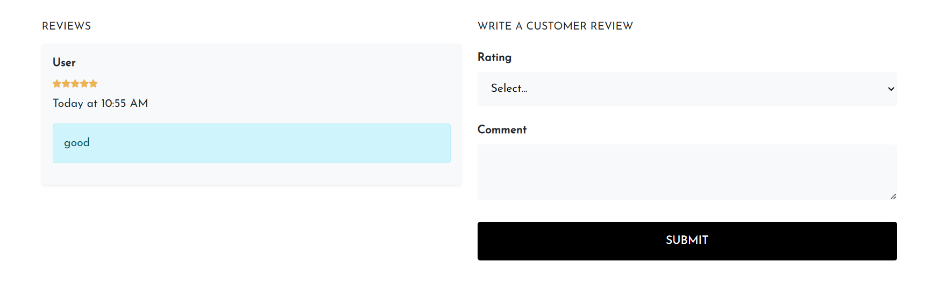

**4.6 Shopping Cart**

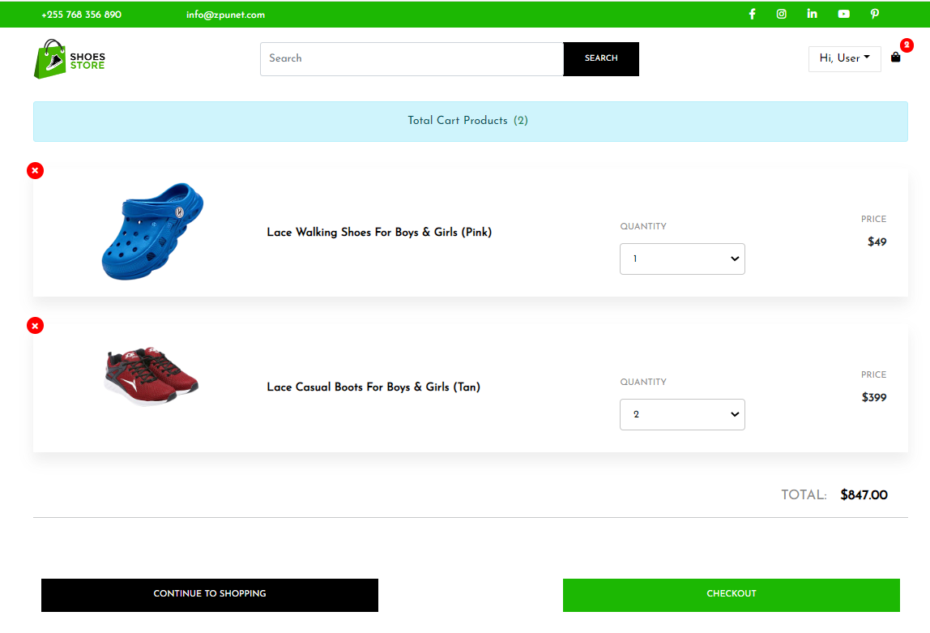

If we want to add to cart, we need to login. We have button “Remove” to delete this product if we don’t buy it anymore. Next to the product detail is a table that contain many options such as resume ordering - back to main page to buy another product, change the quantity of products, check out by car,…

**4.7 Check out:**

When click on check out, a form will appear asking you to fill the adress for delivery:

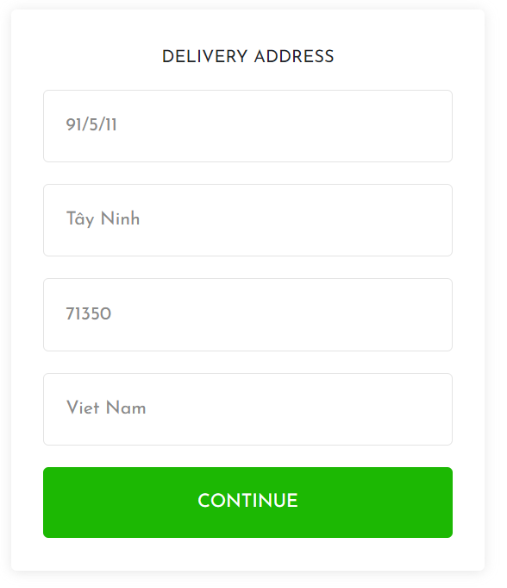

When click on CONTINUE, a form will appear asking you to check 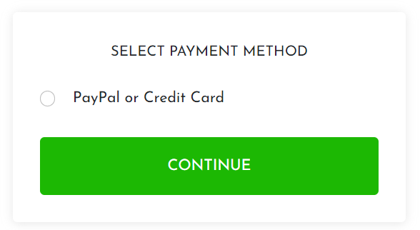

We check again information for delivery:

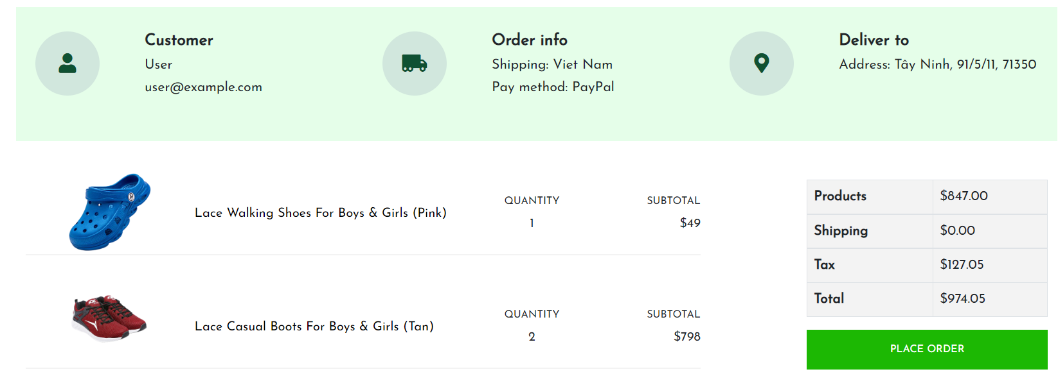

And finally we fill the card information:

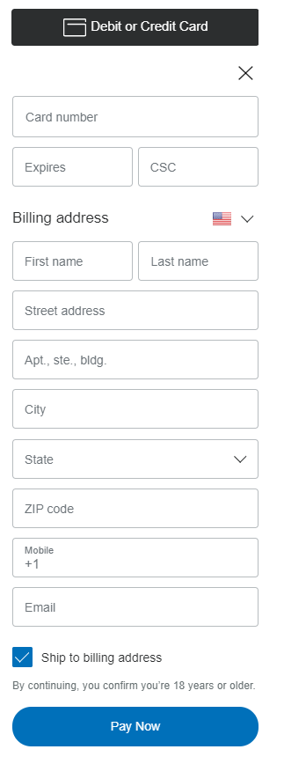

**4.8 Users information**

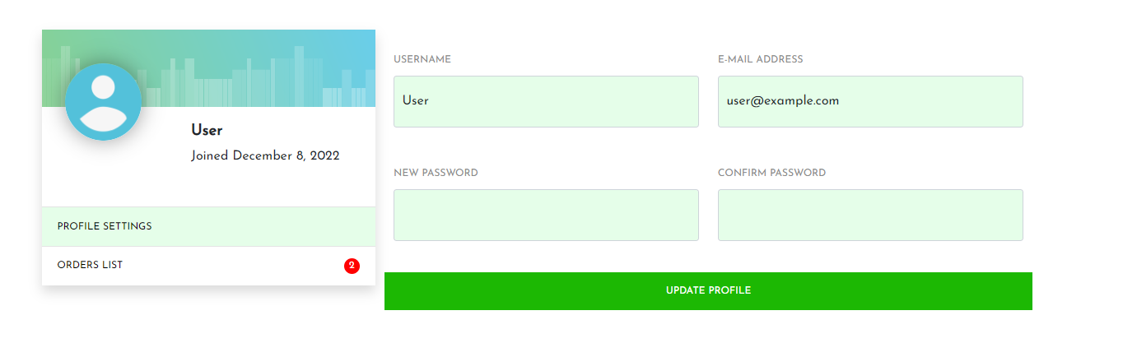

It is for user to change their username or password or check for their orders

**IV. Conclusion**

**1. Student evaluation**

- Almost requirements are met

- Know how to write report

- Simple design UI for easy using

- The code is quite clean and easy to understand

**2.Advantages**

- Quite clean code

- UI Simple to used, has the responsive web for many devices to access.

- Easy to find the description of product and has function “add to cart” for customer easily to buy.

1. **Disadvantages**

- Load the page is so long

- UI need to improve to more attractive

- There is a few function.

1. **Development ideas**

- After finishing this project, we see this website is not really good and has the limitation. So, we search on the internet some common e-commerce website and refer, try to do better. In future, we will try to complete this website is better, has more functions and integrate more payment methods for better user experience.

**References:**