MIRAISTACK
Partnership proposal

A new website and Design Studio for Eminence Printing
Built at no cost to Eminence, as MiraiStack's launch partner
Prepared for Eminence Printing, Empangeni, KwaZulu-Natal
Prepared by Nhlanhla Ngcobo, Director of Innovation, MiraiStack
Date 5 November 2026
Reference MS-EP-01
We have rebuilt the Eminence website and built an online Design Studio where your customers put their logo on your products, see a realistic preview, get your price and send you a print-ready job. We would like Eminence to be the first print shop to use it, as MiraiStack's launch partner.
IN SHORT

What we are offering, and why
You get | A working website, the Design Studio and a price settings page, set up and launched, with hosting and support for the first 12 months. No invoice.
We ask | Your real prices and photos, honest feedback for three months, and permission to show Eminence as our first customer.
Why free | MiraiStack will offer the Studio to other print shops under their own names. Eminence is where we prove it works.
WHAT WE FOUND

Your current website is losing you work
We tested the live site at eminenceprinting.co.za on 20 October 2026. The biggest problems:
Area | What happens
Contact form | It shows “Message Sent!” and then throws the message away. No enquiry typed into the website has ever reached you.
Email address | hello@eminenceprinting.co.za cannot receive mail. The domain has no mailbox set up, so those emails bounce.
Portfolio | The six “completed projects” are AI-generated pictures with nonsense words on them, such as “LATG WAiR” on the van. Customers who look closely notice.
WhatsApp | The WhatsApp button in the footer goes to a placeholder number, not yours.
Google | The hidden business details tell Google you are at “123 Print Avenue, Johannesburg”, in the wrong province.
Sharing | The preview image for shared links is missing, so every link shared on WhatsApp or Facebook shows no picture.
WHAT WE BUILT

A website that tells the truth, and a studio that sells

The website
- A new home page and six service pages (clothing, vehicle branding, signage, banners and gazebos, cards and flyers, mugs and laser cutting), written for people searching in Empangeni and Richards Bay.
- Only real facts and real job photos from your Facebook page: Khula Med, Stop & Buy, Ant Ranch and Pbtoz.
- A contact form that delivers to your inbox, with WhatsApp as the first option and your real number everywhere.
- A look built from your own CMYK ink logo, readable on phones and quick on slow connections.

The Design Studio
- 18 products: T-shirts, oversized tees, golf shirts, hoodies, caps, totes, mugs, business cards, welcome cards, flyers, posters, pull-up and PVC banners, correx boards, teardrop flags, gazebos, vehicle branding and shopfront signs.
- Photo-realistic garment previews in 14 colours, with the print following the folds of the fabric, the way the large online printers show it.
- True size and print checks: every design shows its size in cm, the A-size it matches (A6 to A2) and its DPI. Customers are warned about blurry files, white boxes around logos, text near the cut line and colours that disappear on the fabric.
- Business and welcome cards designed start to finish from templates: the customer types their details once, adds a logo and a QR code, and gets a ready front and back.
- Your prices, not estimates: priced the way you charge (garment, print size, ink colours, quantity, square metre) and set by you on a private settings page.
- Print-ready handover: the customer's original files, a proof sheet with sizes and placements, and the order arrive by email and WhatsApp.
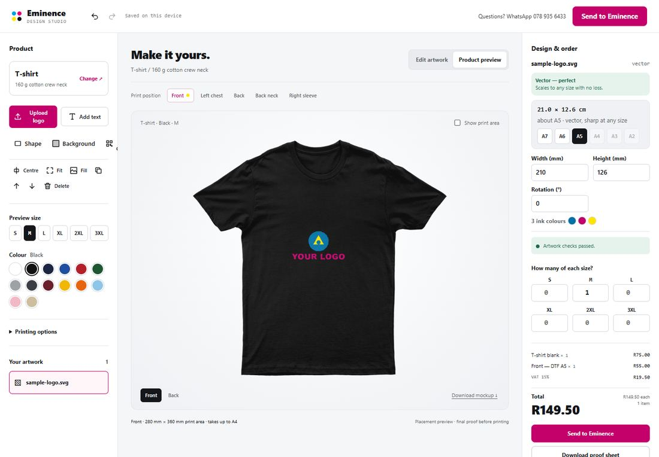
The Studio: a logo on a black T-shirt, print size and DPI on the right, your price below.
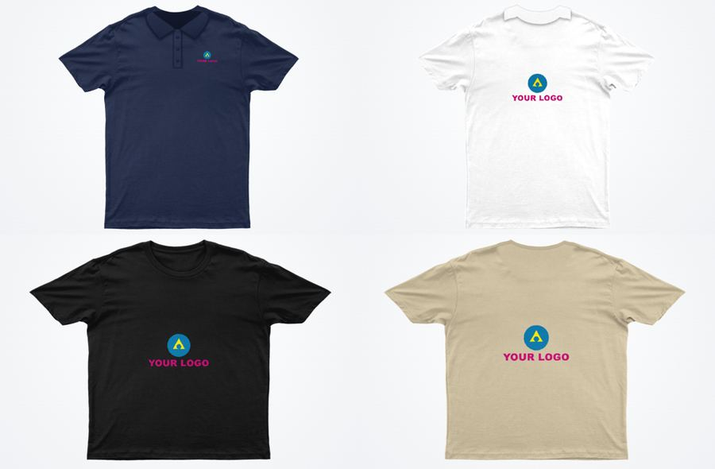
Golf shirt and oversized tee, front and back.
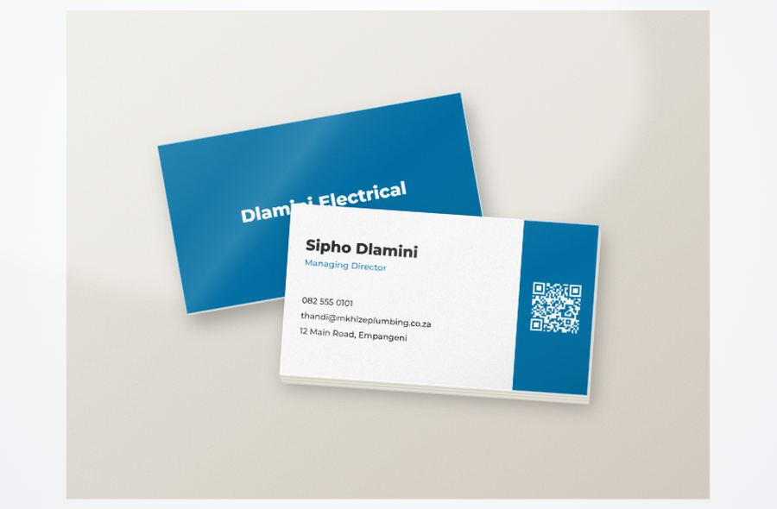
A business card made from a template, shown front and back.
THE PARTNERSHIP

What each side brings
EMINENCE RECEIVES  - The finished website and Design Studio, launched on your domain.  - Set-up of your email, so the address on your website receives mail.  - Hosting, running costs and support paid by MiraiStack for the first 12 months.  - A free, permanent licence to use the Studio for Eminence, including every improvement we make to it.  - One hour of training for you and your staff on taking orders and changing prices.  - Local exclusivity: for 12 months from launch, MiraiStack will not offer the Studio to any other print shop in the King Cetshwayo District (Empangeni, Richards Bay, Eshowe and surrounds). | MIRAISTACK ASKS OF EMINENCE  - Your real prices, entered on the settings page (we sit with you to do it).  - Photos of your plain blank garments, taken to a short guide we provide.  - Answers to the questions under “Before we launch”.  - A 30-minute check-in once a month for the first three months, telling us what works and what does not.  - Permission to name Eminence as our first customer, show the site and Studio to other print shops, and quote you if you are happy with it.  - A small “Studio by MiraiStack” credit in the website footer.

Who owns what
- Eminence owns its name, logo, domain, website content, photos, prices, customer details and every order. None of it is shared with anyone else.
- MiraiStack owns the Design Studio software and may offer it to other print shops under their own names. Other shops never see your customers, your prices or your orders.
- If either side wants to stop, your website and domain stay yours, and we help move everything to accounts in Eminence's name.
RUNNING COSTS

What it costs to keep running
A website like this costs very little to run. MiraiStack pays these for the first 12 months. Figures are today's published prices, at about R16.50 to the US dollar (October 2026).
What | Service | Cost | Year 1
Website and Studio hosting | Vercel Pro (commercial use) | $20 a month, about R330 | MiraiStack
Storage for customers' artwork | Cloudflare R2 | Free up to 10 GB, then about R0.25 per GB a month | MiraiStack
Order and enquiry emails | Resend | Free up to 3,000 emails a month | MiraiStack
Mailbox on your domain | Zoho Mail Lite | $1 per mailbox a month, about R17 | MiraiStack
Domain name | eminenceprinting.co.za | Your existing renewal | Eminence, as now
Expected monthly total |  | About R350 – R370 | R0 to Eminence
At Eminence's size, storage and email stay inside the free allowances. From month 13 there are two options, chosen then: stay on MiraiStack's hosting for a monthly fee we agree with you, or take over the accounts in Eminence's own name at about R370 a month at today's prices.
BEFORE WE LAUNCH

What we need from you
- Your street address and trading hours. Neither is published anywhere yet.
- The year Eminence started. Your 2023 post says “15 years and counting”.
- Whether you offer DTF transfers and cut vinyl on garments. The Studio currently assumes yes.
- Your prices, entered together on the settings page.
- Your delivery area and minimum quantities.
- Permission from Khula Med, Stop & Buy, Ant Ranch and Pbtoz to show their jobs, or we remove those photos.
- Photos of plain white blanks: T-shirt, golf shirt, hoodie, cap and tote, front and back.
- Access to your domain settings at GoDaddy for the switch-over, and the names for your mailboxes (for example orders@ and info@).
TIMELINE

From yes to live in about three weeks
- Week 1 · Walkthrough. We show you the site and Studio, collect the answers above and enter your prices together.
- Week 2 · Your preview. A private link for you and your staff to place test orders on every product. We fix whatever you find.
- Week 3 · Launch. Email set up on your domain, the new site switched on at eminenceprinting.co.za, and one hour of training.
- Months 1 – 3 · Check-ins. A 30-minute call each month, looking at the orders and enquiries that came in and what to improve.
NEXT STEP

Let's walk through it together
The best way to judge this is to try it. We would like 45 minutes at your shop to show you the Studio on a laptop and a phone, and design one of your own jobs in it. If you are happy, sign below and we start week 1.

For Eminence Printing  Name  Signature  Date | For MiraiStack  Nhlanhla Ngcobo, Director of Innovation  Signature  Date
This proposal sets out the intended terms. A short written agreement with the same points will be signed before launch. Running-cost figures are published prices on 5 November 2026 and may change.

