MIRAISTACK
Setup and order guide

The Design Studio at Eminence Printing
How to switch it on, and what you receive with every order: the design mockup, the print sizes and the print-ready files
For Eminence Printing — the owner and whoever handles orders; Part 2 for whoever sets it up
From Nhlanhla Ngcobo, Director of Innovation, MiraiStack
Date November 2026
CONTENTS
- Part 1 · How it works, in one page
- Part 2 · Setting it up, once (about a day, with access to GoDaddy and the accounts)
- Part 3 · Receiving an order: WhatsApp, email, the proof sheet with the mockup, the print files
- Part 4 · Reading the sizes and producing the job
- Part 5 · Prices, everyday questions and troubleshooting

PART 1

How it works
A customer opens the Studio on Eminence's website, chooses a product, uploads a logo or types text, and sees it on a photo-realistic mockup at its real size. The Studio checks the artwork (resolution, white boxes, colours that vanish on the fabric), shows Eminence's price, and the customer presses Send to Eminence.
- The customer designs. Product, colour, sizes and quantities, artwork on each print position (front, back, chest, sleeve…), with the print size shown in cm and A-sizes.
- The customer sends. They type their name and WhatsApp number (email and company optional), choose collect / deliver / install, and press Send.
- Eminence receives, at the same moment: a WhatsApp message with the order written out, and an email with the mockup proof sheet, the print-ready PNG for every side, the customer's original files and the placement spec.
- Eminence replies on WhatsApp to confirm the price, send payment details and, where needed, a production proof to approve.
- Eminence prints from the print-ready PNGs (true size, DPI set in the file) or the originals, and the customer collects.
Nothing is charged online. The Studio takes the order; payment stays the way Eminence does it today (EFT, card machine, cash on collection).
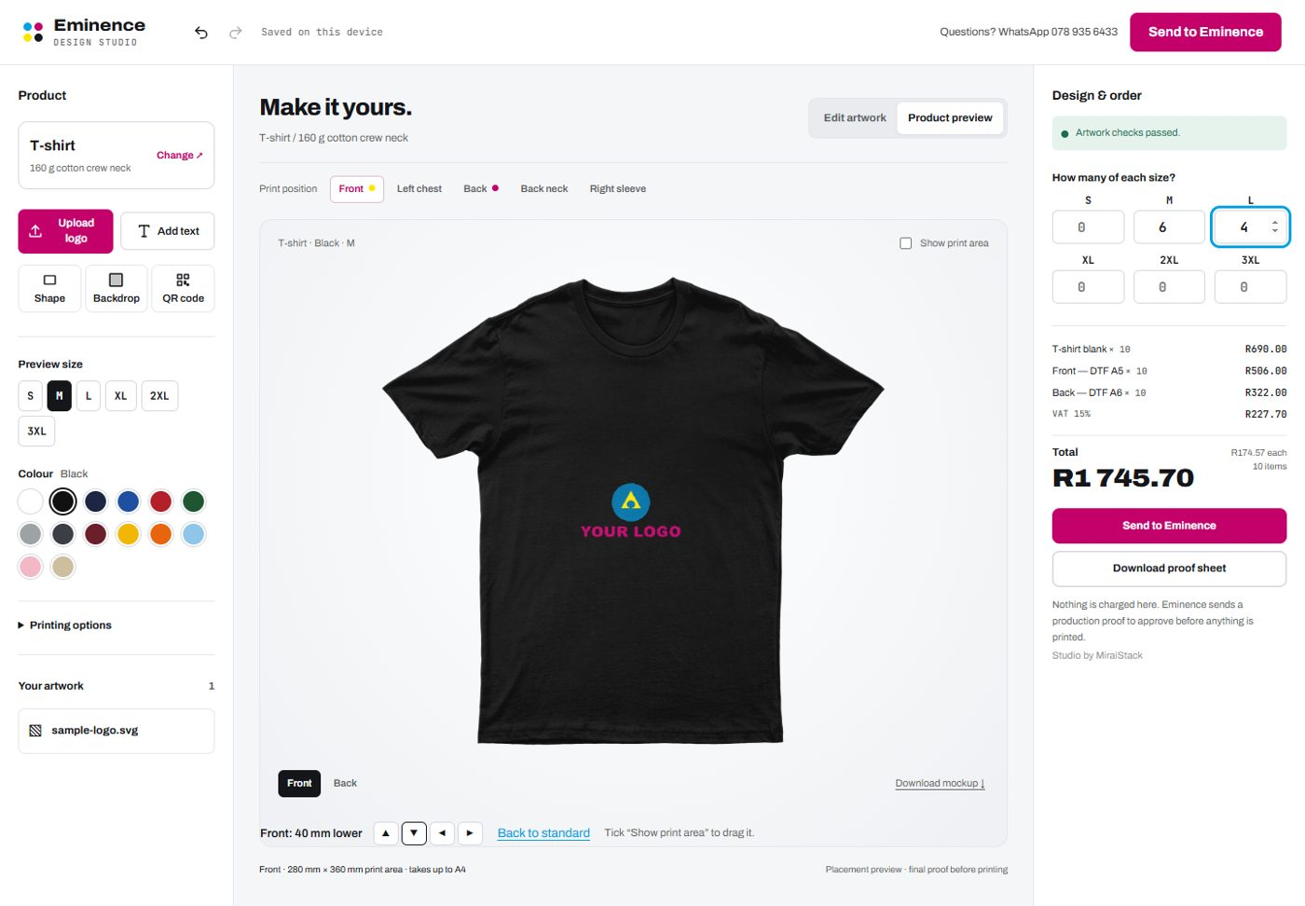
The Studio: a black T-shirt with the customer's logo, print size and price on the right.

PART 2 · FOR WHOEVER SETS IT UP

Setting it up, once
Everything is in the GitHub repository (github.com/NhlanhlaNgcobo/Design-Studio-). Technical detail is in ops/DEPLOY.md and ops/PLUG-INTO-EMINENCE.md; this is the short version. You need: the GoDaddy login for eminenceprinting.co.za, and about a day.

Step 1 — Open four accounts
Account | What it does | Cost (Nov 2026)
Vercel (Pro) | Hosts the website, the Studio and its order functions | US$20 a month (about R330)
Cloudflare R2 | Stores the order files: print PNGs, originals, proofs | Free up to 10 GB
Resend | Sends the order and contact-form emails | Free up to 3,000 a month
Zoho Mail (or Google Workspace) | A mailbox on the domain, e.g. orders@eminenceprinting.co.za | About R17 per mailbox a month

Step 2 — Storage (Cloudflare R2)
- Create a private bucket called eminence-jobs.
- Create an API token with Object Read & Write on that bucket only; keep the key ID and secret.
- Add the CORS rule from ops/DEPLOY.md (allows uploads from www.eminenceprinting.co.za, eminenceprinting.co.za and studio.eminenceprinting.co.za).
- Add a lifecycle rule deleting order files under tenants/ after 90 days. Customer artwork is someone else's brand; don't keep it forever.

Step 3 — Email (Resend)
- Add the domain eminenceprinting.co.za in Resend and copy its DNS records into GoDaddy (they don't affect receiving mail).
- Create an API key.
- Set up the mailbox Eminence will read orders in (Zoho or Google). Orders go to the address in the shop settings file, studio/tenants/eminence.json — today eminenceprinting@gmail.com.

Step 4 — Deploy on Vercel
- New project → import the GitHub repository → Root Directory: site → no build command.
- Settings → Environment Variables:
Name | Value
RESEND_API_KEY | the key from Step 3
MAIL_FROM | Eminence Studio <studio@eminenceprinting.co.za> (a verified Resend domain)
MAIL_TO | eminenceprinting@gmail.com (inbox for the website contact form)
S3_ENDPOINT | https://<account-id>.r2.cloudflarestorage.com
S3_REGION | auto
S3_BUCKET | eminence-jobs
S3_ACCESS_KEY_ID / S3_SECRET_ACCESS_KEY | the token from Step 2
JOB_SECRET | 32+ random characters
STUDIO_ADMIN_PASSWORD | a long passphrase for Eminence's price settings — give it only to the owner

Step 5 — Put the Studio on Eminence's website
Choose one (detail in ops/PLUG-INTO-EMINENCE.md):
Option | What to do | Result
A. Replace the site (recommended) | Vercel → Domains: add www.eminenceprinting.co.za and eminenceprinting.co.za; change the records at GoDaddy as Vercel shows | New website with the Studio at /studio/
B. Link from the current site | Vercel → Domains: add studio.eminenceprinting.co.za; GoDaddy: CNAME studio → cname.vercel-dns.com; add a "Design online" button | studio.eminenceprinting.co.za/studio/
C. Embed in a page of the current site | Do B's DNS, then add a page with the code below | The Studio inside the current site

Embed code for option C (any site that allows a code block; a React version is in ops/PLUG-INTO-EMINENCE.md):
<div id="eminence-studio"></div>
<script type="module">
import { mountStudio } from "https://studio.eminenceprinting.co.za/studio/embed.js";
mountStudio("#eminence-studio", { tenant: "eminence", product: "tee" });
</script>

Step 6 — Enter Eminence's prices
Open /studio/admin/ (e.g. https://www.eminenceprinting.co.za/studio/admin/), type the admin password, go through every section — blanks, DTF and sublimation by A-size, screens, embroidery, bulk discounts, cards, flyers, banners, gazebos, VAT — and press Save prices. A live example on the right shows what a customer will be charged. Until this is saved, customers see the starter prices.

Step 7 — Place a test order
- Open the Studio, choose a T-shirt, upload a logo, send it to yourself with your own name and WhatsApp number.
- Check: the WhatsApp message opens to 078 935 6433 with the order written out; the email arrives at the orders inbox with the proof and the print files; the files open.
- Check the same on a phone.
If storage or email isn't set up yet, nothing is lost: the Studio downloads the proof and print files to the customer's device and asks them to attach the proof to the WhatsApp message.

PART 3 · FOR EMINENCE

Receiving an order
Every order arrives two ways at once, with the same reference number (here EP-261106-LAS). The example on these pages is a real test order: 10 black T-shirts, a logo on the front moved 40 mm lower than standard, and the company name on the back.

1. The WhatsApp message
The customer's WhatsApp opens with this already typed; they press send, and it arrives on 078 935 6433. Reply in that chat to confirm the price and payment.
Hi Eminence — I'd like to order from the Design Studio.

Ref: EP-261106-LAS
10 × T-shirt, Black, DTF transfer
Sizes: M×6, L×4
• Front: 202 × 121 mm (placed 40 mm lower than standard)
• Back: 269 × 40 mm
Studio price: R1 745.70 incl. VAT

Collect in Empangeni
Notes: Please match our logo blue.

Print files: front 280×360 mm @ 300 dpi, back 300×400 mm @ 300 dpi
Proof: https://…/proof.png (a download link, valid 7 days)
— Sipho Dlamini

2. The email
Sent to the orders inbox the moment the customer presses Send, as "Eminence Printing Studio". Reply to it and the reply goes to the customer's email, if they gave one.
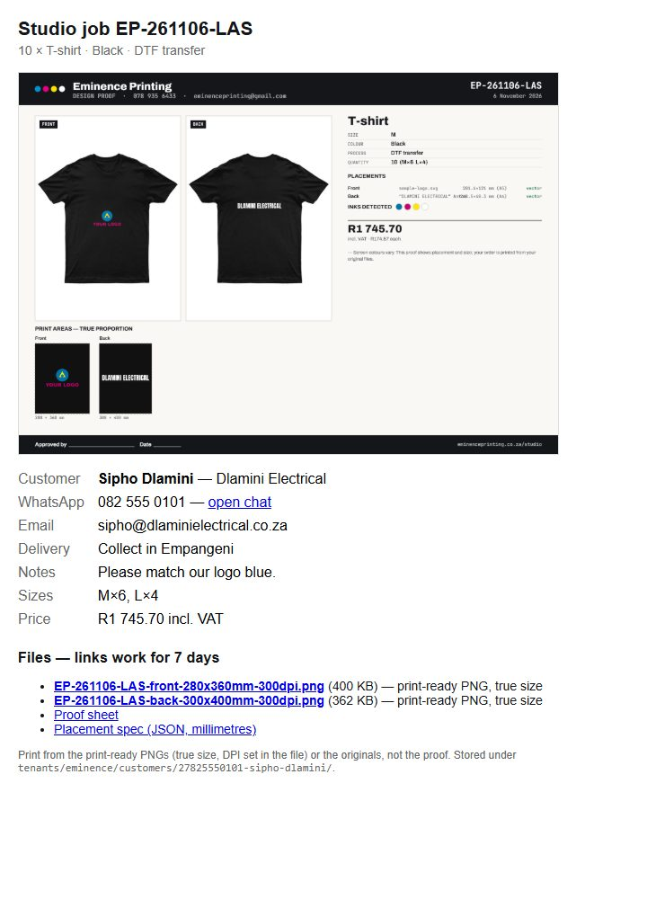
The order email: the proof sheet, the customer's details, and the download links.
In the email | What it is
Subject | Studio job EP-261106-LAS — T-shirt × 10 — Sipho Dlamini
Proof sheet (picture) | The mockup of every printed side, the print areas at true proportion, sizes, inks and the price — Part 3.3
Customer, WhatsApp, Email | Who to contact. "open chat" starts a WhatsApp chat with them
Delivery, Needed by, Notes | Collect / deliver / install, the date they need it, and their instructions
Sizes, Price | How many of each size, and the Studio price including VAT
…-front-280x360mm-300dpi.png | Print-ready file for the front — Part 3.4
…-back-300x400mm-300dpi.png | Print-ready file for the back
Customer's original | The logo or photo exactly as they uploaded it (PDF, AI, SVG, PNG…)
Placement spec (JSON) | Every size and position in millimetres, for the record — Part 4
Links in the email work for 7 days. Save the files to the job folder when the order comes in. After that, they are still in Cloudflare R2 (Part 3.5) until the 90-day clean-up.

3. The proof sheet — the design mockup
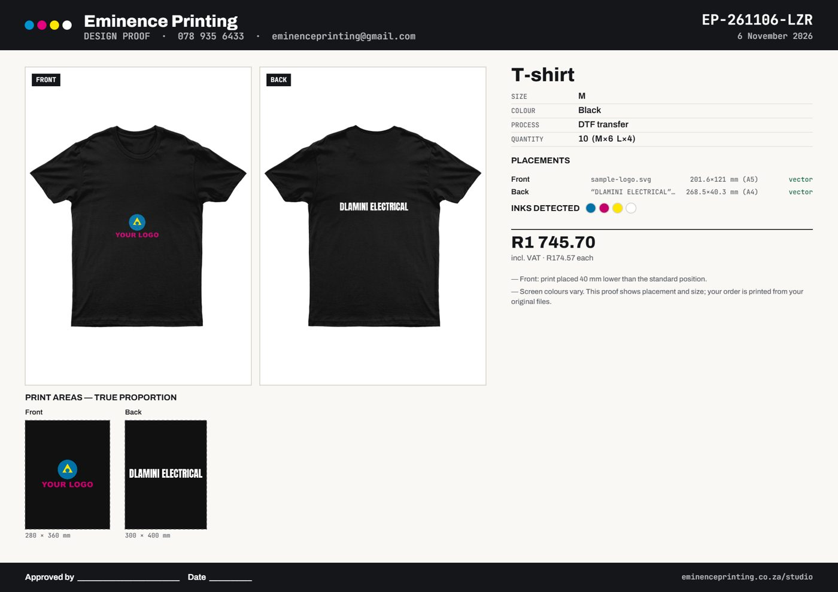
The proof sheet for order EP-261106-LAS.
On the proof sheet | What it tells you
Mockups (left) | Each printed side on the garment in the chosen colour — this is what the customer approved on screen
Print areas — true proportion | Each print area drawn to scale with the design inside it, with the area size (280 × 360 mm)
Size · colour · process · quantity | M, Black, DTF transfer, 10 (M×6, L×4)
Placements | Each piece of artwork, its printed size in mm, the A-size it matches (A5, A4) and its resolution: "vector" (sharp at any size) or the DPI at that size
Inks detected | The colours in the artwork — the number of screens for screen printing
Price | Total including VAT and the price each
Notes | Anything production must know, e.g. "Front: print placed 40 mm lower than the standard position"
Approved by / Date | Print it or send it back for the customer to sign before a big run

4. The print-ready files
One PNG per printed side, made at the moment of sending from exactly what the customer saw. The file name says what it is:
EP-261106-LAS - front - 280x360mm - 300dpi .png
ref side size on the garment resolution
- True size. The file is the whole print area at its real size: 280 × 360 mm at 300 dpi = 3307 × 4252 pixels. The DPI is written into the file, so Photoshop, the RIP or the DTF software opens it at 280 × 360 mm. Print it at 100 %.
- The design sits where the customer put it inside that area; the rest is transparent. Crop to the artwork for ganging DTF transfers — the spec gives the exact box (Part 4).
- Transparent background on garments. On banners, flags, gazebos and mugs, the background colour the customer chose is printed into the file.
- Big banners are made at the product's own resolution (e.g. 120 dpi for a pull-up), kept under 50 megapixels.
- For screen printing and embroidery, use the customer's original file (vector where possible); the PNG shows placement and size.

The front print file, shown on a grey check where it is transparent: 280 × 360 mm, the logo where the customer placed it.

5. Where the files are kept
Every order is filed in Cloudflare R2 by customer — WhatsApp number and name — so a repeat customer's orders sit together:
tenants/eminence/customers/27825550101-sipho-dlamini/
customer.json ← name, phone, email, company, every order they've sent
EP-261106-LAS-<code>/
print/ the print-ready PNGs
artwork/ the customer's original files
proof/ the proof sheet
spec.json sizes, placements, inks, the price, the print files
Open them from Cloudflare → R2 → eminence-jobs → tenants → eminence → customers.

PART 4

Reading the sizes and producing the job

Four sizes, and what each means
Size | In the example | Meaning
Print area | Front 280 × 360 mm | The biggest the print can be on that position. Set per product and size; the print file is this size
Design size | Front 201.6 × 121 mm (A5) | The artwork as placed — what you actually print, and what DTF / sublimation is priced on
Position in the area | 39 mm from the left, 120 mm from the top | Where the design sits inside the print area (spec: design_bounds_mm)
Position on the garment | 40 mm lower than standard | If the customer moved the print area up, down or sideways (spec: position_offset_mm). Blank = standard

Standard positions
The Studio places each print area where a print shop normally does. "Moved 40 mm lower" means 40 mm lower than this. Adjust to Eminence's own house rules if they differ.
Position | Standard placement (size M)
T-shirt front | Centred; top of the print area about 75 mm below the collar seam
T-shirt back | Centred; top about 90 mm below the back collar seam
Left chest | On the wearer's left, centred about 105 mm from the centre line; top about 50 mm below the collar
Hoodie front | Centred, above the pocket
Golf shirt chest | Left or right chest, below the collar points
Back neck | Centred just below the back collar

The same job, from the spec (millimetres)
Side | Print area | Design (size, A-size) | Position
Front | 280 × 360 | 201.6 × 121 mm, A5, vector | 40 mm lower than standard; design 39 mm from left, 120 mm from top of the area
Back | 300 × 400 | 268.5 × 40.3 mm, A4, text | Standard; design 16 mm from left, 180 mm from top of the area

Producing it — a checklist
- Reply on WhatsApp: confirm the price (from the Studio), send payment details, agree the date.
- Save the email's files to the job folder (the links expire in 7 days).
- Check the proof sheet's warnings and notes: resolution, background removal, moved print areas.
- For a large run, send the proof sheet back for a signature (Approved by / Date).
- Print from the print-ready PNG at 100 % (DTF, sublimation, large format), or from the original file (screen, embroidery, vinyl).
- Apply at the standard position plus any move in the notes; check against the mockup.
- Message the customer that it's ready for collection or delivery.
PART 5

Prices, everyday questions and troubleshooting

Changing a price
Open /studio/admin/, type the password, change the number, press Save prices. The Studio uses the new price straight away for new orders. The example box on the right shows the effect.

Questions
Question | Answer
A customer's file is too low resolution | The Studio already warned them and the proof says so. Ask on WhatsApp for a bigger file or a vector (PDF, AI, SVG), or print smaller
The logo had a white box | The customer can remove it in the Studio (solid colour or AI); the proof notes it. Redo the cut-out properly from the original for production
A customer wants a change after sending | Ask them to change it in the Studio and send again — it makes a new reference — or edit in-house from the original files
A product, colour or size isn't offered | MiraiStack changes the product list in Eminence's settings file; no rebuild
DTF and cut vinyl | The Studio offers them on garments. If Eminence doesn't do them, MiraiStack removes them

Troubleshooting
What happens | What to do
The WhatsApp came in but no email | Check spam; then Resend → Logs. If storage or email isn't set up, the customer's device downloads the proof and asks them to attach it in WhatsApp
A download link says expired | Links last 7 days; get the file from Cloudflare R2 (Part 3.5)
The price settings page says "not configured" | STUDIO_ADMIN_PASSWORD or the storage settings are missing in Vercel
The Studio inside the current site is blank | The site's address must be allowed to show it (frame-ancestors in site/vercel.json) — MiraiStack adds it

Support: MiraiStack — Nhlanhla Ngcobo, Director of Innovation.

