FitSocial Level 2 MVP Plan

Executive Summary
FitSocial is a social‑first fitness app designed for the South African market. The original plan was over‑scoped; this level‑2 plan trims features to the core habit loop (tracking workouts/runs, logging meals via photos, social sharing and basic insights), adds an investor‑grade monetization strategy and aligns all screens with a polished dark‑mode UI. The app uses a black background with deep orange accents throughout. The plan recommends Flutter and Firebase for rapid cross‑platform development, integrates OpenAI’s vision API for meal analysis, and includes detailed Codex prompts to build each screen. Investors will appreciate the lean scope, predictable subscription revenue model and modern tech stack.

1. Market & Opportunity
The fitness app market continues to expand rapidly. Projections show revenue growth from $2.5 billion in 2024 to $9.6 billion by 2032. The global user base numbered 345 million in 2024 with average revenue per user around $20.79. This growth is driven by increasing interest in remote personal training and apps with engagement features and community support. Estimates for compound annual growth rates range from 4.9 % to 17.8 % through 2030. South Africa’s smartphone penetration and growing health awareness present a compelling opportunity for a locally‑tailored social fitness app.

2. Monetization Plan
FitSocial will follow a subscription‑led monetization strategy similar to Spotify’s pricing in South Africa. Spotify’s Premium Standard plan costs R94.99 per month after a three‑month introductory offer, while My Broadband notes that the Premium Lite plan is R69.99 per month and Premium Standard is R94.99 per month for high‑quality audio. Adopting this pricing ensures familiarity and parity with a widely used digital subscription.
Proposed tiers:
• **Free tier:** limited posts per day, basic workout/run logging and community feed, supported by unobtrusive advertising.
• **Premium (R 94.99/month): unlimited posts, full meal analysis, advanced insights, offline mode and priority support.
• **Student plan (R 47.99/month): all premium features at half price for verified students (mirroring Spotify’s Student plan).
The free trial will run for seven days; research shows trials convert roughly 2 % of users to paid plans. Additional revenue streams include one‑off sales of specialised workout programs and nutrition guides and brand partnerships promoting relevant fitness products.

3. Concept & Value Proposition
FitSocial combines the utility of a fitness tracker with the motivation of a social network. Users can log workouts, runs and meals, share their progress with friends, and receive encouragement through likes, comments and challenges. Social fitness platforms succeed because community features such as challenges, goal‑setting, progress sharing and group chats drive motivation and accountability. Studies show that combining personal tracking with community interaction improves exercise adherence and social engagement. Gamification elements like badges and streaks create a sense of achievement that keeps users returning. FitSocial will leverage these proven mechanics to build an inclusive community where beginners and experienced athletes support each other.

4. Tech Stack & Architecture
**Framework.** Cross‑platform development is essential for cost efficiency. Enablis’ 2025 comparison recommends Flutter for most new projects because it compiles directly to native binaries, controls every pixel and delivers smoother 60 fps animations than React Native. Flutter’s Impeller rendering engine avoids the performance bottlenecks of React Native’s JavaScript bridge. Developers report higher satisfaction despite the smaller talent pool. The plan therefore adopts Flutter (Dart) with Riverpod for state management and go_router for navigation.
**Backend.** Firebase provides authentication, Firestore for data storage, and Cloud Storage for media. Its serverless architecture supports rapid iteration and scales automatically. Cloud Functions will host the meal‑analysis endpoint, which forwards meal images to OpenAI’s vision API (GPT‑4 Vision). The API can identify foods, estimate calories, macronutrients and highlight potential allergens from an image. Prompts will ask the model to return structured JSON with item names, estimated weights and nutrients and to provide reasoning, because portion size estimation remains challenging.
**AI & Analytics.** Use OpenAI’s vision model via the chat completions API for meal analysis. For analytics, integrate Firebase Analytics and BigQuery to track user retention, DAU/MAU ratios and feature usage patterns.
**Security & Privacy.** Apply OAuth authentication, secure Firestore rules and encrypted connections. Allow users to control visibility of their posts. Ensure compliance with South Africa’s POPIA by anonymising data in analytics.

5. UI/UX Design & Screen Breakdown
The design uses a **black background** (#000000) with **deep orange accents** (#D35400) and white typography, reflecting an energetic yet elegant feel. Cards use dark charcoal backgrounds with rounded corners. The template image provided by the user inspired the hierarchy: bold headers, prominent cards, consistent spacing and bottom navigation. Each screen is described below along with a Codex prompt to generate it.
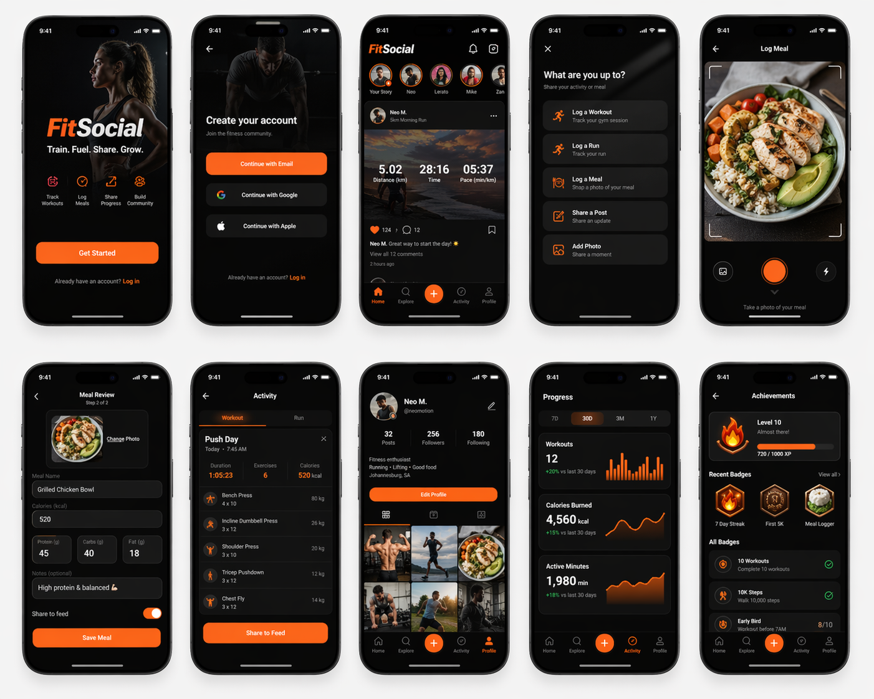
Figure 1: Template UI screens (provided by the user)

5.1 Onboarding & Authentication
Users are greeted with a welcoming screen featuring the app name, tagline and a bold call‑to‑action button. Black backgrounds and deep orange buttons create contrast. Onboarding pages summarise app features and include illustrations. The authentication page offers social sign‑in (Google/Apple) and email/password.
Codex Prompt:
Create a Flutter screen named `OnboardingScreen`. Use a `PageView` to show three onboarding slides, each with an illustration, a title and description. Add a deep orange ‘Get Started’ button on the last slide that navigates to `LoginScreen`. Use Riverpod for state management, go_router for navigation and apply a black background with deep orange primary colour.

5.2 Feed Screen
The main feed displays posts in a vertical list. Each post card includes the user’s avatar, name, timestamp, text content, optional image (e.g., meal photo) and action icons (like, comment, share). A floating action button allows users to create a new post. The bottom navigation bar includes icons for Feed, Workouts, Runs, Meals and Profile.
Codex Prompt:
Create a `FeedScreen` widget using Flutter. It should contain an `AppBar` titled 'Feed', a `ListView.builder` rendering `PostCard` widgets, and a `FloatingActionButton` with an add icon. Use a black scaffold background and deep orange accent colour for the FAB and selected navigation item. Each `PostCard` should show a circular user avatar, username (bold white text), timestamp, content text, optional rounded‑corner image and a row of icon buttons for like/comment/share. Implement bottom navigation with five items (Feed, Workouts, Runs, Meals, Profile) using `BottomNavigationBar`.

5.3 Workout Logging
Users can log strength or gym workouts by entering the exercise name, duration, sets/reps and optional notes. The screen uses form fields on a dark card with an orange save button at the bottom. A toggle allows users to share the workout to the feed.
Codex Prompt:
Create a `WorkoutLogScreen` in Flutter. Use a `Form` with text fields for 'Workout Title', 'Duration (minutes)', 'Sets' and 'Reps', plus a multiline 'Notes' field. Include a `SwitchListTile` labelled 'Share to feed'. Place an orange ‘Save Workout’ button at the bottom that validates the form and saves the log to Firestore. Use Riverpod to manage form state and go_router to navigate back to the feed after saving.

5.4 Run Logging
A simplified run logging screen captures distance, duration and route. Users can manually enter distance and time or import data from connected wearables. A mini‑map preview shows the route when available. After saving, the run can be shared to the feed.
Codex Prompt:
Create a `RunLogScreen`. Display form fields for 'Distance (km)' and 'Duration (minutes)'. Include a small map widget placeholder (e.g., using Google Maps Flutter plugin) to preview the route. Add a toggle to share the run to the feed and a deep orange ‘Save Run’ button. Store the run in Firestore and navigate back to the feed on completion.

5.5 Meal Photo Upload
This screen lets users take or choose a meal photo. A dark card displays the selected image with a prompt to retake or proceed. A button triggers the AI analysis.
Codex Prompt:
Create a `MealUploadScreen` with a black scaffold. Include a centered container with a placeholder icon prompting users to upload or capture a meal photo using `ImagePicker`. Once an image is selected, display it inside a rounded rectangle card and show an orange button labelled 'Analyze Meal' that navigates to `MealReviewScreen` with the image.

5.6 Meal Review & Confirmation
After AI analysis, users review the meal summary (calories, protein, carbs, fats) generated by OpenAI. They can adjust values manually and add notes. A toggle decides whether to post the meal to the feed.
Codex Prompt:
Create a `MealReviewScreen` that accepts an image and analysis result. Show the image at the top, followed by editable fields for 'Meal Name', 'Calories', 'Protein (g)', 'Carbs (g)', and 'Fat (g)'. Add a 'Notes' field and a switch labelled 'Share to feed'. Place a deep orange 'Save Meal' button at the bottom that saves the record to Firestore and returns to the feed.

5.7 Profile & Insights
The profile screen displays the user’s avatar, bio, follower/following counts and aggregated metrics (total workouts, runs and meals logged). A tabbed view shows 'Posts', 'Workouts', 'Runs' and 'Meals'. An insights screen (accessible via the profile) presents weekly charts of activity and nutrition using bar charts similar to the template.
Codex Prompt:
Create a `ProfileScreen` with a top section containing a circular avatar, username, bio text and stats. Add a `TabBar` with four tabs (Posts, Workouts, Runs, Meals) each displaying a list of the user’s records. Implement an `InsightsScreen` accessible from the profile via an icon, which shows weekly bar charts of workouts, runs and macronutrient intake using the `charts_flutter` package.

6. Implementation Roadmap
The MVP will be delivered over an 8‑week timeline:
1. **Week 1–2:** Set up Flutter project, configure Firebase (Auth, Firestore, Storage), implement onboarding, authentication and bottom navigation.
2. **Week 3:** Build Feed screen with Firestore integration and post creation. Seed the database with demo posts to demonstrate activity.
3. **Week 4:** Implement WorkoutLogScreen and RunLogScreen with Firestore data models. Enable sharing toggles.
4. **Week 5:** Implement MealUploadScreen and MealReviewScreen. Create Cloud Function to call OpenAI’s vision API and return nutrition estimates.
5. **Week 6:** Develop ProfileScreen and InsightsScreen with aggregated metrics and charts.
6. **Week 7:** Integrate analytics, push notifications and privacy settings. Implement in‑app purchase logic for subscriptions.
7. **Week 8:** Conduct beta testing, refine UI details, fix bugs and prepare Google Play beta release.

7. Marketing & Pre‑Launch Strategy
Market success begins before launch. Research indicates that apps engaging in pre‑launch marketing 6–8 weeks ahead achieve 85 % higher day‑one retention. FitSocial will create a landing page capturing email sign‑ups, share teaser videos on TikTok and Instagram and invite early adopters. Paid ads will target South African fitness communities. An onboarding waitlist will convert early interest into the first cohort.

8. KPIs & Metrics
Key performance indicators measure traction and retention:
• **User acquisition:** number of downloads, waitlist sign‑ups and conversion rate from landing page.
• **Activation:** percentage of users completing onboarding and posting their first workout/run/meal.
• **Engagement:** daily/monthly active users (DAU/MAU), average posts per user and challenge participation rates.
• **Retention:** day‑1, day‑7 and day‑30 retention rates.
• **Revenue:** subscriber count, conversion rate from trial to paid, average revenue per user and revenue from digital product sales.

9. Conclusion
This level‑2 plan distils FitSocial into a focused, investor‑ready product. By limiting scope to the core social fitness loop and aligning monetization with Spotify’s familiar pricing, the app can achieve sustainable revenue while building an inclusive community. The use of Flutter and Firebase accelerates development, and OpenAI’s meal analysis differentiates the product. With a clear roadmap and strong user‑centric features, FitSocial is positioned to become South Africa’s leading social fitness platform.

