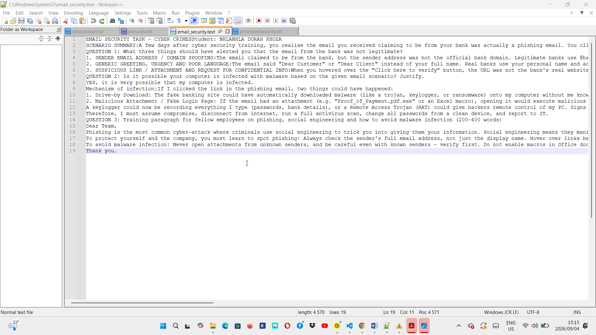
SECURITY TASK - CYBER CRIMES Student: NHLANHLA DORAH KHOZA
SCENARIO SUMMARY: A few days after cyber security training, you realise the email you received claiming to be from your bank was actually a phishing email. You clicked the link.
QUESTION 1: What three things should have alerted you that the email from the bank was not legitimate?
1. SENDER EMAIL ADDRESS / DOMAIN SPOOFING: The email claimed to be from the bank, but the sender address was not the official bank domain. Legitimate banks use @bankname.co.za (e.g. @fnb.co.za, @standardbank.co.za). The phishing email used something like @fnb-secure.com, @fnb.com.alert-support.com, or a Gmail address. If you hover over the name, the real address is fake. This is called spoofing.
2. GENERIC GREETING, URGENCY AND POOR LANGUAGE: The email said "Dear Customer" or "Dear Client" instead of your full name. Real banks use your personal name and account number. It also used urgent scare tactics: "Your account will be closed in 24 hours!", "Urgent action required!", "Verify now or lose access”. It had spelling errors, bad grammar, and poor logo quality. Banks do not write like that.
3. SUSPICIOUS LINK / ATTACHMENT AND REQUEST FOR CONFIDENTIAL INFO: When you hovered over the "Click here to verify" button, the URL was not the bank's real website. It was something like http://fnb-secure-login.ru/verify or an IP address. Real banks NEVER ask you to click a link to enter your password, PIN, or OTP via email. They also never ask you to download an attachment to "secure your account". That link was designed to steal credentials or install malware.
QUESTION 2: Is it possible your computer is infected with malware based on the given email scenario? Justify.
YES, it is very possible that my computer is infected.
Mechanism of infection: If I clicked the link in the phishing email, two things could have happened:
1. Drive-by Download: The fake banking site could have automatically downloaded malware (like a trojan, keylogger, or ransomware) onto my computer without me knowing, just by visiting the page. This happens through exploiting outdated browsers.
2. Malicious Attachment / Fake Login Page: If the email had an attachment (e.g. "Proof_of_Payment.pdf.exe" or an Excel macro), opening it would execute malicious code. Or, if I entered my banking details on the fake page, I gave attackers my credentials, and they could have also prompted me to "Download security software" which was actually malware.
A keylogger could now be recording everything I type (passwords, bank details), or a Remote Access Trojan (RAT) could give hackers remote control of my PC. Signs would be slow computer, pop-ups, antivirus disabled.
Therefore, I must assume compromise, disconnect from internet, run a full antivirus scan, change all passwords from a clean device, and report to IT.
QUESTION 3: Training paragraph for fellow employees on phishing, social engineering and how to avoid malware
Dear Team,
Phishing is the most common cyber-attack where criminals use social engineering to trick you into giving them your information. Social engineering means they manipulate human emotions - fear, urgency, curiosity, or trust - instead of hacking computers. For example, a phishing email pretends to be from your bank, SARS, your boss, or IT department, saying "Urgent: Your account is compromised" to make you panic and click without thinking.
To protect yourself and the company, you must learn to spot phishing: Always check the sender's full email address, not just the display name. Hover over links before clicking to see the real URL. Look for generic greetings, spelling mistakes, and urgent threats. Remember, no legitimate bank or company will ever ask for your password, PIN, or OTP via email. If you are unsure, do not reply or click - instead, go directly to the official website by typing the address yourself or call the company using the number on their official site.
To avoid malware infection: Never open attachments from unknown senders, and be careful even with known senders - verify first. Do not enable macros in Office documents unless you are 100% sure. Keep your antivirus, Windows, and browser updated. Enable Two-Factor Authentication (2FA) on all accounts. Use strong, unique passwords with a password manager. Finally, if you think you clicked something suspicious, report it immediately to IT - you will not be in trouble, but quick reporting can save the whole company from a ransomware attack. Stop, Think, Verify before you click.
Thank you.

