**University Of Cape Town**

PHY3004W

**Lab Report:** Poisson Statistics

Nhlanhla Hlengane

**Abstract**

The decaying of a radioactive nucleus is a random event, this report studies the distribution of that random variable. The key findings of this report is that the distribution of a random variable is distributed according to the Poisson equation. 68% of the data agrees with this observation and so do the plots included in this report. Various statistical analysis methods are used in this report and the most important is the method of Maximum Likelihood elaborated in the introduction section.

**Introduction**

Statistical analysis is the science of collecting data and uncovering patterns and trends. Statistical analysis is used extensively in science, from physics to the social sciences. As well as testing hypotheses, statistics can provide an approximation for an unknown that is difficult or impossible to measure. The purpose of this report is to investigate and interpret the parameters of a set of data obtained from a series of random events. The random event studied in this report is the frequency distribution of the numbers of counts of gamma rays (or other types of ionizing radiation) from a radioactive source obtained in equal time intervals recorded using a **Geiger counter**. Detailed workings of a Geiger counter are attached in appendix B.

Radioactive sources such as **Cobalt-60** emit ionizing radiation. Ionizing radiation is a type of radiation that has enough energy to remove an electron from an atom or molecule causing it to become ionized. Ionizing radiation can cause chemical changes in cells and damage DNA. This may increase the risk of developing certain health conditions, such as cancer. There are five types of ionizing radiation, these are alpha particles, beta particles, positrons, gamma rays and X-rays. When Cobalt-60 decays it releases gamma rays and using a Geiger counter, the gamma rays can be detected and counted for further statistical analysis.

There are two different approaches to classical statistics, namely, the frequentist approach and the Bayesian approach. The two different approaches each have their advantages and disadvantages but for the purpose of this experiment, a frequentist approach was implemented. The frequentist approach limits itself to independently determining physical parameters and testing goodness-of-fit. For this test, a hypothesis needs to be made and **the hypothesis made for this report** is that the number of nuclei (n) of Cobalt-60 that decay in a 10 second time step is given by the Poisson distribution discussed further in the theory section below.

**Theory**

* **A Binomial distribution**

A **binomial distribution** can be thought of as simply the probability of a success or failure outcome in an experiment that is repeated multiple times. For example, a coin toss has only two possible outcomes: heads or tails. Repeating an experiment (such as tossing a coin multiple times) in which there are only two possible outcomes in each event results in a binomial distribution.

This distribution tells us that for an event to occur $x$ times in $z$ trials, where the probability of the event to occur in one trial $p$

$$P\left(x;p,z\right)≡\frac{z!}{x!\left(z-x\right)!}p^{x}{\left(1-p\right)}^{z-x}$$

Note that the random variable is listed as an argument of the probability function to the left of the semicolon, and any other parameters (in this case p and z) are listed to the right.

* **A Poisson distribution**

If we consider the binomial distribution in the case when the number of trials ($z$) becomes very large, the probability ($p$) becomes very small but the product $pz$ remains a constant value ($μ=pz$) it can be shown that

$$P\left(x;μ\right)=\frac{μ^{x}}{x!}e^{-μ}$$

The Poisson asks for the probability of a number of successes during a period of time while the binomial asks for the probability of a certain number of successes for a given number of trials. For this report the probability of a radioactive nucleus decaying is considered for a large number of nuclei (on the order of Avogadro’s number $\sim {10}^{23}$). The probability of one nucleus decays in a single trial would be $\sim \frac{1}{{10}^{23}}$ and therefore the probability ($p$) is very small due to the large number of nuclei in a radioactive source.

* **The Method of Maximum Likelihood (MML)**

In statistics, MML estimation is a method of estimating the parameters of a probability distribution by maximizing a likelihood function so that the assumed statistical model of the observed data is most probable. The likelihood function measures the goodness of fit of a statistical model to a sample of data for given values of the unknown parameters. MML yields the arithmetic mean

$$\overline{x}≡\frac{1}{N}\sum_{i=1}^{N}{x_{i}}$$

as the estimator for the parameter that gives the mean of the assumed distribution. The MML approach will be implemented in this report. A derivation of the mean estimator is included in the appendix A section. The arithmetic mean is an unbiased estimator, this is also shown the fact that the expectation value of the arithmetic mean is the mean $μ$ itself.

**Method & Apparatus**

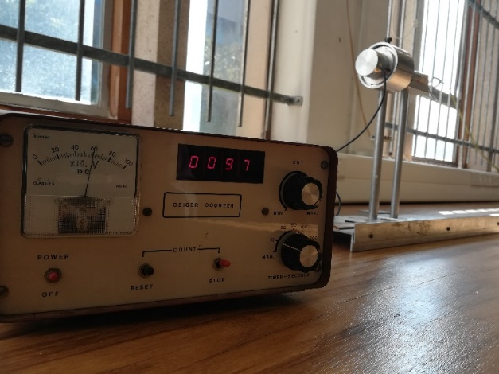For this experiment a Cobalt-60 source obtained from the PHY3004W Lab was used. The first part of this experiment was to use a Geiger counter as shown in figure 1 below to count the background radiation for a period of ten seconds (this period remained unchanged throughout the experiment). For this part of the experiment the Cobalt-60 source was placed at approximately 5 meters away from the detector in the direction opposite from where the detector part of the Geiger counter was facing to minimize the interference of the radioactive source with the data obtained. After turning on the Geiger counter, the DC current on the Geiger counter was set to approximately 60mA to ensure that the voltage applied to the Geiger counter was approximately 600V. This value of the DC current would change slightly whilst the experiment continued, this was continuously reset to approximately 60mA. With the timer set to 10 seconds the switch labelled stop on the Geiger counter was pushed up to start the counting process. After ten seconds the Geiger counter had counted and displayed the number of ionizing (background) radiation counted. This value was then recorded on a text file (on a laptop) and the counting process was repeated. This was repeated until 100 counts were obtained.

**Figure 1**: Experimental setup showing the Geiger counter reading 97 counts in a 10 second period with the DC current at 60mA. Part of the Geiger counter that detects ionizing radiation located in the background is shown up close in figure 2.

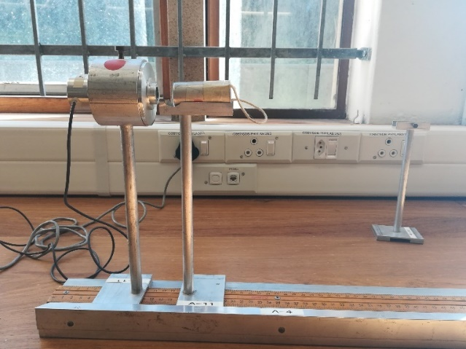For the second part of the experiment, the source was placed on the stand as shown in figure 2. The mean counting rate was controlled by adjusting distance of the radioactive source from the Geiger counter as shown in figure 2 below. A mean counting rate of approximately 100 counts per 10 seconds was approximated by placing the radioactive source at approximately 14cm from the Geiger counter. The counting process as described for part one above was repeated with the radioactive source in place to approximate a mean counting rate of 100 counts per 10 seconds.

**Figure 2**: Part of the experimental set up showing the Cobalt-60 source on a stand at approximately 14cm from the part of the Geiger counter that detects ionizing radiation.

Approximate means counting rates of $μ=4, μ=10,$ and $μ=30$ are also investigated in this report.

**Analysis**

* **Arithmetic mean and sample variance of the data**
* The arithmetic mean for each of the data sets is determined by the formula included in the theory section of this report (page 2). Following the hypothesis made for this experiment, the uncertainty of the arithmetic mean is estimated as one standard deviation of the Gaussian distribution about this value, this is given by the square root of the variance. For a Gaussian distribution we have that the variance

$V\left[x\right]≡$ $E[{\left(x-μ\right)}^{2}]=σ^{2}$.

From the answered prelab questions (included in appendix B) it is shown in part c of question 2 that $E\left[{\left(x-μ\right)}^{2}\right]=μ$. Since the data obtained is assumed to be distributed according to the Poisson distribution pdf, we know that $μ=σ^{2}$, hence $E[{\left(x-μ\right)}^{2}]=σ^{2}$.

For data distributed according to Poisson distribution, $E\left[{\left(\overline{x}-μ\right)}^{2}\right]=\frac{μ}{N}$ $≃\frac{\overline{x}}{N}$ where N is the number of data points collected. A proof of this is included in appendix A.

$∴$ The uncertainty for the arithmetic mean was determined as $∆x=\sqrt{\frac{\overline{x}}{N}}$

* The sample variance (s2) is a measure of the degree to which the numbers in a list are spread out. If the numbers in a list are all close to the expected values, the variance will be small. If they are far away, the variance will be large.

$$s^{2}≡\frac{1}{N-1}\sum_{i=1}^{N}{{(x_{i}-\overline{x})}^{2}}$$

The sample variance above is an unbiased estimator of the sample variance. This is shown by showing that the expectation value of the sample variance (of the measured data) is the variance of the underlying Poisson distribution.

$E\left[s^{2}\right]=$ $σ^{2}$.

The proof for this is included in appendix A.

For the purpose of this report, the uncertainty on any measurement is the square root of the variance of the estimator for that quantity under the hypothesis for the underlying (Poisson) distribution of the data. Therefore, the uncertainty of the sample variance is obtained by evaluating the variance of the sample variance.

$V\left[s^{2}\right]=E[{(s^{2}-μ)}^{2}]$. $=\frac{2Nμ^{2}+(N-1)μ}{N(N-1)}$

The proof for this is also included in appendix A.

The table below lists the arithmetic mean and sample variance obtained from the different data sets with their associated uncertainties.

|  |  |  |
| --- | --- | --- |
| **Data** | **Arithmetic mean** | **Sample variance** |
| $$μ=100$$ | $$102.75±1.01$$ | $$132.09±14.64$$ |
| $$μ=30$$ | $$31.13±0.56$$ | $$27.27±4.46$$ |
| $$μ=10$$ | $$10.27±0.32$$ | $$8.26±1.49$$ |
| $$μ=4$$ | $$6.29±0.25$$ | $$6.77±0.93$$ |
| Background | $$4.91±0.22$$ | $$3.64±0.73$$ |

Table 1: The arithmetic mean and sample variance values (with their uncertainties) obtained for the different data sets with different mean counting rates (including the background data). In the first column the data sets are labelled by their approximate mean counts.

Now that the arithmetic mean and sample variance data have been extracted from the data sets, a test to determine how close the data is from the hypothesis made can be done. The assumption is that the random data obtained is distributed according to the Poisson distribution. This implies that the mean (the arithmetic mean in the case of this report) should be equal to the sample variance. Figure 3 below was obtained by plotting the values of $\frac{s^{2}}{\overline{x}}$ on the vertical axis with the values of $\overline{ x}$ on the horizonal axis.

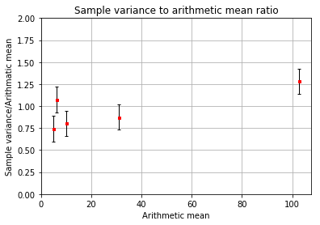

**Figure 3:** An error bar plot showing the ratio of the sample variance to the arithmetic mean $(\frac{s^{2}}{\overline{x}}$, with their uncertainties) on the vertical axis with the arithmetic mean count rate on the horizontal axis.

The uncertainties obtained for each of the points in the plot above were obtained through an uncertainty propagation.

$$∆\frac{s^{2}}{\overline{x}}=\frac{s^{2}}{\overline{x}}\sqrt{{\left(\frac{∆s^{2}}{s^{2}}\right)}^{2}+{\left(\frac{∆\overline{x}}{\overline{x}}\right)}^{2}}$$

* **The cumulative (running) average**

The cumulative average describe how the data obtained for each data set approaches the arithmetic mean of the data. The cumulative average $r_{c}(j)$ is given as a function of the sequence of events (in this case a sequence of count intervals $j$).

$$r_{c}\left(j\right)≡\overline{x}=\frac{1}{j}\sum_{i=1}^{i=j}{x_{i}}$$

Where $x_{i}$ is the number of counts detected in trial $i$.

Figures 4, 5, 6, 7 and 8 show the cumulative average $r_{c}(j)$ of the approximate mean counting rates (including the background data) explored in this report as a function of the sequence number with its associated uncertainty.

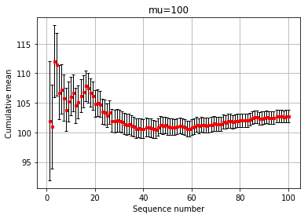 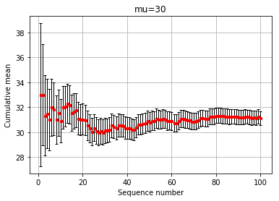

**Figure 4:** The cumulative average $r_{c}(j)$ plot for an approximate mean counting rate $μ=100$ counts per ten second shown on the vertical axis (with its associated uncertainty represented by the vertical error bars) with the sequence number $j$ shown on the x axis.

**Figure 5:** The cumulative average $r_{c}(j)$ plot for an approximate mean counting rate $μ=30$ counts per ten second shown on the vertical axis (with its associated uncertainty represented by the vertical error bars) with the sequence number $j$ shown on the x axis.

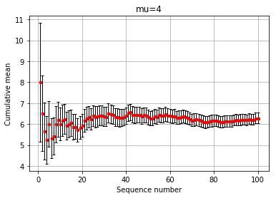 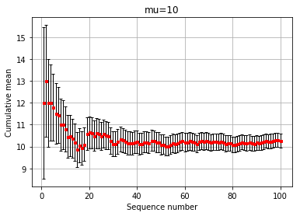

**Figure 7:** The cumulative average $r_{c}(j)$ plot for an approximate mean counting rate $μ=10$ counts per ten second shown on the vertical axis (with its associated uncertainty represented by the vertical error bars) with the sequence number $j$ shown on the x axis.

**Figure 6:** The cumulative average $r_{c}(j)$ plot for an approximate mean counting rate $μ=4$ counts per ten second shown on the vertical axis (with its associated uncertainty represented by the vertical error bars) with the sequence number $j$ shown on the x axis.

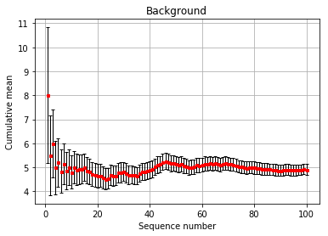

**Figure 8:** The cumulative average $r_{c}(j)$ plot for the background counts shown on the vertical axis (with its associated uncertainty represented by the vertical error bars) with the sequence number $j$ shown on the x axis.

The uncertainties of each of the cumulative means (the error bars) were determined as the square root of the variance of the mean estimator for each of the means in the sequence. The equation used to determine the uncertainties is the same as the one used to determine the uncertainty of the arithmetic mean above with the arithmetic mean replaced by each of these cumulative means.

* **Poisson Plots**

The following figures compares the Poisson distribution of the true mean counting rate which this report aims to approximate with a binned data set that represents the number of trials with a specific number of counts (with the associated uncertainty) on the vertical axis and the counts per trial on the horizontal axis. The bin width is different for different values of the approximate mean count rate.

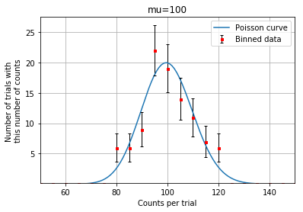 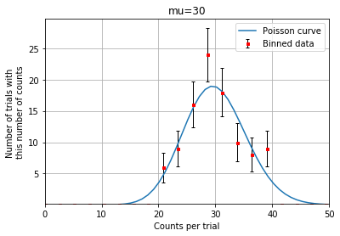

**Figure 9:** The frequency distribution of observed numbers of counts for a set of 100 trials with mean number of counts per trial of approximately 100 with a bin-width of 5 counts per interval. The data are compared to the Poisson distribution whose mean counting rate is the true value $μ=100$

**Figure 10:** The frequency distribution of observed numbers of counts for a set of 100 trials with mean number of counts per trial of approximately 30 with a bin-width of 2.6 counts per interval. The data are compared to the Poisson distribution whose mean counting rate is the true value $μ=30$

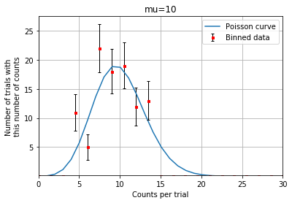 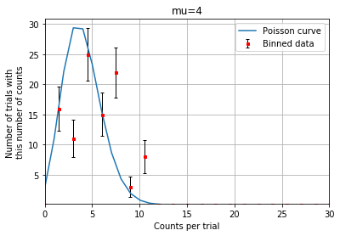

**Figure 12** The frequency distribution of observed numbers of counts for a set of 100 trials with mean number of counts per trial of approximately 4 with a bin width of 1.5 counts per interval. The data are compared to the Poisson distribution whose mean counting rate is the true value $μ=4$

**Figure 11 :** The frequency distribution of observed numbers of counts for a set of 100 trials with mean number of counts per trial of approximately 10 with a bin-width of 1.5 counts per interval. The data are compared to the Poisson distribution whose mean counting rate is the true value $μ=10$

* Figure 13 below shows the fraction of bins that agree with the Poisson curve within one standard deviation plotted against the mean rate.

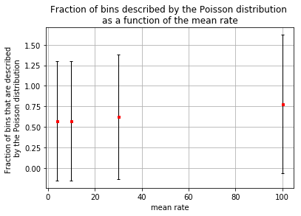

**Figure 13:** Plots showing the fraction of bins (shown in figures 9, 10, 11, and 12) that agree with the Poisson curve within one standard deviation on the vertical axis with the mean rate on the horizontal axis

For the plot above, the fraction of bins that are described by the distribution ($n_{a}$) is an estimate for the probability that any given bin will agree within uncertainty with the Poisson prediction. The uncertainty ($∆n_{a}$) shown by the error bars in figure 13 is given by;

$$∆n_{a}=\sqrt{n_{a}\left(1-\frac{n_{a}}{N_{bins}}\right)}$$

Where $N_{bins}$ is the number of bins for each data set.

**Discussion**

* **Arithmetic mean and sample variance of the data**

Table 1 lists the extracted mean and sample variance of the data sets considered for this report. Figure 3 plots the ratio of the sample variance to the arithmetic mean as a function of the arithmetic mean. Only two of the points have an uncertainty interval that includes the expected value on 1. The other 3 values do not include this expected value but are fairly close to 1. Not much conclusions can be drawn from this but we can still be sure that the hypothesis made for this report is not too far off.

* **The cumulative (running) average**

Figures 4, 5, 6, 7, and 8 show the cumulative averages as a function of the sequence number. For each of these plots we see that as more data is included the mean approaches the approximate mean count rate value. As more data is included the uncertainty decreases as the cumulative mean approaches the arithmetic mean values listed in table 1. An interesting observation is that the background approximate mean counting rate approaches a value of 4 counts per 10 seconds.

* **Poisson Plots**

Figures 9, 10, 11, and 12 compares the Poisson distribution of the true mean counting rate with a binned data set that represents the number of trials with a specific number of counts (with the associated uncertainty). Here we see that most of the binned data sets agree with the Poisson distribution of the mean count rate given within one standard deviation. These plots suggests that the hypothesis made for this experiment was reasonable. Of course we may never know the true mean count rate of the data obtained but the data obtained is close at least up to one standard deviation to the Poisson curves of the known mean count rates.

* Figure 13 shows the fraction of bins that agree with the Poisson curve within one standard deviation plotted against the mean rate. The uncertainties obtained for this plot are quite large, but the fractions (the red dots) are quite close to 0.68, hence we can be confident that at least the recorded data will always agree with the Poisson distribution 68% of the time.

**Conclusion**

After various tests we see that the data obtained lies sufficiently close to the Poisson curve and although the data may not agree with the distribution 100% of the time, we know that at least for 68% of the time, the data will be distributed according to a Poisson distribution and that is all that we need for the hypothesis made for this experiment to hold strongly.

**References**

[1] Glen Cowan, Statistical Data Analysis.

[2] <https://www.statisticshowto.com/statistical-analysis/#:~:text=Statistical%20analysis%20is%20the%20science,Find%20key%20measures%20of%20location>.

[3] <https://www.cancer.gov/publications/dictionaries/cancer-terms/def/ionizing-radiation>

[4] <https://www.osha.gov/ionizing-radiation/background#:~:text=Five%20types%20of%20ionizing%20radiation,Safety%20and%20Health%20Topics%20page>.

[5] <https://www.statisticshowto.com/probability-and-statistics/binomial-theorem/binomial-distribution-formula/>

[6]<https://en.wikipedia.org/wiki/Maximum_likelihood_estimation#:~:text=In%20statistics%2C%20maximum%20likelihood%20estimation,observed%20data%20is%20most%20probable>.

[7] <https://www.sciencedirect.com/topics/mathematics/sample-variance>

Oxford languages

<https://languages.oup.com/google-dictionary-en/>

Cosmos: The science of everything.

<https://cosmosmagazine.com/technology/how-does-geiger-counter-work/>

Wikipedia

<https://en.wikipedia.org/wiki/Geiger_counter>

<https://www.le.ac.uk/users/dsgp1/COURSES/LEISTATS/poisson.pdf>

Poisson Processes

<https://images-na.ssl-images-amazon.com/images/G/01/books/stech-ems/Intro-to-Stochastic-Modeling-4E-sample-9780123814166._V154961835_.pdf>

**Appendix A**

* **The arithmetic mean derivation.**

Suppose that one has n measurements of a random variable x assumed to be distributed according to a Gaussian probability density function of unknown mean ($μ$) and variance ($σ^{2}$). The log-likelihood function is

$$logL\left(μ,σ^{2}\right)=\sum_{i=1}^{n}{log}P\left(x_{i},μ,σ^{2}\right)=\sum_{i=1}^{n}{(log}\frac{1}{\sqrt{2π}}+\frac{1}{2}log\frac{1}{σ^{2}}-\frac{{{(x}_{i}-μ)}^{2}}{σ^{2}})$$

$$setting the derivative of logL with respect to μ equal to zero and solving gives$$

$$\overline{x}≡\frac{1}{N}\sum_{i=1}^{N}{x_{i}}$$

* To show that the arithmetic mean is an unbiased estimator we need to show that $E\left[\overline{x}\right]=μ$

By our hypothesis that the data set is distributed according to the Poisson distribution

$$E\left[\overline{x}\right]=E\left[\frac{1}{N}\sum_{i=1}^{N}{x_{i}}\right]$$

$$=\frac{1}{N}\sum_{i=1}^{N}{{E[x}_{i}]}$$

$${E[x}_{i}]=μ$$

$E\left[\overline{x}\right]=\frac{1}{N}\sum_{i=1}^{N}{μ}=\frac{1}{N}Nμ=μ$

**Appendix B**

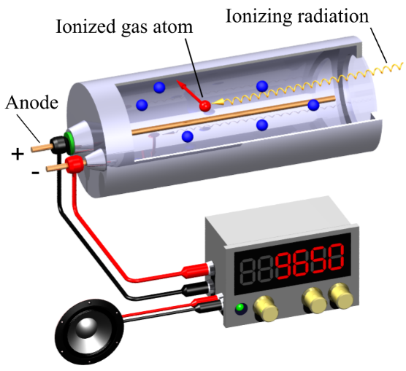1. A Geiger counter (also known as a Geiger–Müller counter) is an instrument used for detecting and measuring [ionizing radiation](https://en.wikipedia.org/wiki/Ionizing_radiation) from radioactive materials. The Geiger counter consists of a Geiger–Müller tube which is a hollow tube connected to the negative terminal of a high voltage power source. The tube is filled with an inert gas such as [helium](https://en.wikipedia.org/wiki/Helium), [neon](https://en.wikipedia.org/wiki/Neon), or [argon](https://en.wikipedia.org/wiki/Argon) at low pressure. A tungsten electrode is placed at the center of the tube and is connected to the positive terminal of the power supply.

When an atom decays due to an instability of the proton-neutron ratio within the nucleus, it releases by products in the form of energy(photons) and small ionizing particles. These ionizing particles are either electrons, alpha particles, or beta particles. When an element decays it can emit one or more of the particles mentioned above subject to the decay processes experienced by that element.

**Fig1: A Picture of a Geiger counter obtained from Wikipedia**

These ionizing particles have enough energy to collide with electrons of other atomic structures. Typically, an electron in the outermost shell of an atomic structure will absorb the energy of the photon or ionizing particle. If the energy is above a certain threshold the electron will be released from its atomic structure. This electron will then be attracted to the positively charged electrode. As it approaches the electrode, it will knock one or more electrons from their atomic structures and these electrons will knock other electrons from their atomic structures and the other electrons will knock other electrons from their atomic structures and so on. This is known as the [Townsend discharge](https://en.wikipedia.org/wiki/Townsend_discharge) effect. As ionization occurs within the Geiger–Müller tube, an electric field is set up within the tube. The positively charged ions are attracted to the tube whilst the electrons are attracted to the electrode. From the electrode, the electrons travel through to a resistor where a voltage drop is recorded and is interpreted as the presence of a radioactive element. From there, the electrons make their way back to the tube where they get attracted to the positive ions and the whole system returns to an equilibrium state. The time it takes for an ionizing particle to ionize an atom within the Geiger–Müller tube to setting an electric field within the Geiger–Müller tube to obtaining a reading of the voltage drop and for the whole system to return to an equilibrium state is known as dead time. This is the time in which any other ionizing radiation cannot be detected. During this time, the Geiger counter is said to be “dead”.

2. The formula for the Binomial distribution for an event to occur x times in z trials, where the probability of the event to occur in one trial is p is given down below.

$P\left(x;p,z\right)≡\frac{z!}{x!\left(z-x\right)!}p^{x}{\left(1-p\right)}^{z-x}$ (1)

The Poisson distribution is a limiting case of the binomial distribution which arises when the number of trials (z) is increased indefinitely whilst the expected value of the number of successes from the trials remains constant.

Let $μ≡pz$

In terms of $μ$ the formula for the binomial distribution can be written as;

$P\left(x;p,z\right)=\frac{μ^{x}}{x!}\frac{z!}{\left(z-x\right)!z^{x}}{\left(1-\frac{μ}{z}\right)}^{z}{\left(1-\frac{μ}{z}\right)}^{-x}$ (2)

Taking the limit as $z→∞$ of each of the products gives,

$\lim_{z→∞}\frac{z!}{\left(z-x\right)!z^{x}}=1$ (3)

$\lim_{z→∞}{\left(1-\frac{μ}{z}\right)}^{z}=e^{- μ}$ (4)

$\lim_{z→∞}{\left(1-\frac{μ}{z}\right)}^{-x}=1$ (5)

Recombining these limits gives the formula for the Poisson distribution.

$$P\left(x;μ\right)=\frac{μ^{x}e^{-μ}}{x!}$$

1. For question 1a we are required to prove $〈x〉=μ$

$$〈x〉=Σ_{x=0}^{∞}xP\left(x;μ\right)$$

The x=0 term gives zero, so we start the summation from x=1.

$$〈x〉={e^{-μ}Σ}_{x=1}^{∞}x\frac{μ^{x}}{x!}$$

$$={{μe}^{-μ}Σ}_{x=1}^{∞}\frac{μ^{x-1}}{(x-1)!}$$

$$={μe}^{-μ} \left(1+\frac{μ}{1!}+\frac{μ^{2}}{2!}+\frac{μ^{3}}{3!}+…\right)$$

$$={μe}^{-μ}e^{μ}$$

$=μ$

1. Required to prove $〈x^{2}〉=μ(μ+1)$

First, we evaluate $〈x(x-1)〉$

$$〈x(x-1)〉=Σ_{x=0}^{∞}x(x-1)P\left(x;μ\right)$$

$$=Σ_{x=0}^{∞}x(x-1)\frac{μ^{x}}{x!}e^{-μ}$$

$$=Σ_{x=2}^{∞}\frac{μ^{x}}{(x-2)!}e^{-μ}$$

$$=μ^{2}e^{-μ}Σ_{x=2}^{∞}\frac{μ^{x-2}}{(x-2)!}$$

$$=μ^{2}$$

$$〈x^{2}〉=〈x\left(x-1\right)〉+〈x〉$$

$${ =μ}^{2}+μ$$

1. Required to prove

3. Let X and Y be independent random variables having a Poisson distribution with parameters $μ$ and $ν$, respectively.

$$P\left(X+Y=n\right)=Σ_{k=0}^{n}P\left(X=k,Y=n-k\right)$$

Where $n≥0$

$$=Σ_{k=0}^{n}P\left(X=k)P(Y=n-k\right)$$

X and Y are independent.

$$=Σ_{k=0}^{n}(\frac{μ^{k}e^{-μ}}{k!})(\frac{ν^{n-k}e^{-ν}}{(n-k)!})$$

$$=(\frac{e^{-\left(μ+ν\right)}}{n!}) Σ_{k=0}^{n}\frac{n!}{k!\left(n-k\right)!}μ^{k}ν^{n-k}$$

$Σ_{k=0}^{n}\frac{n!}{k!\left(n-k\right)!}μ^{k}ν^{n-k}$ is the binomial expansion of ${(μ+ν)}^{n}$

$$∴ P\left(X+Y=n\right)=\frac{e^{-\left(μ+ν\right)}{(μ+ν)}^{n}}{n!}$$

$∴$ The sum X+Y has Poisson distribution with parameter $μ+ν$

4. $Γ\left(t\right)≡\int_{0}^{∞}{x^{t-1}e^{-x}}dx$

$$Γ\left(1\right)=\int_{0}^{∞}{x^{0}e^{-x}}dx$$

$$=-e^{-x}|_{0}^{∞}$$

$$=-(0-1)$$

$$=1$$

$$Γ\left(n\right)=\int_{0}^{∞}{x^{n-1}e^{-x}}dx$$

$$=\int_{0}^{∞}{x^{n-1}e^{-x}}dx$$

Using integration by parts we get,

$$=-x^{n-1}e^{-x}|_{0}^{∞}+(n-1)\int_{0}^{∞}{x^{n-2}e^{-x}}dx$$

Boundary terms at x=0 and x= $∞$ are zero,

$$=(n-1)\int_{0}^{∞}{x^{n-2}e^{-x}}dx$$

$$=(n-1)Γ\left(n-1\right)$$

Using the same procedure we find that $Γ\left(n-1\right)=\left(n-2\right)Γ\left(n-2\right)$

$$⇒ Γ\left(n\right)=\left(n-1\right)(n-2) Γ\left(n-2\right)$$

$$Γ\left(n-2\right)=\left(n-3\right)Γ\left(n-3\right)$$

$$⇒ Γ\left(n\right)=\left(n-1\right)(n-2) (n-3)Γ\left(n-3\right)$$

In general

5. The plot below shows the frequency distribution of counts when the average counts per interval is 1.5.

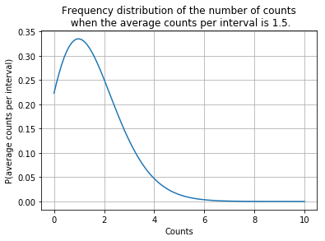

Fig2: The frequency distribution of the number of counts when the average counts per interval is 1.5.

6. The plot below shows the frequency distribution of the number of counts when the mean counting rate of a certain detector of random events is 2.1 counts.

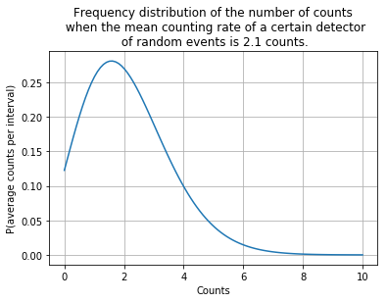

Fig2: The frequency distribution of the number of counts when the average counts per interval is 1.5.

$$P\left(x;μ\right)=\frac{μ^{x}}{x!}e^{-μ}$$

The probability of obtaining zero counts in a one-second counting interval where the meant counting rate of a certain detector of random events is 2.1 counts per second is.

$$P\left(0;2.1\right)=\frac{{2.1}^{0}}{0!}e^{-2.1}=1.22$$

From Fig2 above, we see that the most likely interval between successive pulses is

7. In this question we assume that the company used 20000 people for the drug test. The trial group consists of 10000 people and the control group also consists of 10000 people. We are given that in the control group, 3 people get sick and 2 people get sick in the trial group.

On average 3 out 10000 people in the control group get sick, therefore we let $μ=\frac{3}{1000}$.

2 out of 10000 people in the trial group get sick, so we let $ν=\frac{2}{10000}$

The probability that fewer than four people (this is the probability that either, 1, 2 or 3 people) would get sick in the trial group is,

$$P\left(ν\right)=e^{-2×{10}^{-4}}(\frac{{\left(2×{10}^{-4}\right)}^{1}}{1!}+\frac{{\left(2×{10}^{-4}\right)}^{2}}{2!}+\frac{{\left(2×{10}^{-4}\right)}^{3}}{3!})$$

$$P\left(ν\right)=1.999800013×{10}^{-4}$$

The probability that fewer than four people in the control group would get sick is,

$$P\left(μ\right)=e^{-3×{10}^{-4}}(\frac{{\left(3×{10}^{-4}\right)}^{1}}{1!}+\frac{{\left(3×{10}^{-4}\right)}^{2}}{2!}+\frac{{\left(3×{10}^{-4}\right)}^{3}}{3!})$$

$P\left(μ\right)=2.999550045×{10}^{-4}$

The probability ratio of the probability that less than four people would get sick in the trial group to the probability that less than four people would get sick in the control group is.

$$\frac{P\left(ν\right)}{P\left(μ\right)}=\frac{1.999800013×{10}^{-4}}{2.999550045×{10}^{-4}}≈0.6667$$

This tells us that compared to the people in the control group, only 66.67% of the people in the trial group would get sick. 33.33% of the people in the trial group would not get sick. Therefore, the companies claim that the drug cuts the disease rate by over 30% is true according to these calculations.

8. For one to conclude that the equipment has malfunctioned a number of factors would need to be considered. Suppose this happens whilst using a Geiger counter to detect the presence of a radioactive substance. In order to determine whether the Geiger counter (in the case of the given question, the equipment) has malfunctioned, one would use the same radioactive source on another Geiger counter and if the other Geiger counter reads a different count rate per hour, than these inconsistencies imply that something may be wrong with either one of the Geiger counters. This problem may be solved if we have a third Geiger counter which supports the observations of on of the Geiger counter. But even then, there is a chance that the other Geiger counter might have malfunctioned and in that case this comparison would not yield a reliable conclusion. Most often an experimentalist might not have more than one Geiger counter so each the experimentalist might call other experimentalists to borrow their Geiger counters or forget about this method of checking.

Another way to check would be to replace the radioactive source with sources of known energy and constructing an energy calibration using the voltages recorded by the Geiger counter. In this way we would be able to see if the Geiger counter is behaving as expected. Doing the same calibration over a period of time is also a good way to check if similar results are obtained every time.

If all these methods fail, repeating the exact experiment over time and comparing the results is another way to check that the Geiger counter still works as expected.

After considering all of these options, if the Geiger counter does not pass any of these tests, then chances are that the Geiger counter (or in this case the equipment) is malfunctioning.