PHENIKAA UNIVERSITY
PHENIKAA SCHOOL OF COMPUTING



MAJOR ASSIGNMENT : SOFTWARE ARCHITECTURE
TOPIC : SOFTWARE DEVELOPMENT OF SHOE SALES WEBSITE
INSTRUCTORS : VŨ QUANG DŨNG
GROUP 9 - CLASS : NO1

MEMBERS : Nguyễn Trường Thành - 23010672
Trương Đình Sơn - 23010527
Vũ Quốc Toản - 23010003

Hà Nội , Tháng 6 Năm 2026

PREFACE
In the era of strong digital technology, e-commerce is increasingly affirming its important role in business activities. Building online sales systems not only helps businesses expand their market but also improves customer experience. Besides, Microservices architecture is becoming a trend in software development thanks to its scalability, maintenance, and flexible deployment. Stemming from that fact, our team carried out the project "Building a shoe sales website according to Microservices architecture" in order to apply the knowledge learned to build a complete online sales system. Through the project, the team had the opportunity to consolidate their professional knowledge, practice teamwork skills and gain experience in the software development process.

ACKNOWLEDGMENTS
Our team would like to express our sincere thanks to the teachers for their dedication to teaching and imparting valuable knowledge during the learning process. In particular, the team would like to sincerely thank the instructor for always enthusiastically guiding, suggesting and supporting the team during the implementation of the project, helping the team complete the report and product on schedule. Finally, the team would like to thank family, friends and team members for always encouraging, supporting and coordinating effectively during the implementation of the project. Thank you very much!

Contents
CHAPTER 1: PROJECT OVERVIEW 1
1.1. Problem Setting 1
1.2. Project objectives 2
1.3. Project scope 2
1.4. Overview of the technology used 3
CHAPTER 2: REQUIREMENTS ANALYSIS (SRS) 5
2.1. Functional Requirements 5
2.2. Non-Functional Requirements 8
2.3: Use Case Diagram 10
UC-01: Place Order 11
UC-02: Login 12
UC-03: Add to Cart 13
UC-04: Admin – Product Management 14
UC-05: Inventory Management & Warehousing (Admin – Inventory) 15
2.4. Requirements of Architectural Importance (ASRs) 18
2.4.1. Why ASR is Important 18
2.4.2. Utility Tree — Defining ASRs 18
2.4.3. ASR and Architecture Driver Tables 19
2.4.4. Ánh xạ ASR → Architecture Driver 21
CHAPTER 3: SYSTEMS ARCHITECTURE AND DESIGN (SDD) 22
3.1. Architectural Style Selection 22
3.1.1. Theoretical foundations 23
3.1.2. Comparison of architectures and reasons for choice 23
3.2. Overall system architecture 24
3.2.1. KickZone Architecture Model 24
3.3. C4 Model — Architectural Documentation 27
3.3.1. C4 Level 1 — System Context Diagram 27
3.3.2. C4 Level 2 — Container Diagram 30
3.3.3. C4 Level 3 — Component Diagram (Product Service) 31
3.4. Database Design 33
3.4.1. Database-per-Service Principles 33
3.4.2. Overview of databases 33
3.4.3. Special design points 34
3.5. API Design (RESTful) 38
3.5.1. Applicable REST Principles 38
3.5.2. Full API Table 38
3.6. UML Chart 42
3.6.1. Class Diagram 42
3.6.2. Activity Diagram 43
3.7. Architecture Decision Records (ADR) 45
ADR-001: Choosing a Microservices Architecture 46
ADR-002: Authentication with JWT at API Gateway 47
ADR-003: MySQL Transaction for Order Flow 48
ADR-004: Selecting MySQL as Database 49
3.8. UI Prototype 50
CHAPTER 4: IMPLEMENTATION 52
4.1. Development Environment and Tools 52
4.2. Project Directory Structure 54
4.3. Outstanding implementation techniques 57
4.3.1. JWT Authentication Mechanism at API Gateway (ADR-002) 57
4.3.2. Secure Registration and Login Mechanism (Auth Service) 59
4.3.3. MySQL Transaction in Order Flow (ADR-003) 61
4.3.4. Product Search, Filtering and Paging (Product Service) 64
4.3.5. Cart with real-time inventory check (Cart Service) 65
4.4. System Screenshots 67
4.4.1. Homepage and product listings 67
4.4.2. Product detail pages 69
4.4.3. Cart and checkout page 69
4.4.4. Customer Order Page 70
4.4.5. Admin Page — Dashboard and Management 71
4.4.6. Login and Registration Page 73
CHAPTER 5: SYSTEM TESTING 76
5.1 Test Plan 76
5.2 Test Cases 76
5.2.1 Authentication Testing 77
5.2.2 Product Service Testing 78
5.2.3 Cart Service 79
5.2.4 Order Service 80
5.2.5 Warehouse & Catalog Management Testing 81
5.3 Summarizing Test Results 82
5.4 Attribute Quality Testing [Optional] 83
5.4.1 Performance Testing 83
5.4.2 Security Testing 83
CHAPTER 6: IMPLEMENTATION & USER GUIDE 85
6.1 System Requirements 85
6.2 Installation & Running Instructions 85
6.2.1 Step 1 - Prepare the Source Code 85
6.2.2 Step 2 – Initialize the Database 86
6.2.3 Step 3 – Configuring Environment Variables 86
6.2.4 Step 4 - Starting the Service 86
6.3 Demo Account 87
6.4 INSTRUCTIONS FOR USE OF KEY FUNCTIONS 88
6.4.1 Procurement function (for customers) 88
6.4.2 Admin Functions (For Admins) 88
CHAPTER 7: CONCLUSION & DEVELOPMENT DIRECTIONS 90
7.1 Results achieved 90
7.2 Limitations and Challenges 91
7.2.1 Technical Limitations 91
7.2.2 Function Restrictions 92
7.2.3 Development challenges 92
7.3 Conclusion 93
REFERENCES 95

CHAPTER 1: PROJECT OVERVIEW

1.1. Problem Setting
E-commerce is growing at a remarkable pace in Vietnam. According to a report by the Vietnam E-Commerce Association (VECOM), Vietnam's B2C e-commerce revenue in 2023 will reach more than 20 billion USD, an average growth of over 25% per year. In particular, the fashion and footwear industry is one of the sectors with the strongest online growth, with millions of transactions arising every day on major platforms.
However, most traditional and small and medium-sized (SME) shoe stores are still operating manually or using outdated monolithic systems. These systems face many serious limitations: they cannot scale when traffic spikes on promotional occasions; difficult to maintain when the business logic of many different features is tightly coupling; Updating a small feature requires a full system redeployment, causing risks and service disruptions.
In addition, inventory management according to each shoe size is a complex problem specific to the industry. A pair of shoes can come in up to 10–12 different sizes, each with a separate amount of inventory. The system does not accurately manage inventory by size, leading to overselling or lost sales opportunities due to misdisplaying information.
Stemming from the above practical problems, the team proposed to build the KickZone system – an online shoe sales website applying the Microservices architecture. This architecture allows each core business feature (authentication, product, cart, order, user profile) to be independently developed, deployed, and extended, radically addressing the limitations of a monolithic architecture.

1.2. Project objectives
The KickZone project sets specific, measurable goals according to SMART criteria as follows:
- Building an online shoe sales web application includes at least 8 core business functions: registration/login, product viewing and search, cart management, ordering, order tracking, inventory management by size, catalog/brand management, and revenue statistics.
- Applying the Microservices architecture as the main architecture of the system: separating into 5 independent microservices (Auth Service, Profile Service, Product Service, Cart Service, Order Service) communicating via API Gateway, each service has its own database.
- Capture all critical architectural decisions through Architecture Decision Record (ADR) documents, system descriptions according to the C4 model (Level 1 to Level 3), and standardized RESTful API design according to v1 version.
- Complete the system to operate stably, can fully demo business flows (login, purchase, payment, administration) within 10 weeks of development.

1.3. Project scope
The project focuses on the functions and scope clearly defined below:

Classification | Contents
Within the range | User authentication (registration, login, JWT); View products, search, filter by category and brand; Shopping cart management; Order and track order status; Manage products, categories, brands, inventory by size; Order and user management (Admin); Basic revenue statistics; API Gateway centralizes authentication and routing.
Out of Scope | Integration of online payment gateways (VNPay, MoMo); Mobile Application; Multilingual support; AI/ML product suggestion system; Third-party carrier integration; Deploy to a physical cloud environment.

Table 1.1: KickZone Project Scope

1.4. Overview of the technology used
The KickZone system is built on a modern technology platform, in accordance with the Microservices architecture and development requirements within 10 weeks of the team of 3 members:

Layers | Technology | Reasons for choice
Frontend | React.js 18, React Router, Axios, CSS | Popular component-based library, large ecosystem, SPA fit
API Gateway | Node.js + Express.js + http-proxy-middleware | Lightweight, easy to configure proxies, suitable as a single entry point
Backend Services | Node.js + Express.js (5 microservices) | Consistent with API Gateway, efficient I/O async, REST-friendly
Authentication | JWT (jsonwebtoken) + bcrypt | Stateless Matching Microservices; bcrypt password security
Database | MySQL (5 separate databases) | ACID compliance, good relationship for shoe/order data, each service owns an independent DB
Internal Communication | HTTP/REST (axios between services) | Simple, easy to debug; Suitable for small group sizes
Version Control | Git / GitHub | Manage source code, commit history, division of team work
Dev Environment | Windows, Node.js v20 LTS, npm | Quick Installation, Convenient start-all.bat Scripting for Windows
Diagram Tool | Draw.io / Structurizr, PlantUML | Supports C4 Model and UML, high-quality SVG/PNG export

Table 1.2: Overview of the technology used in the KickZone project

The choice of Node.js + Express.js for the entire backend (both API Gateway and 5 microservices) ensures consistency in programming languages, allowing the team of 3 members to flexibly support each other in the development process without context switching between different languages. MySQL was chosen over NoSQL because of its shoe data, inventory by size, order structure with a clear relational structure, and high data integrity requirements (ACID transactions), especially in the order flow that combines inventory reduction and order creation.

CHAPTER 2: REQUIREMENTS ANALYSIS (SRS)

2.1. Functional Requirements
The KickZone system serves two main groups of users: Customers and Admins. Functional requirements are determined based directly on the analysis of the source code and database of the system:

Code | Features | Detailed Description | Priority
FR01 | Register an account | Users enter their full name, email, and password to create an account. The system checks for duplicate emails, hashes passwords with bcrypt (salt 10 rounds), returns JWT tokens upon successful registration. | High
FR02 | System Login | The user enters the email/password. Auth Service authenticates with bcrypt, issuing JWT tokens containing ids, emails, roles. The token is stored at the client (localStorage) and attached to every subsequent request via the Authorization: Bearer header. | High
FR03 | View product list | Displays paginated product listings (12 products/page), supports search by name/description, filters by brand, category, price range. Displays the total inventory of each product. | High
FR04 | View Product Details | Display full product information: name, description, price, brand, category, image, and inventory by size (e.g., size 39: 10 pairs, size 40: 15 pairs). | High
FR05 | Shopping cart management | Logged-in users can add products to the cart (select the required size), update the quantity, or delete products. Cart Service checks inventory before adding it, preventing adding more than enough inventory. | High
FR06 | Order Now | The user confirms the cart, enters the shipping address, and phone number. Order Service creates orders in the transaction: calculate the total amount, save the product list, call the Product Service to remove the inventory, call the Cart Service to delete the cart. | High
FR07 | Order Tracking | Users view their order history and status (pending → confirmed → shipping → delivered/cancelled) with a list of products and total amounts. | High
FR08 | Personal Profile Management | Users view and update their names, phone numbers, and addresses. The Profile Service stores extended information separately from the Auth Service. | Medium
FR09 | Admin – Product Manager | Admin performs product CRUD including inventory by size. When creating a product, enter the quantity for each size. When updating, replace the entire stock table with the new size. | High
FR10 | Admin – Brand & Portfolio Management | Admin implements CRUD Brand and Category. The catalog has a slug field to filter products by friendly URLs. | Medium
FR11 | Admin – Inventory Management | The admin views the entire inventory by size, creates a warehouse receipt from the supplier, and the system automatically adds the quantity to the product_stock when confirming the receipt. | High
FR12 | Admin – Order Management | Admin views all orders of all users, updates order status (confirmed, shipping, delivered, cancelled). | High
FR13 | Admin – User Management | Admin can view the list of accounts, delete user accounts (accounts with admin roles cannot be deleted). | Medium
FR14 | Admin – Revenue Statistics | Admin view the dashboard summarized: total revenue, number of orders by status, top selling products, revenue chart over time. | Medium
Table 2.1: KickZone System Function Requirements List

2.2. Non-Functional Requirements
Non-functional requirements are defined according to a Quality Attribute Scenario (QAS) structure consisting of 6 components: Stimulus Source → Stimulus → Artifact → Environment → Response → Measurement Indicators. These are the most important architectural constraints of the system:

Attributes | Requirements | Quality Attribute Scenario | Measurement Index
Performance | API response time < 2 seconds for 95% of typical requests | Source: End users. Stimulation: Send product search requests. Artifact: Product Service. Environment: Normal operation (≤ 50 concurrent users). Response: Returns the paging result. Measurement: P95 < 2s | P95 < 2 seconds
Availability | The system works stably during office hours | Source: User. Stimulation: Visit any page. Artifact: API Gateway + full service. Environment: Office Hours. Feedback: The system processes and returns the results. Measurement: Uptime ≥ 99% during demo time | Uptime ≥ 99%
Security | JWT authentication and RBAC decentralization (user/admin) | Source: Hacker/unauthenticated user. Stimulation: Invoking an endpoint that requires a Bearer token without a token or counterfeit token. Artifact: API Gateway middleware. Environment: All the time. Response: Decline the request. Measurement: 100% of invalid requests blocked, HTTP 401/403 | 100% block unauthorized requests
Data Consistency | Order successfully → inventory reduced correctly, cart cleared correctly | Source: Customer. Stimulation: Place an order. Artifact: Order Service (transaction). Environment: Normal. Feedback: Commit the transaction when all steps are successful, rollback when there is an error. Measurement: 0 instances of data inconsistency loss | 0 data inconsistency
Maintainability | Each service is independent, deploying/updating does not affect other services | Source: Developer. Stimulus: Updated Product Service logic. Artifact: Product Service. Environment: Development. Response: Just restart Product Service. Measurement: Time to deploy a service < 2 minutes | Deploy 1 service < 2 minutes
Usability | Responsive interface on multiple screen sizes | Source: Mobile/desktop users. Stimulation: Access on 375px to 1920px devices. Artifact: React Frontend. Environment: Any device. Feedback: The interface displays the correct layout. Measurement: No layout breakage on 3 test screen sizes | Display correctly on 375px – 1920px
Table 2.2: Non-functional requests by Quality Attribute Scenario structure

2.3: Use Case Diagram
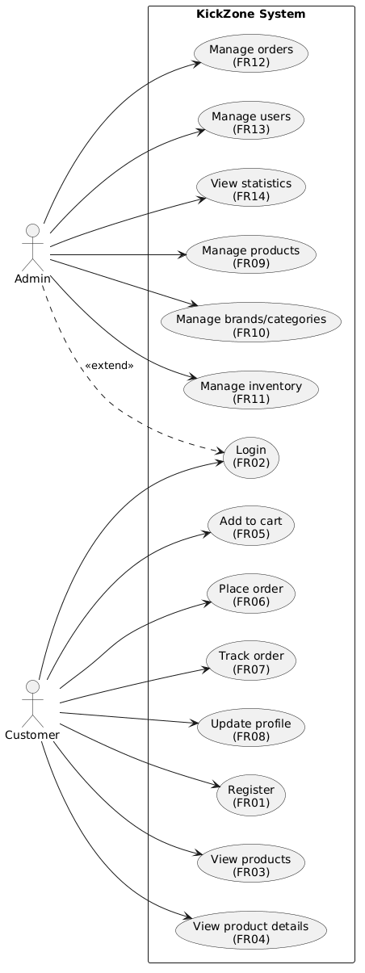
Figure 2.1: KickZone system overview use case chart

UC-01: Place Order
Mã Use Case | UC-01
Tên Use Case | Place Order
Actor chính | Logged-in Customer
Pre-condition | The customer has logged in to the system; a shopping cart with at least 1 product; Each product in the basket has enough inventory according to the selected size.
Post-conditioning | The order is created with a 'pending' status; inventory according to the size of each product is deducted in the right quantity; the user's shopping cart is wiped clean.
Main Stream | 1. Customers click 'Proceed to order' on the shopping cart page. 2. The system displays the Checkout page with a form to enter the delivery address and phone number. 3. Customers fill in the information and click 'Confirm Order'. 4. Order Service calls Cart Service to get the current cart list. 5. Order Service calculates the total amount, creates an order record and order details in the transaction. 6. Order Service calls Product Service minus inventory by product/size. 7. Order Service calls Cart Service to delete the entire cart. 8. Commit transaction, return orderId and order notification successful.
Alternate Flow | 3a. Customer does not enter the shipping address: the system displays a validation error, does not send a request.
Exception flow | 6a. Insufficient inventory (race condition): The Order Service called the Product Service failed → rollback the entire transaction → returned HTTP 500, error message, the order was not created. 8a. Database connection error: rollback transaction, return HTTP 500.
Table 2.3: Use Case UC-01 Description – Ordering

UC-02: Login
Mã Use Case | UC-02
Tên Use Case | Login
Actor chính | Client / Administrator (not logged in)
Pre-condition | The user already has an account in the system (db_auth).
Post-conditioning | Users receive JWT tokens; frontend stores tokens to localStorage; AuthContext updates the login status; navigate to the home page (user) or the Admin Dashboard (admin) page.
Main Stream | 1. The user accesses the /login page, enters the email and password. 2. The frontend calls POST /api/auth/login via API Gateway. 3. API Gateway proxy request to Auth Service (port 5001). 4. Auth Service queries db_auth find users by email. 5. Auth Service compares passwords with bcrypt.compare(). 6. Auth Service issues JWT tokens containing { id, email, role } with configuration duration. 7. Frontend receives tokens, saves them to localStorage, updates AuthContext. 8. Navigation: role='admin' → /admin; role='user' → /.
Alternate Flow | 1a. Logged-in users access /login: automatically redirect to the home page.
Exception flow | 5a. Wrong password or non-existent email: Auth Service returns HTTP 401 with the generic message 'Incorrect email or password.' (no specific information is disclosed).
Table 2.4: UC-02 Use Case Description – Login

UC-03: Add to Cart
Mã Use Case | UC-03
Tên Use Case | Add products to cart
Actor chính | Logged-in customers
Pre-condition | The user is logged in; are on the product detail page; The product exists in the system.
Post-conditioning | Cart Item created or updated in quantity in db_cart; The quantity does not exceed the inventory by size.
Main Stream | 1. The user selects the size from the inventory list according to the size displayed on the page. 2. The user presses the 'Add to Cart' button. 3. Frontend calls POST /api/cart with { product_id, size, quantity=1 }. 4. Cart Service calls Product Service GET /api/products/:id to get information and inventory. 5. Cart Service checks inventory by size: sizeStock.quantity >= quantity. 6. If the product+size is already in the basket: add the quantity (check not to exceed the inventory). 7. If not already: INSERT a new cart_item with snapshot product information (name, price, picture). 8. Return HTTP 200, 'Added to cart!' message
Alternate Flow | 1a. Users have not selected the size: the 'Add to cart' button is disabled on the frontend.
Exception flow | 5a. Size Out of Stock: Cart Service pays HTTP 400 'Size X insufficient inventory.' 6a. Overstock: HTTP 400 'Only Y Double Size X.'
Table 2.5: Use Case UC-03 Description – Add Products to Cart

UC-04: Admin – Product Management
Mã Use Case | UC-04
Tên Use Case | Product Manager (Admin)
Actor chính | Admin
Pre-condition | Admin logged in with role='admin'; JWT tokens are valid.
Post-conditioning | Product and inventory information by size in the db_product are added/updated/removed correctly.
Main Stream | 1. Admin go to the /admin/products page. 2. The system displays the list of products with total inventory. 3a. Add new: Admin click 'Add product', enter information + inventory by size → POST /api/products (Admin auth). 3b. Update: Admin click 'Edit', adjust the information/size → PUT /api/products/:id. 3c. Delete: Admin click 'Delete', confirm → DELETE /api/products/:id (cascade delete product_stock). 4. API Gateway checks isAdmin middleware before the proxy arrives at the Product Service. 5. Product Service in transaction: upsert product → remove old stock → insert new stock according to size.
Exception flow | 4a. Token without admin privileges: API Gateway pays HTTP 403 Forbidden.
Table 2.6: Description of Use Case UC-04 – Product Management (Admin)

UC-05: Inventory Management & Warehousing (Admin – Inventory)
Mã Use Case | UC-05
Tên Use Case | Inventory management and warehousing
Actor chính | Admin
Pre-condition | The admin is logged in with role='admin'.
Post-conditioning | Warehouse receipts are kept in db_product (tables import_receipts, import_receipt_items); The number of product_stock is added according to each product/size.
Main Stream | 1. Admin access /admin/inventory, view the current inventory list by product and size. 2. Admin creates an entry form: select Supplier, add details (product, size, quantity, import price). 3. Admin confirms the warehousing. 4. Inventory Controller creates import_receipt, inserts import_receipt_items, adds quantity to product_stock (INSERT... ON DUPLICATE KEY UPDATE quantity = quantity + ?). 5. The system displays the notification of successful warehousing and updates the inventory display.
Exception flow | 2a. Supplier not yet in the system: Admin creates a new Supplier first.
Table 2.7: Use Case UC-05 Description – Inventory Management

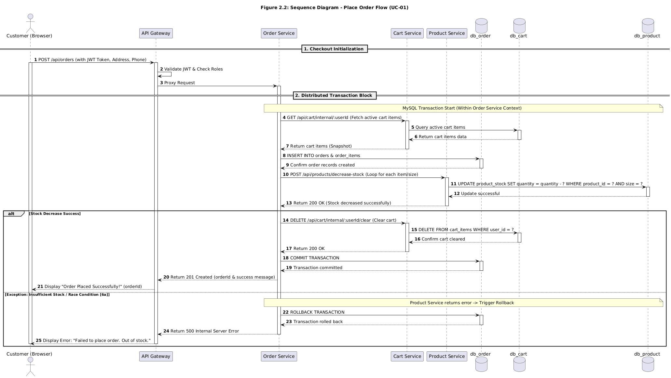
Picture 2.2:Place order flow(UC-01)

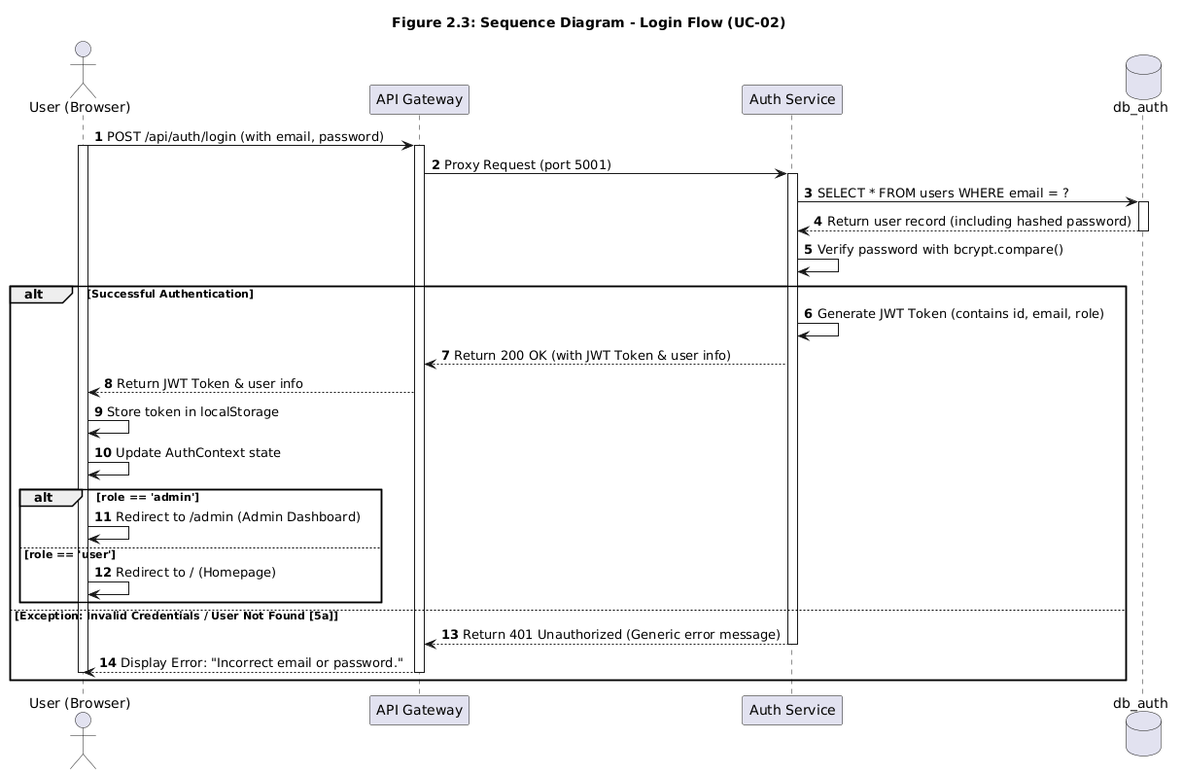
Picture 2.3: Login Flow(UC-02)

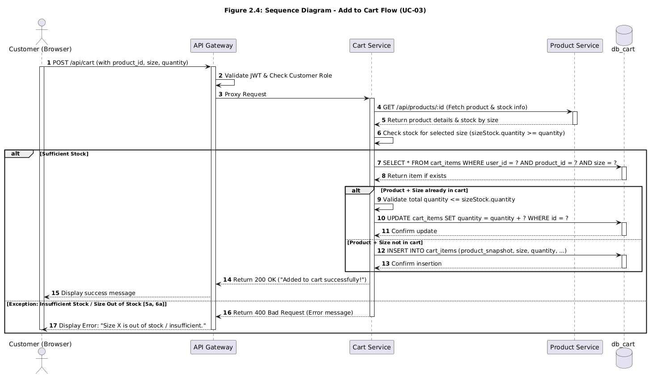
Picture 2.4 Add to cart flow(UC-03)

2.4. Requirements of Architectural Importance (ASRs)

2.4.1. Why ASR is Important
Architecturally Significant Requirements (ASRs) are a subset of system requirements that have a disproportionate impact on software architecture. According to Bass, Clements & Kazman (Software Architecture in Practice, 4th ed.), an ASR is a requirement that has a measurable and significant impact on architecture. Not every requirement shapes architecture — ASRs are requirements that require an architectural trade-off, constraint on technology choices, or define the overall structure of the system.
A good example in KickZone: the 'User-Orderable' requirement is satisfying for nearly any architecture. But the requirement 'Order must be atomic — if inventory subtract fails, order rollback must be used' directly decides that the Order Service must use MySQL Transactions and communicate synchronously with the Product Service and the Cart Service in the same transaction block, eliminating pure event-driven architecture options.

2.4.2. Utility Tree — Defining ASRs
The Utility Tree (Kazman, 2001) is the standard ATAM method for separating the system value (utility) into quality attributes, which are then into specific testable scenarios. Each leaf scenario is evaluated in 2 dimensions:
- Business Value (BV): High / Medium / Low — How important is this requirement to stakeholders?
- Architectural Impact (AI): High/Medium/Low — To what extent does satisfying this requirement bind the architecture?
The evaluated scenarios (High, High) or (High, Medium) are true ASRs, which need to be explicitly addressed in the architectural design (Chapter 3).
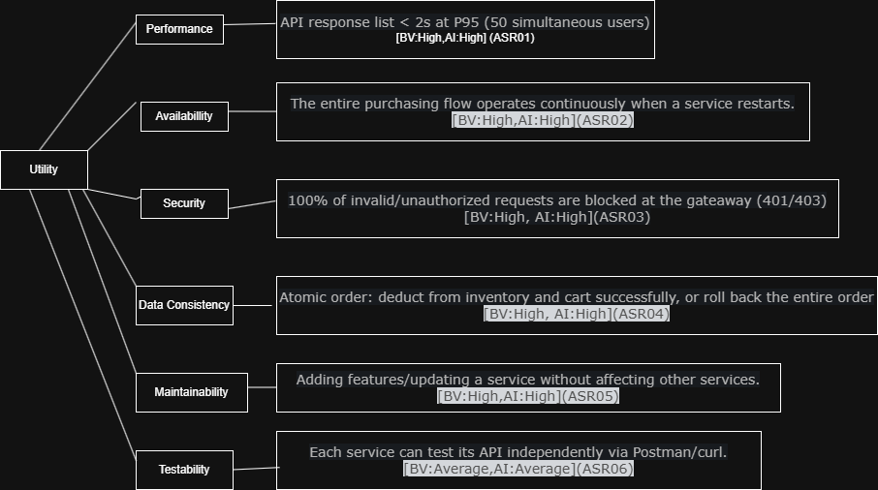
Picture 2.5: Utility tree

2.4.3. ASR and Architecture Driver Tables
After identifying ASRs via the Utility Tree, the table below maps each ASR to the specific architectural decision it drives:

CL Properties | ASR Scenario (summary) | BV Value | KT Impact | Architecture Driver
Performance | Product listing API (search + pagination) responds < 2s at P95 with 50 concurrent users | High | High | Stateless REST API + MySQL Index + phân trang server-side (LIMIT/OFFSET)
Availability | The entire flow of purchases (find products → add carts → place orders) works continuously; Each service can be rebooted independently without crashing the entire system | High | High | Microservices Architecture: 5 separate services; API Gateway Error Handling Service (HTTP 502 gracefully)
Security | Users who are not logged in cannot access cart/order/profile; Admins can access the Admin API | High | High | JWT Bearer + RBAC middleware at API Gateway; isAdmin guard for the admin route
Consistent DL | Order: subtract inventory and delete cart must atomic; if the inventory is subtracted from failure, the full rollback | High | High | MySQL Transaction in Order Service; Call Product Service & Cart Service in the same transaction block
Maintainability | Adding features to a Product Service (e.g., adding a product field) doesn't require editing other services | Medium | High | Database-per-Service: each service owns its own DB; communication via HTTP API, not shared schema
Testability | Each service can test the API independently via Postman/curl without starting the entire system | Medium | Medium | Clear Controller → Route Structure; dotenv allows flexible configuration of service URLs
Usability | The responsive React interface displays correctly on mobile (375px) and desktop (1920px) | High | Low | React.js + CSS responsive; No special architecture required → low architectural impact
Table 2.8: Utility Tree – ASRs of the KickZone system

Comment: The High Architectural Impact ASRs (ASR01–ASR05) all aim for the same architectural choices: Microservices with Database-per-Service, JWT-based authentication at the API Gateway, and MySQL Transaction for data consistency in the order flow. This is the foundation for the team to choose the architecture in Chapter 3.

2.4.4. Ánh xạ ASR → Architecture Driver
ASR Code | Summary scenario | CL Properties | Architecture Driver → ADR liên quan
ASR01 | Product API < 2s, P95, 50 user | Performance | REST stateless + MySQL Index → ADR-001 (Microservices)
ASR02 | The entire purchase flow does not collapse when 1 service restarts | Availability | Microservices Architecture + API Gateway → ADR-001
ASR03 | 100% of unauthorized requests blocked (401/403) | Security | JWT+RBAC at Gateway → ADR-002 (JWT Auth)
ASR04 | Atomic order: rollback if deducting inventory errors | Data consistency | MySQL Transaction trong Order Service → ADR-003
ASR05 | Updating the Product Service does not affect other services | Maintainability | Database-per-Service → ADR-001
ASR06 | Each service test is independent over HTTP | Testability | Stateless REST + env config → ADR-001
Table 2.9: Mapping the ASR to the Architecture Driver and the corresponding ADR

CHAPTER 3: SYSTEMS ARCHITECTURE AND DESIGN (SDD)

3.1. Architectural Style Selection

3.1.1. Theoretical foundations
According to Bass, Clements & Kazman (Software Architecture in Practice, 4th ed.), software architecture is organized around two core concepts:
- Component: An independent implementation unit with a well-defined interface. Can be replaced or reused without affecting the rest of the system. In KickZone, each microservice (Auth Service, Product Service, etc.) is a Component.
- Connector: The communication mechanism between the components. In KickZone, the main connector is HTTP/REST through the API Gateway, and internal HTTP calls between the Order Service and the Cart Service and the Product Service.

It is necessary to clearly distinguish two levels of design:
- Architectural Style: High-level design principles that define how the entire system is organized. KickZone uses Microservices Architecture.
- Architectural Pattern: A specific solution to the problem of repetition, applied within a style. KickZone uses the API Gateway Pattern and the Database-per-Service Pattern.

3.1.2. Comparison of architectures and reasons for choice
Architecture | Characteristics | When to use | KickZone Fit
Layered (3-tier) | Presentation → Business → Data Stratification; The upper layer only depends on the lower layer | Small CRUD application, small team, clear scope | Not enough—no support for feature-based deployment standalone
Microservices | Small, independent services; Separate DB; HTTP/Message communication | Large system, distributed team, need to scale independently of each module | KickZone's Choice — Suitable for 5 Separate Business Domains
Event-Driven | Communication via event/message queue; loose coupling; async | Real-time, audit trail, multi-service notification | Not a good fit — requires a message broker, increases operational complexity
MVC Monolith | Whole logic in one application; Model-View-Controller | Server-side rendering, prototype nhanh | Not suitable — tight coupling, difficult to scale peak sales features
Table 3.1: Comparison of popular architectures and reasons for choosing Microservices for KickZone

The Microservices architecture was chosen because the KickZone system has 5 naturally separate business domains (authentication, profile, product/warehouse, shopping cart, order), each with its own data model and update lifecycle. Splitting into 5 independent services with 5 separate databases allows each domain to grow, deploy, and expand without affecting other domains — this is the requirement set out in Chapter 2 by ASR01, ASR02, and ASR05.

3.2. Overall system architecture

3.2.1. KickZone Architecture Model
The KickZone system applies Microservices Architecture in combination with two important Architectural Patterns:
- API Gateway Pattern: All requests from the frontend pass through a single entry point — the API Gateway (port 8000). The gateway is responsible for JWT authentication, checking Admin permissions, and proxy requests to the respective service. This ensures that the frontend doesn't know the internal address of each service.
- Database-per-Service Pattern: Each of the 5 services owns an independent MySQL database (db_auth, db_profile, db_product, db_cart, db_order). No service directly accesses the other service's database — communicates only through the HTTP API. This is a necessary condition for the independence of ASR05 (Maintainability) deployment and support.

The table below summarizes all the services in the system:

Service | Port | Database | Technology | Responsibilities
API Gateway | 8000 | — | Node.js + Express + http-proxy-middleware | Single entry point; JWT authentication; RBAC decentralization; proxy to the appropriate service; Health Check
Auth Service | 5001 | db_auth | Node.js + Express + bcryptjs + jsonwebtoken | Registration, login, distribution of JWT tokens; user list management (Admin)
Profile Service | 5002 | db_profile | Node.js + Express | Store and update user extension information (name, phone, address, avatar)
Product Service | 5003 | db_product | Node.js + Express | CRUD products, inventory by size, brand, category, supplier, receipt
Cart Service | 5004 | db_cart | Node.js + Express + axios | Shopping cart management; check inventory with Product Service; internal API for Order Service
Order Service | 5005 | db_order | Node.js + Express + axios | Creating orders (MySQL transaction); Call Product & Cart Service; Single Status Management
Frontend | 3000 | — | React.js 18 + React Router + Axios + CSS | SPA; render UI; call all APIs via API Gateway port 8000
Table 3.2: Overview of services in the KickZone system

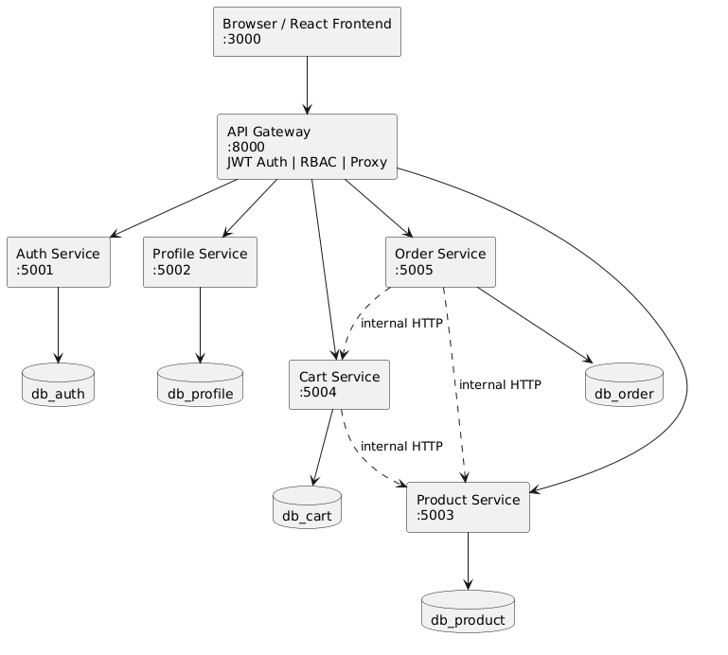
Picture 3.1:Architerture model

3.3. C4 Model — Architectural Documentation
The C4 model (Simon Brown, 2018) is a method of documenting software architecture in 4 levels of abstraction. The name C4 stands for Context, Containers, Components, and Code. The common problem-solving model is that the architecture diagram is too abstract or too detailed, by providing 4 levels of clear zoom that serve different reading objects.

3.3.1. C4 Level 1 — System Context Diagram
Purpose: Show the big picture — who uses the system, which external system interacts with. This is the level for business stakeholders and product owners.
External Objects and Systems in KickZone:
- Customer (Web Browser): Customers browse products, add to carts, place orders, and track orders.
- Administrator (Web Browser): Administrators manage products, inventory, orders, and view statistics.
- KickZone Platform (system under construction): The entire system of selling shoes online.
Note: KickZone does not integrate the actual external system (no payment gateway, shipping provider). This is a deliberate decision that falls within the Out-of-Scope defined in Chapter 1, reflecting the size and 10-week duration of the project.

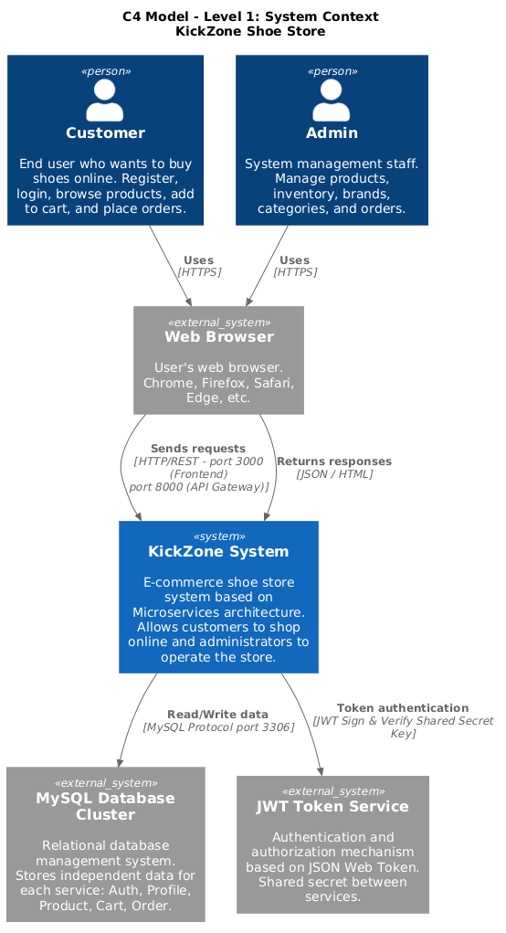
Picture 3.2:C4 model-level 1

3.3.2. C4 Level 2 — Container Diagram
Purpose: Zoom inside the KickZone Platform and display containers — units that can be deployed independently. This is the level for software architects and DevOps.
Containers in KickZone:
- React SPA (port 3000): The React app runs in a browser. Call all APIs through API Gateway. Do not call any microservices directly.
- API Gateway (port 8000): Node.js + Express + http-proxy-middleware. Unique entry point, JWT authentication, permission checking, proxy request.
- Auth Service (port 5001) + db_auth: Validation, token issuance. Database: users table.
- Profile Service (port 5002) + db_profile: Extended user profile. Database: profiles table.
- Product Service (port 5003) + db_product: Product, warehouse, brand, catalog, warehousing. Database: 7 tables.
- Cart Service (port 5004) + db_cart: Shopping cart. Call Product Service to check inventory. Database: table cart_items.
- Order Service (port 5005) + db_order: Order. Call Cart Service and Product Service in the transaction. Database: orders, order_items.

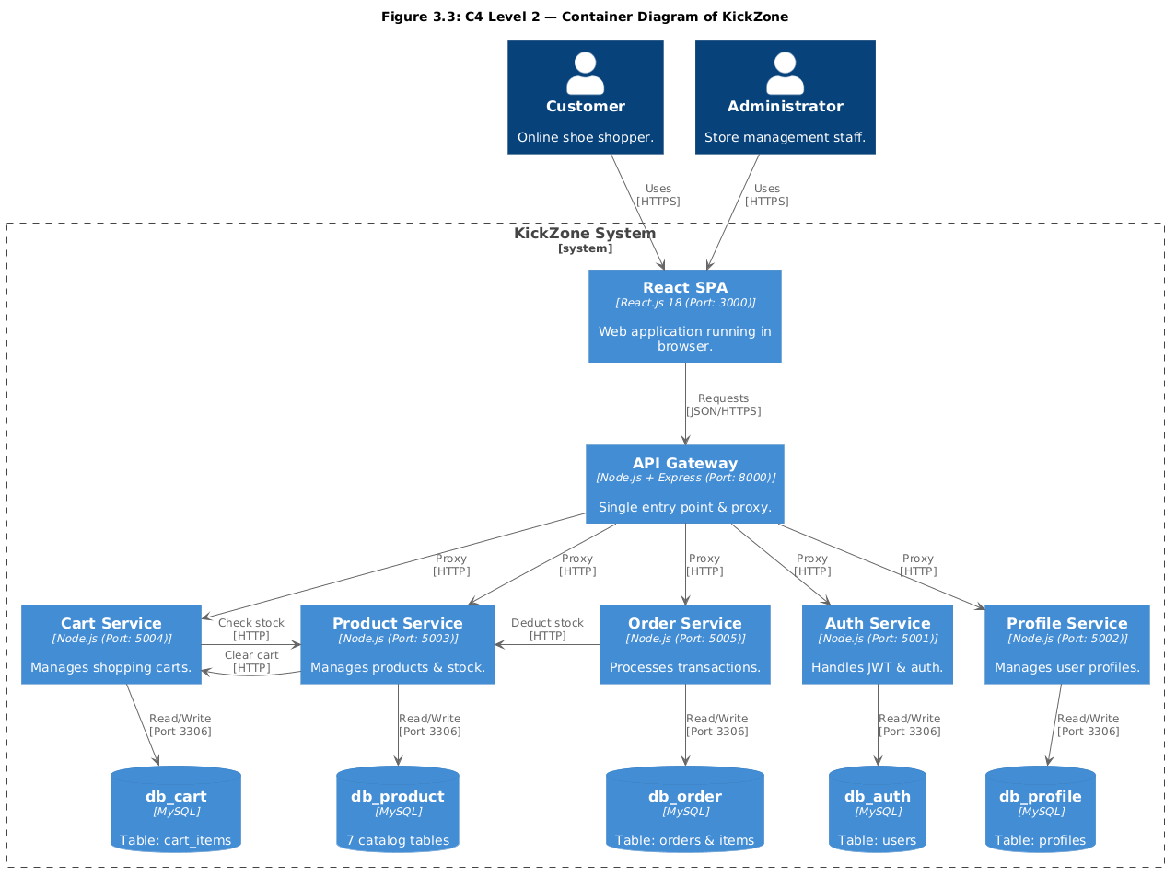
Picture 3.3: C4 model – level 2

3.3.3. C4 Level 3 — Component Diagram (Product Service)
Purpose: Zoom inside a specific container and display the internal components. The team chose Product Service because it is the most complex service with 4 controllers, inventory logic by size, and warehousing.
Components inside the Product Service:
- productController: Handles CRUD products (GET /api/products, GET /api/products/:id, POST, PUT, DELETE). Call the pool directly via MySQL queries. Handle inventory logic by size in a transaction.
- brandController: CRUD brand. Endpoint: GET/POST/PUT/DELETE /api/brands.
- categoryController: CRUD danh mục với slug. Endpoint: GET/POST/PUT/DELETE /api/categories.
- inventoryController: Manage suppliers and import_receipts. Add inventory to product_stock when confirming import.
- productRoutes: Defines all routes of the Product Service, mapped to the corresponding controller. Apply auth middleware to write routes (POST/PUT/DELETE).
- authMiddleware: Authenticate the JWT token within the service (reusing the same logic as API Gateway but at the service level).
- database.js (config): Create a MySQL connection pool with information from .env (DB_HOST, DB_PORT, DB_NAME, DB_USER, DB_PASSWORD).

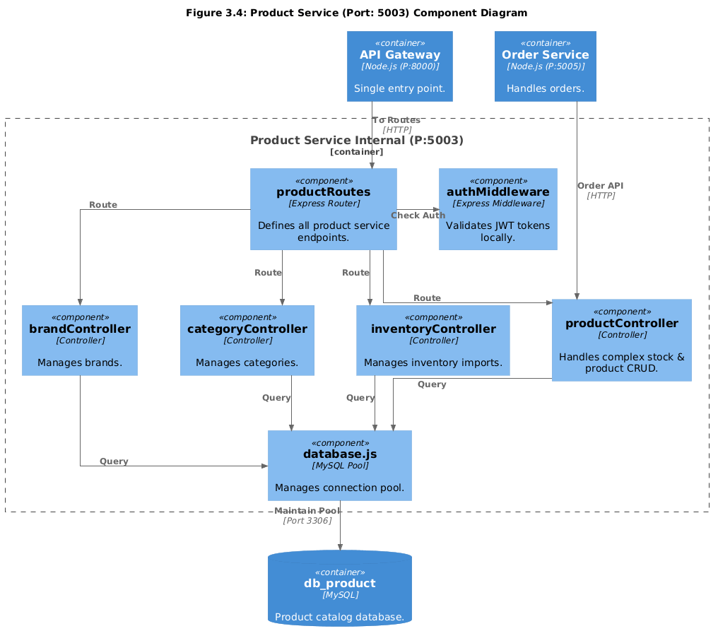
Picture 3.4: C4 model – level 3

3.4. Database Design

3.4.1. Database-per-Service Principles
KickZone strictly applies the Database-per-Service principle: each microservice owns and manages its own database, no service is allowed to directly access the database of other services. Communication between services is only via HTTP API.
An important consequence of this design: There are no foreign keys that bind across the database. For example, table cart_items (db_cart) saves user_id but doesn't have an FK pointing to the users table (db_auth). Reference consistency is ensured at the application-level consistency, not at the database layer.

3.4.2. Overview of databases
Database | Service Ownership | Main Table | Description
db_auth | Auth Service | users | Save accounts: id, name, email, password (bcrypt), role (user/admin), created_at
db_profile | Profile Service | profiles | Save extension information: user_id (FK logic), name, phone, address, avatar_url
db_product | Product Service | products, product_stock, brands, categories, suppliers, import_receipts, import_receipt_items | products save product information; product_stock stock by size (UNIQUE product_id+size);  Suppliers & import_receipts  Warehousing Management
db_cart | Cart Service | cart_items | Snapshot Cart: user_id, product_id, product_name, product_price, size, quantity. UNIQUE(user_id, product_id, size)
db_order | Order Service | orders, order_items | orders save the order with a status (pending/confirmed/shipping/delivered/  cancelled); order_items lưu chi  product at the time of booking
Table 3.3: Overview of database design according to the Database-per-Service principle

3.4.3. Special design points
Inventory by size (product_stock): This is the most specific and important design point of the shoe system. Instead of saving a single stock field on the products table, KickZone separates the product_stock table from the natural key (product_id, size). The UNIQUE KEY binding uq_product_size(product_id, size) ensures that each product has only one inventory record per size, and allows the INSERT statement ... ON DUPLICATE KEY UPDATE operates safely when warehoused.

Describe the structure of important tables:
Users table (db_auth — Auth Service):
Column | Data types | NULL | Default | Description
id | INT (PK, AUTO) | NOT NULL | — | Self-rising main key
name | VARCHAR(100) | NOT NULL | — | Username
email | VARCHAR(100) UNIQUE | NOT NULL | — | Unique login email
password | VARCHAR(255) | NOT NULL | — | Hashed passwords with bcrypt (10 rounds)
role | ENUM('user','admin') | NOT NULL | 'user' | Decentralization: user or admin
created_at | TIMESTAMP | NOT NULL | CURRENT_TIMESTAMP | When to create an account
updated_at | TIMESTAMP | NOT NULL | ON UPDATE | Last Updated Time
Table 3.4: Data Dictionary — Table of users (db_auth)

Bảng products (db_product — Product Service):
Column | Data types | NULL | Default | Description
id | INT (PK, AUTO) | NOT NULL | — | Master Key
name | VARCHAR(200) | NOT NULL | — | Product Name
description | TEXT | NULL | — | Detailed Description
price | DECIMAL(10,2) | NOT NULL | — | Price (VND)
brand_id | INT (FK) | NULL | — | FK → brands.id (SET NULL khi xóa brand)
category_id | INT (FK) | NULL | — | FK → categories.id (SET NULL khi xóa category)
image_url | VARCHAR(255) | NULL | — | Product Image URL
created_at | TIMESTAMP | NOT NULL | CURRENT_TIMESTAMP | When to create
updated_at | TIMESTAMP | NOT NULL | ON UPDATE | When to update
Table 3.5: Data Dictionary — Products Table (db_product)

Table product_stock (db_product — Product Service:
Column | Data types | NULL | Default | Description
id | INT (PK, AUTO) | NOT NULL | — | Master Key
product_id | INT (FK) | NOT NULL | — | FK → products.id (CASCADE DELETE)
size | VARCHAR(10) | NOT NULL | — | Shoe Size (e.g. '39', '40', '41')
quantity | INT | NOT NULL | 0 | Inventory of this size
UNIQUE KEY | (product_id, size) | — | — | Make sure each product has only 1 record/size
Table 3.6: Data Dictionary — Table product_stock (db_product)

Orders table (db_order — Order Service):
Column | Data types | NULL | Default | Description
id | INT (PK, AUTO) | NOT NULL | — | Master Key
user_id | INT | NOT NULL | — | User ID  (logical reference,  not FK through DB)
user_name | VARCHAR(100) | NULL | — | Snapshot tên user  at the time of booking
user_email | VARCHAR(100) | NULL | — | Snapshot email  user at the time of booking
total_amount | DECIMAL(10,2) | NOT NULL | — | Total order amount
status | ENUM(...) | NOT NULL | 'pending' | Status: pending  /confirmed  /shipping  /delivered  /cancelled
shipping_address | TEXT | NOT NULL | — | Delivery Address
phone | VARCHAR(20) | NULL | — | Contact Number
note | TEXT | NULL | — | Order Notes
created_at | TIMESTAMP | NOT NULL | current_timestamp | When to place an order
Table 3.7: Data Dictionary — Orders table (db_order)

3.5. API Design (RESTful)

3.5.1. Applicable REST Principles
All of KickZone's APIs comply with Roy Fielding's 6 REST constraints (2000). Specifically, the principles are applied as follows:
- Client-Server: React Frontend (client) and microservices (servers) are completely separate. The frontend doesn't know the deployment details of any service, only the API Gateway at port 8000.
- Stateless: Each request must contain sufficient credentials (JWT Bearer tokens). The server does not save sessions. This supports ASR05 — which allows each service to be restarted without losing state.
- Uniform Interface: All endpoints named after plural, lowercase, with versioning /api/v1/ (currently using /api/ but the structure is ready to add versioning).
- Layered System: The client only communicates with the API Gateway; I don't know if there are microservices behind it. Gateway can add caching and load balancing later without changing the client.

The HTTP method and HTTP status code conventions apply consistently:
- GET: Get the data, idempotent. Pay 200 OK or 404 Not Found.
- POST: Create new, not idempotent. Pay 201 Created or 400 Bad Request, 409 Conflict.
- PUT: Full update, idempotent. Pay 200 OK or 404 Not Found.
- PATCH: Partial update (used for order status updates). Pay 200 OK.
- DELETE: Delete, idempotent. Pay 200 OK or 404 Not Found.

3.5.2. Full API Table
Method | Endpoint | Auth | Service Destination | HTTP Code | Description
POST | /api/auth/register | Public | Auth Svc | 201 / 400 / 409 | Register a new account
POST | /api/auth/login | Public | Auth Svc | 200 / 401 | Log in, pay JWT tokens
GET | /api/auth/verify | Bearer | Auth Svc | 200 / 401 | Verify the current JWT token
GET | /api/auth/profile | Bearer | Auth Svc | 200 / 404 | Get your logged-in account information
GET | /api/auth/users | Bearer + Admin | Auth Svc | 200 / 403 | List of all users (Admin)
DELETE | /api/auth/users/:id | Bearer + Admin | Auth Svc | 200 / 403 | Delete user (do not delete admin)
GET | /api/profile | Bearer | Profile Svc | 200 | Get a logged-in user extension profile
PUT | /api/profile | Bearer | Profile Svc | 200 | Update name, phone, address, avatar
GET | /api/products | Public | Product Svc | 200 | Product listings, search/filter/page support
GET | /api/products/:id | Public | Product Svc | 200 / 404 | Product details + inventory by size
POST | /api/products | Bearer + Admin | Product Svc | 201 / 400 | Create a new product with stock_by_size
PUT | /api/products/:id | Bearer + Admin | Product Svc | 200 / 404 | Update products and inventory by size
DELETE | /api/products/:id | Bearer + Admin | Product Svc | 200 / 404 | Product removal (cascade removal product_stock)
GET | /api/brands | Public | Product Svc | 200 | Brand List
POST | /api/brands | Bearer + Admin | Product Svc | 201 | Create a new brand
GET | /api/categories | Public | Product Svc | 200 | List of categories
POST | /api/categories | Bearer + Admin | Product Svc | 201 | Create a new category
GET | /api/inventory | Bearer + Admin | Product Svc | 200 | Vendor list and entry slips
POST | /api/inventory/import | Bearer + Admin | Product Svc | 201 | Create warehouse receipts, plus product_stock
GET | /api/cart | Bearer | Cart Svc | 200 | View logged-in user's cart
POST | /api/cart | Bearer | Cart Svc | 200 / 400 | Add products to cart (with size)
PUT | /api/cart/:id | Bearer | Cart Svc | 200 | Update the number of items in the cart
DELETE | /api/cart/:id | Bearer | Cart Svc | 200 | Remove an item from the cart
DELETE | /api/cart/clear | Bearer | Cart Svc | 200 | Delete the entire cart
GET | /api/orders | Bearer | Order Svc | 200 | Order list of logged-in users
POST | /api/orders | Bearer | Order Svc | 201 / 400 | Create a new order (transaction: remove stock + delete cart)
GET | /api/admin/orders | Bearer + Admin | Order Svc | 200 | Full Order (Admin)
PATCH | /api/admin/orders/:id/status | Bearer + Admin | Order Svc | 200 / 400 | Update order status
GET | /api/admin/stats | Bearer + Admin | Order Svc | 200 | Revenue and order statistics
Table 3.8: KickZone System Full RESTful API Design

3.6. UML Chart

3.6.1. Class Diagram
The Class Diagram describes the system's main model domain classes and the relationships between them. Because KickZone uses a Microservices architecture with services written in JavaScript (no complex inheritance classes), the Class Diagram focuses on describing the data structure and relationships between the main entities:
- User: id, name, email, password (hashed), role. Relationship: 1 User has 1 Profile (composition); 1 User has multiple Orders (associations); 1 User has 1 Cart (aggregation).
- Profile: id, userId (FK logic), name, phone, address, avatarUrl.
- Product: id, name, description, price, imageUrl. Quan hệ: 1 Product thuộc 1 Brand (association); 1 Product thuộc 1 Category (association); 1 Product có nhiều ProductStock (composition).
- ProductStock: id, productId, size, quantity. — Separate entities that represent inventory of each size.
- Brand: id, name, logoUrl. Relationship: 1 Brand has many products.
- Category: id, name, slug, description. Relationship: 1 Category with multiple Products.
- CartItem: id, userId, productId, productName, productPrice (snapshot), productImage (snapshot), size, quantity.
- Order: id, userId, userName (snapshot), userEmail (snapshot), totalAmount, status, shippingAddress, phone. Quan hệ: 1 Order có nhiều OrderItem (composition).
- OrderItem: id, orderId, productId, productName (snapshot), productImage (snapshot), quantity, size, price (snapshot).

Important design note: CartItem and OrderItem save snapshots of product information (productName, productPrice, productImage) at the time of adding/ordering. This is a deliberate architectural decision: to ensure that order history data is not affected when product information changes later.

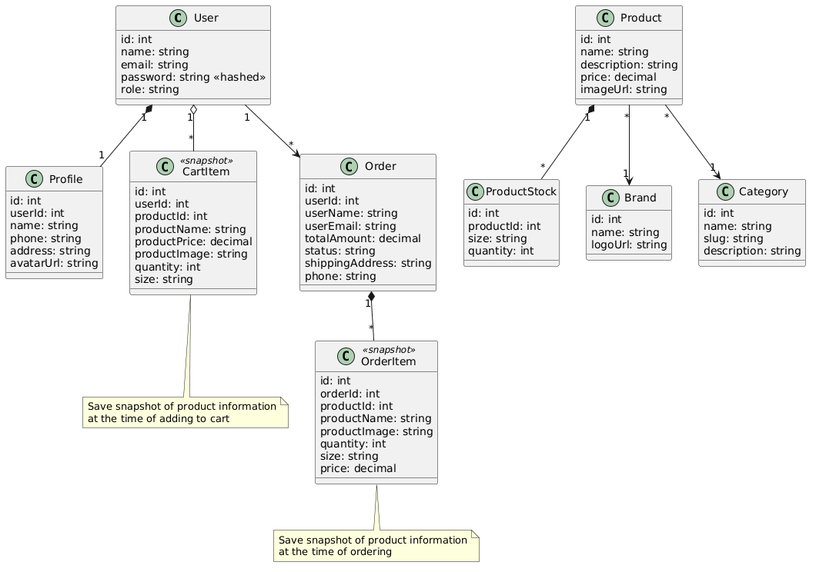
Picture 3.5: Class Diagram

3.6.2. Activity Diagram
The team builds 2 Activity Diagrams for key business flows:

3.6.2.1. Activity Diagram: Purchase flow
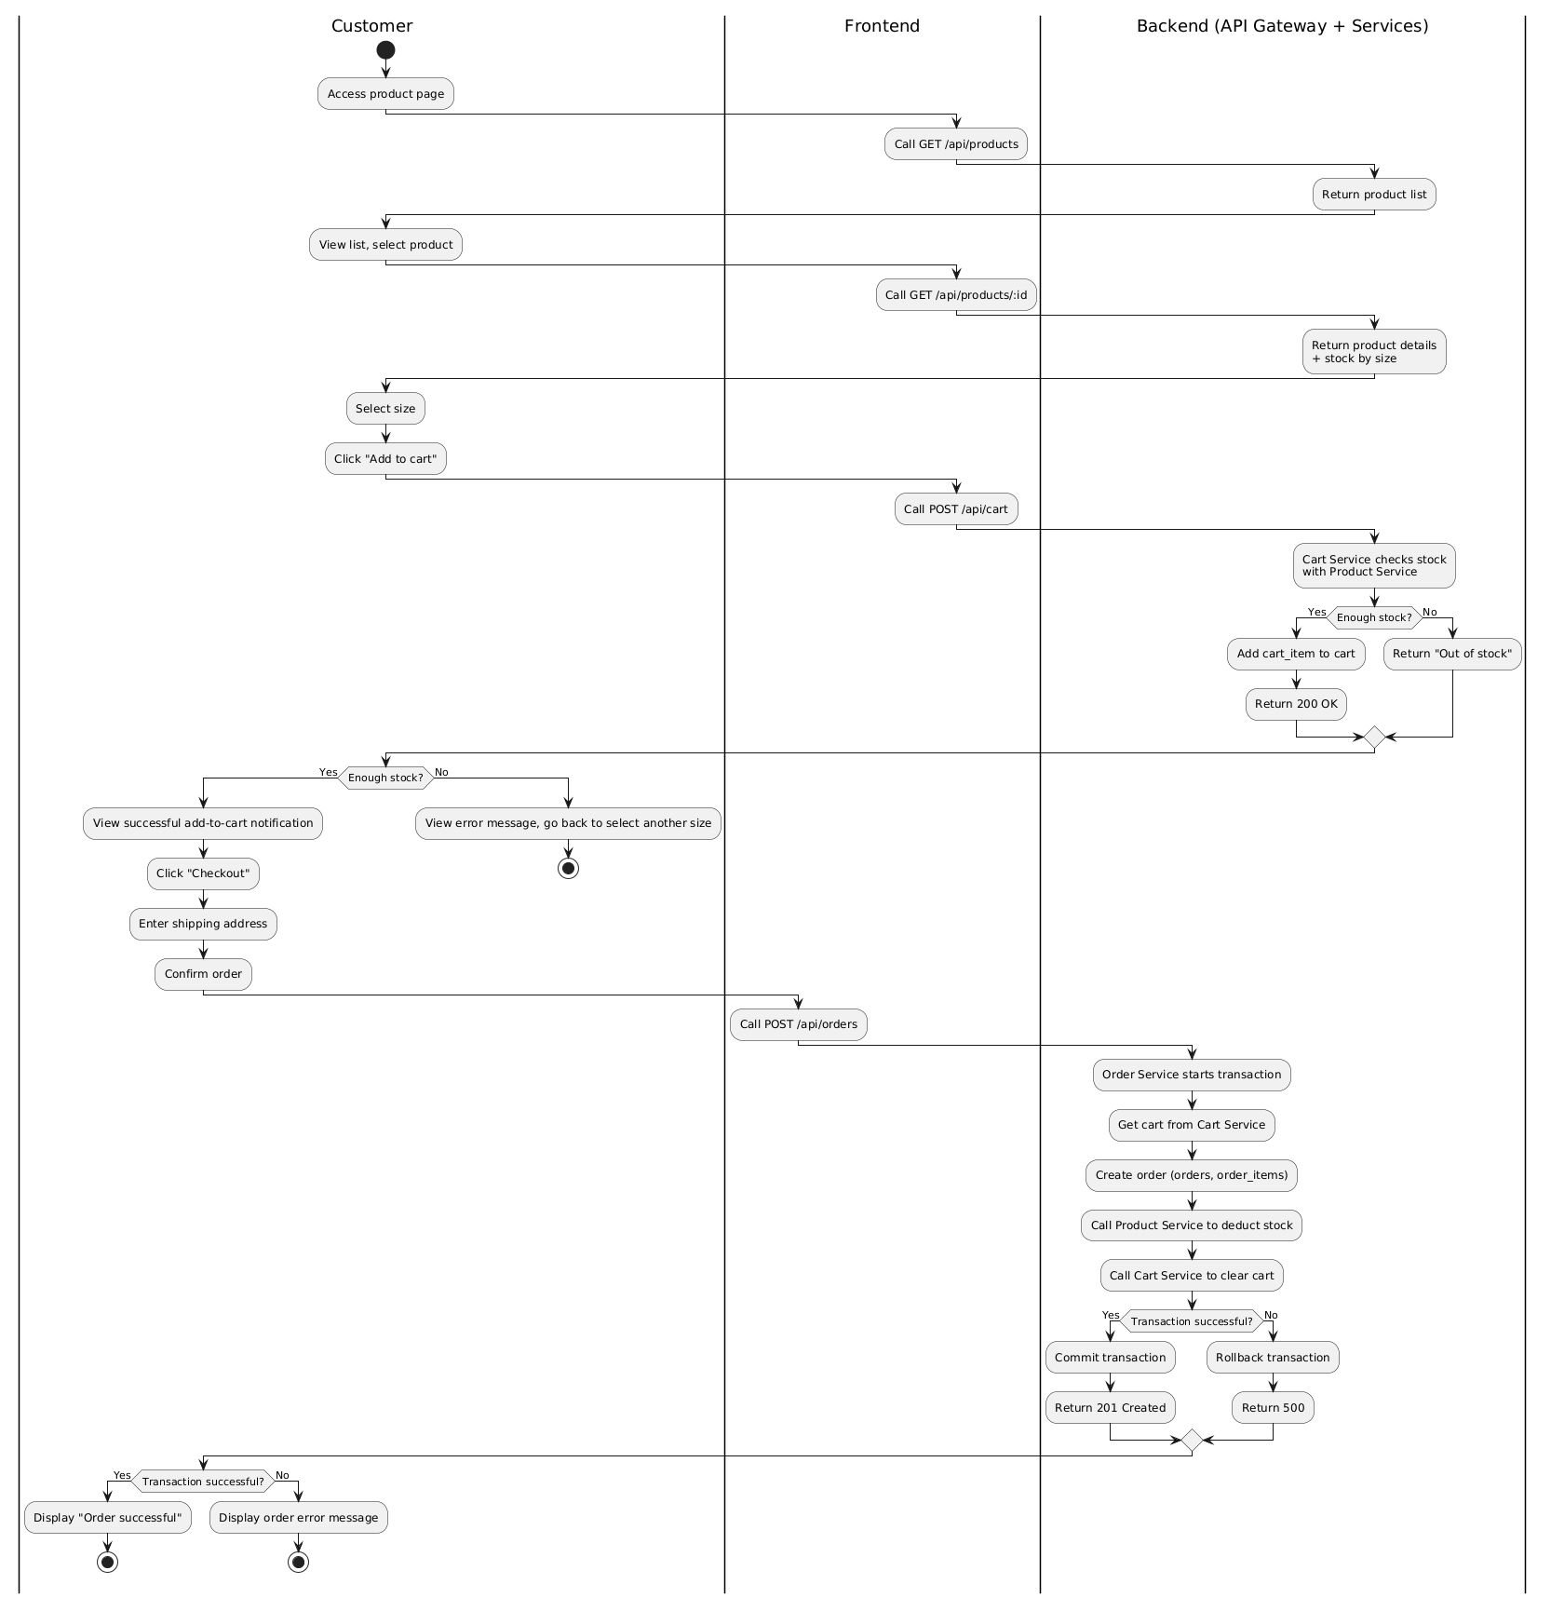
Picture 3.6: Purchase Flow

3.6.2.2. Activity Diagram: Inventory Management Flow
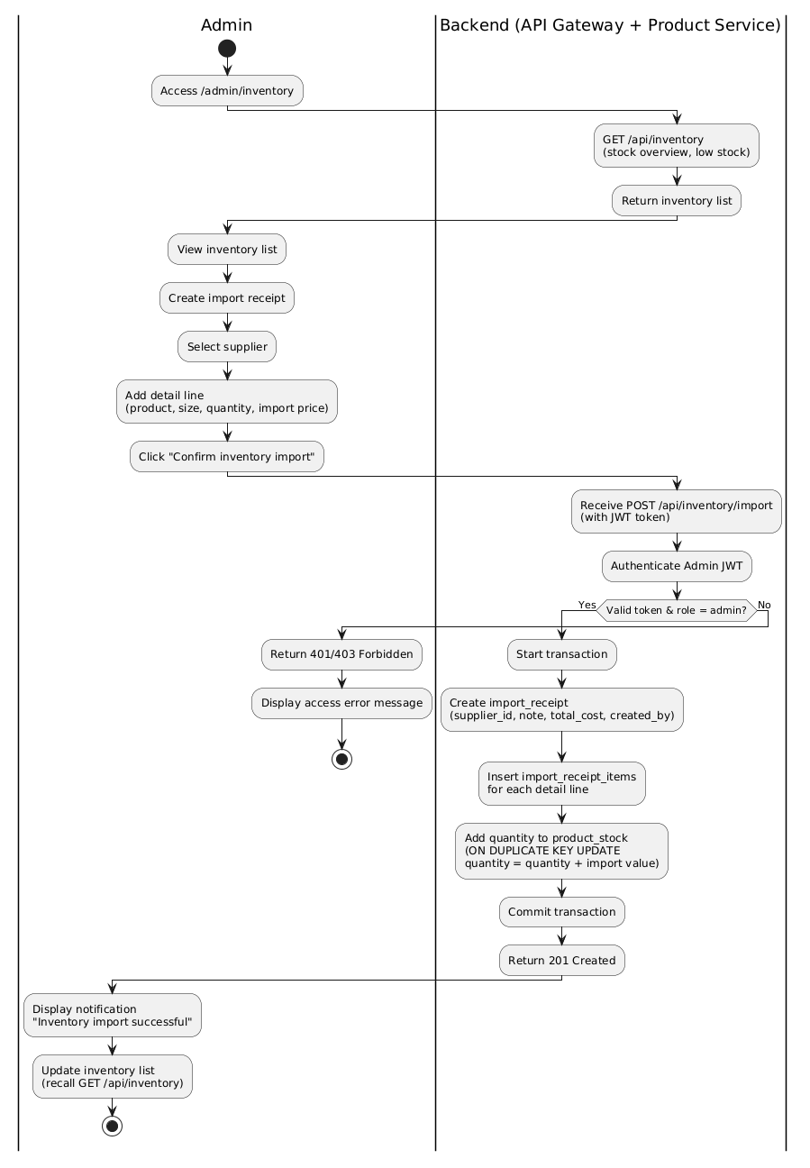
Picture 3.7: Inventory management flow

3.7. Architecture Decision Records (ADR)
Architecture Decision Records (ADRs) document important architectural decisions: context, options considered, reasons for choice, and consequences. ADR helps new members understand why the system is designed the way it is, not just how.

ADR-001: Choosing a Microservices Architecture
Status | Accepted | Date: 2026-03-01 | Decision Team: KickZone Team
Background | The KickZone shoe sales system needs to serve 2 groups of users (Customer and Admin) with 5 naturally separate business domains: authentication, profile, product/warehouse, shopping cart and order. Each domain has its own data model and independent update lifecycle. The ASR01 requires good performance; ASR02 requires the entire purchase flow to operate stably; ASR05 requires updating one domain without affecting the other. The group consists of 3 members, the duration is 10 weeks.
Decision | Apply Microservices Architecture with 5 independent services (Auth, Profile, Product, Cart, Order), each with its own codebase, process, and database. Use the API Gateway Pattern as the only entry point. All services are written in Node.js + Express to ensure language consistency in small teams.
Considered Options | 1. Layered Monolith (3-tier): Simpler to get started, but doesn't meet ASR05—updating the cart logic will require redeploying the entire application. The risk is high if a faulty module leads to the collapse of the entire system. 2. Microservices with multiple languages (polyglot): Too complex for a team of 3 people, increasing learning overhead and difficult to support each other.
Positive consequences | (+) Each service deploys and restarts independently—errors in the Cart Service do not affect the Product Service. (+) Database-per-Service frees each domain from a common schema constraint. (+) It's easy to divide work by service in the team. (+) The platform is ready to scale each service individually if needed.
Negative consequences | (-) More complex to operate than Monolith: 7 processes (5 service + 1 gateway + 1 frontend) need to be started. (-) HTTP synchronous communication between services in the order flow creates a distributed call chain, increasing latency compared to monolith. (-) No distributed tracing — debugging is harder. (-) ASR04 (order consistency) must be resolved at the application layer instead of using a single database transaction.
Table 3.9: ADR-001 — Microservices Architecture Selection

ADR-002: Authentication with JWT at API Gateway
Status | Accepted | Date: 2026-03-05 | Decision Team: KickZone Team
Background | The system has 5 independent services, each request from the frontend needs to be authenticated. ASR03 requires 100% of unauthorized requests to be blocked. Need a stateless authentication mechanism suitable for Microservices (without shared session storage).
Decision | Use JWT (JSON Web Token) as a stateless authentication mechanism. Auth Service issues JWT tokens containing { id, email, role } when logged in/registered. The API Gateway authenticates the JWT in the middleware authenticate() before the proxy request. Admin permissions are further checked using the isAdmin() middleware at the Gateway. Each service also has its own auth.js middleware as a second layer of protection.
Considered Options | 1. Session-based authentication: Requires shared session storage (Redis/database). Inappropriate Microservices stateless. 2. OAuth2/OpenID Connect: Too complicated for the project scope, needs to add a separate authorization server.
Positive consequences | (+) Stateless — fully compatible with Microservices; The service can be scaled horizontal. (+) JWT self-contained: each service validates itself without calling the Auth Service per request. (+) RBAC simplifies the role field in the JWT payload.
Negative consequences | (-) JWT cannot be revoke immediately (unless implemented blacklisted). If the token is exposed, it lasts until it expires. (-) Expired tokens require users to log in again (Refresh Token has not been implemented within the scope of the project).
Table 3.10: ADR-002 — JWT Authentication at API Gateway

ADR-003: MySQL Transaction for Order Flow

Status | Accepted | Date: 2026-03-10 | Decision Team: KickZone Team
Background | ASR04 requires data consistency in the order flow: creating orders, subtracting inventory, and deleting carts must act as an atomic unit. This flow spans 3 different services and 3 databases (db_order, db_product, db_cart).
Decision | Using MySQL Transaction in Order Service incorporates HTTP synchronous communication. The Order Service opens the MySQL transaction on the db_order, performing the steps in order: (1) Retrieve the cart from the Cart Service via HTTP. (2) INSERT orders + order_items into the db_order in the transaction. (3) Call the Product Service to subtract inventory via HTTP. (4) Call the Cart Service to delete the cart via HTTP. (5) COMMIT if all succeeds, ROLLBACK if there is a failed step.
Considered Options | 1. Saga Pattern (Choreography): Services communicate through events, each service rolls back itself when receiving a compensating event. More theoretically suitable but requires a message broker (RabbitMQ/Kafka) and complex compensation logic — beyond the 10-week scope. 2. Two-Phase Commit (2PC): Requires a distributed transaction coordinator, which is not common with regular MySQL.
Positive consequences | (+) Ensure atomicity for db_order. (+) Easy to implement with MySQL and Node.js (pool.getConnection() → beginTransaction() → commit/rollback). (+) Properly handle insufficient inventory: complete order rollback.
Negative consequences | (-) Only transactions actually include db_order. The steps of calling Product Service and Cart Service over HTTP are manual compensating calls, not actual distributed transactions. (-) Race conditions can still occur: if 2 people order at the same time with the same product/size remaining 1 pair, both requests can successfully check inventory before one of the 2 subtracts the stock. (-) Trade-off is accepted: with a demo size and a small team, this is a pragmatic solution and good enough.
Table 3.11: ADR-003 — MySQL Transaction for Order Flow

ADR-004: Selecting MySQL as Database
Status | Accepted | Date: 2026-03-01 | Decision Team: KickZone Team
Background | The system needs to store data with a clear relational structure: products under brands and categories; inventory associated with each product-size; The order contains multiple products. ASR04 requires data consistency (ACID transactions) in the order flow.
Decision | Use MySQL as the only RDBMS for all 5 databases. Each service has its own connection pool through the mysql2 package. Don't use ORMs to keep queries transparent and easy to optimize.
Considered Options | 1. MongoDB (NoSQL): Flexible schema but does not support multi-collection ACID transactions as much as necessary. Doesn't match the shoe's tight correlation data (product → stock → size. 2. PostgreSQL: Better than MySQL in some features, but the team is more familiar with MySQL.
Positive consequences | (+) ACID compliance ensures consistency in the order flow. (+) Clear, easy-to-debug table structure using MySQL Workbench. (+) Supports UNIQUE KEY (product_id, size) for product_stock — simplifies warehousing logic (ON DUPLICATE KEY UPDATE).
Negative consequences | (-) Rigid schema—add new attributes (e.g., shoe color) that need migration. (-) Horizontal scaling MySQL is more difficult than NoSQL.
Table 3.12: ADR-004 — Selecting MySQL as Database

3.8. UI Prototype
The KickZone system is built with React.js 18, using the React Router DOM to navigate the SPA. Below is a description of the main screens and navigation flows.

Screen | Route | Function Description
Home | / (Home.js) | Display banners, featured products, and quickly filter by category. The navbar displays the user's name if logged in.
Product List | /products (Products.js) | Product grid 12 items/page, search bar, brand/category/price range filters, pagination.
Detailed Product Description | /products/:id (ProductDetail.js) | Image, name, price, description, select size (show inventory quantity), Add to cart button.
Login / Registration | /login, /register | Login/registration form. After success: redirect /admin if role=admin, redirect / if role=user.
Shopping Cart | /cart (Cart.js) — Protected | List of products in the basket, update the quantity, delete, display the total amount, Proceed to order button.
Payment | /checkout (Checkout.js) — Protected | Enter the delivery address, phone number, and note. Confirm the order.
My Orders | /orders (Orders.js) — Protected | Order history, status of each order, product details in the order.
Admin Dashboard | /admin (AdminDashboard.js) — Admin | Overview: revenue, number of orders by status, top best-selling products.
Admin — Products | /admin/products — Admin | CRUD products with inventory by size. Search, pagination.
Admin — Inventory | /admin/inventory — Admin | View inventory, create receipt slips, manage suppliers.
Admin — Orders | /admin/orders — Admin | List all orders, status updates.
Admin — User | /admin/users — Admin | List of accounts, delete users.
Admin — Brand/DM | /admin/brands, /admin/categories — Admin | CRUD brands and categories.
Admin — Statistics | /admin/reports — Admin | Revenue charts over time, order statistics.
Table 3.13: List of KickZone System Navigation Screens and Flows

CHAPTER 4: IMPLEMENTATION

4.1. Development Environment and Tools
The KickZone system is developed on the Windows environment with Node.js as a unified platform for the entire backend. This choice ensures language consistency in the 3-member team and minimizes context switching when working on different services.

Categories | Tools/Versions | Versions | Purpose
Backend Languages | Node.js | v20 LTS | Runtime for all 5 microservices and API Gateways
Framework Backend | Express.js | 4.x | HTTP server, routing, middleware pipeline
Frontend Languages | JavaScript (ES6+) | — | Frontend Programming Language
Framework Frontend | React.js | 18.x | Xây dựng SPA — Single Page Application
Routing Frontend | React Router DOM | 6.x | Client-side routing
HTTP Client | Axios | 1.x | API calls from the frontend and between services
Authentication | jsonwebtoken (JWT) | 9.x | Issuing and verifying stateless JWT tokens
Password hash | bcryptjs | 2.x | Password hash with salt 10 rounds (ASR03)
HTTP Proxy | http-proxy-middleware | 3.x | Proxy request at API Gateway to services
Logging | morgan | 1.x | Log HTTP request at API Gateway (dev format)
Database | MySQL | 8.x | RDBMS — 5 independent databases (Database-per-Service)
MySQL Driver | mysql2 | 3.x | Connection pool — MySQL queries from Node.js
Environmental Variables | dotenv | 16.x | Configuration management via .env file
Utilities | nodemon | 3.x | Auto-reload server when code changes (dev mode)
Version Control | Git / GitHub | 2.x | Source code management, commitment history, branching
IDE | Visual Studio Code | Latest | Code drafting, terminal integration, extensions
DB Client | MySQL Workbench | 8.x | Manage databases, run SQL, view ERD
API Testing | Postman | Latest | Test and debug the API endpoint of each service
Diagram | Draw.io (diagrams.net) | Latest | Vẽ C4 Model, ERD, UML, Activity Diagram
Script | start-all.bat (Windows) | — | Start all 7 processes (6 services + frontend) with 1 command
Table 4.1: KickZone development environment table and system tools

4.2. Project Directory Structure
The directory structure directly reflects the Microservices Architecture designed in Chapter 3: each service is an independent directory with a separate codebase, configuration, and .env. There are no shared folders between services—communication is only via HTTP APIs.

shoe-store-microservices/ ← Root project
├── api-gateway/ ← API Gateway (port 8000)
│ └── src/
│ ├── middleware/
│ │ └── auth.js ← JWT verify + isAdmin guard
│ └── server.js ← Express app, proxy routing
│
├── auth-service/ ← Auth Service (port 5001)
│ └── src/
│ ├── config/database.js ← MySQL pool → db_auth
│ ├── controllers/authController.js ← register, login, getProfile...
│ ├── middleware/auth.js ← JWT verify (service-level)
│ └── routes/authRoutes.js ← Route definitions
│
├── profile-service/ ← Profile Service (port 5002)
│ └── src/
│ ├── config/database.js ← MySQL pool → db_profile
│ ├── controllers/profileController.js ← getProfile, updateProfile
│ ├── middleware/auth.js
│ └── routes/profileRoutes.js
│
├── product-service/ ← Product Service (port 5003)
│ └── src/
│ ├── config/database.js ← MySQL pool → db_product
│ ├── controllers/
│ │ ├── productController.js ← CRUD + decreaseStock
│ │ ├── brandController.js ← CRUD brand
│ │ ├── categoryController.js ← CRUD category
│ │ └── inventoryController.js ← Supplier, import receipts
│ ├── middleware/auth.js
│ └── routes/productRoutes.js
│
├── cart-service/ ← Cart Service (port 5004)
│ └── src/
│ ├── config/database.js ← MySQL pool → db_cart
│ ├── controllers/cartController.js ← addToCart, updateCart...
│ ├── middleware/auth.js
│ └── routes/cartRoutes.js ← Bao gồm internal routes
│
├── order-service/ ← Order Service (port 5005)
│ └── src/
│ ├── config/database.js ← MySQL pool → db_order
│ ├── controllers/orderController.js ← createOrder (transaction)...
│ ├── middleware/auth.js
│ └── routes/orderRoutes.js
│
├── frontend/ ← React SPA (port 3000)
│ └── src/
│ ├── context/
│ │ ├── AuthContext.js ← Global auth state + localStorage
│ │ └── CartContext.js ← Cart state management
│ ├── components/
│ │ └── Navbar.js ← Navigation, user info, cart badge
│ ├── pages/ ← 14 page components
│ │ ├── Home.js, Products.js, ProductDetail.js
│ │ ├── Login.js, Register.js
│ │ ├── Cart.js, Checkout.js, Orders.js
│ │ └── Admin*.js (8 admin pages)
│ ├── App.js ← Router + PrivateRoute + AdminRoute
│ └── index.css ← Global styles
│
└── database/ ← SQL init scripts
├── 01_auth_db.sql
├── 02_profile_db.sql
├── 03_product_db.sql
├── 04_cart_db.sql
└── 05_order_db.sql

Figure 4.1: KickZone project directory structure according to Microservices architecture

Notable points about the folder structure:
- Each service has its own middleware/auth.js file: this is a second layer of protection at the service level, independent of the API Gateway middleware. This defense-in-depth design ensures that even if a request goes through the gateway, the service still authenticates itself.
- Each service has its own config/database.js: create a MySQL connection pool that connects to the service's own database. No service imports database.js of other services.
- The frontend has 2 Contexts: AuthContext manages the global login status (user, token, isAdmin), CartContext manages the badge of the number of products in the cart displayed on the Navbar.

4.3. Outstanding implementation techniques
This section presents the 5 most important techniques/mechanisms in the implementation process, which are directly linked to architectural decisions (ADRs) in Chapter 3.

4.3.1. JWT Authentication Mechanism at API Gateway (ADR-002)
Technical: JWT Authentication + RBAC at the Gateway floor
Description: All authentication is centralized at the API Gateway (server.js). Middleware authenticate() verifies JWT tokens; middleware isAdmin() checks for Admin permissions. The back-end microservices don't need to worry about authentication—they just receive requests that have been authenticated by the gateway and attach user information.

Code Snippet 4.1 — API Gateway: Defining Middleware and Applying Routes
// api-gateway/src/middleware/auth.js
const jwt = require('jsonwebtoken');

const authenticate = (req, res, next) => {
const token = req.headers.authorization?. split(' ')[1]; // Bearer <token>
if (!token)
return res.status(401).json({ success: false, message: 'No token.' });
try {
req.user = jwt.verify(token, process.env.JWT_SECRET);
next();
} catch {
return res.status(401).json({ success: false, message: 'Invalid token.' });
}
};

const isAdmin = (req, res, next) => {
if (req.user?. role !== 'admin')
return res.status(403).json({ success: false, message: 'No permission.' });
next();
};

Code Snippet 4.2 — API Gateway: Applying middleware by route group
// api-gateway/src/server.js (trích)

Public: registration, login — no authenticate required
app.use('/api/auth', proxy(AUTH_SERVICE_URL));

Protected: must be logged in
app.use('/api/cart', authenticate, proxy(CART_SERVICE_URL));
app.use('/api/orders', authenticate, proxy(ORDER_SERVICE_URL));

admin-only: must be logged in AND have role='admin'
app.post('/api/products', authenticate, isAdmin, proxy(PRODUCT_SERVICE_URL));
app.use('/api/admin', authenticate, isAdmin, proxy(ORDER_SERVICE_URL));
app.use('/api/inventory', authenticate, isAdmin, proxy(PRODUCT_SERVICE_URL));

Architectural Analysis: This mechanism directly implements ASR03 (Security — 100% of unauthorized requests are blocked at the Gateway). The centralized authentication layer helps the microservices behind the scenes focus only on the business logic. This is a typical advantage of the API Gateway Pattern: cross-cutting concerns (authentication, logging) are handled once at the gateway instead of repeated at every service.

4.3.2. Secure Registration and Login Mechanism (Auth Service)
Kỹ thuật: Bcrypt password hashing + JWT token generation
Description: Auth Service handles registration with bcrypt.hash() (10 salt rounds) and logins with bcrypt.compare(). The JWT token contains a payload { id, email, role } — enough for the gateway and services to know the identity and permissions of the user without the need for additional database queries.

Code Snippet 4.3 — Auth Service: Register and Login Functions
// auth-service/src/controllers/authController.js (trích)

const register = async (req, res) => {
const { name, email, password } = req.body;
// 1. Input Testing
if (!name || !email || !password)
return res.status(400).json({ message: 'Please fill in the details.' });
// 2. Check for duplicate emails
const [existing] = await pool.query(
'SELECT id FROM users WHERE email = ?', [email]);
if (existing.length > 0)
return res.status(409).json({ message: 'Email has been used.' });
// 3. Password hash (bcrypt, 10 salt rounds)
const hash = await bcrypt.hash(password, 10);
// 4. Save to db_auth
const [result] = await pool.query(
'INSERT INTO users (name, email, password) VALUES (?, ?, ?)',
[name, email, hash]);
// 5. Distribute JWT tokens immediately after registration
const token = jwt.sign(
{ id: result.insertId, email, role: 'user' },
process.env.JWT_SECRET,
{ expiresIn: process.env.JWT_EXPIRES_IN }
);
res.status(201).json({ success: true, token, user: {...} });
};

const login = async (req, res) => {
const { email, password } = req.body;
const [users] = await pool.query(
'SELECT * FROM users WHERE email = ?', [email]);
General error message — does not disclose specific wrong email/password
if (users.length === 0)
return res.status(401).json({ message: 'Incorrect email or password.' });
const isMatch = await bcrypt.compare(password, users[0].password);
if (!isMatch)
return res.status(401).json({ message: 'Incorrect email or password.' });
const token = jwt.sign(
{ id: users[0].id, email: users[0].email, role: users[0].role },
process.env.JWT_SECRET, { expiresIn: process.env.JWT_EXPIRES_IN }
);
res.json({ success: true, token, user: { id, name, email, role } });
};

Architecture Analysis: The error message uses the generic 'Incorrect email or password' message for both scenarios (non-existent email and wrong password) — this is a security best practice that prevents account enumeration attacks. Minimalist JWT payloads (id, email, role) make the token compact and do not reveal sensitive information.

4.3.3. MySQL Transaction in Order Flow (ADR-003)
Technical: MySQL Transaction + Cross-service HTTP Calls
Description: createOrder() is the most complex function in the system, directly implementing ADR-003. The function uses its own MySQL Connection (pool.getConnection()) to open transactions on the db_order, and makes HTTP calls to the Cart Service and the Product Service in a controlled order. If any step fails, conn.rollback() is called and an error is answered.

Code Snippet 4.4 — Order Service: Create Orders with MySQL Transaction
// order-service/src/controllers/orderController.js (trích)

const createOrder = async (req, res) => {
const conn = await pool.getConnection(); // Lấy connection riêng
try {
await conn.beginTransaction(); Start a transaction

const { shipping_address, phone, note } = req.body;
if (!shipping_address)
return res.status(400).json({ message: 'Please enter a shipping address.' });

STEP 1: Retrieve the cart from Cart Service via HTTP internal
const cartRes = await axios.get(
`${CART_URL}/api/cart/internal/${req.user.id}`);
const cartItems = cartRes.data.cart;
if (!cartItems?. length) {
await conn.rollback();
return res.status(400).json({ message: 'Empty cart.' });
}

STEP 2: Calculate the total amount and create an order in the transaction
const total = cartItems.reduce(
(sum, i) => sum + parseFloat(i.product_price) * i.quantity, 0);
const [orderResult] = await conn.query(
`INSERT INTO orders (user_id, user_name, user_email,
total_amount, shipping_address, phone, note)`,
VALUES (?, ?, ?, ?, ?, ?, ?)
[req.user.id, req.user.name, req.user.email,
total, shipping_address, phone, note]
);

STEP 3: Insert order_items (snapshot the product at the time of ordering)
for (const item of cartItems) {
await conn.query(
'INSERT INTO order_items (order_id, product_id, product_name,',
'product_image, quantity, size, price) VALUES (?,?,?,?,?,?,?)',
[orderResult.insertId, item.product_id, item.product_name,
item.product_image, item.quantity, item.size, item.product_price]
);
}

STEP 4: Call Product Service to subtract inventory
await axios.post(`${PRODUCT_URL}/api/products/decrease-stock`, {
items: cartItems.map(i => ({
product_id: i.product_id, size: i.size, quantity: i.quantity
}))
});

STEP 5: Call Cart Service to delete the cart
await axios.delete(
`${CART_URL}/api/cart/internal/${req.user.id}/clear`);

await conn.commit(); Commit if all succeeds
res.status(201).json({ success: true, message: 'Order successful!',
orderId: orderResult.insertId });

} catch (err) {
await conn.rollback(); Rollback when there are any errors
res.status(500).json({ success: false, message: err.message });
} finally {
conn.release(); Always return connections to the pool
}
};

Architectural Analysis: The try-catch-finally structure with conn.release() in finally ensures that connections are always returned to the pool, avoiding connection leaks. conn.rollback() in the catch ensures that there are no orphan orders (the order is created but the inventory is not deducted). This is the actual reality of ADR-003 noted in Chapter 3.

4.3.4. Product Search, Filtering and Paging (Product Service)
Kỹ thuật: Dynamic WHERE clause + MySQL LIMIT/OFFSET pagination
Description: getProducts() constructs dynamic SQL queries based on passed query parameters (search, brand_id, category_id, category slug, min_price, max_price, page, limit). Does this technique avoid SQL Injection by using prepared statements with placeholders? instead of direct chaining.

Code snippet 4.5 — Product Service: Dynamic search and pagination
// product-service/src/controllers/productController.js (trích)

const getProducts = async (req, res) => {
const { search, brand_id, category_id, category,
min_price, max_price, page = 1, limit = 12 } = req.query;
const offset = (page - 1) * limit;
let where = [], params = [];

Dynamic WHERE clause construction
if (search) {
where.push('(p.name LIKE ? OR p.description LIKE ?)');
Params.Bush('%${Church}%', '%${Church}%');
}
if (brand_id) { where.push('p.brand_id = ?'); params.push(brand_id); }
if (category_id) { where.push('p.category_id = ?'); params.push(category_id); }
if (category) { where.push('c.slug = ?'); params.push(category); }
if (min_price) { where.push('p.price >= ?'); params.push(min_price); }
if (max_price) { where.push('p.price <= ?'); params.push(max_price); }

const w = where.length ? 'WHERE ' + where.join(' AND ') : '';

Main query: JOIN brands + categories + total inventory subquery
const [products] = await pool.query(
`SELECT p.*, b.name as brand_name, c.name as category_name,
COALESCE((SELECT SUM(quantity) FROM product_stock
WHERE product_id = p.id), 0) as stock
FROM products p
LEFT JOIN brands b ON p.brand_id = b.id
LEFT JOIN categories c ON p.category_id = c.id
${w} ORDER BY p.created_at DESC LIMIT ? OFFSET ?`,
[... params, parseInt(limit), parseInt(offset)]
);

The query counts the sum to calculate totalPages
const [[{ total }]] = await pool.query(
`SELECT COUNT(*) as total FROM products p
LEFT JOIN brands b ON p.brand_id = b.id
LEFT JOIN categories c ON p.category_id = c.id ${w}`, params
);

res.json({ success: true, products, total,
page: parseInt(page), totalPages: Math.ceil(total / limit) });
};

Architectural Analysis: The API returns simultaneously products, total, page, and totalPages — enough information for the frontend to render pagination on its own without additional requests. Subquery COALESCE(SELECT SUM(quantity)...) calculates the total inventory directly in the main query, avoiding the N+1 query problem.

4.3.5. Cart with real-time inventory check (Cart Service)
Technical: Cross-service HTTP call to check inventory before adding to cart
Description: Before INSERT into the cart_items, the Cart Service calls the Product Service to get the product information and check the inventory by size. This is the reality of the Database-per-Service principle: Cart Service does not directly access db_product but communicates via API. In addition, the Cart Service saves snapshots (product_name, product_price, product_image, brand_name) to the cart_items — ensuring that the cart is not changed when the Admin updates the product price.

Code snippet 4.6 — Cart Service: Add products to cart
// cart-service/src/controllers/cartController.js (trích)

const addToCart = async (req, res) => {
const { product_id, quantity = 1, size } = req.body;
if (!product_id || !size)
return res.status(400).json({ message: 'Please select product and size.' });

STEP 1: Call Product Service to get information + inventory
const { data } = await axios.get(
`${PRODUCT_URL}/api/products/${product_id}`);
const product = data.product;

STEP 2: Check the inventory according to the selected size
const sizeStock = product.stock_by_size?. find(s => s.size === size);
if (!sizeStock || sizeStock.quantity < quantity)
return res.status(400).json({
message: 'Size ${size} is not in stock.' });

STEP 3: If already in the basket → plus (do not exceed the inventory)
const [existing] = await pool.query(
'SELECT id, quantity FROM cart_items
WHERE user_id=? AND product_id=? AND size=?',
[req.user.id, product_id, size]);

if (existing.length > 0) {
const newQty = existing[0].quantity + quantity;
if (newQty > sizeStock.quantity)
return res.status(400).json({
message: 'Only ${sizeStock.quantity} double size ${size}.' });
await pool.query('UPDATE cart_items SET quantity=? WHERE id=?',
[newQty, existing[0].id]);
} else {
STEP 4: There is no INSERT → with product information snapshot
await pool.query(
`INSERT INTO cart_items (user_id, product_id, product_name,
product_price, product_image, brand_name, quantity, size)`,
VALUES (?, ?, ?, ?, ?, ?, ?, ?)
[req.user.id, product_id, product.name, product.price,
product.image_url, product.brand_name, quantity, size]
);
}
res.json({ success: true, message: 'Added to cart!' });
};

Architectural Analysis: The snapshot technique (save product_name, product_price at the time of adding to cart) solves the problem of historical data: if the Admin changes the price of the product after the Customer has added it to the cart, the price in the cart is still the price at the time of adding. This is a common design in e-commerce and is applied consistently to order_items.

4.4. System Screenshots
This section presents the main interfaces of the KickZone system that have been implemented. All interfaces are built using React.js 18 with pure CSS, ensuring responsive on a wide range of screen sizes from 375px (mobile) to 1920px (desktop).

4.4.1. Homepage and product listings
The homepage displays introductory banners, featured product listings, and shoe categories. The navbar displays the username and number of products in the cart (badge).
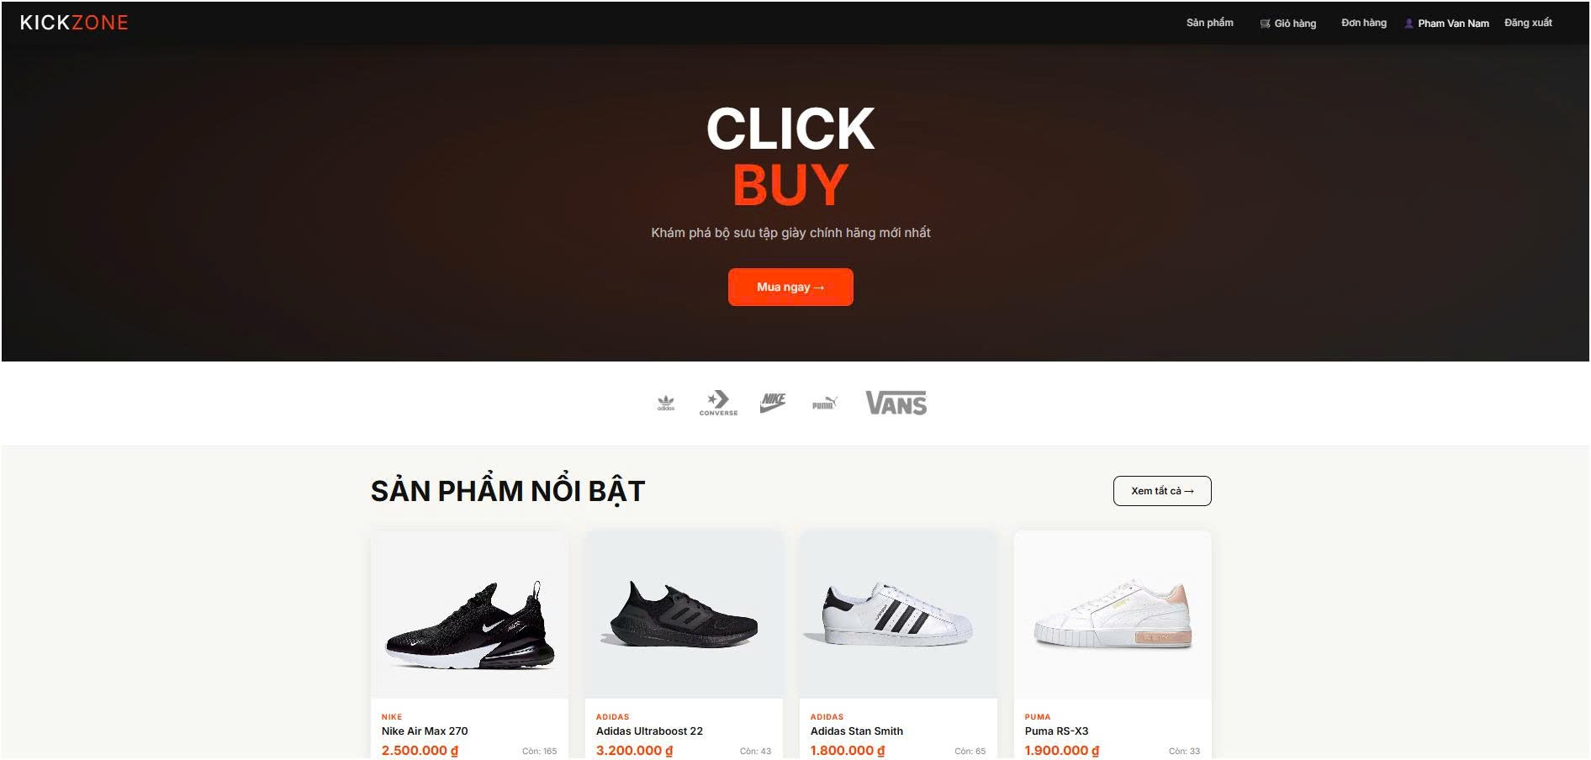
Figure 4.2: KickZone homepage interface

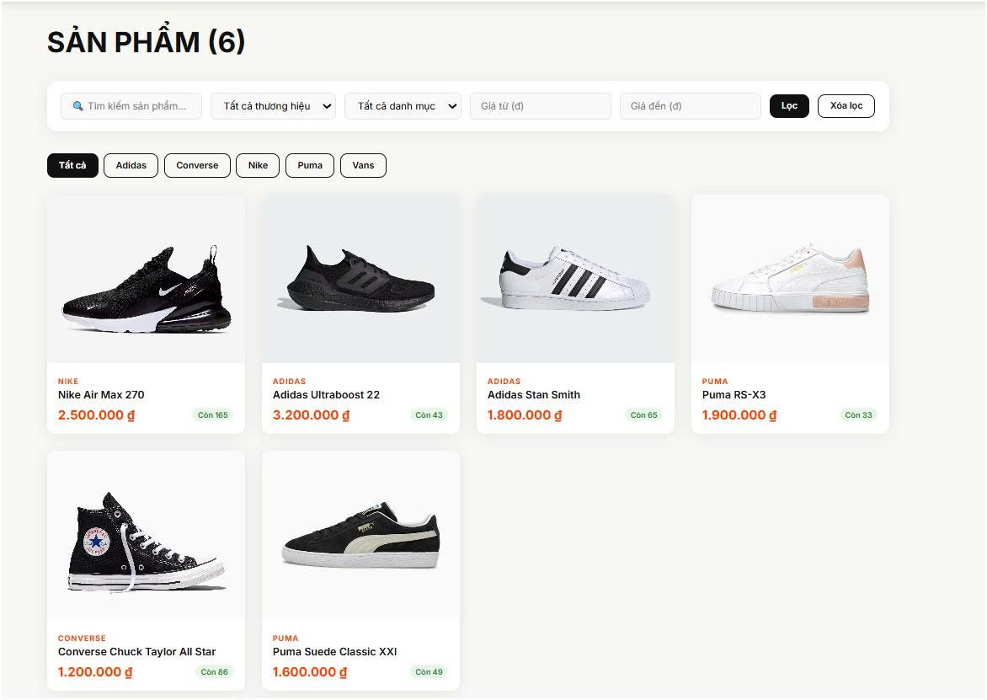
Figure 4.3: Product listing page interface with filters and pagination

4.4.2. Product detail pages
The detail page displays complete product information including images, name, price, brand, category, description. The size selector shows inventory by size — out-of-stock size (quantity=0) is disabled and visually different. The 'Add to Cart' button is only activated when the user has selected the size.
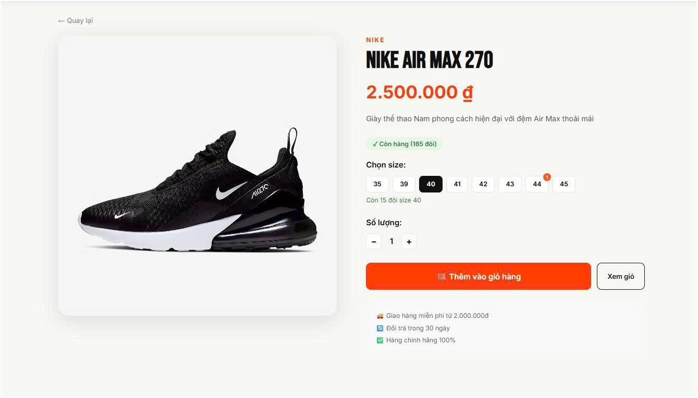
Figure 4.4: Detailed product interface with inventory by size

4.4.3. Cart and checkout page
The cart page displays the list of added products (snapshots: name, price, size, image), allowing to change the quantity or delete individual items. The total amount is calculated automatically. The Checkout page displays a form to enter the shipping address and phone number, along with an order summary.
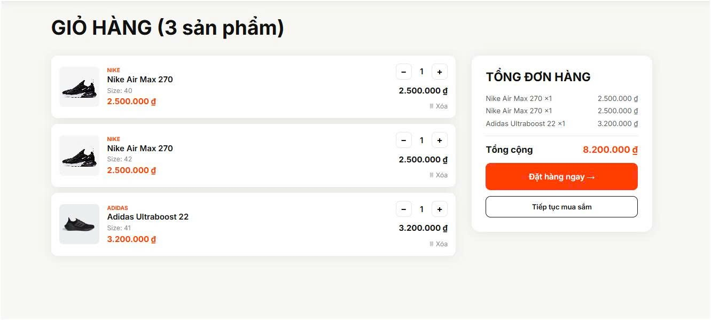
Figure 4.5: Cart page interface

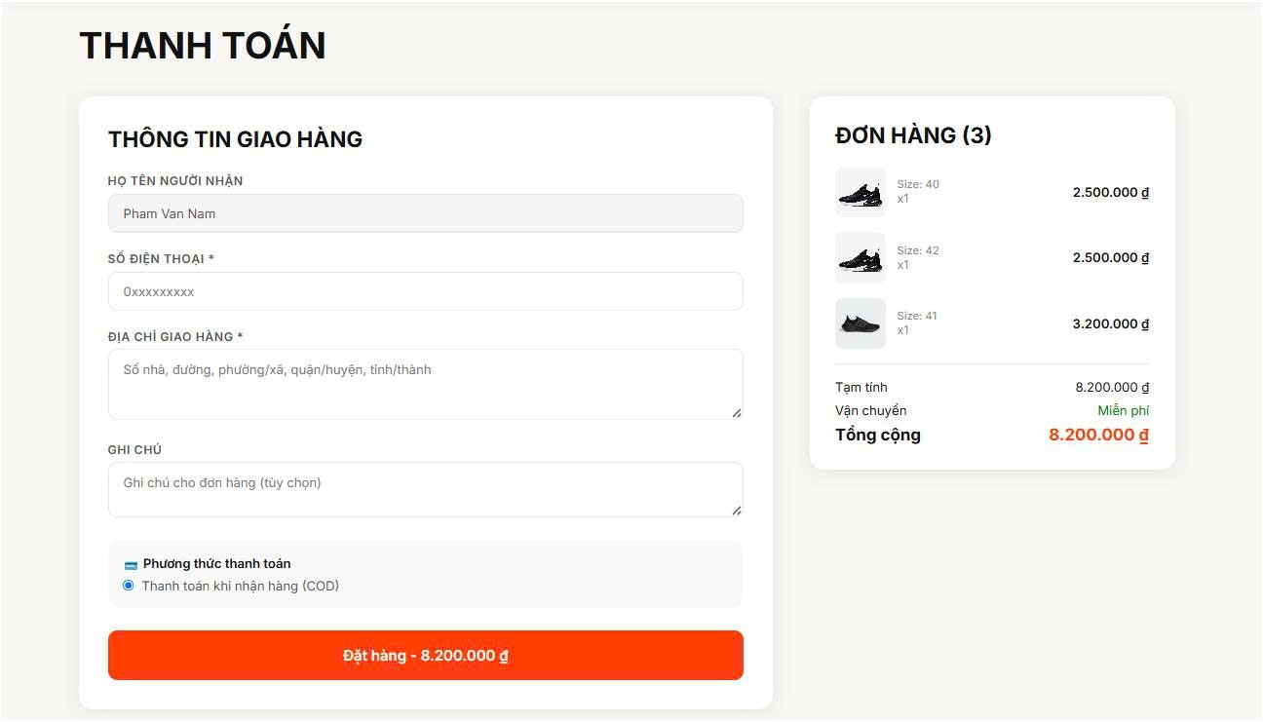
Figure 4.6: Checkout page interface

4.4.4. Customer Order Page
The 'My Orders' page displays a history of all orders of logged-in users, with order status displayed with a colored badge
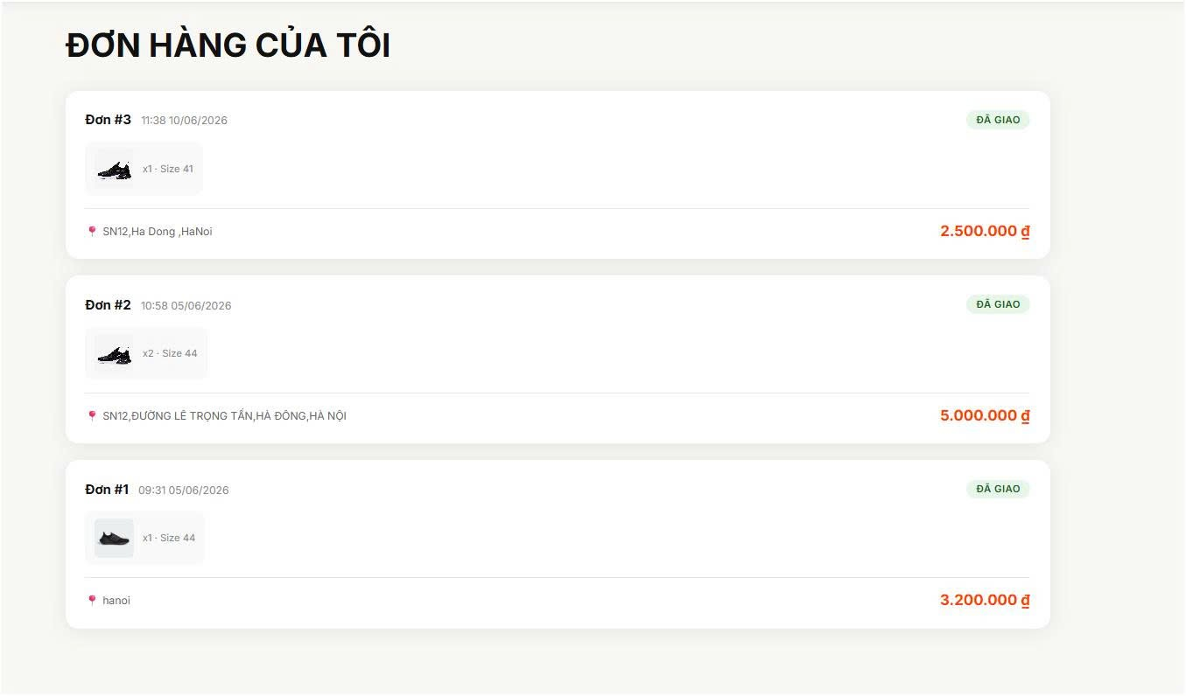
Figure 4.7: Order tracking page interface

4.4.5. Admin Page — Dashboard and Management
The Admin Dashboard displays an overview of the system: total revenue (excluding cancelled orders), total orders, number of pending orders, and a list of the last 5 orders. The Product Admin page allows full CRUD with inventory management by size.
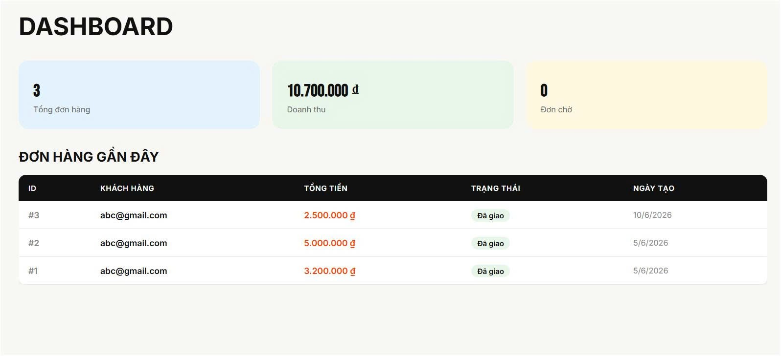
Figure 4.8: Admin Dashboard interface

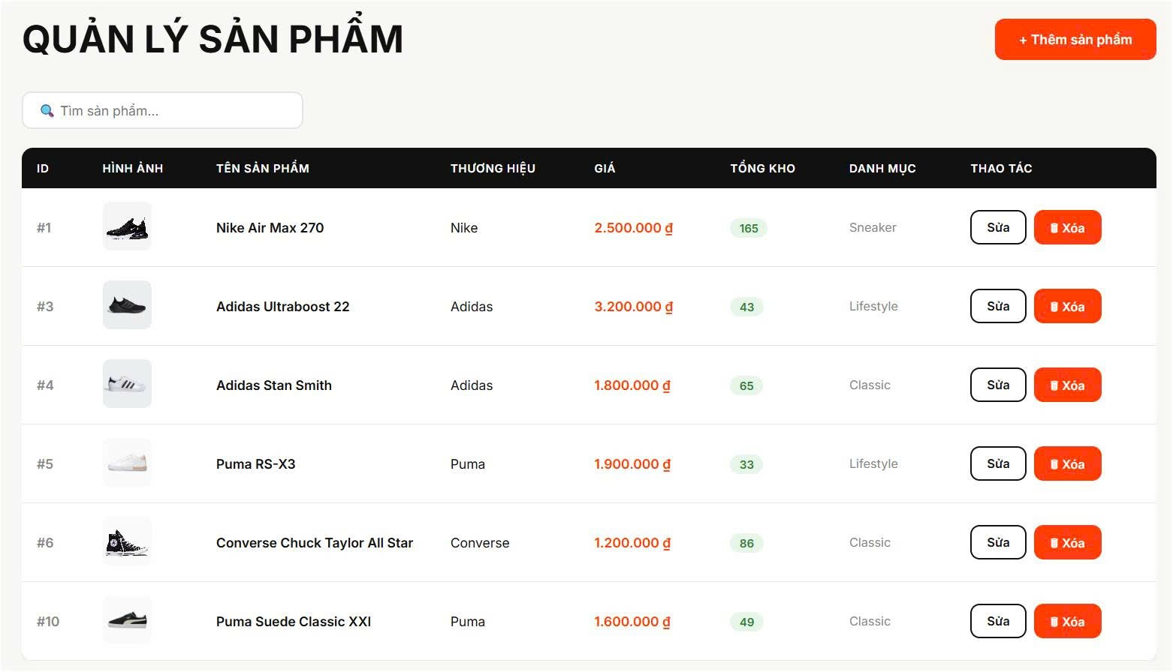
Figure 4.9: Admin interface to manage products and inventory by size

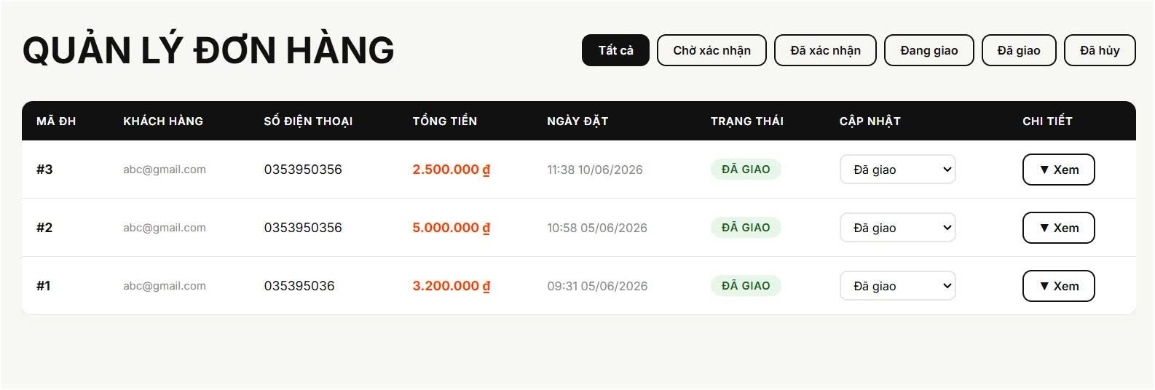
Figure 4.10: Admin interface for order management

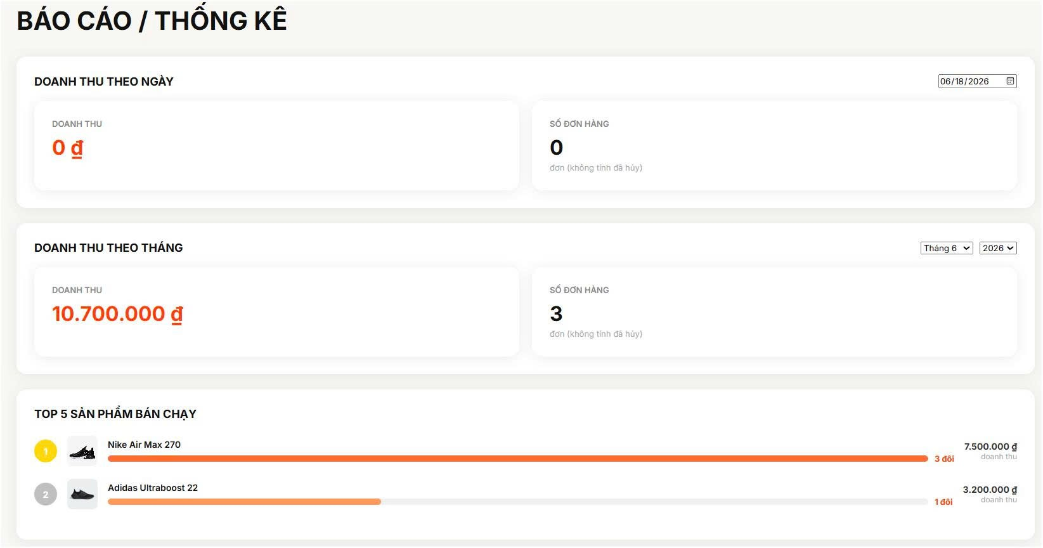
Figure 4.11: Revenue statistics admin interface

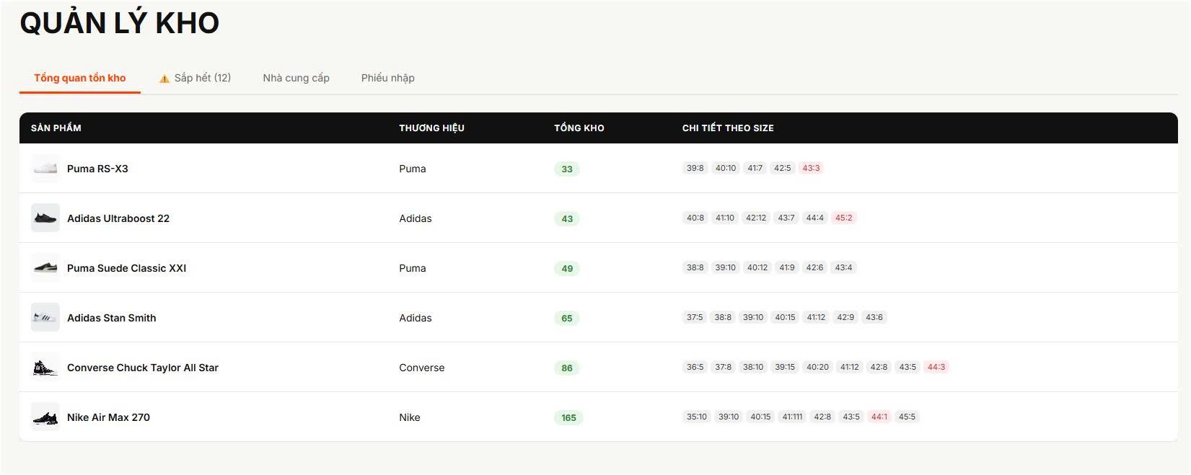
Figure 4.12: Admin interface for inventory management and warehousing

4.4.6. Login and Registration Page
Login and sign-up pages don't have a navbar — form-centric design. After successfully logging in, the system automatically redirects: role='admin' → /admin, role='user' → /.
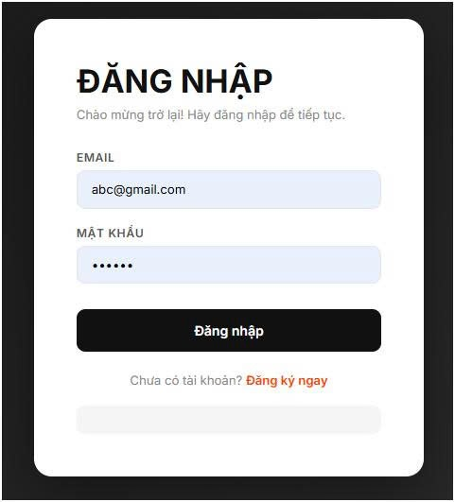
Figure 4.13: Login page interface

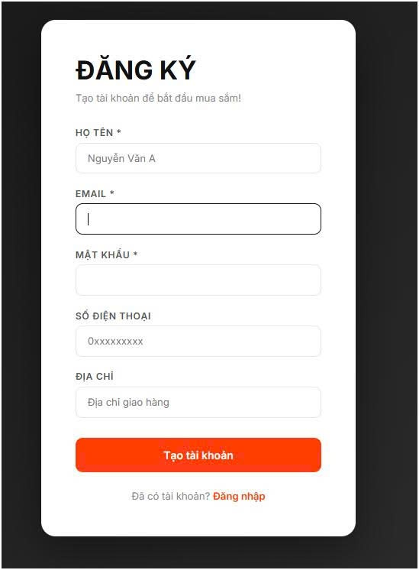
Figure 4.14: Account registration page interface

CHAPTER 5: SYSTEM TESTING

5.1 Test Plan
The goal of the testing phase is to ensure that the KickZone system works properly according to the functional requirements set forth in Chapter 2, and that it meets the non-functional quality criteria for performance, security, and usability. The testing strategy is organized in many layers, from small-unit testing to system-wide testing.
Test Type | Objectives | Tools | Floor | In charge
Unit Test | Test each function/module individually, verify correct processing logic | That's right, postman. | Backend | Nguyen Truong Thanh
Integration Test | Testing integrations between microservices via API Gateway | Supertest, Postman | API | Truong Dinh Son
UI Test | End-to-end user flow testing on the web interface | Manual | Frontend | Truong Dinh Son
Performance Test | NFR Verification of Response Time and Concurrent Load | k6 / JMeter | System | The whole group
UAT | Testing user acceptance according to real-world scenarios | Manual | System | The whole group
Table 5.1: KickZone System Testing Plan

5.2 Test Cases
To evaluate the accuracy and stability of the KickZone system, the team built and implemented a test case that covered the system's critical functions. Test cases are designed based on the functional requirements described in Chapter 2, including common use cases and fault scenarios. Through the testing process, the team can verify that the functions work as required, and ensure that the system handles exceptions and invalid data well.

5.2.1 Authentication Testing
TCID | Test Case Name | References | Input Data | Expected Results | Results | Status
TC01 | Login Successful | FR01 | Email:son261105@gmail.com, Password: 123456 | Return JWT tokens, return to the homepage | Yes | Pass
TC02 | Log in with the wrong password | FR01 | Correct email, wrong password | HTTP 401, authentication error messages | Yes | Pass
TC03 | Email login doesn't exist | FR01 | Email: notexist@gmail.com | HTTP 401, error message | Yes | Pass
TC04 | Register a new account | FR01 | Full name, new email, valid password | HTTP 201, account created | Yes | Pass
TC05 | Email subscriptions already exist | FR01 | The email is already in the system | HTTP 400, duplicate email notifications | Yes | Pass
TC06 | Tokenless API Access | FR01 | Call /api/orders without Bearer tokens | HTTP 401 Unauthorized | Yes | Pass
Table 5.2: Test cases

5.2.2 Product Service Testing
TCID | Test Case Name | References | Input Data | Expected Results | Results | Status
TC07 | View product list | FR03 | GET /api/products | HTTP 200, returns a list of 10 products | Yes | Pass
TC08 | View Product Details | FR03 | GET /api/products/1 | HTTP 200, returns full product information | Yes | Pass
TC09 | View products that don't exist | FR03 | GET /api/products/9999 | HTTP 404 Not Found | Yes | Pass
TC10 | Admin adds new products | FR04 | POST /api/products, full valid data | HTTP 201, the product is saved to the DB | Yes | Pass
TC11 | Admin added SP missing name | FR04 | POST /api/products, name = rỗng | HTTP 400, validation error | Yes | Pass
TC12 | Admin Product Updates | FR04 | PUT /api/products/1, price mới | HTTP 200, updated product pricing | Yes | Pass
TC13 | Admin delete product | FR04 | DELETE /api/products/1 | HTTP 200, the product is removed from the DB | Yes | Pass
TC14 | Users are generally not allowed to delete SP | FR04 | DELETE /api/products/1 với user token | HTTP 403 Forbidden | Yes | Pass
Table 5.3: Test cases

5.2.3 Cart Service
TCID | Test Case Name | References | Input Data | Expected Results | Results | Status
TC15 | Add products to cart | FR05 | product_id=1, size=40, quantity=1 | HTTP 200, the product appears in the cart | Yes | Pass
TC16 | Add SP of the same size to the cart | FR05 | product_id=1, size=40 (available) | Increase the number instead of creating new ones | Yes | Pass
TC17 | View Cart | FR05 | GET /api/cart (with token) | HTTP 200, returns the list of products in the cart | Yes | Pass
TC18 | Update the number of products | FR05 | PUT /api/cart/1, quantity=3 | HTTP 200, the number is updated | Yes | Pass
TC19 | Remove products from cart | FR05 | DELETE /api/cart/1 | HTTP 200, the product is removed from the cart | Yes | Pass
TC20 | View Tokenless Cart | FR05 | GET /api/cart without tokens | HTTP 401 Unauthorized | Yes | Pass
Table 5.4: Test cases of shopping cart testing

5.2.4 Order Service
TCID | Test Case Name | References | Input Data | Expected Results | Results | Status
TC21 | Successful Order | FR06 | Cart with products, fill in the shipping address | HTTP 201, order created, cart deleted | Yes | Pass
TC22 | Order when the basket is empty | FR06 | Shopping cart without products | HTTP 400, empty cart notifications | Yes | Pass
TC23 | Order missing address | FR06 | shipping_address = empty | HTTP 400, address entry required | Yes | Pass
TC24 | View order history | FR07 | GET /api/orders/my (có token) | HTTP 200, the user's order list | Yes | Pass
TC25 | Admin update single status | FR08 | PUT /api/orders/1/status, status=confirmed | HTTP 200, Updated Single State | Yes | Pass
TC26 | Admin update invalid status | FR08 | status = 'invalid_status' | HTTP 400, invalid status message | Yes | Pass
Table 5.5: Test cases

5.2.5 Warehouse & Catalog Management Testing
TCID | Test Case Name | References | Input Data | Expected Results | Results | Status
TC27 | See the list of categories | FR09 | GET /api/categories | HTTP 200, category list | Yes | Pass
TC28 | Add a new category | FR09 | POST /api/categories, name='Boot', slug='boot' | HTTP 201, catalog created | Yes | Pass
TC29 | Add a slug duplicate category | FR09 | slug='sneaker' already exists | HTTP 500, Duplicate entry error | Yes | Pass
TC30 | View product inventory | FR10 | GET /api/inventory/stock-overview (admin) | HTTP 200, inventory overview | Yes | Pass
TC31 | See products that are running out of stock | FR10 | GET /api/inventory/low-stock (admin) | HTTP 200, SP Inventory List < 5 | Yes | Pass
TC32 | Create a receipt | FR10 | POST /api/inventory/receipts, full data | HTTP 201, import slip generated, inventory increased | Yes | Pass
Table 5.6: Warehouse & Catalog Management Test Cases

5.3 Summarizing Test Results
After implementing all 32 designed test cases, the test results are summarized as follows:
Type of Test | Total TC | Pass | Fail | Pass Rate | Tools | Notes
Unit Test / API Test | 20 | 20 | 0 | 100% | Postman | Testing the API for each service
Integration Test | 6 | 6 | 0 | 100% | Postman | Qua API Gateway
UI Test (Manual) | 6 | 6 | 0 | 100% | Manual | User Flow
Total | 32 | 32 | 0 | 100%
Table 5.7: Summary of test results
The test results showed that all 32 test cases achieved Pass status, corresponding to a 100% success rate. The test cases cover both successful handling scenarios and exception cases to evaluate the accuracy, stability, and reliability of the system.
During the test, all functions worked according to the specifications. The system accurately processes input data, performs the correct operations and returns the desired results. For errors such as invalid data, missing information, or unauthorized access, the system responds with an appropriate HTTP status code and a clear error message, making it easy for users to determine the cause.
In addition, microservices communicating through API Gateway operate stably, data is transmitted accurately between services without connection errors or synchronization. The test results show that the system meets the functional requirements well, ensures stable operation and is ready for actual deployment.

5.4 Attribute Quality Testing [Optional]

5.4.1 Performance Testing
The team performs manual performance testing by calling the API continuously and observing the response time. The measurement results are as follows:
API Endpoint | Time TB (ms) | NFR Objectives | Results
GET /api/products | 120ms | < 2000ms | Pass (16x faster)
POST /api/auth/login | 180ms | < 2000ms | Reach
POST /api/orders | 350ms | < 2000ms | Pass (call 3 service)
GET /api/orders/admin/all | 95ms | < 2000ms | Reach
Table 5.8: Performance test results

5.4.2 Security Testing
The team examined some basic security points according to the OWASP Top 10:
Broken Access Control: Try calling the admin API with a user token → the system returns HTTP 403 Forbidden. Pass.
Broken Authentication: Try calling a tokenless protected API → the system returns HTTP 401. Pass.
Injection: Try typing SQL injection into the email field → the system uses prepared statements, without being attacked. Pass.
JWT Token: The token has a maturity of 7 days, signed with JWT_SECRET. Try using fake tokens → the Disapproval System. Pass.
Password Hashing: Passwords are hashed using bcrypt with salt rounds = 10. Do not save plaintext passwords. Pass.

CHAPTER 6: IMPLEMENTATION & USER GUIDE

6.1 System Requirements
To install and run the KickZone system, team computers need to meet the following minimum software requirements:
Software | Minimum version | Recommended Version | Purpose
Node.js | LTS v16.x | v20.x LTS | Run the backend microservices
npm | v8.x | v10.x | Package Management
MySQL | v8.0 | v8.0 | Database
MySQL Workbench | v8.0 | v8.0 | Database management (optional)
RabbitMQ | v3.x | v3.12 | Message broker (optional)
Browser | Chrome 90+ | Latest Chrome/Edge | Accessing the web interface
RAM | 4GB | 8GB or more | Run 7 services simultaneously
Table 6.1: System Requirements

6.2 Installation & Running Instructions

6.2.1 Step 1 - Prepare the Source Code
Download the source code from the github repository and extract it to the working directory:
- Extract the shoe-store-microservices.zip file to the D:\shoe-store-microservices\ folder
- The directory structure includes: auth-service, profile-service, product-service, cart-service, order-service, api-gateway, frontend, database

6.2.2 Step 2 – Initialize the Database
Open MySQL Workbench, connect to MySQL Server, and run 5 SQL files in the database directory one by one:
- 01_auth_db.sql — Create db_auth database, users table, default account data
- 02_profile_db.sql — Create db_profile databases, profiles
- 03_product_db.sql — Create databases db_product, brands, categories, products, product_stock, suppliers
- 04_cart_db.sql — Create db_cart databases, cart_items tables
- 05_order_db.sql — Create db_order databases, order tables, order_items

6.2.3 Step 3 – Configuring Environment Variables
Open the .env file in each service directory and update the MySQL password:
File .env | Variables to be fixed | Example Values
auth-service\.env | DB_PASSWORD | DB_PASSWORD=your_mysql_password
profile-service\.env | DB_PASSWORD | DB_PASSWORD=your_mysql_password
product-service\.env | DB_PASSWORD | DB_PASSWORD=your_mysql_password
cart-service\.env | DB_PASSWORD | DB_PASSWORD=your_mysql_password
order-service\.env | DB_PASSWORD | DB_PASSWORD=your_mysql_password
Table 6.2: Configuring Environment Variables

6.2.4 Step 4 - Starting the Service
Open 7 separate Command Prompt (CMD) windows, each running a service in the following order:

Terminal | Service | Run Command | Port
1 | Auth Service | cd auth-service && npm install && npm run dev | :5001
2 | Profile Service | cd profile-service && npm install && npm run dev | :5002
3 | Product Service | cd product-service && npm install && npm run dev | :5003
4 | Cart Service | cd cart-service && npm install && npm run dev | :5004
5 | Order Service | cd order-service && npm install && npm run dev | :5005
6 | API Gateway | cd api-gateway && npm install && npm run dev | :8000
7 | Frontend | cd frontend && npm install && npm start | :3000
Table 6.3: Commands to start services
After all services start successfully, access the system at: http://localhost:3000

6.3 Demo Account
The system offers demo accounts available to test the functionality:
Role | Email | Password | Authority
Admin | Son261105@gmail.com | 123456 | Full system administration
Customers | abc@gmail.com | 123456 | Shopping, personal order management
Create a new one | Register a new account | Self-Setting | Regular customer rights
Table 6.4: Demo Account

6.4 INSTRUCTIONS FOR USE OF KEY FUNCTIONS

6.4.1 Procurement function (for customers)
The basic shopping flow on the KickZone system is carried out in the following steps:
- Log in: Go to http://localhost:3000/login, enter your email and password, and click Sign In.
- Browse products: Go to the Products section, view the list, and click the product to view its details.
- Add to cart: Select the size, click Add to cart.
- Checkout: Go to the Shopping Cart, check the product, click Order Now.
- Fill in the information: Enter the shipping address, phone number, note (if applicable), click Order.
- Track orders: Go to My Orders to view the status of your order.

6.4.2 Admin Functions (For Admins)
After logging in with the admin account, the admin interface is accessed at http://localhost:3000/admin with the following modules:
- Dashboard: View a system overview — number of orders, revenue, pending orders, recent orders.
- Product Management (/admin/products): Add, edit, delete products. Upload the image via URL.
- Brand Management (/admin/brands): Add, edit, remove brands with logos.
- Category Management (/admin/categories): Add, edit, delete product categories.
- Warehouse Management (/admin/inventory): View an overview of inventory, products running low, suppliers, and receipts.
- Order Management (/admin/orders): View and update order status (pending → confirmed → shipping → delivered).
- User Management (/admin/users): View the list of users, decentralize admin/user permissions.
- Reports (/admin/reports): View revenue by day, month, and top 5 best-selling products.

CHAPTER 7: CONCLUSION & DEVELOPMENT DIRECTIONS

7.1 Results achieved
After the development process, the team has completed the KickZone system with all the functions set out. The table below makes a direct comparison between the initial goal and the actual results achieved:
Initial Objectives | Results
Building a shoe sales system according to the Microservices architecture | 7 service độc lập: auth, profile, product, cart, order, api-gateway, frontend
User authentication function (registration, login, JWT) | Bcrypt + JWT, RBAC decentralization (admin/user)
Product, category, brand management | Full CRUD, decentralized admin
Shopping Cart and Ordering | Cart-service and order-service integration, automatically reduce inventory
Warehouse management and receipt slips | Inventory by size, import slip, supplier
Admin dashboard with statistical reports | Revenue by day/month, top 5 best-selling SPs
Responsive User Interface (React.js) | Desktop and mobile compatibility, modern design
Unified API Gateway | Complete request orchestration, centralized validation
Testing 30+ test cases | 32 test cases, Pass rate 100%
Table 7.1: Comparison of goals and results achieved
Architecturally, the system is built according to the Microservices architecture with API Gateway pattern, each service has its own database (Database per Service pattern), communication via synchronous REST API. The system has properly applied the software design principles learned in the course, including clear separation of responsibilities, loose coupling between services, and independent scalability.

7.2 Limitations and Challenges
Although the KickZone system has completed the main functions as set out and operated stably during testing, the team found that there are still certain technical and functional limitations. These limitations mainly stem from the scope of the project, limited implementation time and limited development resources.

7.2.1 Technical Limitations
One of the first limitations is that the system does not currently apply a cache mechanism to optimize performance. All data retrieval requests are processed directly through the database. In the test environment, the number of users is not large, so the system is still responsive. However, when implemented in practice with higher traffic, continuous queries to the database can increase response times and affect the overall performance of the system. Due to time constraints, the team did not have time to research and integrate Redis or similar caching solutions.
In addition, the system is still deployed directly on the server environment instead of using Docker to containerize services. This makes installation and deployment on different environments highly dependent on the configuration of each machine. If deploying at scale or moving to a cloud environment, the lack of Docker can increase the complexity of managing and operating the system.
In addition, the project has not yet built a CI/CD process to automate the testing, build and deployment steps. Currently, all operations are done manually by team members. While this approach is still suitable for the scale of the project, in the long run it will increase the risk of errors and reduce efficiency when developing new features.
Another limitation is that the ability to handle errors between microservices is not really complete. When one service crashes or is temporarily unresponsive, other services may be affected by the lack of proper protection mechanisms. The team has only focused on ensuring the stable operation of the main business flow without implementing advanced solutions to increase the fault tolerance of the system.
Besides, monitoring and monitoring the operation of the system is quite simple. The services currently log independently and are not centralized into a common log management system. This makes it difficult to analyze the cause of an error or track the entire processing flow of a request that goes through many different services.

7.2.2 Function Restrictions
In terms of functionality, the system currently meets the basic needs of an online shoe sales website. Some advanced features have not yet been implemented due to limitations on the time and scope of the project.
Currently, the system only supports payment on delivery (COD). Users cannot pay online through popular payment gateways such as VNPay, MoMo or Stripe. This reduces convenience for customers and does not fully reflect the online shopping process in reality.
The product search function is also only at the basic level. Users can search by keyword, but they can't filter products by many criteria such as brand, price range, size, or popularity. The system also does not support product suggestions or intelligent search to improve the user experience.
In addition, the project is currently only developed as a web application. While the interface can be displayed on mobile devices through a browser, the team hasn't built its own mobile app for Android or iOS. This is a significant limitation in the context of users' increasing tendency to shop through smartphones.

7.2.3 Development challenges
The biggest difficulty that the team encountered during the implementation of the project was the design and implementation of the Microservices architecture. Compared to traditional monolithic architectures, microservices offer many benefits in terms of scalability and maintenance, but also significantly increase the complexity of system development.
Building a communication mechanism between services through API Gateway requires the team to do more research on request routing, user authentication, access decentralization, and error handling. During the development process, the team encountered many difficulties when handling errors related to CORS, JWT authentication, and data transfer between services.
Besides, ensuring data consistency between services is also a relatively complicated problem. An order operation can involve product-service, cart-service, and order-service simultaneously. If one of the services fails during processing, ensuring that the data is not skewed is an issue that the team must consider and test repeatedly.
In addition to the technical challenges, the team also faced pressure in terms of time and manpower. With a limited number of members, each member has to take on a variety of roles from requirements analysis, system design, programming, testing, to writing reports. This makes the team have to balance between perfecting the function and researching advanced technical solutions. However, this is also an opportunity to help members accumulate more teamwork experience and better understand the software development process in practice.

7.3 Conclusion
Conclusion
The KickZone project was built to solve the problem of e-commerce selling shoes online, applying the Microservices architecture — one of the most modern and popular software architectures today. Through requirements analysis, system design, deployment, and testing, the team completed a fully functional system with 7 independent microservices, communicating with each other via API Gateway and RabbitMQ Message Broker.
The system meets all the set functional requirements, from user authentication, product management, shopping carts, ordering to warehouse management and statistical reports. The test results with 32 test cases with a 100% pass rate show that the system operates stably and properly handles both success and failure scenarios.
Academically, the project has successfully practiced the core knowledge of Software Architecture, including the selection and application of a microservices architecture that explains through ADR, building a C4 Model that describes the system at various levels of abstraction, designing a standard RESTful API, etc. define ASR through the Utility Tree and make grounded architectural decisions. These are essential skills that a software engineer needs to master when working with large-scale systems in practice.
Although there are still some limitations such as no containerization using Docker, no integration of online payments or CI/CD Pipeline, the team finds these to be valuable lessons for future projects. The Microservices architecture has been designed with future scalability in mind, providing a solid foundation for further development of the system in the proposed directions.

REFERENCES

Documentation | Link
C4 Model (Simon Brown) | https://c4model.com
REST Dissertation (Fielding) | https://ics.uci.edu/~fielding/pubs/dissertation/top.htm
Microservices (Martin Fowler) | https://martinfowler.com/articles/microservices.html
Express.js Docs | https://expressjs.com
React Docs | https://react.dev
Structurizr DSL | https://docs.structurizr.com
PlantUML C4 | https://github.com/plantuml-stdlib/C4-PlantUML

