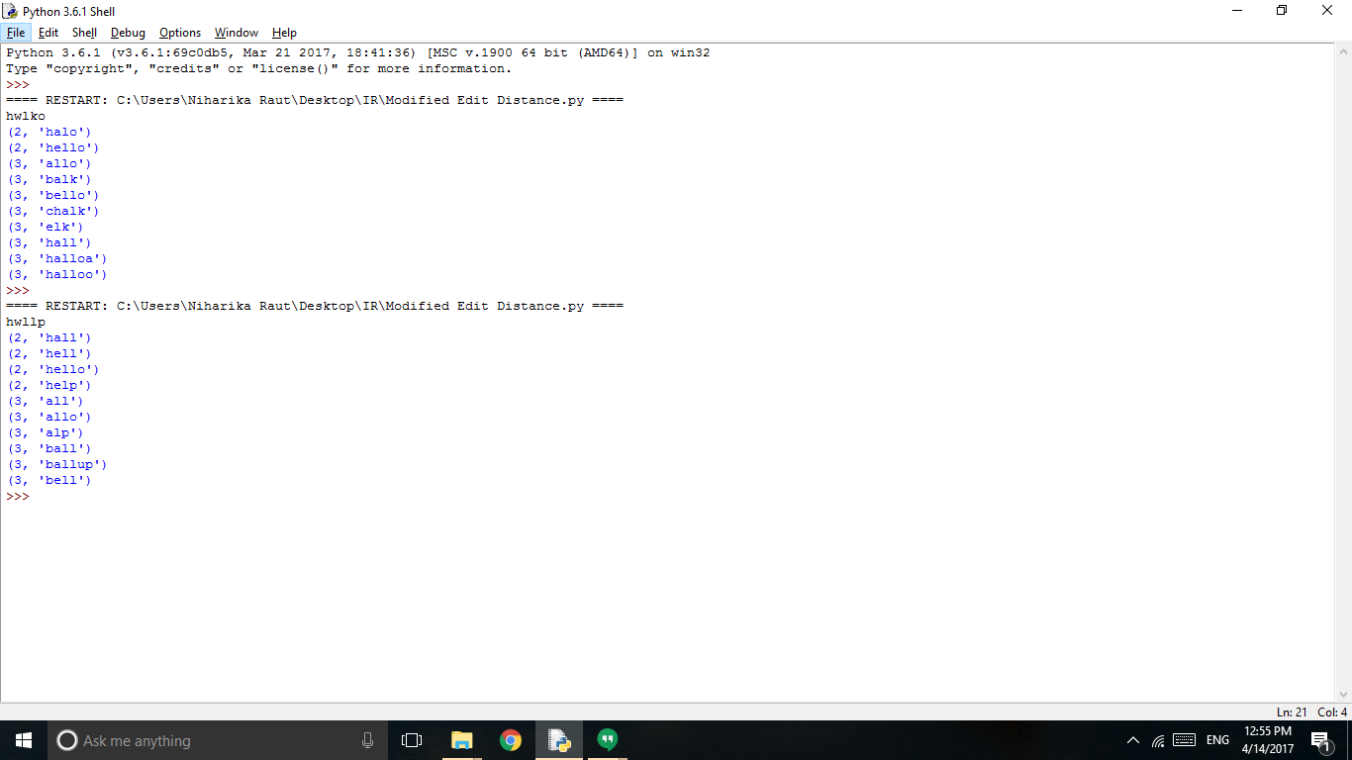

References:

1. <https://web.stanford.edu/class/cs124/lec/med.pdf>
2. <https://web.stanford.edu/~jurafsky/slp3/5.pdf>
3. <https://web.stanford.edu/class/cs124/lec/spelling.pdf>