

International School
Capstone Project 1
CMU-SE 450 – C1SE.30

Database Design
Version 1.2
Date: September 11th, 2026
COVAI
TEST COVERAGE ANALYSIS AND AI-DRIVEN TEST GENERATION SYSTEM
Created by C1SE.30
Dinh, Huynh Tan
Phuc, Tran Huu
Quy, Nguyen Duy
Thuan, Ngo Huu
Hien, Nguyen Thanh Long
Approved by
Man, Nguyen Duc, Ph.D.

Database Design Review Panel Representative:

Name Signature Date

Capstone Project 1 - Mentor:

Name Signature Date

Project acronym | COVAI
Project Title | Test Coverage Analysis and AI-Driven Test Generation System
Start Date | 10 Aug 2026 | End Date | 12 Dec 2026
Lead Institution | International School, Duy Tan University
Project Mentor | Man, Nguyen Duc, Ph.D.
Scrum master / Project Leader & contact details | Dinh, Huynh Tan  Email: huynhtandinh.dev@gmail.com  Tel: 0365 472 162 ID: 29219052500
Product Owner | Phuc, Tran Huu
Partner Organization | Duy Tan University
Team members | Name | Email | Tel
1 | Dinh, Huynh Tan | huynhtandinh.dev@gmail.com | 0365472162
2 | Phuc, Tran Huu | phuc12435az@gmail.com | 0842644169
3 | Quy, Nguyen Duy | quylavip333@gmail.com | 0334814522
4 | Thuan, Ngo Huu | thuanhuugl@gmail.com | 0385591447
PROJECT INFORMATION
DOCUMENT APPROVALS
The following signatures are required for approval of this document.
Dinh, Huynh Tan  Student ID: 29219052500  Scrum Master | Signature | Date
Phuc, Tran Huu  Student ID: 29211458179  Database & Backend Lead | Signature | Date
Quy, Nguyen Duy  Student ID: 29211158823  Data & Full-Stack Developer | Signature | Date
Thuan, Ngo Huu  Student ID: 29219065178  Frontend Lead & Full-Stack Developer | Signature | Date

DATABASE DESIGN DOCUMENT
Document Title | Database Design Document
Author(s) | Thuan, Ngo Huu
Date | September 11th, 2026 | File name: | C1SE.30_DatabaseDesign_v1.2.doc

REVISION HISTORY
Version | Date | Comments | Author | Approval
1.0 | Aug 18th 2026 | Initial Database Design Document for Core Testing & Coverage Models | Dinh, Huynh Tan
1.1 | Sep 02nd 2026 | Extended Relational Schema with CFG, Cyclomatic Complexity & Quality Metrics | Thuan, Ngo Huu
1.2 | Sep 11th 2026 | Complete Relational Specification for Multi-Framework, AI Test Generation & Chatbot RAG Evaluation | Thuan, Ngo Huu

TABLE OF CONTENTS
1. Introduction 1
1.1 Purpose 1
1.2 Scope 1
1.3 Introduction about MongoDB 1
2. Database Diagram 2
2.1 Table Overview 2
2.2 Table Relationship Diagram 3
3. Database Design for Sprint 5
3.1 Table Users 5
3.2 Table Cameras 5
3.3 Table Heamaps 7
3.4 Table Invoices 8
3.5 Table PersonTrackings 10
3.6 Table Products 12
3.7 Table Stores 13
3.8 Table StoresSumaries 14
3.9 Table Zones 16
3.10 Table ZonesSumaries 18
4. Hardware and software Requirements 20

1. Introduction
The Database Design maps the logical data model of the COVAI system to the target database management system (PostgreSQL 16 managed via Prisma ORM) with consideration to the system's performance, concurrency, and integrity requirements. The Database Design converts logical or conceptual data constructs to physical relational tables, indices, foreign key constraints, and cascade policies of the target Database Management System.

1.1 Purpose
The purpose of the Database Design is to ensure that every database transaction meets or exceeds its performance requirements within the COVAI ecosystem. This document takes into account high-throughput asynchronous job execution, complex multi-level code coverage aggregation, control flow graph storage, AI-generated test management, and internal AI chatbot evaluation datasets to produce a schema, normalization strategy, and index environment that guarantees optimal execution speed, data consistency, and strict multi-tenant project isolation.

1.2 Scope
The Database Design Document has the following objectives:
- To describe the physical and logical design of the database, that is, a collection of related relational tables stored in PostgreSQL that can be accessed by the Express.js backend services, BullMQ asynchronous workers, and analytics engines via Prisma ORM.
- To serve as a basis for implementing database migrations, ORM schemas, validation rules, and data access layers. It provides project stakeholders and the development team visibility into the relational model, relationships, constraints, and hardware/software specifications necessary for system deployment.

1.3 Introduction about PostgreSQL and Prisma ORM
PostgreSQL is an advanced, enterprise-grade open-source object-relational database management system known for its proven architecture, reliability, data integrity, robust feature set, and extensibility. In the COVAI system, PostgreSQL 16 is selected as the primary persistence layer. It provides ACID-compliant transactions essential for managing user project configurations, snapshot versioning, and test execution results. PostgreSQL delivers high concurrency via Multi-Version Concurrency Control (MVCC) and excels at handling complex relational queries with foreign keys and cascade deletions. Furthermore, PostgreSQL features native JSONB support, allowing COVAI to efficiently store and query semi-structured data—such as Control Flow Graph AST nodes, framework detection payloads, and AI test metadata—while maintaining strict relational integrity across core entities.
Prisma is a next-generation Object-Relational Mapping (ORM) framework for Node.js and TypeScript that bridges the application backend with the PostgreSQL database. In COVAI, Prisma provides a declarative single source of truth through its schema file (schema.prisma), defining models, relations, indices, and constraints. Prisma generates a type-safe database client (Prisma Client) that eliminates common query errors and prevents SQL injection vulnerabilities. Additionally, Prisma Migrate enables automated, predictable database migrations, ensuring seamless schema synchronization across local development, Docker containers, and production deployments on cloud-hosted PostgreSQL instances.

2. Database Diagram

2.1 Table Overview
Table 1. Table Overview
Table Name | Short Description
Users | Stores user credentials, profiles, encrypted GitHub OAuth tokens, and daily AI token/request rate-limiting quotas.
Projects | Manages user project workspaces, repository URLs, default branches, and detected testing configurations.
ProjectSnapshots | Stores immutable source code snapshots, archive checksums, storage paths, and framework detection results.
CoverageSummaries | Summarizes aggregated 4-dimension test coverage (lines, branches, functions, statements percentages) for snapshots.
CoverageDetails | Captures detailed source-file and function-level coverage hit counts, boundary lines, and branch metrics.
CodeStructureAnalyses | Stores AST-derived Control Flow Graphs (CFG JSON) and McCabe Cyclomatic Complexity calculations per function.
QualityReports | Consolidates multi-metric code health scores (overall, coverage, security, maintainability) and static vulnerabilities.
BackgroundJobs | Manages asynchronous BullMQ worker tasks, lifecycle execution statuses, chronological logs, and Docker terminal outputs.
TestRunsAndAiTests | Stores test execution runs across frameworks (Jest, Vitest, etc.) and AI-generated unit test suites (skeleton/full).
ChatbotEvaluations | Manages internal AI chatbot trustworthiness benchmark datasets, multi-criteria RAG evaluations, and test cases.

2.2 Table Relationship Diagram
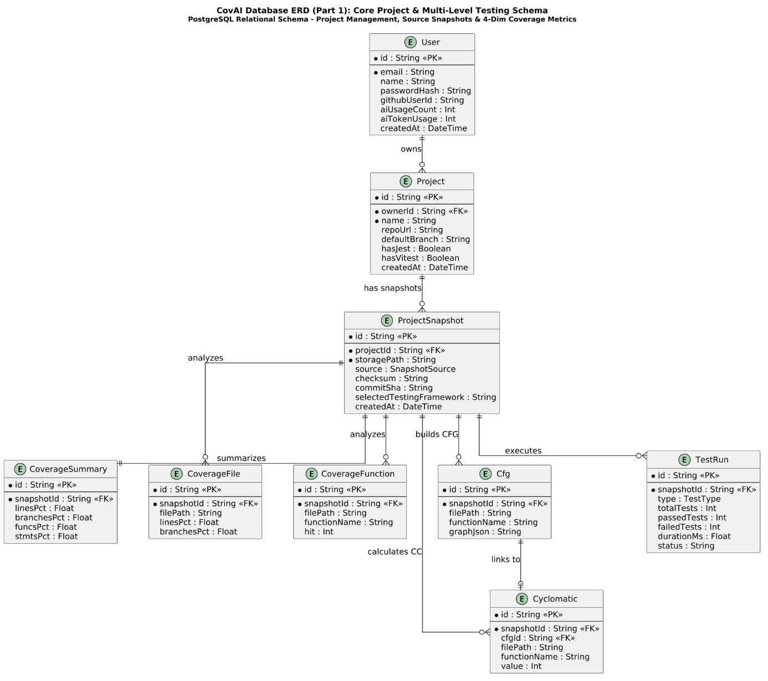

Figure 1. CovAI Database ERD (Part 1): Core Project & Multi-Level Testing Schema

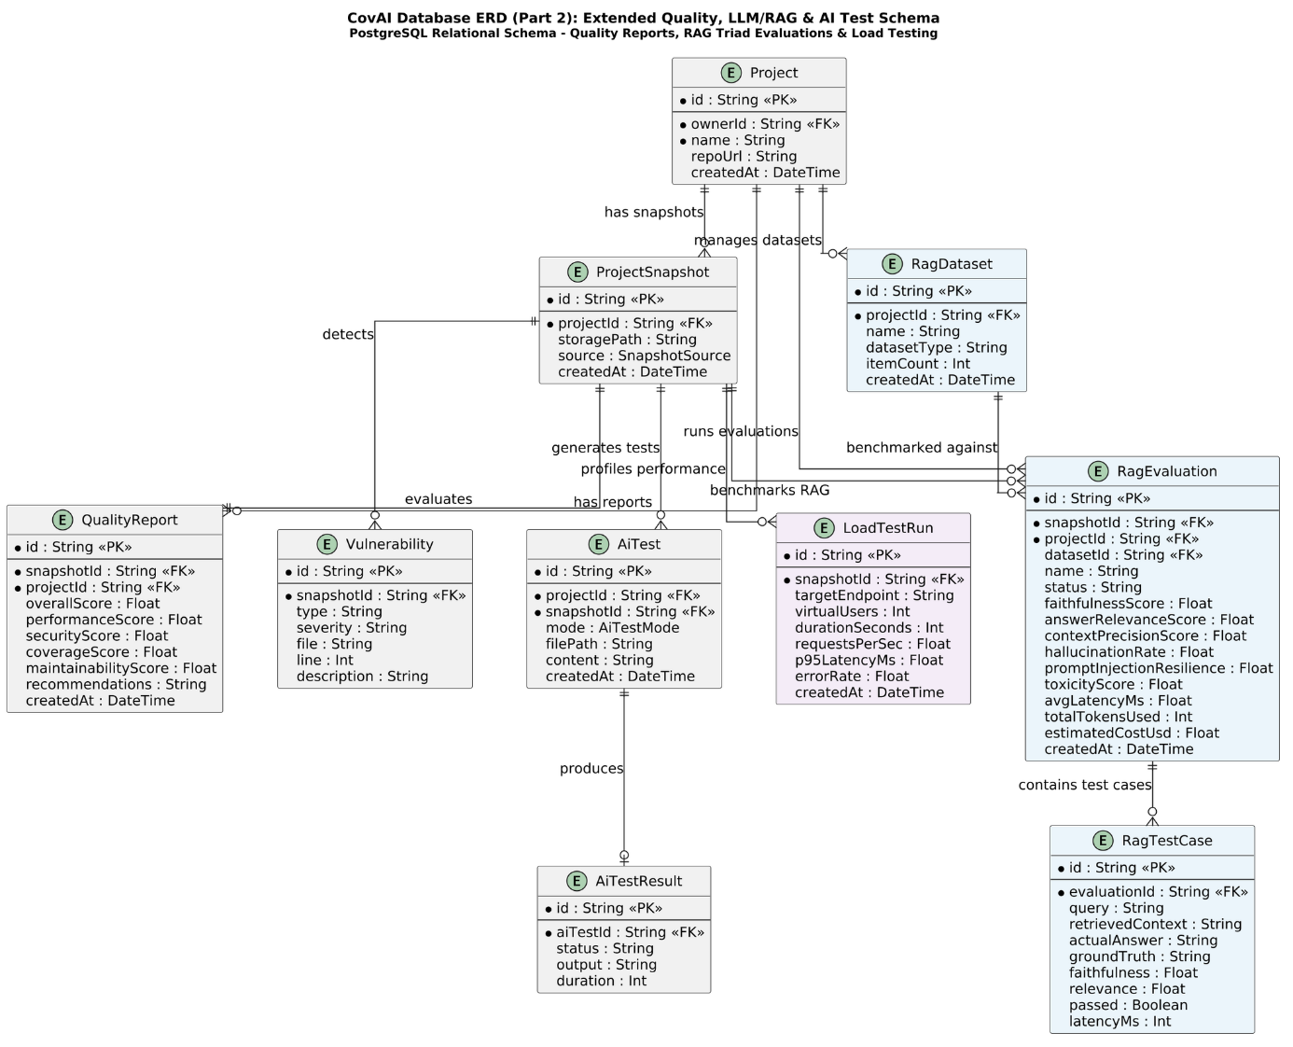

Figure 2. CovAI Database ERD (Part 2): Extended Quality, LLM/RAG & AI Test Schema
The entity relationship diagrams above illustrate the complete relational architecture of the COVAI system:
- Part 1 represents core project management, source code snapshots, and multi-level coverage metrics. A User owns multiple Projects (1:N). Each Project contains multiple immutable ProjectSnapshots (1:N, cascade delete). Each snapshot is decomposed into an overall CoverageSummary (1:1), granular CoverageFiles (1:N), CoverageFunctions (1:N), and AST-derived Control Flow Graphs (Cfg, 1:N) with associated McCabe Cyclomatic Complexity scores (1:1).
- Part 2 details the extended quality assurance, AI test generation, and AI chatbot trustworthiness evaluation architecture. Each ProjectSnapshot produces a consolidated QualityReport (1:1), detects static code Vulnerabilities (1:N), tracks multi-framework TestRuns (1:N), and generates AiTests (1:N) with automated verification AiTestResults (1:1). In addition, each Project manages benchmark RagDatasets (1:N), against which ProjectSnapshots execute multi-metric RagEvaluations (1:N), evaluating individual RagTestCases (1:N) for faithfulness, relevance, hallucination rate, and latency, complemented by LoadTestRuns (1:N) for endpoint performance profiling.

3. Database Design for Sprint

3.1 Table Users

Users
Id | Field | Type | Constraint | Description
1 | id | String | Primary Key, CUID | Auto-generated unique identifier for user accounts.
2 | email | String | Required, Unique, Index | User email address used for credentials, login, and system notifications.
3 | passwordHash | String | Optional | Bcrypt salted hash for password-based authentication (null for OAuth users).
4 | name | String | Optional | Full name or display name of the developer or QA engineer.
5 | avatarUrl | String | Optional | URL to the user's avatar image hosted on cloud storage or GitHub.
6 | githubUserId | String | Unique, Optional | Unique GitHub user ID linked via GitHub OAuth 2.0.
7 | githubAccessTokenEnc | String | Optional | AES-256-CBC encrypted GitHub access token for repository access and webhooks.
8 | passwordResetToken | String | Optional | Secure random token used for password reset verification flow.
9 | passwordResetExpires | DateTime | Optional | Timestamp when the password reset token expires (default 15 minutes).
10 | refreshToken | String | Optional | Cryptographic JWT refresh token for persistent session management.
11 | aiUsageCount | Int | Default: 0 | Number of AI test generation and analysis requests made within the current day.
12 | aiUsageDate | String | Optional | Date tracking string (YYYY-MM-DD) for resetting daily AI usage quotas.
13 | aiTokenUsage | Int | Default: 0 | Cumulative total of LLM tokens consumed by user across Gemini API requests.
14 | bio | String | Optional | Developer biography and organization notes.
15 | jobTitle | String | Optional | Professional role (e.g., Senior Full-Stack Engineer, QA Automation Lead).
16 | createdAt | DateTime | Default: now() | Timestamp when the user account was registered.
17 | updatedAt | DateTime | UpdatedAt | Timestamp of the most recent profile modification.

3.2 Table Projects
Projects
Id | Field | Type | Constraint | Description
1 | id | String | Primary Key, CUID | Unique identifier of the project workspace.
2 | ownerId | String | Required, FK (User.id), Index | Foreign key referencing the User who owns this project workspace.
3 | name | String | Required | Human-readable name of the software project or repository.
4 | description | String | Optional | Detailed description of the software project, scope, and objectives.
5 | repoUrl | String | Optional | URL to the remote Git repository (e.g., https://github.com/org/repo).
8 | defaultBranch | String | Default: 'main' | Default Git branch utilized for analysis, checkout, and webhook triggers.
9 | rootDir | String | Optional | Subdirectory path where the project source code resides (for monorepos).
10 | hasJest | Boolean | Default: false | Flag indicating whether Jest framework is detected in project dependencies.
11 | jestCommand | String | Optional | Custom execution command for running Jest tests (e.g., 'npm test --').
12 | jestConfigPath | String | Optional | Relative path to custom Jest configuration file (e.g., 'jest.config.js').
13 | hasVitest | Boolean | Default: false | Flag indicating whether Vitest framework is detected.
14 | vitestCommand | String | Optional | Custom execution command for running Vitest (e.g., 'npx vitest run --coverage').
15 | vitestConfigPath | String | Optional | Relative path to Vitest configuration file (e.g., 'vitest.config.ts').
16 | storageBasePath | String | Optional | Firebase Storage or local filesystem base path storing project archives.
17 | createdAt | DateTime | Default: now() | Timestamp when the project workspace was created.
18 | updatedAt | DateTime | UpdatedAt | Timestamp when project configuration or settings were last updated.

3.3 Table ProjectSnapshots
ProjectSnapshots
Id | Field | Type | Constraint | Description
1 | id | String | Primary Key, CUID | Unique identifier of the specific source code snapshot.
2 | projectId | String | Required, FK (Project.id), Index | Foreign key referencing parent Project (Cascade deletion).
3 | source | Enum | SnapshotSource (ZIP, GITHUB) | Ingestion method: direct ZIP archive upload or GitHub repository clone.
4 | checksum | String | Optional, Unique(projectId, checksum) | SHA-256 hash of archive/codebase for deduplication and caching.
5 | commitSha | String | Optional, Unique(projectId, commitSha) | Git commit SHA identifying the exact version of the codebase.
6 | storagePath | String | Required | Cloud or filesystem path where snapshot source code is unpacked and stored.
7 | rootDir | String | Optional | Detected source code root directory within the snapshot.
8 | selectedTestingFramework | String | Optional | Active test framework selected by user or detected by system (JEST, VITEST, etc.).
9 | testingFrameworksJson | String (JSON) | Optional | Detailed JSON array of all detected testing frameworks and confidence metrics.
10 | frameworkRecommendationJson | String (JSON) | Optional | AI-assisted recommendation and rationale for the optimal testing strategy.
11 | hasJest | Boolean | Default: false | Snapshot-specific detection flag for Jest framework.
12 | jestCommand | String | Optional | Snapshot-specific Jest execution command override.
13 | hasVitest | Boolean | Default: false | Snapshot-specific detection flag for Vitest framework.
14 | vitestCommand | String | Optional | Snapshot-specific Vitest run command override.
15 | vitestConfigPath | String | Optional | Snapshot-specific Vitest configuration path.
16 | structureAnalysis.resultJson | String (JSON) | Optional | Deep AST structure analysis: module hierarchy, entry points, dependencies.
17 | createdAt | DateTime | Default: now() | Timestamp when the snapshot was uploaded and registered.

3.4 Table CoverageSummaries
CoverageSummaries
Id | Field | Type | Constraint | Description
1 | id | String | Primary Key, CUID | Unique identifier of the coverage summary record.
2 | snapshotId | String | Required, FK (ProjectSnapshot.id), Unique | Foreign key referencing target snapshot (1-to-1 relationship).
3 | linesPct | Float | Required | Overall percentage of executable source lines covered by tests (0.0 - 100.0).
4 | branchesPct | Float | Required | Overall percentage of conditional branch decision paths covered (0.0 - 100.0).
5 | funcsPct | Float | Required | Overall percentage of declared functions executed during tests (0.0 - 100.0).
6 | stmtsPct | Float | Required | Overall percentage of executable statements covered across project (0.0 - 100.0).
7 | testRun.id | String | PK, CUID | Unique identifier of the test execution run associated with this summary.
8 | testRun.type | Enum | TestType | Test framework used: JEST, VITEST, SUPERTEST, PLAYWRIGHT, CYPRESS.
9 | testRun.totalTests | Int | Required | Total count of test cases executed across test suites.
10 | testRun.passedTests | Int | Required | Total count of passing test cases.
11 | testRun.failedTests | Int | Required | Total count of failing test cases.
12 | testRun.skippedTests | Int | Required | Total count of skipped or disabled test cases.
13 | testRun.durationMs | Float | Required | Total test execution time in milliseconds inside Docker container.
14 | testRun.status | String | Required | Overall test run status (PASSED, FAILED, TIMED_OUT).
15 | testRun.startedAt | DateTime | Required | Timestamp when test runner commenced execution.
16 | testRun.finishedAt | DateTime | Required | Timestamp when test execution concluded.
17 | createdAt | DateTime | Default: now() | Timestamp when the coverage summary was compiled and stored.

3.5 Table CoverageDetails
CoverageDetails
Id | Field | Type | Constraint | Description
1 | file.id | String | Primary Key, CUID | Unique identifier for file-level coverage entry.
2 | file.snapshotId | String | Required, FK (ProjectSnapshot.id), Index | Foreign key referencing analyzed snapshot (Cascade deletion).
3 | file.filePath | String | Required, Unique(snapshotId, filePath) | Relative file path of source code module (e.g., 'src/services/auth.js').
4 | file.linesPct | Float | Required | Percentage of executable code lines covered in this file (0.0 - 100.0).
5 | file.branchesPct | Float | Required | Percentage of logical decision branches covered in this file (0.0 - 100.0).
6 | file.funcsPct | Float | Required | Percentage of declared functions covered in this file (0.0 - 100.0).
7 | file.stmtsPct | Float | Required | Percentage of executable statements covered in this file (0.0 - 100.0).
8 | func.id | String | Primary Key, CUID | Unique identifier for function-level coverage entry.
9 | func.snapshotId | String | Required, FK (ProjectSnapshot.id), Index | Foreign key referencing analyzed snapshot (Cascade deletion).
10 | func.filePath | String | Required, Index | Relative file path containing the declared function.
11 | func.functionName | String | Required | Name of function, class method, or arrow function closure.
12 | func.startLine | Int | Optional | 1-based starting source code line of the function declaration.
13 | func.endLine | Int | Optional | 1-based ending source code line of the function declaration.
14 | func.hit | Int | Required | Execution hit counter: total number of times this function was executed.

3.6 Table CodeStructureAnalyses
CodeStructureAnalyses
Id | Field | Type | Constraint | Description
1 | cfg.id | String | Primary Key, CUID | Unique identifier of the Control Flow Graph entry.
2 | cfg.snapshotId | String | Required, FK (ProjectSnapshot.id), Index | Foreign key referencing analyzed snapshot (Cascade deletion).
3 | cfg.filePath | String | Required, Index | Relative path of source file containing target function.
4 | cfg.functionName | String | Required | Name of parsed JavaScript/TypeScript function.
5 | cfg.startLine | Int | Optional | 1-based starting line number of the analyzed function.
6 | cfg.endLine | Int | Optional | 1-based ending line number of the analyzed function.
7 | cfg.graphJson | String (JSON) | Required | Serialized CFG data containing basic blocks (nodes) and branch edges.
8 | cyclomatic.id | String | Primary Key, CUID | Unique identifier for Cyclomatic Complexity calculation record.
9 | cyclomatic.cfgId | String | Optional, FK (Cfg.id), Unique | 1-to-1 foreign key linking complexity score to underlying CFG.
10 | cyclomatic.value | Int | Required | McCabe Cyclomatic Complexity score: M = E - N + 2P.
11 | cyclomatic.riskLevel | String | Derived (LOW, MODERATE, HIGH) | Risk classification based on McCabe value (1-10: Low, 11-20: Moderate, 21+: High).
12 | createdAt | DateTime | Default: now() | Timestamp when AST parsing and complexity analysis were performed.

3.7 Table QualityReports
QualityReports
Id | Field | Type | Constraint | Description
1 | qr.id | String | Primary Key, CUID | Unique identifier of consolidated quality report.
2 | qr.snapshotId | String | Required, FK (ProjectSnapshot.id), Unique | Foreign key referencing analyzed snapshot (1-to-1 relationship).
3 | qr.projectId | String | Required, FK (Project.id), Index | Foreign key referencing parent project workspace.
4 | qr.overallScore | Float | Required | Weighted overall software quality score (0.0 - 100.0).
5 | qr.coverageScore | Float | Required | Coverage quality sub-score based on 4-dimension test coverage (0.0 - 100.0).
6 | qr.maintainabilityScore | Float | Required | Maintainability score derived from cyclomatic complexity and function sizes.
7 | qr.securityScore | Float | Required | Security score derived from vulnerability detection and static hygiene analysis.
8 | qr.performanceScore | Float | Required | Performance sub-score based on test execution speed and runtime efficiency.
9 | qr.recommendations | String (Text) | Required | AI-generated actionable suggestions for refactoring and test improvements.
10 | qr.debugReport | String (Text) | Required | Detailed diagnostic information: failed assertions, syntax errors, and stack traces.
11 | vuln.id | String | Primary Key, CUID | Unique identifier of detected code hygiene issue or vulnerability.
12 | vuln.type | String | Required | Issue type: CONSOLE_LOG, DEBUGGER, HARDCODED_SECRET, SQL_INJECTION, etc.
13 | vuln.severity | Enum | Severity (INFO, WARNING, HIGH, CRITICAL) | Risk severity level assigned to detected issue.
14 | vuln.file | String | Required | Relative file path where issue was detected.
15 | vuln.line | Int | Optional | 1-based source code line number triggering security/hygiene alert.
16 | vuln.description | String (Text) | Required | Detailed explanation of vulnerability and remediation recommendations.

3.8 Table BackgroundJobs
BackgroundJobs
Id | Field | Type | Constraint | Description
1 | job.id | String | Primary Key, CUID | Unique identifier of asynchronous background job.
2 | job.projectId | String | Required, FK (Project.id), Index | Foreign key referencing project workspace.
3 | job.snapshotId | String | Optional, FK (ProjectSnapshot.id), Index | Foreign key referencing target snapshot.
4 | job.userId | String | Optional, FK (User.id), Index | Foreign key referencing user who triggered the job.
5 | job.type | Enum | JobType | Job execution type (INGEST, RUN_TESTS, PARSE_COVERAGE, BUILD_CFG, AI_TESTS, etc.).
6 | job.status | Enum | JobStatus | Lifecycle state: QUEUED, RUNNING, SUCCESS, FAILED, CANCELED.
7 | job.progress | Int | Default: 0 | Execution progress percentage (0 - 100).
8 | job.payloadJson | String (JSON) | Optional | Input arguments and configuration passed to BullMQ worker process.
9 | job.resultJson | String (JSON) | Optional | Output summary and structured result payload produced by the job.
10 | job.errorMessage | String | Optional | Detailed error message and stack trace if job failed.
11 | job.computeTimeMs | Int | Optional | Total compute execution duration in milliseconds.
15 | job.startedAt | DateTime | Optional | Timestamp when a background worker picked up and started executing the job.
16 | job.finishedAt | DateTime | Optional | Timestamp when job execution reached a terminal state (SUCCESS/FAILED).
17 | log.id | String | Primary Key, CUID | Unique identifier of an individual job log event.
18 | log.level | String | Required | Log classification level: INFO, WARN, ERROR, DEBUG.
19 | log.message | String | Required | Chronological execution message or status log.
20 | output.stdout | String (Text) | Optional | Full standard output stream captured from isolated Docker execution.
21 | output.stderr | String (Text) | Optional | Full standard error stream captured from isolated Docker execution.

3.9 Table TestRunsAndAiTests
TestRunsAndAiTests
Id | Field | Type | Constraint | Description
1 | aiTest.id | String | Primary Key, CUID | Unique identifier of AI-generated test specification.
2 | aiTest.projectId | String | Required, FK (Project.id), Index | Foreign key referencing project workspace.
3 | aiTest.snapshotId | String | Required, FK (ProjectSnapshot.id), Index | Foreign key referencing source code snapshot.
4 | aiTest.mode | Enum | AiTestMode (SKELETON, FULL) | Generation mode: SKELETON (structure & stubs) or FULL (complete test suite).
5 | aiTest.filePath | String | Optional | Target test file path (e.g., 'tests/unit/payment.test.js').
6 | aiTest.content | String (Text) | Required | Complete executable test code generated by Gemini AI.
7 | aiTest.metaJson | String (JSON) | Optional | Metadata detailing targeted functions, branches, and framework setup.
8 | result.id | String | Primary Key, CUID | Unique identifier of test execution result for generated tests.
9 | result.status | String | Required | Verification outcome: SYNTAX_VALID, EXECUTED_PASS, EXECUTED_FAIL.
10 | result.output | String (Text) | Optional | Terminal output and test assertion logs from executing the generated test.
11 | result.duration | Int | Optional | Runtime execution duration in milliseconds.
12 | sugg.id | String | Primary Key, CUID | Unique identifier of an AI test improvement suggestion.
13 | sugg.priority | Enum | AiSuggestionPriority (LOW, MEDIUM, HIGH) | Priority level determined by low coverage and high cyclomatic complexity.
14 | sugg.message | String (Text) | Required | Specific recommendations on edge cases and parameters to test.
15 | cache.inputHash | String | Required, Unique | SHA-256 hash of AST context used for prompt caching and token optimization.
16 | cache.payloadJson | String (JSON) | Required | Cached response payload returned from Gemini API.

3.10 Table ChatbotEvaluations
ChatbotEvaluations
Id | Field | Type | Constraint | Description
1 | dataset.id | String | Primary Key, CUID | Unique identifier of benchmark evaluation dataset.
2 | dataset.projectId | String | Required, FK (Project.id), Index | Project workspace owning this evaluation benchmark dataset.
3 | dataset.name | String | Required | Descriptive benchmark dataset name (e.g., 'E-Commerce FAQ & Actions Benchmark').
4 | dataset.datasetType | String | Required | Category: KNOWLEDGE_QA, USAGE_GUIDANCE, ACTION_TOOL, SAFETY_REFUSAL.
5 | dataset.itemCount | Int | Required | Total number of test prompt scenarios contained in this dataset.
6 | eval.id | String | Primary Key, CUID | Unique identifier of chatbot trustworthiness evaluation run.
7 | eval.snapshotId | String | Required, FK (ProjectSnapshot.id), Index | Source snapshot containing business rules and knowledge base tested.
8 | eval.status | String | Required | Evaluation status: QUEUED, IN_PROGRESS, COMPLETED, FAILED.
9 | eval.faithfulnessScore | Float | Required | Anti-hallucination rate (0.0 - 1.0): fraction of claims grounded in ground truth.
10 | eval.answerRelevanceScore | Float | Required | Relevance score (0.0 - 1.0) assessing how directly response answers prompt.
11 | eval.contextPrecisionScore | Float | Required | Precision score (0.0 - 1.0) measuring accuracy of retrieved knowledge passages.
12 | eval.hallucinationRate | Float | Required | Rate of fabricated facts or unauthorized commitments (0.0 - 1.0).
13 | eval.promptInjectionResilience | Float | Required | Robustness score (0.0 - 1.0) against prompt injection and jailbreak attacks.
14 | eval.toxicityScore | Float | Required | Safety score measuring absence of toxic, biased, or inappropriate language.
15 | eval.avgLatencyMs | Float | Required | Average response latency in milliseconds across all evaluated prompts.
16 | case.query | String (Text) | Required | Evaluation prompt submitted to the internal chatbot under test.
17 | case.retrievedContext | String (Text) | Optional | Knowledge base passages retrieved by target chatbot's RAG pipeline.
18 | case.actualAnswer | String (Text) | Required | Actual response produced by the internal chatbot under test.
19 | case.groundTruth | String (Text) | Required | Domain-expert validated reference answer, allowed tools, or forbidden actions.
20 | case.passed | Boolean | Required | Automated evaluation verdict (True if all criteria met, False if violated).
21 | load.virtualUsers | Int | Optional | Number of concurrent virtual users in endpoint stress/load testing.
22 | load.p95LatencyMs | Float | Optional | 95th percentile response latency in milliseconds under load.
23 | load.errorRate | Float | Optional | HTTP error rate percentage during performance load profiling.

4. Hardware and software Requirements
This section provides an overview of hardware and software requirements. Below are descriptions of the technological components of the CovAI – Test Coverage Analysis and AI-Driven Test Generation System:
Table 12. Attributes of CovAI System Architecture
Attributes of CovAI System Architecture
Attributes | Descriptions
Database | PostgreSQL 16 (Relational Database with ACID compliance, partial indexes, and JSONB support), Prisma ORM 5.x (Object-Relational Mapping & automated schema migrations), Redis 7 (In-memory caching and BullMQ job queue storage).
Software | Frontend: React 19, Vite, Tailwind CSS, Lucide React, Socket.IO Client.  Backend: Node.js (v20 LTS), Express.js, Babel AST Parser (@babel/parser, @babel/traverse), BullMQ, Docker Engine SDK.  Testing Frameworks: Jest, Vitest, Supertest, Playwright, Cypress.  AI Core: Google Gemini 3.5 Flash / Flash API (generative test synthesis and trustworthiness evaluation).  Cloud Storage: Firebase Cloud Storage.  Version Control & CI/CD: Git, GitHub OAuth 2.0 & Webhook automation.
Hardware | Development & Test Server: Multi-core CPU (Intel Xeon / AMD Ryzen 8+ cores), Minimum 16 GB RAM (32 GB recommended for concurrent Docker test containers), 100 GB NVMe SSD storage for snapshot caching and Docker images, High-speed Internet connection.  Client Workstation: Modern web browser (Google Chrome, Firefox, Microsoft Edge), Minimum 8 GB RAM.
Library & Tools | Backend Libraries: @prisma/client, bullmq, socket.io, ioredis, dotenv, cors, jsonwebtoken, bcrypt, multer, adm-zip.  Frontend Libraries: react-router-dom, recharts, mermaid.js, clsx, tailwind-merge.  Development & DevOps Tools: Docker, Docker Compose, Postman, Visual Studio Code, Git.

