Lab1_Installations (Git and GitHub)

Step 1:
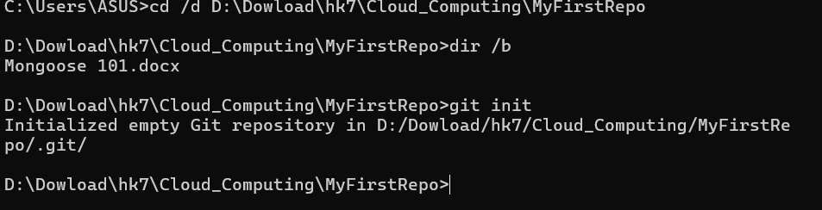

Step 2:

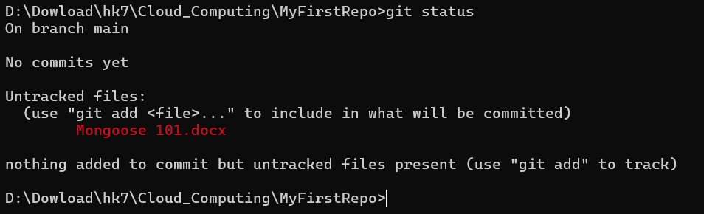

Step 3:

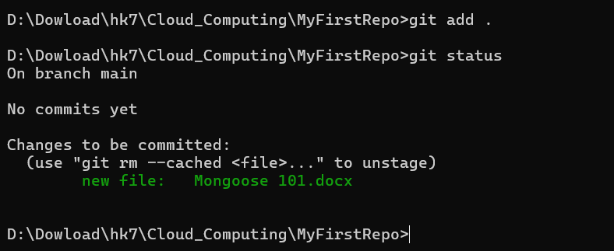

Step 4:

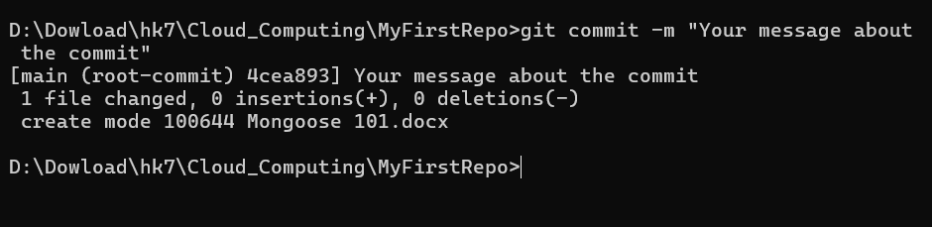

Step 5:

