Snake game

Agent:

* Game
  + Use pygame

Play_step(action)

* + - Reward, game_over, score
* Model (PyTorch)
  + Linear_QNet (DQN)

Model.predict(state)

* + - Action
* Training:
  + State = get_state(game)
  + Action = get_move(state):
    - Model.predict()
  + Reward, game_over, score = game.play_step(action)
  + New_state = get_state(game)
  + Rêmmber
  + Model.train()
* Reward:
  + Eat food: +10
  + Game over: -10
  + Else: 0
* Action:
  + [1, 0, 0]: Straight
  + [0, 1, 0]: right turn
  + [0, 0, 1]: left turn
* State: tell the snake information about the game that it knows about the environment
  + Have 11 values:
  + Danger straight, danger right, danger left
  + Direction left, direction right, direction up, direction down
  + Food left, food right, food up, food down

(Deep) Q Learning

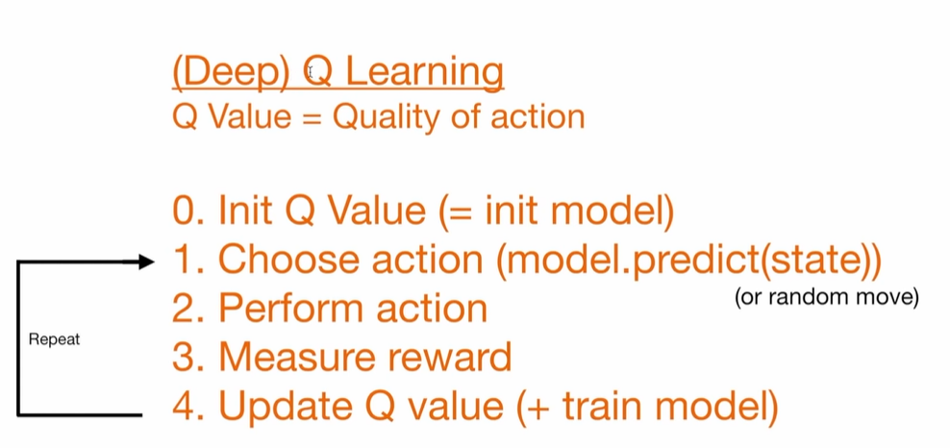

Bellman Equation

$$NewQ\left(s, a\right)=Q\left(s, a\right)+α[R\left(s, a\right)+γmaxQ^{'}\left(s^{'}, a^{'}\right)-Q(s, a)$$

* $NewQ(s, a)$: new Q value for that state and that action
* $Q(s, a)$: current Q value
* $α$: learning rate
* $R(s, a)$: reward for taking that action at that state
* $γ$: discount rate
* $maxQ'(s^{'}, a^{'})$: max expected future reward given the new s’ and all possible actions at that new state

Q Update rule simplified

$Q=model.predict({state}_{0})$

$Q_{new}=R+γ*max⁡(Q\left({state}_{1}\right))$

Loss function

$$loss={\left(Q_{new}-Q\right)}^{2}$$

Game

* Conda create -n snake_game python=3.10
* Conda activate snake_game