Conestoga College – SET

Ego App Document

Name : Group 5
Date of Submission : March 14, 2020

MAD
(PROG 1350)

Table of Contents
Section 1: Summary 3
Section 2: Scenario 3
Section 3: Functionality 4
Section 5: Database Design – SQLite: 6
Section 6: Connecting with JSON Server: 6

Section 1: Summary
Ego app is developed to support book trip through the list of cities.

Section 2: Scenario
The Ego App is used to book the trip from selected city to end city. User can make the trip, see the trip details and bill information.
User also can open google search for searching any information they want and make a phone call

Section 3: Functionality
3.1 Main Functionality:
Main functions are displayed in the main screen dash broad and tool bar navigation
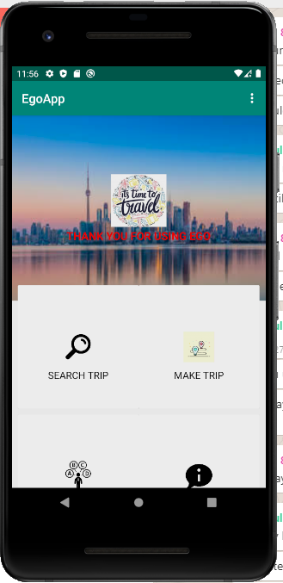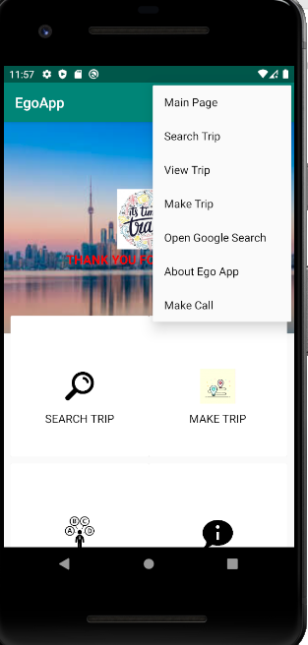

- Make Trip Option:
There are three steps:
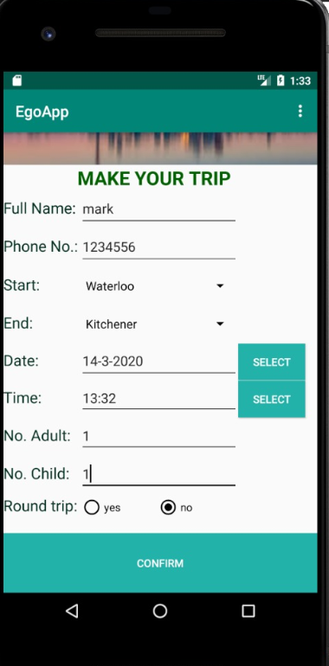 | 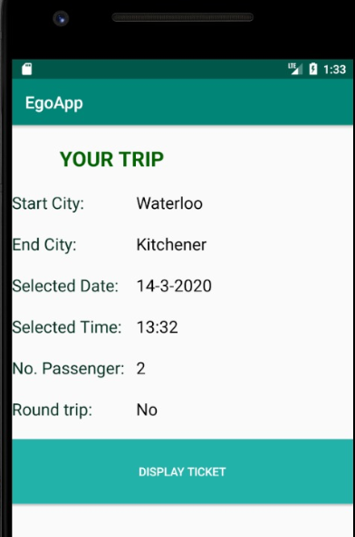 | 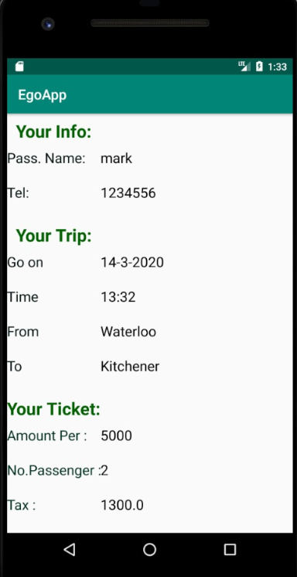

Step 1:
This function is used to allow user booking the trip by enter customer info which are customer name and phone number and trip information such as start city, end city, date, time, number of adult, number of children, and round trip option

Step 2:
After user enter all information in make trip, user can press the button to see trip info based on the information that they entered
Step 3:
Next, they can press the button to see the bill and invoice details for the trip which are customer information, trip info and bill info.
In the bill info, we calculate the bill base on comparing the start city and end city with start city and end city in route table from SQLite database to get distance value. With the distance value, we calculate the bill for per passengers and add all the bills together to get the total price with tac included.

- View Trip:
View trip option is used to help user can view the list of trip offered. User just click on any trip option in the list, the start city and end city will update and display in the make trip screen for user.
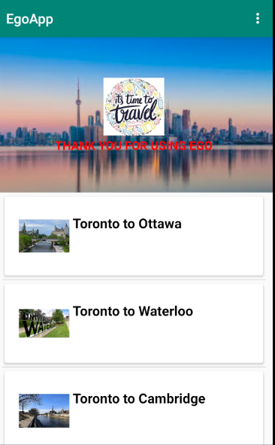

- Search City Engine:
Search engine is used to search the city that we allow to book the trip to. As a result, we minimize the list of cities contain cities that user can book trip to. User can enter the guessed city name in to the search engine, the search engine will display the results based on the list of the cities that we offer.
In order to get the list of the city, we get the list of the city in the city table of the database handler.
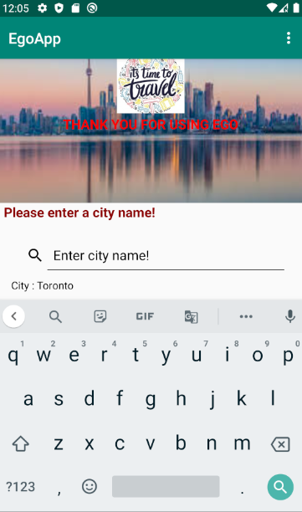

- About Ego App:
This option is used to describe about the ego app, and tell user how to use the trip
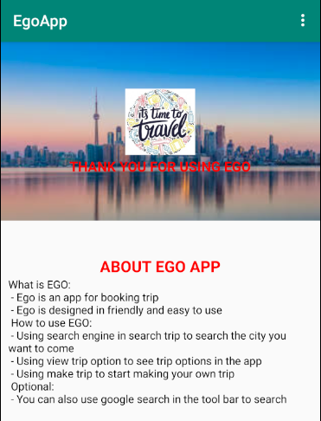

3.2 Additional Functionality
- Open Google Search:
With the google search, user can search any information by opening Google search in the tool bar option
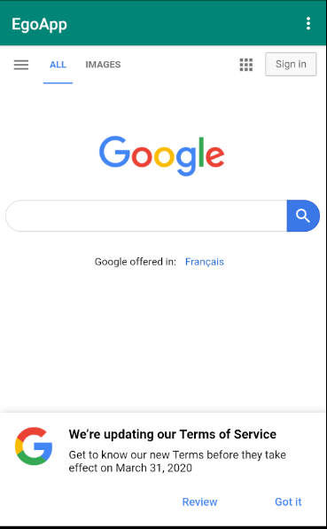 | 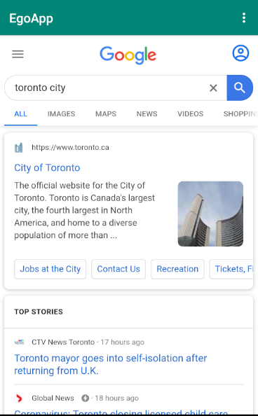

- Make A Phone Call:
With making a phone call, user can search any information by making phone call in the tool bar option
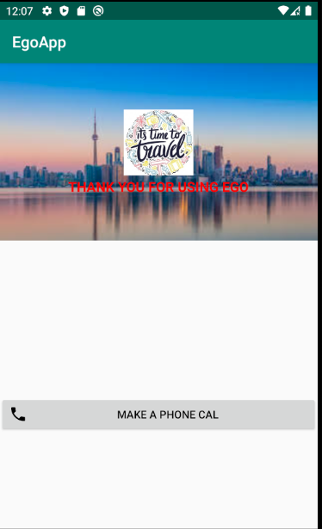 | 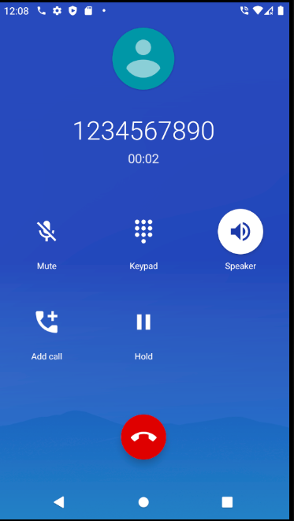

Section 4: Technician Functionality
3.1 Asynchronous tasks
- The first asynchronous task is user to load the list of the city for search engine. When you click on the search trip option in the main page dash broad, the asynchronous task will load the list of the city first. The process will be displayed by the progress bar.
- The second asynchronous task is used to check Wi-Fi connection for the EGP app in the search engine and open Google Search option in the tool bar
- The third asynchronous is use to connect with the json server and working with json file

3.2 External Activities
- The first external activity is opening Google search that help user easy searching any information they want. The Google search engine is placed in the tool bar (not in the main page dash broad, because it is an optional functionality)
- The second external activity is making phone call that help user make a phone call. This one is placed in the tool bar (not in the main page dash broad, because it is an optional functionality)

3.3 Working with files
- We open and read two Json files and add them in to database for using the calculating bill, adapter city lists for search engine and start city and end city spinner in make trip option.

3.4 List and Adapter
- We use the list adapter to display the list view in the View Trip option
- We also use the adapter in the filter searching engine.

Section 5: Database Design – SQLite:
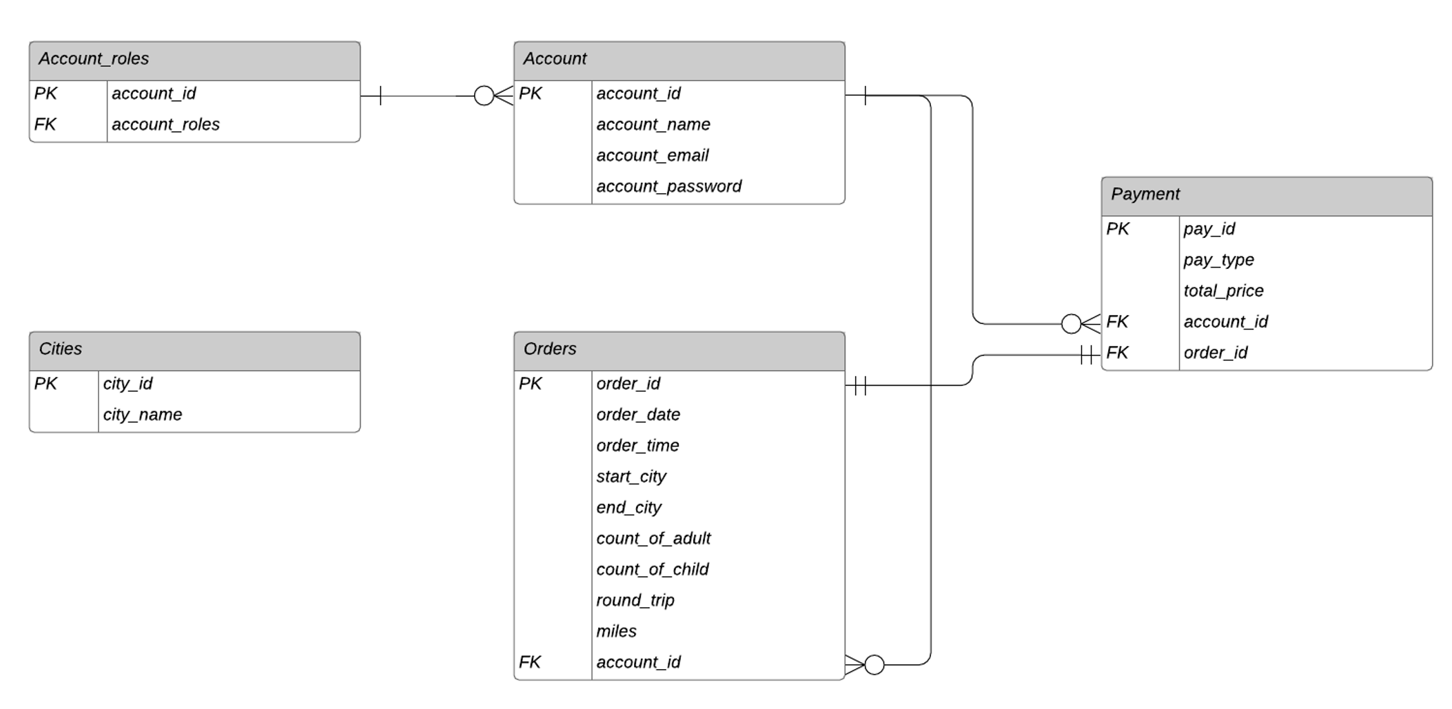

Section 6: Connecting with JSON Server:
In order to run and connect with the JSON-Server, we need to install the Node.js server. In this app, we use and implement the data from two external resource which help us connect to the JOSN-Server. The first JSON file is db1, which contains the information of 8 cities and the second JSON file is db2.json, which contains the start – end cities and distance. To run the JSON-Server, I made two bat file called test1.bat and test2.bat that contains all the command to run the server (Example: json-server –watch db1.json). But we need two run two server with different port. In the app, I make some code which established with the URL from the server and implements AsyncTask to get the data from the Server.

