Dịch vụ lên kế hoạch du lịch

Bước 1 add file database tourtrip.sql vào Mysql.

Bước 2 chạy project ToutripAPI bằng IDE(netbean , eclip, IntelIJ)

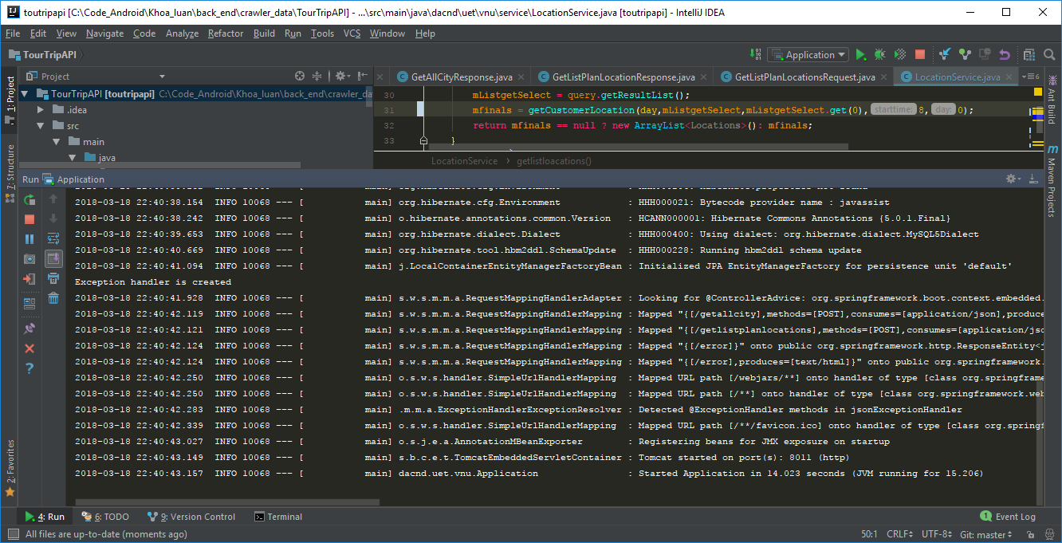

Bước 3 : Test thử api với postmen

<http://localhost:8011/getlistplanlocations>

request

{

"wsCode": "Ws_getlistplanlocations",

"wsRequest": {

"city_id":2,

"cate_id":1,

"day_number":3

}

}

Response

{

"errorCode": "S200",

"errorMessage": "The api access successful",

"result": {

"errorCode": "0",

"errorMessage": "successful",

"data": {

"mLocations": [

{

"id": 218,

"sub_id": 5,

"city_id": 2,

"cate_id": 1,

"name": "Hoàng Thành Huế",

"ratting": 40,

"feedback_number": 8361,

"address": "Thành phố Huế, Thừa Thiên Huế, Việt Nam",

"lat": 16.4677596,

"lon": 107.5769439,

"google_count": 1760000,

"time_open": "0:00 - 23:59",

"time_limit": "1h - 2h",

"content": "https://media-cdn.tripadvisor.com/media/photo-w/07/b6/32/e2/photo1jpg.jpg",

"time": 8,

"status": 1

},

{

"id": 221,

"sub_id": 8,

"city_id": 2,

"cate_id": 1,

"name": "Tử Cấm Thành",

"ratting": 40,

"feedback_number": 744,

"address": "Thuận Thành, Huế,Việt Nam",

"lat": 16.4677596,

"lon": 107.5769439,

"google_count": 2060000,

"time_open": "0:00 - 23:59",

"time_limit": "1h - 2h",

"content": "https://media-cdn.tripadvisor.com/media/photo-s/12/24/69/de/entrada.jpg",

"time": 9.625,

"status": 0

},

{

"id": 223,

"sub_id": 10,

"city_id": 2,

"cate_id": 1,

"name": "Chùa Thiên Mụ",

"ratting": 40,

"feedback_number": 2921,

"address": "Kim Long Road, Huế,Việt Nam",

"lat": 16.452421,

"lon": 107.5428561,

"google_count": 3450000,

"time_open": "0:00 - 23:59",

"time_limit": "1h - 2h",

"content": "https://media-cdn.tripadvisor.com/media/photo-w/12/41/8f/be/img-20180306-085342-largejpg.jpg",

"time": 12.125,

"status": 2

},

{

"id": 219,

"sub_id": 6,

"city_id": 2,

"cate_id": 1,

"name": "Lăng Tự Đức Khiêm Lăng",

"ratting": 40,

"feedback_number": 1652,

"address": "17/69 Lê Ngô Cát, Thủy Xuân, Thành phố Huế, Thừa Thiên Huế, Việt Nam",

"lat": 16.4331527,

"lon": 107.5631757,

"google_count": 1300000,

"time_open": "0:00 - 23:59",

"time_limit": "1h - 2h",

"content": "https://media-cdn.tripadvisor.com/media/photo-s/12/3f/6a/07/photo5jpg.jpg",

"time": 15,

"status": 0

},

{

"id": 216,

"sub_id": 3,

"city_id": 2,

"cate_id": 1,

"name": "Lăng Khải Định",

"ratting": 45,

"feedback_number": 800,

"address": "Khải Định, Thủy Bằng, Hương Thủy, Thừa Thiên Huế, Việt Nam",

"lat": 16.4331498,

"lon": 107.5303447,

"google_count": 2020000,

"time_open": "0:00 - 23:59",

"time_limit": "1h - 2h",

"content": "https://media-cdn.tripadvisor.com/media/photo-s/12/3d/78/0f/img-20171021-144106-largejpg.jpg",

"time": 17.5,

"status": 0

},

{

"id": 215,

"sub_id": 2,

"city_id": 2,

"cate_id": 1,

"name": "Lăng Minh Mạng (Hiếu Lăng)",

"ratting": 45,

"feedback_number": 2116,

"address": "QL49, Hương Thọ, Hương Trà, Thừa Thiên Huế, Việt Nam",

"lat": 16.3874871,

"lon": 107.5685545,

"google_count": 2480000,

"time_open": "0:00 - 23:59",

"time_limit": "1h - 2h",

"content": "https://media-cdn.tripadvisor.com/media/photo-s/12/32/21/ca/photo0jpg.jpg",

"time": 20,

"status": 3

},

{

"id": 214,

"sub_id": 1,

"city_id": 2,

"cate_id": 1,

"name": "Imperial Tomb of Dong Khanh",

"ratting": 45,

"feedback_number": 336,

"address": "8 Đoàn Nhữ Hải, Thủy Xuân, Thành phố Huế, Thừa Thiên Huế, Việt Nam",

"lat": 16.429808,

"lon": 107.5679203,

"google_count": 6890000,

"time_open": "0:00 - 23:59",

"time_limit": "1h - 2h",

"content": "https://media-cdn.tripadvisor.com/media/photo-o/08/bf/66/3f/imperial-tomb-of-dong.jpg",

"time": 10.5,

"status": 0

}

]

}

}

}

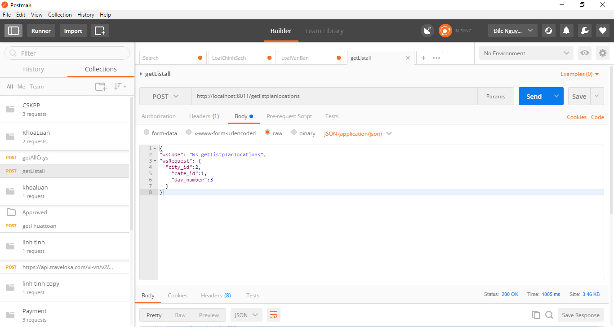

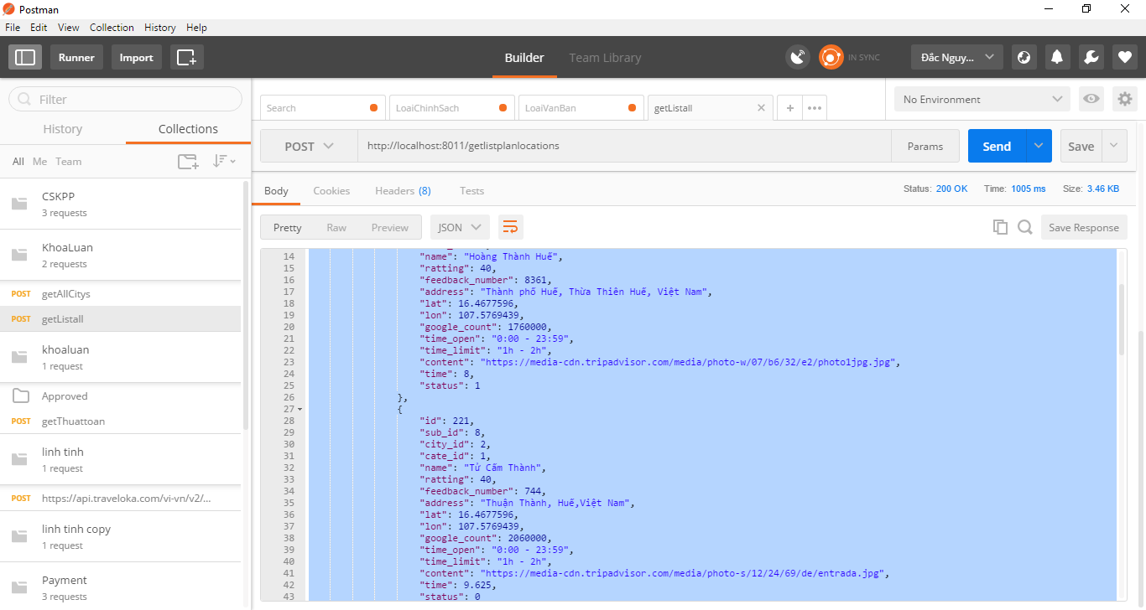

Về Dịch vụ Tìm kiếm khách sạn , và uber;

Chạy project Android font_end;