RelativeLayout

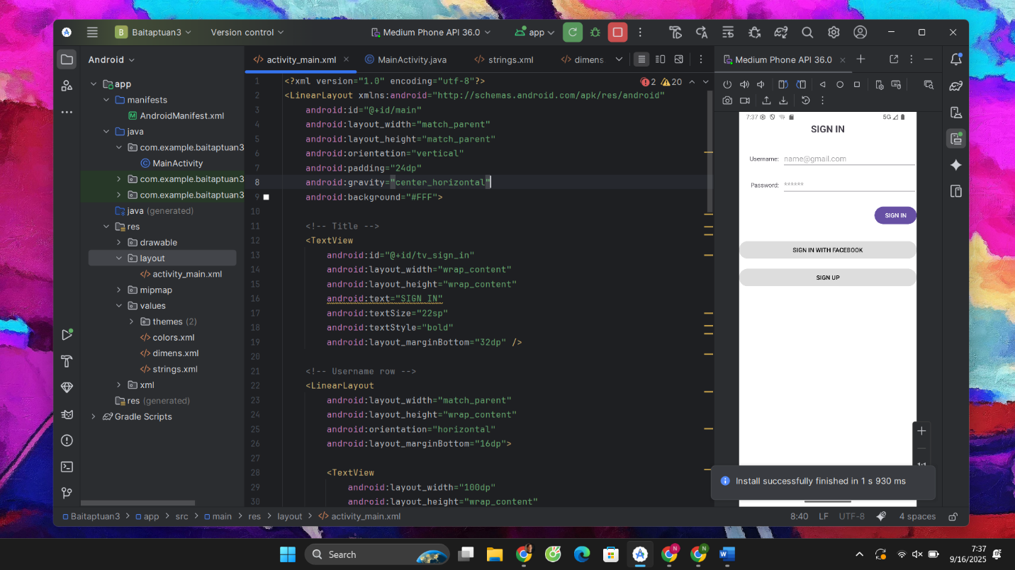

**Nội dung file string.xml**

<resources>  
 <string name="app_name">Lab01_2c</string>  
 <string name="sign_in">Sign in</string>  
 <string name="username">Username: </string>  
 <string name="password">Password: </string>  
 <string name="signup">Sign up</string>  
</resources>

**Nội dung file dimens.xml**

<resources>  
 <!-- Default screen margins, per the Android Design guidelines. -->  
 <dimen name="activity_horizontal_margin">16dp</dimen>  
 <dimen name="activity_vertical_margin">16dp</dimen>  
 <dimen name="margin_base">5dp</dimen>  
 <dimen name="margin_basex2">10dp</dimen>  
 <dimen name="margin_basex3">15dp</dimen>  
 <dimen name="margin_basex4">20dp</dimen>  
 <dimen name="text_small">16sp</dimen>  
 <dimen name="text_medium">18sp</dimen>  
 <dimen name="text_large">20sp</dimen>  
</resources>

**Nội dung file activity_main.xml**

<?xml version="1.0" encoding="utf-8"?>  
<LinearLayout xmlns:android="http://schemas.android.com/apk/res/android"  
 android:id="@+id/main"  
 android:layout_width="match_parent"  
 android:layout_height="match_parent"  
 android:orientation="vertical"  
 android:padding="24dp"  
 android:gravity="center_horizontal"  
 android:background="#FFF">  
  
 <!-- Title -->  
 <TextView  
 android:id="@+id/tv_sign_in"  
 android:layout_width="wrap_content"  
 android:layout_height="wrap_content"  
 android:text="SIGN IN"  
 android:textSize="22sp"  
 android:textStyle="bold"  
 android:layout_marginBottom="32dp" />  
  
 <!-- Username row -->  
 <LinearLayout  
 android:layout_width="match_parent"  
 android:layout_height="wrap_content"  
 android:orientation="horizontal"  
 android:layout_marginBottom="16dp">  
  
 <TextView  
 android:layout_width="100dp"  
 android:layout_height="wrap_content"  
 android:text="Username:"  
 android:gravity="end"  
 android:layout_gravity="center_vertical"  
 android:paddingRight="8dp" />  
  
 <EditText  
 android:id="@+id/et_username"  
 android:layout_width="0dp"  
 android:layout_height="wrap_content"  
 android:layout_weight="1"  
 android:hint="name@gmail.com"  
 android:inputType="textEmailAddress" />  
 </LinearLayout>  
  
 <!-- Password row -->  
 <LinearLayout  
 android:layout_width="match_parent"  
 android:layout_height="wrap_content"  
 android:orientation="horizontal"  
 android:layout_marginBottom="24dp">  
  
 <TextView  
 android:layout_width="100dp"  
 android:layout_height="wrap_content"  
 android:text="Password:"  
 android:gravity="end"  
 android:layout_gravity="center_vertical"  
 android:paddingRight="8dp" />  
  
 <EditText  
 android:id="@+id/et_password"  
 android:layout_width="0dp"  
 android:layout_height="wrap_content"  
 android:layout_weight="1"  
 android:hint="******"  
 android:inputType="textPassword" />  
 </LinearLayout>  
  
 <!-- Sign In Button -->  
 <Button  
 android:id="@+id/btn_sign_in"  
 android:layout_width="wrap_content"  
 android:layout_height="wrap_content"  
 android:text="SIGN IN"  
 android:layout_gravity="end"  
 android:layout_marginBottom="32dp" />  
  
 <!-- Extra buttons -->  
 <Button  
 android:id="@+id/btn_sign_in_facebook"  
 android:layout_width="match_parent"  
 android:layout_height="wrap_content"  
 android:text="SIGN IN WITH FACEBOOK"  
 android:backgroundTint="#DDDDDD"  
 android:textColor="@android:color/black"  
 android:layout_marginBottom="16dp" />  
  
 <Button  
 android:id="@+id/btn_sign_up"  
 android:layout_width="match_parent"  
 android:layout_height="wrap_content"  
 android:backgroundTint="#DDDDDD"  
 android:text="SIGN UP"  
 android:textColor="@android:color/black" />  
  
</LinearLayout>

ContraintLayout

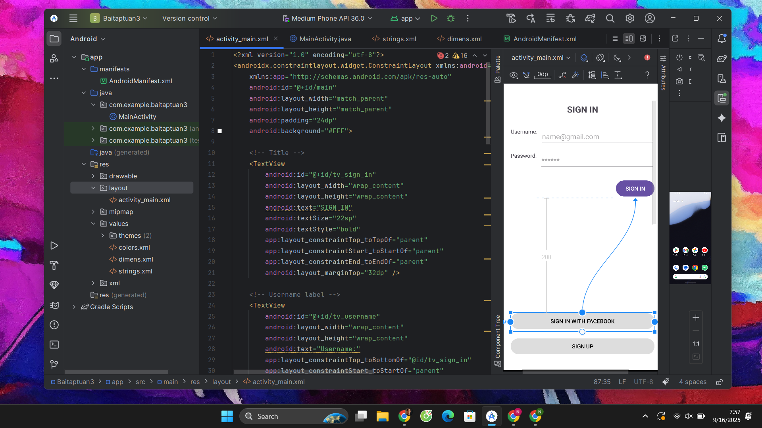

**Nội dung file activity_main.xml**

<?xml version="1.0" encoding="utf-8"?>  
<androidx.constraintlayout.widget.ConstraintLayout xmlns:android="http://schemas.android.com/apk/res/android"  
 xmlns:app="http://schemas.android.com/apk/res-auto"  
 android:id="@+id/main"  
 android:layout_width="match_parent"  
 android:layout_height="match_parent"  
 android:padding="24dp"  
 android:background="#FFF">  
  
 <!-- Title -->  
 <TextView  
 android:id="@+id/tv_sign_in"  
 android:layout_width="wrap_content"  
 android:layout_height="wrap_content"  
 android:text="SIGN IN"  
 android:textSize="22sp"  
 android:textStyle="bold"  
 app:layout_constraintTop_toTopOf="parent"  
 app:layout_constraintStart_toStartOf="parent"  
 app:layout_constraintEnd_toEndOf="parent"  
 android:layout_marginTop="32dp" />  
  
 <!-- Username label -->  
 <TextView  
 android:id="@+id/tv_username"  
 android:layout_width="wrap_content"  
 android:layout_height="wrap_content"  
 android:text="Username:"  
 app:layout_constraintTop_toBottomOf="@id/tv_sign_in"  
 app:layout_constraintStart_toStartOf="parent"  
 android:layout_marginTop="32dp" />  
  
 <!-- Username input -->  
 <EditText  
 android:id="@+id/et_username"  
 android:layout_width="0dp"  
 android:layout_height="wrap_content"  
 android:hint="name@gmail.com"  
 android:inputType="textEmailAddress"  
 app:layout_constraintStart_toEndOf="@id/tv_username"  
 app:layout_constraintTop_toTopOf="@id/tv_username"  
 app:layout_constraintEnd_toEndOf="parent"  
 android:layout_marginStart="8dp" />  
  
 <!-- Password label -->  
 <TextView  
 android:id="@+id/tv_password"  
 android:layout_width="wrap_content"  
 android:layout_height="wrap_content"  
 android:text="Password:"  
 app:layout_constraintTop_toBottomOf="@id/et_username"  
 app:layout_constraintStart_toStartOf="parent"  
 android:layout_marginTop="16dp" />  
  
 <!-- Password input -->  
 <EditText  
 android:id="@+id/et_password"  
 android:layout_width="0dp"  
 android:layout_height="wrap_content"  
 android:hint="******"  
 android:inputType="textPassword"  
 app:layout_constraintStart_toEndOf="@id/tv_password"  
 app:layout_constraintTop_toTopOf="@id/tv_password"  
 app:layout_constraintEnd_toEndOf="parent"  
 android:layout_marginStart="8dp" />  
  
 <!-- Sign In button -->  
 <Button  
 android:id="@+id/btn_sign_in"  
 android:layout_width="wrap_content"  
 android:layout_height="wrap_content"  
 android:text="SIGN IN"  
 app:layout_constraintTop_toBottomOf="@id/et_password"  
 app:layout_constraintEnd_toEndOf="parent"  
 android:layout_marginTop="24dp" />  
  
 <!-- Facebook button -->  
  
 <!-- Sign Up button -->  
  
 <Button  
 android:id="@+id/btn_sign_in_facebook"  
 android:layout_width="0dp"  
 android:layout_height="wrap_content"  
 android:layout_marginTop="288dp"  
 android:backgroundTint="#DDDDDD"  
 android:text="SIGN IN WITH FACEBOOK"  
 android:textColor="@android:color/black"  
 app:layout_constraintEnd_toEndOf="parent"  
 app:layout_constraintHorizontal_bias="0.0"  
 app:layout_constraintStart_toStartOf="parent"  
 app:layout_constraintTop_toBottomOf="@id/btn_sign_in" />  
  
 <Button  
 android:id="@+id/btn_sign_up"  
 android:layout_width="0dp"  
 android:layout_height="wrap_content"  
 android:text="SIGN UP"  
 android:backgroundTint="#DDDDDD"  
 android:textColor="@android:color/black"  
 app:layout_constraintTop_toBottomOf="@id/btn_sign_in_facebook"  
 app:layout_constraintStart_toStartOf="parent"  
 app:layout_constraintEnd_toEndOf="parent"  
 android:layout_marginTop="16dp" />  
  
</androidx.constraintlayout.widget.ConstraintLayout>